FORM 6-K

SECURITIES AND EXCHANGE COMMISSION

Washington, D.C. 20549

Report of Foreign Private Issuer

Pursuant to Rule 13a-16 under

the Securities Exchange Act of 1934

For the month ended July, 2013

ICON plc

(Registrant's name)

0-29714

(Commission file number)

South County Business Park, Leopardstown, Dublin 18, Ireland

(Address of principal executive offices)

Brendan Brennan, CFO

South County Business Park, Leopardstown, Dublin 18, Ireland.

Brendan.Brennan@iconplc.com

00-353-1-291-2000

(Name, telephone number, email and/or facsimile number and address of Company contact person)

Indicate by check mark whether the registrant files or will file annual reports under cover Form 20-F or Form 40-F.

Yes___X___ No_______

Indicate by check mark whether the registrant is submitting the Form 6-K in paper as permitted by Regulation S-T Rule 101(b)(1):

Yes______ No___X___

Indicate by check mark whether the registrant by furnishing the information contained in this Form is also thereby furnishing the information to the Commission pursuant to Rule12g3-2(b) under the Securities Exchange Act of 1934.

Yes______ No___X___

If "Yes" is marked, indicate below the file number assigned to the registrant in connection with Rule 12g3-2(b):82 N/A

EXHIBIT LIST

Exhibit Description

99.1 Letter to ISS dated 11 July 2013

SIGNATURES

Pursuant to the requirements of the Securities Exchange Act of 1934, the Registrant has duly caused this report to be signed on its behalf by the undersigned thereunto duly authorized.

 | ICON plc
 | /s/ Brendan Brennan
Date: July 11, 2013 | Brendan Brennan
 | Chief Financial Officer

Exhibit 99.1
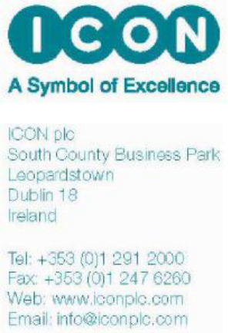

Mr Justin Levis

ISS

20850 King Farm Boulevard

Rockville

MD 20850

11 July 2013

ICON plc Annual General Meeting (AGM)

Dear Justin

Thank you for your engagement in relation to the ISS report on our upcoming AGM.

As discussed, ICON feels that resolutions 4 and 5 (which are linked and related resolutions) included in our proxy (the ability to issue shares and also to disapply offer round when shares are issued) are reasonable taking into account of ICON’s status as a solely NASDAQ listed company. However, as the ISS report notes concerns in relation to these resolutions and recommends a no vote on each, this letter is intended to give additional context in relation to the resolutions.

In relation to resolution 5 (disapplication of statutory pre-emption rights), I can confirm that ICON plc does not currently intend to issue more than 5% of its issued share capital as at 11th June 2013 (being the date used in our proxy for the calculation of the cap in resolution 5) in any year of the 5 year authority without offering shares to existing shareholders on a pro rata basis.

If you have any questions, please do not hesitate to contact me.

Regards
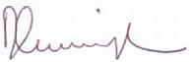

Diarmaid Cunningham

General Counsel & Company Secretary

ICON plc

