FORM 6-K

SECURITIES AND EXCHANGE COMMISSION

Washington, D.C. 20549

Report of Foreign Private Issuer

Pursuant to Rule 13a-16 under
the Securities Exchange Act of 1934

For the month ended December, 2015

ICON plc

(Registrant's name)

333-08704

(Commission file number)

South County Business Park, Leopardstown, Dublin 18, Ireland

(Address of principal executive offices)

Brendan Brennan, Chief Financial Officer
South County Business Park, Leopardstown, Dublin 18, Ireland
Brendan.Brennan@iconplc.com
00-353-1-291-2000

(Name, telephone number, email and/or facsimile number and address of Company contact person)

Indicate by check mark whether the registrant files or will file annual reports under cover Form 20-F or Form 40-F.

Yes___X___ No_______

Indicate by check mark whether the registrant is submitting the Form 6-K in paper as permitted by Regulation S-T Rule 101(b)(1):

Yes______ No___X___

Indicate by check mark whether the registrant is submitting the Form 6-K in paper as permitted by Regulation S-T Rule 101(b)(7):

Yes______ No___X___

Indicate by check mark whether the registrant by furnishing the information contained in this Form is also thereby furnishing the information to the Commission pursuant to Rule 12g3-2(b) under the Securities Exchange Act of 1934.

Yes_______ No___X___

If "Yes" is marked, indicate below the file number assigned to the registrant in connection with Rule 12g3-2(b):82 N/A

 |  |  |  | EXHIBIT LIST
Exhibit |  | Description
99.1 |  | Form B7 Notice of Redemption of 25,661 Shares on November 6, 2015 filed in Companies Registration Office in Ireland on December 2,
 |  | 2015
99.2 |  | Form B7 Notice of Redemption of 24,000 Shares on November 9, 2015 filed in Companies Registration Office in Ireland on December 2,
 |  | 2015
99.3 |  | Form B7 Notice of Redemption of 50,545 Shares on November 10, 2015 filed in Companies Registration Office in Ireland on December
 |  | 2, 2015
99.4 |  | Form B7 Notice of Redemption of 33,775 Shares on November 12, 2015 filed in Companies Registration Office in Ireland on December
 |  | 2, 2015
99.5 |  | Form B7 Notice of Redemption of 23,500 Shares on November 13, 2015 filed in Companies Registration Office in Ireland on December
 |  | 2, 2015
99.6 |  | Form B7 Notice of Redemption of 33,030 Shares on November 16, 2015 filed in Companies Registration Office in Ireland on December
 |  | 2, 2015
99.7 |  | Form B7 Notice of Redemption of 33,534 Shares on November 16, 2015 filed in Companies Registration Office in Ireland on December
 |  | 2, 2015
99.8 |  | Form B7 Notice of Redemption of 61,209 Shares on November 17, 2015 filed in Companies Registration Office in Ireland on December
 |  | 2, 2015
99.9 |  | Form B7 Notice of Redemption of 78,556 Shares on November 18, 2015 filed in Companies Registration Office in Ireland on December
 |  | 2, 2015
99.10 |  | Form B7 Notice of Redemption of 46,551 Shares on November 19, 2015 filed in Companies Registration Office in Ireland on December
 |  | 2, 2015
99.11 |  | Form B7 Notice of Redemption of 30,745 Shares on November 20, 2015 filed in Companies Registration Office in Ireland on December
 |  | 2, 2015

SIGNATURES

Pursuant to the requirements of the Securities Exchange Act of 1934, the Registrant has duly caused this report to be signed on its behalf by the undersigned thereunto duly authorized.

ICON plc

Date: December 2, 2015 | /s/ Brendan Brennan
 | Brendan Brennan
 | Chief Financial Officer

Exhibit 99.1
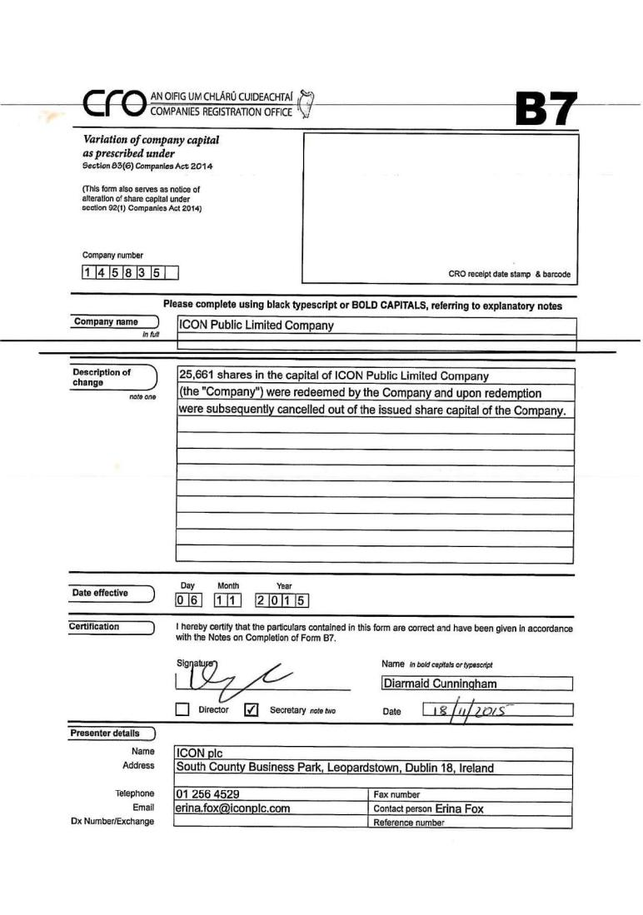

Exhibit 99.2
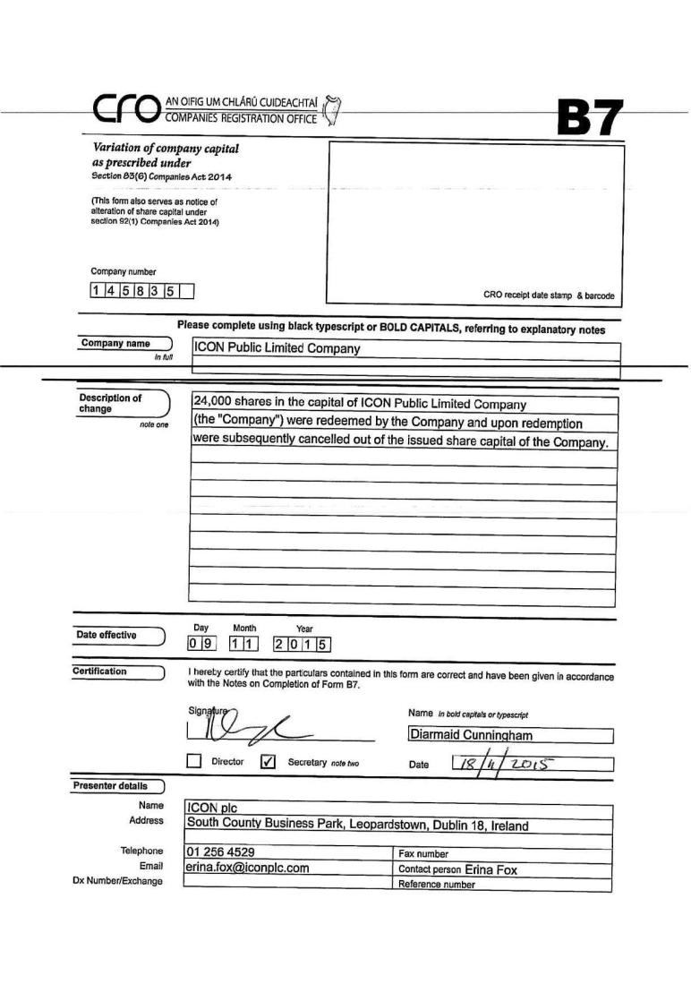

Exhibit 99.3
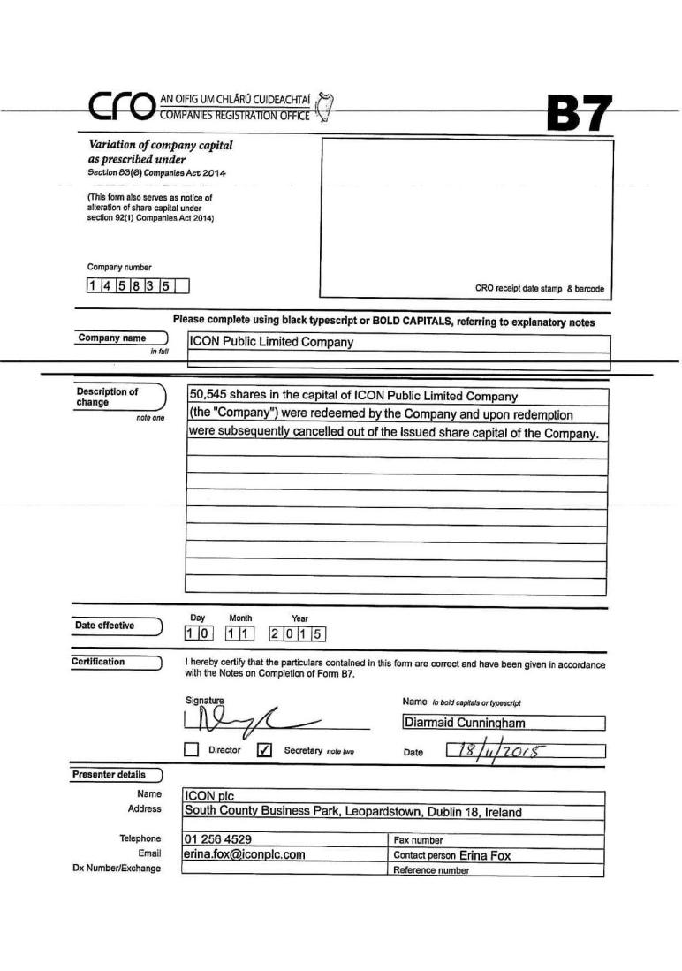

Exhibit 99.4
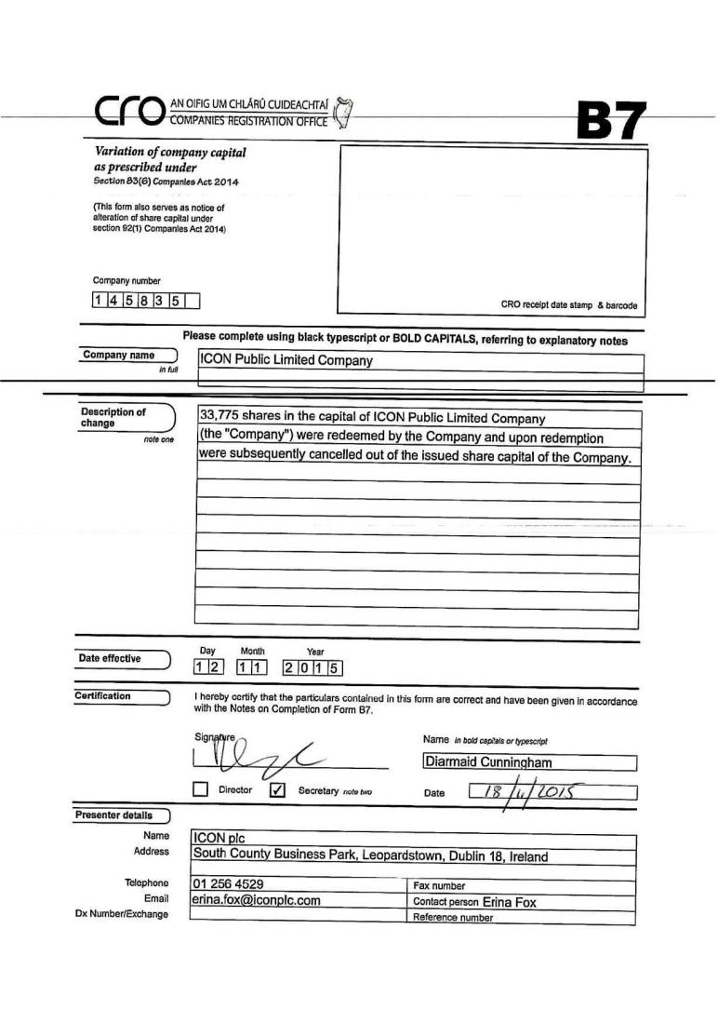

Exhibit 99.5
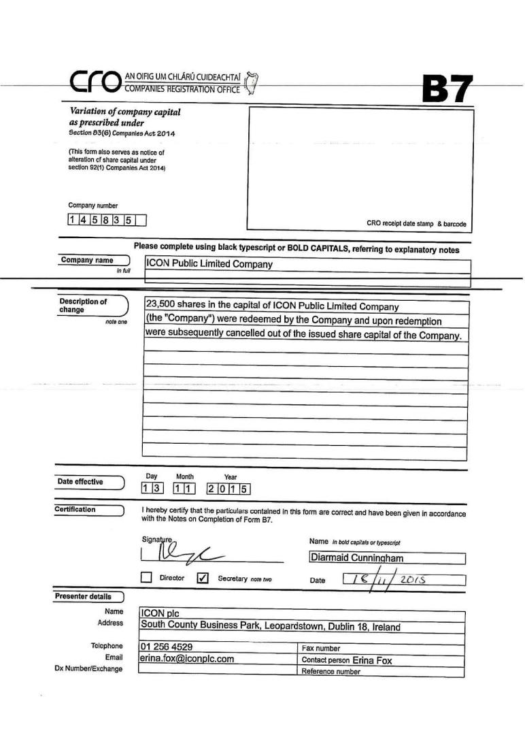

Exhibit 99.6
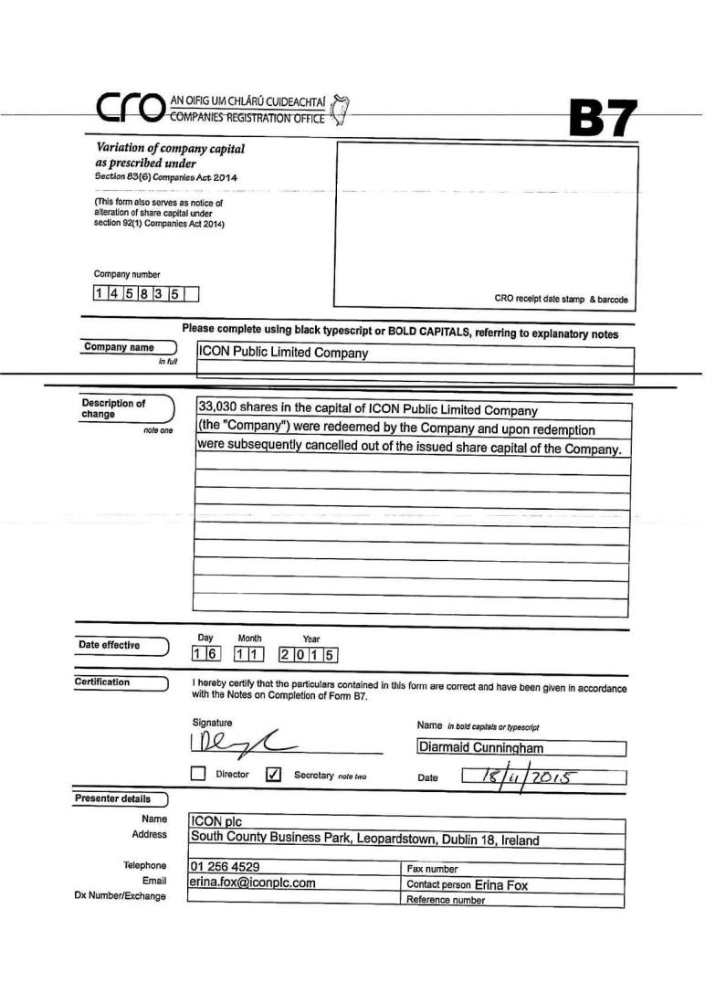

Exhibit 99.7
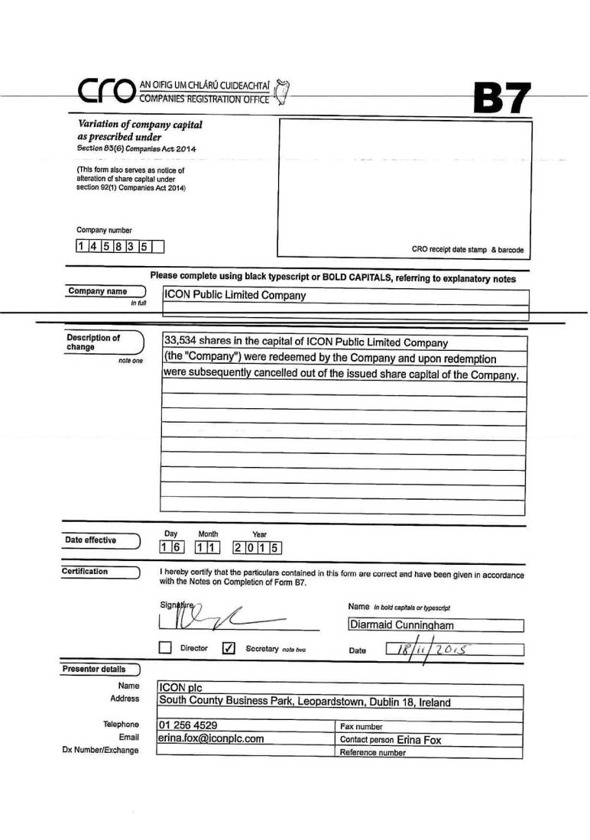

Exhibit 99.8
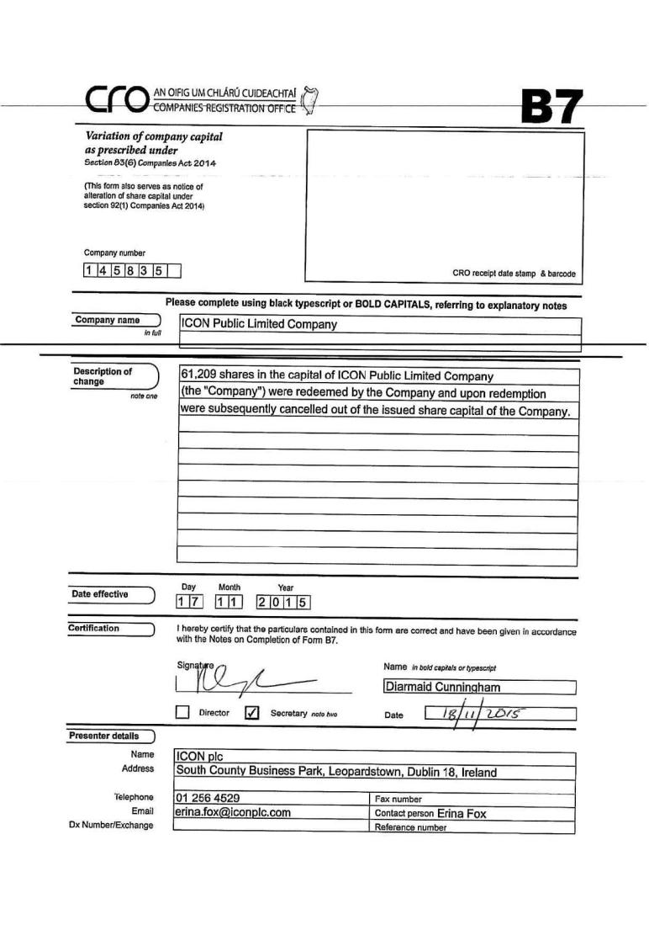

Exhibit 99.9
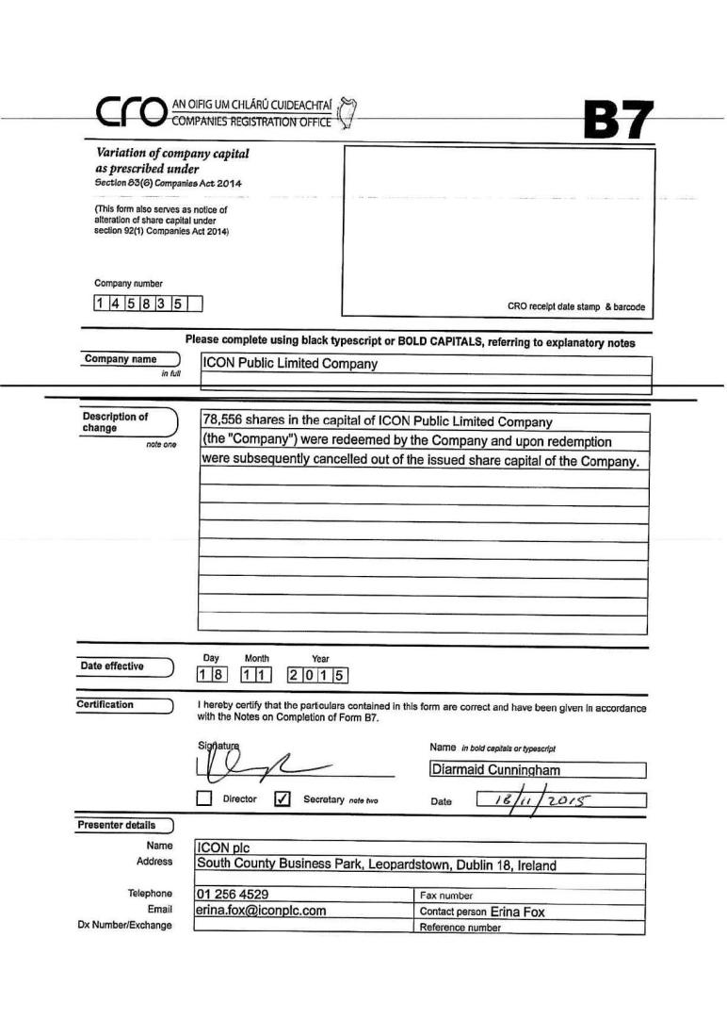

Exhibit 99.10
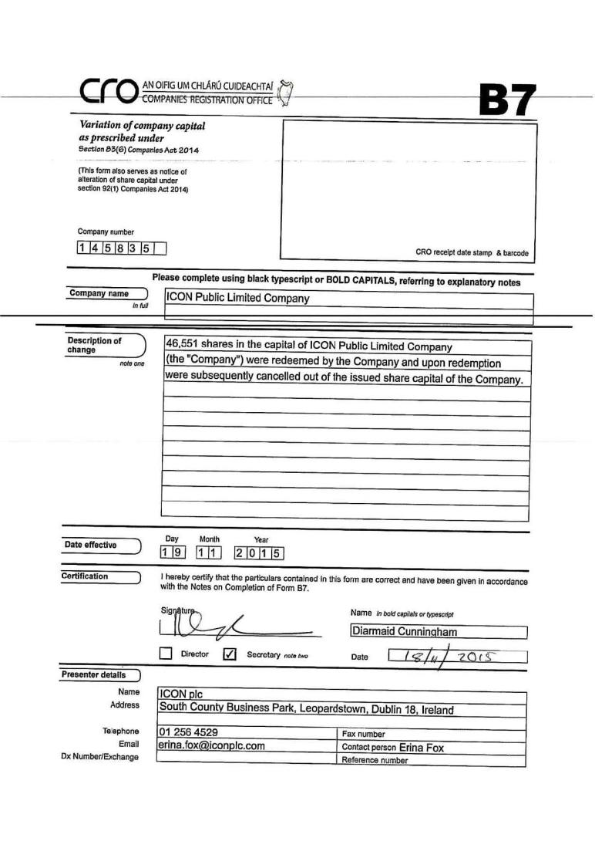

Exhibit 99.11


