FORM 6-K

SECURITIES AND EXCHANGE COMMISSION

Washington, D.C. 20549

Report of Foreign Private Issuer

Pursuant to Rule 13a-16 under

the Securities Exchange Act of 1934

For the month ended November, 2018

ICON plc

(Registrant's name)

333-08704

(Commission file number)

South County Business Park, Leopardstown, Dublin 18, Ireland

(Address of principal executive offices)

Brendan Brennan, CFO

South County Business Park, Leopardstown, Dublin 18, Ireland.

Brendan.Brennan@iconplc.com

00-353-1-291-2000

(Name, telephone number, email and/or facsimile number and address of Company contact person)

Indicate by check mark whether the registrant files or will file annual reports under cover Form 20-F or Form 40-F.

Yes___X___ No_______

Indicate by check mark whether the registrant is submitting the Form 6-K in paper as permitted by Regulation S-T Rule 101(b)(1):

Yes______ No___X___

Indicate by check mark whether the registrant is submitting the Form 6-K in paper as permitted by Regulation S-T Rule 101(b)(7):

Yes______ No___X___

Indicate by check mark whether the registrant by furnishing the information contained in this Form is also thereby furnishing the information to the Commission pursuant to Rule12g3-2(b) under the Securities Exchange Act of 1934.

Yes______ No___X___

If "Yes" is marked, indicate below the file number assigned to the registrant in connection with Rule 12g3-2(b):82 N/A

 |  |  |  |  |  |  | EXHIBIT LIST
Exhibit |  |  |  | Description
99.1 |  |  |  | Form B7 Notice of Redemption of 1,514 Shares on October 11, 2018 filed in Companies Registration Office in Ireland on November 8, 2018
99.2 |  |  |  | Form B7 Notice of Redemption of 18,000 Shares on October 12, 2018 filed in Companies Registration Office in Ireland on November 8, 2018
99.3 |  |  |  | Form B7 Notice of Redemption of 53,362 Shares on October 15, 2018 filed in Companies Registration Office in Ireland on November 8, 2018
99.4 |  |  |  | Form B7 Notice of Redemption of 43,392 Shares on October 16, 2018 filed in Companies Registration Office in Ireland on November 8, 2018
99.5 |  |  |  | Form B7 Notice of Redemption of 56,954 Shares on October 17, 2018 filed in Companies Registration Office in Ireland on November 8, 2018
99.6 |  |  |  | Form B7 Notice of Redemption of 1,209 Shares on October 23, 2018 filed in Companies Registration Office in Ireland on November 8, 2018
99.7 |  |  |  | Form B7 Notice of Redemption of 13,840 Shares on October 25, 2018 filed in Companies Registration Office in Ireland on November 8, 2018
99.8 |  |  |  | Form B7 | Notice of Redemption of 59,368 Shares on October 26, 2018 filed in Companies Registration Office in Ireland on November 8, 2018
99.9 |  |  |  | Form B7 | Notice of Redemption of 59,368 Shares on October 29, 2018 filed in Companies Registration Office in Ireland on November 8, 2018
99.10 |  |  |  | Form B7 | Notice of Redemption of 50,293 Shares on October 30, 2018 filed in Companies Registration Office in Ireland on November 8, 2018
99.11 |  |  |  | Form B7 | Notice of Redemption of 3 Shares on October 31, 2018 filed in Companies Registration Office in Ireland on November 8, 2018

SIGNATURES

Pursuant to the requirements of the Securities Exchange Act of 1934, the Registrant has duly caused this report to be signed on its behalf by the undersigned thereunto duly authorized.

ICON plc

/s/ Brendan Brennan

Date: November 8, 2018 Brendan Brennan Chief Financial Officer

Exhibit 99.1

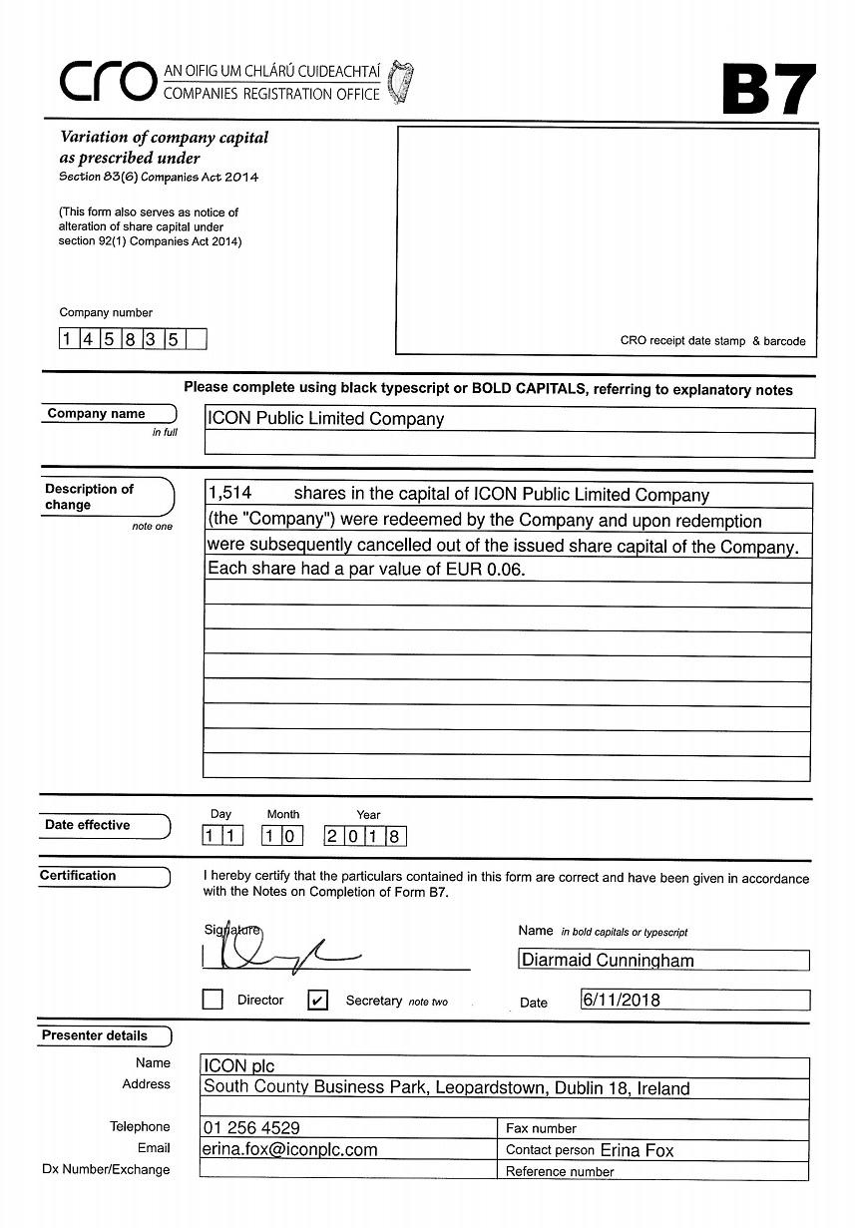

Exhibit 99.2

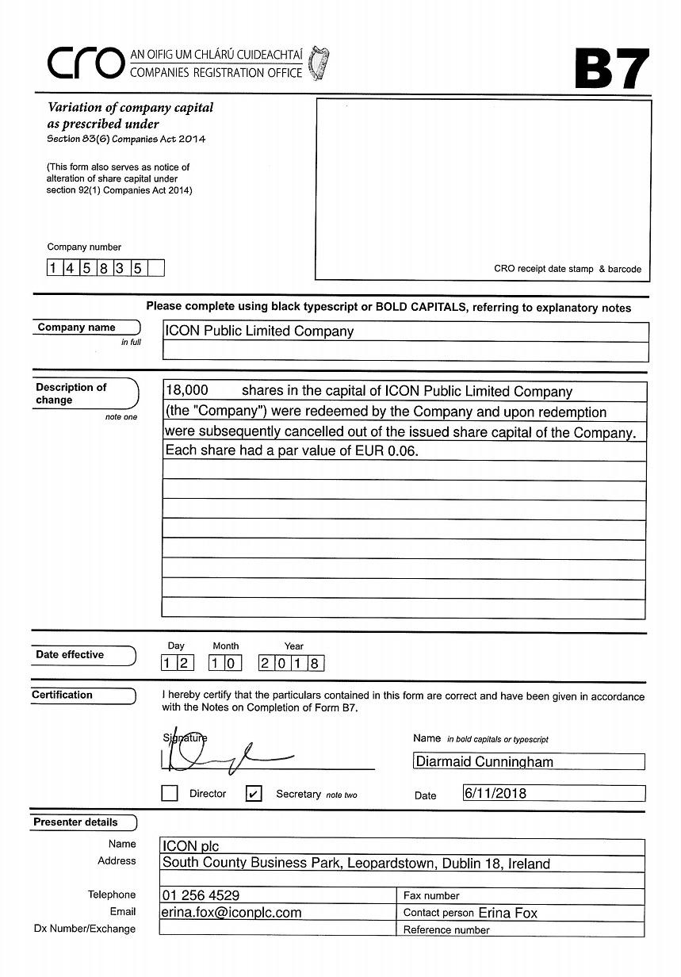

Exhibit 99.3

Exhibit 99.4

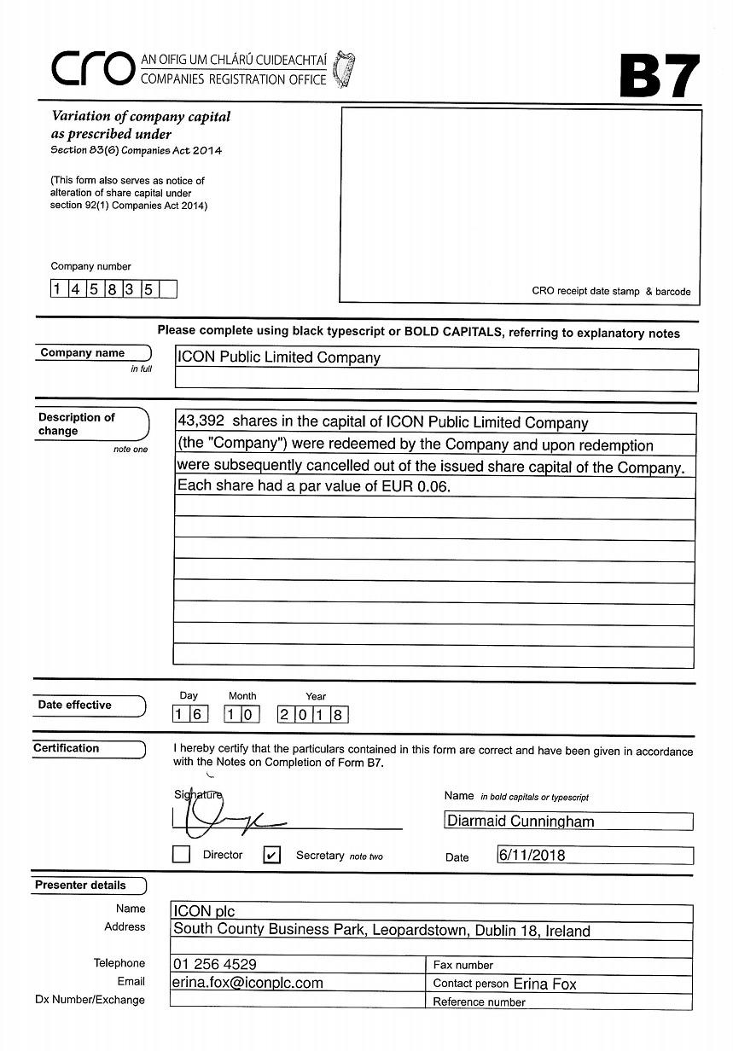

Exhibit 99.5

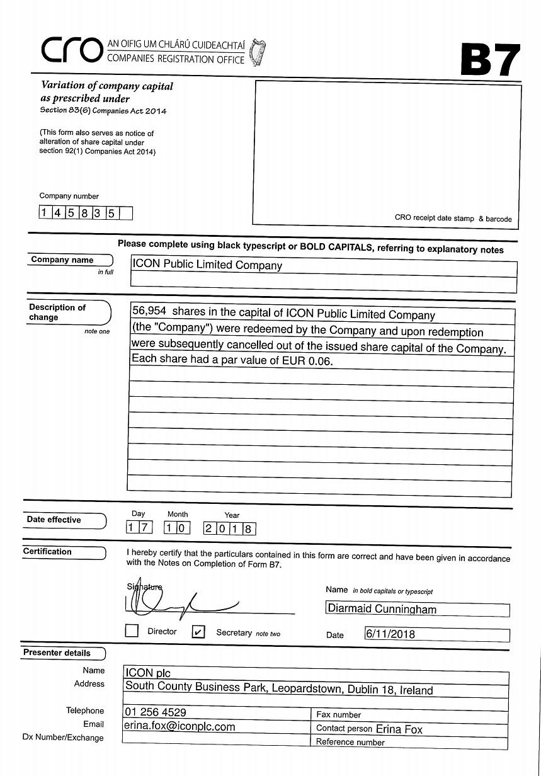

Exhibit 99.6

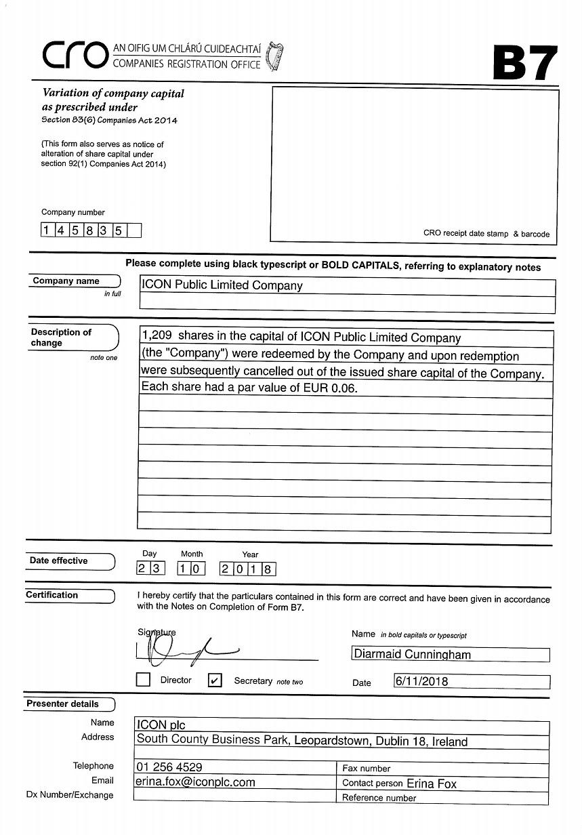

Exhibit 99.7

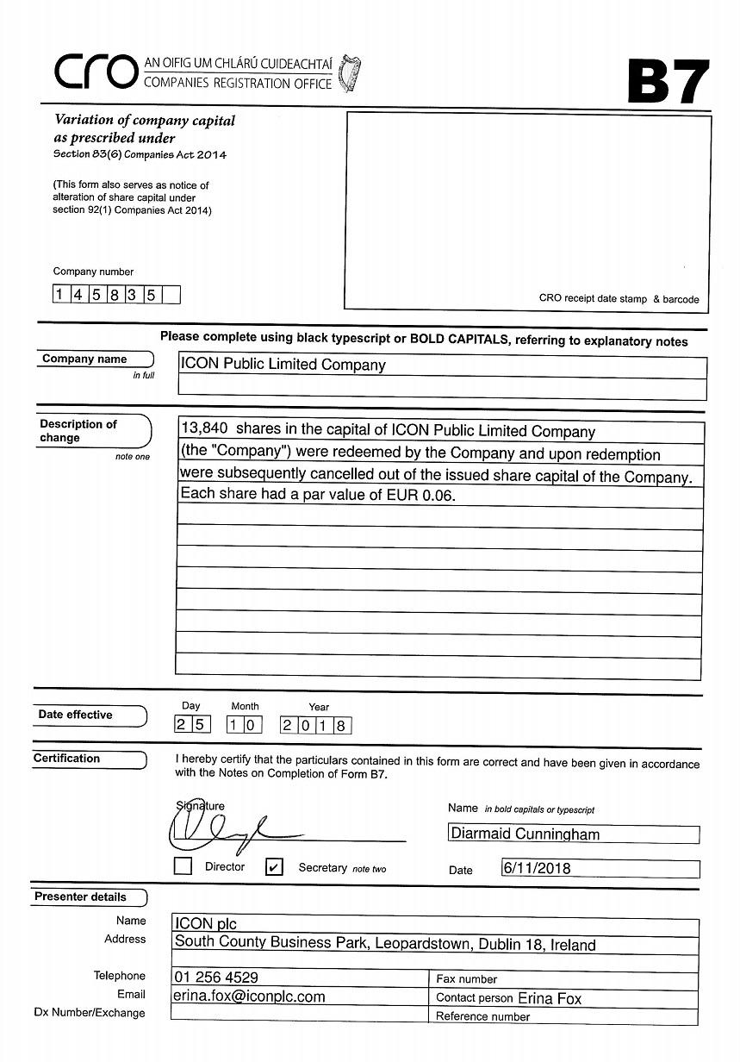

Exhibit 99.8

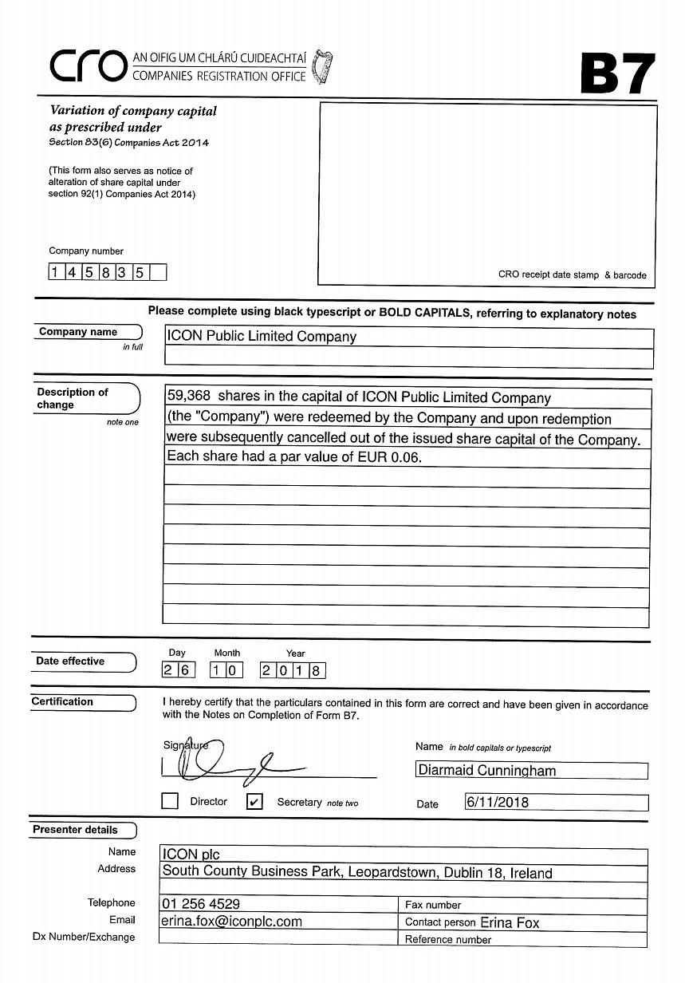

Exhibit 99.9

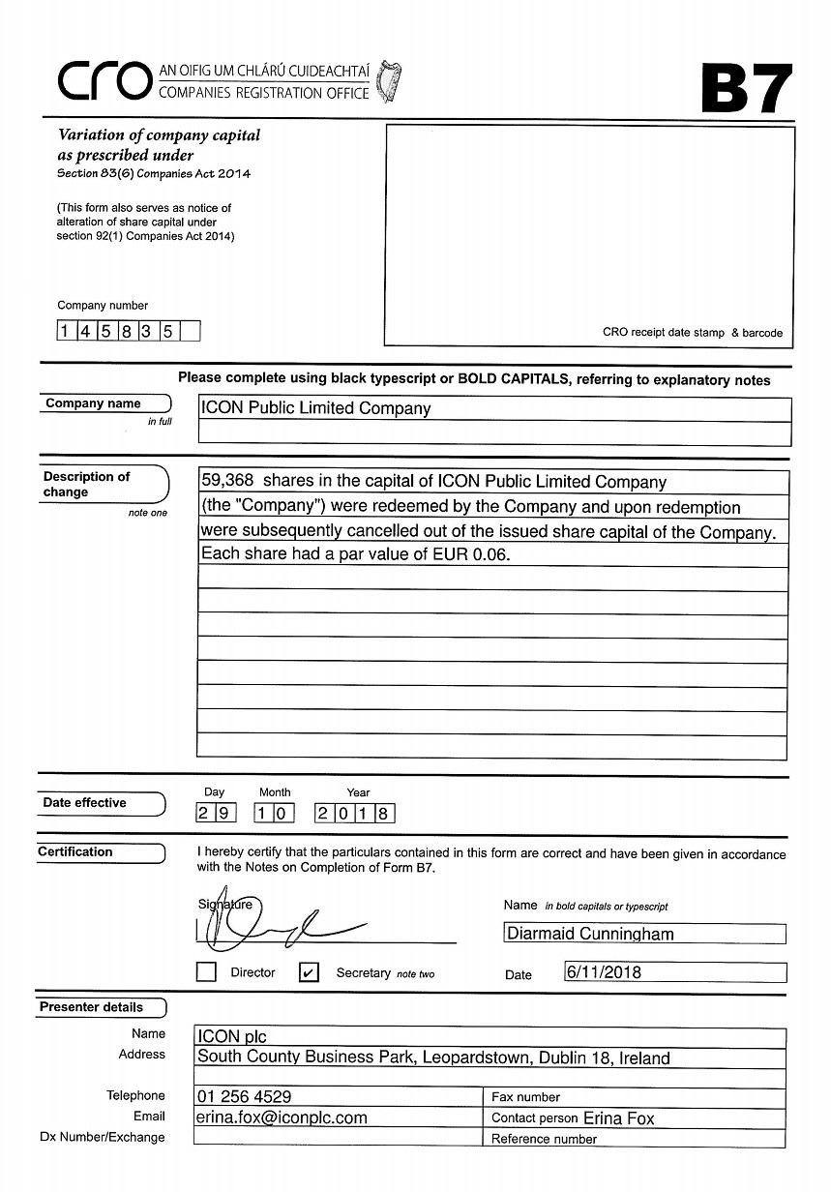

Exhibit 99.10

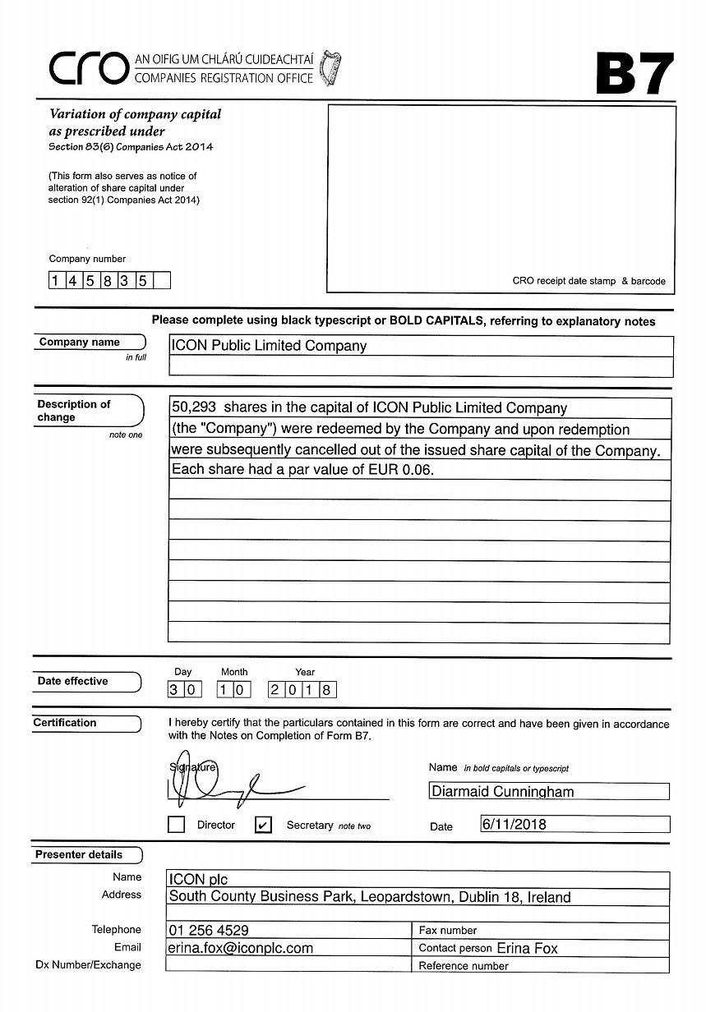

Exhibit 99.11



