Filed by ICON plc
This communication is filed pursuant to Rule 425 under the United States Securities Act of 1933
Subject Company: PRA Health Sciences, Inc.

(Commission File No. 001-36732)

Date: May 20, 2021

ICON plc emailed the following communication to its employees on May 20, 2021.

Integration Newsletter Email Copy

Subject: Integration Newsletter - May Edition

Dear Colleague,

In line with our commitment to keeping you regularly updated on news and developments regarding the integration of ICON and PRA, I'm pleased to share the first edition of our monthly Integration Newsletter.

In this month's edition, we feature:

–The new leadership team of the combined organisation, including short biographies of each leader.

–An overview of the Integration workstreams and the five key principles that are guiding our integration efforts.

–Some milestones and updates on decisions regarding compensation & benefits, IT and work locations on Day One (the date the acquisition closes).

–A short, Pulse Check survey, where you can give us your thoughts on the combination of both companies, how we are managing the integration, and how we are communicating updates to you.

I hope you enjoy the newsletter and if you have any questions or topics that you would like us to address in future newsletters, please make sure to let us know by emailing Ask@iconplc.com.

With kind regards,

Simon


Simon Holmes

EVP Corporate Development and ICON Integration Lead

•

Integration Newsletter
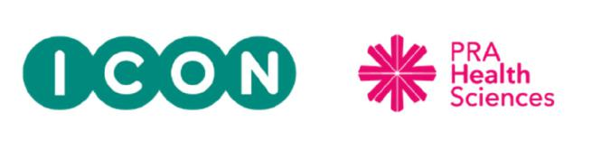

Integration Update

20 May, 2021

Welcome to the first Integration Newsletter!

In line with our commitment to keeping you regularly updated on news and developments regarding the integration of ICON and PRA, we will be distributing a monthly newsletter.

Our integration planning is well underway and several workstreams are working diligently on plans to ensure the smooth integration of both companies. We have been very impressed by the collaboration demonstrated by employees from both organisations who are leading these workstreams, and we look forward to keeping you updated on their progress over the months ahead.

As we move toward acquisition close, which we currently estimate to be in July, our main focus is on ensuring business continuity and no disruption to customer studies. We also recognise that employees have a number of questions about the impact of the integration on them personally, so we will share as much information as possible as we move through integration. In this first newsletter, we have included updates from the HR, IT and Facilities workstreams that address the top employee questions.


New Combined Organisation Leadership Team

Last week, ICON CEO Steve Cutler announced the new leadership team for the combined organisation, which takes effect at the acquisition close. This team includes leaders from the legacy ICON and PRA organisations and is united by shared values, dedication to serving our customers, and the development of our greatest strength – our employees.
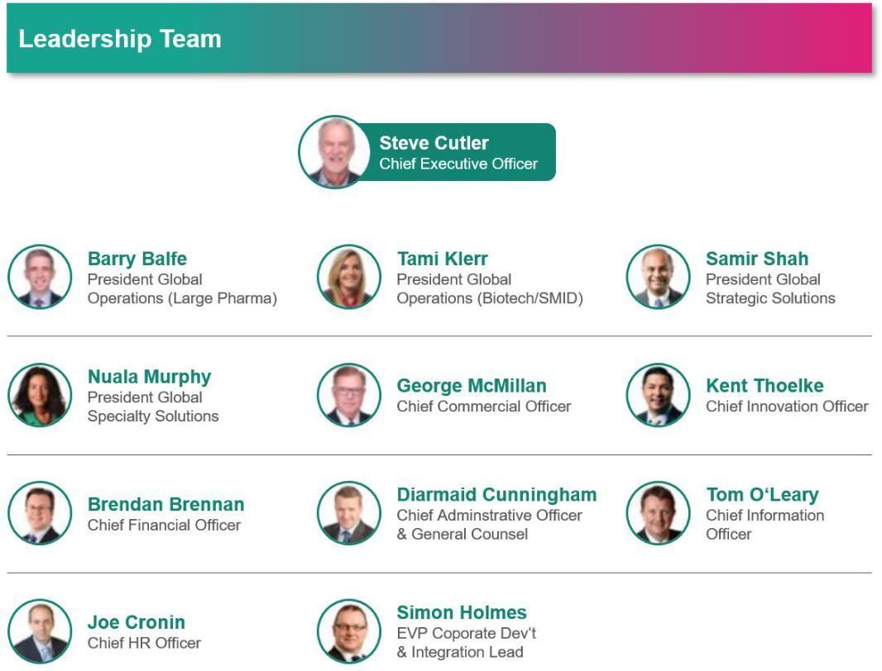

To help you get to know your new leadership team, we have created short bios for each leader, which ICON team members can access here. PRA team members can access the bios via InsidePRA here.

Earlier this week, Steve shared a video where he discussed the team he has assembled, how they will work together upon closing, and when we can expect to see some of the integration plans coming into effect, post-close.


•

View the Q&A video via the links below:

ICON TEAM


- PRA TEAM

Our Integration Guiding Principles
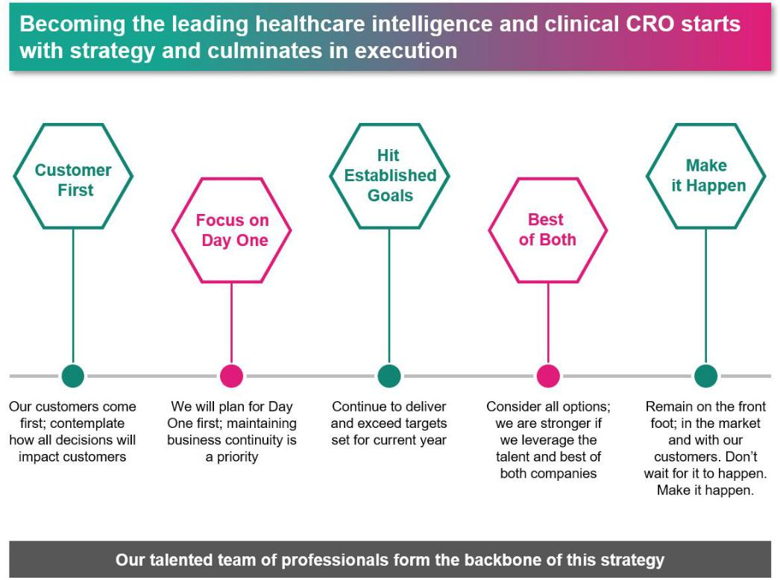

In conversation with Simon Holmes and Harris Koffer

IMO leaders, Simon Holmes and Harris Koffer, shared their thoughts on several questions submitted by employees. Here’s what they had to say:

• | Integration Approach | • | • | What’s Not Going to Change on Day One
 | PRA – LINK | ICON - LINK |  |  | PRA – LINK | ICON - LINK
• | Assessing our Culture | • | • | Driving Innovation
 | PRA – LINK | ICON - LINK |  |  | PRA – LINK | ICON - LINK





How We Are Progressing with Integration Planning

Integration Workstreams are guiding our planning efforts across both PRA and ICON teams.
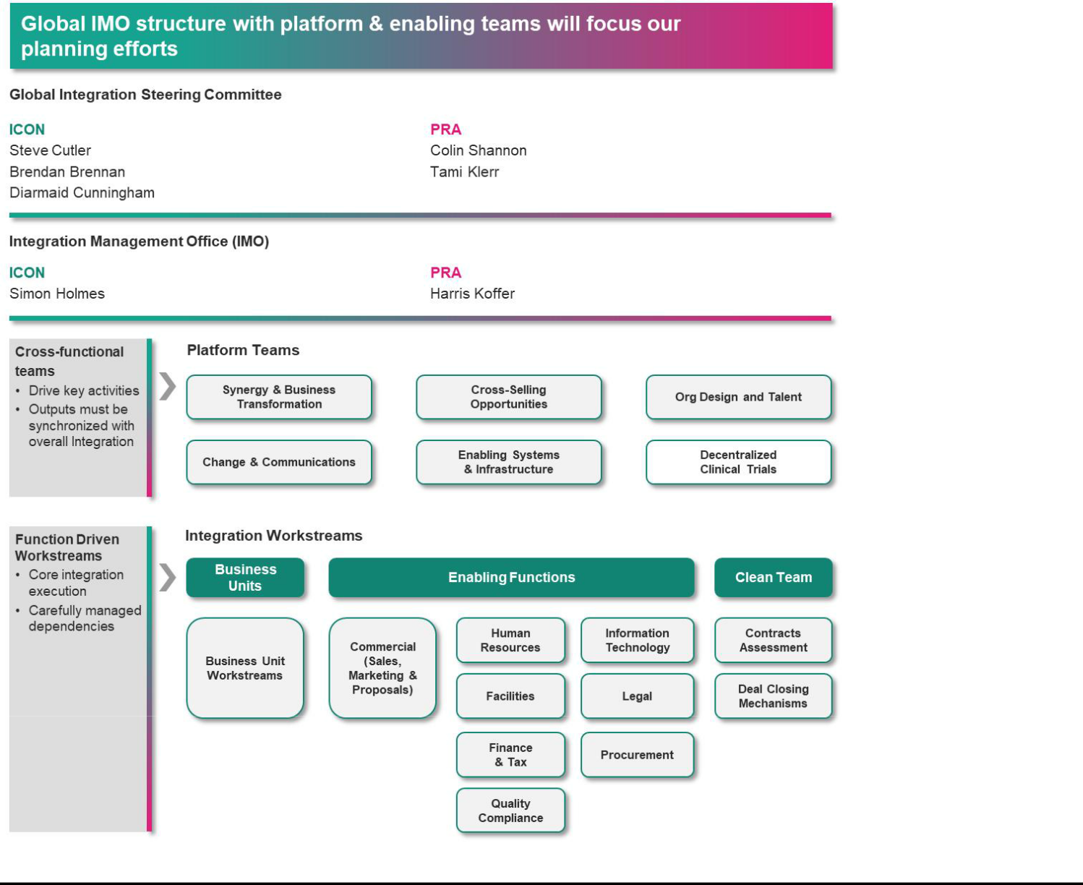

Below is an overview of some milestones and updates on decisions that have been made, as we plan for Day One.
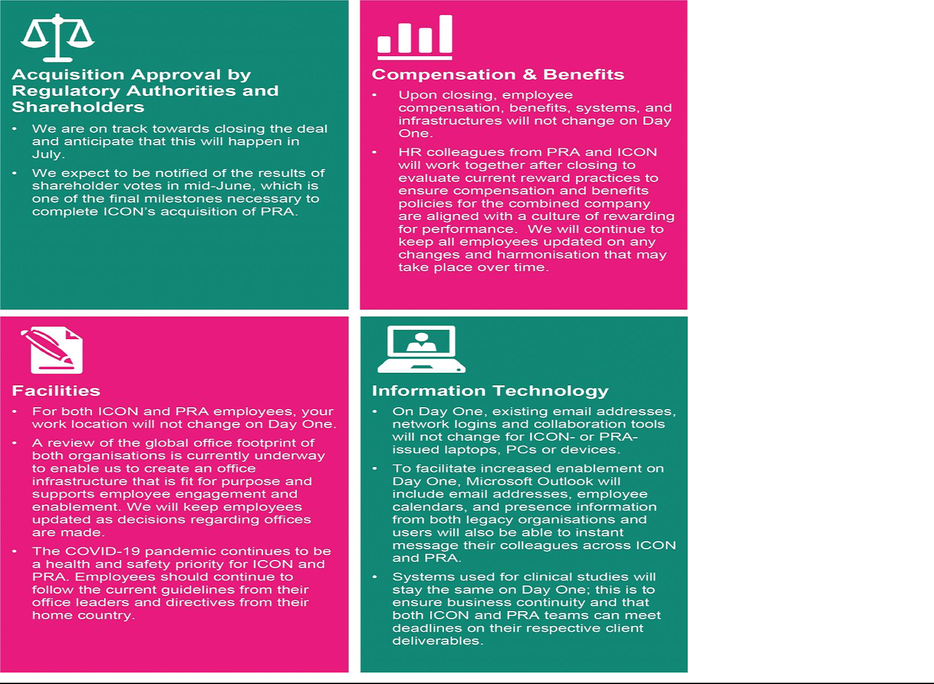

Share Your Opinion

•

•

Assessment of our Culture

Pulse Check

ICON and PRA employees will be asked to complete a Culture In each newsletter, we will include a quick survey to enable us Survey that will help us understand the similarities and to gauge your thoughts on the combination of both companies, differences between the two organisations. The information you how we are managing the integration, and how we are

provide will be used to understand the sources of strength of our communicating updates to you. Please share your feedback with
current cultures, will allow us to create a common language to | the Communications Team by completing this month’s 2-minute
articulate our culture, and ultimately will help us define the | survey via Survey Monkey. Your responses are completely
behaviors that will help grow our combined organisation. More | anonymous.
information will be communicated as we roll out the survey. | *Click here to take this month’s Pulse Check Survey.

Thank you for your attention and support as we continue integration planning and look toward Day One.
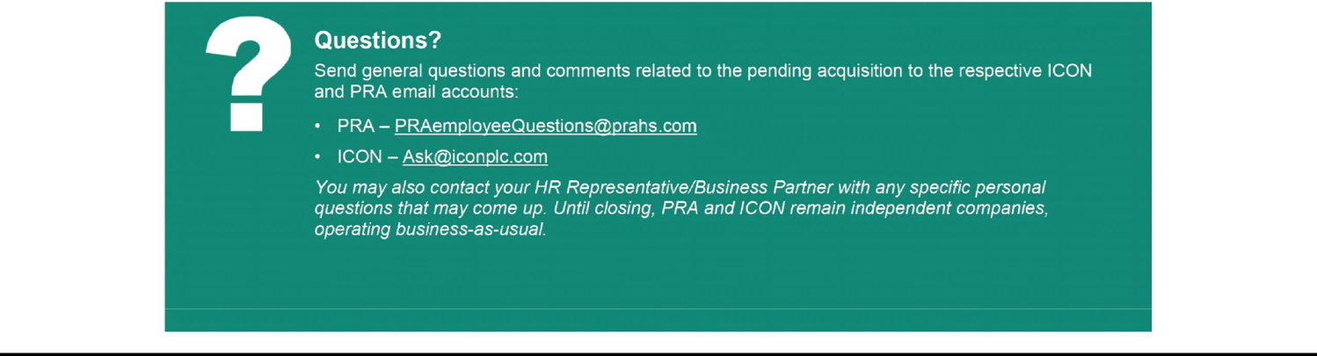

Leadership Bios linked and referenced in the Integration Newsletter
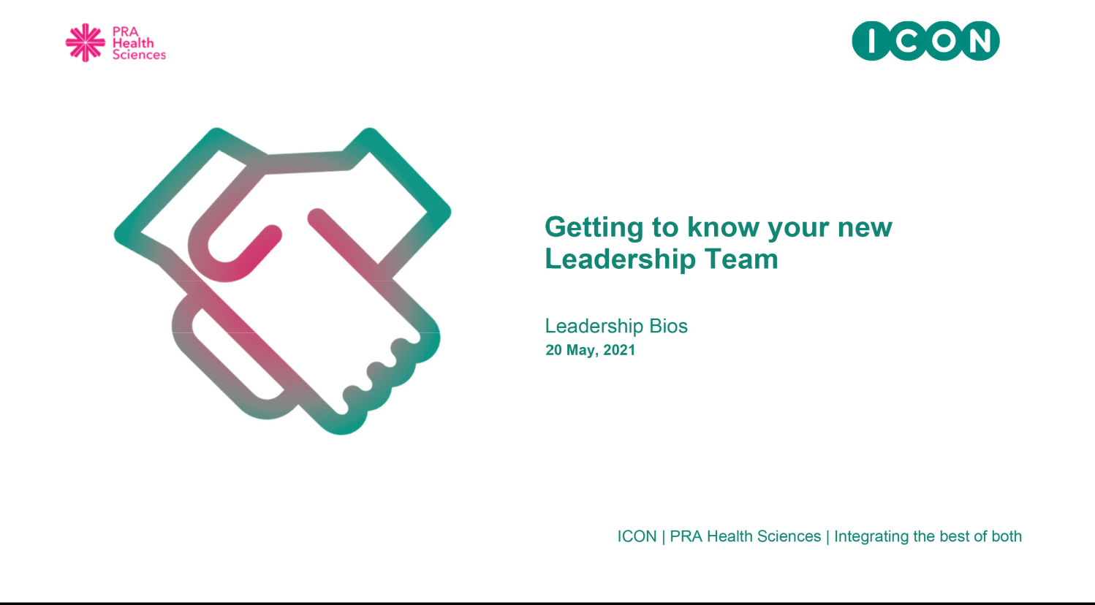

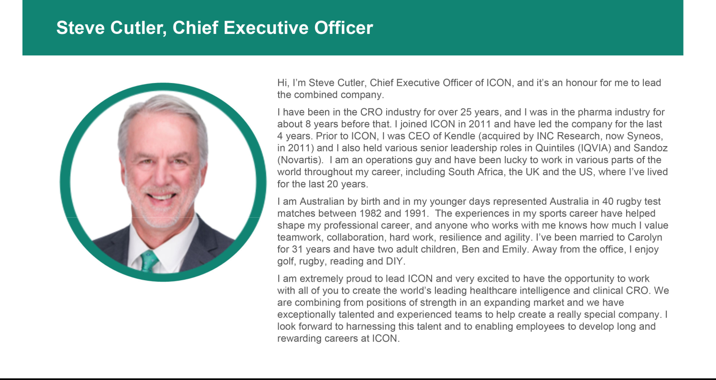

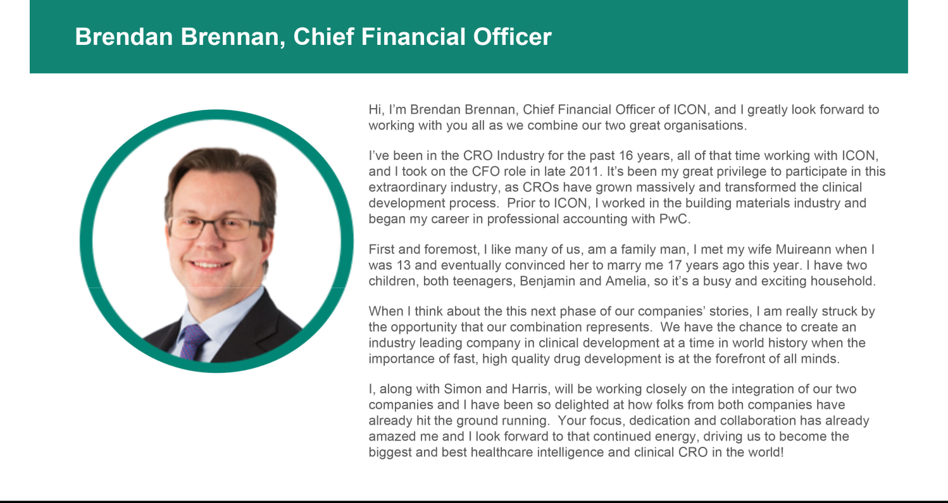

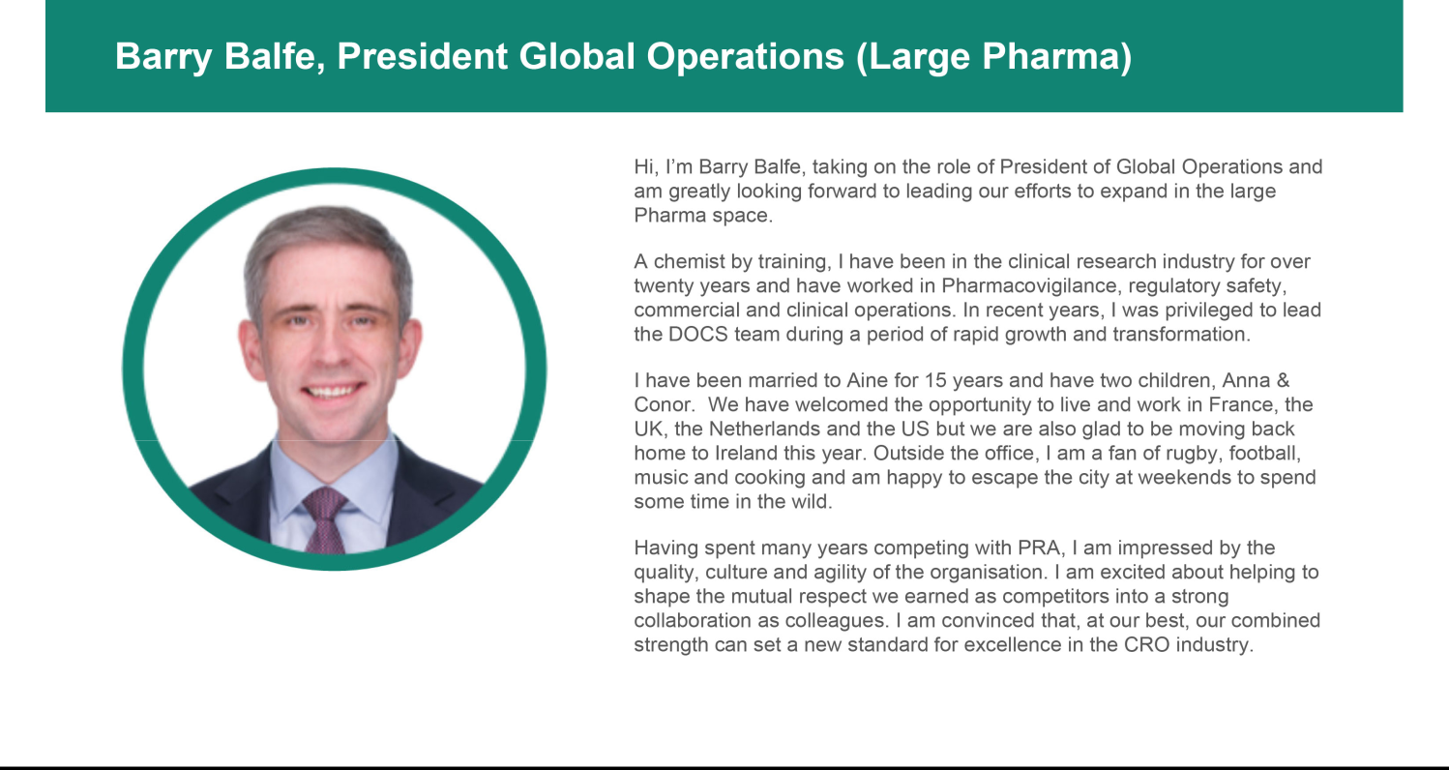

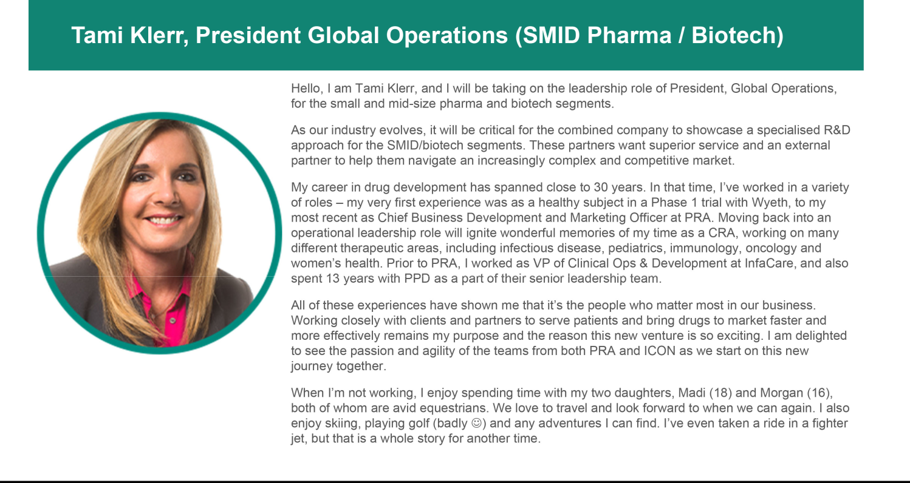

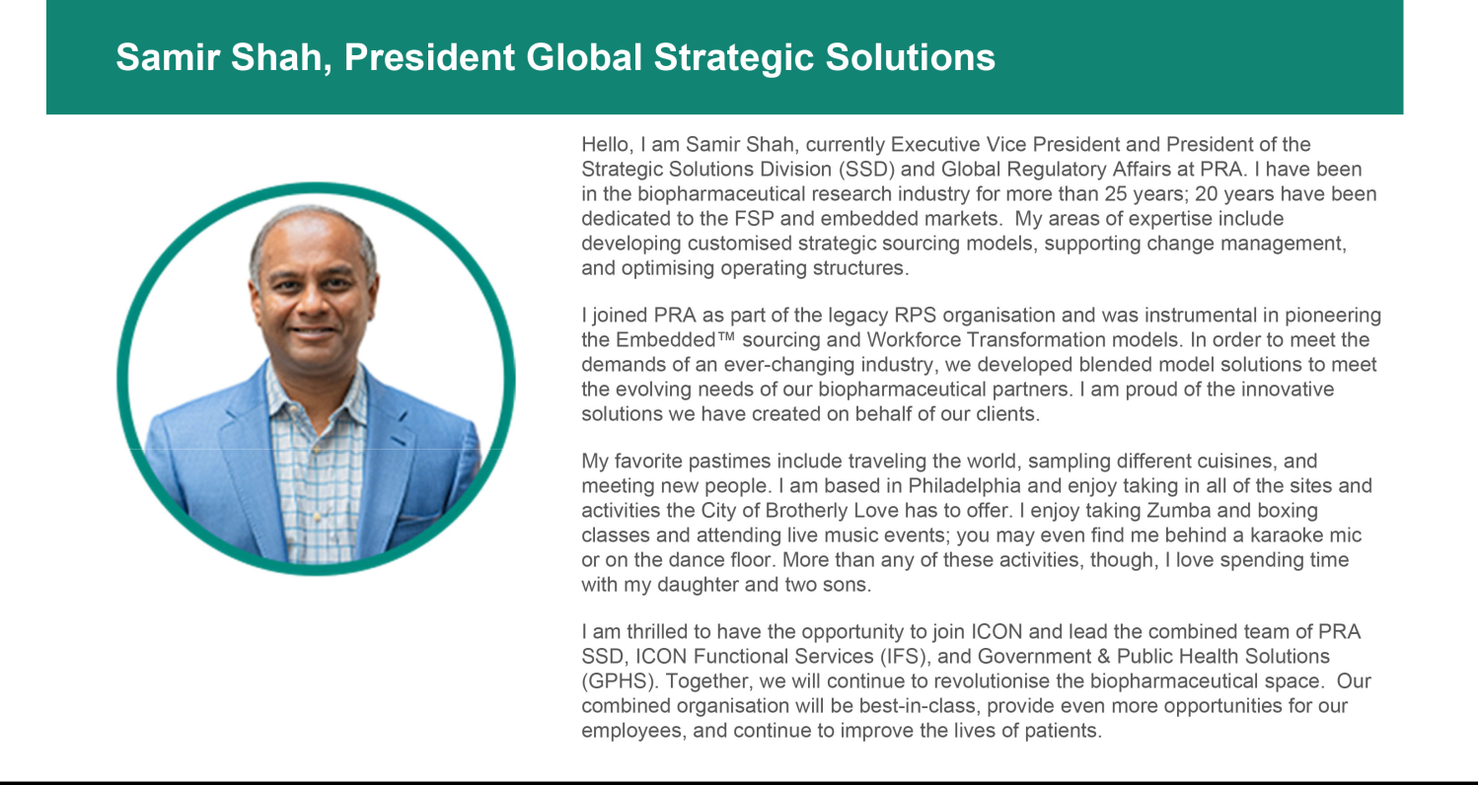

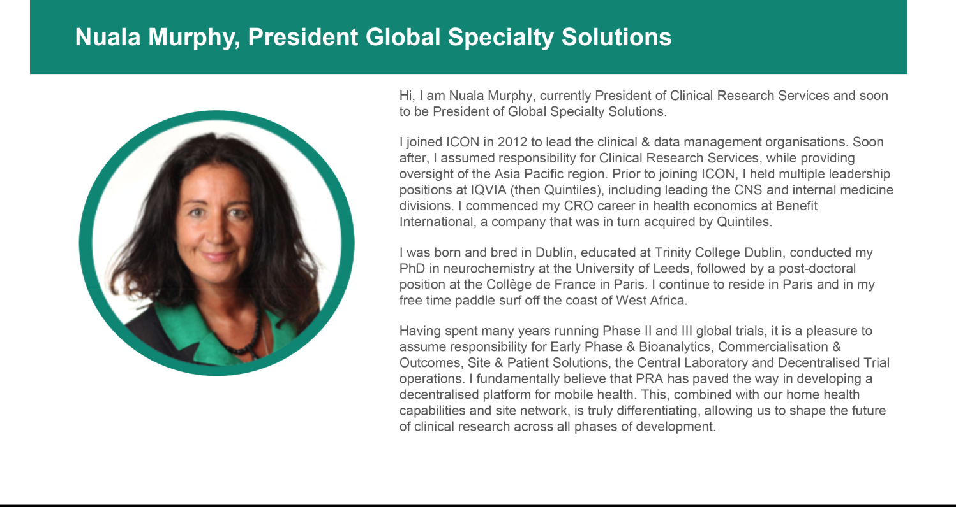

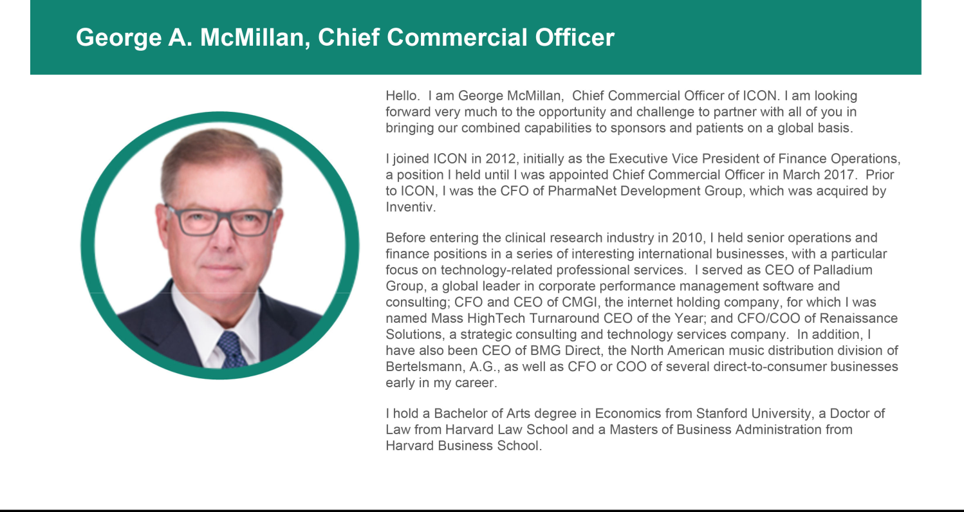

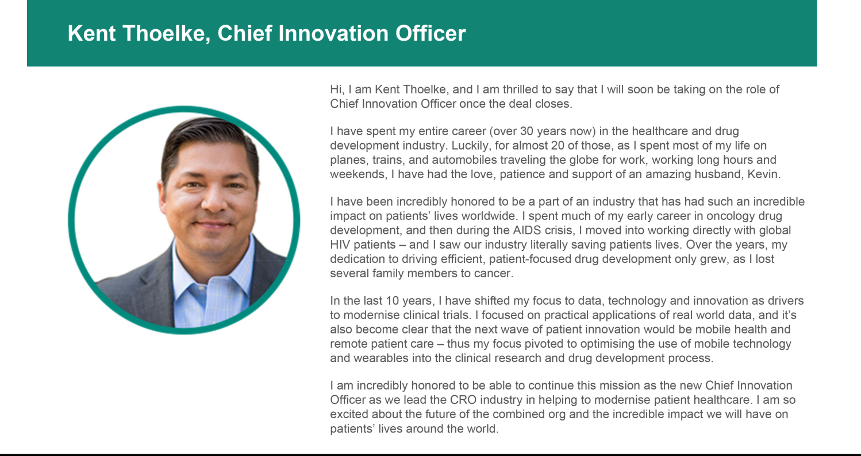

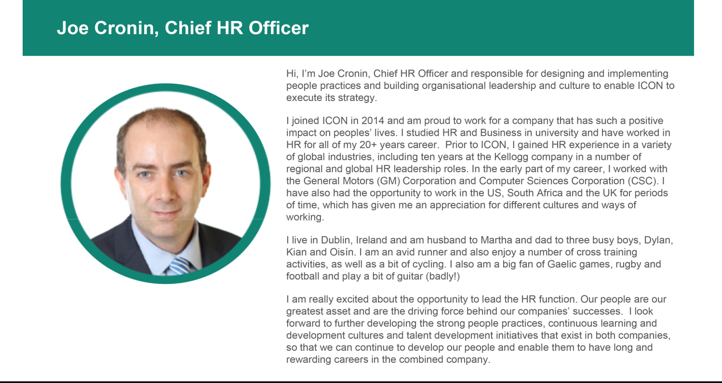

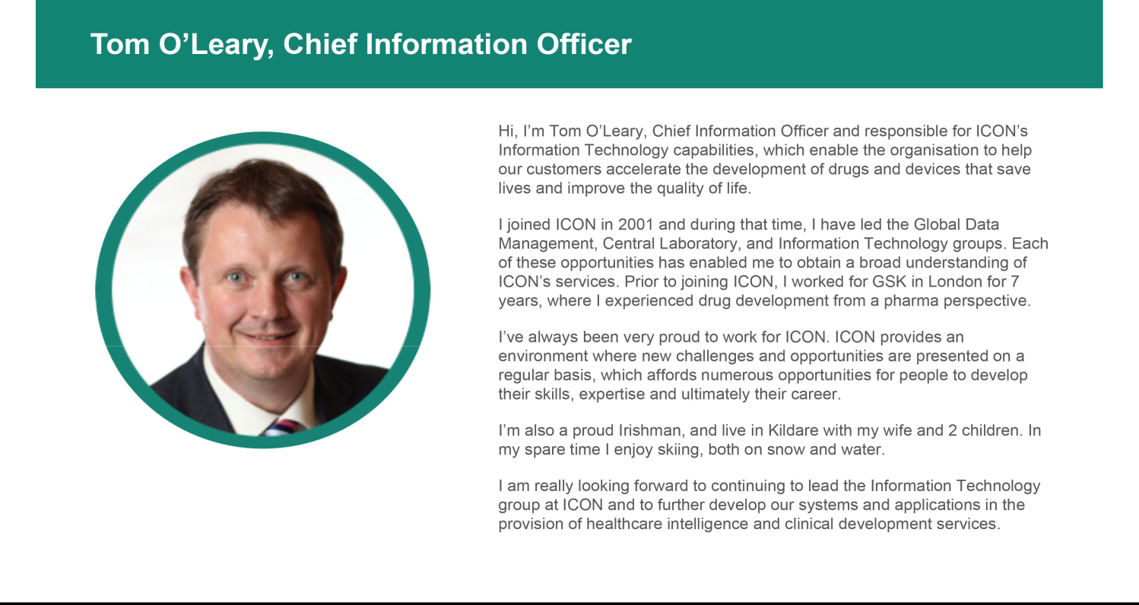

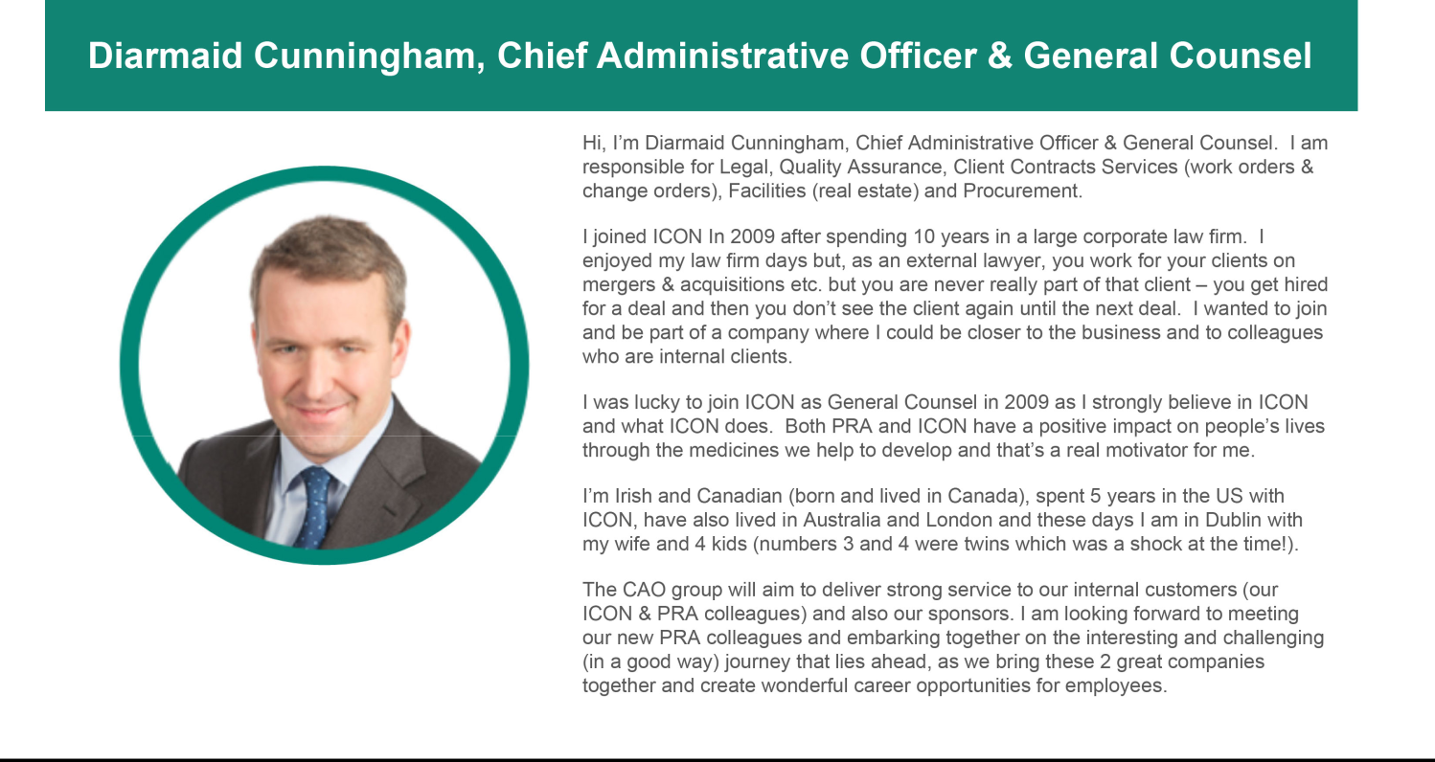

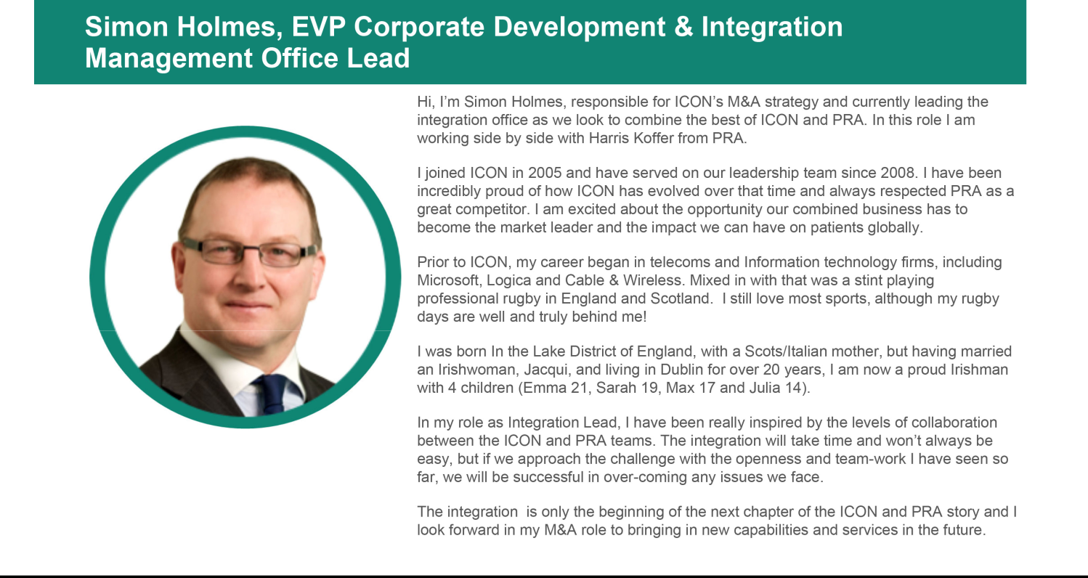

Transcript of video clips that were included in the Integration Newsletter

Holmes, Integration Lead, ICON

Harris Kofler, Integration Lead, PRA


- Our Overall Approach to Integration

Simon Holmes: This is a big, large complex task for everybody, and I say everybody because it has got to be a collective team effort. I am involved around orchestration, making sure as a collective we are hitting the key tasks we need to hit and helping to resolve issues when they need to be resolved, helping to bring our organisational knowledge to the integration in order to find the quickest and smoothest way to get decisions made. It is a marathon and not a sprint and it is about focusing our time on key issues, for example, at the moment we have 50 or 60 days to close the transaction so we need to get people thinking about Day One and what happens on Day One. As we move towards Day One, we will start thinking beyond the horizon into the next 30 days, 100 days and beyond. Our role is to put up some structure behind that, a lot of work streams whether they be functional, operational, and making sure we have the right folks on those teams. They are the experts, the people who really know what needs to happen in those functions. Our role is to help them, be supportive to them and help them make decisions when decisions need to be made.

Harris Kofler: I just want to echo what Simon said, I said on a committee meeting yesterday that I couldn’t have picked a better partner in Simon. We work really well together. I do want to highlight the fact that integration is a very complex process particularly for organisations of our size and there is a lot of work to be done before we close. I would also say that it won’t be perfect, there will be bumps along the road for sure, but we are trying to be flexible, facile and course correct as we move through the process. But we are meeting frequently and doing our best to communicate to the rest of the organisation how we are doing on an ongoing basis. I know a few of you aren’t part of workstreams yet or else your workstreams haven’t kicked off, we will talk about that obviously but some streams we will be dealing with later than others. We are waiting on Steve Cutler to finalise the organisational design, but we all remain focused on the same important key principles; continuing to execute for our clients, being ready for day 1. To quote Gene Kranz from Apollo 13, ‘failure is not an option’ for us, we need to meet the goals that have been set for us and we need to make sure we are leveraging the best of both companies. As you have heard Steve say, we need to make it happen.

- Assessing our culture.

Simon Holmes: We are a people business, so culture is at the heart of what we do, and I think it is important to recognise that culture is not static. In the time I have been here, both ICON and PRA have evolved from small to medium to large companies, so clearly in that time our cultures have evolved. We have made many acquisitions and as you make acquisitions, they bring something new to the organisation. It is true to say that in this particular transaction between two large organisations, what will come out at the end will be a hybrid culture of both companies and we have to think about that. It is not one company imposing their culture on another, it is about how we blend them together. At the same time while we are all united by some common values and when I have worked with the PRA people I have met, collaboration and sharing the same passion for what we do in common, but I am sure there are also a lot of things that we do differently. How things happen in one organisation will be different to how it happens in another. I think job number one is to understand that and to note those differences and see where they manifest themselves from. One of things that will be important to the combined organisation is a process of listening and understanding as we come together and find out more on a detailed, functional level. There is going to be some activity going on to know what you are part of and others such as Laurie, Joe and Tina will be looking at listening to the combined organisation about what is important to them through surveys, focus groups and lots of other activities. Through that listening from the bottom up and thinking about the differences at an operational and at a functional level, we will chart a way to bring the best of the both from a cultural perspective and then at some point that will come down onto a piece of paper about cultural values. To me it is more than words on paper, it is about behaviours and what we expect, how the leaders act and how we reward people for those behaviours. That is how we will be framing the culture moving forwards. I see a lot of optimism from that because all I have seen so far is a good commonality about how we think about things and even though there may be differences in terms of details when you get below that.


- What’s not going to change on Day One.

Simon Holmes: As you can imagine, there is a fair amount of parallel running for the two organisations so things like employee T&C’s, key benefits etc, they are not going to change on day 1. For the operational groups, operational processes as we evolve in the future, we will have to look at how our systems infrastructure will be. Tom and James have done a huge amount of work on mapping systems, we are not going to be changing those systems in 50 days frankly. So clearly, we will be running on the same systems and processes. Going back to what Harris said about guiding principles, customers come first and business continuity all of that applies - keep doing what we are doing in many of the same ways. Once we get past Day One and leaders come together then we can start thinking about how does that combined organisation start to evolve in the future. We still have to bring in systems and processes, road maps etc., but very clearly, I think the message is loud and clear that in the majority of cases things will continue to run as they do today. Albeit there will be some areas where we will look to see how we can glue the organisation together a bit more coherently. Things like communications, having a common platform to post communications on Day One and also very importantly from a customer perspective how do we triage opportunities so not to confuse customers so they know the right people to contact from a sales perspective and an operational perspective. I would say the majority of things on day 1 are going to be the same, particularly for employees, they will be worried about terms and conditions and benefits which won’t be changing on Day One.

- Driving Innovation.

Harris Kolfer: I would start by saying the current clinical development paradigm is not sustainable. The process from bringing a product from research through to marketing is a far too risky, in fact 1 in 10 products that make it into clinical development phase one actually make it onto the market. It takes far too long to bring cures to patients, and it is far too costly. When began my career in clinical research, it took 12 to 16 years to bring a product through from discovery to marketing and today it still takes the same amount of time. This is not sustainable, and it is hard to believe that we haven’t discovered some efficiencies during that process. We are seeing some of the changes now, being able to bring a vaccine to market in record time is an example of what the industry can do with proper investment focus and making processes more efficient. When we think about that we need to position ourselves to lead the market in bringing breakthrough products to people faster, better and more efficiently than the competition. That means we need to find every ounce of innovation existing in our companies, the best technology, the best processes, the best talent and create something better than what our competition can create. And we need to do this while our industry is evolving, the pandemic has clearly hastened the evolution towards decentralised trials, mobile health technologies and wearables to provide real time access to biometric data, the use of medicine direct to patient paradigms which bring the trial and investigator to the patient, improving access to patients and addressing the key impediments to trial success. We know that trials generally fail because we can’t get enough patients quick enough which is why they are not done on time and that they are so expensive. We need to solve that particularly problem and be ready for that. It is our collective belief of the Executive team that ICON and PRA are best positioned to exploit the changes that are happening within our industry through our existing tools, capabilities, expertise and geographic scale that we have as a combined company.

Simon Holmes: I was involved with some early discussions with Harris and the team, clearly if all we do is put our two organisations together, say we are close to number one and continue doing things the way we are, we will fail. If you want to lead it is not about being the biggest in size, it is about showing leadership and helping to move this industry forward. We have to drive the agenda for areas such as hybrid trials, DCT trials with economies of scale, we should have more scope then to drive things forward.

Cautionary Note Regarding Forward-Looking Statements

This communication contains forward-looking statements within the meaning of the Private Securities Litigation Reform Act of 1995, Section 27A of the Securities Act of 1933, as amended, and Section 21E of the Securities Exchange Act of 1934, as amended. These forward-looking statements generally include statements regarding the potential transaction between ICON public limited company, a public limited company in Ireland (“ICON”) and PRA Health Sciences, Inc., a Delaware corporation (“PRA”), including any statements regarding the expected timetable for completing the potential transaction, the ability to complete the potential transaction, the expected benefits of the potential transaction (including anticipated synergies, projected financial information and future opportunities) and any other statements regarding ICON’s and PRA’s future expectations, beliefs, plans, objectives, results of operations, financial condition and cash flows, or future events or performance. These statements are often, but not always, made through the use of words or phrases such as “anticipate,” “intend,” “plan,” “believe,” “project,” “estimate,” “expect,” “may,” “should,” “will” and similar expressions. All such forward-looking statements are based on current expectations of ICON’s and PRA’s management and therefore involve estimates and assumptions that are subject to risks, uncertainties and other factors that could cause actual results to differ materially from the results expressed in the statements. Key factors that could cause actual results to differ materially from those projected in the forward-looking statements include the ability to obtain the requisite ICON and PRA stockholder approvals; uncertainties as to the timing to consummate the potential transaction; the risk that a condition to closing the potential transaction may not be satisfied; the risk that regulatory approvals are not obtained or are obtained subject to conditions that are not anticipated by the parties; litigation relating to the potential transaction that has been or could be instituted against ICON, PRA or their respective directors; the effects of disruption to ICON’s or PRA’s respective businesses; restrictions during the pendency of the potential transaction that may impact ICON’s or PRA’s ability to pursue certain business opportunities or strategic transactions; the effect of this communication on ICON’s or PRA’s stock prices; transaction costs; ICON’s ability to achieve the benefits from the proposed transaction; ICON’s ability to effectively integrate acquired operations into its own operations; the ability of ICON or PRA to retain and hire key personnel; unknown liabilities; and the diversion of management time on transaction-related issues. Other important factors that could cause actual results to differ materially from those in the forward-looking statements include the effects of industry, market, economic, political or regulatory conditions outside of ICON’s or PRA’s control (including public health crises, such as pandemics and epidemics); risks regarding PRA’s ability to maintain large customer contracts or enter into new contracts; PRA’s ability to attract suitable investigators and patients for its clinical trials; PRA’s ability to keep pace with rapid technological change; PRA’s potential liability if a patient is harmed; and the factors set forth under the heading “Risk Factors” of ICON’s Annual Report on Form 20-F and PRA’s Annual Report on Form 10-K and most recent Quarterly Report on Form 10-Q, and in subsequent filings with the U.S. Securities and Exchange Commission (the “SEC”). These risks, as well as other risks associated with the potential transaction, are more fully discussed in the joint proxy statement/prospectus filed with the SEC in connection with the proposed transaction. Other unpredictable or unknown factors not discussed in this communication could also have material adverse effects on forward-looking statements. Neither ICON nor PRA assumes any obligation to update any forward-looking statements, except as required by law. Readers are cautioned not to place undue reliance on these forward-looking statements that speak only as of the date hereof.

No Offer or Solicitation

This communication does not constitute an offer to sell or the solicitation of an offer to buy any securities or a solicitation of any vote or approval, nor shall there be any sale of securities in any jurisdiction in which such offer, solicitation or sale would be unlawful prior to registration or qualification under the securities laws of any such jurisdiction. No offer of securities shall be made except by means of a prospectus meeting the requirements of Section 10 of the Securities Act of 1933, as amended.

Important Information for Investors and Stockholders

In connection with the potential transaction, ICON has filed a registration statement on Form F-4 (File No. 333-254891) with the SEC containing a prospectus of ICON that also constitutes a proxy statement of each of ICON and PRA. The registration statement, as amended, was declared effective, by the SEC on April 28, 2021. Each of ICON and PRA commenced mailing copies of the definitive joint proxy statement/prospectus to stockholders of ICON and PRA, respectively, on or about April 28, 2021. ICON and PRA may also file other documents with the SEC regarding the potential transaction. This communication is not a substitute for the joint proxy statement/prospectus or registration statement or for any other document that ICON or PRA have filed or may file with the SEC in connection with the potential transaction. INVESTORS AND SECURITY HOLDERS OF ICON AND PRA ARE URGED TO READ THE JOINT PROXY STATEMENT/PROSPECTUS AND OTHER DOCUMENTS THAT ARE FILED OR WILL BE FILED WITH THE SEC, AS WELL AS ANY AMENDMENTS OR SUPPLEMENTS TO THESE DOCUMENTS, CAREFULLY AND IN THEIR ENTIRETY BECAUSE THEY CONTAIN IMPORTANT INFORMATION. Investors and security holders are able to obtain free copies of the joint proxy statement/prospectus and other documents filed with the SEC by ICON or PRA through the website maintained by the SEC at http://www.sec.gov. Copies of the documents filed with the SEC by ICON are available free of charge on ICON’s website at https://www.iconplc.com and copies of the documents filed with the SEC by PRA are available free of charge on PRA’s website at https://www.prahs.com/. Additionally, copies may be obtained by contacting the investor relations departments of ICON or PRA. ICON and PRA and certain of their respective directors, certain of their respective executive officers and other members of management and employees may be considered participants in the solicitation of proxies with respect to the potential transaction under the rules of the SEC. Information about the directors and executive officers of ICON is set forth in its annual report on Form 20-F, which was filed with the SEC on February 24, 2021. Information about the directors and executive officers of PRA is set forth in its Amendment to Annual Report on Form 10-K/A for the fiscal year ended December 31, 2020, which was filed with the SEC on March 30, 2021. These documents can be obtained free of charge from the sources indicated above. Additional information regarding the interests of such participants in the solicitation of proxies in respect of the potential transaction are included in the registration statement and joint proxy statement/prospectus and other relevant materials filed with the SEC.

The term “ICON” and such terms as “the company,” “our,” “we,” “us” and “its” may refer to ICON public limited company, one or more of its consolidated subsidiaries, or to all of them taken as a whole. All of these terms are used for convenience only and are not intended as a precise description of any of the separate companies, each of which manages its own affairs.

