FORM 6-K

SECURITIES AND EXCHANGE COMMISSION

Washington, D.C. 20549

Report of Foreign Private Issuer

Pursuant to Rule 13a - 16 under

the Securities Exchange Act of 1934

For the month of March 2007

ICON plc

(Registrant’s name)

0-29714

(Commission file number)

South County Business Park, Leopardstown, Dublin 18, Ireland.

(Address of principal executive offices)

Indicate by check mark whether the registrant files or will file annual reports under cover Form 20-F or Form 40-F.

Yes X No _____

Indicate by check mark whether the registrant is submitting the Form 6-K in paper as permitted by Regulation S-T Rule 101(b)(1):

Yes _____ No X

Indicate by check mark whether the registrant is submitting the Form 6-K in paper as permitted by Regulation S-T Rule 101(b)(7):

Yes _____ No X

Indicate by check mark whether the registrant by furnishing the information contained in this Form is also thereby furnishing the information to the Commission pursuant to Rule 12g3-2(b) under the Securities Exchange Act of 1934.

Yes _____ No X

If “Yes” is marked, indicate below the file number assigned to the registrant in connection with Rule 12g3-2(b):82 N/A

EXHIBIT INDEX

Exhibit
Number | Description of Exhibit
99.1 | Investor Relations Presentation - March 2, 2007

SIGNATURES

Pursuant to the requirements of the Securities Exchange Act of 1934, the Registrant has duly caused this report to be signed on its behalf by the undersigned, thereunto duly authorized.

 |  | ICON plc
March 2, 2007 |  | /s/ Ciaran Murray
Date |  | Ciaran Murray
 |  | Chief Financial Officer

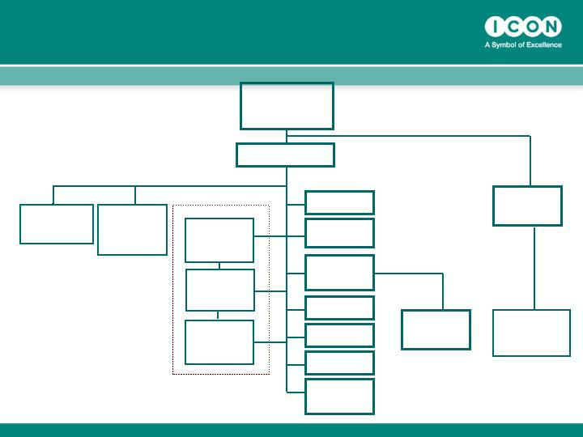
ICON plc Global Organization

Chairman

Dr. John
Climax

ICON Central ICON
Laboratories Development
President ^{Solutions}
^{Bob} President

Scott-Edwards

Dr Thomas Frey

CEO

Peter Gray

ICON Clinical Research

ICON Clinical
US
President

Dr John

Hubbard

ICON Clinical
EU

President

Dr Peter

Sowood

ICON Clinical

ROW President

Dr Dan Weng

CFO

Ciaran Murray

VP Process
Development

Alan Morgan

Exec. VP
Organisational
Development

Sean Leech

VP Corporate
QA
Jo Coyle

VP Global IT

Mike McGrath

VP Strategic HR

Eimear Kenny

Group Director
Market
Development

Simon Holmes

ICON Corporate
Dev
President

Bill Taaffe

ICON | Beacon
Contracting | Bioscience
Solutions
Tony Southers | CEO
Snr VP | Ted Gastineau



ICON PLC

Investor Relations Day 2007

Peter Gray

March 2nd 2007

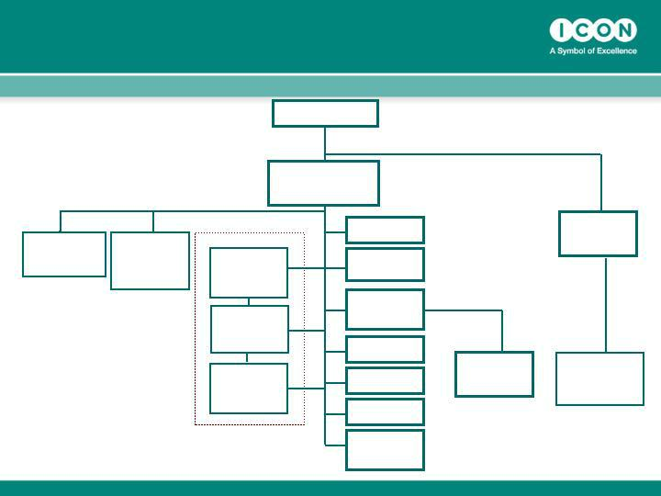
ICON plc Global Organization

ICON Central ICON
Laboratories Development
_{President} Solutions
^{Bob} President

Scott-Edwards

Dr Thomas Frey

Chairman

Dr. John Climax

 |  | CEO
 | Peter Gray
 |  | CFO
ICON Clinical Research |  | Ciaran Murray
ICON Clinical |  | VP Process
US |  | Development
President |  | Alan Morgan
Dr John |  | Alan Morgan
Hubbard |  | Exec. VP
 |  | Organisational
ICON Clinical |  | Development
EU |  | Sean Leech
President |  | Sean Leech
Dr Peter |  | VP Corporate
Sowood |  | VP Corporate
Sowood |  | QA

 | Jo Coyle
ICON Clinical | VP Global IT
ROW President | Mike McGrath
Dr Dan Weng | VP Strategic HR
 | Eimear Kenny
 | Group Director
 | Market
 | Development
 | Simon Holmes

ICON Corporate
Dev
President

Bill Taaffe

ICON | Beacon
Contracting | Bioscience
Solutions
Tony Southers | CEO
Snr VP | Ted Gastineau


Forward Looking Statements

Certain statements contained herein including, without limitation, statements containing the words “believes,” “anticipates,” “intends,” “expects” and words of similar import, constitute forward-looking statements concerning the Company's operations, performance, financial condition and prospects. Because such statements involve known and unknown risks and uncertainties, actual results may differ materially from those expressed or implied by such forward-looking statements. Given these uncertainties, prospective investors are cautioned not to place undue reliance on such forward-looking statements. The Company undertakes no obligation to publicly update or revise any forward-looking statements, whether as a result of new information, future events or otherwise.

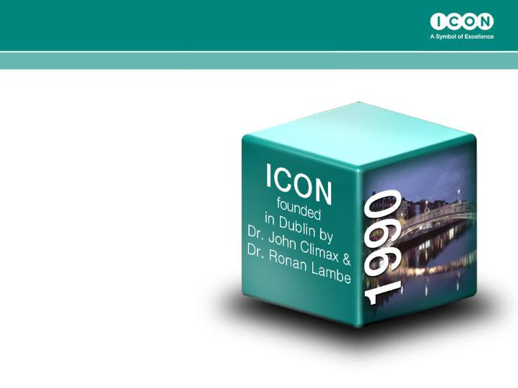
The Journey So Far

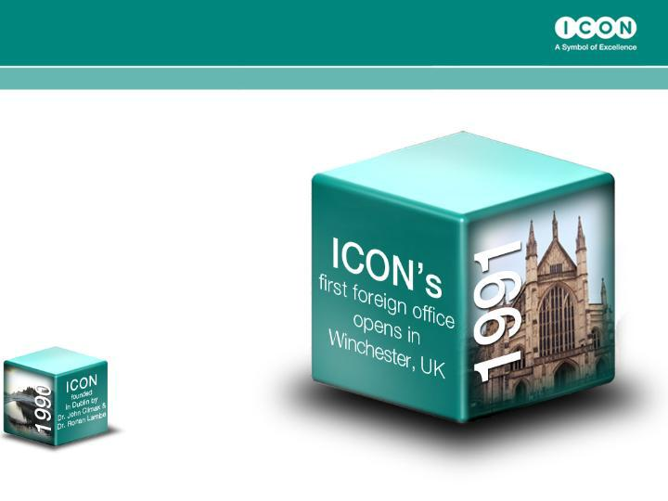
The Journey So Far

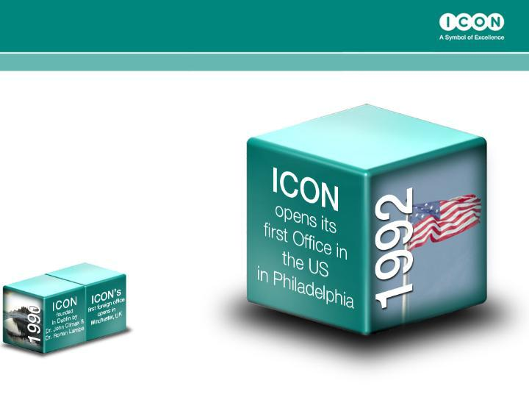
The Journey So Far

The Journey So Far

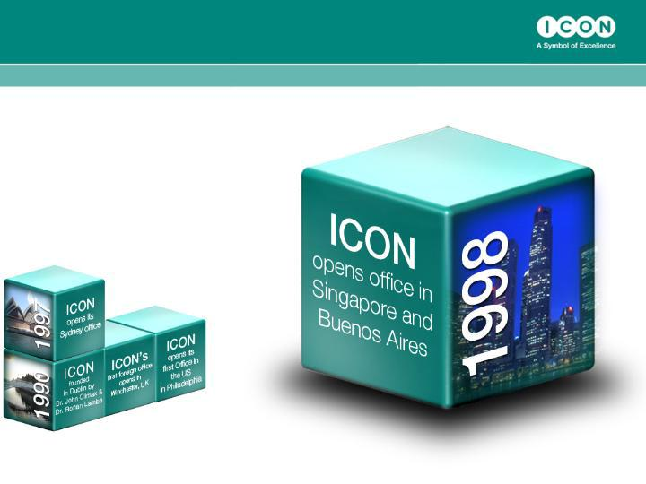
The Journey So Far

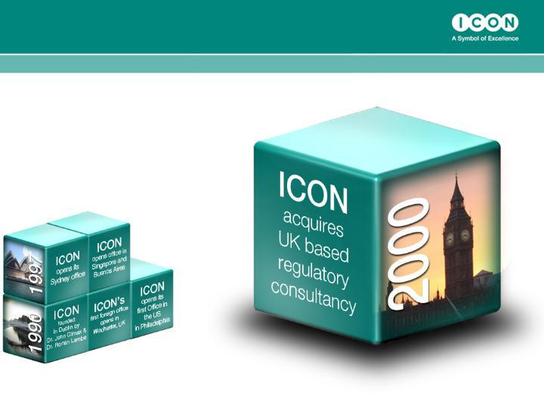
The Journey So Far

The Journey So Far

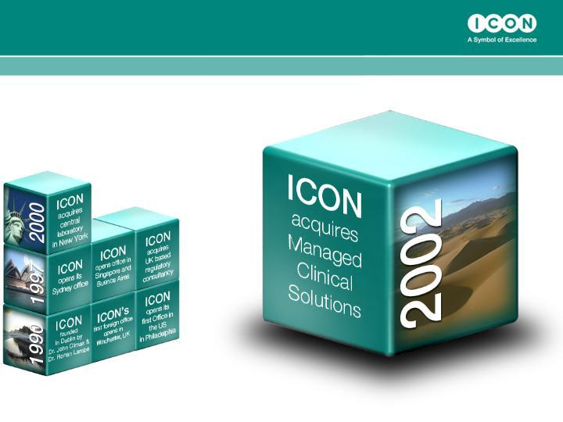
The Journey So Far

The Journey So Far

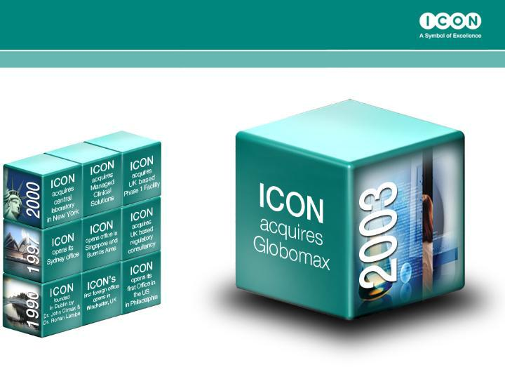
The Journey So Far

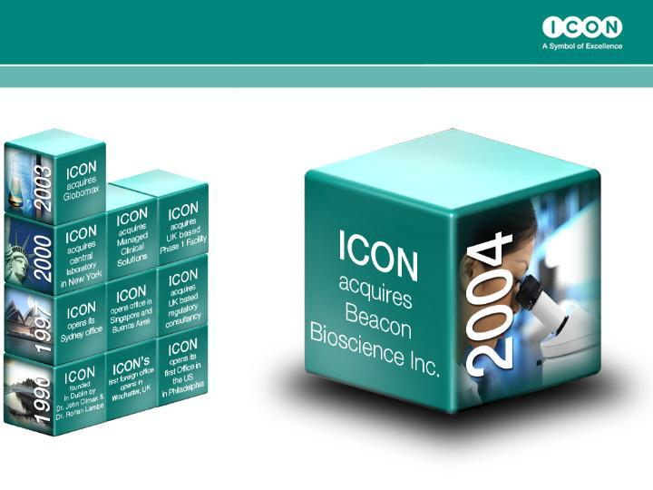
The Journey So Far

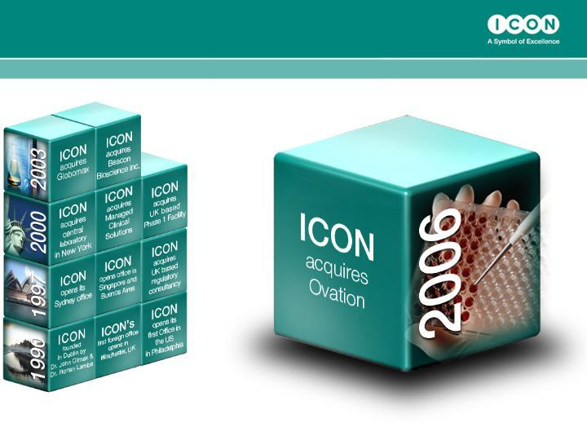
The Journey So Far

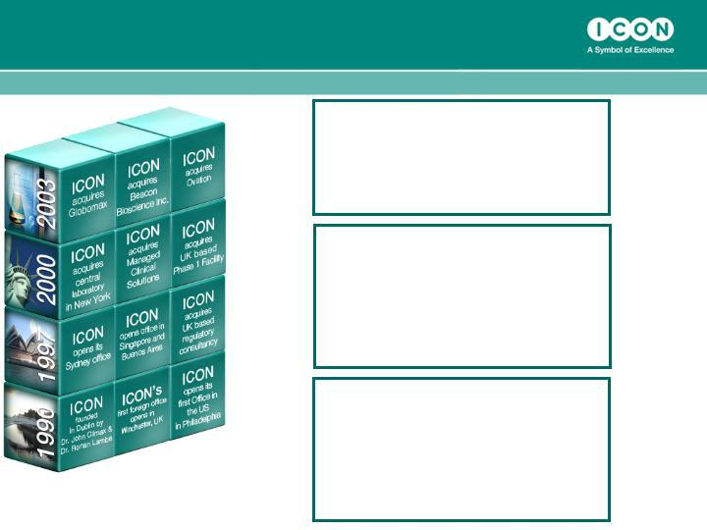
The Journey So Far

1990

• Revenues $0.5 million

• Operating Profits $0m

• Staff 5

2006

• | Revenues $450 million
• | Operating Profits $47m
• | EPS $1.33
• | Staff 4,300
2007 Guidance
• | Revenues $530-$550
• | Operating Profits $58 - $62m
• | EPS $1.63 - $1.71
• | Staff 4,800 – 5,100

Market Environment

Strong Market Environment with...

- Fundamental R&D Spending Growth Trend 6%- 8% p.a.

  - Phase II / III pipelines strengthening

- Increased Outsourcing

  - Being accelerated by activity & funding in Biotech / Speciality

  - Globalisation of clinical research

  - Cost containment pressures

  - Evidence that projects, where CROs are engaged, complete faster than “internal only” studies*

  - Growth c.15% p.a. since 2001*

- Increasing Regulation

  - More patients/ more studies

  - Post marketing surveillance

*Source: Tufts Centre for Study of Drug Development

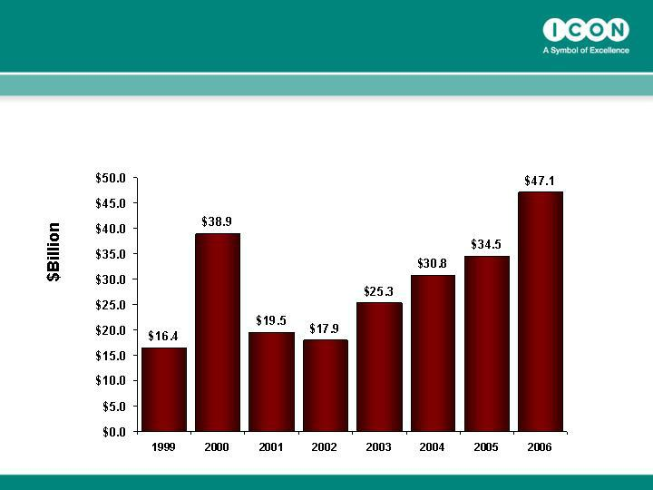
…US Biotech Funding continuing to grow, leading to...

Biotech fund raising ($billions)

Source: Burrill and Company

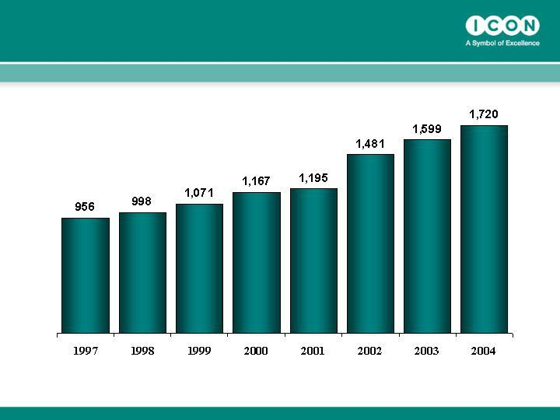
…significant growth in the number of companies with active clinical projects,….

Number of companies running clinical projects

Source: Informa Health

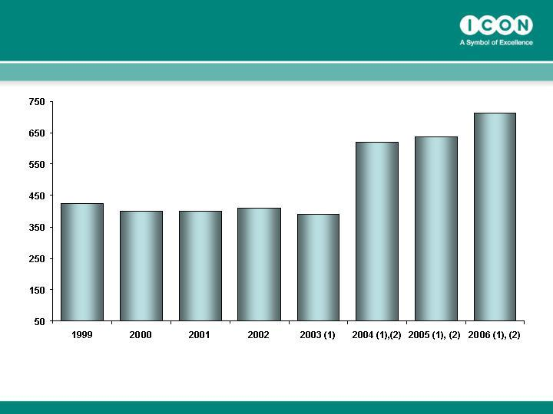
… good recent growth in original IND Applications,….

- Includes active INDs for Therapeutic Biological Products Transferred from CBER to CDER effective 10/01/2003

- Includes INDs for Therapeutic Biological Products Transferred from CBER to CDER

Source: FDA Centre for Drug Evaluation & Research

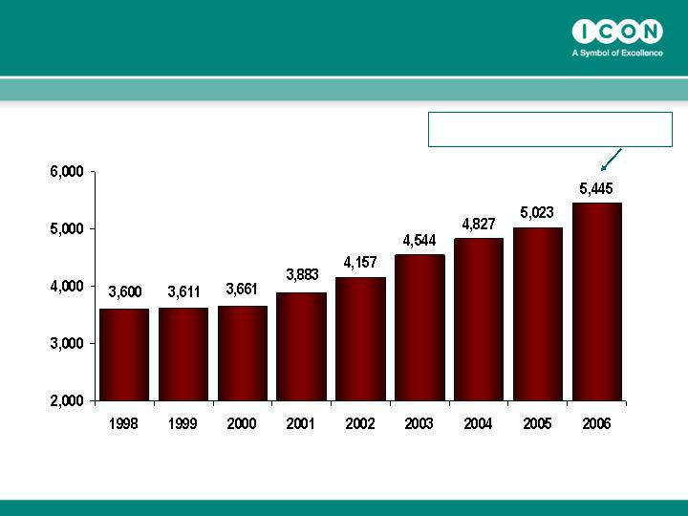
- which has lead to significant growth in the number of active INDs,…

Number of Active INDs

49% Increase since 2000

Source: FDA

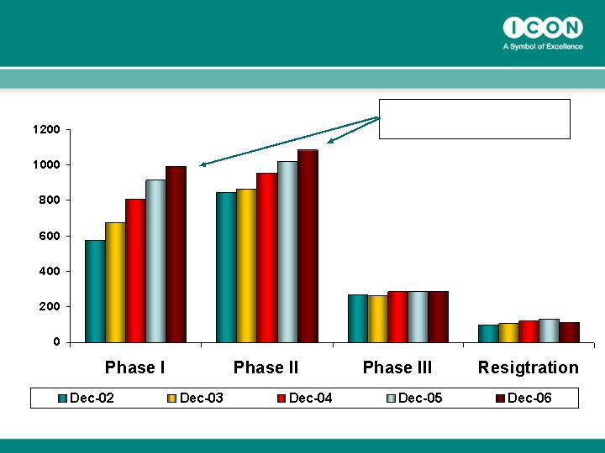
…which is enriching pipelines generally, and leading to…

2002 – 2006

46% Growth Phase I – II

Source: IMS R&D Focus, Dec 2006 and previous year SMRs

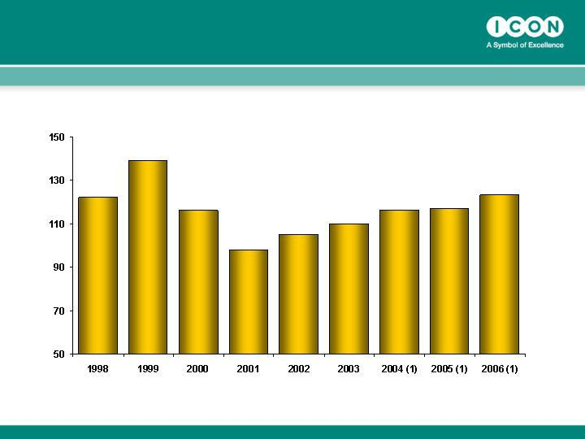
….a re-emergence of growth in NDA applications.

1) Includes the Therapeutic Biological Products Transferred from CBER to CDER effective 10/01/2003

Source: FDA Centre for Drug Evaluation & Research

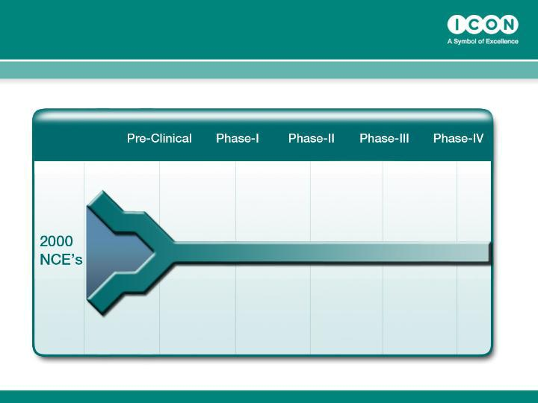
Not a “ Pig in a Python”, rather a …….

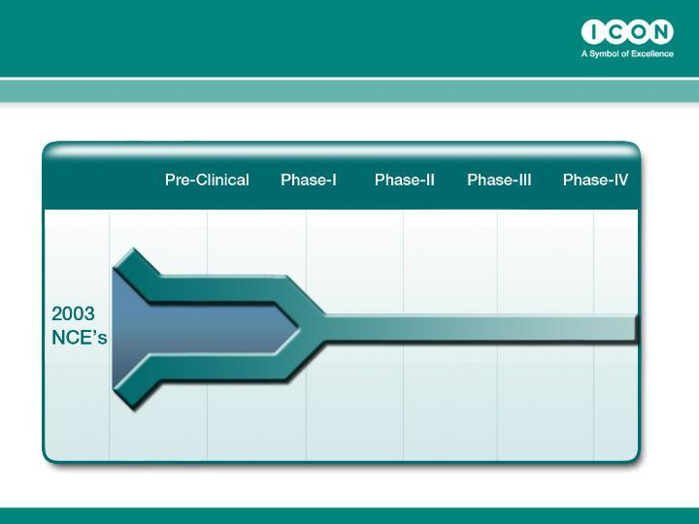
…bursting dam….

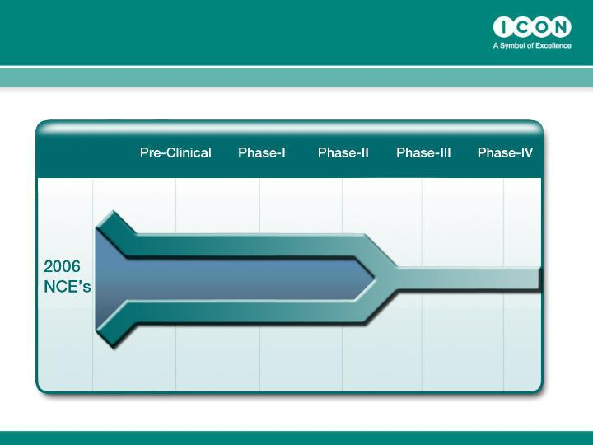
…bursting dam….

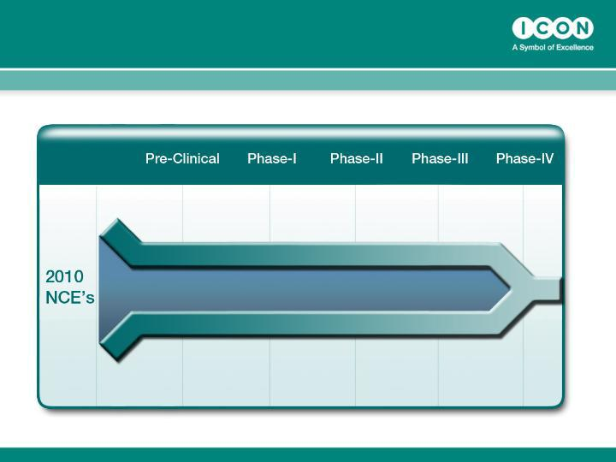
…bursting dam.

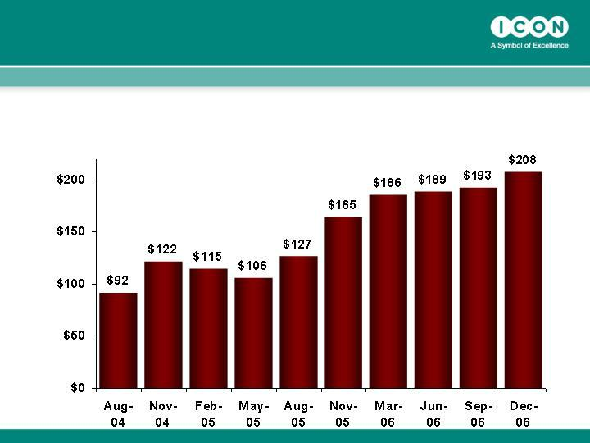
Strong business wins have led to…..

ICON Gross Business Wins - Last 10 Quarters ($ millions)

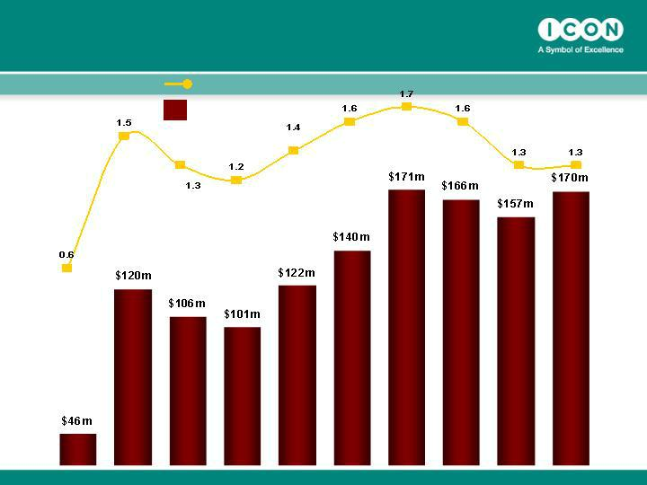
…good Net New Business Wins

and strong book-to-bill…

Book to Bill Ratio

Net Business Wins

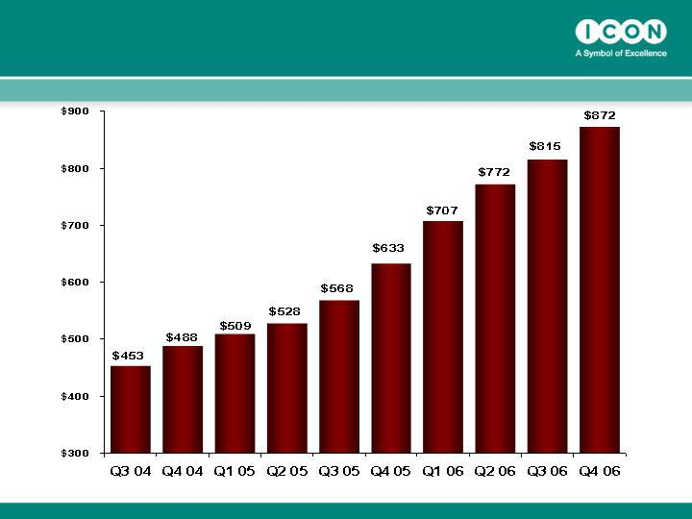
…leading to record total backlog levels… ($ millions)

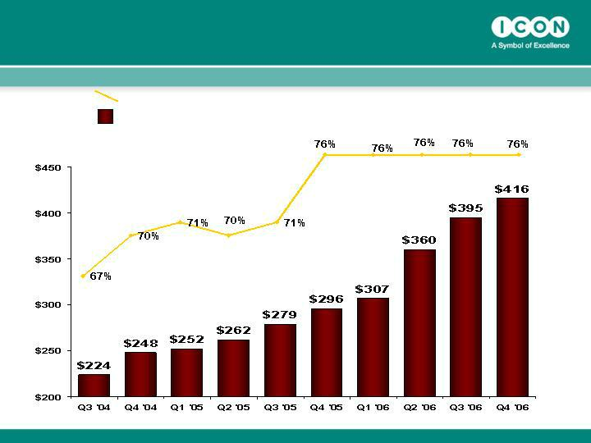
…, strong forecast coverage of next 4 quarters revenues……..

% coverage of next 4 quarters forecast revenues

Value of backlog forecast to be earned in next 4 quarters

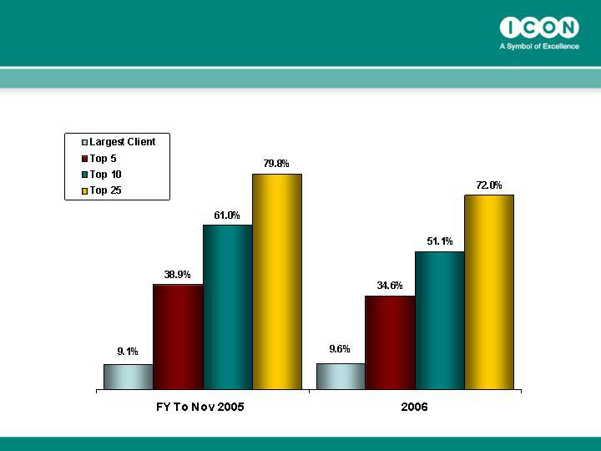
…..and a broadening of the customer base.

Client Concentration 2006 v 2005

STRATEGY

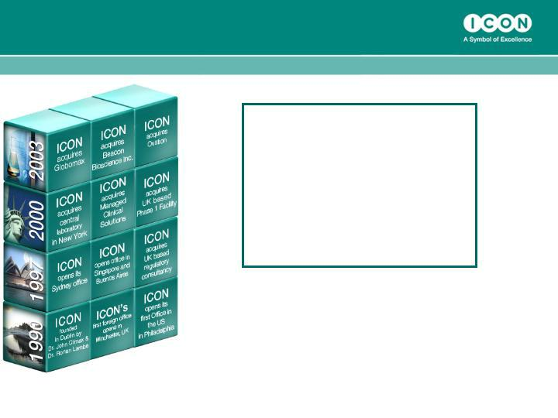
Core Strategy is Organic Growth, with acquisitions adding new services or scale.

2006

• Revenues $450 million

• Operating Profits $51m

• Bookings $665m

• Staff 4,300

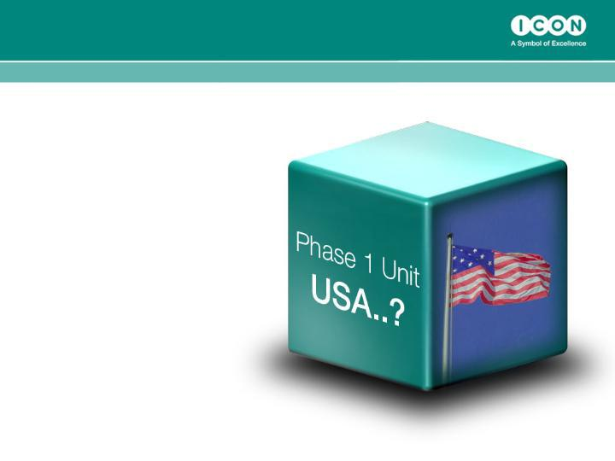
Core Strategy is Organic Growth, with acquisitions adding new services or scale.

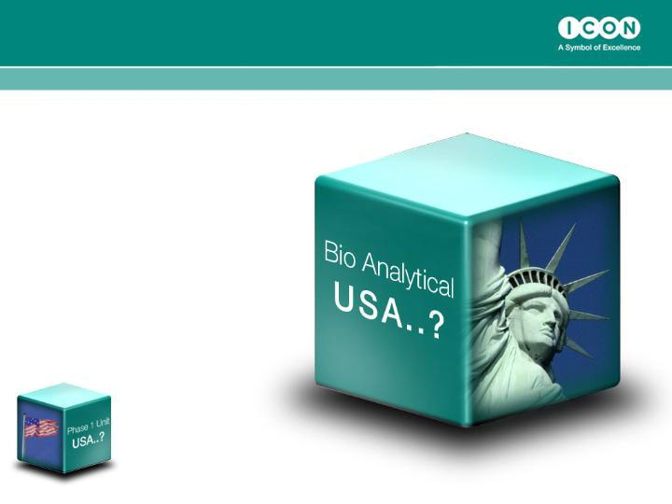
Core Strategy is Organic Growth, with acquisitions adding new services or scale.

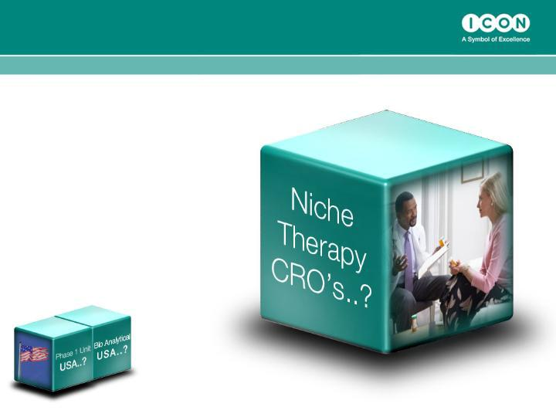
Core Strategy is Organic Growth, with acquisitions adding new services or scale.

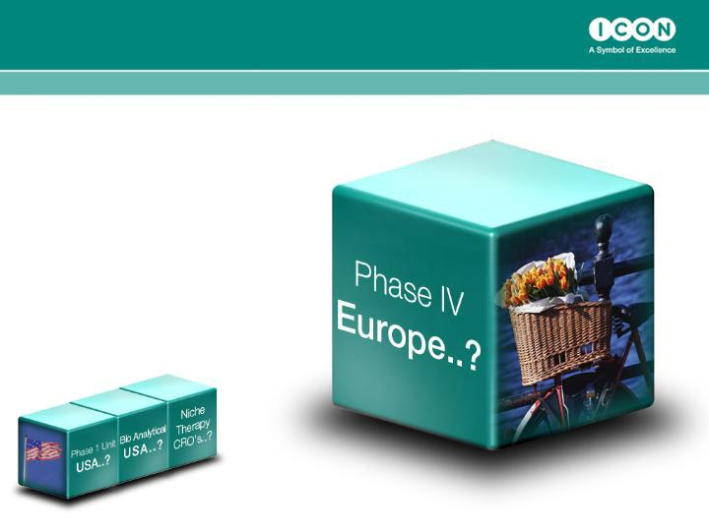
Core Strategy is Organic Growth, with acquisitions adding new services or scale.

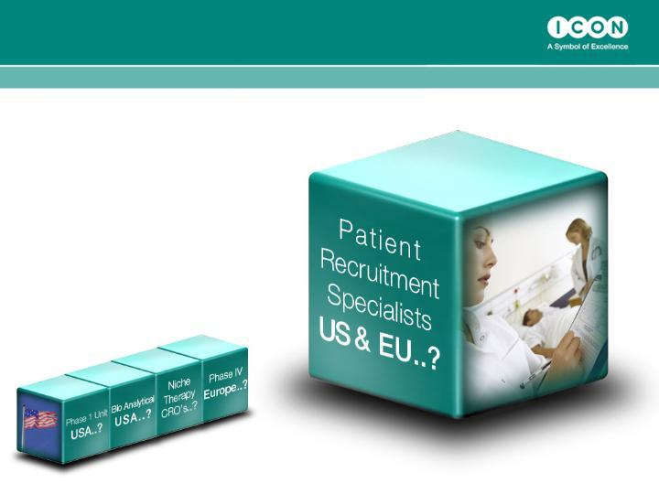
Core Strategy is Organic Growth, with acquisitions adding new services or scale.

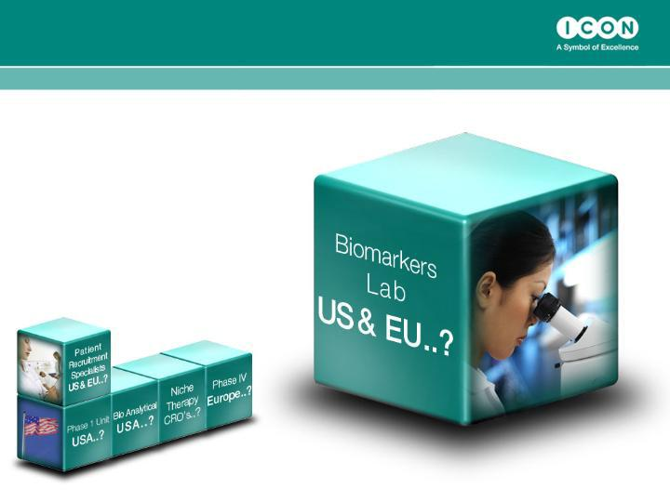
Core Strategy is Organic Growth, with acquisitions adding new services or scale.

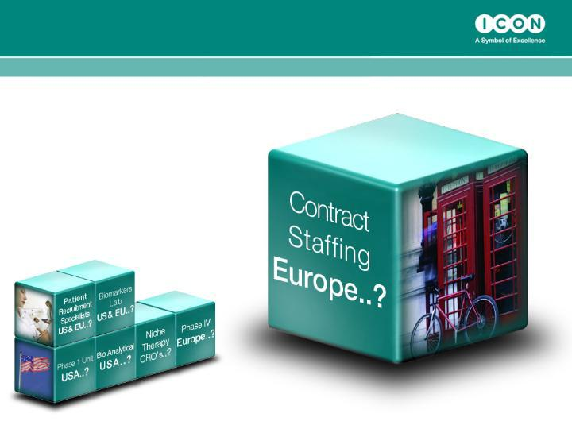
Core Strategy is Organic Growth, with acquisitions adding new services or scale.

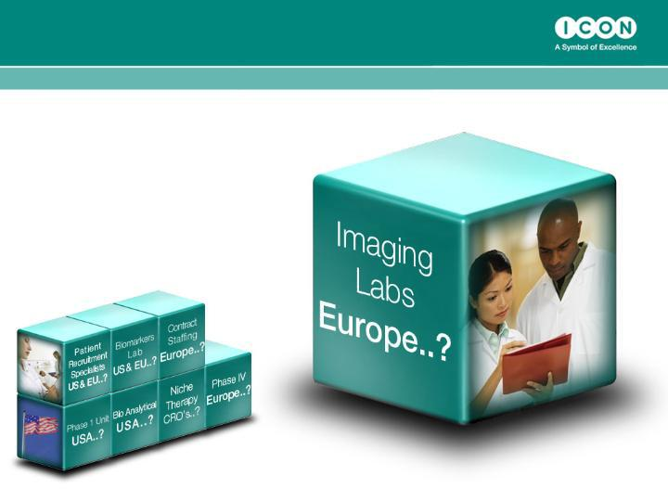
Core Strategy is Organic Growth, with acquisitions adding new services or scale.

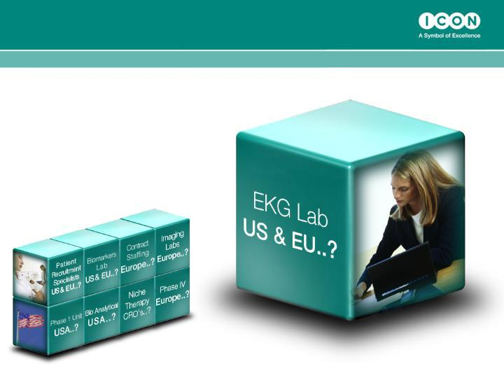
Core Strategy is Organic Growth, with acquisitions adding new services or scale.

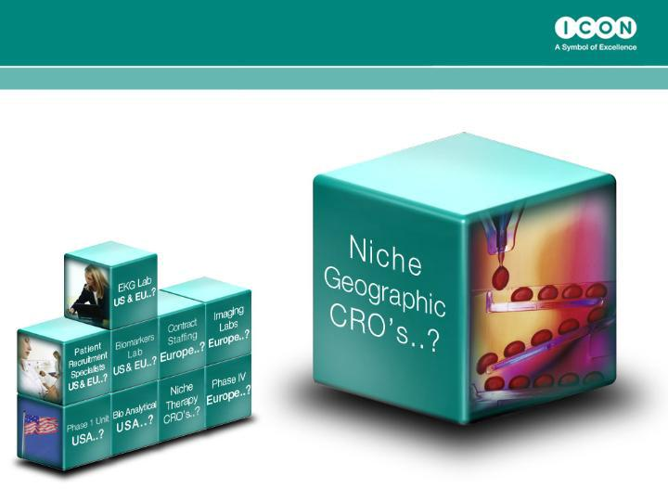
Core Strategy is Organic Growth, with acquisitions adding new services or scale.

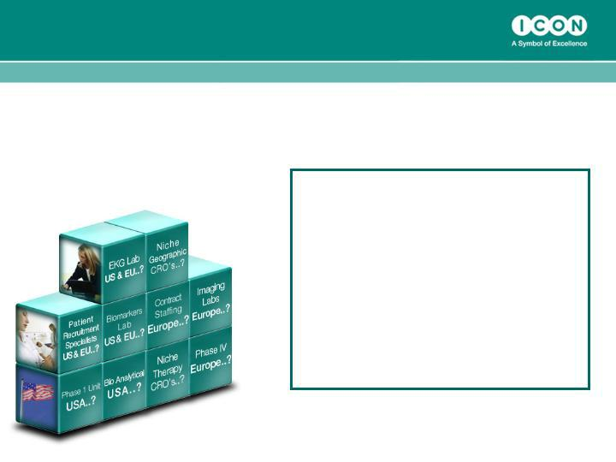
Core Strategy is Organic Growth, with acquisitions adding new services or scale.

Goal 2010

• Revenues $1bn

• Of which acquisitions

contribute $150m

• Margins ≥14%

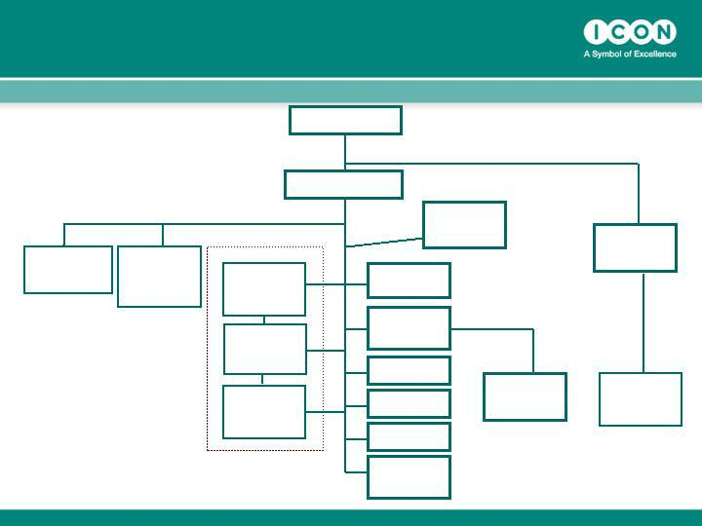
ICON plc Global Organization

Chairman

Dr. John Climax

ICON Central | ICON
Laboratories | Development
President | Solutions
Bo b | President
Scott-Edwards
 | Dr Thomas Frey

CEO

Peter Gray

ICON Clinical Research

ICON Clinical
US

President

Dr John

Hubbard

ICON Clinical
EU

President

Dr Peter

Sowood

ICON Clinical

ROW President

Dr Dan Weng

CFO
Ciaran

Murray

VP Process
Development

Alan Morgan

Exec. VP
Organisational
Development

Sean Leech

VP Corporate
QA
Jo Coyle

VP Global IT

Mike McGrath

VP Strategic HR

Eimear Kenny

Group Director
Market
Development

Simon Holmes

ICON
Contracting
Solutions

Tony Southers

Snr VP

ICON Corporate

Dev

President

Bill Taaffe

Beacon
Bioscience

CEO

Ted Gastineau

Financial Performance

Recent Financial Performance

($ millions, except EPS)

Net Revenue | Q4 ’06 |  |  | Q4 ’PY |  |  | % Increase
Net Revenue |  | 128.9 |  |  | 88.1 |  |  | 46.4%
Direct Costs | 72.5 |  |  | 48.7 |  |  | 48.8%
SG & A | 37.6 |  |  | 26.8 |  |  | 40.3%
D & A | 3.9 |  |  | 3.5 |  |  | 11.2%
 | _____ |  |  | _____ |  |  | _____
Operating Income | 14.9 |  |  | 9 |  |  | 65%
Net Income | 12.4 |  |  | 7 |  |  | 79%
 | _____ |  |  | _____ |  |  | _____
EPS (ex SFAS123R) |  | 42c |  |  | 24c |  | 75%
EPS (Inc SFAS123R) |  | 39c |  |  | 28.5m
Weighted Average no. of |  | 29.7m
Shares (ex SFAS123R)

Recent Financial Performance

($ millions, except EPS)

Net Revenue | FY 2006 |  |  | FY 2005 |  |  | % Increase
Net Revenue |  | 456 |  |  | 342.8 |  |  | 32.9%
Direct Costs | 254 |  |  | 189.6 |  |  | 34%
SG & A | 134.7 |  |  | 108.5 |  |  | 24.1%
D & A | 14.9 |  |  | 13.9 |  |  | 7.4%
 | _____ |  |  | _____ |  |  | _____
Operating Income | 51.9 |  |  | 30.8 |  |  | 68.6%
Net Income | 42.4 |  |  | 24.3 |  |  | 74.3%
 | _____ |  |  | _____ |  |  | _____
EPS (ex SFAS123R) |  | 145c |  |  | 86c |  | 68.6%
EPS (Inc SFAS123R) |  | 133c
Weighted Average no. of |  | 29.3m |  |  | 28.3m
Shares

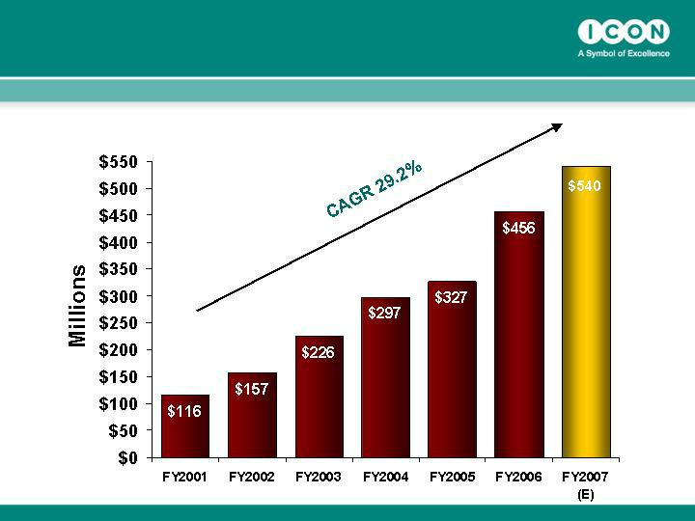
Net Revenue CAGR of 29% over 7 Years

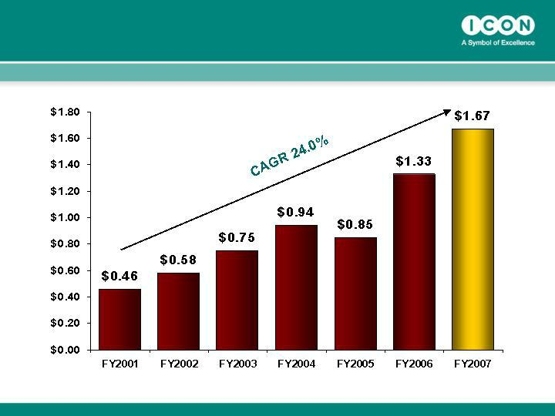
Earnings Per Share Growth

Summary Balance Sheet and Cash Flow

($ millions)

 | May 31, 05 |  |  |  |  | Dec 31, 05 |  | Dec 31, 06
 |  | (Year) |  |  |  | (7 mths) |  | (Year)
Net Cash |  |  | $78.4 |  | $82.3 |  |  | $98
Total assets | $347.6 |  |  |  | $349.1 |  |  | $476.3
Shareholder’s equity | $233.1 |  |  |  | $241.6 |  |  | $302.7
Cashflow from operations | $23.8 |  |  |  | $11.7 |  |  | $51.5
Capital expenditures | $15.6 |  |  |  | $7.8 |  |  | $12.3
Shares outstanding | 27.8 |  |  |  | 28.0 |  |  | 28.5

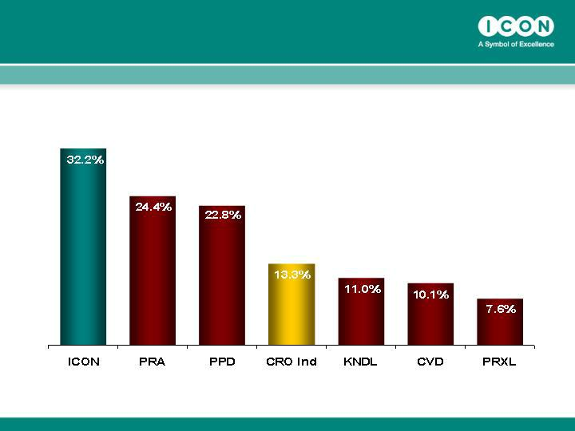
Revenue Growth v Peers: Net Revenue CAGR between 2000 and 2005

*Source SEC Filings

Investment Highlights

- Top 4 global CRO

- Strong market fundamentals

- Outstanding record of organic growth

- Strong balance sheet

- Margin expansion opportunity

- Good strategic position

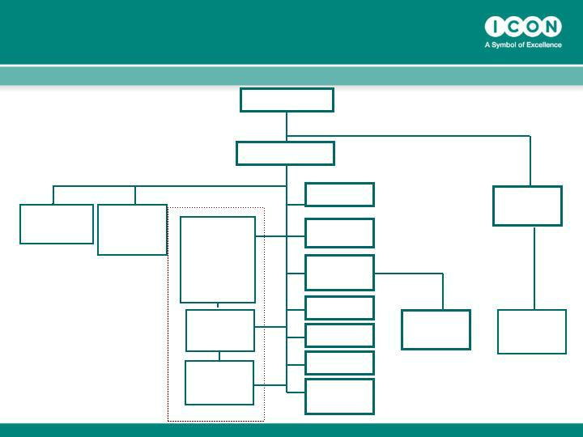
ICON plc Global Organization

ICON Central ICON
Laboratories Development
President ^{Solutions}
^{Bob} President

Scott-Edwards

Dr Thomas Frey

ICON Clinical Research

ICON

Clinical US

President

Dr John

Hubbard

ICON Clinical
EU

President

Dr Peter
Sowood

ICON Clinical

ROW President

Dr Dan Weng

Chairman

Dr. John Climax

CEO

Peter Gray

CFO

Ciaran Murray

VP Process
Development

Alan Morgan

Exec. VP
Organisational
Development

Sean Leech

VP Corporate
QA
Jo Coyle

VP Global IT

Mike McGrath

VP Strategic HR

Eimear Kenny

Group Director
Market
Development

Simon Holmes

ICON Corporate
Dev

President

Bill Taaffe

ICON | Beacon
Contracting | Bioscience
Solutions | CEO
Tony Southers | CEO
Snr VP | Ted Gastineau

ICON Clinical Research

Service Overview

Services

- ICON Clinical Research is a global provider of outsourced Phase II – IV development services to the pharmaceutical, biotechnology and medical device industries.

- Clinical trial management services include:

  - Project Management

  - Clinical Monitoring

  - Data Management

  - Biostatistics

  - Medical Affairs, Medical Writing & Safety Surveillance

  - Late Phase Services (patient registries, health economics, outcomes research)

  - Interactive Technologies (IVRS, ePRO, Portals, etc.)

ICON’s Business Trends

In Clinical Research

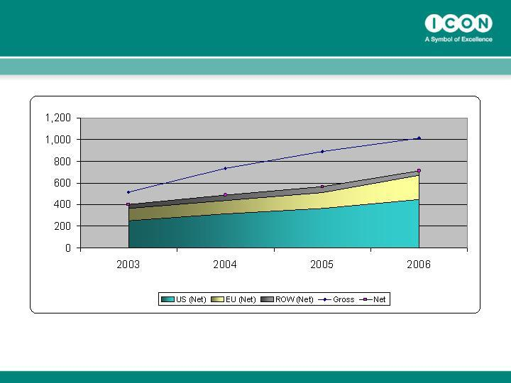
Global RFP Flow

Clinical Research 2003 – 2006 Annual (Gross vs. Net)

1Excludes IVR only data

2Gross = All RFPs Received

- Net = (Gross minus Cancelled, Declined, Non Award, Sent to Other Division)

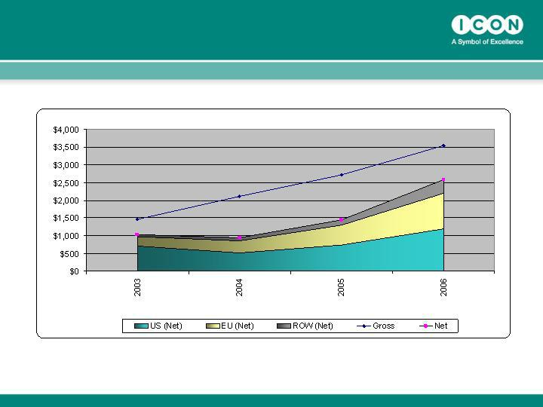
Global RFP Value ($ Million)

by Participating Region

Clinical Research 2003 - 2006 Annual (Gross vs. Net)

1Excludes IVR and Lab data

2Gross = All RFPs Received

- Net = (Gross minus Cancelled, Declined, Non Award, Sent to Other Division)

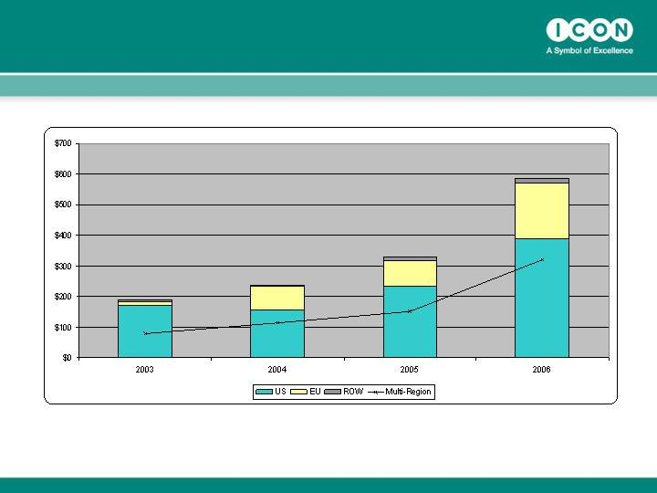
Global Historical Awards by Originating Region

Award Value in Millions

- Excludes Change Order Values

- Includes IVR Values

- Based on Award Notification Date

- Adjusted Value not used as 2003-2005 data would not be accurate

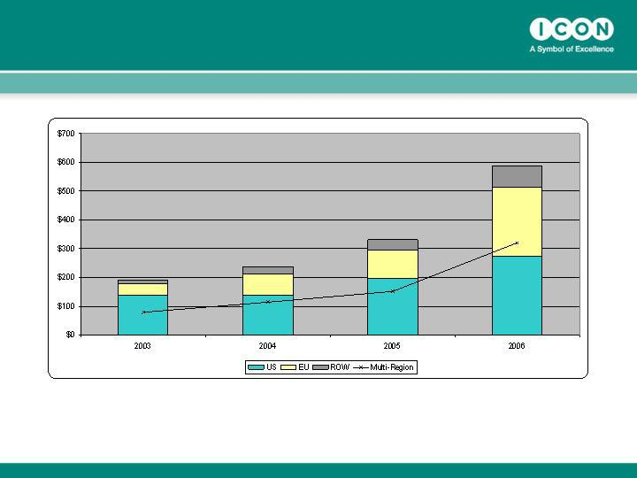
Global Historical Awards by Participating Region

Award Value in Millions

- Excludes Change Order Values

- Includes IVR Values

- Based on Award Notification Date

- Adjusted Value not used as 2003-2005 data would not be accurate

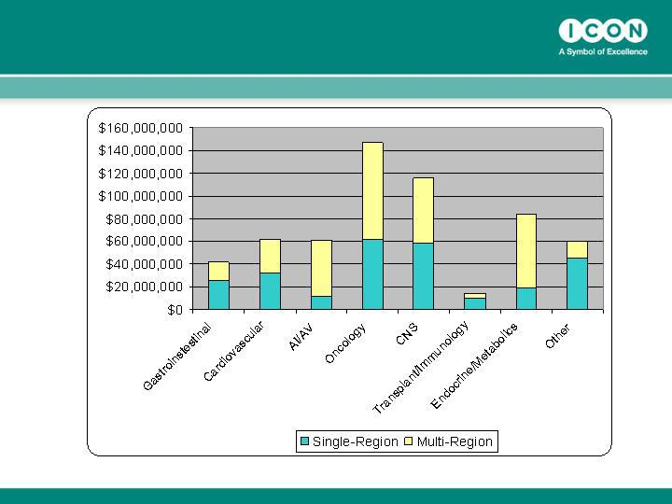
Award Values by Therapeutic Area Summary

Award Value in Millions

Award Value in Millions

Excludes IVR Values

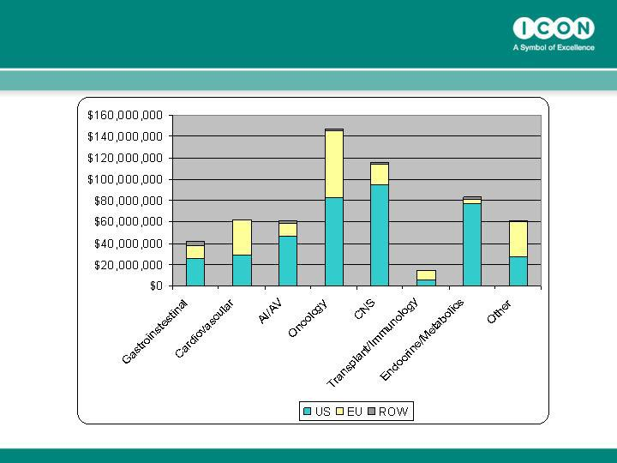
Global/Regional Award Values

Therapeutic Area Summary - 2006

Award Value in Millions

Excludes IVR Values

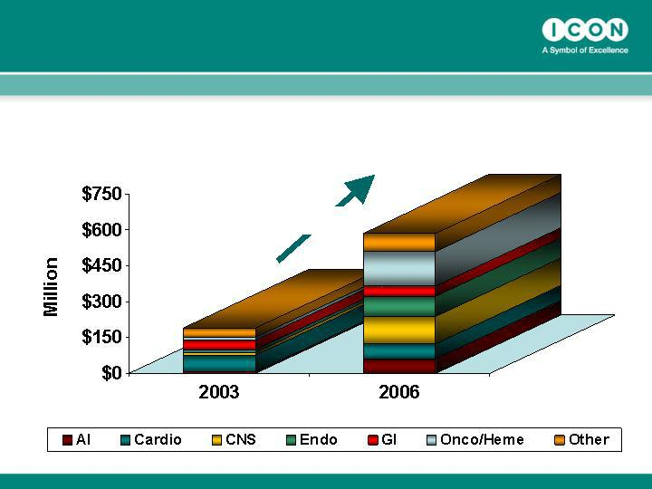
Therapeutic Growth (Awards)

Significant growth in Oncology, CNS, Anti-infectives & Endocrinology

+ 200%

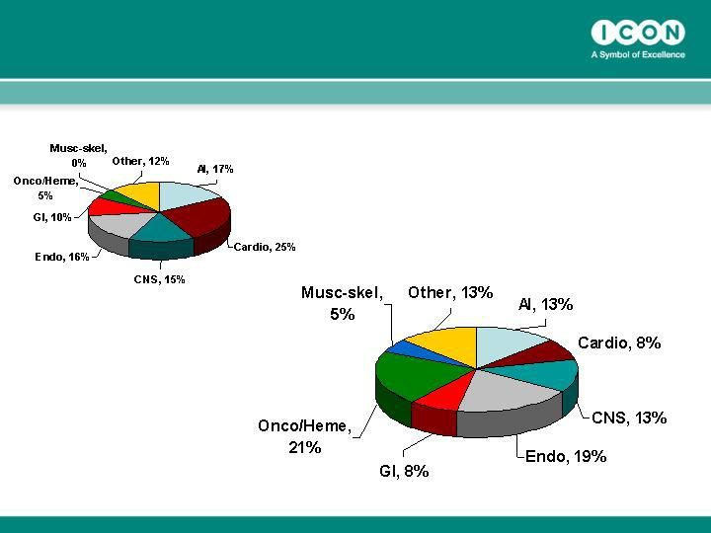
Therapeutic Growth (%Revenues)

2003

2006

Composition of Business
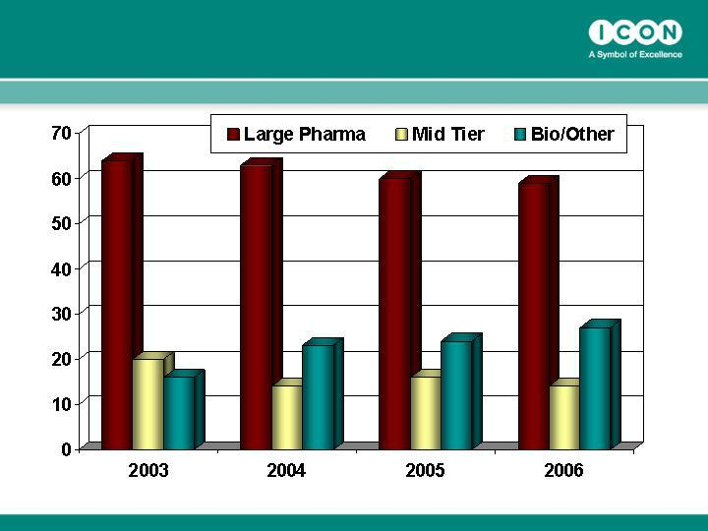

(Phase II-IV only) (% of Revenue)

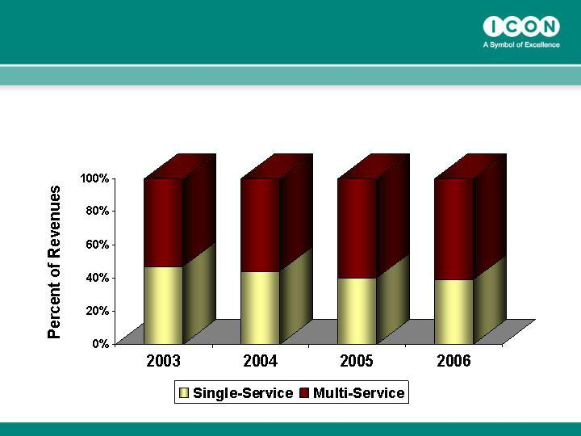
Increased Outsourcing of Full Service Work (U.S. Business)

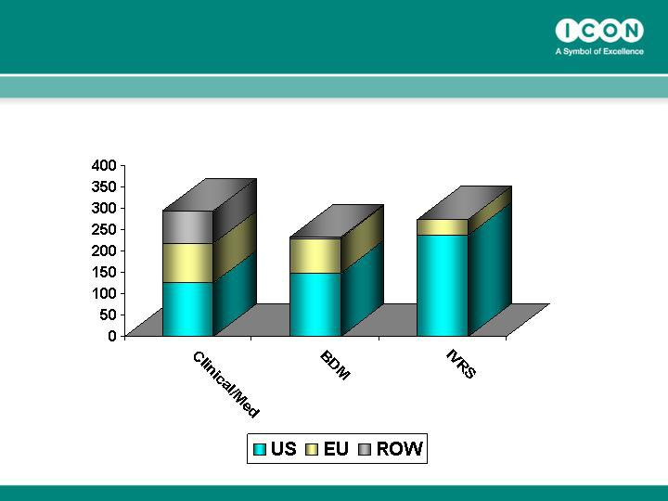
Total Number of Active Projects by Region

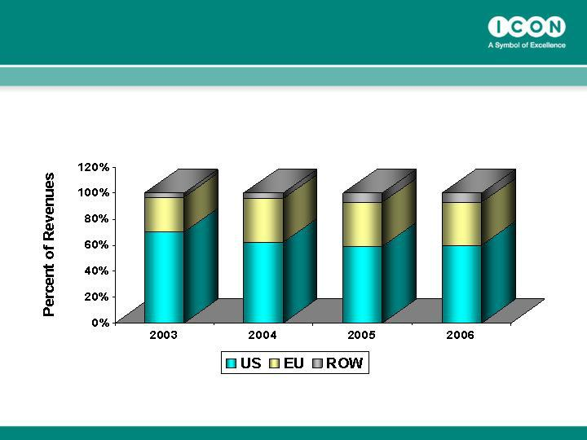
Increasing Contribution by EU and ROW to ICON’s Business growth….

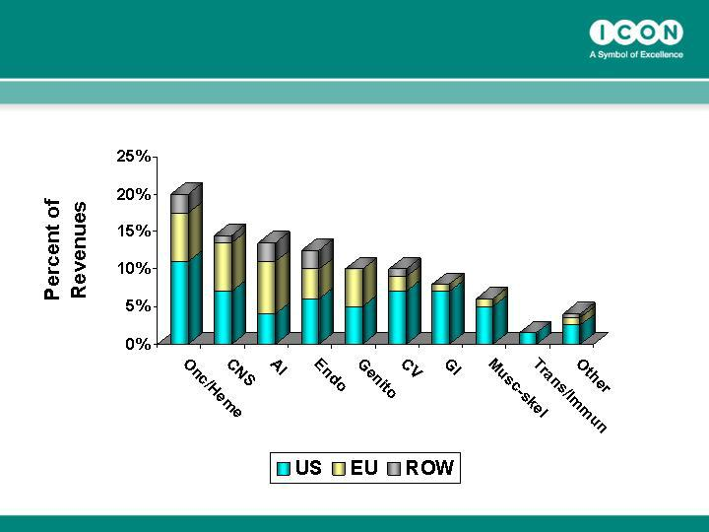
Active Projects & Therapeutic Mix by Region (% of Backlog for 2007)

Concluding Remarks

ICON is well Positioned to…….

- Capitalise on the expanding market in late phase and safety studies

- Increase geographical “foot print” to enhance patient recruitment for global studies

- Shift backend support to low cost regions such as India

- Utilize technology to improve efficiency and enhance value (ICOPhone, ePRO, EDC, ICOnet)

- Achieve excellence in key therapeutic areas and global project management

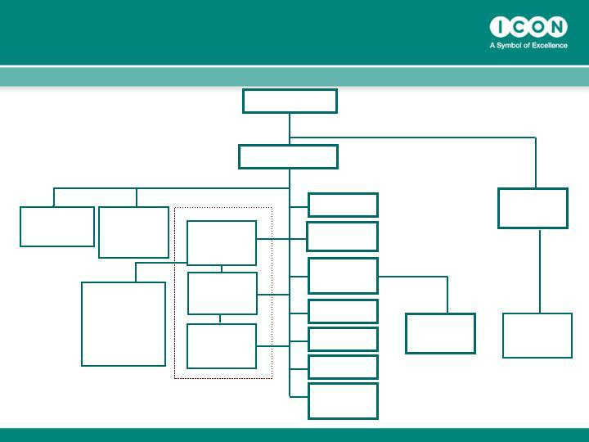
ICON plc Global Organization

ICON Central ICON
Laboratories Development Solutions

President
^{Bob} President

Scott-Edwards

Dr Thomas Frey

ICON
Clinical US

COO

Malcolm
Burgess

Chairman

Dr. John Climax

 | CEO
 | Peter Gray
 | CFO
ICON Clinical Research | Ciaran Murray
ICON Clinical | VP Process
US | Development
President | Alan Morgan
Dr John | Alan Morgan
Hubbard | Exec. VP
 | Organisational
ICON Clinical | Development
EU | Sean Leech
President | Sean Leech
Dr Peter | VP Corporate
Sowood | VP Corporate
Sowood | QA
 | Jo Coyle
ICON Clinical | VP Global IT
ROW President | Mike McGrath
Dr Dan Weng | VP Strategic HR
 | Eimear Kenny
 | Group Director
 | Market
 | Development
 | Simon Holmes

ICON Corporate
Dev

President

Bill Taaffe

ICON | Beacon
Contracting | Bioscience
Solutions | CEO
Tony Southers | CEO
Snr VP | Ted Gastineau

EDC – Origins of the species

- Electronic Data Capture (EDC) has been around almost 30 years

- Adoption has been slower than the technologists predicted

- So what’s changed

ICON’s evaluation and selection of vendors

- Historical experience with 14 different systems

  - Driven by state of the market and client variation (no clear leader)

  - Breath of experience beyond the reach of Pharma

- Evaluated top 15 systems during 2004

  - Functionality (Investigator, Monitor & Data Manager)

  - Scalability & Financial stability

  - Cost comparison

- Selected Medidata Rave™ (February 2005)

  - Non-exclusive agreement

    - Rave™ well accepted but clients continue to mandate other systems

- Added Phase Forward Inform™ (January 2007)

  - Rave™ and Inform™ dominated 2006 sales (each about 40% of market)

  - Allows us to cover the majority of our EDC committed client base

- So why Rave™ & Inform™ (and not other suppliers)

  - Ease of use (Investigator, Monitor and Data Management)

  - Internet enabled with zero footprint at site (minimal support overhead)

  - Established relationships with ICON & positive real life experiences

  - Limit to speed of technology transfer & number of systems

  - Continue to review other niche providers (eg Late Phase)

Adoption metrics

- In the last 3 years

  - ICON has won 6 times as many EDC projects than in the preceding 13 years

  - EDC Wins have more than doubled year on year

    - 8 wins in 2004, 17 wins in 2005 and 38 wins in 2006

  - Requests for proposals featuring EDC comprised about 35% of our portfolio at the end of 2006 (<1% in 2003)

  - Currently over 20% of our projects are using EDC, this is projected to reach between 35 and 40% by the end of 2007

- Current EDC project portfolio

  - 53 ongoing EDC studies (plus 25 completed studies)

    - 31 studies in Medidata Rave™

      - Over 2,000 sites and 20,000 patients

    - 11 studies using Phase Forward Inform™

      - Over 450 sites and 5,000 patients

    - 11 studies using other EDC systems (client mandated)

Drivers for adoption – cost, speed & visibility

Supports complex

studies (eg
Oncology)

Faster time to

database lock and
final study reports

>$6M

Access to data

(Adaptive trials)

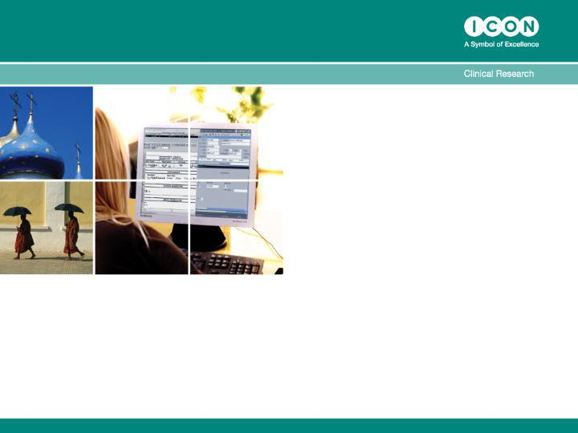

ICON

Investor Relations Day 2007

Short Break

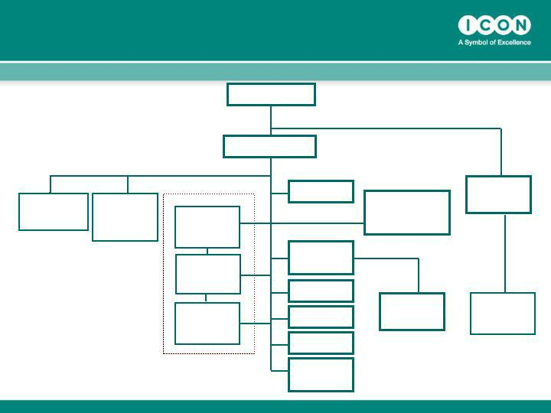
ICON plc Global Organization

ICON Central | ICON
Laboratories | Development
President | Solutions
President | President
Bo b | President
Scott-Edwards | Dr Thomas Frey

Chairman

Dr. John Climax

CEO

Peter Gray

 | CFO
ICON Clinical Research | Ciaran Murray
ICON Clinical
US
President
Dr John
Hubbard | Exec. VP
 | Organisational
ICON Clinical | Development
EU | Sean Leech
President | Sean Leech
Dr Peter | VP Corporate
Sowood | VP Corporate
Sowood | QA
 | Jo Coyle
ICON Clinical | VP Global IT
ROW President | Mike McGrath
Dr Dan Weng | VP Strategic HR
 | Eimear Kenny
 | Group Director
 | Market
 | Development
 | Simon Holmes

VP Process
Development

Alan Morgan

ICON
Contracting
Solutions
Tony Southers

Snr VP

ICON Corporate

Dev

President

Bill Taaffe

Beacon
Bioscience

CEO

Ted Gastineau

IMPROVE

- Root and branch review of Standard Operating Procedures to enhance consistency of client experience and efficiency of operational delivery

  - Data Management

  - Site visits

  - Document Management & Archiving

  - Regulatory & Ethics submissions

  - Site selection & feasibility

EXPEDITE

- A review of project management methodology, procedures, and tools, to enhance consistency of client experience and effectiveness of operational delivery

  - Consistent work break down structure across systems

  - Templates to assist in task planning

  - More structured approach to risk management

  - Standardised global training for project leaders

  - Creation of a global Project Management Office

New Investments in tools

- Continuous investment in new tools to support new processes and to provide a scaleable system framework for the enterprise

  - Clinical Trial management system ( ICOTrial ) active on over 70 projects

  - SOPs management systems launched at the end of 2006 (iDoc )

  - Sales contact management tool launched in January 2007 (salesforce.com)

  - New training and compliance system currently being launched (iLearn )

  - New enterprise wide financial and project accounting system will go live in Q3 2007

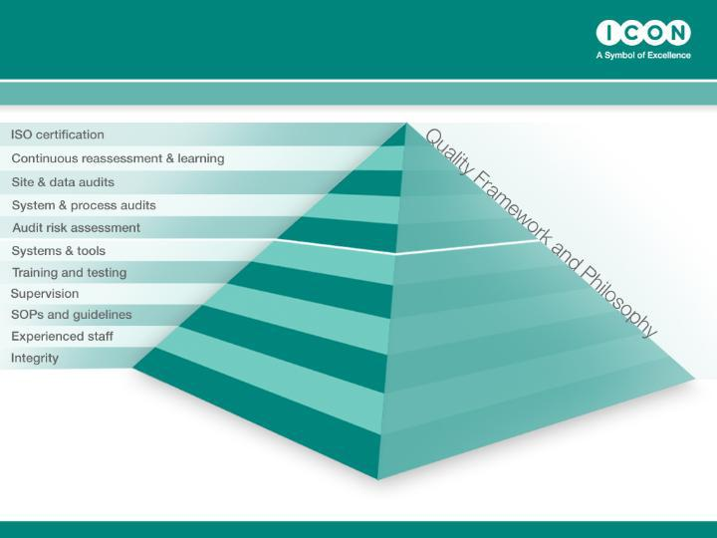
Supporting Growth – Systems, Process, and QA

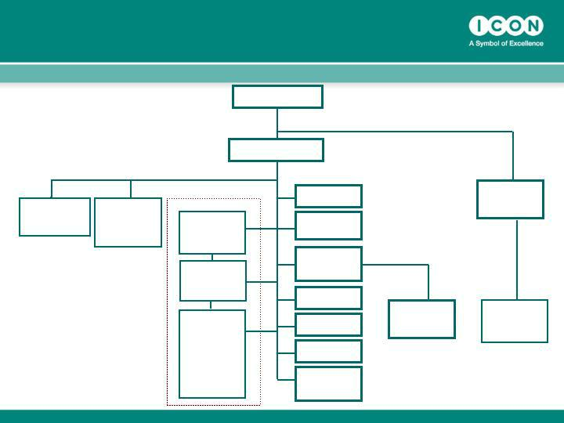
ICON plc Global Organization

Chairman

Dr. John Climax

ICON Central ICON
Laboratories
_{President} Development
Solutions
^{Bob} President

Scott-Edwards

Dr Thomas Frey

CEO

Peter Gray

ICON Clinical Research

ICON Clinical
US
President

Dr John

Hubbard

ICON Clinical
EU

President

Dr Peter

Sowood

ICON
Clinical

ROW
President

Dr Dan
Weng

CFO

Ciaran Murray

VP Process
Development

Alan Morgan

Exec. VP
Organisational
Development

Sean Leech

VP Corporate
QA
Jo Coyle

VP Global IT

Mike McGrath

VP Strategic HR

Eimear Kenny

Group Director
Market
Development

Simon Holmes

ICON Corporate
Dev

President

Bill Taaffe

ICON | Beacon
Contracting | Bioscience
Solutions
Tony Southers | CEO
Snr VP | Ted Gastineau

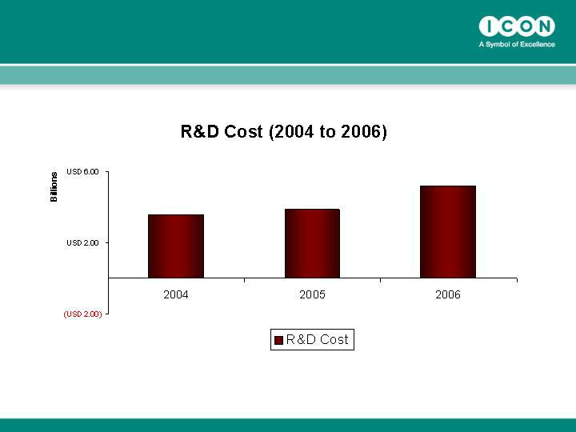
Total R&D Spend of Japanese Pharmaceutical Companies

JPMA – Japan Dec 2006

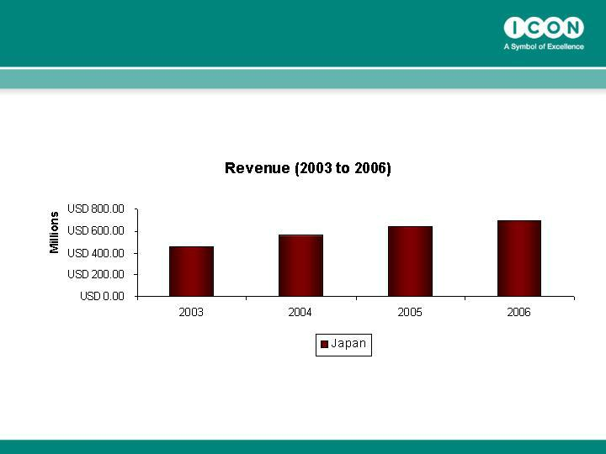
The Revenue of CROs in Japan

JCROA-Japan, Dec 2006

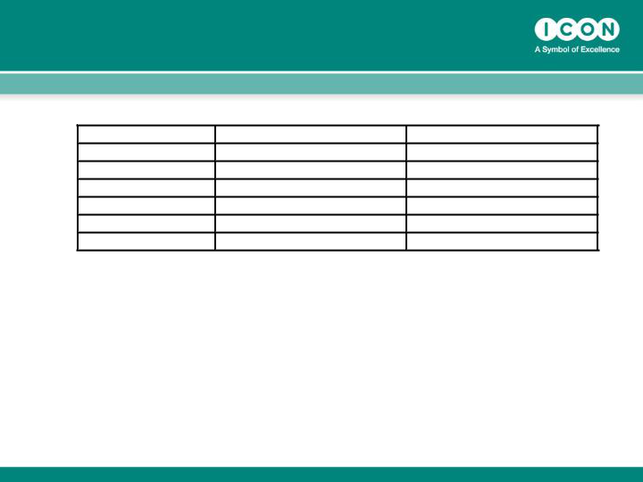
CROs in Japan (as of 2006)

ICON | Clinical Staff | Location
ICON | 70 | Tokyo
Quintiles | 300 | 10 offices in Japan
CMIC | 350 | 10 offices in Japan
EPS | 300 | 10 offices in Japan
MSP | 150 | 3-4 offices in Japan
Parexel | 250 | Kobe/Tokyo

CRO Opportunities in Japan

- Domestic growth

  - Increasing Demands

    - Headcount cut in pharma Vs more clinical trials

    - Pivotal studies Vs local studies

    - Mega companies (big three) Vs middle/small pharmas

    - CRO growth Vs SMO involvement (less SMO needs)

      - SMO currently acts as a ‘patient broker’

- Regional study management

  - Joint studies between Japan and region

•

•

Unique processes, culture difference, language, ICON’s presence in the region

Current modification on Japanese Regulations (Asia data to support Japanese NDA)

Clinical Research in India – Medium term opportunity

- Progressively developing infrastructure ( >14000 hospitals by 2010)

- Cost effectiveness -50% of the cost in US

- Large Population

¯

¯

¯

Genetically heterogeneous

Treatment Naive Patient population

Expedited target recruitment

- Indications

  - Prevalence of rare diseases

  - Huge patient population of diseases like Diabetes and Tuberculosis
- Compliance to global quality and ethical standards

- Availability of highly skilled medical professionals and research staff

- Large pool of English speaking Caucasian population

- Streamlined regulatory structure

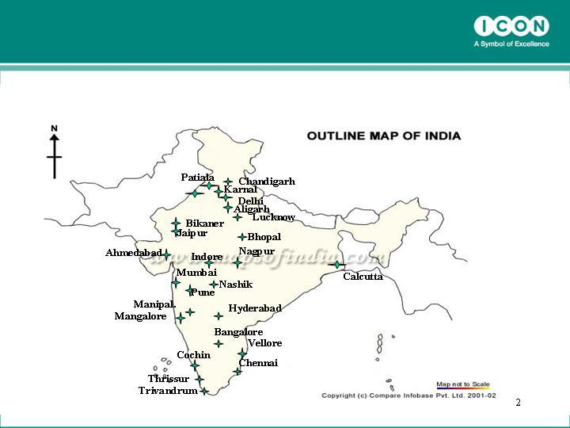
Geographical spread of current ICON managed sites

Amritsar

Clinical Research in China – Longer term opportunity

- Top investigators-5-10 years global experience

- Patient pool/ Recruitment reliability (216 hospitals,53 different specialties for GCP certified clinical trials centers)

- Rapidly expanding pharmaceutical market ---5th largest by 2010, 2nd/3rd largest by 2020
- Huge CRO market potential

- Cost-competitive : 40% reduction Vs EU & USA

- Global trials accelerated China marketing registration

- More clinical trials for domestic NDAs

- Long timeline for CTA approval

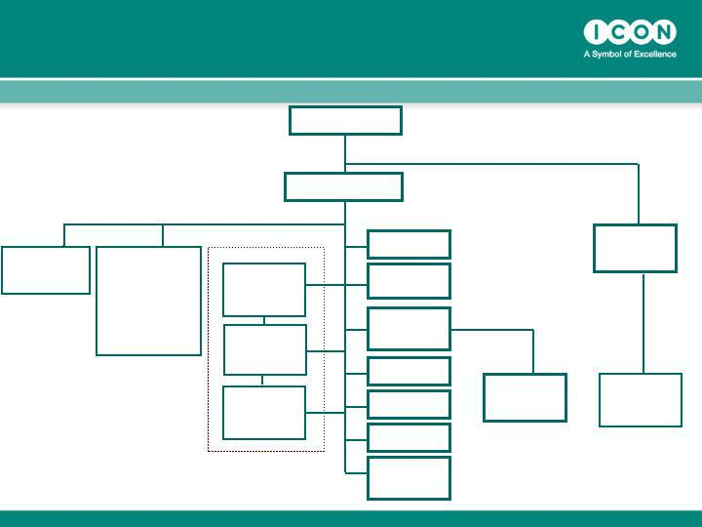
ICON plc Global Organization

Chairman

Dr. John Climax

ICON Central

Laboratories
President

Bob

Scott-Edwards

ICON
Developme

nt Solutions

President

Dr Thomas

Frey

CEO

Peter Gray

ICON Clinical Research

ICON Clinical
US

President

Dr John

Hubbard

ICON Clinical
EU

President

Dr Peter

Sowood

ICON Clinical

ROW President

Dr Dan Weng

CFO

Ciaran Murray

VP Process
Development

Alan Morgan

Exec. VP
Organisational
Development

Sean Leech

VP Corporate
QA
Jo Coyle

VP Global IT

Mike McGrath

VP Strategic HR

Eimear Kenny

Group Director
Market
Development

Simon Holmes

ICON Corporate
Dev

President

Bill Taaffe

ICON | Beacon
Contracting | Bioscience
Solutions | CEO
Tony Southers | CEO
Snr VP | Ted Gastineau

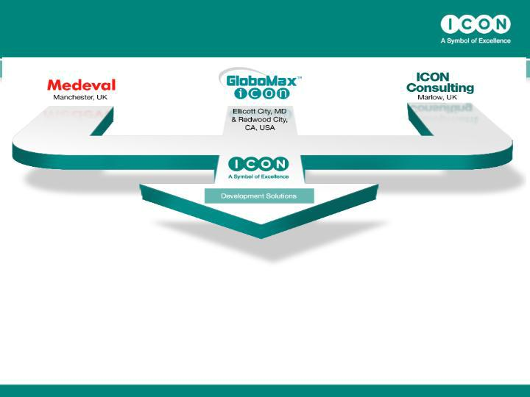
ICON Development Solutions

- Medeval: Full Service Clinical Pharmacology Unit, Manchester, UK

- GloboMax: Strategic Product Development Consulting, Baltimore, US

- ICON Consulting (YRCR): Regulatory Affairs Consulting, Early Phase Clinical Operations, Marlow, UK

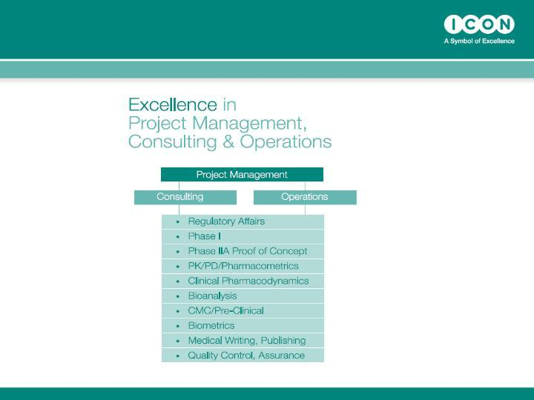
ICON Development Solutions

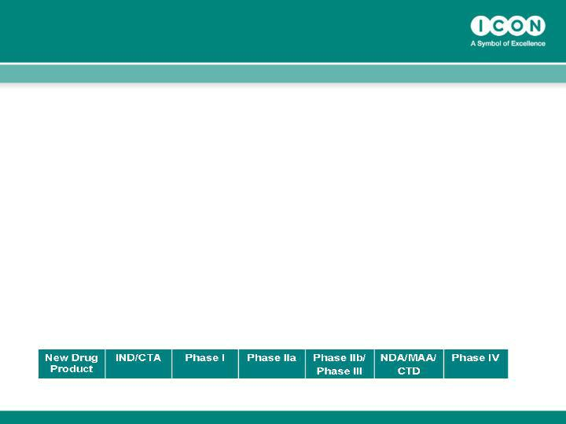
Service Proposition

- Regulatory and Development Strategy

- Protocol Design

- Regulatory Submissions and Agency Meetings

- Study/Program Execution

- Evaluation and Reporting

- From compound selection through development to approval and beyond


Scientific Capability

 |  | Area | Collective Expertise
 |  | Clinical Drug Development / Clinical | >12 MDs/PhD >130 years experience,
 |  | Pharmacology | >1200 ph I/IIA trials
 |  | Regulatory Affairs | 15 MSc/PhD >150 years
 |  |  | EU/US experience
 |  | CMC, Formulation Development | >6 MSc/PhD >100 years experience
 |  | PK/PD, Pharmacometrics | 14 MSc/PhD, over 100 years
 |  |  | experience


Strategy For Growth

 |  | Area | Activity
 |  | Development Consulting | Build on US strengths and expand in
 |  |  | EU
 |  | Regulatory, Publishing | E-submission requirement in EU/US
 |  |  | creates big growth opportunity
 |  | Phase I | US Phase I acquisition
 |  |  | Expansion into special population
 |  |  | studies
 |  | PK, PD, Pharmacometrics | Constant demand for services,
 |  |  | modeling and simulation rising
 |  | CMC, Non-clinical | Life cycle management segment
 |  |  | growing

ICON plc Global Organization

Chairman

Dr. John Climax

ICON Central
Laboratories

President

Bob

Scott-Edwards

ICON
Development
Solutions

President

Dr Thomas Frey

CEO

Peter Gray

ICON Clinical Research

ICON Clinical
US

President

Dr John

Hubbard

ICON Clinical
EU

President

Dr Peter

Sowood

ICON Clinical

ROW President

Dr Dan Weng

CFO

Ciaran Murray

VP Process
Development

Alan Morgan

Exec. VP
Organisational
Development

Sean Leech

VP Corporate
QA
Jo Coyle

VP Global IT

Mike McGrath

VP Strategic HR

Eimear Kenny

Group Director
Market
Development

Simon Holmes

ICON Corporate

Dev

President

Bill Taaffe

ICON | Beacon
Contracting | Bioscience
Solutions | CEO
Tony Southers | CEO
Tony Southers | Dr Ted
Snr VP | Dr Ted
Snr VP | Gastineau

Central Laboratory – 2006 Overview

- Revenue grew by +65%

  - Europe: +93%USA:+62%

- Won 289 New studies

  - Strike rate:47%

  - Repeat business:88%(31 New Clients)

- Backlog:~$100m(+26%)

- Customer Satisfaction:

  - 94% would use us again

  - 94% would recommend us to colleagues

  - 54% thought we were the “best” Central Laboratory

  - 33% thought we were as good as the “others”

- Headcount grew to 356

Central Laboratory – 2007 Outlook

- Target Revenue growth:>20%

- Target margin:8-10% at year end

- Expanding Sales Team

- Organization growth tailored to demand

- Expanded use of Six Sigma and Metrics

- Continue to expand test menu/platforms

  - Focus on Flow Cytometry and key biomarkers

Central Laboratory – 2007 Outlook

- Kit output:

  - ~45,000 kits/month compared to ~25,000 in 2005

- Upgrading systems & processes to yield further efficiencies
  - Kit automation initiative underway

  - Upgrade to IT systems underway

  - Launched new RDA system

- Dublin has expanded – Laboratory & Support Teams

  - Will continue as new HQ comes on line

- Singapore is on line

  - Sample receipt/Reporting

- Actively seeking partners in India & China

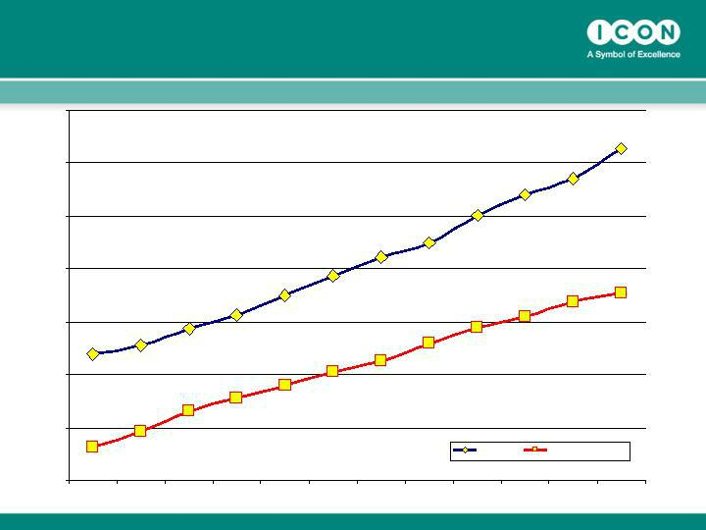
Kits & Accessions - 2006

550,000

500,000

450,000

400,000

350,000

300,000

250,000

Total Kits Total Accessions

200,000

Jan-06 Feb-06 Mar-06 Apr-06 May-06 Jun-06 Jul-06 Aug-06 Sep-06 Oct-06 Nov-06 Dec-06

Challenges…

- Extending our Global presence…

    - Singapore, India, China…

    - Upgrading our Affiliate activity…

  - Adding high caliber staff

  - Retaining our distinctive style -

    - A service business built around a Lab

      - Producing high quality data

    - Noted for Responsiveness and Flexibility

    - Focused on Customer Delight!

- Keeping focused:

    - Efficiency & Effectiveness with High Quality!

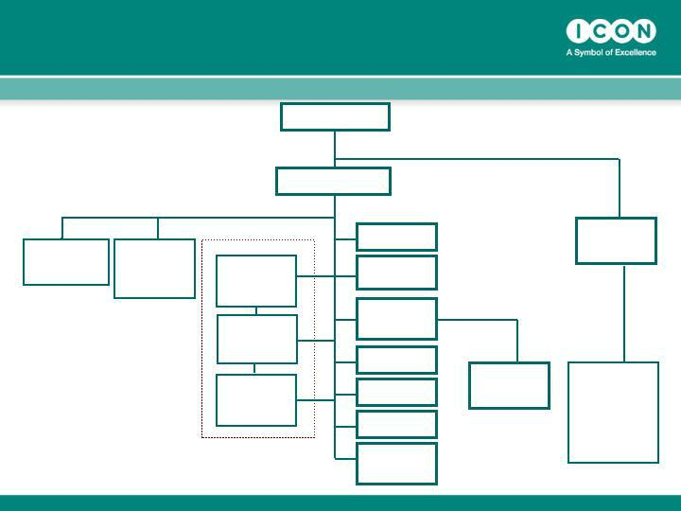
ICON plc Global Organization

ICON Central | ICON
Laboratories | Development
President | Solutions
Bob | President
Scott-Edwards | Dr Thomas Frey

ICON Clinical Research

ICON Clinical
US
President

Dr John

Hubbard

ICON Clinical
EU

President

Dr Peter

Sowood

ICON Clinical

ROW President

Dr Dan Weng

Chairman

Dr. John Climax

CEO

Peter Gray

CFO

Ciaran Murray

VP Process
Development

Alan Morgan

Exec. VP
Organisational
Development

Sean Leech

VP Corporate
QA
Jo Coyle

VP Global IT

Mike McGrath

VP Strategic HR

Eimear Kenny

Group Director
Market
Development

Simon Holmes

ICON Corporate

Dev

President

Bill Taaffe

ICON | Beacon
Contracting | Beacon
Solutions | Bioscience
Tony Southers
Snr VP | CEO
 | Ted
 | Gastineau

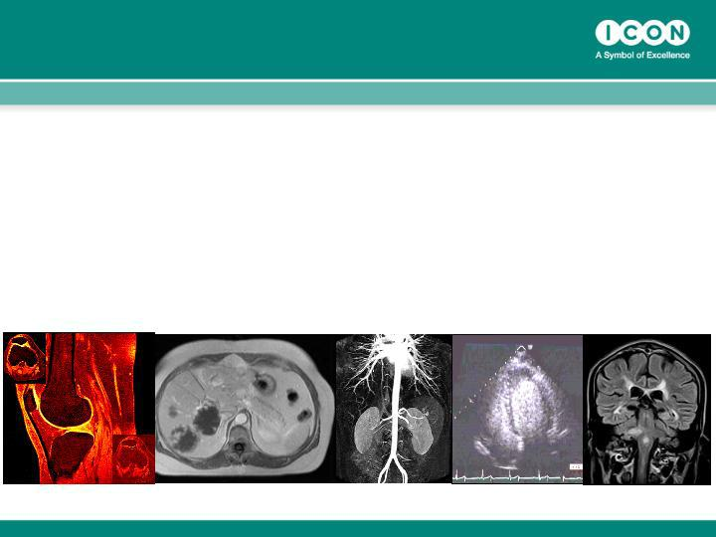
What we do

Beacon provides a Complete Solution for medical imaging based product development.

A Complete Solution

• | Design | Clinical Trial Design focused
 |  | on imaging. Regulatory
 |  | ________________________________________________________________
• | Implement | the imaging at hospitals
 |  | _________________________________________________________________
• | Manage | all digital images centrally from
 |  | radiology department
 |  | _________________________________________________________________
• | Analyze | Provide centralized analysis of images
 |  | quantitative, qualitative
 |  | _________________________________________________________________
• | Deliver | Develops comprehensive digital
 |  | databases for Sponsor and Agency

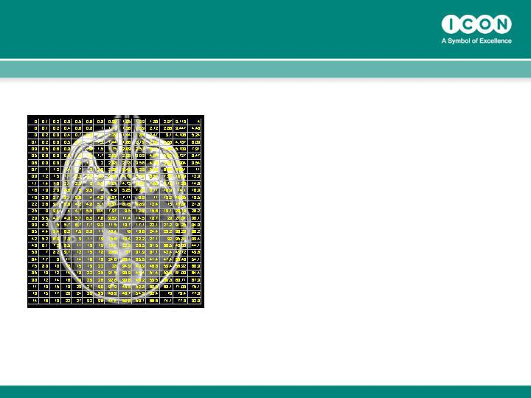
We think differently

- Imaging sees/measures structure and function

- Each pixel represents a physiologic/metabolic characteristic.

- Images are spatially

distributed data

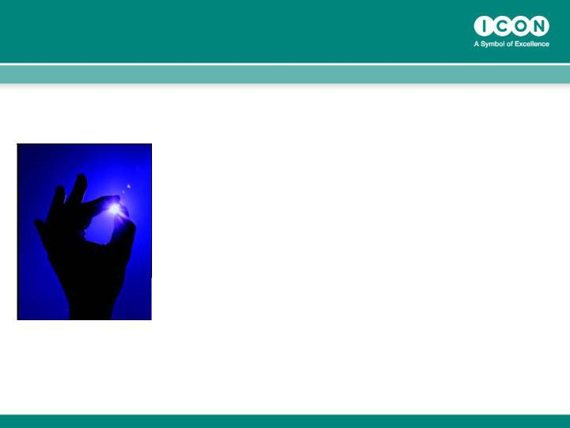
Information is a Verb

“Information: verb

active information derived from passive
data using a new level of information analysis.”

-Michael Dertouzous, M.I.T. 1998

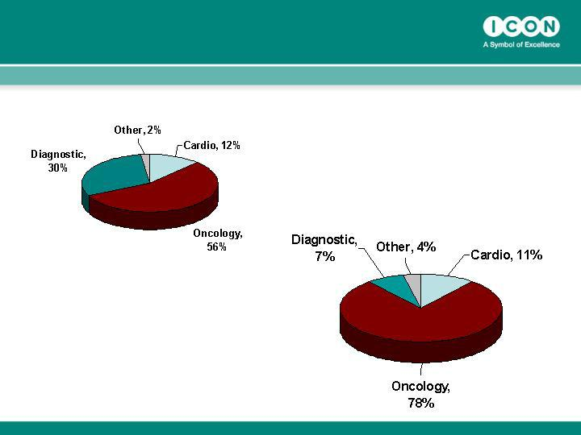
Therapeutic Growth (%Revenues)

2005

2006

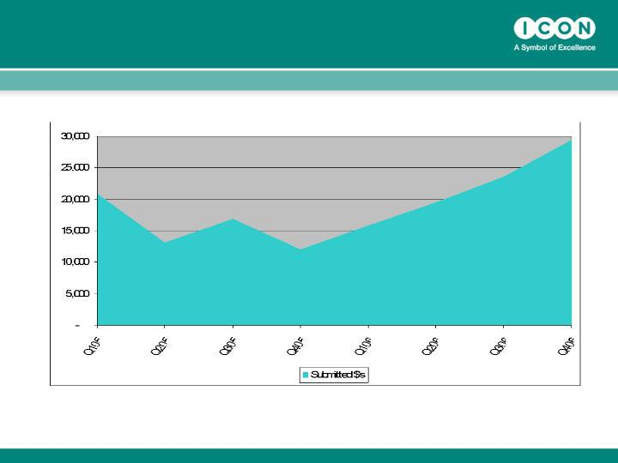
Global RFP Value ($ Million)

Medical Imaging – 2005 and 2006

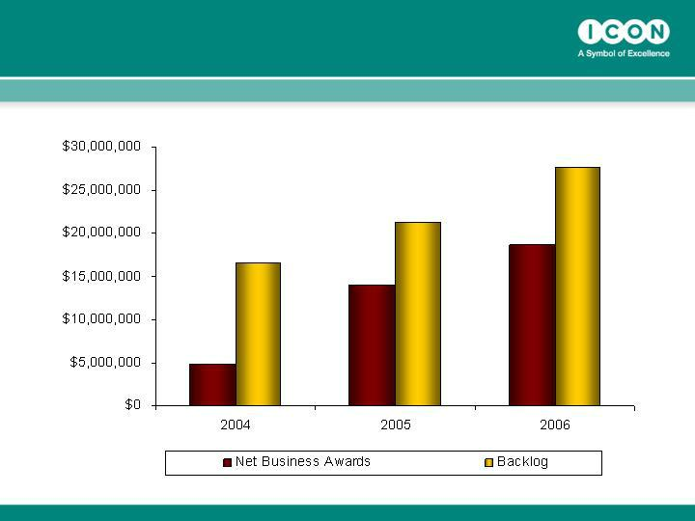
New Awards and Backlog

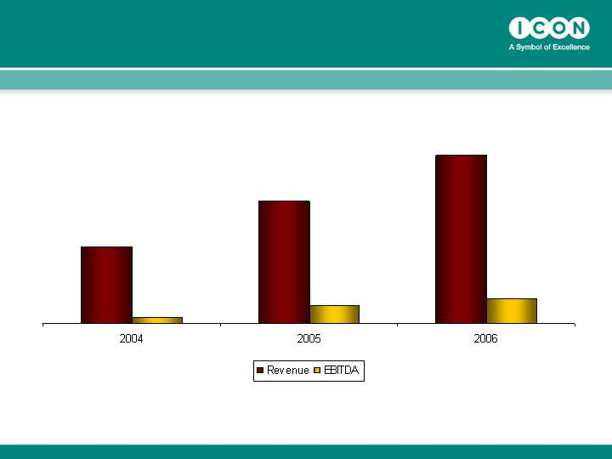
Revenue and Margin

Re-branding Beacon Bioscience to

ICON Medical Imaging

- Beacon Bioscience will be re-branded to become ICON Medical Imaging
- This reflects our further integration and our status as a core division of ICON

- We are launching a year long campaign including mailers, meetings, and trade shows
- Excellent opportunity to re-tell our growth story, emphasize our size and differentiate the value proposal

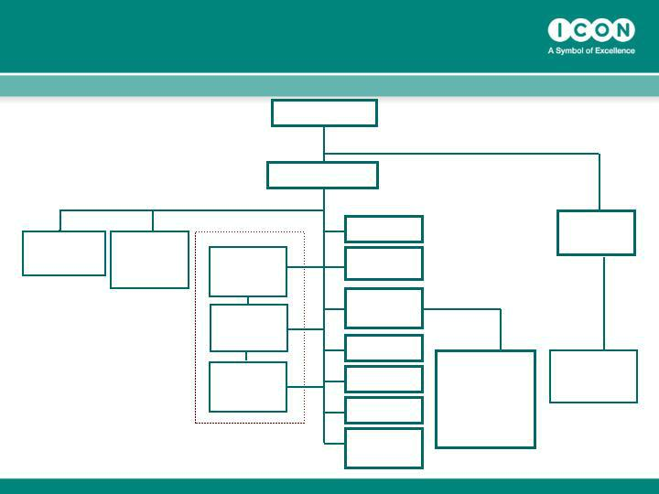
ICON plc Global Organization

Chairman

Dr. John Climax

ICON Central ICON
Laboratories Development
President ^{Solutions}
^{Bob} President

Scott-Edwards

Dr Thomas Frey

CEO

Peter Gray

ICON Clinical Research

ICON Clinical
US

President

Dr John

Hubbard

ICON Clinical
EU
President

Dr Peter

Sowood

ICON Clinical

ROW President

Dr Dan Weng

CFO

Ciaran Murray

VP Process
Development

Alan Morgan

Exec. VP
Organisational
Development

Sean Leech

VP Corporate
QA
Jo Coyle

VP Global IT

Mike McGrath

VP Strategic HR

Eimear Kenny

Group Director
Market
Development

Simon Holmes

ICON
Contracting

Solutions

Tony

Southers

Snr VP

ICON Corporate

Dev

President

Bill Taaffe

Beacon
Bioscience

CEO

Ted Gastineau

BPA / MCS Acquisition October 2002

- Two business segments BPA and MCS

- BPA

  - Clinical Division with good Transplant, Oncology and Vaccine experience
  - BPA integrated into the US clinical division

- MCS –

  - Focused on contract staffing

  - New service for ICON

  - Stand alone status

BPA – Post Acquisition

- BPA was integrated into ICON and many of the personnel are still with ICON 4 years on

- Added to the overall value of ICON

  - Critical mass when required and

  - Therapeutic expertise and experience

Success !!!!!!

June 2005

- Tony Southers (Ex VP of BD-Europe) appointed Head of MCS

  - Introduced a Sales Team and a Client ‘Service’ focus

  - Improved / Updated processes & technology

  - Upgraded candidate package

  - Developed growth strategy

  - Re-aligned the group into ICON and improved operational leverage

  - Change of name

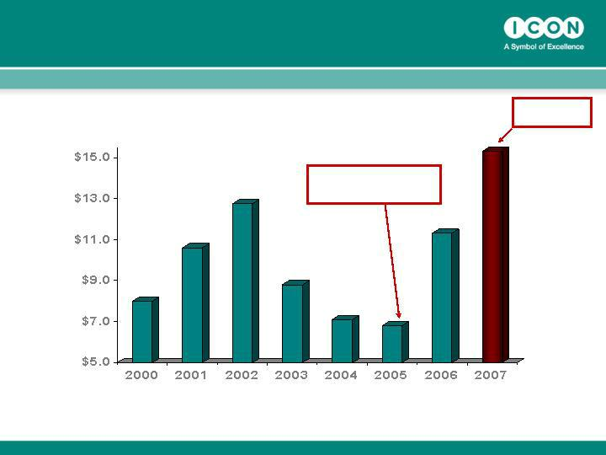
ICS Revenue History

Plan

MCS Re-
launch

ICS Future Growth Opportunities

- Growth within the US will continue

  - 35% growth next year (current NY location)

  - Expand permanent placement capabilities

  - West Coast market exploration (build or buy)

- Other opportunities within new markets

  - Europe (build or buy)

  - Advantage of offering global coverage

  - Same clients within US and EU

- Further opportunities beyond EU would include the new emerging markets
  - South America & Asia

ICON PLC

Q&A Session

