UNITED STATES

SECURITIES AND EXCHANGE COMMISSION

WASHINGTON, D.C.20549

____________

FORM 20-F

(Mark One)

___ Registration statement pursuant to Section 12(b) or (g) of the Securities Exchange Act of 1934

OR

_X_ Annual report pursuant to Section 13 or 15 (d) of the Securities Exchange Act of 1934

For the fiscal year ended: December 31, 2013

OR

___ Transition report pursuant to Section 13 or 15(d) of the Securities Exchange Act of 1934

OR

___ Shell company report pursuant to section 13 or 15(d) of the Securties Exchange Act of 1934.

______ ____

Commission File Number: 000-29714

ICON PUBLIC LIMITED COMPANY

(Exact name of Registrant as Specified in its Charter)

ICON PUBLIC LIMITED COMPANY
(Translation of Registrant’s name into English)

Ireland
(Jurisdiction of Incorporation or Organization)

SOUTH COUNTY BUSINESS PARK,

LEOPARDSTOWN,

DUBLIN 18, IRELAND

_______________________________________

(Address of principal executive offices)

Brendan Brennan, CFO

South County Business Park Leopardstown, Dublin 18, Ireland.

Brendan.Brennan@iconplc.com

011-353-1-291-2000

___________________________________

(Name, telephone number, email and/or facsimile number and address of Company contact person)

Securities registered or to be registered pursuant to Section 12(b) of the Act:

Title of each class

ORDINARY SHARES, PAR VALUE €0.06 EACH

Name of exchange on which registered

NASDAQ GLOBAL SELECT MARKET

Securities registered or to be registered pursuant to section 12(g) of the Act:

Title of each class

NONE

Securities for which there is a reporting obligation pursuant to Section 15(d) of the Act:

NONE

(Title of class)

Indicate the number of outstanding shares of each of the issuer’s classes of capital or common stock as of the close of the period covered by the annual report: 61,587,257 Ordinary Shares. Indicate by check mark if the registrant is a well-known seasoned issuer, as determined in Rule 405 of the Securities Act. Yes X No__
If this report is an annual or transition report, indicate by check mark if the registrant is not required to file reports pursuant to section 13 or 15(d) of the Securities Exchange Act of 1934. Yes __ No X

Indicate by check mark whether the registrant (1) has filed all reports required to be filed by Section 13 or 15(d) of the Securities Exchange Act 1934 during the preceding 12 months (or for such shorter period that the registrant was required to file such reports), and (2) has been subject to such filing requirements for the past 90 days: Yes X No__
Indicate by check mark whether the registrant has submitted electronically and posted on its corporate Web site, if any, every Interactive Data File required to be submitted and posted pursuant to Rule 405 of

Regulation S-T during the preceding 12 months: Yes X No__
Indicate by check mark whether the registrant is a large accelerated filer, an accelerated filer, or a non- accelerated filer.
Large accelerated filer X |  |  |  |  |  | Accelerated filer __ | Non-accelerated filer __
Indicate by check mark which basis of accounting the registrant has used to prepare the financial statements included in this filing:
U.S. GAAP X |  |  |  | International Financial Reporting Standards as issued __ |  |  | Other __
 |  |  |  | by the International Accounting Standards Board
If “Other” has been checked in response to the previous question, indicate by check mark which financial statement item the registrant has elected to follow. Item 17 __ Item 18__ If this is an annual report, indicate by check mark whether the registrant is a shell company (as defined in Rule 12b-2 of the Exchange Act) Yes __ No X

 |  |  |  |  |  |  |  |  |  |  |  |  |  |  |  |  |  |  |  |  |  |  |  | TABLE OF CONTENTS
 |  |  |  |  |  |  |  |  |  |  |  |  |  |  |  |  |  |  |  |  |  |  |  |  | Page
General |  |  |  |  |  |  |  |  |  |  |  |  |  |  |  |  |  |  |  |  |  |  |  |  |  |  | 1
Cautionary Statement |  |  |  |  |  |  |  |  |  |  |  |  |  |  |  |  |  |  |  |  |  |  |  |  |  |  | 1
 |  |  |  |  |  |  |  |  |  |  |  |  |  |  |  |  |  |  |  |  |  |  |  | PART I
Item 1. Identity of Directors, Senior Management and Advisors |  |  |  |  |  |  |  |  |  |  |  |  |  |  |  |  |  |  |  |  |  |  |  |  |  |  | 2
Item 2. Offer Statistics and Expected Timetable |  |  |  |  |  |  |  |  |  |  |  |  |  |  |  |  |  |  |  |  |  |  |  |  |  |  | 2
Item 3. Key Information |  |  |  |  |  |  |  |  |  |  |  |  |  |  |  |  |  |  |  |  |  |  |  | 2
Item 4. Information on the Company |  |  |  |  |  |  |  |  |  |  |  |  |  |  |  |  |  |  |  |  |  |  |  | 12
Item 4A. Unresolved Staff Comments |  |  |  |  |  |  |  |  |  |  |  |  |  |  |  |  |  |  |  |  |  |  |  | 26
Item 5. Operating and Financial Review and Prospects |  |  |  |  |  |  |  |  |  |  |  |  |  |  |  |  |  |  |  |  |  |  |  | 27
Item 6. Directors, Senior Management and Employees |  |  |  |  |  |  |  |  |  |  |  |  |  |  |  |  |  |  |  |  |  |  |  | 37
Item 7. Major Shareholders and Related Party Transactions |  |  |  |  |  |  |  |  |  |  |  |  |  |  |  |  |  |  |  |  |  |  |  | 51
Item 8. Financial Information |  |  |  |  |  |  |  |  |  |  |  |  |  |  |  |  |  |  |  |  |  |  |  | 52
Item 9. The Offer and Listing |  |  |  |  |  |  |  |  |  |  |  |  |  |  |  |  |  |  |  |  |  |  |  | 52
Item 10. Additional Information |  |  |  |  |  |  |  |  |  |  |  |  |  |  |  |  |  |  |  |  |  |  |  | 53
Item 11. Quantitative and Qualitative Disclosures about Market Risk |  |  |  |  |  |  |  |  |  |  |  |  |  |  |  |  |  |  |  |  |  |  |  | 61
Item 12. Description of Securities Other than Equity Securities |  |  |  |  |  |  |  |  |  |  |  |  |  |  |  |  |  |  |  |  |  |  |  | 62
 |  |  |  |  |  |  |  |  |  |  |  |  |  |  |  |  |  |  |  |  |  |  |  | PART II
Item 13. Defaults, Dividend Arrearages and Delinquencies |  |  |  |  |  |  |  |  |  |  |  |  |  |  |  |  |  |  |  |  |  |  |  | 62
Item 14. Material Modifications to the Rights of Security Holders and Use of Proceeds |  |  |  |  |  |  |  |  |  |  |  |  |  |  |  |  |  |  |  |  |  |  |  | 62
Item 15. Controls and Procedures |  |  |  |  |  |  |  |  |  |  |  |  |  |  |  |  |  |  |  |  |  |  |  | 63
Item 16. Reserved |  |  |  |  |  |  |  |  |  |  |  |  |  |  |  |  |  |  |  |  |  |  |  | 63
Item 16A. Audit Committee Financial Expert |  |  |  |  |  |  |  |  |  |  |  |  |  |  |  |  |  |  |  |  |  |  |  | 63
Item 16B. Code of Ethics |  |  |  |  |  |  |  |  |  |  |  |  |  |  |  |  |  |  |  |  |  |  |  | 63
Item 16C. Principal Accountant Fees and Services |  |  |  |  |  |  |  |  |  |  |  |  |  |  |  |  |  |  |  |  |  |  |  | 63
Item 16D. Exemptions from the Listing Standards for Audit Committees |  |  |  |  |  |  |  |  |  |  |  |  |  |  |  |  |  |  |  |  |  |  |  | 64
Item 16E. Purchases of Equity Securities by the Issuer and Affiliated Purchasers |  |  |  |  |  |  |  |  |  |  |  |  |  |  |  |  |  |  |  |  |  |  |  | 64
Item 16F. Changes in Registrant’s Certifying Accountant |  |  |  |  |  |  |  |  |  |  |  |  |  |  |  |  |  |  |  |  |  |  |  | 64
Item 16G. Corporate Governance |  |  |  |  |  |  |  |  |  |  |  |  |  |  |  |  |  |  |  |  |  |  |  | 64
Item 16H. Mine Safety Disclosure |  |  |  |  |  |  |  |  |  |  |  |  |  |  |  |  |  |  |  |  |  |  |  | 65
 |  |  |  |  |  |  |  |  |  |  |  |  |  |  |  |  |  |  |  |  |  |  |  | PART III
Item 17. Financial Statements |  |  |  |  |  |  |  |  |  |  |  |  |  |  |  |  |  |  |  |  |  |  |  | 65
Item 18. Financial Statements |  |  |  |  |  |  |  |  |  |  |  |  |  |  |  |  |  |  |  |  |  |  |  | 65
Item 19. Exhibits |  |  |  |  |  |  |  |  |  |  |  |  |  |  |  |  |  |  |  |  |  |  |  | 65

General

As used herein, “ICON plc”, “ICON”, the “Company” and “we” or “us” refer to ICON public limited company and its consolidated subsidiaries, unless the context requires otherwise.

Unless otherwise indicated, ICON plc’s financial statements and other financial data contained in this Form 20-F are presented in United States dollars (“$”) and are prepared in accordance with generally accepted accounting principles in the United States (“U.S. GAAP”).

In this Form 20-F, references to "U.S. dollars", "U.S.$" or "$" are to the lawful currency of the United States, references to "pounds sterling", "sterling", "£", "pence" or "p" are to the lawful currency of the United Kingdom, references to “Euro” or “€” are to the European single currency adopted by seventeen members of the European Union (including the Republic of Ireland, France, Germany, Spain, Italy, Finland, Belgium and the Netherlands). ICON publishes its consolidated financial statements in U.S. dollars.

Cautionary Statement Regarding Forward-looking Statements

Statements included herein which are not historical facts are forward-looking statements. Such forward-looking statements are made pursuant to the safe harbor provisions of the U.S. Private Securities Litigation Reform Act of 1995 (the “PSLRA”). Forward-looking statements may be identified by the use of future tense or other forward looking words such as “believe”, “expect”, “anticipate”, “should”, “may”, “strategy”, or other variations or comparable terminology. The forward looking statements involve a number of risks and uncertainties and are subject to change at any time. In the event such risks or uncertainties materialize, our results could be materially affected. The risks and uncertainties include, but are not limited to, dependence on the pharmaceutical industry and certain clients, the need to regularly win projects and then to execute them efficiently and correctly, the challenges presented by rapid growth, competition and the continuing consolidation of the industry, the dependence on certain key executives, changes in the regulatory envoirnment and other factors identified in the Company’s Securities and Exchange Commission filings and in the “Risk Factors” included on pages 4 to 11. The Company has no obligation under the PSLRA to update any forward looking statements and does not intend to do so.

1

Part I

Item 1. Identity of Directors, Senior Management and Advisors.

Not applicable.

Item 2. Offer Statistics and Expected Timetable.

Not applicable.

Item 3. Key Information.

Selected Historical Consolidated Financial Data for ICON plc

The following selected financial data set forth below are derived from the Company’s consolidated financial statements and should be read in conjunction with, and are qualified by reference to, Item 5 “Operating and Financial Review and Prospects” and the Company’s consolidated financial statements and related notes thereto included elsewhere in this Form 20-F.

 |  |  |  |  | Year Ended December 31,
 |  |  | 2013 |  | 2012 |  | 2011 |  | 2010 |  | 2009
 |  |  |  |  | (in thousands, except share and per share data)
Statement of Operations Data:
 | Gross revenue | $ | 1,784,345 | $ | 1,503,993 | $ | 1,296,509 | $ | 1,263,147 | $ | 1,258,227
 | Reimbursable expenses (1) |  | (448,287) |  | (388,987) |  | (350,780) |  | (363,103) |  | (370,615)
 | Net revenue |  | 1,336,058 |  | 1,115,006 |  | 945,729 |  | 900,044 |  | 887,612
 | Costs and expenses:
 | Direct costs |  | 845,413 |  | 717,750 |  | 611,923 |  | 541,388 |  | 507,783
 | Selling, general and administrative |  | 313,931 |  | 280,780 |  | 255,864 |  | 232,688 |  | 230,910
 | Depreciation and amortization |  | 46,514 |  | 42,823 |  | 38,682 |  | 33,873 |  | 32,659
 | Restructuring and other items (2),(3),(4),(5) |  | 9,033 |  | 5,636 |  | 9,817 |  | - |  | 8,808
 | Total costs and expenses |  | 1,214,891 |  | 1,046,989 |  | 916,286 |  | 807,949 |  | 780,160
 | Income from operations |  | 121,167 |  | 68,017 |  | 29,443 |  | 92,095 |  | 107,452
 | Net interest (expense) / income |  | (302) |  | (796) |  | (448) |  | 629 |  | (2,778)
 | Income before provision for income taxes |  | 120,865 |  | 67,221 |  | 28,995 |  | 92,724 |  | 104,674
 | Provision for income taxes |  | (18,053) |  | (11,801) |  | (6,115) |  | (5,653) |  | (10,375)
 | Net income | $ | 102,812 | $ | 55,420 | $ | 22,880 | $ | 87,071 | $ | 94,299
 | Net income per ordinary share (6):
 | Basic | $ | 1.69 | $ | 0.92 | $ | 0.38 | $ | 1.46 | $ | 1.61
 | Diluted | $ | 1.65 | $ | 0.92 | $ | 0.37 | $ | 1.44 | $ | 1.57
Weighted average number of ordinary shares outstanding:

Basic | 60,907,274 | 59,968,174 | 60,379,338 | 59,718,934 | 58,636,878
Diluted | 62,253,251 | 60,450,706 | 61,070,686 | 60,637,103 | 59,900,504
 | 2

 |  |  |  |  |  | Year Ended December 31,
 |  |  | 2013 |  | 2012 |  | 2011 |  | 2010 |  | 2009
 |  |  |  |  |  |  | (in thousands)
 | Balance Sheet Data:
 | Cash and cash equivalents | $ | 182,519 | $ | 114,047 | $ | 119,237 | $ | 255,706 | $ | 144,801
 | Short term investments |  | 138,317 |  | 76,183 |  | 54,940 |  | - |  | 49,227
 | Working capital |  | 352,259 |  | 250,326 |  | 253,514 |  | 330,333 |  | 235,906
 | Total assets |  | 1,442,460 |  | 1,202,108 |  | 1,027,517 |  | 949,538 |  | 908,398
 | Long term government grants |  | 1,359 |  | 1,427 |  | 1,351 |  | 1,470 |  | 1,750
 | Long term liabilities |  | 11,198 |  | 14,312 |  | 20,038 |  | 4,659 |  | 2,844
 | Ordinary share capital |  | 5,168 |  | 5,067 |  | 5,055 |  | 5,063 |  | 4,965
 | Additional paid-in capital |  | 279,572 |  | 237,217 |  | 211,549 |  | 196,960 |  | 174,188
 | Shareholders’ equity | $ | 910,579 | $ | 754,575 | $ | 681,544 | $ | 669,999 | $ | 572,246

- Reimbursable expenses are comprised of payments to investigators and certain other costs reimbursed by clients under terms specific to each of the Company’s contracts. See Note 2 (d) to the Audited Consolidated Financial Statements.

- During 2013 the Company conducted a review of its operations. This review resulted in the adoption of an initial restructuring plan, which included the closure of its Phase I facility in Omaha, Nebraska. This followed the expansion of the Company’s Phase I facility in San Antonio, Texas and the consolidation of the Company’s US Phase I capabilities in this location. The restructuring plan also included resource rationalizations in certain areas of the business to improve resource utilization. A further restructuring plan was also adopted during 2013 which resulted in resource rationalizations in order to improve operating efficiencies and reduce expenses. See Note 14 to the Audited Consolidated Financial Statements.

- Restructuring and other items of $5.6 million were recorded during the year ended December 31, 2012 (inclusive of the release of $0.1 million relating to the 2011 Restructuring Plans). During the year ended December 31, 2012 the Company completed a review of its operations to improve resource utilization throughout the business. This review resulted in the adoption of a restructuring plan, to include resource rationalizations in certain areas of the business and a re-organization of available office space at the Company’s Philadelphia facility. A restructuring charge of $4.6 million was recognized during the year ended December 31, 2012; $3.4 million in respect of resource rationalizations and $1.2 million in respect of lease termination and exit costs. The Company also incurred certain other charges of $1.1 million in relation to the retirement of Mr. Peter Gray, former Vice Chairman of the Board and former CEO of the Company in 2012. See Note 14 to the Audited Consolidated Financial Statements.

- Restructuring charges of $9.8 million were recorded during the year ended December 31, 2011. During 2011 the Company conducted a review of its operations to improve resource utilization within the business and better align resources to current and future growth opportunities. This review resulted in the adoption of an initial restructuring plan, which included the closure of the Company’s facility in Edinburgh, United Kingdom and resource rationalizations in certain of the more mature markets in which it operates. A further restructuring plan was also adopted during 2011 which resulted in the relocation of the Company’s facility in Maryland, USA and further resource rationalizations. See Note 14 to the Audited Consolidated Financial Statements.

- Restructuring charges of $8.8 million were recorded during the year ended December 31, 2009. During 2009 the Company conducted a review of its infrastructure to better align its resources with the needs of its clients. This realignment resulted in resource rationalizations in certain more mature markets in which the Company operates and the recognition of a restructuring charge of $13.3 million. This was partially offset by research and development incentives of $4.5 million received by the Company in certain European Union jurisdictions in which it operates.

- Net income per ordinary share is based on the weighted average number of outstanding ordinary shares. Diluted net income per share includes potential ordinary shares from the exercise of options.

3

Risk Factors

Various risk factors that are relevant to our business and the services we provide are outlined below. If any of these events were to occur, our business operations and financial results could be materially adversely affected.

Risk Related to Our Business and Operations

We depend on a limited number of customers and a loss of or significant decrease in business from one or more of them could affect our business.

The increased use of strategic partnership arrangements in recent years has resulted in a greater proportion of our net revenues being derived from a relatively limited number of customers. During the year ended December 31, 2013 53% of our net revenues were derived from our top five customers, with two customers individually contributing more than 10% of our net revenues during the period (26% and 10% respectively). No other customer contributed more than 10% of our net revenues during this period. During the year ended December 31, 2012 48% of our net revenues were derived from our top five customers, with two customers individually contributing more than 10% of our net revenues during the period (18% and 12% respectively). No other customer contributed more than 10% of our net revenues during this period. During the year ended December 31, 2011 37% of our net revenues were derived from our top five customers, with 13% of our net revenues derived from one customer. No other customer contributed more than 10% of net revenues during this period. The loss of, or a significant decrease in business from one or more of these key customers could have a material adverse impact on our results of operations.

Many of our contracts are long-term fixed-fee contracts. We would lose money in performing these contracts if the costs of performance exceed the fixed fees for these projects and we were unable to negotiate a change order for the value of work performed.

Many of our contracts are long-term fixed fee contracts. Revenues on these contracts are agreed in the contract between the Company and the customer and are based on estimated time inputs to the contract. Factors considered in estimating time requirements include the complexity of the study, the number of geographical sites where trials are to be conducted and the number of patients to be recruited at each site. The Company regularly reviews the estimated hours on each contract to determine if the budget accurately reflects the agreed tasks to be performed taking into account the state of progress at the time of review. The Company further endeavours to ensure that changes in scope are appropriately monitored and change orders for additional revenue are promptly negotiated for additional work as necessary. If we were to fail to recognize and negotiate change orders for changes in the resources required or the scope of the work to be performed the Company could lose money if the costs of performance of these contracts exceeded their fixed fees.

If our customers discontinue using our services, or cancel or discontinue projects, our revenue will be adversely affected and/or we may not receive their business in the future or may not be able to attract new clients.

Our clients may discontinue using our services completely or cancel some projects either without notice or upon short notice. The termination or delay of a large contract or of multiple contracts could have a material adverse effect on our revenue and profitability. Historically, clients have cancelled or discontinued projects and may in the future cancel their contracts with us for reasons including:

- the failure of products being tested to satisfy safety or efficacy requirements;

- unexpected or undesired clinical results of the product;

- a decision that a particular study is no longer necessary or viable;

- poor project performance, quality concerns, insufficient patient enrollment or investigator recruitment; or

- production problems resulting in shortages of the drug.

If we lose clients, we may not be able to attract new ones, and if we lose individual projects, we may not be able to replace them.

4

If we fail to attract or retain qualified staff, our performance may suffer.

Our business, future success and ability to continue to expand operations depends upon our ability to attract, hire, train and retain qualified professional, scientific and technical operating staff. We compete for qualified professionals with other Clinical Research Organisations “CROs”, temporary staffing agencies and the in-house departments of pharmaceutical, biotechnology and medical device companies. An inability to attract and retain a sufficient number of high calibre clinical research professionals (in particular, key personnel and executives) at an acceptable cost would impact our ability to provide our services, our future performace and results of operations.

Our ability to perform clinical trials is dependent upon the ability to recruit suitable willing patients.

The successful completion of clinical trials is dependent upon the ability to recruit suitable and willing patients on which to test the drug under study. The availability of suitable patients for enrollment on studies is dependent upon many factors including, amongst others, the size of the patient population, the design of the study protocol, eligibility criteria, the referral practices of physicians, the perceived risks and benefits of the drug under study and the availability of alternative medication, including medication undergoing separate clinical trial. Insufficient or inappropriate patient enrollment may result in the termination or delay of a study which could have a material adverse impact on our results of operations.

Our ability to perform clinical trials is dependent upon our ability to recruit suitable willing investigators.

We contract with physicians located in hospitals, clinics or other such sites, who serve as investigators in conducting clinical trials to test new drugs on their patients. Investigators supervise administration of the study drug to patients during the course of the clinical trial. The successful conduct of a clinical trial is dependent upon the integrity, experience and capabilities of the investigators conducting the trial. Insufficient investigator recruitment, which in turn may lead to insufficient or inappropriate patient enrolment, may result in the termination or delay of a study which could have a material adverse impact on our results of operations.

We rely on third parties for important products and services.

We depend on certain third parties to provide us with products and services critical to our business. Such services include, amongst others, suppliers of drugs for patients participating in trials, suppliers of kits for use in in our central laboratory business, suppliers of reagents for use in our testing equipment and providers of maintenance services for our equipment. The failure of any of these third parties to adequately provide the required products or services could have a material adverse effect on our business.

We are highly dependent on information technology. If we fail to keep our systems up to date, or our systems fail or are unreliable, our operations may be adversely impacted.

The efficient operation of our business depends on our information technology infrastructure and our management information systems. Our information technology infrastructure includes both third party solutions and applications designed and maintained internally. Since our Company operates on multiple platforms, the failure of our information technology infrastructure and/or our management information systems to perform could severely disrupt our business and adversely affect our results of operation. In addition, our information technology infrastructure and/or our management information systems are vulnerable to damage or interruption from, amongst others, natural or man-made disasters, terrorist attacks, computer viruses or hackers, power loss, other computer systems, internet telecommunications or data network failures. Any such interruption could adversely affect our business and results of operations.

A significant portion of our operations rely on the secure processing, storage and transmission of confidential information, including client and personal confidential information. For example, through our Phase I business, we obtain and store personal health-related information of participating subjects. Our activities are subject to a risk of cyber security issues and/or attacks which could result in the disclosure or loss of confidential client or customer information, damage to our reputation, additional costs, regulatory penalties and financial losses. Despite our security measures, our computer systems, software and networks, or those of our suppliers, customers and so on, are vulnerable to unauthorized access, loss or destruction of data (including confidential client information and personal health data), hardware malfunctions, unavailability of service, computer viruses or other malicious code, cyber attacks and other events. These threats may derive from human error, fraud or malice on the part of employees or third parties, or may result from accidental technological failure.

5

If we do not keep pace with rapid technological changes in the CRO industry, our products and services may become less competitive or even obsolete. This applies in particular to our ICONIK and Firecrest services. Also, changes to our operating systems, software or programs could adversely impact our business.

We rely on our interactive response technologies to provide accurate information regarding the randomization of patients and the dosage required for patients enrolled in the trials.

We develop and maintain computer run interactive response technologies to automatically manage the randomization of patients in trials, assign the study drug, and adjust the dosage when required for patients enrolled in trials we support. An error in the design, programming or validation of these systems could lead to inappropriate assignment or dosing of patients which could give rise to patient safety issues, incorrect dosing of patients, invalidation of the trial and/or liability claims against the Company among other things.

Our operations might be impacted by a disruption to travel systems.

Many of our operations rely on the availability of air or other transportation for the distribution of clinical trial materials, study samples and personnel. While we have developed contingency plans to minimize the impact of such events, a disruption to the availability of air transportation or other travel systems could have a material adverse impact on our activities and results of operations.

We may make, or be unable to make, acquisitions in the future, which may lead to disruptions to our ongoing business.

We have made a number of acquisitions and will continue to review new acquisition opportunities. If we are unable to identify suitable acquisition targets, consummate an acquisition or successfully integrate an acquired company or business, our business may be disrupted. The success of an acquisition will depend upon, among other things, our ability to:

- assimilate the operations and services or products of the acquired company or business;

- integrate acquired personnel;

- retain and motivate key employees;

- retain customers; and

- minimize the diversion of management's attention from other business concerns.

In the event that the operations of an acquired company or business do not meet our performance expectations, we may have to restructure the acquired company or business or write-off the value of some or all of the assets of the acquired company or business.

Serious adverse events can occur in Phase I trials.

We conduct Early Phase and Proof of Principle clinical trials including first-in human and healthy volunteer studies. Although we have policies and procedures in place, due to the experimental nature of these studies, serious adverse events may arise.

Risk Related to Our Industry

We are dependent on the continued outsourcing of research and development by the pharmaceutical, biotechnology and medical device industries.

We are dependent upon the ability and willingness of the pharmaceutical, biotechnology and medical device companies to continue to spend on research and development and to outsource the services that we provide. We are therefore subject to risks, uncertainties and trends that affect companies in these industries and that we do not control. We have benefited to date from the tendency of pharmaceutical, biotechnology and medical device companies to outsource clinical research projects. Any downturn in these industries or reduction in spending or outsourcing could adversely affect our business. The following could each result in such a downturn:

6

- if pharmaceutical, biotechnology or medical device companies expanded upon their in-house clinical or development capabilities, they would be less likely to utilize our services

- if governmental regulations were changed, it could affect the ability of our clients to operate profitably, which may lead to a decrease in research spending and therefore this could have a material adverse effect on our business

- if unfavourable economic conditions or disruptions in the credit and capital markets negatively impacted our clients

Large pharmaceutical companies are increasingly consolidating their vendor base and entering strategic partnership arrangements with a limited number of outsource providers.

Large pharmaceutical companies are continually seeking to drive efficiencies in their development processes to both reduce costs associated with the development of new drug candidates and accelerate time to market. As a result, large pharmaceutical companies in particular are increasingly looking to consolidate the number of outsource providers with which they engage, with many entering strategic partnership arrangements with a limited number of outsource providers. The failure to enter strategic partnership arrangements with customers or the loss of existing customers as a result of them entering strategic partnership arrangements with our competitors could have a material adverse impact on our results of operations.

Increased collaboration amongst pharmaceutical companies in research and development activities may lead to fewer research opportunities.

Certain pharmaceutical companies have begun to collaborate in seeking to develop new drug candidates. Increased collaboration amongst pharmaceutical companies may lead to fewer research opportunities, which in turn may lead to fewer outsource opportunities for companies within the CRO industry. A reduction in outsource opportunities as a result of this increased collaboration could have a material adverse impact on our results of operations.

We operate in a highly competitive and dynamic market.

The CRO industry is highly competitive. In particular, we compete with other large global CROs for strategic relationships with large pharmaceutical companies. If we are unable to retain and renew existing strategic relationships and win new strategic relationships, there would be a material adverse impact on our results of operations. Similarly, we compete with other CROs for work which comes outside of these strategic relationships.

The type and depth of services provided by CROs have changed in recent years. Failure to develop and market new services or expand existing service offerings could adversely effect our business and operations.

Risk Related to Our Financial Results and Financial Position

Our quarterly results are dependent upon a number of factors and can fluctuate from quarter to quarter.

Our results of operations in any quarter can fluctuate or differ from expected or forecasted results depending upon or due to, among other things, the number and scope of ongoing client projects, the commencement, postponement, variation cancellation or termination of projects in a quarter, the mix of revenue, cost overruns, employee hiring and other factors. Our net revenue in any period is directly related to the number and percentage of employees who were working on projects billable to the client during that period. We may be unable to compensate for periods of underutilization during one part of a fiscal period by augmenting revenues during another part of that period. We believe that operating results for any particular quarter are not necessarily a meaningful indication of future results.

Also, if in future quarters, we are unable to achieve efficiencies and our expenses grow faster than our net revenues, our operating margins and profitability will be adversely impacted.

7

Our exposure to exchange rate fluctuations could adversely affect our results of operations.

Our contracts with clients are sometimes denominated in currencies other than the currency in which we incur expenses related to such contracts. Where expenses are incurred in currencies other than those in which contracts are priced, fluctuations in the relative value of those currencies could have a material adverse effect on our results of operations.

In addition, we are also subject to translation exposures as our consolidated financial results are presented in U.S. dollars, while the local results of certain of our subsidiaries are prepared in currencies other than U.S. dollars, including, amongst others, the pound sterling and the euro. Accordingly, changes in exchange rates between the U.S. dollar and those other currencies will affect the translation of a subsidiary’s financial results into U.S. dollars for purposes of reporting our consolidated financial results.

Our effective tax rate may fluctuate from quarter-to-quarter, which may affect our results of operations.

Our quarterly effective tax rate has depended and will continue to depend on the geographic distribution of our taxable earnings amongst the multiple tax jurisdictions in which we operate and the tax law in those jurisdictions. Changes in the geographic mix of our results of operations amongst these jurisdictions may have a significant impact on our effective tax rate from quarter to quarter. Changes in tax law in one or more jurisdictions could also have a significant impact on our tax rate and results of operations. In addition, as we operate in multiple tax jurisdictions, we may be subject to audits in certain jurisdictions. These audits may involve complex issues which could require an extended period of time for resolution. The resolution of audit issues may lead to differences which could have a significant impact on our effective tax rate.

Our backlog may not convert to net revenue and the rate of conversion may slow.

Our backlog consists of potential net revenue yet to be earned from projects awarded by clients. Our backlog at any date is not necessarily a meaningful predictor of future results, due to the potential for the cancellation or delay of projects included in the backlog. No assurances can be given that we will be able to realize this backlog as net revenue. A failure to realize backlog as net revenue could have a material adverse impact on our results of operations. In addition, as the length and complexity of projects underlying our backlog increases, the rate at which backlog converts to net revenue may be slower than in the past. A significant reduction in the rate at which backlog converts to net revenue could have a material impact on our results of operations.

Significant changes from our estimates of contingent consideration payable on acquisitions could have a serious adverse impact on our results of operations.

We have made a number of acquisitions in the past and will continue to review new acquisition opportunities. The cost of many of these acquisitions includes a portion which is contingent upon certain future events, such as the achievement of a particular revenue or earnings target. Where an acquisition agreement provides for such additional consideration, the amount of the estimated additional consideration is recognized at the acquisition date fair value. Any changes to this estimate in subsequent periods will depend on the classification of the contingent consideration. If the contingent consideration is classified as equity it shall not be re-measured and the settlement shall be accounted for within equity. If the contingent consideration is classified as an asset or liability any adjustments will be accounted for through the consolidated statement of operations or other comprehensive income depending on whether the asset or liability is considered a financial instrument. Significant estimates and judgements are required in estimating the acquisition date fair value of the additional consideration. Changes in business conditions or the performance of the acquired business could lead to a significant change between our estimate of the acquisition date fair value and amounts payable which could have a significant impact on our results of operations.

The Company is exposed to various risks in relation to our cash and cash equivalents and short term investments.

The Company’s treasury function actively manages our available cash resources and invests significant cash balances in various financial institutions to try to ensure optimum returns for our surplus cash balances. These balances are classified as cash and cash equivalents or short term investments depending on the maturity of the related investment. Cash and cash equivalents comprise cash and highly liquid investments with maturities of three months or less. Short term investments comprise highly liquid investments with maturities of greater than three months and minimum “A-” rated fixed and floating rate securities.

8

Given the global nature of our business, we are exposed to various risks in relation to these balances including liquidity risk, credit risk associated with the counterparties with which we invest, interest rate risk on floating rate securities, sovereign risk (our principal sovereign risk relates to investments in U.S. Treasury funds), and other factors.

Although we have not recognized any significant losses to date on our cash and cash equivalents or short term investments, any significant declines in their market values could have a material adverse affect on our financial position and operating results.

Risk Related to Political, Legal or Regulatory Environment

We may lose business opportunities as a result of health care reform and the expansion of managed care organizations.

Numerous governments, including the U.S. government and governments outside of the U.S., have undertaken efforts to control growing health care costs through legislation, regulation and voluntary agreements with medical care providers and drug companies. If these efforts are successful, pharmaceutical, biotechnology and medical device companies may react by spending less on research and development and therefore this could have a material adverse effect on our business.

In addition to healthcare reform proposals, the expansion of managed care organizations in the healthcare market may result in reduced spending on research and development. Managed care organizations' efforts to cut costs by limiting expenditures on pharmaceuticals and medical devices could result in pharmaceutical, biotechnology and medical device companies spending less on research and development. If this were to occur, we would have fewer business opportunities and our revenues could decrease, possibly materially.

We may lose business as a result of changes in the regulatory environment.

Various regulatory bodies throughout the world may enact legislation, rules and guidance which could introduce changes to the regulatory environment for drug development and research. The adoption and implementation of such legislation, rules and guidance is difficult to predict and therefore could have a material adverse effect on our business.

Failure to comply with the regulations of the U.S. Food and Drug Administration and other regulatory authorities could result in substantial penalties and/or loss of business.

The U.S. Food and Drug Administration, or FDA, and other regulatory authorities inspect us from time to time to ensure that we comply with their regulations and guidelines, including environmental and health and safety matters. We must comply with the applicable regulatory requirements governing the conduct of clinical trials in all countries in which we operate. If we fail to comply with any of these requirements we could suffer some or all of:

- termination of or delay in any research;

- disqualification of data;

- denial of the right to conduct business;

- criminal penalties;

- other enforcement actions;

- loss of clients and/or business; and

- litigation from clients and resulting material penalties, damages and costs.

9

We are subject to political, regulatory, operational and legal risks associated with our international operations.

We are one of a small group of organizations with the capability and expertise to conduct clinical trials on a global basis. We believe that this capability to provide our services globally in most major and developing pharmaceutical markets enhances our ability to compete for new business from large multinational pharmaceutical, biotechnology and medical device companies. We have expanded geographically in the past and intend to continue expanding in regions that have the potential to increase our client base or increase our investigator and patient populations. We expect that revenues earned in emerging markets will continue to account for an increasing portion of our total revenues. However, emerging market operations may present several risks, including civil disturbances, health concerns, cultural differences such as employment, regulatory and business practices, volatility in gross domestic product, economic and governmental instability, the potential for nationalization of private assets and the imposition of exchange controls. In addition, operating globally means the Company faces the challenges associated with coordinating its services across different countries, time zones and cultures.

Changes in the political and regulatory environment in the international markets in which we operate such as price or exchange controls could impact our revenue and profitability, and could lead to penalties, sanctions and reputational damages if we are not compliant with those regulations. Political uncertainty and a lack of institutional continuity in some of the emerging and developing countries in which we operate could affect the orderly operation of markets in these economies. In addition, in countries with a large and complicated structure of government and administration, national, regional, local and other governmental bodies may issue inconsistent decisions and opinions that could increase our cost of regulatory compliance and/or have a material adverse effect on our business.

Uncertainty of the legal environment in some emerging countries could also limit our ability to enforce our rights. In certain emerging and developing countries we enjoy less comprehensive protection for some of our rights, including intellectual property rights, which could undermine our competitive position.

Finally, we operate in some countries where national laws may require not only proper books and records, but also sufficient controls, policies and processes to ensure business is conducted without the influence of bribery and corruption. Given the high level of complexity of some of these laws and the large number of employees and contractors we have in many jurisdictions, there is a risk that some provisions may inadvertently be breached by the Company, for example through negligent behavior of individual employees, or failure to comply with certain formal documentation requirements or otherwise. Any violation of these laws or allegations of such violations, whether merited or not, could have a material adverse effect on our reputation and could cause the trading price of our common stock to decline.

If any of the above risks or similar risks associated with our international operations were to materialize, our results of operations and financial condition could be materially adversely affected.

Data Privacy

Current and proposed laws and regulations relating to the confidentiality of personal data of patients and others could limit the scope of our services, expose us to increased risk and liability and increase the cost of doing business.

Liability claims brought against us could result in payment of substantial damages to plaintiffs and decrease our profitability.

Customer Claims

If we breach the terms of an agreement with a client (for example if we fail to comply with the agreement, all applicable regulations or Good Clinical Practice) this could result in claims against us for substantial damages which could have a material adverse effect on our business. As we are a “people business” in that we provide staff to provide our services in hospitals and other sites, there is a risk that our management, quality and control structures fail to quickly detect should one or more employees or contractors fail to comply with all applicable regulations and Good Clinical Practice and thereby expose us to the risk of claims by clients.

10

Claims relating to Investigators

We contract with physicians who serve as investigators in conducting clinical trials to test new drugs on their patients. This testing creates the risk of liability for personal injury to or death of the patients. Although investigators are generally required by law to maintain their own liability insurance, we could be named in lawsuits and incur expenses arising from any professional malpractice or other actions against the investigators with whom we contract.

Indemnification from Clients

Indemnifications provided by our clients against the risk of liability for personal injury to or death of the patients arising from the study drug vary from client to client and from trial to trial and may not be sufficient in scope or amount or the client may not have the financial ability to fulfill their indemnification obligations. Furthermore, we would be liable for our own negligence and negligence of our employees and such negligence could lead to litigation from clients.

Insurance

We maintain what we believe is an appropriate level of worldwide Professional Liability/Error and Omissions Insurance. We may in the future be unable to maintain or continue our current insurance coverage on the same or similar terms. If we are liable for a claim or settlement that is beyond the level of insurance coverage, we may be responsible for paying all or part of any award or settlement amount. Also, the insurance policies contain exclusions which mean that the policy will not respond or provide cover in certain circumstances.

Claims to Date

To date, we have not been subject to any liability claims that are expected to have a material effect on our business; however, there can be no assurance that we will not become subject to such claims in the future or that such claims will not have a material effect on our business.

Risk Related to Our Common Stock

Volatility in the market price of our common stock could lead to losses by investors.

The market price of our common stock has experienced volatility in the past and may experience volatility in the future which could lead to losses for investors. Factors impacting volatility in the market price of our common stock include, amongst others, our results of operations, analyst expectations, developments impacting the industry or our competitors and general market and economic conditions. In addition, stock markets have from time to time experienced significant price and volume fluctuations unrelated to the operating performance of particular companies. Future fluctuations in stock markets may lead to volatility in the market price of our common stock which could lead to losses by investors.

11

Item 4. Information on the Company.

Business

ICON public limited company (“ICON plc”) is a contract research organization (“CRO”), providing outsourced development services on a global basis to the pharmaceutical, biotechnology and medical device industries. We specialize in the strategic development, management and analysis of programs that support all stages of the clinical development process - from compound selection to Phase I-IV clinical studies. The Company earns revenues by providing a number of different services to its customers. These services, which are integral elements of the clinical development process, include clinical trials management, biometric activities, consulting, imaging, contract staffing, informatics and laboratory services. The Company has the expertise and capability to conduct clinical trials in most major therapeutic areas on a global basis and has the operational flexibility to provide development services on a stand-alone basis or as part of an integrated “full service” solution. The Company has expanded predominately through organic growth, together with a number of strategic acquisitions to enhance its expertise and capabilities in certain areas of the clinical development process. The Company’s mission is to accelerate the development of drugs that save lives and improve the quality of life. Our vision is to be the Global CRO partner of choice in drug development by delivering best in class information, solutions and performance in clinical and outcomes research.

We believe that we are one of a select group of CRO’s with the expertise and capability to conduct clinical trials in most major therapeutic areas on a global basis and have the operational flexibility to provide development services on a stand-alone basis or as part of an integrated “full service” solution. At December 31, 2013, we employed approximately 10,300 employees, in 77 locations in 38 countries. During the year ended December 31, 2013, we derived approximately 43.6%, 45.4% and 11.0% of our net revenue in the United States, Europe and Rest of World, respectively.

We began operations in 1990 and have expanded our business predominately through internal growth, together with a number of strategic acquisitions, to enhance our capabilities and expertise in certain areas of the clinical development process.

On February 15, 2013 the Company acquired the Clinical Trial Services division of Cross Country Healthcare, Inc. Cross Country Healthcare’s Clinical Trial Services division includes US resourcing providers, ClinForce and Assent Consulting, whose services include contract staffing, permanent placement and functional service provision (“FSP”). The division also includes AKOS, a leading US and EU provider of pharmacovigilance and drug safety services. ClinForce and Assent have been combined with ICON’s FSP division, DOCS, creating a leader in global resourcing and FSP, while AKOS has been combined with the services offered by ICON’s medical and safety services team.

On December 17, 2012 the Company’s shareholders voted in favour of terminating the Company’s ADR programme and replacing its ADRs with a direct listing of its shares on NASDAQ. The Company also decided to cancel the Company’s secondary listing on the official list of the Irish Stock Exchange, mainly due to the very low levels of liquidity in the Company’s shares on this exchange. This followed a review by the Company of its share trading arrangements with the objective of ensuring that the arrangements in place are appropriate to the size, scale and locations of the business, are conducive to supporting a liquid market in the Company’s shares, enhance the Company’s profile and attractions for a wide range of international investors, and that the costs and maintenance of the associated trading arrangements are proportionate to the expected benefits. The last day of trading of the Company’s shares on the Irish Stock Exchange was January 29, 2013 with the Company’s delisting from the Irish Stock Exchange being effected as of January 30, 2013. Direct trading of the Company’s shares on NASDAQ commenced on February 4, 2013.

We are incorporated in Ireland and our principal executive office is located at: South County Business Park, Leopardstown, Dublin 18, Republic of Ireland. The contact telephone number of this office is 353 (1) 291 2000.

12

Industry Overview

The CRO industry provides independent product development services for the pharmaceutical, biotechnology and medical device industries. Companies in these industries outsource product development services to CROs in order to manage the drug development process more efficiently and to cost-effectively maximize the profit potential of both patent-protected and generic products. The CRO industry has evolved since the 1970s from a small number of companies that provided limited clinical services to a larger number of CROs that offer a range of services that encompass the entire research and development process, including pre-clinical development, clinical trials management, clinical data management, study design, biostatistical analyses, post marketing surveillance, regulatory affairs services and central laboratory services. CROs are required to provide these services in accordance with good clinical and laboratory practices, as governed by the applicable regulatory authorities.

The CRO industry is highly fragmented, consisting of several hundred small, limited-service providers and a limited number of medium and large CROs with global operations. Although there are few barriers to entry for small, limited-service providers, we believe there are significant barriers to becoming a CRO with global capabilities and expertise. Some of these barriers include the infrastructure and experience necessary to serve the global demands of clients (Sponsors), the ability to manage simultaneously complex clinical trials in numerous countries, broad therapeutic expertise and the development and maintenance of the complex information technology systems required to integrate these capabilities. In recent years, the CRO industry has experienced consolidation, resulting in the emergence of a select group of CROs that have the capital, technical resources, integrated global capabilities and expertise to conduct multiple phases of clinical trials on behalf of pharmaceutical, biotechnology and medical device companies. We believe that some large pharmaceutical companies, rather than utilizing many CRO service providers, are selecting a limited number of CROs with which they deal, with many also seeking to form strategic partnerships with global CROs in an effort to drive incremental development efficiencies. We believe that this trend will further concentrate the market share among CROs with a track record of quality, speed, flexibility, responsiveness, global capabilities and overall development experience and expertise.

New Drug Development – Ethical Pharmaceuticals and Biologics - An Overview

Before a new drug or biologic may be marketed, it must undergo extensive testing and regulatory review in order to determine that it is safe and effective. The following discussion primarily relates to the U.S. Food and Drug Administration (FDA) approval process for such products. Similar procedures must be followed for product development with other global regulatory agencies. The stages of this development process are as follows:

Preclinical Research (approximately 1 to 3.5 years). “In vitro” (test tube) and animal studies must be conducted in accordance with applicable regulations to establish the relative toxicity of the drug over a wide range of doses and to detect any potential to cause birth defects or cancer. If results warrant continuing development of the drug or biologic, the manufacturer will file for an Investigational New Drug Application, or IND, which must become effective by the FDA before starting the proposed clinical studies.

Clinical Trials (approximately 3.5 to 6 years).

Phase I (6 months to 1 year). Consists of basic safety and pharmacology testing in 20 to 80 human subjects, usually healthy volunteers, and includes studies to determine how the drug works, if it is safe, how it is affected by other drugs, where it goes in the body, how long it remains active and how it is broken down and eliminated from the body.

Phase II (1 to 2 years). Includes basic efficacy (effectiveness) and dose-range testing in a limited patient population (usually) 100 to 200 patients to help determine the best effective dose, confirm that the drug works as expected, and provide additional safety data. If the Phase II results are satisfactory and no clinical hold is enforced by the FDA, the Sponsor may proceed to Phase III studies.

Phase III (2 to 3 years). Efficacy and safety studies in hundreds or thousands of patients at many investigational sites (hospitals and clinics). These studies can be placebo-controlled trials, in which the new drug is compared with a “sugar pill”, or studies comparing the new drug with one or more drugs with established safety and efficacy profiles in the same therapeutic category.

13

TIND (may span late Phase II, Phase III, and FDA review). When results from Phase II or Phase III show special promise in the treatment of a serious condition for which existing therapeutic options are limited or of minimal value, the FDA may allow the Sponsor to make the new drug or biologic available to a larger number of patients through the regulated provision of a Treatment Investigational New Drug, or TIND. Although less scientifically rigorous than a controlled clinical trial, a TIND may enroll and collect a substantial amount of data from tens of thousands of patients.

NDA or BLA Preparation and Submission. Upon completion of Phase III trials, the Sponsor assembles the statistically analyzed data from all phases of development into a single large submission along with the Chemistry and Manufacturing and preclinical data and the proposed labeling into the New Drug Application (NDA), or Biologics License Application (BLA) which today comprises, on average, approximately 100,000 pages.

FDA Review & Approval of NDA or BLA (1 to 1.5 years). Data from all phases of development (including a TIND) is scrutinized to confirm that the manufacturer has complied with all applicable regulations and that the drug or biologic is safe and effective for the specific use (or “indication”) under study. The FDA may refuse to accept the NDA or BLA if the Sponsor’s application has certain administrative or content criteria which do not meet FDA standards. The FDA may also deny approval of the drug or biologic product if applicable regulatory requirements are not satisfied.

Post-Marketing Surveillance and Phase IV Studies. Federal regulation requires the Sponsor to collect and periodically report to the FDA additional safety and efficacy data on the drug or biologic for as long as the Sponsor markets it (post-marketing surveillance). If the product is marketed outside the U.S., these reports must include data from all countries in which the drug is sold. Additional studies (Phase IV) may be undertaken after initial approval to find new uses for the drug, to test new dosage formulations, or to confirm selected non-clinical benefits, e.g., increased cost-effectiveness or improved quality of life. Additionally, FDA and other regulatory agencies are requiring Sponsors of marketed drugs or biologics to prepare Risk Management plans which are aimed at assessing areas of product risk and plans for managing such risk should they occur. The FDA Amendment Act of 2007 has imposed additional regulatory requirements on Sponsors which address product safety, to conduct post-marketing surveillance studies and to submit the clinical trial information, including clinical study results of investigational and marketed products, to a databank managed and maintained by the National Institutes of Health. The information is accessible to the public via the worldwide web. This action was taken as a result to increase “public transparency” of Sponsor’s clinical studies and respective clinical results.

Key Trends Affecting the CRO Industry

CROs derive substantially all of their revenue from the research and development expenditures of pharmaceutical, biotechnology and medical device companies. Based on investment analyst research and our internal estimates, we estimate that development expenditures outsourced by pharmaceutical and biotechnology companies worldwide in 2013 was approximately $24 billion. We believe that the following trends create further growth opportunities for global CROs, although there is no assurance that growth will materialize.

Innovation Driving New Drug Development Activity.

New technologies together with improved understanding of disease pathology (driven by scientific advances such as the mapping of the human genome) have greatly increased the number of new drug candidates being investigated in early development and greatly broadened the number of biological mechanisms being targeted by such candidates. This should lead to significant increased activity in both Preclinical and Phase I development and in turn lead to more treatments in Phase II-III clinical trials. As the number of trials that need to be performed increases, we believe that drug developers will increasingly rely on CROs to manage these trials in order to continue to focus on drug discovery.

Declining Productivity Within Research and Development Programs.

Whilst the total number of compounds that have entered clinical development has risen over the last few years, the number of novel drugs that have successfully been approved for marketing has remained relatively stable. Pharmaceutical and biotechnology companies have responded in a number of ways including looking to extend the product life cycle of existing drugs and initiating programs to drive efficiency in the development process. One example of this has been the efforts to achieve a more seamless transition across development phases, particularly Phase I-III. In parallel, regulatory initiatives such as the FDA’s “Critical Path” and the emergence of techniques such as adaptive trial design are focused on ensuring unsafe or ineffective drugs are eliminated from the development process earlier, allowing effective treatments to get to patients quicker at potentially reduced development costs.

14

Pressure to Accelerate Time to Markets; Globalization of the Marketplace.

Reducing product development time maximizes the client’s potential period of patent exclusivity, which in turn maximizes potential economic returns. We believe that clients are increasingly using CROs that have the appropriate expertise to improve the speed of product development to assist them in improving economic returns. In addition, applying for regulatory approval in multiple markets and for multiple indications simultaneously, rather than sequentially, reduces product development time and thereby maximizes economic returns. We believe that CROs with global capabilities and considerable knowledge and experience in a broad range of therapeutic areas are a key resource to support a global regulatory approval strategy. Alongside this, the increasing need to access pools of new patients is leading to the conduct of clinical trials in new “emerging regions” such as Eastern Europe, Latin America, Asia-Pacific, South America and India. We believe that having access to both traditional and emerging clinical research markets gives global CROs a competitive advantage.

Emergence of the Biotechnology Sector.

The nature of the drugs being developed is changing. Biotechnology is enabling the development of targeted drugs with diagnostic tests to determine whether a drug will be effective given a patient’s genomic profile. An increasing proportion of research and development (“R&D”) expenditure is being spent on the development of highly technical drugs to treat very specific therapeutic areas. Much of this discovery expertise is found in smaller biotechnology firms. We believe that it is to these organizations that the large pharmaceutical companies will look for an increasing proportion of their new drug pipelines. Whether it is through licensing agreements, joint ventures or equity investment, we believe we may see the emergence of more strategic relationships between small discovery firms and the larger pharmaceutical groups. As the majority of these biotechnology companies do not have a clinical development infrastructure, we believe that the services offered by CROs will continue to be in demand from such companies.

Cost Containment Pressures.

Over the past several years, drug companies have sought more efficient ways of conducting business due to margin pressures stemming from patent expirations, greater acceptance of generic drugs, pricing pressures caused by the impact of managed care, purchasing alliances and regulatory consideration of the economic benefit of new drugs. Consequently, drug companies are centralizing research and development, streamlining their internal structures and outsourcing certain functions to CROs, thereby converting previously fixed costs to variable costs. Larger drug companies in particular are actively entering strategic partnerships with a limited number of CROs in an effort to drive increased efficiencies. The CRO industry and in particular large CROs with global capabilities and considerable scientific knowledge and expertise are often able to perform the needed services with greater focus and at a lower cost than the client could perform internally, although CRO companies themselves are facing increased cost containment pressures as drug companies seek to further reduce their cost base.

Increasing Number of Large Long-Term Studies.

We believe that to establish competitive claims, to obtain reimbursement authorization from bodies such as the National Institute for Health and Clinical Excellence in the UK, and to encourage drug prescription by physicians in some large and competitive categories, more clients need to conduct outcome studies to demonstrate, for example, that mortality rates are reduced by certain drugs. To verify such outcomes, very large patient numbers are required and they must be monitored over long time periods. We believe that as these types of studies increase there will be a commensurate increase in demand for the services of CROs who have the ability to quickly assemble large patient populations, globally if necessary, and manage this complex process throughout its duration.

A Focus on Long–term Product Safety

In the wake of a number of high profile recalls of previously approved drugs, regulatory authorities, such as the FDA and the European Medicines Agency, are increasingly demanding that Sponsors make arrangements to track the long-term safety of their products. The clinical trial approval process can only detect major and common adverse side effects of drugs; less common but no less serious effects may only become apparent after many years of use. As a result, there is an increase in the number of drugs given “conditional approvals” where further ‘post-approval’ studies are being mandated. In addition, prudent sponsors undertake similar studies to detect early warning signs of any potential problems with their products. Such studies may take the form of prospective long-term safety studies, simpler observational studies or registries where patients meeting specific criteria for disease or drug use are followed for long periods to detect any safety issues. CROs are well positioned to perform these studies on behalf of sponsors. Furthermore, a variety of healthcare databases containing medical and prescribing records can be “data mined” to collect patient data from very large populations in support of on-going safety and efficacy assessments.

15

Increasing Regulatory Demands.

We believe that regulatory agencies are becoming more demanding with regard to the data required to support new drug approvals and are seeking more evidence that new drugs are safer and more effective than existing products. As a result, the complexity of clinical trials and the size of regulatory submissions are driving the demand for services provided by CROs.

An Increasing Requirement to Show the Economic Value of New Treatments

The rising costs of healthcare in most developed countries means there is an increasing pressure to show that new medical treatments are more cost effective and deliver better patient outcomes than existing treatments regimes. In many countries there are formal assessment processes to determine the economic value of new treatments and product reimbursement is often dependent on the outcome of such assessments. This means that sponsors need to increasingly generate outcomes data both as part of the product approval submissions and as part of post-approval research programmes. This is creating opportunities for CRO’s who can offer support in developing and interpreting this outcomes data.

The ICON Strategy

ICON’s mission is to accelerate the development of drugs that save lives and improve the quality of life. Our vision is to be the global CRO partner of choice in drug development by delivering best in class information, solutions and performance.

We have achieved strong growth since our foundation in 1990. The impact of the International Conference on Harmonisation, the resulting globalization of clinical research and the acceleration in the understanding of human and molecular biology which has led to many new treatment paths being explored have been key drivers of this growth.

The lack of productivity in the development department of the biopharmaceutical companies together with health budget constraints and the current economic and financial environment, are placing increased pressure on revenues and profitability of development companies. This however has been generally positive for CROs, as increased outsourcing has been adopted by these companies as they seek to create greater efficiencies in their development processes, convert previously fixed costs to variable, and accelerate time to market.

One consequence of the drive to accelerate time to market will be increased emphasis on early stage development and translational medicine, as companies seek to filter compounds earlier in the development process, thereby lowering attrition rates and development expenditure. Regulatory pressures too will increase the emphasis on late stage (post marketing) surveillance, while increasing requirements to demonstrate the economic value of new compounds, through outcomes and comparative effectiveness research, will most likely be required in order to secure reimbursement. Furthermore, we believe advances in molecular biology will drive further growth in innovation in the long term which in turn should create further growth opportunities for both development companies and their outsource providers.

We expect the increased adoption of outsourcing will be a core strategy of clients in the near term as they respond to the increased pressures on their revenues and profitability. Larger clients in particular are seeking to form strategic partnerships with global CROs in an effort to reduce the number of outsource partners with whom they engage and to reduce inefficiencies in their current drug development models. As outsourcing penetration increases, we believe clients will seek a greater level of integration of service offerings from CROs, although some will continue to purchase services on a stand-alone basis. Creating greater connectivity and “seamlessness” between our services and the sharing of “real-time” clinical and operational data with clients will therefore become increasingly important for CROs. ICON will seek to benefit from this increased outsourcing by clients to grow our business byincreasing market share with our existing client base and adding new clients within the Phase I-IV outsourced development services market; the aim being to ensure we will be considered for all major Phase I–IV projects.

16

Our core strategies to achieve these objectives will be as follows:

Build Scale

Building scale within the organization will be central to achieving our objectives and will be achieved through developing strategic relationships with clients, growing positions in existing and selected new markets, broadening our service offerings and targeted strategic acquisitions as required.

Strategic client relationships will manifest themselves in many different forms. Many of these relationships will require new forms of collaboration across ICON divisions and departments and will therefore require increased flexibility to offer services on both a standalone basis and as part of a fully integrated service model. To support this objective we are developing programs to incorporate expanded relationship management, closer data integration across our service lines and enhanced project management capabilities.

We will also continue to build our positions in emerging markets and have expanded our presence in regions such as Asia-Pacific, in particular in China and Japan, as is evident from our acquisition of BeijingWits Medical Limited, a leading Chinese CRO. In 2013, we added scale to our contract resourcing service offering in the US through the acquisition of ClinForce and Assent Consulting. Additionally we are taking steps to address new and emerging markets such as the market for biosimilars and government sponsored research programs.

Improve Quality and Competitiveness

Ensuring that we have a competitive offering by providing our customers a broad range of services across the development spectrum and the global coverage to deliver their programs remains a focus. Over the past year we have strengthened the depth of our services through organic growth and also in specific areas such as resourcing and Functional Service Provision through the acquisition of ClinForce and Assent Consulting. We continue to evolve our Commercialization and Outcomes offering, building on the platforms we acquired with Oxford Outcomes and PriceSpective. Our global coverage has also increased, with a new office in Turkey which will allow us to continue supporting our customers’ global development programmes.

We continue to enhance our operating processes and delivery models to gain competitive advantage. Our proprietary ICONIK platform, which integrates clinical data across multiple systems, is helping us drive better project execution and identify significant operational efficiencies. We are also reducing patient recruitment times through enhanced site and investigator selection based on key performance metrics and we continue to work with investigator sites to optimise study conduct and enhance data quality. Our Firecrest technology is supporting our efforts in this area.

We are successfully leveraging our support costs and have created global business support infrastructure across functions such as Finance, Information Technology, Facilities and Human Resources which is helping us to enhance service levels whilst driving down the costs of this service provision.

Quality project execution underpins all we do and we have an ongoing focus on developing our people and processes to continue to enhance our service delivery. We are also deploying supporting technologies which we believe will also enable faster and deeper insights into the quality of trial data.

Leadership and Talent

Core to all our strategies are our people. The need to grow and retain talent within the organisation is fundamental in enabling us to be the global CRO partner of choice. ICON’s talent review and succession planning processes are core strategies in the achievement of this objective. We launched the ICON Business Academy with University College Dublin (UCD) in 2013 which provides customised management and development programs for global employees involved in people management roles. We have also created a new Graduate Certificate in Clinical Trial Management in association with the UCD School of Medicine, which will enhance the quality of graduate training in clinical research and increase the pool of talent available to ICON to support our customer’s drug development programmes.

17

Leveraging Informatics

Developing best in class information to help clients improve the costs and efficiencies associated with drug development will be another key strategy in achieving our objectives. Our proprietary ICONIK platform, a web-based information platform that enables the management, reporting, analysis and visualization of all data relating to drug development will be a key tool in this regard. Firecrest’s comprehensive site performance management system, a web-based solution which enables accurate study information, including protocol information, training manuals and case report forms amongst others, to be rolled out quickly and simultaneously to investigative sites is also a key platform in this regard and will allow site behavior to be tracked to ensure training is understood, procedures are being followed and that timelines are met and study parameters are met (see information systems on page 20 for further information).

Enhance Expertise

Increased scientific knowledge and expertise will be important as clients will increasingly look to their partners for advice and guidance on how to identify promising drug candidates earlier in the development process and eliminate others. Having the right blend of scientific and commercial leadership in this area will be of key importance. The Company has made a number of strategic acquisitions in recent years to develop our scientific base in areas such as special patient populations, biomarkers and large molecule bioanalysis. We continue to build additional expertise in this and other areas (epidemiological, outcomes, regulatory and market access) and strengthen our therapeutic expertise.

Services

ICON specializes in the strategic development, management and analysis of programs that support Clinical Development - from compound selection to Phase I-IV clinical studies.

Our Clinical Research business specializes in the planning, management, execution and analysis of Phase I – IV clinical trials, ranging from small studies to complex, multinational projects. We also conduct various laboratory tests on the patient's blood, urine and other bodily fluids at appropriate intervals during the trial Specific clinical research services offered include:

- Investigator Recruitment

- Study Monitoring and Data Collection

- Case Report Form ("CRF") Preparation

- Statistical Analysis

- Patient Safety Monitoring

- Clinical Data Management

- Interactive Response Technologies

- Electronic Patient Reported Outcomes

- Medical Reporting

- Patient Registries

- Outcomes Research

- Health Economics

- Marker Access and commercialization services

- Strategic Analysis and Data Operations

- Clinical Pharmacology

- Bioanalysis

- Immunoassay development

- Pharmacokinetic and Pharmacodynamic analysis

- Study Protocol Preparation

18

- Regulatory Consulting

- Product Development Planning

- Strategic Consulting

- Pricing and Market Access Consulting

- Medical Imaging

- Contract Staffing

- Electronic Endpoint Adjudication

- Sample analyses

- Safety testing

- Microbiology

- Custom flow cytometry

- Electronic transmission of test results

- Biomarker development

Sales and Marketing

Our global sales and marketing strategy is to focus our business development efforts on pharmaceutical, biotechnology and medical device companies whose development projects are advancing. By developing and maintaining strategic relationships with our clients, we gain repeat business, can leverage a full service portfolio and achieve lateral penetration into other therapeutic indications and adjacent service lines where applicable. Simultaneously, we are actively establishing new client relationships.

While our sales and marketing activities are carried out locally by executives in each of the major locations, the sales and marketing process is coordinated centrally to ensure a consistent and differentiated market positioning for ICON and ongoing development of the ICON brand. In addition, all our business development professionals, senior executives and project team leaders share responsibility for the maintenance of key client relationships and business development activities.

Competition

The CRO industry is highly fragmented, consisting of many small, limited-service providers and a limited number of medium-sized and large CROs with global operations. We compete against in-house departments of pharmaceutical companies and other CROs with global operations. Some of these competitors have greater capital, technical and other resources than us. CROs generally compete on the basis of previous experience, the quality of contract research, the ability to organize and manage large-scale trials on a global basis including the ability to recruit suitable investigators and patients, the ability to manage large and complex medical databases, the ability to provide additional drug development consulting services, the ability to integrate and make available clinical and operational data to improve the efficiency of contract research, medical and scientific expertise in specific therapeutic areas and price. We believe that we compete favorably in these areas. Our principal CRO competitors are Covance Inc., PAREXEL International Corporation, Pharmaceutical Product Development Inc., Quintiles Transnational Corporation, inVentiv Health , PRA and INC Research. Globalization is driving market share to global CROs while the trend toward CRO industry consolidation has resulted in heightened competition among the larger CROs for clients, skilled employees and acquisition candidates.

Customers

During the year ended December 31, 2013 revenue was earned from over 700 clients. The increased use of strategic partnership arrangements in recent years has resulted in a greater proportion of our net revenues being derived from a relatively limited number of customers. During the year ended December 31, 2013 53% of our net revenues were derived from our top five customers, with two customers individually contributing more than 10% of our net revenues during the period (26% and 10% respectively). No other customer contributed more than 10% of our net revenues during this period. During the year ended December 31, 2012 48% of our net revenues were derived from our top five customers, with two customers individually contributing more than 10% of our net revenues during the period (18% and 12% respectively). No other customer contributed more than 10% of our net revenues during this period. During the year ended December 31, 2011 37% of our net revenues were derived from our top five customers, with 13% of our net revenues derived from one customer. No other customer contributed more than 10% of net revenues during this period. The loss of, or a significant decrease in business from one or more of these key customers could have a material adverse impact on our results of operations.

19

Backlog

Our backlog consists of potential net revenue yet to be earned from projects awarded by clients. At December 31, 2013 we had a backlog of approximately $3.1 billion, compared with approximately $2.8 billion at December 31, 2012. We believe that our backlog as of any date is not necessarily a meaningful predictor of future results, due to the potential for cancellation or delay of the projects underlying the backlog, and no assurances can be given on the extent to which we will be able to realize this backlog as net revenue.

Information Systems

Having access to accurate and timely information is critical in the management, delivery and quality of all aspects of drug development. To enable this ICON has developed an Informatics strategy built around ICONIK, a web-based information platform that enables the management, reporting, analysis and visualisation of all data relating to drug development. ICONIK collects, manages and standardises study data from multiple sources, including Electronic Data Capture (EDC), patient diaries, central laboratories and imaging, to provide a single view of study information. ICONIK enables ICON to deliver new services such as ICONIK monitoring which uses near-real time clinical data to drive monitoring visit schedules thereby reducing overall cost and time to market.

In addition to managing clinical data, ICONIK collects operational data, such as project management, clinical trials management system (CTMS) and metric information to drive trial efficiency and transparency. Investigator data, such as payments, site details and performance, can also be incorporated. ICONIK can be accessed via a portal that allows clients access to study related information via a secure web based environment.

Our site management and training technology, Firecrest, is another important component of our Informatics strategy. Firecrest provides an on-line web-based portal to access visit by visit study guides which drive site performance and quality.

ICON also utilizes a range of enterprise applications that enable the delivery of our business services in a global environment. The focus is to provide ease of access and capture of study information for our staff and clients globally. Our current information systems are built on open standards and leading commercial business applications from vendors including Microsoft, Oracle, EMC, SAS and Medidata. IT expenditure is authorized by strict IT governance policies requiring senior level approval of all strategic IT expenditure based on defined, measurable business benefits.

In Clinical Operations, we have deployed a suite of software applications that assist in the management and tracking of our clinical trial activities. These software applications are both internally developed and commercially available applications from external vendors. These include a clinical trial management application that tracks all relevant data in a trial and automates all management and reporting processes. In our Data Management function, we have deployed leading clinical data management solutions including EDC and Clinical Data Warehouse solutions from external vendors. This allows us to guarantee the integrity of client data and provide consolidated information across client studies. In our clinical trials management area Firecrest Clinical provides a comprehensive site performance management system that improves compliance, consistency and execution of activities at investigative sites. The web-based solution enables accurate study information, including protocol information, training manuals and case report forms, to be rolled out quickly and simultaneously to sites. Site behaviour can then be tracked to ensure training is understood, procedures are being followed, timelines are met and study parameters are maintained. As well as meeting day to day operational requirements, these systems are feeder systems into the ICONIK platform.

We have also developed an interactive response technology (IXR) system which provides features such as centralized patient randomization, drug inventory management, patient diary collection and provides our clients with a fully flexible data retrieval solution which can be utilized via telephone, internet browser or a mobile device. In our central laboratory business, we utilize a comprehensive suite of software, including a laboratory information management system (LIMS), a kit/sample management system and a web interface system to allow clients to review results online.

20

All of the Company’s global finance operations utilize Oracle’s eBusiness suite to serve the organization’s financial and project accounting requirements, while Oracle Peoplesoft and Success Factors are used to fulfill our HR people management requirements.

The Company’s strategy of using technology to enhance our global processes can be seen from our deployment of platforms like ICONIK, iDoc our global SOP Document Management system and our Web-based training delivery solution, iLearn.

Our IT systems are operated from two centralized hubs in Dublin, Ireland and Philadelphia, Pennsylvania. Other offices are linked to these hubs through a network managed by Verizon, a tier one global telecommunications provider. This network provides global connectivity for our applications and allows collaboration and communication using tools like Microsoft Lync, Sharepoint and eRooms. Mobile staff can also access all systems via secure remote access facilities. A global corporate intranet portal provides access to all authorized data and applications for our internal staff as well as providing an internal platform for company wide communication.

Contractual Arrangements

We are generally awarded projects based upon our responses to requests for proposals received from companies in the pharmaceutical, biotechnology and medical device industries, or work orders executed under our strategic partnership agreements.

Our revenues on contracts are recognized on a proportional performance method. Depending on the contractual terms revenue is either recognized on the percentage of completion method based on the relationship between hours incurred and the total estimated hours of the trial or on the unit of delivery method. Payment terms usually provide either for payments based on the achievement of certain identified milestones, units delivered or monthly payments, according to a contracted payment schedule over the life of the contract. Where clients request changes in the scope of a trial or in the services to be provided by us, a change order or amendment is issued which may result either in an increase or decrease in the contract value. We also contract on a "fee-for-service" or "time and materials" basis.

Contract periods may range from several weeks to several years depending on the nature of the work to be performed. In most cases, an upfront portion of the contract fee is paid at the time the study or trial is started. The balance of the contract fee is generally payable in installments over the study or trial duration and may be based on the achievement of certain performance targets or "milestones" or, based on units delivered, or on a fixed monthly payment schedule. For instance, installment payments may be based on patient enrollment dates or delivery of the database. During the course of the study, the Company will generally incur reimbursable expenses. Reimbursable expenses are typically estimated and budgeted within the contract and are generally invoiced on a monthly basis based on actual expenses incurred. Reimbursable expenses include payments to investigators, travel and accommodation costs and various other expenses incurred over the course of the clinical trial which are fully reimbursable by the client.

As the currency in which contracts are priced can be different from the currencies in which costs relating to those contracts are incurred, we usually negotiate currency fluctuation clauses in our contracts which allow for price adjustments if changes in the relative value of those currencies exceed predetermined tolerances.

Most of our contracts are terminable immediately by the client with justifiable cause or with 30 to 90 days notice without cause. In the event of termination, we are usually entitled to all sums owed for work performed and expenses incurred through the notice of termination and certain costs associated with termination of the study. Termination or delay in the performance of a contract occurs for various reasons, including, but not limited to, unexpected or undesired results, production problems resulting in shortages of the drug, adverse patient reactions to the drug, the client's decision to de-emphasize a particular trial, inadequate patient enrollment, or investigator recruitment.

21

Government Regulation

Regulation of Clinical Trials

The clinical investigation of new drugs is highly regulated by government agencies. The standard for the conduct of clinical research and development studies is Good Clinical Practice (“GCP”), which stipulates procedures designed to ensure the quality and integrity of data obtained from clinical testing and to protect the rights and safety of clinical subjects.

Regulatory authorities, including the United States Food and Drug Administration (“FDA”), have promulgated regulations and guidelines that pertain to applications to initiate trials of products, the approval and conduct of studies, report and record retention, informed consent, applications for the approval of drugs and post-marketing requirements. Pursuant to these regulations and guidelines, service providers that assume the obligations of a drug sponsor are required to comply with applicable regulations and are subject to regulatory action for failure to comply with such regulations and guidelines. In the United States and Europe, the trend has been in the direction of increased regulation and enforcement by the applicable regulatory authority.

In providing our services in the United States, we are obligated to comply with FDA requirements governing such activities. These include ensuring that the study is approved by an appropriate independent review board (“IRB”)/Ethics Committee, obtaining patient informed consents, verifying qualifications of investigators, reporting patients’ adverse reactions to drugs and maintaining thorough and accurate records. We must maintain critical documents for each study for specified periods, and such documents may be reviewed by the study sponsor and the FDA.

The services we provide outside the United States are ultimately subject to similar regulation by the relevant regulatory authority, including the Medicines and Healthcare products Regulatory Agency (“MHRA”) in the United Kingdom and the Bundesinstitut für Arzneimittel und Medizinprodukte (“BfARM”) in Germany. In addition, our activities in Europe are affected by the European Medicines Agency (“EMA”), which is based in London, England.

We must retain records for each study for specified periods for inspection by the client and by the applicable regulatory authority during audits. If we fail to comply adequately with applicable regulations and guidelines, it could result in a material adverse effect. In addition, our failure to comply with applicable regulations and guidelines, depending on the extent of the failure, could result in fines, debarment, termination or suspension of ongoing research, the disqualification of data or litigation by clients, any of which could also result in a material adverse effect.

Potential Liability and Insurance

Both ICON and its customers contract with physicians who serve as investigators in conducting clinical trials to test new drugs on their patients. Such testing creates a risk of liability for personal injury to or death of the patients resulting from adverse reactions to the drugs administered. In addition, although we do not believe that we should be legally accountable for the medical care rendered by third party investigators, it is possible that we could be subject to claims and expenses arising from the performance of the investigators with whom we or our clients contract. We also could be liable for negligence errors and/or omissions in connection with the services we perform and this could result in us being liable to make large payments to sponsor(s) and/or other parties.

From time to time, we are asked to act as the legal representative of a client in certain jurisdictions. As we believe that acting as legal representative of clients exposes us to a higher risk of liability, there is a designated entity within the ICON Group which is generally used to provide this service in relevant jurisdictions subject to certain preconditions being met. The preconditions relate to obtaining protections such as specific insurance commitments and indemnities from the client to cover the nature of the exposure.

We believe that the risk of liability to patients in clinical trials is mitigated by various regulatory requirements, including the role of institutional review boards and the need to obtain each patient’s informed consent. The FDA requires each human clinical trial to be reviewed and approved by the institutional review board at each study site. An institutional review board is an independent committee that includes both medical and non-medical personnel and is obligated to protect the interests of patients enrolled in the trial. After the trial begins, the institutional review board monitors the protocol and measures designed to protect patients, such as the requirement to obtain informed consent.

22

We further attempt to reduce our risks through seeking contractual indemnification provisions with clients in relation to the study drug and through insurance maintained by clients, investigators and us. However, the contractual indemnifications from our clients do not protect us in certain circumstances or against our own actions such as our negligence or poor performance. The terms and scope of such indemnification in relation to the study drug vary from client to client and from trial to trial, and the financial performance of these indemnities is not secured. Therefore, we bear the risk that the indemnity may not be sufficient or that the indemnifying party may not have the financial ability to fulfill its indemnification obligations. In addition, we also would be liable to our clients where our performance does not reach the required contractual standard, such as our failure to comply with regulatory standaards, negligence or poor performance. We maintain worldwide professional liability insurance and while we believe that our insurance coverage is adequate there can be no assurance that we will continue to be able to maintain such insurance coverage on terms acceptable to us, if at all, or that the policy will respond and provide cover when we want it to. We could be materially adversely affected if we were required to pay damages or bear the costs of defending or settling any claim outside the scope of or in excess of a contractual indemnification provision or beyond the level of insurance coverage or if our insurance cover does not cover the relevant circumstances or in the event that an indemnifying party does not fulfill its indemnification obligations.

Description of Property

Our principal executive offices are located in South County Business Park, Leopardstown, Dublin, Republic of Ireland, where we own an office facility of approximately 15,000 square meters. We lease all other properties under operating leases.

We maintain three offices in New York, two offices in each of the following US locations: Chicago, San Antonio and Philadelphia and one office in each of the following U.S. locations: Baltimore, Bethesda, Boston, Houston, Los Angeles, Morristown, Nashville, Raleigh, San Diego, San Francisco and Wilmington.

Our European operations maintain two offices in Amsterdam, Frankfurt and one office in each of the following locations: Barcelona, Berlin, Brussels, Bucharest, Budapest, Munich, Kiev, Limerick, London, Madrid, Manchester, Marlow, Milan, Moscow, Oxford, Paris, Prague, Riga, Southampton, Stockholm, Tel Aviv, Ankara, Vilnius and Warsaw.

We also maintain two offices in Bangalore and Singapore and one office in each of the following locations: Auckland, Bangkok, Beijing, Bogota, Buenos Aires, Chennai, Hong Kong, Johannesburg, Lima, Manila, Mexico City, Montreal, Osaka, Santiago, Sao Paolo, Seoul, Shanghai, Sydney, Taipei, Tianjin, Tokyo, Toronto, Trivandrum and Vancouver.

23

Organizational Structure
Details of the Company’s significant operating subsidiaries are as follows:
 | Name | Country of incorporation | Group ownership
 | ICON Clinical Research Limited | Republic of Ireland | 100%
 | ICON Holdings | Republic of Ireland | 100%
 | ICON Clinical International | Republic of Ireland | 100%
 | ICON Holdings Clinical Research International Limited | Republic of Ireland | 100%
 | DOCS Resourcing Limited | Republic of Ireland | 100%
 | ICON Development Solutions, LLC | Delaware, USA | 100%
 | ICON Development Solutions, LLC | Maryland, USA | 100%
 | ICON Clinical Pharmacology, LLC | USA | 100%
 | ICON Clinical Research, LLC | USA | 100%
 | ICON Central Laboratories, Inc. | USA | 100%
 | Beacon Bioscience, Inc. | USA | 100%
 | DOCS Global, Inc. | USA | 100%
 | Healthcare Discoveries, LLC | USA | 100%
 | Oxford Outcomes LLC | USA | 100%
 | PriceSpective LLC | USA | 100%
 | ICON US Holdings Inc. | USA | 100%
 | DOCS International Belgium N.V | Belgium | 100%
 | ICON Clinical Research EOOD | Bulgaria | 100%
 | ICON Research Ltd. (Ispitivanja ICON d.o.o) | Croatia | 100%
 | ICON Clinical Research s.r.o. | Czech Republic | 100%
 | DOCS International Nordic Countries A/S | Denmark | 100%
 | DOCS International Finland Oy | Finland | 100%
 | ICON Clinical Research S.A.R.L. | France | 100%
 | DOCS International France S.A.S. | France | 100%
 | ICON Clinical Research GmbH | Germany | 100%
 |  | 24

 | Name |  | Country of incorporation | Group ownership
 | DOCS International Germany GmbH |  | Germany | 100%
 | ICON Clinical Research Kft (ICON Klinikai Kutató Kft) |  | Hungary | 100%
 | ICON Clinical Research Israel Limited |  | Israel | 100%
 | DOCS Italia S.R.L. |  | Italy | 100%
 | ICON Investments Limited |  | Jersey | 100%
 | DOCS International BV |  | Netherlands | 100%
 | DOCS Insourcing BV |  | Netherlands | 100%
 | DOCS International Poland Sp.zo.o. |  | Poland | 100%
 | ICON Clinical Research Sp.zo.o. |  | Poland | 100%
 | ICON Clinical Research S.R.L. |  | Romania | 100%
 | ICON Clinical Research d.o.o. Beograd |  | Serbia | 100%
 | ICON Clinical Research Slovakia, s.r.o. |  | Slovakia | 100%
 | ICON Clinical Research Espana, S.L. |  | Spain | 100%
 | DOCS International Sweden AB |  | Sweden | 100%
 | ICON Medical Imaging AG |  | Switzerland | 100%
 | DOCS International Switzerland GmbH |  | Switzerland | 100%
 | ICON Ankara Klinik Arastirma Dis Ticaret Anonim Sirketi |  | Turkey | 100%
 | ICON Clinical Research LLC |  | Ukraine | 100%
 | ICON Development Solutions Limited |  | United Kingdom | 100%
 | DOCS International UK Limited |  | United Kingdom | 100%
 | Oxford Outcomes Limited |  | United Kingdom | 100%
 | PriceSpective Limited |  | United Kingdom | 100%
 | ICON Clinical Research (U.K.) Limited |  | United Kingdom | 100%
 | AKOS Limited |  | United Kingdon | 100%
 | ICON Clinical Research, S.A. |  | Argentina | 100%
 | ICON Pesquisas Clinicas LTDA |  | Brazil | 100%
 | ICON Clinical Research (Canada) Inc. |  | Canada | 100%
 | Oxford Outcomes Limited |  | Canada | 100%
 | ICON Chile Limitada |  | Chile | 100%
 | ICON Clinical Research México, S.A. de C.V. |  | Mexico | 100%
 |  |  | 25

Name | Country of incorporation | Group ownership
ICON Clinical Research Peru S.A. | Peru | 100%
ICON Clinical Research PTY Limited | Australia | 100%
ICON Clinical Research (Beijing) Co., Limited | China | 100%
ICON Clinical Research (Beijing No.2) Co., Limited | China | 100%
ICON Clinical Research India Private Limited | India | 100%
ICON Japan K.K. | Japan | 100%
ICON Clinical Research Korea Yuhan Hoesa | Korea | 100%
ICON Clinical Research Hong Kong Limited | Hong Kong | 100%
ICON CRO Malaysia SDN. BHD. | Malaysia | 100%
ICON Clinical Research (New Zealand) Limited | New Zealand | 100%
ICON Clinical Research Services Philippines, Inc. | Philippines | 100%
ICON Clinical Research (Pte) Limited | Singapore | 100%
ICON Clinical Research Taiwan Limited | Taiwan | 100%
ICON Clinical Research (Thailand) Limited | Thailand | 100%

Item 4A. Unresolved Staff Comments

Not applicable.

26

Item 5. Operating and Financial Review and Prospects

The following discussion and analysis should be read in conjunction with our Consolidated Financial Statements, accompanying notes and other financial information, appearing in Item 18. The Consolidated Financial Statements have been prepared in accordance with accounting principles generally accepted in the United States.

Overview

We are a contract research organization (“CRO”), providing outsourced development services on a global basis to the pharmaceutical, biotechnology and medical device industries. We specialize in the strategic development, management and analysis of programs that support all stages of the clinical development process - from compound selection to Phase I-IV clinical studies. Our vision is to be the Global CRO partner of choice in drug development by delivering best in class information, solutions and performance in clinical and outcomes research.

We believe that we are one of a select group of CRO’s with the expertise and capability to conduct clinical trials in most major therapeutic areas on a global basis and have the operational flexibility to provide development services on a stand-alone basis or as part of an integrated “full service” solution. At December 31, 2013, we employed approximately 10,300 employees, in 77 locations in 38 countries. During the year ended December 31, 2013 we derived approximately 43.6%, 45.4% and 11.0% of our net revenue in the United States, Europe and Rest of World, respectively.

Revenue consists primarily of fees earned under contracts with third-party clients. In most cases, a portion of the contract fee is paid at the time the study or trial is started, with the balance of the contract fee generally payable in installments over the study or trial duration, based on the achievement of certain performance targets or "milestones". Revenue from contracts is recognized on a proportional performance method based on the relationship between time incurred and the total estimated duration of the trial or on a fee-for-service basis according to the particular circumstances of the contract. As is customary in the CRO industry, we contract with third party investigators in connection with clinical trials. All investigator fees and certain other costs, where reimbursed by clients, are, in accordance with industry practice, deducted from gross revenue to arrive at net revenue. As these costs vary from contract to contract, we view net revenue as our primary measure of revenue growth.

As the nature of our business involves the management of projects having a typical duration of one to four years, the commencement or completion of projects in a fiscal year can have a material impact on revenues earned with the relevant clients in such years. In addition, as we typically work with some, but not all, divisions of a client, fluctuations in the number and status of available projects within such divisions can also have a material impact on revenues earned from such clients from year to year.

Termination or delay in the performance of an individual contract may occur for various reasons, including, but not limited to, unexpected or undesired results, production problems resulting in shortages of the drug, adverse patient reactions to the drug, the client’s decision to de-emphasize a particular trial or inadequate patient enrolment or investigator recruitment. In the event of termination the Company is usually entitled to all sums owed for work performed through the notice of termination and certain costs associated with the termination of the study. In addition, contracts generally contain provisions for renegotiation in the event of changes in the scope, nature, duration, or volume of services of the contract.

Our backlog consists of potential net revenue yet to be earned from projects awarded by clients. At December 31, 2013 we had a backlog of approximately $3.1 billion, compared with approximately $2.8 billion at December 31, 2012. We believe that our backlog as of any date is not necessarily a meaningful predictor of future results, due to the potential for cancellation or delay of the projects underlying the backlog, and no assurances can be given on the extent to which we will be able to realize this backlog as net revenue.

Although we are domiciled in Ireland, we report our results in U.S. dollars. As a consequence the results of our non-U.S. based operations, when translated into U.S. dollars, could be materially affected by fluctuations in exchange rates between the U.S. dollar and the currencies of those operations.

27

In addition to translation exposures, we are also subject to transaction exposures because the currency in which contracts are priced can be different from the currencies in which costs relating to those contracts are incurred. Our operations in the United States are not materially exposed to such currency differences as the majority of our revenues and costs are in U.S. dollars. However, outside the United States the multinational nature of our activities means that contracts are usually priced in a single currency, most often U.S. dollars or Euros, while costs arise in a number of currencies, depending, among other things, on which of our offices provide staff for the contract and the location of investigator sites. Although many such contracts benefit from some degree of natural hedging, due to the matching of contract revenues and costs in the same currency, where costs are incurred in currencies other than those in which contracts are priced, fluctuations in the relative value of those currencies could have a material effect on our results of operations. We regularly review our currency exposures and usually negotiate currency fluctuation clauses in our contracts which allow for price negotiation if changes in the relative value of those currencies exceed predetermined tolerances.

As we conduct operations on a global basis, our effective tax rate has depended and will depend on the geographic distribution of our revenue and earnings among locations with varying tax rates. Our results therefore may be affected by changes in the tax rates of the various jurisdictions. In particular, as the geographic mix of our results of operations among various tax jurisdictions changes, our effective tax rate may vary significantly from period to period.

Operating Results

The following table sets forth for the periods indicated certain financial data as a percentage of net revenue and the percentage change in these items compared to the prior comparable period. The trends illustrated in the following table may not be indicative of future results.

 |  |  | Year Ended December 31,
 |  | 2013 | 2012 | 2013 | 2012
 |  | Percentage of Net Revenue |  | Percentage Increase/(Decrease)
 | Net revenue | 100% | 100% | 19.8% | 17.9%
 | Costs and expenses:
 | Direct costs | 63.3% | 64.4% | 17.8% | 17.3%
 | Selling, general and administrative | 23.5% | 25.2% | 11.8% | 9.7%
 | Depreciation | 2.9% | 3.1% | 10.7% | 3.5%
 | Amortization | 0.6% | 0.7% | (0.1)% | 61.7%
 | Income from operations
(excluding restructuring and other items) |  | 9.7% | 6.6% | 76.8% | 87.6%
 | Restructuring and other items | 0.6% | 0.5% | 60.3% | (42.6%)
 | Income from operations
 | (including restructuring and other items ) | 9.1% | 6.1% | 78.1% | 131.0%
 |  | 28

Year ended December 31, 2013 compared to year ended December 31, 2012

Net revenue for the year increased by $221.1 million, or 19.8%, from $1,115.0 million for the year ended December 31, 2012 to $1,336.1 million for the year ended December 31, 2013. For the year ended December 31, 2013 we derived approximately 43.6%, 45.4% and 11.0% of our net revenue in the United States, Europe and Rest of World, respectively.

Net revenue in Ireland increased from $172.0 million for the year ended December 31, 2012 to $272.7 million for the year ended December 31, 2013. Net revenue in Ireland is principally a function of the Company’s global transfer pricing model. Previous strategic investment in personnel and related infrastructure complemented with enhanced operating processes and the successful leveraging of our support costs in the current year has resulted in a decrease of the proportion of the Group’s net revenue being used to support other Group entities and a corresponding increase in net revenue in Ireland in the current year.

Direct costs for the year increased by $127.7 million, or 17.8%, from $717.7 million for the year ended December 31, 2012 to $845.4 million for the year ended December 31, 2013. Direct costs consist primarily of compensation, associated fringe benefits and share based compensation expense for project-related employees and other direct project driven costs. The increase in direct costs during the period arose from an increase in headcount and a corresponding increase in personnel related expenditure of $131.3 million offset by a decrease in other direct project related costs of $3.6 million. As a percentage of net revenue, direct costs have decreased from 64.4% for the year ended December 31, 2012 to 63.3% for the year ended December 31, 2013.

Selling, general and administrative expenses for the year increased by $33.1 million, or 11.8%, from $280.8 million for the year ended December 31, 2012 to $313.9 million for the year ended December 31, 2013. Selling, general and administrative expenses comprise primarily of compensation, related fringe benefits and share based compensation expense for non-project-related employees, recruitment expenditure, professional service costs, advertising costs and all costs related to facilities and information systems. The increase in selling, general and administration expense for the period arose primarily from an increase in personnel related expenditure, including bonus, of $24.1 million, an increase in facilities and related costs of $4.9 million and an increase in other general overhead costs of $4.1 million. As a percentage of net revenue, selling, general and administrative expenses, decreased from 25.2% for the year ended December 31, 2012 to 23.5% for the year ended December 31, 2013.

Total share based compensation expense recognized during the years ended December 31, 2013 and December 31, 2012 amounted to $14.2 million and $11.5 million respectively.

Depreciation expense for the period increased by $3.8 million, or 10.7%, from $35.2 million for the year ended December 31, 2012 to $39.0 million for the year ended December 31, 2013 and principally arises from an investment in facilities, information systems and equipment to support the Company’s growth. As a percentage of net revenue, depreciation expense decreased from 3.1% of net revenues for the year ended December 31, 2012 to 2.9% for the year ended December 31, 2013. Amortization expense for the year decreased by $0.1 million, or 1%, from $7.6 million for the year ended December 31, 2012 to $7.5 million for the year ended December 31, 2013. Amortization expense represents the amortization of intangible assets acquired on business combinations. The decrease in the amortization expense in the current period is primarily a result of certain intangible assets acquired from the acquisitions of Firecrest and Oxford Outcomes being fully amortized during the year ended 31 December 2012. This was offset by the intangible assets acquired from the acquisition of the clinical trial services division of Cross Country Healthcare Inc. during the three months ended March 31, 2013. As a percentage of net revenue, amortization expense decreased from 0.7% of net revenues for the year ended December, 2012 to 0.6% of net revenues for the year ended December 31, 2013.

29

Restructuring and other items of $9.0 million were recorded during the year ended December 31, 2013. During 2013 the Company conducted a review of its operations. This review resulted in the adoption of an initial restructuring plan, which included the closure of its Phase I facility in Omaha, Nebraska. This followed the expansion of the Company’s Phase I facility in San Antonio, Texas and the consolidation of the Company’s US Phase I capabilities in this location. The restructuring plan also included resource rationalizations in certain areas of the business to improve resource utilization. A further restructuring plan was also adopted during 2013 which resulted in resource rationalizations in order to improve operating efficiencies and reduce expenses (see note 14 Restructuring and other non-recurring items for further information).

As a result of the above, income from operations increased by $53.2 million, or 78.1%, from $68.0 million for the year ended December 31, 2012 ($73.7 million excluding restructuring charges) to $121.2 million for the year ended December 31, 2013 ($130.2 million, or 76.8% excluding restructuring charges). As a percentage of net revenue, income from operations increased from 6.1% of net revenues for the year ended December 31, 2012 (6.6% excluding restructuring charges) to 9.1% of net revenues for year ended December 31, 2013 (9.7% excluding restructuring charges).

Income from operations in Ireland increased from a profit of $9.7 million for the year ended December 31, 2012 ($11.7 million excluding the impact of restructuring and other charges), to a profit of $81.8 million for year ended December 31, 2013 ($82.9 million excluding the impact of restructuring and other charges). Income/ (losses) from operations in Ireland are impacted by the Group’s global transfer pricing model. Previous strategic investment in personnel and related infrastructure complemented with enhanced operating processes and the successful leveraging of our support costs in the current year has resulted in a decrease of the proportion of the Group’s net revenue being used to support other Group entities and a corresponding increase in profit from operations in Ireland in the current year.

Interest expense decreased from $1.9 million for the year ended December 31, 2012 to $1.3 million for the year ended December 31, 2013. Interest expense for the year ended December 31, 2013 includes $0.2 million in respect of non-cash finance charges relating to acquisition contingent consideration compared to $0.9 million recognized during the year ended Deceber 31, 2012. Interest income for the year ended December 31, 2013 decreased from $1.2 million for the year ended December 31, 2012 to $1.0 million for the year ended December 31, 2013. Even though our U.S. dollar cash balances increased significantly during the year, a historical low level of interest rates payable on U.S. dollars resulted in a reduction of our interest income in comparison to 2012.

Provision for income taxes for the period increased from $11.8 million for the year ended December 31, 2012 ($12.5 million excluding the impact of restructuring charges) to $18.1 million ($19.9 million excluding the impact of restructuring charges) for the year ended December 31, 2013. The Company’s effective tax rate for the year ended December 31, 2013 was 14.9% (15.3% excluding the impact of restructuring charges) compared with 17.6% (17.2% excluding the impact of restructuring charges) for the year ended December 31, 2012. The Company’s effective tax rate is principally a function of the distribution of pre-tax profits in the territories in which it operates and the lower effective rate in the current year reflects the fact that a greater proportion of its pre-tax profits were earned in lower tax jurisdictions.

Year ended December 31, 2012 compared to year ended December 31, 2011

Net revenue for the year increased by $169.3 million, or 17.9%, from $945.7 million for the year ended December 31, 2011 to $1,115.0 million for the year ended December 31, 2012. For the year ended December 31, 2012 we derived approximately 42.3%, 45.8% and 11.9% of our net revenue in the United States, Europe and Rest of World, respectively.

Net revenue in Ireland increased from $88.9 million for the year ended December 31, 2011 to $172.0 million for the year ended December 31, 2012. Net revenue in Ireland is principally a function of the Company’s global transfer pricing model. Significant investment in personnel and related infrastructure in the prior period, to support the expansion into new territories, resulted in an increased proportion of the Company’s net revenue being used to support other Group entities and a corresponding reduction in net revenue in Ireland.

Direct costs for the year increased by $105.8 million, or 17.3%, from $611.9 million for the year ended December 31, 2011 to $717.7 million for the year ended December 31, 2012. Direct costs consist primarily of compensation, associated fringe benefits and share based compensation expense for project-related employees and other direct project driven costs. The increase in direct costs during the period arose from an increase in personnel related expenditure of $84.7 million and an increase in other direct project related costs of $21.1 million. As a percentage of net revenue, direct costs have decreased from 64.7% for the year ended December 31, 2011 to 64.4% for the year ended December 31, 2012.

30

Selling, general and administrative expenses for the year increased by $24.9 million, or 9.7%, from $255.9 million for the year ended December 31, 2011 to $280.8 million for the year ended December 31, 2012. Selling, general and administrative expenses comprise primarily of compensation, related fringe benefits and share based compensation expense for non-project-related employees, recruitment expenditure, professional service costs, advertising costs and all costs related to facilities and information systems. The increase in selling, general and administration expense for the period arose primarily from an increase in personnel related expenditure of $20.4 million and an increase in other general overhead costs of $4.3 million. These increases were offset by the decrease in facilities and related costs of $1.5 million. Selling, general and administrative costs for the year ended December 31, 2011 included the release of $1.7 million in respect of accrued contingent consideration relating to the Timaq acquisition. This amount was released as the Company had assessed the likelihood of the achievement of the earn-out targets related to this consideration as remote. As a percentage of net revenue, selling, general and administrative expenses, decreased from 27.1% for the year ended December 31, 2011 to 25.2% for the year ended December 31, 2012.

Total share based compensation expense recognized during the years ended December 31, 2012 and December 31, 2011 amounted to $11.5 million and $9.4 million respectively.

Depreciation expense for the period increased by $1.2 million, or 3.5%, from $34.0 million for the year ended December 31, 2011 to $35.2 million for the year ended December 31, 2012 and principally arises from an investment in facilities, information systems and equipment to support the Company’s growth. As a percentage of net revenue, depreciation expense decreased from 3.6% of net revenues for the year ended December 31, 2011 to 3.1% for the year ended December 31, 2012. Amortization expense for the year increased by $2.9 million, or 61.7%, from $4.7 million for the year ended December 31, 2011 to $7.6 million for the year ended December 31, 2012. Amortization expense represents the amortization of intangible assets acquired on business combinations. The increase in the amortization expense in the current year is primarily a result of intangible assets acquired from the acquisitions of BeijingWits Medical and PriceSpective in February 2012. As a percentage of net revenue, amortization expense increased from 0.5% of net revenues for the year ended December, 2011 to 0.7% of net revenues for the year ended December 31, 2012.

Restructuring and other items of $5.6 million were recorded during the year ended December 31, 2012 (inclusive of the release of $0.1 million relating to the 2011 Restructuring Plans). During the year ended December 31, 2012 the Company completed a review of its operations to improve resource utilization throughout the business. This review resulted in the adoption of a restructuring plan, to include resource rationalizations in certain areas of the business and a re-organization of available office space at the Company’s Philadelphia facility. A restructuring charge of $4.6 million was recognized during the year ended December 31, 2012; $3.4 million in respect of resource rationalizations and $1.2 million in respect of lease termination and exit costs. The Company also incurred certain other charges in relation to the retirement of Mr. Peter Gray, former Vice Chairman of the Board and former CEO of the Company of $1.1 million for the year ended 31 December 2012 (see note 14 Restructuring and other non-recurring items for further information).

As a result of the above, income from operations increased by $38.6 million, or 131.0%, from $29.4 million for the year ended December 31, 2011 ($39.2 million excluding restructuring charges) to $68.0 million for the year ended December 31, 2012 ($73.7 million, or 87.6% excluding restructuring charges). As a percentage of net revenue, income from operations increased from 3.1% of net revenues for the year ended December 31, 2011 (4.1% excluding restructuring charges) to 6.1% of net revenues for year ended December 31, 2012 (6.6% excluding restructuring charges).

Losses from operations in Ireland decreased from a loss of $34.7 million for the year ended December 31, 2011($33.1 million excluding the impact of restructuring and other charges), to a profit of $9.7 million for year ended December 31, 2012 ($11.7 million excluding the impact of restructuring and other charges). Income/(losses) from operations in Ireland are impacted by the Group’s global transfer pricing model. In 2011, a significant upfront investment in personnel and related infrastructure in the prior period led to a greater proportion of the Group’s revenue being used to support other Group entities and a corresponding increase in losses from operations in Ireland. Increased revenue flows in the current period, arising from this upfront investment in personnel and related infrastructure, has led to an increase in income from operations in 2012.

31

Interest expense increased from $1.6 million for the year ended December 31, 2011 to $1.9 million for the year ended December 31, 2012. Interest expense for the year ended December 31, 2012 includes $0.9 million in respect of non-cash finance charges relating to acquisition contingent consideration. Interest income for the period remained at $1.2 million for the year ended December 31, 2011 and the year ended December 31, 2012.

Provision for income taxes for the period increased from $6.1 million for the year ended December 31, 2011 ($7.4 million excluding the impact of restructuring charges) to $11.8 million ($12.5 million excluding the impact of restructuring charges) for the year ended December 31, 2012. The Company’s effective tax rate for the year ended December 31, 2012 was 17.6% (17.2% excluding the impact of restructuring charges) compared with 21.1% (18.9% excluding the impact of restructuring charges) for the year ended December 31, 2011. The Company’s effective tax rate is principally a function of the distribution of pre-tax profits in the territories in which it operates.

Liquidity and Capital Resources

The CRO industry is generally not capital intensive. The Group’s principal operating cash needs are payment of salaries, office rents, travel expenditures and payments to investigators. Investing activities primarily reflect capital expenditures for facilities and information systems enhancements, the purchase and sale of short term investments and acquisitions.

Our clinical research and development contracts are generally fixed price with some variable components and range in duration from a few weeks to several years. Revenue from contracts is generally recognized as income on the basis of the relationship between time incurred and the total estimated contract duration or on a fee-for-service basis. The cash flow from contracts typically consists of a small down payment at the time the contract is entered into, with the balance paid in installments over the contract's duration, in some cases on the achievement of certain milestones. Accordingly, cash receipts do not correspond to costs incurred and revenue recognized on contracts.

The Company’s cash and short term investment balances at December 31, 2013 amounted to $320.8 million compared with cash and short term investment balances of $190.2 million at December 31, 2012. The Company’s cash and short term investment balances at December 31, 2013 comprised cash and cash equivalents $182.5 million and short-term investments $138.3 million. The Company’s cash and short-term investment balances at December 31, 2012 comprised cash and cash equivalents $114.0 million and short-term investments $76.2 million.

On July 20, 2011 the Company entered into a three year committed multi currency revolving credit facility for $150.0 million with Citibank, JP Morgan, Ulster Bank, Deutsche Bank and Barclays Bank. Each bank subject to the agreement has committed $30 million to the facility, with equal terms and conditions in place with all institutions. The facility bears interest at LIBOR plus a margin and includes certain composite guarantees, indemnities and pledges in favor of the banks. Amounts available to the Group under the facility amounted to $150.0 million at December 31, 2013 compared with $150.0 million at December 31, 2012.

Net cash provided by operating activities was $221.2 million for the year ended December 31, 2013 compared with net cash provided by operating activities of $113.4 million for the year ended December 31, 2012. The most significant influence on our operating cash flow is revenue outstanding, which comprises accounts receivable and unbilled revenue, less payments on account. The dollar value of these balances and the related number of days revenue outstanding (i.e. revenue outstanding as a percentage of revenue for the period, multiplied by the number of days in the period) can vary over a study or trial duration. Contract fees are generally payable in installments based on the achievement of certain performance targets or “milestones” (e.g. target patient enrollment rates, clinical testing sites initiated or case report forms completed), such milestones being specific to the terms of each individual contract, while revenues on contracts are recognized as contractual obligations are performed. Days revenue outstanding can vary therefore due to, amongst others, the scheduling of contractual milestones over a study or trial duration, the achievement of a particular milestone during the period or the timing of cash receipts from customers. A decrease in the number of days revenue outstanding during a period will result in cash inflows to the Company while an increase in days revenue outstanding will lead to cash outflows. The number of days revenue outstanding at December 31, 2013 was 32 days compared to 40 days at December 31, 2012.

32

Net cash used in investing activities was $184.4 million for the year ended December 31, 2013 compared to net cash used in investing activities of $121.1 million for the year ended December 31, 2012. Net cash used in the year ended December 31, 2013 arose principally from cash paid for acquisitions, capital expenditures and the purchase of short-term investments.

During the year ended December 31, 2013 the Company completed the acquisition of the clinical trial services division of Cross Country Healthcare Inc. for an initial cash consideration of $51.9 million (after giving effect to $1.0 million in cash acquired by the Company at closing). The acquisition agreement also provided for a net working capital adjustment to the purchase price for certain working capital targets to be achieved by the clinical trial services division of Cross Country Healthcare, Inc on completion. In October 2013 the Company received $0.2 million on completion of this review. Amounts payable at December 31, 2013 in relation to acquisitions include $3.2 million payable contingent upon the results of BeijingWits Medical. (See note 4 Goodwill for further information relating to acquisitions and amounts potentially payable contingent upon the future results of acquired businesses).

Capital expenditure for the year ended December 31, 2013 amounted to $29.5 million, and comprised mainly of expenditure on global infrastructure and information technology systems to support the Company’s growth. During the year ended December 31, 2013 the Company invested a net $62.4 million in short-term investments.

Net cash provided by financing activities during the year ended December 31, 2013 amounted to $28.8 million compared with net cash used by financing activities of $1.2 million for the year ended December 31, 2012. Net cash provided by financing activities during the year ended December 31, 2013 arose primarily from the $27.0 million received from the exercise of stock options. Net cash used by financing activities during the year ended December 31, 2012 arose primarily from payments amounting to $15.6 million to repurchase shares under the Company’s share repurchase plans (see Note 12 Share Capital for further information). This was offset by $13.0 million received from the exercise of stock options.

As a result of these cash flows, cash and cash equivalents increased by $68.5 million for the year ended December 31, 2013 compared to a decrease of $5.2 million for the year ended December 31, 2012.

Contractual obligations table

The following table represents our contractual obligations and commercial commitments as of December 31, 2013:

 |  |  |  |  | Payments due by period
 |  |  |  | Less than 1 |  | 1 to 3 |  | 3 to 5 |  | More than
 |  | Total |  | year |  | years |  | years |  | 5 years
 |  |  |  |  | (U.S.$ in millions)
Operating lease obligations |  | 163.8 |  | 36.1 |  | 57.8 |  | 29.7 |  | 40.2
Non-current tax liabilities |  | 5.3 |  | - |  | 4.3 |  | 0.9 |  | 0.1
Acquisition contingent consideration |  | 3.2 |  | 3.2 |  | - |  | - |  | -
Total (U.S.$ in millions) | $ | 172.3 | $ | 39.3 | $ | 62.1 | $ | 30.6 | $ | 40.3

We expect to spend approximately $42.5 million in the next twelve months on further investments in information technology, the expansion of existing facilities and the addition of new offices. We believe that we will be able to fund our additional foreseeable cash needs for the next twelve months from cash flow from operations, existing cash balances and funds available under negotiated facilities. In the future, we may consider acquiring businesses to enhance our service offerings and global presence. Any such acquisitions could require additional external financing and we may from time to time seek to obtain funds from public or private issues of equity or debt securities. There can be no assurance that such financing will be available on terms acceptable to us.

33

Critical Accounting Policies

The preparation of consolidated financial statements in accordance with generally accepted accounting principles in the United States requires management to make estimates and judgments that affect the reported amounts of assets and liabilities at the date of the financial statements and the reported amounts of revenues and expenses during the reported period.

We base our estimates and judgments on historical experience and on the other factors that we believe are reasonable under current circumstances. Actual results may differ from these estimates if these assumptions prove to be incorrect or if conditions develop other than as assumed for the purposes of such estimates. The following is a discussion of the accounting policies used by us, which we believe are critical in that they require estimates and judgments by management.

Goodwill

We review our goodwill for impairment annually, or more frequently if facts or circumstances warrant such a review. We evaluate goodwill for impairment by firstly comparing the fair value of each reporting segment to its carrying value. Fair value is determined using the market approach, by assessing the market value of each reporting unit. If the carrying amount exceeds the fair value then a second step is completed which involves the fair value of the reporting unit being allocated to each asset and liability with the excess being implied goodwill. If the implied goodwill is lower than its carrying amount, goodwill is impaired and written down to its implied fair value.

Significant estimates and judgments are required in allocating the fair value of the reporting unit to each asset and liability. If we were to use different estimates or judgments a material impairment charge to the statement of operations could arise. We believe that we have used reasonable estimates and judgments in assessing the carrying value of our goodwill.

Revenue Recognition

Significant management judgments and estimates must be made and used in connection with the recognition of revenue in any accounting period. Material differences in the amount of revenue in any given period may result if these judgments or estimates prove to be incorrect or if management’s estimates change on the basis of development of the business or market conditions. To date there have been no material differences arising from these judgments and estimates.

We earn revenues by providing a number of different services to our clients. These services include clinical trials management, biometric activities, consulting, imaging, contract staffing and laboratory services. Revenue for services, as rendered, are recognized only after persuasive evidence of an arrangement exists, the sales price is fixed or determinable and collectability is reasonably assured.

Clinical trials management revenue is recognized on a proportional performance method. Depending on the contractual terms, revenue is either recognized on the percentage of completion method, based on the relationship between hours incurred and the total estimated hours of the trial, or on the unit of delivery method. Contract costs equate to the product of labor hours incurred and compensation rates. For the percentage of completion method, the input (effort expended) method has been used to measure progress towards completion as there is a direct relationship between input and productivity. Contract revenue is the product of the aggregated labor hours required to complete the specified contract tasks at the agreed contract rates. Where revenue is recognized on the unit of delivery method, the basis applied is the number of units completed as a percentage of the total number of contractual units.

We recognize biometric revenues on a fee-for-service basis as each unit of data is prepared. Imaging revenue is recognized on a fee-for-service basis recognizing revenue for each image completed. Consulting revenue is recognized on a fee-for-service basis recognizing revenue as each hour of the related service is performed. Contract staffing revenue is recognized on a fee-for-service basis, over the time the related service is performed, or in the case of permanent placement, once the candidate has been placed with the client. Informatics revenue is recognized on a fee-for-service basis. Informatics contracts are treated as multiple element arrangements, with contractual elements comprising licence fee revenue, support fee revenue and revenue from software services, each of which can be sold separately. Sales prices for contractual elements are determined by reference to objective and reliable evidence of their sales price. Licence and support fee revenues are recognized rateably over the period of the related agreement. Revenue from software services is recognized using the percentage of completion method based on the relationship between hours incurred and the total estimated hours required to perform the service.

34

Laboratory service revenue is recognised on a fee-for-service basis. The Company accounts for laboratory service contracts as multiple element arrangements, with contractual elements comprising laboratory kits and laboratory testing, each of which can be sold separately. Sales prices for contractual elements are determined by reference to objective and reliable evidence of their sales price. Revenues for contractual elements are recognised on the basis of the number of deliverable units completed in the period.

We invoice our customers upon achievement of specified contractual milestones. This mechanism, which allows us to receive payment from our customers throughout the duration of the contract, is not reflective of revenue earned. We recognize revenues over the period from the awarding of the customer’s contract to study completion and acceptance. This requires us to estimate total expected revenue, time inputs, contract costs, profitability and expected duration of the clinical trial. The Company regularly reviews the estimate of total contract time to ensure such estimates remain appropriate taking into account actual contract stage of completion, remaining time to complete and any identified changes to the contract scope. Remaining time to complete depends on the specific contract tasks and the complexity of the contract and can include geographical site selection and initiation, patient enrolment, patient testing and level of results analysis required. While we may routinely adjust time estimates, estimates and assumptions historically have been accurate in all material respects in the aggregate.

If we do not accurately estimate the resources required or the scope of the work to be performed, or do not manage our projects properly within the planned cost or satisfy our obligations under the contracts, this would impact on the fair presentation of our future results.

Taxation

Given the global nature of our business and the multiple taxing jurisdictions in which we operate, the determination of the Company’s provision for income taxes requires significant judgments and estimates, the ultimate tax outcome of which may not be certain. Although we believe our estimates are reasonable, the final outcome of these matters may be different than those reflected in our historical income tax provisions and accruals. Such differences could have a material effect on our income tax provision and results in the period during which such determination is made.

Deferred tax assets and liabilities are determined using enacted tax rates for the effects of net operating losses and temporary differences between the book and tax bases of assets and liabilities. In assessing the realizability of deferred tax assets, management considers whether it is more likely than not that some portion or all of the deferred tax assets will not be realized. The ultimate realization of deferred tax assets is dependent upon the generation of future taxable income during the periods in which those temporary differences become deductible. While management considers the scheduled reversal of deferred tax liabilities, projected future taxable income, and tax planning strategies in making this assessment, there can be no assurance that these deferred tax assets may be realizable.

In addition, we are also subject to audits in the multiple taxing jurisdictions in which we operate. These audits can involve complex issues which may require an extended period of time for resolution. Management believe that adequate provisions for income taxes have been made in the financial statements.

Business Combinations

The Group has concluded a number of business combinations in recent years. The cost of a business combination is measured as the aggregate of the fair values at the date of exchange of assets given, liabilities incurred or assumed, and equity instruments issued in exchange for control. The cost of a business combination may include a portion which is contingent upon the achievement of certain future events, such as the achievement of a particular revenue or earnings target. Where a business combination agreement provides for such additional consideration, the amount of the estimated adjustment is recognised on the acquisition date fair value. Any changes to the estimate in subsequent periods will depend on the classification of the contingent consideration. If the contingent consideration is classified as equity it shall not be re-measured and the settlement shall be accounted for within equity. If the contingent consideration is classified as an asset or liability any adjustments will be accounted for through the Consolidated Statement of Operations or other comprehensive income depending on whether the asset or liability is considered a financial instrument.

35

Significant management judgments and estimates are required in estimating the acquisition date fair value of the additional consideration. Changes in business conditions or the performance of the acquired business could lead to a significant change between our estimate of the acquisition date fair value and amounts payable, which could have a material impact on our results of operations.

Impact of New Accounting Pronouncements

In July 2013, the FASB issued ASU No. 2013-11, Income Taxes (Topic 740): Presentation of an Unrecognized Tax Benefit When a Net Operating Loss Carryforward, a Similar Tax Loss, or a Tax Credit Carryforward Exists. ASU 2013-11 requires an entity to present an unrecognized tax benefit, or a portion of an unrecognized tax benefit, in the financial statements as a reduction to a deferred tax asset for a net operating loss carryforward, a similar tax loss, or a tax credit carryforward. To the extent a net operating loss carryforward, a similar tax loss, or a tax credit carryforward is not available at the reporting date under the tax law of the applicable jurisdiction to settle any additional income taxes that would result from the disallowance of a tax position or the tax law of the applicable jurisdiction does not require the entity to use, and the entity does not intend to use, the deferred tax asset for such purpose, the unrecognized tax benefit should be presented in the financial statements as a liability and should not be combined with deferred tax assets. The amendments in ASU 2013-11 are effective for fiscal years, and interim periods within those years, beginning after December 15, 2013. The Company does not expect the adoption of ASU 2013-11 to have a material impact on the financial statements.

In March 2013, the FASB issued ASU No. 2013-05, Foreign Currency Matters (Topic 830): Parent’s Accounting for the Cumulative Translation Adjustment upon Derecognition of Certain Subsidiaries or Groups of Assets within a Foreign Entity or of an Investment in a Foreign Entity. When a reporting entity (parent) ceases to have a controlling financial interest in a subsidiary or group of assets that is a nonprofit activity or a business (other than a sale of in substance real estate or conveyance of oil and gas mineral rights) within a foreign entity, the parent is required to apply the guidance in Subtopic 830-30 to release any related cumulative translation adjustment into net income. Accordingly, the cumulative translation adjustment should be released into net income only if the sale or transfer results in the complete or substantially complete liquidation of the foreign entity in which the subsidiary or group of assets had resided. For an equity method investment that is a foreign entity, a pro rata portion of the cumulative translation adjustment should be released into net income upon a partial sale of such an equity method investment. However, this treatment does not apply to an equity method investment that is not a foreign entity. In those instances, the cumulative translation adjustment is released into net income only if the partial sale represents a complete or substantially complete liquidation of the foreign entity that contains the equity method investment. The amendments in ASU 2013-05 are effective prospectively for fiscal years, and interim periods within those years, beginning after December 15, 2013. The Company does not expect the adoption of ASU 2013-05 to have a material impact on the financial statements.

In February 2013, the FASB issued ASU No. 2013-02, Comprehensive Income (Topic 220): Reporting of Amounts Reclassified Out of Accumulated Other Comprehensive Income. ASU 2013-02 requires an entity to provide information about the amounts reclassified out of accumulated other comprehensive income by component. In addition, an entity is required to present, either on the face of the statement where net income is presented or in the notes, significant amounts reclassified out of accumulated other comprehensive income by the respective line items of net income. ASU 2013-02 is effective prospectively for reporting periods beginning after December 15, 2012. The adoption of ASU 2013-02 did not have a material impact on the financial statements.

In December 2011, the FASB issued ASU No. 2011-11, Balance Sheet (Topic 210): Disclosures about Offsetting Assets and Liabilities. ASU 2011-11 requires an entity to disclose information about offsetting and related arrangements to enable users of financial statements to understand the effect of those arrangements on its financial position, and to allow investors to better compare financial statements prepared under U.S. GAAP with financial statements prepared under International Financial Reporting Standards (IFRS). ASU 2011-11 is effective retrospectively for fiscal years beginning after January 1, 2013. The adoption of ASU 2011-11 did not have a material impact on the financial statements.

Inflation

We believe that the effects of inflation generally do not have a material adverse impact on our operations or financial conditions.

36

Item 6. Directors, Senior Management and Employees.

Directors and Senior Management

The following table and accompanying biographies set forth certain information concerning each of ICON plc’s directors, officers and other key employees as of March 12, 2014.

Name |  | Age | Position
 | Thomas Lynch (2)(3)(4)(5) | 57 | Chairman of the Board, Director
 | Ciaran Murray (1)(5) | 51 | Chief Executive Officer, Director
 | Brendan Brennan (1)(5) | 35 | Chief Financial Officer
 | Dr. Steve Cutler (1) | 53 | Chief Operating Officer
 | Dr. John Climax (6) | 61 | Director
 | Dr. Ronan Lambe (6) | 74 | Director
 | Professor Dermot Kelleher (3)(6) | 58 | Director
 | Declan McKeon (3)(4) | 62 | Director
 | Professor William Hall (2)(3)(4)(6) | 64 | Director
 | Mary Pendergast (2)(6) | 63 | Director
 | Diarmaid Cunningham | 39 | General Counsel & Company Secretary

- Executive Officer of the Company.

- Member of Compensation and Organization Committee.

- Member of Audit Committee.

- Member of Nominating and Governance Committee.

- Member of Execution Committee.

- Member of Quality Committee.

Thomas Lynch was appointed Chairman of Board of the Company in January 2013. He has served as an outside director of the Company since August 1994. Mr. Lynch served as Chairman and Chief Executive Officer of Amarin Corporation from December 2007 to December 2009, during which time he re-purposed and refinanced the company towards the development of Vascepa for hypertriglyceridemia and dislipidemia. Mr Lynch retired from the Board of Amarin in October 2010 but continues to serve as Chairman of Amarin Pharmaceuticals Ireland Ltd. Mr. Lynch served in a variety of senior roles in Elan Corporation plc from 1993 to 2004. He was a director of IDA Ireland from 2001 to 2010 and of the Royal Opera House (Covent Garden) from 2001 to 2010. He currently serves as a director of GW Phamaceuticals plc, is Chairman of Dublin Academic Medical Centre and the Queens University of Belfast Foundation. He also serves as a board member of a number of public and privately held pharmaceutical companies.

Ciaran Murray was appointed Chief Executive Officer of the Company in October 2011. Mr. Murray joined ICON in 2005 as Chief Financial Officer, a position he held until his appointment as Chief Executive Officer. Prior to joining the Company he held a number of senior financial positions in global organisations including Kraft Foods, Novell Inc and Northern Foods. Mr. Murray graduated with a Bachelor of Commerce degree from the University College Dublin and is a fellow of the Institute of Chartered accountants Ireland, having trained with PricewaterhouseCoopers.

Brendan Brennan has served as Chief Financial Officer since February 2012. Mr. Brennan joined ICON in 2006 and he has served in a number of senior finance roles in the Company including the role of Senior Vice President of Corporate Finance. Prior to this he developed his corporate finance experience in Cement Roadstone Holdings, a major Irish building materials organization. Mr. Brennan qualified as a chartered accountant with PricewaterhouseCoopers and obtained a bachelors degree in Accounting and Finance from Dublin City University.

37

Dr. Steve Cutler was appointed Chief Operating Officer of the Company in January 2014, having previously occupied the position of Group President Clinical Research Services since November 2011. Prior to joining the Company Dr. Cutler held the position of Chief Executive Officer of Kendle, having previously served as Chief Operating Officer. Prior to Kendle, Dr. Cutler spent 14 years with Quintiles where he served as Senior Vice President, Global Project Management; Senior Vice President, Clinical, Medical and Regulatory; Senior Vice President, Project Management - Europe; and Vice President, Oncology - Europe as well as regional leadership positions in South Africa and Australia. Prior to joining Quintiles, Dr. Cutler held positions with Sandoz (now Novartis) in Australia and Europe. He holds a B.Sc. and a Ph.D from the University of Sydney and a Masters of Business Administration from the University of Birmingham (UK).

Dr. John Climax, one of the Company’s co-founders, served as Chairman of the Board of the Company from November 2002 to December 2009, and Chief Executive Officer from June 1990 to October 2002. From January 2010 he has held a position as an outside director of the Company. Dr. Climax has over 25 years of experience in the contract research industry. Dr. Climax received his primary degree in pharmacy in 1977 from the University of Singapore, his masters in applied pharmacology in 1979 from the University of Wales and his Ph.D. in pharmacology from the National University of Ireland in 1982. He has authored a significant number of papers and presentations, and holds adjunct professorship at the Royal College of Surgeons of Ireland.

Dr. Ronan Lambe, one of the Company’s co-founders, served as Chairman of the Board of the Company from June 1990 to November 2002. He has served as an outside director of the Company since January 2008. Dr. Lambe has over 30 years of experience in the contract research industry. Dr. Lambe attended the National University of Ireland where he received his Bachelor of Science degree in chemistry in 1959, his masters in biochemistry in 1962 and his Ph.D. in pharmacology in 1976.

Professor Dermot Kelleher has served as an outside director of the Company since May 2008. Professor Kelleher is currently Vice President (Health) and Dean of the Faculty of Medicine at Imperial College London and Dean of the Lee Kong Chian School of Medicine Singapore, a partnership between Imperial College London and Nanyang Technological University (NTU), which was formed in 2010. From 2004 to 2012 he was Head of the School of Medicine and Vice Provost for Medical Affairs at Trinity College, Dublin, Ireland where he led the development of the Institute of Molecular Medicine and Molecular Medicine Ireland. His research interests have focussed on gastrointestinal infectious and inflammatory diseases and over a distinguished thirty year career he has led significant research projects in this field. Alongside his notable academic appointments he has served as a visiting research scientist with a major pharmaceutical company and has been a founder of a number of biotechnology companies.

Declan McKeon has served as an outside director of the Company since April 2010. Mr. McKeon was a partner in PricewaterhouseCoopers from 1986 to 2007. His roles included leadership of the audit and business advisory team for PricewaterhouseCoopers Ireland, membership of the PwC Europe audit and business advisory services executive and market sector leader for consumer and industrial products. Mr. McKeon is a non-executive director of Ryanair plc, remains a consultant to PricewaterhouseCoopers and sits on the audit committee of the Royal College of Surgeons in Ireland. Mr. McKeon holds a Bachelor of Commerce and Masters in Business Studies from University College Dublin and is a Fellow of The Institute of Chartered Accountants in Ireland.

Professor William Hall has served as an outside Director of the Company since February 2013. He is a renowned expert in infectious diseases and virology, is Chair of Medical Microbiology and Director of the Centre for Research in Infectious Diseases at University College Dublin’s (UCD) School of Medicine and Medical Science. He is also a director of UCD’s National Virus Reference Laboratory and is a consultant microbiologist at St. Vincent’s University Hospital Dublin. Professor Hall also serves as a consultant to the Minister of Heath and Children in the Republic of Ireland, providing input on a number of topics including influenza pandemic preparedness and bioterrorism. Prior to his tenure at UCD, Professor Hall was Professor and Head of the Laboratory of Medical Virology, Senior Physician and Director of the Clinical Research Centre at the Rockefeller University in New York. He previously served as an Assistant and Associate Professor of Medicine at Cornell University. Professor Hall is a board member of The Atlantic Philanthropies and is a co-founder of the Global Virus Network.

Mary Pendergast has served as an outside director of the Company since February 2014. She is an expert in the regulatory aspects of drug development and is President of Pendergast Consulting, a consulting firm that advises biopharmaceutical companies, patient groups, professional and advocacy organisations, governments and academic and financial institutions. Prior to founding her own firm, Ms. Pendergast was Executive Vice President of Government Affairs at Elan Corporation from 1998 to 2003. Ms. Pendergast also spent more than 18 years at the US Food and Drug Administration (FDA), serving as Deputy Commissioner and Senior Advisor to the FDA Commissioner and Associate Chief Counsel for Enforcement. Ms. Pendergast is also a board member of AesRx, ARCH Foundation and Impax Laboratories, Inc.

38

Diarmaid Cunningham is the Company’s General Counsel and Company Secretary. Mr. Cunningham joined the Company in November 2009 and was appointed Company Secretary in October 2011. Mr Cunningham spent 10 years with A&L Goodbody, one of Ireland's premier corporate law firms prior to joining the Company. Mr. Cunningham graduated with a Bachelor of Business and Legal Studies from University College Dublin in 1997 and qualified as a Solicitor with A&L Goodbody in 2001.

Board Practices

Board of Directors

The business of the Company is managed by the directors who may exercise all the powers of the Company which are not required by the Companies Acts 1963 to 2013 of Ireland or by the Articles of Association of the Company to be exercised by the Company in general meeting. A meeting of directors at which a quorum is present may exercise all powers exercisable by the directors. The directors may delegate (with power to sub-delegate) to any director holding any executive office and to any Committee consisting of one or more directors, together with such other persons as may be appointed to such Committee by the directors, provided that a majority of the members of each Committee appointed by the directors shall at all times consist of directors and that no resolution of any such Committee shall be effective unless two of the members of the Committee present at the meeting at which it was passed are directors.

The Board comprises one executive and seven outside-directors at the date of this report. The outside-directors bring independent judgment to bear on issues of strategy, performance, resources, key appointments and standards. The Company considers all of its outside-directors to be of complementary skills, experience and knowledge and each outside-director has specific skills, experience and knowledge that are valuable to the Company. Board members between them have very strong financial, pharmaceutical, CRO, scientific, medical and other skills and knowledge which are harnessed to address the challenges facing the Group. The Board meets regularly throughout the year and all Directors have full and timely access to the information necessary for them to discharge their duties. There is a formal schedule of matters reserved to the Board for consideration and decision including approval of strategic plans, financial statements, acquisitions, material capital expenditures and review of the effectiveness of the Company’s system of internal controls, thereby maintaining control of the Company and its future direction. The Directors have access to the advice and services of the Company Secretary and may seek external independent professional advice where required. The Board considers its current size (8 directors) to be adequate but continues to look for suitable qualified potential candidates to join the Board.

As detailed below, certain other matters are delegated to Board Committees and all Board Committees report to the Board. The Company maintains what it considers an appropriate level of insurance cover in respect of legal action against its Directors. The Board, through the Nominating and Governance Committee, engages in succession planning for the Board and in so doing considers the strength and depth of the Board and the levels of knowledge, skills and experience of the directors necessary for the Company to achieve its objectives. The Board normally meets at least four times each year. During the year ended December 31, 2013 the Board met on five occasions. Additional Board updates were held on 3 occasions, to provide updates to the Board on various items. All directors allocated sufficient time to the Company during the year ended December 31, 2013 to effectively discharge their responsibilities to the Company.

Directors’ retirement and re-election

The Company’s Articles of Association provide that, unless otherwise determined by the Company at a general meeting, the number of directors shall not be more than 15 nor less than 3. At each annual general meeting, one third of the directors who are subject to retirement by rotation, rounded down to the next whole number if it is a fractional number, shall retire from office. The directors to retire shall be those who have been longest in office, but as between persons who became or were last re-appointed on the same day, those to retire shall be determined, unless otherwise agreed, by lot. Any additional director appointed by the Company shall hold office until the next annual general meeting and will be subject to re-election at that meeting. Accordingly, at the annual general meeting of the Company to be held in 2014, it is anticipated that two directors will retire by rotation and offer themselves for re-election. In addition, Ms. Mary Pendergast, having been appointed a Director by the Company in February 2014, will also offer herself for re-election.

39

Board committees

The Board has delegated some of its responsibilities to Board Committees. There are five permanent Committees. These are the Audit Committee, the Compensation and Organization Committee, the Nominating and Governance Committee, the Execution Committee and the Quality Committee. Each Committee has been charged with specific responsibilities and each has written terms of reference that are reviewed periodically. Minutes of Committee meetings are available to all members of the Board. The Company Secretary is available to act as secretary to each of the Board Committees if required. Appropriate key executives are regularly invited to attend meetings of the Board committees. Each committee Chairman informally evaluated the contribution of each Committee member during the year ended December 31, 2013 and was satisfied with each director’s contribution.

Audit Committee

The Audit Committee meets a minimum of four times a year. It reviews the quarterly and annual financial statements, the effectiveness of the system of internal control (including the arrangement for the Company’s employees to raise concerns in confidence about financial inappropriateness) and recommends the appointment and removal of the external auditors. It monitors the adequacy of internal accounting practices and addresses all issues raised and recommendations made by the external auditors. It pre-approves on an annual basis, the audit and non-audit services provided to the Company by its external auditors. Such annual pre-approval is given with respect to particular services. The Audit Committee, on a case by case basis, may approve additional services not covered by the annual pre-approval, as the need for such services arises. The Audit Committee reviews all services which are provided by the external auditors regularly to review the independence and objectivity of the external auditors taking into consideration relevant professional and regulatory requirements so that these are not impaired by the provisions of permissible non-audit services. The Chief Financial Officer, the Head of Internal Audit, the General Counsel and the external auditors normally attend all meetings of the Audit Committee and have direct access to the Committee Chairman at all times. During 2013, the Audit Committee was comprised of, and still comprises of, the following four independent directors: Declan McKeon (Chairman); Thomas Lynch; Professor Dermot Kelleher; and Professor William Hall.

Compensation and Organization Committee

The Compensation and Organization Committee is responsible for senior executive remuneration. The committee aims to ensure that remuneration packages are competitive so that individuals are appropriately rewarded relative to their responsibility, experience and value to the Company. Annual bonuses for the executive directors and senior executive management are determined by the committee based on the achievement of the Company’s objectives. The Committee also oversees succession planning for the Company’s senior management.

During 2013, the Compensation and Organization Committee comprised of the following independent directors: Cathrin Petty (Chairperson); Thomas Lynch; Dr. Bruce Given (up to his retirement as of July 22, 2013) and Professor William Hall. In February 2014, composition of the Compensation and Organization Committee was amended to comprise Professor William Hall (Chairperson), Thomas Lynch, and Mary Pendergast.

Nominating and Governance Committee

The Nominating and Governance Committee reviews the membership of the Board of the Company and Board committees on an ongoing basis. As part of this it regularly evaluates the balance of skills, knowledge and experience on the Board and then based on this evaluation, identifies and, if appropriate, recommends individuals to join the Board of the Company. The Committee uses an external search consultant to assist it in identifying potential new outside directors. Once potential suitable candidates are identified either by the external search consultants or by members of the Nominating Committee, the Committee then discusses and considers the skills, knowledge and experience of the potential candidate. The Committee will assess if the Board of the Company requires and would benefit from the potential candidate’s skills knowledge and experience and, if it decides the potential candidate is suitable, the Committee would recommend to the Board of the Company that the potential candidate be appointed. The Board of the Company then decides whether or not to appoint the candidate. The Committee considers diversity of the Board members when making recommendations to the Board of the Company. The Committee also reviews and recommends the corporate governance principles of the Company.

40

During 2013 the Nominating and Governance Committee comprised of the following independent directors: Thomas Lynch (Chairman), Cathrin Petty, Dr Bruce Given (up to his retirement as of July 22, 2013) and Declan McKeon. In February 2014, composition of the Nomination and Governance Committee was amended to comprise Thomas Lynch (Chairman), Declan McKeon and Professor William Hall.

Execution Committee

The primary function of the Execution Committee is to exercise the powers and authority of the board in intervals between meetings of the board within the limits set out in the Charter of the Execution Committee. The Execution Committee exercises business judgment to act in what the committee members reasonably believe to be in the best interest of the Company and its shareholders. All powers exercised by the Execution Committee are ratified at board meetings. This Committee convenes as often as it determines to be necessary or appropriate. During 2013, the Execution Committee comprised Ciaran Murray (Chairman), Thomas Lynch and Brendan Brennan.

Quality Committee

The purpose of the Quality Committee is to provide oversight of the quality strategy and initiatives in place within the Company. As part of this the Committee is required to review the Company’s strategy in relation to quality and to review continuous improvement initiatives and activities in place within the Company. The Committee also reviews reports of audits by internal and external auditors or regulatory agencies (including the FDA and European Medicines Agency). During 2013 the Quality Committee comprised comprise Professor Dermot Kelleher (Chairman), Dr. John Climax (Vice Chairman), Dr. Ronan Lambe, and Professor William Hall. In February 2014, composition of the Quality Committee was amended to comprise Professor Dermot Kelleher (Chairman), Dr. John Climax (Vice Chairman), Dr. Ronan Lambe, Professor William Hall and Mary Pendergast.

Attendance at Board and Committee meetings

Attendance at Board and committee meetings by the Directors who held office during 2013 are set out as follows:

Directors’ Attendance Table

 |  | Board |  | Audit |  |  | Compensation |  |  |  | Nominating |  |  |  | Execution |  | Quality
 |  |  |  |  |  |  | and |  |  |  | and
 |  |  |  |  |  |  | Organisation |  |  |  | Governance
 | Director |  |  |  |  | Number of meetings attended / number of meetings eligible to attend
 | Thomas Lynch (1) | 5/5 |  | 4/4 |  | 4/4 |  |  |  |  | 2/2 |  |  |  | 1/1 |  | -
 | Ciaran Murray | 5/5 |  | - |  | - |  |  |  |  | - |  |  |  | 1/1 |  | -
 | John Climax | 5/5 |  | - |  | - |  |  |  |  | - |  |  |  |  |  | 4/4
 | Ronan Lambe (1) | 5/5 |  | - |  | - |  |  |  |  | - |  |  |  | - |  | 4/4
 | Prof. Dermot Kelleher (1) | 3/5 |  | 3/4 |  | - |  |  |  |  | - |  |  |  | - |  | 4/4
 | Declan McKeon (1) | 5/5 |  | 4/4 |  | 1/1 |  |  |  |  | 2/2 |  |  |  | - |  | -
 | Prof. William Hall (1) | 4/4 |  | 3/3 |  | 3/3 |  |  |  |  | - |  |  |  | - |  | 3/3
 | Bruce Given (1)(2) | 2/2 |  |  |  | 2/2 |  |  |  |  | - |  |  |  | - |  | -
 | Cathrin Petty (1)(3) | 5/5 |  |  |  | 2/3 |  |  |  |  | 2/2 |  |  |  | - |  | -

- Independent director as defined under NASDAQ Rule 5605(a)(2)

- Bruce Given resigned as a director on July 22, 2013.

- Cathrin Petty resigned as a director on January 24, 2014.

41

Executive Officers and Directors Remuneration

Compensation Discussion & Analysis

Remuneration policy

The Compensation and Organization Committee seeks to achieve the following goals with the Company’s executive compensation programs: to attract, motivate and retain key executives and to reward executives for value creation. The Committee seeks to foster a performance-oriented environment by ensuring that a significant portion of each executive’s cash and equity compensation is based on the achievement of performance targets that are important to the Company and its shareholders.

The Company’s executive compensation program has three main elements: base salary, a bonus plan and equity incentives in the form of share related awards granted under the Company’s equity incentive plans. All elements of key executives compensation are determined by the Committee based on the achievement of the Group’s objectives.

Outside Directors’ remuneration

Outside Directors are remunerated by way of Directors’ fees and are also eligible for participation in the share option scheme. Each Outside Director (excluding the Board Chairman) is paid an annual retainer of $50,000 and additional fees for Board Committee service. The Board Chairman is paid $315,000 annually and does not receive additional payment for Board Committee service. Outside Directors are not eligible for performance related bonuses and no pension contributions are made on their behalf. The Board of Directors as a whole, taking into account input from the Execution Committee of the Board of Directors, sets non-Executive remuneration.

Executive Directors’ and Key Executive Officers’ remuneration

Total cash compensation is divided into a base salary portion and a bonus incentive portion. Base salary is established based on peer group and is adjusted based on individual performance, experience and the importance of the role. The Committee targets total cash compensation at the peer group median of comparable Irish companies and peer CRO companies, adjusted upward or downward based on individual performance and experience and level of responsibility. The Committee believes that the higher the executive’s level of responsibility within the Company, the greater the percentage of the executive’s compensation that should be tied to the Company’s performance. Target bonus incentive for executive officers range between 60% and 160% of base salary.

An additional bonus was also awarded by the Committee in respect of 2012 to the executive officers to reflect their contribution in the successful turnaround in the performance of the Company during the year and the creation of a platform to allow for the delivery of long-term sustainable returns to the Company’s shareholders. This bonus will be payable in either cash or ordinary shares of the Company (at the discretion of the Committee) over the period up to December 31, 2015.

The Company’s executives are eligible to receive equity incentives, including stock options, restricted share units and performance share units, granted under the Company’s equity incentive plans. If executives receive equity incentive grants, they are normally approved annually at the first regularly scheduled meeting of the Committee in the fiscal year and awarded at the closing price on the second full day following the release of the Company’s prior year results. Newly hired executives may receive sign-on grants, if approved by the Committee. In addition, the Committee may, in its discretion, issue additional equity incentive awards to executives if the Committee determines such awards are necessary to ensure appropriate incentives are in place. The number of equity awards granted to each participant is determined primarily by the Committee at the start of each year based on peer groups and advice from independent compensation consultants. The extent of existing options is not generally considered in granting equity awards, except that the Company occasionally grants an initial round of equity awards to newly recruited executives to provide them a stake in the Company’s success from the commencement of their employment. The Company granted equity incentive awards to executive officers in its fiscal years ended December 31, 2011, December 31, 2012 and December 31, 2013 (see Share Ownership section for further information).

All executive officers are eligible to participate in a defined contribution pension plan. The Company’s contributions are generally a fixed percentage of their annual compensation, supplementing contributions by the executive. The Company has the discretion to make additional contributions if deemed appropriate by the Committee. The Company’s contributions are determined at the peer group median of comparable Irish companies and peer CRO companies. Contributions to this plan are recorded as an expense in the Consolidated Statement of Operations.

42

Executive Compensation
Summary compensation table - Year ended December 31, 2013
 |  |  |  |  |  | Pension | All other |  |  | Share-based | Director’s | Total
 | Name & principal position | Year |  | Salary | Bonus | contribution | compensation | Subtotal | Subtotal | compensation | Fees | compensation
 |  |  |  | €’000 | €’000 | €’000 | €’000 | €’000 | $’000 | $’000 | $’000 | $’000
 | Ciaran Murray,
 | Chief Executive Officer | 2013 |  | 713 | 1,120 | 89 | 30 | 1,952 | 2,588 | 3,188 | - | 5,776
 | Brendan Brennan,
 | Chief Financial Officer | 2013 |  | 342 | 322 | 43 | 23 | 730 | 967 | 528 | - | 1,495
 | Dr. Steve Cutler
 | Group President Clinical
 | Research Services* | 2013 |  | 423 | 511 | 124 | 22 | 1,080 | 1,436 | 1,416 | - | 2,852
 | Total | 2013 |  | 1,478 | 1,953 | 256 | 75 | 3,762 | 4,991 | 5,132 | - | 10,123
*Appointed Chief Operating Officer on January 1, 2014
Summary compensation table - Year ended December 31, 2012
 |  |  |  |  |  | Pension | All other |  |  | Share-based | Director’s | Total
 | Name & principal position | Year |  | Salary | Bonus | contribution | compensation | Subtotal | Subtotal | compensation | Fees | compensation
 |  |  |  | €’000 | €’000 | €’000 | €’000 | €’000 | $’000 | $’000 | $’000 | $’000
 | Peter Gray,
 | Vice Chairman of the Board ** | 2012 |  | 402 | 194 | 50 | 27 | 673 | 862 | 1,029 | - | 1,891
 | Ciaran Murray,
 | Chief Executive Officer | 2012 |  | 606 | 4,230**** | 863 | 28 | 5,727 | 7,374 | 1,942 | - | 9,316
 | Brendan Brennan,
 | Chief Financial Officer*** | 2012 |  | 262 | 1,416***** | 32 | 20 | 1,730 | 2,228 | 174 | - | 2,402
 | Total | 2012 |  | 1,270 | 5,840 | 945 | 75 | 8,130 | 10,464 | 3,145 | - | 13,609
** | Retired on July 19, 2012. | *** Appointed Chief Financial Officer on February 13, 2012.


- €4.2 million ($5.5 million) which is made up of: €1,260,000 which was paid in March 2013, €1,485,000 which is payable in March 2014 and €1,485,000 of which is payable in March 2015.

- €1.2 million ($1.5 million) which is made up of: €360,000 which was paid in March 2013, €397,000 which is payable in March 2014 and €397,000 which is payable in March 2015.

43

Director Compensation

Summary compensation table - Year ended December 31, 2013
 |  |  | Company
 |  |  | pension | All other |  |  | Share-based | Director’s | Total
Name | Year | Salary | contribution | compensation | Subtotal | Subtotal | compensation | fees | Compensation
 |  | €’000 | €’000 | €’000 | €’000 | $’000 | $’000 | $’000 | $’000
Thomas Lynch* | 2013 | - | - | - | - | - | 19 | 315 | 334
Bruce Given** | 2013 | - | - | - | - | - | 79 | 38 | 117
Ciaran Murray | 2013 | 713 | 89 | 1,150 | 1,952 | 2,588 | 3,188 | - | 5,776
John Climax | 2013 | - | - | - | - | - | 12 | 58 | 70
Ronan Lambe | 2013 | - | - | - | - | - | 15 | 58 | 73
Dermot Kelleher | 2013 | - | - | - | - | - | 18 | 78 | 96
Declan McKeon | 2013 | - | - | - | - | - | 16 | 97 | 113
Cathrin Petty | 2013 | - | - | - | - | - | 13 | 78 | 91
William Hall | 2013 | - | - | - | - | - | 12 | 76 | 88
Total | 2013 | 713 | 89 | 1,150 | 1,952 | 2,588 | 3,372 | 798 | 6,758
 | * | Appointed Chairman on January 1, 2013 ** Retired on July 22, 2013
Summary compensation table - Year ended December 31, 2012
 |  |  |  |  | Company
 |  |  |  |  | pension | All other |  |  | Share-based | Director’s | Total
 | Name |  | Year | Salary | contribution | compensation | Subtotal | Subtotal | compensation | fees | Compensation
 |  |  |  | €’000 | €’000 | €’000 | €’000 | $’000 | $’000 | $’000 | $’000
 | Bruce Given*** |  | 2012 | - | - | - | - | - | 29 | 317 | 346
 | Peter Gray**** |  | 2012 | 402 | 50 | 221 | 673 | 862 | 1,029 | - | 1,891
 | Ciaran Murray |  | 2012 | 606 | 863 | 4,258***** | 5,727 | 7,374 | 1,942 | - | 9,316
 | John Climax |  | 2012 | - | - | - | - | - | 10 | 52 | 62
 | Ronan Lambe |  | 2012 | - | - | - | - | - | 19 | 53 | 72
 | Thomas Lynch |  | 2012 | - | - | - | - | - | 19 | 78 | 97
 | Dermot Kelleher |  | 2012 | - | - | - | - | - | 21 | 73 | 94
 | Declan McKeon |  | 2012 | - | - | - | - | - | 13 | 73 | 86
 | Cathrin Petty |  | 2012 | - | - | - | - | - | 10 | 51 | 61
 | Total |  | 2012 | 1,008 | 913 | 4,479 | 6,400 | 8,236 | 3,092 | 697 | 12,025
*** |  | Retired as Chairman on December 31, 2012 |  |  | **** Retired on July 19, 2012
- €4.2 million ($5.5 million) which is made up of: €1,260,000 which was paid in March 2013, €1,485,000 which is payable in March 2014 and €1,485,000 of which is payable in March 2015.

44

Disclosure of Compensation Agreements

Employment Contracts, Termination of Employment and Change in Control Arrangements

The Company does not have any termination or change of control agreements with its named executive officers other than as set out below.

Directors’ and Executive Officers’ service agreements and letters of engagement

Mr. Thomas Lynch

Mr. Thomas Lynch has served as Chairman of the Board of the Company since January 2013 and has served as an outside director of the Company since August 1994. The arrangements with Mr. Lynch provide for the payment to him of director fees of $315,000 per annum plus reasonable expenses properly incurred in carrying out his duties for the Company. He was previously granted and held at December 31, 2013 19,000 ordinary share options at exercise prices ranging from $20.28 to $35.33 per share.

Mr. Ciaran Murray

Mr. Ciaran Murray is currently Chief Executive Officer of the Company, a position he has held since October 2011. He has served as an Executive Director of the Company since October 2011. He previously served as Chief Financial Officer of the Company from October 2005 until October 2011. The service agreement with Mr. Murray is terminable on 12 months notice by either party. Under the terms of this agreement Mr. Murray is entitled to receive an annual salary of €730,000, ($1,003,000) and a bonus to be agreed by the Compensation and Organization Committee. He is also entitled to receive a pension contribution, a car allowance of €25,000 ($34,000) and medical insurance coverage for himself and his dependants. He was previously granted and held at December 31, 2013 368,873 ordinary share options at exercise prices ranging from $16.80 to $35.33 per share, 243,447 Restricted Share Units which vest on various dates between May 2014 and May 2016 and 62,299 (up to a maximum of 124,598 based on certain performance conditions) Performance Share Units which vest in May 2016 subject to the fulfillment of certain performance conditions. His service agreement requires him to devote his full time and attention to his duties for the Company excepting certain outside director positions authorized by the Board. The agreement with Mr. Murray includes termination and change of control provisions and also includes certain post-termination clauses including non-disclosure, non-competition and non-solicitation provisions.

Mr. Brendan Brennan

Mr. Brendan Brennan has served as Chief Financial Officer since February 2012 having previously served as acting Chief Financial Officer since October 2011. Prior to this appointment he served in a number of senior finance roles in the Company including the role of Senior Vice President of Corporate Finance. The service agreement with Mr. Brennan is terminable on 12 months notice by either party. Under the terms of this agreement Mr. Brennan is entitled to receive an annual salary of €350,000 ($481,000) and a bonus to be agreed by the Compensation and Organization Committee. He is also entitled to receive a pension contribution, a car allowance of €20,000 ($27,000) and medical insurance coverage for himself and his dependants. He was previously granted and held at December 31, 2013 43,233 ordinary share options at exercise prices ranging from $20.28 to $32.37 per share, 38,975 Restricted Share Units, which vest on various dates between May 2014 and May 2016, and 12,650 (up to a maximum of 25,300 based on certain performance conditions) Performance Share Units which vest in May 2016 subject to the fulfillment of certain performance conditions. His service agreement requires him to devote his full time and attention to his duties for the Company excepting certain outside director positions authorized by the Board. The agreement with Mr. Brennan includes termination and change of control provisions and also includes certain post-termination clauses including non-disclosure, non-competition and non-solicitation provisions.

Dr. Steve Cutler

Dr. Steve Cutler was appointed Chief Operating Officer of the Company in January 2014. Prior to this appointment he served as Group President Clinical Research Services since November 2011. The service agreement with Dr. Cutler is terminable on 180 days’ notice by either party. Under the terms of this agreement Dr. Cutler is entitled to receive an annual salary of $563,750 and a bonus to be agreed by the Compensation and Organization Committee. He is also entitled to receive a pension contribution, a car allowance of $12,000 and medical insurance coverage for himself and his dependants. He was previously granted and held at December 31, 2013 103,539 ordinary share options at exercise prices ranging from $17.17 to $32.37 per share, 112,245 Restricted Share Units which vest on various dates between May 2014 and May 2016 and 34,831 (up to a maximum of 69,662 based on certain performance conditions) Performance Share Units which vest in May 2016 subject to the fulfillment of certain performance conditions. His service agreement requires him to devote his full time and attention to his duties for the Company excepting certain outside director positions authorized by the Company. The agreement with Dr. Cutler includes termination and change of control provisions and also includes certain post-termination clauses including non-disclosure, non-competition and non-solicitation provisions.

45

Dr. John Climax

Dr. John Climax, one of the Company’s co-founders, served as Chairman of the Board of the Company from November 2002 to December 2009. He also served as Chief Executive Officer of the Company from June 1990 to October 2002 and is currently an outside director of the Company. The arrangements with Dr. Climax provide for the payment to him of director fees of $60,000 per annum (pre: April 1, 2013: $53,000 per annum) plus reasonable expenses properly incurred in carrying out his duties for the Company. He was previously granted and held at December 31, 2013 80,500 ordinary share options at exercise prices ranging from $15.84 to $35.33 per share.

Following Dr. Climax’s retirement as Chairman in December 2009, the Company entered a three year agreement with Rotrua Limited, a company controlled by Dr. Climax, for the provision of consultancy services at an agreed fee of €262,500 ($346,000) per annum. This agreement expired in December 2012. Pursuant to the consultancy agreement, Dr. Climax also agreed to certain restrictions that will apply to him after the termination of the consultancy agreement including non-disclosure, non-competition and non-solicitation.

Dr. Ronan Lambe

Dr. Ronan Lambe, one of the Company’s co-founders, served as Chairman of the Board of the Company from June 1990 to November 2002 and is currently an outside director of the Company. The arrangements with Dr. Lambe provide for the payment to him of director fees of $60,000 per annum (pre: April 1, 2013: $53,000 per annum) plus reasonable expenses properly incurred in carrying out his duties for the Company. He was previously granted and held at December 31, 2013 14,500 ordinary share options at exercise prices ranging from $20.28 to $35.33 per share.

Dr. Bruce Given

Dr. Bruce Given served as an outside director of the Company since September 2004 until his retirement on July 22, 2013. He served as Chairman of the Board of the Company from January 2009 to December 2012. The arrangements with Dr. Given during 2013 provided for the payment to him of director fees of $70,000 per annum (pre April 1, 2013: $58,000 per annum) plus reasonable expenses properly incurred in carrying out his duties for the Company. He was previously granted and held at July 22, 2013 26,500 ordinary share options at exercise prices ranging from $11.00 to $35.33. Dr. Given’s unvested share options vested on the date of his retirement.

Professor Dermot Kelleher

Professor Dermot Kelleher has served as an outside director of the Company since May 2008. The arrangements with Professor Kelleher provide for the payment to him of director fees of $80,000 per annum (pre:

April 1, 2013: $73,000 per annum). He was previously granted and held at December 31, 2013 16,500 ordinary share options at an exercise price ranging from $20.28 to $36.04.

Mr. Declan McKeon

Mr. Declan McKeon has served as an outside director of the Company since April 2010. The arrangements with Mr. McKeon provide for the payment to him of directors fees of $105,000 per annum (pre: April 1,

2013: $73,000 per annum). He was previously granted and held at December 31, 2013 9,500 ordinary share options at exercise prices ranging from $20.28 to $32.37.

46

Ms Cathrin Petty

Ms. Cathrin Petty served as an outside director of the Company since October 2010 until her retirement in January 2014. The arrangements with Ms. Petty provided for the payment to her of directors fees of $80,000 per annum (pre: April 1, 2013: $73,000 per annum). She was previously granted and held at December 31, 2013 9,500 ordinary share options at exercise prices ranging from $19.45 to $32.37. Ms. Petty’s unvested share options vested on the date of her retirement.

Professor William Hall

Professor William Hall has served as an outside director of the Company since February 2013. The arrangements with Professor Hall provide for the payment to him of directors fees of $100,000 per annum (pre:

February 18, 2014: $80,000 per annum, pre: April 1, 2013: $63,000 per annum). He was previously granted and held at December 31, 2013 7,500 ordinary share options at an exercise price of $32.37.

Ms. Mary Pendergast

Ms. Mary Pendergast has served as an outside director of the Company since February 2014. The arrangements with Ms. Pendergast provide for the payment to her of directors fees of $70,000 per annum.

Employees

We employed approximately 10,300, 9,500 and 8,470 people for the years ended December 31, 2013, December 31, 2012 and December 31, 2011 respectively. Our employees are not unionized and we believe we have a satisfactory relationship with our employees.

Share Ownership

Shares

The following table sets forth certain information as of March 12, 2014 regarding beneficial ownership of our ordinary shares by all of our current directors and executive officers. Unless otherwise indicated below, to our knowledge, all persons listed below have sole voting and investment power with respect to their ordinary shares, except to the extent authority is shared by spouses under applicable law.

Name of Owner or | No. of | % of total
Identity of Group | Shares (1) | Shares
Mr. Thomas Lynch | 4 | -
Mr. Ciaran Murray | - | -
Mr. Brendan Brennan | - | -
Dr. Steve Cutler | - | -
Dr. John Climax | 1,357,568 | 2.2%
Dr. Ronan Lambe | 400 | -
Professor Dermot Kelleher | - | -
Mr. Declan McKeon | - | -
Professor William Hall | - | -
Ms. Mary Pendergast | - | -

- As used in these tables, each person has the sole or shared power to vote or direct the voting of a security, or the sole or shared investment power with respect to a security (i.e. the power to dispose, or direct the disposition, of a security). A person is deemed as of any date to have "beneficial ownership" of any security if that such person has the right to acquire such security within 60 days after such date.

47

Restricted Share Units and Performance Share Units

The following table sets forth certain information as of March 12, 2014 regarding beneficial ownership of restricted share units (“RSU’s”) and performance share units (“PSU’s”) which have been issued to our current directors and executive officers. Unless otherwise indicated below, to our knowledge, all persons listed below have sole voting and investment power with respect to their ordinary shares, except to the extent authority is shared by spouses under applicable law.

Name of Owner or | No. of | Vesting Date | No. of | Vesting Date
Identity of Group | RSU’s ⁽¹⁾ |  | _{PSU’s}(1)(3)
Mr. Ciaran Murray | 100,000 | October 1, 2014 | 62,299 | May 1, 2016
 | 50,000 | February 10, 2016 | 63,638 | March 3, 2017
 | 93,447 | May 1, 2016⁽²⁾
Mr. Brendan Brennan | 20,000 | February 21, 2015 | 12,650 | May 1, 2016
 | 18,975 | May 1, 2016⁽²⁾ | 10,179 | March 3, 2017
Dr. Steve Cutler | 30,000 | November 7, 2014 | 34,831 | May 1, 2016
 | 30,000 | February 21, 2015 | 32,125 | March 3, 2017
 | 52,245 | May 1, 2016⁽²⁾

- As used in these tables, each person has the sole or shared power to vote or direct the voting of a security, or the sole or shared investment power with respect to a security (i.e. the power to dispose, or direct the disposition, of a security). A person is deemed as of any date to have "beneficial ownership" of any security if that such person has the right to acquire such security within 60 days after such date.
- RSU’s vest a third each year from the first anniversary of the grant and in May 2016 the last one third tranche will vest.

- Of the issued PSUs, performance conditions will determine how many of them vest and, for certain of the PSU participants if performance targets are exceeded, additional PSUs will be issued and vest in accordance with the terms of the relevant PSU award.

Share Options

The following table sets forth certain information as of March 12, 2014 regarding options to acquire ordinary shares of the Company by all of our current directors and executive officers.

Name of Owner or |  | No. of | Exercise price | Expiration Date
Identity of Group |  | Options ⁽¹⁾
 | Mr. Thomas Lynch | 2,000 | $35.33 | February 26, 2016
 |  | 2,000 | $24.46 | March 4, 2018
 |  | 2,000 | $20.28 | March 3, 2019
 |  | 2,000 | $22.30 | April 27, 2020
 |  | 5,000 | $32.37 | May 1, 2021
 | Mr. Ciaran Murray | 14,000 | $35.33 | February 26, 2016
 |  | 3,400 | $22.26 | February 25, 2017
 |  | 12,000 | $24.46 | March 4, 2018
 |  | 18,000 | $20.28 | March 3, 2019
 |  | 90,000 | $16.80 | October 31, 2019
 |  | 40,000 | $22.30 | April 27, 2020
 |  | 77,873 | $32.37 | May 1, 2021
 |  | 31,344 | $47.03 | March 3, 2022
 | Mr. Brendan Brennan | 420 | $22.26 | February 25, 2017
 |  | 3,000 | $24.46 | March 4, 2018
 |  | 4,000 | $20.28 | March 3, 2019
 |  | 20,000 | $20.59 | February 22, 2020
 |  | 15,813 | $32.37 | May 1, 2021
 |  | 5,014 | $47.03 | March 3, 2022
 |  |  | 48

Name of Owner or | No. of | Exercise price | Expiration Date
Identity of Group | Options ⁽¹⁾
Dr. Steve Cutler | 30,000 | $17.17 | November 7, 2019
 | 30,000 | $20.59 | February 22, 2020
 | 43,539 | $32.37 | May 1, 2021
 | 15,823 | $47.03 | March 3, 2022
Dr. John Climax | 12,000 | $21.25 | February 16, 2015
 | 10,000 | $35.33 | February 26, 2016
 | 50,000 | $15.84 | April 30, 2017
 | 2,000 | $24.46 | March 4, 2018
 | 2,000 | $20.28 | March 3, 2019
 | 2,000 | $22.30 | April 27, 2020
 | 2,500 | $32.37 | May 1, 2021
Dr. Ronan Lambe | 2,000 | $21.25 | February 16, 2015
 | 2,000 | $35.33 | February 26, 2016
 | 2,000 | $22.26 | February 25, 2017
 | 2,000 | $24.46 | March 4, 2018
 | 2,000 | $20.28 | March 3, 2019
 | 2,000 | $22.30 | April 27, 2020
 | 2,500 | $32.37 | May 1, 2021
Professor Dermot Kelleher | 6,000 | $36.04 | May 27, 2016
 | 2,000 | $22.26 | February 25, 2017
 | 2,000 | $24.46 | March 4, 2018
 | 2,000 | $20.28 | March 3, 2019
 | 2,000 | $22.30 | April 27, 2020
 | 2,500 | $32.37 | May 1, 2021
Mr. Declan McKeon | 3,000 | $29.45 | April 29, 2018
 | 2,000 | $20.28 | March 3, 2019
 | 2,000 | $22.30 | April 27, 2020
 | 2,500 | $32.37 | May 1, 2021
Professor William Hall | 7,500 | $32.37 | May 1, 2021

- The title of securities covered by all of the above options are non-revenue qualified.

49

Equity Incentive Schemes

On July 21, 2008 the Company adopted the Employee Share Option Plan 2008 (the “2008 Employee Plan”) pursuant to which the Compensation and Organization Committee of the Company’s Board of Directors may grant options to any employee, or any director holding a salaried office or employment with the Company or a Subsidiary for the purchase of ordinary shares. On the same date, the Company also adopted the Consultants Share Option Plan 2008 (the “2008 Consultants Plan”), pursuant to which the Compensation and Organization Committee of the Company’s Board of Directors may grant options to any consultant, adviser or non-executive director retained by the Company or any Subsidiary for the purchase of ordinary shares.

Each option granted under the 2008 Employee Plan or the 2008 Consultants Plan (together the “2008 Option Plans”) will be an employee stock option, or NSO, as described in Section 422 or 423 of the Internal Revenue Code. Each grant of an option under the 2008 Options Plans will be evidenced by a Stock Option Agreement between the optionee and the Company. The exercise price will be specified in each Stock Option Agreement, however option prices will not be less than 100% of the fair market value of an ordinary share on the date the option is granted.

An aggregate of 6.0 million ordinary shares have been reserved under the 2008 Employee Plan as reduced by any shares issued or to be issued pursuant to options granted under the 2008 Consultants Plan, under which a limit of 400,000 shares applies. Further, the maximum number of ordinary shares with respect to which options may be granted under the 2008 Employee Option Plan, during any calendar year to any employee shall be 400,000 ordinary shares. There is no individual limit under the 2008 Consultants Plan. No options may be granted under the 2008 Option Plans after July 21, 2018.

On July 21, 2008 the Company adopted the 2008 Employees Restricted Share Unit Plan (the “2008 RSU Plan”) pursuant to which the Compensation and Organization Committee of the Company’s Board of Directors may select any employee, or any director holding a salaried office or employment with the Company or a Subsidiary to receive an award under the plan. An aggregate of 1.0 million ordinary shares have been reserved for issuance under the 2008 RSU Plan.

On January 17, 2003 the Company adopted the Share Option Plan 2003 (the “2003 Share Option Plan”) pursuant to which the Compensation and Organization Committee of the Board could grant options to officers and other employees of the Company or its subsidiaries for the purchase of ordinary shares. An aggregate of 6.0 million ordinary shares were reserved under the 2003 Share Option Plan; and, in no event could the number of ordinary shares issued pursuant to options awarded under this plan exceed 10% of the outstanding shares, as defined in the 2003 Share Option Plan, at the time of the grant, unless the Board expressly determined otherwise. Further, the maximum number of ordinary shares with respect to which options could be granted under the 2003 Share Option Plan during any calendar year to any employee was 400,000 ordinary shares. The 2003 Share Option Plan expired on January 17, 2013. No new options may be granted under this plan.

Share option awards are granted with an exercise price equal to the market price of the Company’s shares at date of grant. Share options typically vest over a period of five years from date of grant and expire eight years from date of grant. The maximum contractual term of options outstanding at December 31, 2012 is eight years.

On April 23, 2013 the Company adopted the 2013 Employees Restricted Share Unit Share Unit Plan (the “2013 RSU Plan”) pursuant to which the Compensation and Organization Committee of the Company’s Board of Directors may select any employee, or any director holding a salaried office or employment with the Company, or a Subsidiary to receive an award under the plan. An aggregate of 1.6 million ordinary shares have been reserved for issuance under the 2013 RSU Plan.

50

Item 7. Major Shareholders and Related Party Transactions.

The following table sets forth certain information regarding beneficial ownership of ICON's ordinary shares as of March 12, 2014 (i) by each person that beneficially owns more than 5% of the outstanding ordinary shares, based upon publicly available information; and (ii) by all of our current directors, officers and other key employees as a group. Unless otherwise indicated below, to our knowledge, all persons listed below have sole voting and investment power with respect to their ordinary shares, except to the extent authority is shared by spouses under applicable law.

Name of Owner or Identity of Group | No. of Shares (1) | Percent of Class
Neuberger Berman, LLC (2) | 5,547,272 | 9.0%
EARNEST Partners, LLC (2) | 5,485,357 | 8.9%
All directors, officers and other key employees as a group (3) | 2,835,582 | 4.6%

- As used in this table, each person has the sole or shared power to vote or direct the voting of a security, or the sole or shared investment power with respect to a security (i.e., the power to dispose, or direct the disposition, of a security). A person is deemed as of any date to have "beneficial ownership" of any security if that such person has the right to acquire such security within 60 days after such date.

- Neither the Company nor any of its officers, directors or affiliates holds any voting power in this entity.

- Includes 615,992 ordinary shares issuable upon the exercise of stock options granted by the Company, 409,768 RSUs awarded by the Company to directors, officers and other key employees and 451,850 PSUs awarded by the Company to directors, officers and other key employees. Of the issued PSUs, performance conditions will determine how many of them vest and, for certain of the PSU participants if performance targets are exceeded, additional PSUs will be issued and vest in accordance with the terms of the relevant PSU award.

ICON plc, is not directly or indirectly, owned or controlled by another corporation or by any government.

Related Party Transactions

On July 19, 2012, Mr. Peter Gray retired as a Director and employee of the Company. The Company subsequently entered into an agreement with Integritum Limited, a company controlled by Mr. Gray, for the provision of consultancy services for a period of two years from August 1, 2012, at an agreed fee of €265,000 ($350,000) per annum.

On December 31, 2009, Dr. John Climax retired as Chairman of the Board of the Company. From January 2010 he has held the position as an outside director of the Company. The Company has entered into an agreement with Rotrua Limited, a company controlled by Dr. Climax, for the provision of consultancy services for a period of three years from January 1, 2010, at an agreed fee of €262,500 ($346,000) per annum. The consultancy agreement expired in December 2012.

51

Item 8. Financial Information.

Financial Statements

See Item 18.

Legal Proceedings

ICON is not party to any litigation or other legal proceedings that we believe could reasonably be expected to have a material adverse effect on our business, results of operations and financial condition.

Dividends

We have not paid cash dividends on our ordinary shares and do not intend to pay cash dividends on our ordinary shares in the foreseeable future.

Item 9. The Offer and Listing

ICON’s ordinary shares are traded on the NASDAQ Global Select Market under the symbol “ICLR”. The following table sets forth the trading price for the dates indicated for ICON plc’s shares as reported by NASDAQ. ICON plc’s ADR program was terminated on January 31, 2013 and ICON plc’s ordinary shares began directly trading on NASDAQ on February 4, 2013. Prior to that date, ICON plc’s ADSs were traded on NASDAQ and ICON plc’s Depository for the ADSs was The Bank of New York Mellon.

 |  | High Sales Price | Low Sales Price
Year Ending |  | During Period | During Period
 | December 31, 2009 | $26.85 | $12.17
 | December 31, 2010 | $30.31 | $18.93
 | December 31, 2011 | $26.22 | $15.03
 | December 31, 2012 | $28.93 | $16.73
 | December 31, 2013 | $44.23 | $26.70
 |  | High Sales Price | Low Sales Price
Quarter Ending |  | During Period | During Period
 | Mar 31, 2012 | $22.33 | $16.73
 | June 30, 2012 | $23.81 | $20.02
 | Sept 30, 2012 | $25.21 | $21.71
 | Dec 31, 2012 | $28.93 | $23.05
 | Mar 31, 2013 | $33.07 | $26.70
 | June 30, 2013 | $36.71 | $29.07
 | Sept 30, 2013 | $41.29 | $35.50
 | Dec 31, 2013 | $44.23 | $36.42
 |  | High Sales Price | Low Sales Price
Month Ending |  | During Period | During Period
 | July 31, 2013 | $40.23 | $35.50
 | Aug 31, 2013 | $40.98 | $36.23
 | Sept 30, 2013 | $41.29 | $35.51
 | Oct 31, 2013 | $44.23 | $38.51
 | Nov 30, 2013 | $41.44 | $37.32
 | Dec 31, 2013 | $40.59 | $36.42
 |  | 52

Item 10. Additional Information

Memorandum and Articles of Association

We hereby incorporate by reference our Memorandum and Articles of Association, as amended, located under the heading “Memorandum and Articles of Association of the Company” in exhibit 3.1.

The following is a summary of certain provisions of the current Articles of Association of the Company. This summary does not purport to be complete and is qualified in its entirety by reference to the complete text of the Articles of Association of the Company, which are included as an exhibit to this annual report.

Objects

The Company is incorporated under the name ICON plc, and is registered in Ireland under registered number 145835. The Company's objects, which are detailed in the Memorandum of Association of the Company, are broad and include, but are not limited to, the carrying on the business of an investment holding company.

Directors

Subject to certain exceptions, directors may not vote on matters in which they have a material interest. Any director who holds any executive office, serves on any committee or otherwise performs services, which, in the opinion of the directors, are outside the scope of the ordinary duties of a director, may be paid such extra remuneration as the directors may determine. The directors may exercise all the powers of the Company to borrow money. These powers may be amended by special resolution of the shareholders. The directors are not required to retire at any particular age. One-third of the directors retire and offer themselves for re-election at each Annual General Meeting ("AGM") of the Company. The directors to retire by rotation are those who have been longest in office since their last appointment or reappointment. As between persons who became or were appointed directors on the same date, those to retire are determined by agreement between them or, otherwise, by lot. All of the shareholders entitled to attend and vote at the AGM may vote on the re-election of directors. There is no requirement for directors to hold shares.

Rights, Preferences and Dividends Attaching to Shares

The Company has only one class of shares, Ordinary Shares with a par value of €0.06 per share. All such Ordinary Shares rank equally with respect to voting, payment of dividends and on any winding-up of the Company. Any dividend, interest or other sum payable to a shareholder that remains unclaimed for one year after having been declared may be invested by the directors for the benefit of the Company until claimed. If the directors so resolve, any dividend which has remained unclaimed for 12 years from the date of its declaration shall be forfeited and cease to remain owing by the Company. In the event of the Company being wound up, if the assets available for distribution among the Members shall be more than sufficient to repay the whole of the share capital paid up or credited as paid up at the commencement of the winding up, the excess shall be distributed among the Members in proportion to the capital at the commencement of the winding up paid up or credited as paid up on the said Ordinary Shares held by them respectively. An Ordinary Share shall be deemed to be a redeemable share in certain circumstances. The liability of shareholders to invest additional capital is limited to the amounts remaining unpaid on the shares held by them.

Action Necessary to Change the Rights of Shareholders

The rights attaching to shares in the Company may be varied by special resolutions passed at class meetings of that class of shareholders of the Company.

Annual and General Meetings

The AGM shall be held in such place and at such time as shall be determined by the board, but no more than 15 months shall pass between the dates of consecutive AGMs. Directors may call an Extraordinary General Meeting (“EGM”) at any time. The members, in accordance with the Articles of Association of the Company and Irish company law, may also requisition EGM’s. Notice of the AGM or an EGM passing any special resolution must be given at least 21 clear days prior to the scheduled date and, in the case of any other general meeting, not less than 14 clear days’ notice. All holders of Ordinary Shares are entitled to attend, speak at and vote at general meetings of the Company.

53

Limitations on the Right to Own Shares

There are no limitations on the right to own shares in the Memorandum and Articles of Association of the Company.

Disclosure of Share Ownership

Under Irish law, the Company can require parties to disclose their interests in shares. The Articles of Association of the Company entitle the directors to require parties to provide details regarding their identity and the nature and extent of any interest which such parties hold in Ordinary Shares. Under Irish law, if a party acquires or disposes of Ordinary Shares so as to bring his interest above or below 5% of the total issued share capital of the Company, he must notify the Company of that. The Company would also need to be notified of the acquisition by an existing substantial (i.e. 5% plus) shareholder, of every movement of one whole percentage integer (e.g. 5.9% to 6.1% but not 6.1% to 6.9%) or more.

Other Provisions of the Articles of Association

There are no provisions in the Articles of Association of the Company:

- delaying or prohibiting a change in the control of the Company, but which operate only with respect to a merger, acquisition or corporate restructuring;

- discriminating against any existing or prospective holder of shares as a result of such shareholder owning a substantial number of shares; or

- governing changes in capital,

in each case, where such provisions are more stringent than those required by law.

Material Contracts

On November 29, 2002 the Company’s subsidiary, ICON Central Laboratories Inc. (“ICL”), formerly ICON Laboratories Inc. entered into a lease agreement with MSM Reality Co., LLC, Davrick, LLC and Sholom Blau Co., LLC. The lease is for office and laboratory space at an annual rate of approximately $2,220,000. The term of the lease was 15 years and ICON Laboratories Inc. had the option to extend the term of the lease for an additional 10 year term upon notice to the landlord at least 24 months prior to the expiration date. This lease was amended on September 1, 2013, to reduce the size of the leased property, effective March 1, 2019, and to correspondingly reduce the annual rent to approximately $1,666,000 for the term of the lease. The term of the lease now expires on February 28, 2028.

On February 17, 2003 the Company’s subsidiary ICON Clinical Research Inc (“ICLR”), entered into a lease agreement with Highwood Reality Limited Partnership. This lease was amended on October 22, 2009 to reduce the size of the leased property, effective January 1, 2011 and to correspondingly reduce the monthly rent to approximately $123,000 for the term of the lease. This lease was further amended on July 10, 2013 to reduce the size of the leased property, effective January 1, 2014 and to correspondingly reduce the monthly rent to approximately $108,000, or an average annual rate of $1,296,000 for the term of the lease. The term of the lease extends to September 30, 2024.

On August 30, 2012 the Company’s subsidiary ICLR, entered into a lease agreement with Pennbrook Development Partners 2100, L.P. The lease is for office space at an initial annual rate of $2,585,000 per annum, subject to annual inflation adjustments. The term of the lease is 10 years, effective 1 July, 2013. ICLR has the option to extend the term of the lease for two additional periods of five years upon notice to the landlord at least 10 months prior to the expiration date.

54

Exchange Controls and Other Limitations Affecting Security Holders

Irish exchange control regulations ceased to apply from and after December 31, 1992. Except as indicated below, there are no restrictions on non-residents of Ireland dealing in domestic securities, which includes shares or depository receipts of Irish companies. Except as indicated below, dividends and redemption proceeds also continue to be freely transferable to non-resident holders of such securities.

The Financial Transfers Act, 1992 gives power to the Minister for Finance of Ireland to make provision for the restriction of financial transfers between Ireland and other countries and persons. Financial transfers are broadly defined, and include all transfers which would be movements of capital or payments within the meaning of the treaties governing the European Communities. The acquisition or disposal of shares issued by an Irish incorporated company and associated payments may fall within this definition. In addition, dividends or payments on redemption or purchase of shares and payments on a liquidation of an Irish incorporated company would fall within this definition. At present, the Financial Transfers Act, 1992 prohibits financial transfers involving: certain persons and activities in Sudan, the Republic of Guinea, Côte d’Ivoire, Libya, Iraq, the Democratic People's Republic of Korea, Somalia and the Democratic Republic of Congo; certain activities in Lebanon; all funds, financial assets or economic benefits belonging to Mr. Slobodan Milosevic and certain associated persons; certain activities, persons and entities in Eritrea; certain persons in Egypt and Tunisia; persons indicted by the International Criminal Tribunal for the former Yugoslavia; certain activities, persons and entities in Syria and Iran; certain persons, entities and bodies in the Republic of Guinea-Bissau; certain persons and entities associated with the Taliban in Afghanistan; certain activities and persons in Zimbabwe; certain activities in Liberia and the former Liberian President Charles Taylor, his immediate family and close associates; President Lukashenko, the Belarusian leadership and certain other officials of Belarus; and countries that harbor certain terrorist groups, without the prior permission of the Central Bank of Ireland.

There are no restrictions under the Company’s Articles of Association or under Irish Law that limit the right of non-residents or foreign owners to hold the Company’s ordinary shares or vote at general meetings of the Company.

55

Taxation

General

The following discussion is based on existing Irish tax law, Irish court decisions and the practice of the Revenue Commissioners of Ireland, and the convention between the United States and Ireland for the Avoidance of Double Taxation and the Prevention of Fiscal Evasion with respect to income and capital gains (the "Treaty"). This discussion does not purport to deal with the tax consequences of owning the ordinary shares for all categories of investors, some of which may be subject to special rules. Prospective purchasers of ordinary shares are advised to consult their own tax advisors concerning the overall tax consequences arising in their own particular situations under Irish law. Each prospective investor should understand that future legislative, administrative and judicial changes could modify the tax consequences described below, possibly with retroactive effect.

As used herein, the term "U.S. Holder" means a beneficial owner of ordinary shares that (i) owns the ordinary shares as capital assets; (ii) is a U.S. citizen or resident, a U.S. corporation, an estate the income of which is subject to U.S. federal income taxation regardless of its source or a trust that meets the following two tests: (A) a U.S. court is able to exercise primary supervision over the administration of the trust, and

- one or more U.S. persons have the authority to control all substantial decisions of the trust; and for the purpose of the discussion under Irish Taxation of U.S. Holders (A) is not a resident of, or ordinarily resident in, Ireland for the purposes of Irish tax; and (B) is not engaged in trade or business in Ireland through a permanent establishment.

AS USED HEREIN, REFERENCES TO THE ORDINARY SHARES SHALL INCLUDE SHARES HELD IN THE ACCOUNTS OF PARTICIPANTS THROUGH THE DEPOSITARY TRUST COMPANY (“THE DTC”).

Irish Taxation

Irish corporation tax on income

ICON is a public limited company incorporated and resident for tax purposes in Ireland.

For Irish tax purposes, the residence of a company is generally in the jurisdiction where the place of central management and control of the company is located. Subject to certain exceptions, all Irish incorporated companies are deemed to be Irish tax resident. Companies which are resident in the Republic of Ireland are subject to Irish corporation tax on their total profits (wherever arising and, generally, whether or not remitted to the Republic of Ireland). The question of residence, by virtue of management and control, is essentially one of fact. It is the present intention of the Company's management to continue to manage and control the Company from the Republic of Ireland, so that the Company will continue to be resident in the Republic of Ireland.

The standard rate of Irish corporation tax on trading income (with certain exceptions) is currently 12.5%.

A research and development tax credit is available in Ireland where an Irish resident company incurs qualifying expenditure on research and development activities. Qualifying expenditure incurred in a particular account period, which exceeds the qualifying expenditure incurred by the company in 2003 results in a tax credit of 25% of that expenditure. With effect from 1 January 2013 the incremental test does not apply to the first €200,000 of qualifying expenditure as such expenditure automatically qualifies for a tax credit of 25%. Legislative changes have been enacted in December 2013 which provide that the incremental test will no longer apply to the first €300,000 of qualifying expenditure for accounting periods commencing after 1 January 2014.

Corporation tax is charged at the rate of 25% on a company's non-trading income and certain types of trading income not eligible for the lower rate of 12.5% referred to above.

56

Capital gains arising to an Irish resident company are liable to tax at 33% (30% for disposals made on or before 5 December 2012). However, a capital gains tax exemption is available in Ireland for qualifying Irish resident companies in respect of disposals of certain qualifying shareholdings.

The exemption from capital gains tax on the disposal of shares by an Irish resident company will apply where certain conditions are met. These conditions principally are:

- The company claiming the exemption must hold (directly or indirectly) at least 5% of the ordinary share capital of the company in which the interest is being disposed of, throughout the period of at least 12 months, within the two year period prior to disposal

- The shares being disposed of must be in a company, which at the date of disposal, is resident in a Member State of the European Communities or in a country with which Ireland has signed or made specific arrangements to sign a double tax agreement (together a “Relevant Territory”)

- The shares must be in a company which is primarily a trading company or the company making the disposal together with its “5% plus subsidiaries” should be primarily a trading group

- The shares must not derive the greater part of their value from land or mineral rights in the State.

Irish withholding tax on dividends

Unless specifically exempted, all dividends paid by the Company, will be subject to Irish withholding tax at the standard rate of income tax in force at the time the dividend is paid, which is currently 20%.

An individual shareholder who is neither resident nor ordinarily resident for tax purposes in Ireland, but is resident in a country with which Ireland has a double tax treaty, or in a member state of the European Union, other than Ireland (together, a Relevant Territory), will be exempt from withholding tax provided he or she makes the requisite declaration.

Irish resident corporate shareholders will be exempt from withholding tax. Where the company paying the dividend is not a 51% subsidiary of the recipient company, a declaration must be made in order to avail of the exemption.

Non-Irish resident corporate shareholders that:

- are resident in a Relevant Territory and are not controlled (directly or indirectly) by Irish residents

- are ultimately controlled (directly or indirectly) by residents of a Relevant Territory or

- have the principal class of their shares, or shares of a 75% parent, substantially and regularly traded on one or more recognized stock exchanges in a Relevant Territory (including Ireland) or Territories; or

- are wholly owned by two or more companies, each of whose principal class of shares is substantially and regularly traded on one or more recognized stock exchanges in a Relevant Territory (including Ireland) or Territories
- will be exempt from withholding tax on the production of the appropriate certificates and declarations.

U.S. holders of ordinary shares should note, however, that detailed documentation requirements may need to be complied with. Special arrangements are available in the case of an interest in shares held in Irish companies through a depositary or in accounts of participants through the DTC. In certain cases the depositary or the DTC can receive and pass on a dividend from an Irish company without deducting withholding tax, provided the depositary or the DTC is a qualifying intermediary, and provided the person beneficially entitled to the distribution would meet the same conditions outlined above for the withholding tax exemption to apply and has provided the qualifying intermediary with the appropriate declarations. The depositary or the DTC shall be regarded as a qualifying intermediary provided the following conditions are met:

57

- the depositary or the DTC is resident in a Relevant Territory and

- the depositary or the DTC have entered into a qualifying intermediary agreement with the Irish tax authorities and

- the depositary or the DTC have been authorized by the Irish Revenue Commissioners as a qualifying intermediary and such authorization has not expired or been revoked.

Irish income tax on dividends

Irish resident or ordinarily resident shareholders will generally be liable to Irish income tax on dividend income at their marginal rate of tax. This income may also be liable to Pay Related Social Insurance (“PRSI”) of up to 4% and the Universal Social Charge (“USC”) of up to 10% (up to 14% in total).

Under certain circumstances, non-Irish resident shareholders will be subject to Irish income tax on dividend income. This liability is limited to tax at the standard rate of 20% and therefore, where withholding tax has been deducted, this will satisfy the tax liability. No PRSI or USC should apply in these circumstances.

However, a non-Irish resident shareholder will not have an Irish income tax liability on dividends from the Company if the holder is neither resident nor ordinarily resident in the Republic of Ireland and the holder is

- an individual resident in the U.S. or in a Relevant Territory;

- a corporation that is ultimately controlled by persons resident in the U.S. or in a Relevant Territory;

- a corporation whose principal class of shares (or its 75% or greater parent’s principal class of shares) is substantially and regularly traded on a recognized stock exchange in an EU country or in a Relevant Territory;
- a corporation resident in another EU member state or in a Relevant Territory, which is not controlled directly or indirectly by Irish residents; or

- a corporation that is wholly owned by two or more corporations each of whose principal class of shares is substantially and regularly traded on a recognized stock exchange in an EU country or in a Relevant Territory.

U.S. Holders who do not qualify for the above income tax exemption may be able to obtain treaty benefits under the double tax treaty.

Irish domicile levy

Certain non-Irish resident individuals that are domiciled in Ireland will be subject to an annual levy of €200,000 if their Irish-located property exceeds €5,000,000, their worldwide annual income exceeds €1,000,000 and their liability to Irish Income Tax in that year is less than €200,000.

Irish capital gains tax on disposal of shares

Irish resident or ordinarily resident shareholders will be liable to capital gains tax at 33% (30% in respect of disposals made up to 5 December 2012) on gains arising from the disposal or part disposal of their shareholding.

A person who is not resident or ordinarily resident in Ireland, who has not been an Irish resident within the past five years and who does not carry on a trade in Ireland through a branch or agency will not be subject to Irish capital gains tax on the disposal of ordinary shares or shares held in accounts of participants through the DTC, so long as the shares are either quoted on a stock exchange or do not derive the greater part of their value from Irish land or mineral rights.

There are provisions to subject a person who disposes of an interest in a company while temporarily being non-Irish resident, to Irish capital gains tax. This treatment will apply to Irish domiciled individuals:

- who cease to be Irish resident;

- who beneficially own the relevant assets when they cease to be resident;

- if there are not more than 5 years of assessment between the last year of Irish tax residence prior to becoming temporarily non-resident and the tax year that he/she resumes Irish tax residency;

58

- who dispose of the relevant assets during this temporary non-residence; and

- the interest disposed of represents 5% or greater of the issued share capital of the company or is worth at least €500,000.

In these circumstances the person will be deemed, for Irish capital gains tax purposes, to have sold and immediately reacquired the interest in the company on the date of his or her departure and will be subject to tax at 33% (30% up to 5 December 2012) of the taxable gain.

Irish capital acquisitions tax

Irish capital acquisitions tax (referred to as CAT) applies to gifts and inheritances. Subject to certain tax-free thresholds, gifts and inheritances are liable to tax at 33% (30% up to 6 December 2012).

Where a gift or inheritance is taken under a disposition made after December 1, 1999, it will be within the charge to CAT:

- to the extent that the property of which the gift or inheritance consists is situated in the Republic of Ireland at the date of the gift or inheritance;

- where the person making the gift or inheritance is or was resident or ordinarily resident in the Republic of Ireland at the date of the disposition under which the gift or inheritance is taken;

- in the case of a gift taken under a discretionary trust where the person from whom the gift is taken was resident or ordinarily resident in the Republic of Ireland at the date he made the settlement, or at the date of the gift or, if he is dead at the date of the gift, at the date of his death; or
- where the person receiving the gift or inheritance is resident or ordinarily resident in the Republic of Ireland at the date of the gift or inheritance.

For these purposes a non-Irish domiciled individual will not be regarded as resident or ordinarily resident in the Republic of Ireland on a particular date unless they are resident or ordinarily resident in the Republic of Ireland on that date and have been resident for the 5 consecutive tax years immediately preceding the year of assessment in which the date falls.

The person who receives the gift or inheritance (“the beneficiary”) is primarily liable for CAT. In the case of an inheritance, where a beneficiary and personal representative of the deceased are both non-residents, a solicitor must be appointed to be responsible for paying inheritance tax. Taxable gifts or inheritances received by an individual since December 5, 1991 from donors in the same threshold class are aggregated and only the excess over a specified tax-free threshold is taxed. The tax-free threshold is dependent on the relationship between the donor and the donees and the aggregation since December 5, 1991 of all previous gifts and inheritances, within the same tax threshold.

The tax-free threshold amounts that apply with effect from 6 December 2012 are:

- €15,075 (€16,750 pre December 6, 2012) in the case of persons who are not related to one another;

- €30,150 (€33,500 pre December 6, 2012) in the case of gifts or inheritances received from inter alia a brother or sister or from a brother or sister of a parent or from a grandparent; and

- €225,000 (€250,000 pre December 6, 2012) in the case of gifts and inheritances received from a parent (or from a grandparent by a minor child of a deceased child) and specified inheritances received by a parent from a child.

Gifts and inheritances passing between spouses are exempt from CAT.

A gift or inheritance of ordinary shares or ADSs will be within the charge to Irish capital acquisitions tax, notwithstanding that the person from whom or by whom the gift or inheritance is received is domiciled or resident outside Ireland.

The Estate Tax Convention between Ireland and the United States generally provides for Irish capital acquisitions tax paid on inheritances in Ireland to be credited against U.S. Federal Estate tax payable in the United States and for tax paid in the United States to be credited against tax payable in Ireland, based on priority rules set forth in the Estate Tax Convention. The Estate Tax Convention does not apply to Irish capital acquisitions tax paid on gifts.

59

Irish stamp duty

Irish stamp duty, which is a tax on certain documents, is payable on all transfers of ordinary shares (other than between spouses) whenever a document of transfer is executed. Where the transfer is attributable to a sale, stamp duty will be charged at a rate of 1%, rounded to the nearest Euro. The stamp duty is calculated on the amount or value of the consideration (i.e. purchase price) or, if the transfer is by way of a gift (subject to certain exceptions) or for consideration less than the market value, on the market value of the shares. Where the consideration for the sale is expressed in a currency other than Euro, the duty will be charged on the Euro equivalent calculated at the rate of exchange prevailing on the date of the transfer.

Transfers through the DTC of book entry interests in shares are not subject to Irish stamp duty.

A transfer of ordinary shares by a shareholder to a depositary or custodian for deposit and a transfer of ordinary shares from the depositary or the custodian for the purposes of the withdrawal of the underlying ordinary shares in accordance with the terms of a deposit agreement will be stampable at the ad valorem rate if the transfer relates to a sale, a contemplated sale, a gift or any other change in the beneficial ownership of such ordinary shares. However transfers of ordinary shares into or out of the DTC are not be subject to Irish stamp duty provided that no change in beneficial ownership of the shares has occurred and provided a contract for sale in respect of the transferring shares is not in place.

The person accountable for payment of stamp duty is normally the transferee or, in the case of a transfer by way of gift, or for a consideration less than the market value, all parties to the transfer.

Transfers of ordinary shares between associated companies (broadly, companies within a 90% group relationship and subject to the satisfaction of certain conditions) are exempt from stamp duty in the Republic of Ireland. In the case of transfers of ordinary shares where no beneficial interest passes (e.g. a transfer of shares from a beneficial owner to his nominee), no stamp duty arises.

No stamp duty shall arise on the transfer of ordinary shares where the consideration for the transfer does not exceed €1,000, provided the instrument contains a statement certifying that the transaction does not form part of a larger transaction or a series of larger transactions, in respect of which the amount of the total consideration attributable to the shares would exceed €1,000.

Documents on Display

We are subject to the informational requirements of the Securities Exchange Act of 1934, as amended, (the “Exchange Act”) and file reports and other information with the SEC. The SEC maintains a web site that contains reports, proxy and information statements and other information regarding registrants that file electronically with the SEC at http://www.sec.gov.

We “incorporate by reference” information that we file with the SEC, which means that we can disclose important information to you by referring you to those documents. The information incorporated by reference is an important part of this report and more recent information automatically updates and supersedes more dated information contained or incorporated by reference in this report. Our SEC file number for Exchange Act reports is 333-08704.

As a foreign private issuer, we are exempt from certain rules under the Exchange Act, prescribing the furnishing and content of proxy statements to shareholders.

We will provide without charge to each person, including any beneficial owner, on the written or oral request of such person, a copy of any or all documents referred to above which have been or may be incorporated by reference in this report (not including exhibits to such incorporated information that are not specifically incorporated by reference into such information). Requests for such copies should be directed to us at the following address: ICON plc, South County Business Park, Leopardstown, Dublin 18, Ireland, Attention: Simon Holmes telephone number: (353) 1 291 2000.

60

Exemptions From Corporate Governance Listing Requirements Under the NASDAQ Marketplace Rules

NASDAQ may provide exemptions from certain NASDAQ corporate governance standards to a foreign private issuer if, among other reasons those standards are contrary to a law, rule or regulation of a public authority exercising jurisdiction over such issuer or contrary to generally accepted business practices in the issuer’s home country of domicile, provided, that, the foreign private issuer properly notifies NASDAQ and makes the required disclosure except to the extent that such exemptions would be contrary to United States federal securities laws.

The exemptions that the Company relies on, and the practices the Company adheres to, are as follows:

- The Company is exempt from provisions set forth in NASDAQ Rule 5620(c), which requires each issuer (other than limited partnerships) to provide for a quorum in its by-laws for any meeting of the holders of common stock, which shall in no case be less than 33.33% of the outstanding shares of the issuer’s common voting stock. The Company’s Articles of Association require that only 3 members be present, in person or by proxy, at a shareholder meeting to constitute a quorum. This quorum requirement is in accordance with Irish law and generally accepted business practices in Ireland.

- The Company is exempt from provisions set forth in NASDAQ Rule 5635(c) which requires (other than for certain specified exceptions) shareholder approval prior to the establishment or material amendment of a stock option or purchase plan or other equity compensation arrangement made or materially amended, pursuant to which stock may be acquired by officers, directors, employees or consultants. Irish law does not require shareholder approval with respect to equity compensation arrangements. Accordingly, the 2013 Employees Restricted Share Unit Plan was adopted by the Board of Directors without shareholder approval.

- The Company is exempt from provisions set forth in NASDAQ Rule 5605(b)(2), which requires independent directors to hold regularly scheduled meetings at which only independent directors are present. Irish law does not require independent directors to hold regularly scheduled meetings at which only independent directors are present. The Company holds regularly scheduled meetings which all of the directors may attend.

Item 11. Quantitative and Qualitative Disclosures about Market Risk

The principal market risks (i.e. risk of loss arising from adverse changes in market rates and prices) to which we are exposed include foreign currency risk and interest rate risk.

Foreign Currency Exchange Risk

We are subject to a number of foreign currency risks given the global nature of our operations. The principal foreign currency risks to which the business is subject to includes both foreign currency translation risk and foreign currency transaction risk.

Although domiciled in Ireland, we report our results in U.S. dollars. As a consequence the results of our non-U.S. based operations, when translated into U.S. dollars, could be affected by fluctuations in exchange rates between the U.S. dollar and the currencies of those operations.

We are also subject to foreign currency transaction exposures as the currency in which our contracts are priced can be different from the currencies in which costs relating to those contracts are incurred. Our operations in the United States are not materially exposed to such currency differences as the majority of revenues and costs are in U.S. dollars. However, outside the United States the multinational nature of our activities means that contracts are usually priced in a single currency, most often U.S. dollars, or Euros, while costs arise in a number of currencies, depending, among other things, on which of our offices provide staff for the contract, and the location of investigator sites. Although many such contracts benefit from some degree of natural hedging due to the matching of contract revenues and costs in the same currency, where costs are incurred in currencies other than those in which contracts are priced, fluctuations in the relative value of those currencies could have a material effect on our results of operations. We regularly review our foreign currency exposures and usually negotiate currency fluctuation clauses in our contracts which allow for price negotiation if certain exchange rate triggers occur.

61

The following significant exchange rates applied during the year:

 |  | 2013 | Average Rate | 2013 | Closing Rate
 |  | 2013 | 2012 | 2013 | 2012
 | Euro:USD | 1.3254 | 1.2876 | 1.3743 | 1.3193
 | Pound Sterling:USD | 1.5653 | 1.5832 | 1.6557 | 1.6255
Interest Rate Risk

We are exposed to interest rate risk in respect of our cash and cash equivalents and short term investments – available for sale. Our treasury function actively manages our available cash resources and invests significant cash balances in various financial instruments to try to ensure optimum returns for the Company’s surplus cash balances. Financial instruments are classified either as cash and cash equivalents or short term investments –available for sale depending upon the maturity of the related investment. Funds may be invested in the form of floating rate notes and medium term minimum “A-” rated corporate securities. We may be subject to interest rate risk in respect of interest rate changes on amounts invested. Our treasury function manages interest rate risk in respect of these balances by monitoring the composition of the Company’s investment portfolio on an ongoing basis having regard to current market interest rates and future trends.

The sensitivity analysis below represents the hypothetical change in our interest income based on an immediate 1% movement in market interest rates.

 | Interest Income | Interest Income | Interest Income
 | for the year ended | Change 1% increase in | Change 1% decrease in
 | December 31, 2013 | market interest rate | market interest rate
 | (in thousands) | (in thousands) | (in thousands)
Interest Income | $986 | $3,214 | $-
Item 12. Description of Securities Other than Equity Securities
Not applicable.
Part II
Item 13. Defaults, Dividend Arrearages and Delinquencies
None.

Item 14. Material Modifications to the Rights of Security Holders and Use of Proceeds

None.

62

Item 15. Controls and Procedures

(a) Disclosure controls and procedures

An evaluation was carried out under the supervision and with the participation of the Company’s management, including the Chief Executive Officer (CEO) and the Chief Financial Officer (CFO), of the effectiveness of our disclosure controls and procedures as at December 31, 2013. Based on that evaluation, the CEO and CFO have concluded that the Company’s disclosure controls and procedures are effective to ensure that information required to be disclosed by the Company in reports that it files or submits under the Securities Exchange Act of 1934 is recorded, processed, summarized and reported within the time periods specified in Securities and Exchange Commission rules and forms.

(b) Management’s Annual Report on Internal Accounting Control over Financial Reporting

Reference is made to page 67 of this Form 20-F.

(c) Attestation Report of Independent Registered Public Accounting Firm

Reference is made to page 69 of this Form 20-F.

(d) Changes in Internal Controls over Financial Reporting

There were no changes in our internal controls over financial reporting that occurred during the period covered by this Form 20-F that have materially affected or are reasonably likely to materially affect our internal controls over financial reporting.

Item 16. Reserved.

Item 16A. Audit Committee Financial Expert

Mr. Declan McKeon acts as the Audit Committee financial expert serving on our Audit Committee and Board of Directors. Mr. McKeon is an independent Board member and serves as one of our non-executive directors.

Item 16B. Code of Ethics

Our Board of Directors adopted a new code of ethics on March 22, 2011, which replaced our previous Code of Ethics. The new Code of Ethics applies to all ICON employees.

There are no material modifications to, or waivers from, the provisions of such code, which are required to be disclosed.

This code is available on our website at the following address:

http://investor.iconplc.com/governance.cfm

Item 16C. Principal Accountant Fees and Services

Our principal accountants for the years ended December 31, 2013 and December 31, 2012, were KPMG.

The table below summarizes the fees for professional services rendered by KPMG for the audit of our annual financial statements for the years ended December 31, 2013 and December 31, 2012 and fees billed for other services rendered by KPMG.

63

 |  |  | 12 month period ended |  |  | 12 month period ended
 |  |  | December 31, 2013 |  |  | December 31, 2012
 |  |  | (in thousands) |  |  | (in thousands)
Audit fees (1) | $ | 1,637 | 65% | $ | 1,597 | 73%
Audit related fees (2) |  | 78 | 3% |  | 23 | 1%
Tax fees (3) |  | 819 | 32% |  | 570 | 26%
Total | $ | 2,534 | 100% | $ | 2,190 | 100%

- Audit fees include annual audit fees for the Company and its subsidiaries.

- Audit related fees principally consisted of fees for financial due diligence services and fees for audit of the financial statements of employee benefit plans.

- Tax fees are fees for tax compliance and tax consultation services.

The Audit Committee pre-approves on an annual basis the audit and non-audit services provided to the Company by its auditors.

Such annual pre-approval is given with respect to particular services. The Audit Committee, on a case-by-case basis, may approve additional services not covered by the annual pre-approval, as the need for such services arises.

Item 16D. Exemptions from the Listing Standards for Audit Committees

Not applicable.

Item 16E. Purchases of Equity Securities by the Issuer and Affiliated Purchasers

On October 27, 2011 the Company announced its intention to commence a share repurchase program of up to $50 million. On November 22, 2011 the Company entered into two separate share repurchase plans of up to $10 million each, covering the periods November 23, 2011 to December 31, 2011 and January 1, 2012 to February 20, 2012 respectively. On February 21, 2012 the Company entered into a further share repurchase plan of up to $20 million, covering the period February 22, 2012 to April 22, 2012. On April 27, 2012 the Company entered into a fourth share repurchase plan of up to $20 million, covering the period April 27, 2012 to July 18, 2012. On July 30, 2012 the Company entered into a fifth share repurchase plan of up to $10 million, covering the period July 30, 2012 to October 26, 2012.

Under the repurchase program, a broker purchased the Company’s shares from time to time on the open market or in privately negotiated transactions in accordance with agreed terms and limitations. The program was designed to allow share repurchases during periods when the Company would ordinarily not be permitted to do so because it may be in possession of material non-public or price-sensitive information, applicable insider trading laws or self-imposed trading blackout periods. The Company’s instructions to the broker were irrevocable and the trading decisions in respect of the repurchase program were made independently of and uninfluenced by the Company. The Company confirms that on entering the share repurchase plans it had no material non-public, price-sensitive or inside information regarding the Company or its securities. Furthermore, the Company will not enter into additional plans whilst in possession of such information.

Item 16F. Changes in Registrant’s Certifying Accountant

Not applicable.

Item 16G. Corporate Governance

See Item 10 “Exemptions from Corporate Governance Listing Requirements under the NASDAQ Marketplace Rules”.

64

Item 16H. Mine Safety Disclosure

Not applicable.

Part III

Item 17. Financial Statements

See item 18.

Item 18. Financial Statements

Reference is made to pages 67 to 113 of this Form 20-F.

Item 19. Financial Statements and Exhibits

Financial statements of ICON plc and subsidiaries

Management's Report on Internal Control over Financial Reporting

Reports of Independent Registered Public Accounting Firm

Consolidated Balance Sheets as at December 31, 2013 and December 31, 2012

Consolidated Statements of Operations for the years ended December 31, 2013, December 31, 2012 and December 31, 2011 Consolidated Statements of Comprehensive Income for the years ended December 31, 2013, December 31, 2012 and December 31, 2011

Consolidated Statements of Shareholders’ Equity and Comprehensive Income for the years ended December 31, 2013, December 31, 2012 and December 31, 2011 Consolidated Statements of Cash Flows for the years ended December 31, 2013, December 31, 2012 and December 31, 2011 Notes to the Consolidated Financial Statements

65

Exhibits of ICON plc and subsidiaries

Exhibit
Number |  | Title
 | 3.1 | Description of the Memorandum and Articles of Association of the Company (incorporated by reference to exhibit 3.1 to the Form 20F (File No. 333-08704) filed on March 6,
 |  | 2013).
 | 10.1* | Office Space Lease, dated September 1, 2013, between ICON Central Laboratories Inc., and MSM Reality Co., LLC, Davrick, LLC and Sholom Blau Co., LLC.
 | 10.2* | Office Space Lease, dated July 10, 2013, between ICON Clinical Research Inc. and Highwood Reality Limited Partnership.
 | 10.3* | Office Space Lease, dated September 30, 2012, between ICON Clinical Research Inc. and Pennbrook Development Partners 2100, L.P.
 | 12.1* | Section 302 certifications.
 | 12.2* | Section 906 certifications.
 | 21.1 | List of Subsidiaries (incorporated by reference to Item 4 of Form 20-F filed herewith).
 | 23.1* | Consent of KPMG, Independent Registered Public Accounting Firm
 | 101.1* | Interactive Data Files (XBRL – Related Documents)

- Filed herewith

66

Management's Report on Internal Control over Financial Reporting

Management is responsible for establishing and maintaining adequate internal control over financial reporting as defined in Rules 13a-15(f) and 15d-15(f) under the Securities Exchange Act of 1934.

The Company’s internal control over financial reporting is a process designed by, or under the supervision of, the Company’s executive and financial officers and effected by the Company’s board of directors, management and other personnel, to provide reasonable assurance regarding the reliability of financial reporting and the preparation of financial statements for external reporting purposes in accordance with generally accepted accounting principles.

A company’s internal control over financial reporting includes those policies and procedures that (i) pertain to the maintenance of records that, in reasonable detail, fairly reflect the transactions and dispositions of the assets of the company; (ii) provide reasonable assurance that transactions are recorded as necessary to permit preparation of financial statements in accordance with generally accepted accounting principles, and that receipts and expenditures of the company are being made only in accordance with authorization of management and directors of the company; and (iii) provide reasonable assurance regarding prevention or timely detection of unauthorized acquisition, use, or disposition of the company’s assets that could have a material effect on the financial statements.

Because of the inherent limitation due to, for example, the potential for human error or circumvention of control, internal control over financial reporting may not prevent or detect misstatements. Also, projections of any evaluation of effectiveness to future periods are subject to the risk that controls may become inadequate because of changes in conditions, or that the degree of compliance with the policies or procedures may deteriorate.

Management assessed the effectiveness of the Company’s internal control over financial reporting as of December 31, 2013. In making this assessment, we used the criteria set forth by the Committee of Sponsoring Organizations of the Treadway Commission (COSO) in Internal Control – Integrated Framework 1992. Based upon the assessment performed, we determined that, as of December 31, 2013 the Company’s internal control over financial reporting was effective. In addition, there have been no changes in the Company’s internal control over financial reporting during 2013 that have materially affected, or are reasonably likely to affect materially, the Group’s internal control over financial reporting.

KPMG, which has audited the consolidated financial statements of the Company for the year ended December 31, 2013, has also audited the effectiveness of the Company’s internal control over financial reporting under Auditing Standard No. 5 of the Public Company Accounting Oversight Board (United States) and their report is included at page 69.

67

REPORT OF INDEPENDENT REGISTERED PUBLIC ACCOUNTING FIRM

The Directors and Shareholders of ICON plc:

We have audited the accompanying consolidated balance sheets of ICON plc and subsidiaries (“the Company”) as of December 31, 2013 and 2012 and the related consolidated statements of operations, shareholders’ equity and comprehensive income, and cash flows for each of the years in the three-year period ended December 31, 2013. These consolidated financial statements are the responsibility of the Company's management. Our responsibility is to express an opinion on these consolidated financial statements based on our audits.

We conducted our audits in accordance with the standards of the Public Company Accounting Oversight Board (United States). Those standards require that we plan and perform the audit to obtain reasonable assurance about whether the financial statements are free of material misstatement. An audit includes examining, on a test basis, evidence supporting the amounts and disclosures in the financial statements. An audit also includes assessing the accounting principles used and significant estimates made by management, as well as evaluating the overall financial statement presentation. We believe that our audits provide a reasonable basis for our opinion.

In our opinion, the consolidated financial statements referred to above present fairly, in all material respects, the financial position of ICON plc and subsidiaries as of December 31, 2013 and 2012 and the results of their operations and their cash flows for each of the years in the three-year period ended December 31, 2013, in conformity with U.S. generally accepted accounting principles.

We also have audited, in accordance with the standards of the Public Company Accounting Oversight Board (United States), ICON plc’s internal control over financial reporting as of December 31, 2013 based on criteria established in Internal Control — Integrated Framework 1992 issued by the Committee of Sponsoring Organizations of the Treadway Commission (COSO) and our report dated March 12, 2014 expressed an unqualified opinion on the effectiveness of the Company’s internal control over financial reporting.

KPMG

Dublin, Ireland

March 12, 2014

68

REPORT OF INDEPENDENT REGISTERED PUBLIC ACCOUNTING FIRM

The Directors and Shareholders of ICON plc:

We have audited ICON plc’s internal control over financial reporting as of December 31, 2013 based on criteria established in Internal Control - Integrated Framework 1992 issued by the Committee of Sponsoring Organizations of the Treadway Commission (COSO). ICON plc’s management is responsible for maintaining effective internal control over financial reporting and for its assessment of the effectiveness of internal control over financial reporting, included in the accompanying Management Report on Internal Control over Financial Reporting. Our responsibility is to express an opinion on the Company’s internal control over financial reporting based on our audit.

We conducted our audit in accordance with the standards of the Public Company Accounting Oversight Board (United States). Those standards require that we plan and perform the audit to obtain reasonable assurance about whether effective internal control over financial reporting was maintained in all material respects. Our audit included obtaining an understanding of internal control over financial reporting, assessing the risk that a material weakness exists, and testing and evaluating the design and operating effectiveness of internal control based on the assessed risk. Our audit also included performing such other procedures as we considered necessary in the circumstances. We believe that our audit provides a reasonable basis for our opinion.

A company's internal control over financial reporting is a process designed to provide reasonable assurance regarding the reliability of financial reporting and the preparation of financial statements for external purposes in accordance with generally accepted accounting principles. A company's internal control over financial reporting includes those policies and procedures that (1) pertain to the maintenance of records that, in reasonable detail, accurately and fairly reflect the transactions and dispositions of the assets of the company; (2) provide reasonable assurance that transactions are recorded as necessary to permit preparation of financial statements in accordance with generally accepted accounting principles, and that receipts and expenditures of the company are being made only in accordance with authorizations of management and directors of the company; and (3) provide reasonable assurance regarding prevention or timely detection of unauthorized acquisition, use, or disposition of the company’s assets that could have a material effect on the financial statements.

Because of its inherent limitations, internal control over financial reporting may not prevent or detect misstatements. Also, projections of any evaluation of effectiveness to future periods are subject to the risk that controls may become inadequate because of changes in conditions, or that the degree of compliance with the policies or procedures may deteriorate.

In our opinion, ICON plc maintained, in all material respects, effective internal control over financial reporting as of December 31, 2013 based on criteria established in Internal Control - Integrated Framework 1992 issued by the Committee of Sponsoring Organizations of the Treadway Commission.

We also have audited, in accordance with the standards of the Public Company Accounting Oversight Board (United States), the consolidated balance sheets of ICON plc and subsidiaries as of December 31, 2013 and 2012 and the related consolidated statements of operations, shareholders’ equity and comprehensive income, and cash flows for each of the years in the three-year period ended December 31, 2013 and our report dated March 12, 2014 expressed an unqualified opinion on those consolidated financial statements.

KPMG

Dublin, Ireland

March 12, 2014

69

ICON plc

CONSOLIDATED BALANCE SHEETS

 |  |  | December 31, |  | December 31,
 |  |  | 2013 |  | 2012
ASSETS |  |  | (in thousands)
Current Assets:
 | Cash and cash equivalents | $ | 182,519 | $ | 114,047
 | Short term investments - available for sale (Note 3) |  | 138,317 |  | 76,183
 | Accounts receivable, net |  | 342,581 |  | 285,419
 | Unbilled revenue |  | 113,239 |  | 112,483
 | Other receivables |  | 14,415 |  | 13,387
 | Deferred tax asset (Note 13) |  | 28,644 |  | 20,574
 | Prepayments and other current assets |  | 24,664 |  | 23,155
 | Income taxes receivable (Note 13) |  | 9,049 |  | 18,500
 | Total current assets |  | 853,428 |  | 663,748
 | Other Assets:
 | Property, plant and equipment, net (Note 6) |  | 160,830 |  | 168,373
 | Goodwill (Note 4) |  | 357,523 |  | 315,441
 | Non-current other assets |  | 6,732 |  | 5,584
 | Non-current income taxes receivable (Note 13) |  | 25,172 |  | 9,506
 | Non-current deferred tax asset (Note 13) |  | 7,421 |  | 5,009
 | Intangible assets (Note 5) |  | 31,354 |  | 34,447
 | Total Assets | $ | 1,442,460 | $ | 1,202,108
 | LIABILITIES AND SHAREHOLDERS’ EQUITY
 | Current Liabilities:
 | Accounts payable | $ | 4,594 | $ | 8,149
 | Payments on account |  | 297,347 |  | 219,467
 | Other liabilities (Note 7) |  | 194,812 |  | 181,092
 | Deferred tax liability (Note 13) |  | - |  | 144
 | Income taxes payable (Note 13) |  | 4,416 |  | 4,570
 | Total current liabilities |  | 501,169 |  | 413,422
 | Other Liabilities:
 | Non-current other liabilities (Note 8) |  | 11,198 |  | 14,312
 | Non-current government grants (Note 11) |  | 1,359 |  | 1,427
 | Non-current income taxes payable (Note 13) |  | 5,288 |  | 5,650
 | Non-current deferred tax liability (Note 13) |  | 12,867 |  | 12,722
 | Shareholders' Equity:
 | Ordinary shares, par value 6 euro cents per share;
 | 100,000,000 shares authorized, (Note 12)
 | 61,587,257 shares issued and outstanding at December 31, 2013 and
 | 60,287,498 shares issued and outstanding at December 31, 2012. |  | 5,168 |  | 5,067
 | Additional paid-in capital |  | 279,572 |  | 237,217
 | Capital redemption reserve (Note 12 (a)) |  | 100 |  | 100
 | Accumulated other comprehensive income (Note 19) |  | 1,960 |  | (8,776)
 | Retained earnings |  | 623,779 |  | 520,967
 | Total Shareholders’ Equity |  | 910,579 |  | 754,575
 | Total Liabilities and Shareholders’ Equity | $ | 1,442,460 | $ | 1,202,108
 | The accompanying notes are an integral part of these consolidated financial statements.
 |  | 70

ICON plc

CONSOLIDATED STATEMENTS OF OPERATIONS

 |  |  |  |  |  | Year Ended
 |  |  |  |  |  | December 31,
 |  |  | 2013 |  |  | 2012 |  | 2011
Revenue: |  |  | (in thousands, except share and per share data)
 | Gross revenue | $ | 1,784,345 |  | $ | 1,503,993 | $ | 1,296,509
 | Reimbursable expenses |  | (448,287) |  |  | (388,987) |  | (350,780)
 | Net revenue |  | 1,336,058 |  |  | 1,115,006 |  | 945,729
Costs and expenses:
 | Direct costs |  | 845,413 |  |  | 717,750 |  | 611,923
 | Selling, general and administrative |  | 313,931 |  |  | 280,780 |  | 255,864
 | Depreciation and amortization |  | 46,514 |  |  | 42,823 |  | 38,682
 | Restructuring and other items, net (Note 14) |  | 9,033 |  |  | 5,636 |  | 9,817
 | Total costs and expenses |  | 1,214,891 |  |  | 1,046,989 |  | 916,286
 | Income from operations |  | 121,167 |  |  | 68,017 |  | 29,443
 | Interest income |  | 986 |  |  | 1,151 |  | 1,194
 | Interest expense |  | (1,288) |  |  | (1,947) |  | (1,642)
 | Income before provision for income taxes |  | 120,865 |  |  | 67,221 |  | 28,995
 | Provision for income taxes (Note 13) |  | (18,053) |  |  | (11,801) |  | (6,115)
 | Net income | $ | 102,812 |  | $ | 55,420 | $ | 22,880
 | Net income per ordinary share:
 | Basic | $ | 1.69 |  | $ | 0.92 | $ | 0.38
 | Diluted | $ | 1.65 |  | $ | 0.92 | $ | 0.37
 | Weighted average number of ordinary shares outstanding:
 | Basic (Note 2 (u)) |  | 60,907,274 |  |  | 59,968,174 |  | 60,379,338
 | Diluted (Note 2 (u)) |  | 62,253,251 |  |  | 60,450,706 |  | 61,070,686
The accompanying notes are an integral part of these consolidated financial statements.
 |  | 71

ICON plc

CONSOLIDATED STATEMENTS OF COMPREHENSIVE INCOME

 |  |  |  |  |  | Year Ended
 |  |  |  |  |  | December 31,
 |  |  |  | 2013 |  | 2012 |  | 2011
 |  |  |  | (in thousands, except share and per share data)
 | Net income | $ |  | 102,812 | $ | 55,420 | $ | 22,880
 | Currency translation adjustment |  |  | 10,725 |  | 4,494 |  | (11,347)
 | Currency impact on long-term funding |  |  | (1,046) |  | 1,982 |  | (802)
 | Tax on currency impact of long term funding |  |  | (87) |  | (356) |  | 294
 | Unrealized capital gain/(loss) – investments |  |  | (239) |  | 861 |  | (622)
 | Actuarial gain/(loss) on defined benefit pension plan |  |  | 1,383 |  | 689 |  | (4,365)
 | Total comprehensive income | $ |  | 113,548 | $ | 63,090 | $ | 6,038
The accompanying notes are an integral part of these consolidated financial statements.
 |  | 72

 |  |  |  | ICON plc
 |  | CONSOLIDATED STATEMENTS OF SHAREHOLDERS' EQUITY AND COMPREHENSIVE INCOME
 |  | (in thousands, except share and per share data) |  |  |  |  |  |  |  | Accumulated
 |  |  |  |  |  | Additional |  | Capital |  | Other
 |  |  |  |  |  | Paid-in |  | Redemption | Comprehensive |  |  | Retained
 |  | Shares |  | Amount |  | Capital |  | Reserve |  | Income |  | Earnings |  |  | Total
 | Balance at December 31, 2010 | 60,247,092 | $ | 5,063 | $ | 196,960 | $ | - | $ | 396 | $ | 467,580 | $ |  | 669,999
 | Comprehensive Income:
 | Net income | - |  | - |  | - |  | - |  | - | $ | 22,880 | $ |  | 22,880
 | Currency translation adjustment | - |  | - |  | - |  | - |  | (11,347) |  | - |  |  | (11,347)
 | Currency impact on long-term funding | - |  | - |  | - |  | - |  | (802) |  | - |  |  | (802)
 | Tax on currency impact of long term funding | - |  | - |  | - |  | - |  | 294 |  | - |  |  | 294
 | Unrealized capital gain/loss - investments | - |  | - |  | - |  | - |  | (622) |  | - |  |  | (622)
 | Actuarial loss on defined benefit pension plan | - |  | - |  | - |  | - |  | (4,365) |  | - |  |  | (4,365)
 | Total comprehensive income |  |  |  |  |  |  |  |  |  |  |  |  |  | 6,038
 | Exercise of share options | 430,340 |  | 36 |  | 4,629 |  | - |  | - |  | - |  |  | 4,665
 | Issue of restricted share units | 3,768 |  | - |  | - |  | - |  | - |  | - |  |  | -
 | Share based compensation expense | - |  | - |  | 9,355 |  | - |  | - |  | - |  |  | 9,355
 | Share issue costs | - |  | - |  | (76) |  | - |  | - |  | - |  |  | (76)
 | Repurchase of ordinary shares | (545,597) |  | (44) |  | - |  | 44 |  | - |  | (9,005) |  |  | (9,005)
 | Share repurchase costs | - |  | - |  | - |  | - |  | - |  | (113) |  |  | (113)
 | Excess tax benefit on exercise of options | - |  | - |  | 681 |  |  |  | - |  | - |  |  | 681
 | Balance at December 31, 2011 | 60,135,603 | $ | 5,055 | $ | 211,549 | $ | 44 | $ | (16,446) | $ | 481,342 | $ |  | 681,544
 | Comprehensive Income:
 | Net income | - |  | - |  | - |  | - |  | - | $ | 55,420 | $ |  | 55,420
 | Currency translation adjustment | - |  | - |  | - |  | - |  | 4,494 |  | - |  |  | 4,494
 | Currency impact on long-term funding | - |  | - |  | - |  | - |  | 1,982 |  | - |  |  | 1,982
 | Tax on currency impact of long term funding | - |  | - |  | - |  | - |  | (356) |  | - |  |  | (356)
 | Unrealized capital loss - investments | - |  | - |  | - |  | - |  | 861 |  | - |  |  | 861
 | Actuarial gain on defined benefit pension plan | - |  | - |  | - |  | - |  | 689 |  | - |  |  | 689
 | Total comprehensive income |  |  |  |  |  |  |  |  |  |  |  |  |  | 63,090
 | Exercise of share options | 890,236 |  | 68 |  | 12,947 |  | - |  | - |  | - |  |  | 13,015
 | Share based compensation expense | - |  | - |  | 11,521 |  | - |  | - |  | - |  |  | 11,521
 | Share issue costs | - |  | - |  | (74) |  | - |  | - |  | - |  |  | (74)
 | Repurchase of ordinary shares | (738,341) |  | (56) |  | - |  | 56 |  | - |  | (15,605) |  |  | (15,605)
 | Share repurchase costs | - |  | - |  | - |  | - |  | - |  | (190) |  |  | (190)
 | Excess tax benefit on exercise of options | - |  | - |  | 1,274 |  |  |  | - |  | - |  |  | 1,274
 | Balance at December 31, 2012 | 60,287,498 | $ | 5,067 | $ | 237,217 | $ | 100 | $ | (8,776) | $ | 520,967 | $ |  | 754,575
 |  |  |  | 73

 |  |  |  | ICON plc
 | CONSOLIDATED STATEMENTS OF SHAREHOLDERS' EQUITY AND COMPREHENSIVE INCOME
 |  | (in thousands, except share and per share data) |  |  |  |  |  |  |  | Accumulated
 |  |  |  |  |  | Additional |  | Capital |  | Other
 |  |  |  |  |  | Paid-in |  | Redemption | Comprehensive |  |  | Retained
 |  | Shares |  | Amount |  | Capital |  | Reserve |  | Income |  | Earnings |  |  | Total
 | Balance at December 31, 2012 | 60,287,498 | $ | 5,067 | $ | 237,217 | $ | 100 | $ | (8,776) | $ | 520,967 | $ |  | 754,575
 | Comprehensive Income:
 | Net income | - |  | - |  | - |  | - |  | - | $ | 102,812 | $ |  | 102,812
 | Currency translation adjustment | - |  | - |  | - |  | - |  | 10,725 |  | - |  |  | 10,725
 | Currency impact on long-term funding | - |  | - |  | - |  | - |  | (1,046) |  | - |  |  | (1,046)
 | Tax on currency impact of long term funding | - |  | - |  | - |  | - |  | (87) |  | - |  |  | (87)
 | Unrealized capital loss - investments | - |  | - |  | - |  | - |  | (239) |  | - |  |  | (239)
 | Actuarial gain on defined benefit pension plan | - |  | - |  | - |  | - |  | 1,383 |  | - |  |  | 1,383
 | Total comprehensive income |  |  |  |  |  |  |  |  |  |  |  |  |  | 113,548
 | Exercise of share options | 1,249,759 |  | 101 |  | 26,888 |  | - |  | - |  | - |  |  | 26,989
 | Issue of restricted share units | 50,000 |  | - |  | 4 |  | - |  | - |  | - |  |  | 4
 | Share based compensation expense | - |  | - |  | 13,882 |  | - |  | - |  | - |  |  | 13,882
 | Share issue costs | - |  | - |  | (70) |  | - |  | - |  | - |  |  | (70)
 | Repurchase of ordinary shares | - |  | - |  | - |  | - |  | - |  | - |  |  | -
 | Share repurchase costs | - |  | - |  | - |  | - |  | - |  | - |  |  | -
 | Excess tax benefit on exercise of equity compensation | - |  | - |  | 1,651 |  |  |  | - |  | - |  |  | 1,651
 | Balance at December 31, 2013 | 61,587,257 | $ | 5,168 | $ | 279,572 | $ | 100 | $ | 1,960 | $ | 623,779 | $ |  | 910,579

The accompanying notes are an integral part of these consolidated financial statements.

74

 | ICON plc
 | CONSOLIDATED STATEMENTS OF CASH FLOWS |  | Year Ended |  | Year Ended |  | Year Ended
 |  |  | December 31, |  | December 31, |  | December 31
 |  |  | 2013 |  | 2012 |  | 2011
Cash flows from operating activities: |  |  |  |  | (in thousands)
 | Net income | $ | 102,812 | $ | 55,420 | $ | 22,880
 | Adjustments to reconcile net income to net cash provided by operating activities:
 | Loss on disposal of property, plant and equipment |  | 662 |  | 233 |  | 136
 | Depreciation expense |  | 38,975 |  | 35,210 |  | 34,030
 | Amortization of intangibles |  | 7,539 |  | 7,613 |  | 4,652
 | Amortization of government grants |  | (349) |  | (154) |  | (115)
 | Stock compensation expense |  | 14,220 |  | 11,521 |  | 9,355
 | Deferred taxes |  | (10,583) |  | (10,430) |  | (6,121)
 | Changes in assets and liabilities:
 | Increase in accounts receivable |  | (37,538) |  | (79,155) |  | (32,081)
 | (Increase)/decrease in unbilled revenue |  | (4,015) |  | 13,227 |  | (27,164)
 | (Increase)/decrease in other receivables |  | (1,638) |  | 1,125 |  | (1,669)
 | (Increase)/decrease in prepayments and other current assets |  | (898) |  | 682 |  | (1,345)
 | Increase in other non current assets |  | (1,146) |  | (861) |  | (233)
 | Increase in payments on account |  | 76,066 |  | 68,654 |  | 9,494
 | Increase in other current liabilities |  | 43,291 |  | 17,035 |  | 20,390
 | Increase/(decrease) in other non current liabilities |  | 899 |  | 189 |  | (613)
 | Decrease in income taxes payable |  | (5,013) |  | (7,916) |  | (2,753)
 | (Decrease)/increase in accounts payable |  | (2,057) |  | 1,038 |  | (8,652)
 | Net cash provided by operating activities |  | 221,227 |  | 113,431 |  | 20,191
 | Cash flows from investing activities:
 | Purchase of property, plant and equipment |  | (29,488) |  | (30,791) |  | (35,284)
 | Purchase of subsidiary undertakings and acquisition costs |  | (93,553) |  | (72,508) |  | (69,836)
 | Cash acquired with subsidiary undertaking |  | 1,039 |  | 2,572 |  | 8,300
 | Sale of short term investments |  | 109,795 |  | 82,193 |  | 438
 | Purchase of short term investments |  | (172,168) |  | (102,575) |  | (56,000)
 | Net cash used in investing activities |  | (184,375) |  | (121,109) |  | (152,382)
 | Cash flows from financing activities:
 | Drawdown of credit lines and facilities |  | - |  | 20,000 |  | -
 | Repayment of credit lines and facilities |  | - |  | (20,000) |  | -
 | Proceeds from the exercise of share options |  | 26,993 |  | 13,015 |  | 4,665
 | Share issuance costs |  | (70) |  | (74) |  | (76)
 | Excess tax benefit on exercise of equity compensation |  | 1,651 |  | 1,274 |  | 681
 | Repurchase of ordinary shares |  | - |  | (15,605) |  | (9,005)
 | Share repurchase costs |  | - |  | (190) |  | (113)
 | Receipt of government grant |  | 225 |  | 340 |  | -
 | Net cash provided by/(used in) financing activities |  | 28,799 |  | (1,240) |  | (3,848)
 | Effect of exchange rate movements on cash |  | 2,821 |  | 3,728 |  | (430)
 | Net increase/(decrease) in cash and cash equivalents |  | 68,472 |  | (5,190) |  | (136,469)
 | Cash and cash equivalents at beginning of year |  | 114,047 |  | 119,237 |  | 255,706
 | Cash and cash equivalents at end of year | $ | 182,519 | $ | 114,047 | $ | 119,237
75

ICON plc

NOTES TO THE CONSOLIDATED FINANCIAL STATEMENTS

1. Description of business

ICON plc and its subsidiaries (“the Company” or “ICON”) is a contract research organization (“CRO”), providing outsourced development services on a global basis to the pharmaceutical, biotechnology and medical device industries. We specialize in the strategic development, management and analysis of programs that support all stages of the clinical development process from compound selection to Phase I-IV clinical studies. Our vision is to be the Global CRO partner of choice in drug development by delivering best in class information, solutions and performance in clinical and outcomes research.

We believe that we are one of a select group of CRO’s with the expertise and capability to conduct clinical trials in most major therapeutic areas on a global basis and have the operational flexibility to provide development services on a stand-alone basis or as part of an integrated “full service” solution. At December 31, 2013 we had approximately 10,300 employees, in 77 locations in 38 countries. During the year ended December 31, 2013, we derived approximately 43.6%, 45.4% and 11.0% of our net revenue in the United States, Europe and Rest of World, respectively.

We began operations in 1990 and have expanded our business predominately through internal growth, together with a number of strategic acquisitions to enhance our capabilities and expertise in certain areas of the clinical development process. We are incorporated in Ireland and our principal executive office is located at: South County Business Park, Leopardstown, Dublin 18, Republic of Ireland. The contact telephone number of this office is 353 (1) 291 2000.

2. Significant Accounting Policies

The accounting policies noted below were applied in the preparation of the accompanying financial statements of the Company and are in conformity with accounting principles generally accepted in the United States.

- Basis of consolidation

The consolidated financial statements include the financial statements of the Company and all of its subsidiaries. All significant intercompany profits, transactions and account balances have been eliminated. The results of subsidiary undertakings acquired in the period are included in the consolidated statement of operations from the date of acquisition.

- Use of estimates

The preparation of financial statements in conformity with generally accepted accounting principles in the United States requires management to make estimates and judgments that affect the reported amounts of assets and liabilities and disclosure of contingent assets and liabilities at the date of the financial statements and the reported amounts of revenues and expenses during the reported period. Actual results could differ from those estimates. The principle management estimates and judgements used in preparing the financial statements relate to revenue recognition, taxation, goodwill and business combinations.

76

- Revenue recognition

The Company primarily earns revenues by providing a number of different services to its customers. These services, which are integral elements of the clinical development process, include clinical trials management, biometric activities, consulting, imaging, contract staffing, informatics and laboratory services. Contracts range in duration from a number of months to several years. Revenue for services, as rendered, is recognized only after persuasive evidence of an arrangement exists, the sales price is fixed or determinable and collectability is reasonably assured.

Clinical trials management revenue is recognized on a proportional performance method. Depending on the contractual terms revenue is either recognized on the percentage of completion method based on the relationship between hours incurred and the total estimated hours of the trial or on the unit of delivery method. Contract costs equate to the product of labor hours incurred and compensation rates. For the percentage of completion method, the input (effort expended) method has been used to measure progress towards completion as there is a direct relationship between input and productivity. Contract revenue is the product of the aggregated labor hours required to complete the specified contract tasks at the agreed contract rates. The Company regularly reviews the estimate of total contract time to ensure such estimates remain appropriate taking into account actual contract stage of completion, remaining time to complete and any identified changes to the contract scope. Remaining time to complete depends on the specific contract tasks and the complexity of the contract and can include geographical site selection and initiation, patient enrolment, patient testing and level of results analysis required. While the Company may routinely adjust time estimates, the Company’s estimates and assumptions historically have been accurate in all material respects in the aggregate. Where revenue is recognized on the unit of delivery method, the basis applied is the number of units completed as a percentage of the total number of contractual units.

Biometrics revenue is recognized on a fee-for-service method as each unit of data is prepared on the basis of the number of units completed in a period as a percentage of the total number of contracted units. Imaging revenue is recognized on a fee-for-service basis recognizing revenue for each image completed. Consulting revenue is recognized on a fee-for-service basis as each hour of the related service is performed. Contract staffing revenue is recognized on a fee-for-service basis, over the time the related service is performed, or in the case of permanent placement, once the candidate has been placed with the client. Informatics revenue is recognized on a fee-for-service basis. Informatics contracts are treated as multiple element arrangements, with contractual elements comprising licence fee revenue, support fee revenue and revenue from software services, each of which can be sold separately. Sales prices for contractual elements are determined by reference to objective and reliable evidence of their sales price. Licence and support fee revenues are recognized rateably over the period of the related agreement. Revenue from software services is recognized using the percentage of completion method based on the relationship between hours incurred and the total estimated hours required to perform the service.

Laboratory service revenue is recognized on a fee-for-service basis. The Company accounts for laboratory service contracts as multiple element arrangements, with contractual elements comprising laboratory kits and laboratory testing, each of which can be sold separately. Sales prices for contractual elements are determined by reference to objective and reliable evidence of their sales price. Revenues for contractual elements are recognised on the basis of the number of deliverable units completed in the period.

Contracts generally contain provisions for renegotiation in the event of changes in the scope, nature, duration, or volume of services of the contract. Renegotiated amounts are recognised as revenue by revision to the total contract value arising as a result of an authorised customer change order.

The difference between the amount of revenue recognized and the amount billed on a particular contract is included in the balance sheet as unbilled revenue or payments on account. Normally, amounts become billable upon the achievement of certain milestones, for example, target patient enrollment rates, clinical testing sites initiated or case report forms completed. Once the milestone target is reached, amounts become billable in accordance with pre-agreed payment schedules included in the contract or on submission of appropriate billing detail. Such cash payments are not representative of revenue earned on the contract as revenues are recognized over the period in which the specified contractual obligations are fulfilled. Amounts included in unbilled revenue are expected to be collected within one year and are included within current assets. Advance billings to customers, for which revenue has not been recognized, are recognized as payments on account within current liabilities.

77

In the event of contract termination, if the value of work performed and recognised as revenue is greater than aggregate milestone billings at the date of termination, cancellation clauses ensure that the Company is paid for all work performed to the termination date.

- Reimbursable expenses

Reimbursable expenses comprise investigator payments and certain other costs which are reimbursed by clients under terms specific to each contract and are deducted from gross revenue in arriving at net revenue. Investigator payments are accrued based on patient enrollment over the life of the contract. Investigator payments are made based on predetermined contractual arrangements, which may differ from the accrual of the expense.

- Direct costs

Direct costs consist of compensation, associated employee benefits and share-based payments for project-related employees and other direct project-related costs.

- Advertising costs

All costs associated with advertising and promotion are expensed as incurred. The advertising and promotion expense was $5,195,120, $3,679,000 and $2,905,000 for the years ended December 31, 2013, December 31, 2012 and December 31, 2011 respectively.

- Foreign currencies and translation of subsidiaries

The Company's financial statements are prepared in United States dollars. Transactions in currencies other than United States dollars are recorded at the rate ruling at the date of the transactions. Monetary assets and liabilities denominated in currencies other than United States dollars are translated into United States dollars at exchange rates prevailing at the balance sheet date. Adjustments resulting from these translations are charged or credited to income. Amounts credited or charged to the statement of operations for the years ended December 31, 2013, December 31, 2012 and December 31, 2011 were as follows:

 |  |  |  |  | Year ended
 |  |  |  |  | December 31,
 |  |  |  |  | (in thousands)
 |  |  | 2013 |  | 2012 |  | 2011
 | Amounts (credited)/charged | $ | (1,233) | $ | (1,231) | $ | 391

The financial statements of subsidiaries with other functional currencies are translated at period end rates for the balance sheet and average rates for the statement of operations. Translation gains and losses arising are reported as a movement on accumulated other comprehensive income.

78

- Disclosure about fair value of financial instruments

The following methods and assumptions were used to estimate the fair value of each material class of financial instrument:

Cash, cash equivalents, unbilled revenue, other receivables, short term investments, prepayments and other current assets, accounts receivable, accounts payable, investigator payments, payments on account, accrued liabilities, accrued bonuses and income taxes payable have carrying amounts that approximate fair value due to the short term maturities of these instruments. Other liabilities’ carrying amounts approximate fair value based on net present value of estimated future cash flows.

- Business combinations

The cost of a business combination is measured as the aggregate of the fair values at the date of exchange of assets given, liabilities incurred or assumed and equity instruments issued in exchange for control. Where a business combination agreement provides for an adjustment to the cost of the acquisition which is contingent upon future events, the amount of the estimated adjustment is recognised on the acquisition date at the acquisition date fair value of this contingent consideration. Any changes to this estimate in subsequent periods will depend on the classification of the contingent consideration. If the contingent consideration is classified as equity it shall not be re-measured and the settlement shall be accounted for within equity. If the contingent consideration is classified as a liability any adjustments will be accounted for through the Consolidated Statement of Operations or other comprehensive income depending on whether the liability is considered a financial instrument.

The assets, liabilities and contingent liabilities of businesses acquired are measured at their fair values at the date of acquisition. In the case of a business combination which is completed in stages, the fair values of the identifiable assets, liabilities and contingent liabilities are determined at the date of each exchange transaction. When the initial accounting for a business combination is determined provisionally, any subsequent adjustments to the provisional values allocated to the identifiable assets, liabilities and contingent liabilities are made within twelve months of the acquisition date and presented as adjustments to the original acquisition accounting.

- Goodwill and Impairment

Goodwill represents the excess of the cost of acquired entities over the net amounts assigned to assets acquired and liabilities assumed. Goodwill primarily comprises acquired workforce in place which does not qualify for recognition as an asset apart from goodwill. Goodwill is stated net of any provision for impairment. The Company tests goodwill annually for any impairments or whenever events occur which may indicate impairment. The first step is to compare the carrying amount of the reporting unit’s assets to the fair value of the reporting unit. If the carrying amount exceeds the fair value then a second step is completed which involves the fair value of the reporting unit being allocated to each asset and liability with the excess being implied goodwill. The impairment loss is the amount by which the recorded goodwill exceeds the implied goodwill. No impairment was recognized as a result of the impairment testing carried out for the years ended December 31, 2013, December 31, 2012 and December 31, 2011.

- Intangible assets

Intangible assets are amortized on a straight line basis over their estimated useful life.

- Cash and cash equivalents

Cash and cash equivalents include cash and highly liquid investments with initial maturities of three months or less and are stated at cost, which approximates market value.

79

- Short term investments - available for sale

The Company classifies short-term investments as available for sale in accordance with the terms of FASB ASC 320, Investments – Debt and Equity Securities. Realized gains and losses are determined using specific identification. The investments are reported at fair value, with unrealized gains or losses reported in a separate component of shareholders’ equity. Any differences between the cost and fair value of the investments are represented by accrued interest.

- Inventory

Inventory is valued at the lower of cost and net market value and after provisions for obsolescence. Cost of inventories comprises the purchase price and attributable costs, less trade discounts. At December 31, 2013 the carrying value of inventory, included within prepayments and other current assets on the balance sheet, was $2.2 million (2012: $3.0 million).

- Property, plant and equipment

Property, plant and equipment is stated at cost less accumulated depreciation. Depreciation of property, plant and equipment is computed using the straight line method based on the estimated useful lives of the assets as listed below:

 |  |  | Years
 |  | Building | 40
 |  | Office furniture and fixtures | 8
 |  | Laboratory equipment | 5
 |  | Motor vehicles | 5
 |  | Computer equipment and software | 2-8
Leasehold improvements are amortized using the straight-line method over the estimated useful life of the asset or the lease term, whichever is shorter.
(p) | Leased assets

Costs in respect of operating leases are charged to the statement of operations on a straight line basis over the lease term.

Assets acquired under capital finance leases are included in the balance sheet at the present value of the future minimum lease payments and are depreciated over the shorter of the lease term and their remaining useful lives. The corresponding liabilities are recorded in the balance sheet and the interest element of the capital lease rental is charged to interest expense.

- Income taxes

The Company applies the asset and liability method of accounting for income taxes. Under the asset and liability method, deferred tax assets and liabilities are recognized for the future tax consequences attributable to differences between the financial statement carrying amounts of existing assets and liabilities and their respective tax bases, and operating loss and tax credit carryforwards. Deferred tax assets and liabilities are measured using enacted tax rates expected to apply to taxable income in the years in which these temporary differences are expected to be recovered or settled. The effect on deferred tax assets and liabilities of a change in tax rates is recognized in income in the period that includes the enactment date. The Company recognizes the effect of income tax positions only if those positions are more likely than not of being sustained. Recognized income tax positions are measured at the largest amount of tax benefit that is greater than 50 percent likely of being realized upon settlement.

80

- Government grants

Government grants received relating to capital expenditure are shown as deferred income and credited to income on a basis consistent with the depreciation policy of the relevant assets. Grants relating to categories of operating expenditures are credited to income in the period in which the expenditure to which they relate is charged.

Under the grant agreements amounts received may become repayable in full should certain circumstances specified within the grant agreements occur, including downsizing by the Company, disposing of the related assets, ceasing to carry on its business or the appointment of a receiver over any of its assets. The Company has not recognized any loss contingency having assessed as remote the likelihood of these events arising.

- Research and development credits

Research and development credits are available to the Company under the tax laws in certain jurisdictions, based on qualifying research and development spend as defined under those tax laws. Research and development credits are generally recognized as a reduction of income tax expense. However, certain tax jurisdictions provide refundable credits that are not wholly dependent on the Company’s ongoing income tax status or income tax position. In these circumstances the benefit of these credits is not recorded as a reduction to income tax expense, but rather as a reduction of operating expenditure.

- Pension costs

The Company contributes to defined contribution plans covering all eligible employees. The Company contributes to these plans based upon various fixed percentages of employee compensation and such contributions are expensed as incurred.

The Company operates, through a subsidiary, a defined benefit plan for certain of its United Kingdom employees. The Company accounts for the costs of this plan using actuarial models required by FASB ASC 715-30 and the plan is presented in accordance with the requirements of FASB ASC 715-60 Defined Benefit Plans – Other Postretirement.

- Net income per ordinary share

Basic net income per ordinary share has been computed by dividing net income available to ordinary shareholders by the weighted average number of ordinary shares outstanding during the period. Diluted net income per ordinary share is computed by adjusting the weighted average number of ordinary shares outstanding during the period for all potentially dilutive ordinary shares outstanding during the period and adjusting net income for any changes in income or loss that would result from the conversion of such potential ordinary shares.

There is no difference in net income used for basic and diluted net income per ordinary share. The reconciliation of the number of shares used in the computation of basic and diluted net income per ordinary share is as follows:

 |  |  | Year Ended December 31,
 |  | 2013 | 2012 | 2011
 | Weighted average number of ordinary shares outstanding for basic net income per ordinary share | 60,907,274 | 59,968,174 | 60,379,338
 | Effect of dilutive share options outstanding | 1,345,977 | 482,532 | 691,348
 | Weighted average number of ordinary shares outstanding for diluted net income per ordinary share | 62,253,251 | 60,450,706 | 61,070,686
 |  | 81

- Share-based compensation

The Company accounts for its share options , restricted share units (“RSU’s”) and performance share units (“PSU’s”) in accordance with the provisions of FASB ASC 718, Compensation – Stock Compensation. Share-based compensation expense for equity-settled awards made to employees and directors is measured and recognized based on estimated grant date fair values. These awards include employee stock options, RSU’s and PSU’s.

Share-based compensation expense for stock options awarded to employees and directors is estimated at the grant date based on each option’s fair value as calculated using the Black-Scholes option-pricing model. Share-based compensation for RSU’s and PSU’s awarded to employees and directors is calculated based on the market value of the Company’s shares on the date of award of the RSU’s and PSU’s. The value of awards expected to vest is recognized as an expense over the requisite service periods. Forfeitures are estimated on the date of grant and revised if actual or expected forfeiture activity differs materially from original estimates.

Estimating the fair value of share-based awards as of the grant date using an option-pricing model, such as the Black-Scholes model, is affected by the Company’s share price as well as assumptions regarding a number of complex variables. These variables include, but are not limited to, the expected share price volatility over the term of the awards, risk-free interest rates, and the expected term of the awards.

- Impairment of long-lived assets

Long lived assets are reviewed for impairment whenever events or changes in circumstances indicate that the carrying amount of an asset may not be recoverable. Recoverability of assets to be held and used is measured by a comparison of the carrying amount of an asset to future undiscounted net cash flows expected to be generated by the asset. If such assets are considered to be impaired, the impairment to be recognized is measured by the amount by which the carrying amount of the assets exceeds the fair value of the assets. Assets to be disposed of are reported at the lower of the carrying amount or fair value less selling costs.

(x) |  | Reclassifications
Certain amounts in the consolidated financial statements have been reclassified where necessary to conform to the current year presentation.
3. Short term investments - available for sale
 |  |  |  | December 31, |  | December 31,
 |  |  |  | 2013 |  | 2012
 |  |  |  | (in thousands)
 | At start of year |  | $ | 76,183 | $ | 54,940
 | Additions |  |  | 172,168 |  | 102,575
 | Disposals |  |  | (109,795) |  | (82,193)
 | Unrealized capital gain/(loss) - investments |  |  | (239) |  | 861
 | At end of year |  | $ | 138,317 | $ | 76,183

The Company classifies its short term investments as available for sale. Short term investments comprise highly liquid investments with maturities of greater than three months and minimum “A-” rated fixed and floating rate securities. Short term investments at December 31, 2013 have an average maturity of 1.6 years compared to 1.7 years at December 31, 2012. The investments are reported at fair value with unrealized gains or losses reported in a separate component of shareholders’ equity. Any differences between the cost and fair value of investments are represented by accrued interest. The fair value of short term investments are represented by level 1 fair value measurements – quoted prices in active markets for identical assets.

82

4. Goodwill
 |  |  | December 31, |  | December 31,
 |  |  | 2013 |  | 2012
 |  |  | (in thousands)
 | Opening goodwill | $ | 315,441 | $ | 253,393
 | Current year acquisitions |  | 36,922 |  | 55,759
 | Prior year acquisitions |  | - |  | 1,382
 | Foreign exchange movement |  | 5,160 |  | 4,907
 | Closing goodwill | $ | 357,523 | $ | 315,441

The Company has made a number of strategic acquisitions since its inception to enhance its capabilities and experience in certain areas of the clinical development process. Goodwill arising on acquisition represents the excess of the cost of acquired entities over the net amounts assigned to assets acquired and liabilities assumed. Goodwill primarily comprises acquired workforce in place which does not qualify for recognition as an asset apart from goodwill.

The Company tests goodwill annually for any impairments or whenever events occur which may indicate impairment. The results of the Company’s goodwill impairment testing during the year ended December 31, 2013, indicated the existence of sufficient headroom such that a reasonably possible change to the key assumptions used would be unlikely to result in an impairment of the related goodwill.

(a) Acquisition of Clinical Trial Services Division of Cross Country Healthcare, Inc.

On February 15, 2013 the Company acquired the clinical trial services division of Cross Country Healthcare Inc. for an initial cash consideration of $51.9 million. The agreement provided for further consideration of up to $3.75 million which could become payable if certain performance milestones were achieved during the period ended December 31, 2013. Cross Country Healthcare’s Clinical Trial Services division includes US resourcing providers, ClinForce and Assent Consulting, whose services include contract staffing, permanent placement and functional service provision. The division also includes AKOS, a leading US and EU provider of pharmacovigilance and drug safety services. ClinForce and Assent will be combined with ICON’s functional service provision (“FSP”) division, DOCS, creating a leader in global resourcing and FSP, while AKOS will enhance the services offered by ICON’s medical and safety services team. Certain operating margin perfomance milestones in relation to ClinForce and Assent Consulting were not achieved during the period ended December 31, 2013 resulting in a reduction of $3.75 million to the contingent consideration.

The acquisition agreement also provided for certain working capital targets to be achieved by the clinical trial services division of Cross Country Healthcare, Inc on completion. In October 2013 the Company received $0.2 million on completion of this review.

The acquisition of the clinical trial services division of Cross Country Healthcare, Inc has been accounted for as a business combination in accordance with FASB ASC 805 Business Combinations. The following table summarizes the estimated fair values of the assets acquired and the liabilities assumed:

83

 |  |  | February 15
 |  |  | 2013
 |  |  | (in thousands)
 | Property, plant and equipment | $ | 339
 | Goodwill* |  | 36,922
 | Intangible asset – customer relationships |  | 3,300
 | Intangible asset – order backlog |  | 600
 | Cash and cash equivalents |  | 1,039
 | Accounts receivable |  | 9,200
 | Unbilled revenue |  | 2,128
 | Prepayments and other current assets |  | 465
 | Non-current assets |  | 6
 | Other liabilities |  | (2,285)
 | Non-current other liabilities |  | (16)
 | Net assets acquired | $ | 51,698
 | Cash consideration | $ | 51,897
 | Working capital adjustment |  | (199)
 | Net assets acquired | $ | 51,698

- Goodwill represents the acquisition of an established workforce with experience in the clinical research industry, thereby allowing the Company to enhance its capabilities in global resourcing and FSP and also medical and safety services. Goodwill related to the US portion of the business acquired is tax deductible.

The proforma effect of the clinical trial services division of Cross Country Healthcare, Inc acquisition if completed on January 1, 2012 would have resulted in net revenue, net income and earnings per share for the fiscal years ended December 31, 2012 and December 31, 2013 as follows:

 |  | Year Ended
 |  | December 31,
 |  | 2013 |  | 2012
 |  | (in thousands)
Net revenue | $ | 1,343,996 | $ | 1,182,734
Net income | $ | 103,133 | $ | 58,944
Basic earnings per share | $ | 1.69 | $ | 0.98
Diluted earnings per share | $ | 1.66 | $ | 0.98

(b) Acquisition of PriceSpective

On February 28, 2012 the Company acquired 100% of the common stock of PriceSpective LLC (PriceSpective) strategy consulting company for an initial cash consideration of $37.1 million. Headquartered in Philadelphia, and with offices in London, Los Angeles, San Diego, Raleigh and Boston, PriceSpective is a premier consultancy that has a strong reputation for excellence in strategic pricing, market access, Health Economics and Outcomes Research (“HEOR”), due diligence support and payer engagement services. Since PriceSpective’s incorporation in 2003, it has developed strategies for dozens of new product launches, and hundreds of development and in-market products, across 40+ disease areas. Further consideration of up to $15.0 million was payable if certain performance milestones were achieved in respect of periods up to December 31, 2012. On August 13, 2012 the Company paid $5.0 million in relation to performance milestones for the year ended December 31, 2011. On May 29, 2013 the Company paid $10.0 million in relation to the remaining performance milestones for the year ended December 31, 2012.

84

The following table summarizes the Company’s estimates of the fair values of assets acquired and the liabilities assumed:
 |  |  | February 28
 |  |  | 2012
 |  |  | (in thousands)
 | Property, plant and equipment | $ | 256
 | Goodwill* |  | 42,247
 | Intangible asset – customer relationships |  | 10,237
 | Intangible asset – order backlog |  | 405
 | Intangible asset – non-compete arrangements |  | 392
 | Cash and cash equivalents |  | 2,311
 | Accounts receivable |  | 2,662
 | Unbilled revenue |  | 1,140
 | Other current assets |  | 236
 | Current liabilities |  | (7,788)
 | Liability arising from contingent consideration arrangement |  | (15,000)
 | Net assets acquired | $ | 37,098
 | Cash consideration | $ | 37,199
 | Working capital adjustment |  | (101)
 | Contingent consideration |  | 15,000
 | Amount of total consideration |  | 52,098
 | Liabilities included in preliminary purchase price allocation re contingent consideration |  | (15,000)
 | Net assets acquired | $ | 37,098

- Goodwill represents the acquisition of an established workforce with experience in strategic pricing, market access, HEOR, due diligence support and payer engagement services. Goodwill related to the US portion of the business acquired is tax deductible.

The proforma effect of the PriceSpective acquisition if completed on January 1, 2011 would have resulted in net revenue, net income and earnings per share for the fiscal years ended December 31, 2011 and

December 31, 2012 as follows:

 |  | Year Ended
 |  | December 31,
 |  | 2012 |  | 2011
 |  | (in thousands)
Net revenue | $ | 1,118,410 | $ | 964,388
Net income | $ | 55,931 | $ | 25,363
Basic earnings per share | $ | 0.93 | $ | 0.42
Diluted earnings per share | $ | 0.93 | $ | 0.42
 | 85

(c) Acquisition of BeijingWits Medical

On February 15, 2012 the Company acquired 100% of the common stock of BeijingWits Medical Consulting Co. Limited (BeijingWits Medical), a leading Chinese CRO, for an initial cash consideration of $9.0 million. BeijingWits Medical offers full-service clinical development capabilities and has a strong track record in clinical trial execution in China. It is a renowned expert in Chinese regulatory processes and a leading advocate of International Conference on Harmonisation Good Clinical Practice (“ICH GCP”) in China. In addition to boosting the Company’s service capabilities in the region, BeijingWits Medical will also strengthen the Company’s presence through the addition of over 100 highly qualified and experienced professionals in Beijing, Shanghai, Chengdu, Guangzhou, Wuhan and Hong Kong. Further consideration of up to $7.0 million may become payable if certain performance milestones are achieved in respect of periods up to December 31, 2013. On June 13, 2013 the Company paid $3.8 million in relation to the remaining performance milestones for the year ended December 31, 2012. At December 31, 2013 the Company has recorded a liability of $3.2 million in respect of the additional consideration.

The following table summarizes the Company’s estimates of the fair values of assets acquired and the liabilities assumed:
 |  |  | February 15
 |  |  | 2012
 |  |  | (in thousands)
 | Property, plant and equipment | $ | 172
 | Goodwill* |  | 13,512
 | Intangible asset – customer relationships |  | 1,761
 | Intangible asset – order backlog |  | 376
 | Intangible asset – non-compete arrangements |  | 97
 | Cash and cash equivalents |  | 587
 | Accounts receivable |  | 657
 | Unbilled revenue |  | 176
 | Other current assets |  | 228
 | Deferred tax liability |  | (559)
 | Current liabilities |  | (1,007)
 | Liability arising from contingent consideration arrangement |  | (7,000)
 | Net assets acquired | $ | 9,000
 | Cash consideration | $ | 9,000
 | Contingent consideration |  | 7,000
 | Amount of total consideration |  | 16,000
 | Liabilities included in preliminary purchase price allocation re contingent consideration |  | (7,000)
 | Net assets acquired | $ | 9,000

- Goodwill represents the acquisition of an established workforce with experience in clinical trial execution and regulatory processes in China and is not tax deductible. 86

The proforma effect of the BeijingWits acquisition if completed on January 1, 2011 would have resulted in net revenue, net income and earnings per share for the fiscal years ended December 31, 2011 and December 31, 2012 as follows:

 |  | Year Ended
 |  | December 31,
 |  | 2012 |  | 2011
 |  | (in thousands)
Net revenue | $ | 1,115,355 | $ | 989,942
Net income | $ | 55,349 | $ | 22,549
Basic earnings per share | $ | 0.92 | $ | 0.37
Diluted earnings per share | $ | 0.92 | $ | 0.37

(d) Acquisition of Firecrest Clinical

On July 14, 2011 the Company acquired 100% of the common stock of Firecrest Clinical Limited (“Firecrest”), a market leading provider of technology solutions that boost investigator site performance and study management, for an initial cash consideration of €17.0 million ($24.5 million). Headquartered in Limerick, Ireland, Firecrest Clinical provides a comprehensive site performance management system that is used to improve compliance consistency and execution of activities at investigative sites. The acquisition agreement provided that further consideration of up to €33.0 million ($46.8 million) would become payable if certain performance milestones were achieved in respect of periods up to June 30, 2013. At the date of acquisition the Company recorded a liability of €31.3 million ($44.0 million) in relation to these performance milestones, with the balance recorded as a non-cash finance charge relating to the acquisition contingent consideration. In March 2012 €3.0 million ($4.0million) was paid by the Company in relation to performance milestones for the six months ended June 30, 2011 and in July 2012 a further €10.0 million ($12.5 million) was paid by the Company in relation to performance milestones for the year ended December 31, 2011. In May 2013 €10.0 million ($13.0 million) was paid by the Company in relation to performance milestones for the year ended December 31, 2012 and in September 2013 a final payment of €10.0 million ($13.2 million) was made.

The acquisition agreement also provided for certain working capital targets to be achieved by Firecrest Clinical on completion. In March 2012 the Company paid €0.4 million ($0.5 million) on completion of this review.

The acquisition of Firecrest has been accounted for as a business combination in accordance with FASB ASC 805 Business Combinations. The following table summarizes the estimated fair values of the assets acquired and the liabilities assumed:

 |  |  | July 14
 |  |  | 2011
 |  |  | (in thousands)
 | Property, plant and equipment | $ | 687
 | Goodwill* |  | 48,073
 | Intangible asset – technology asset |  | 11,169
 | Intangible asset – customer relationships |  | 5,243
 | Intangible asset – order backlog |  | 1,172
 | Intangible asset - trade name |  | 1,357
 | Cash and cash equivalents |  | 1,965
 | Other current assets |  | 3,713
 | Deferred tax liability |  | (2,367)
 | Other liabilities |  | (2,521)
 | Liability arising from contingent consideration arrangement |  | (44,028)
 | Net assets acquired | $ | 24,463
 | Cash consideration | $ | 24,463
 | Contingent consideration |  | 44,028
 | Amount of total consideration |  | 68,491
 | Liabilities included in preliminary purchase price allocation re contingent consideration |  | (44,028)
 | Net assets acquired | $ | 24,463

- Goodwill represents the cost of an established workforce with experience in the development of site performance and study management systems and process related efficiencies expected to be generated from the use of the Firecrest site performance management system and is not tax deductible.

87

The proforma effect of the Firecrest acquisition if completed on January 1, 2010 would have resulted in net revenue, net income and earnings per share for the fiscal years ended December 31, 2010 and December 31, 2011 as follows:

 |  |  | Year Ended
 |  |  | December 31,
 |  |  | 2011 |  | 2010
 |  |  | (in thousands)
 | Net revenue | $ | 952,729 | $ | 906,311
 | Net income | $ | 25,851 | $ | 86,127
 | Basic earnings per share | $ | 0.43 | $ | 1.44
 | Diluted earnings per share | $ | 0.42 | $ | 1.42
5. Intangible Assets
 |  |  | December 31, |  | December 31,
 |  |  | 2013 |  | 2012
Cost |  |  | (in thousands)
 | Customer relationships acquired | $ | 36,900 | $ | 33,951
 | Technology asset acquired |  | 11,169 |  | 11,169
 | Order backlog |  | 3,171 |  | 2,571
 | Tradenames acquired |  | 1,357 |  | 1,357
 | Volunteer list acquired |  | 1,325 |  | 1,325
 | Non-compete arrangements |  | 489 |  | 489
 | Foreign exchange movement |  | (62) |  | (1,001)
 | Total cost |  | 54,349 |  | 49,861
 | Accumulated amortization |  | (22,550) |  | (15,363)
 | Foreign exchange movement |  | (445) |  | (51)
 | Net book value | $ | 31,354 | $ | 34,447

On February 15, 2013 the Company acquired the Clinical Trial Services division of Cross Country Healthcare, Inc. Cross Country Healthcare’s Clinical Trial Services division includes US resourcing providers, ClinForce and Assent Consulting, whose services include contract staffing, permanent placement and functional service provision (“FSP”). The value of certain customer relationships and order backlog identified of $3.3 million and $0.6 million respectively are being amortized over approximately 3 years and 1 year, the estimated period of benefit. $1,488,000 has been amortized in the period since the date of acquisition.

88

On February 28, 2012 the Company acquired PriceSpective a strategy consulting company. The value of certain customer relationships identified of $10.2 million is being amortized over approximately 10 years, the estimated period of benefit. The value of order backlog and certain non-compete arrangements identified of $0.4 million and $0.4 million respectively are being amortized over approximately 0.8 and 3 years, the estimated period of benefit. $2,521,000 has been amortized in the period since the date of acquisition.

On February 15, 2012 the Company acquired BeijingWits Medical, a Chinese CRO. The value of certain customer relationships and order backlog identified of $1.8 million and $0.4 million respectively are being amortized over approximately 10 and 4 years, the estimated period of benefit. The value of certain non-compete arrangements identified of $0.01 million are being amortized over approximately 5 years, the estimated period of benefit. $549,000 has been amortized in the period since the date of acquisition.

On July 14, 2011 the Company acquired Firecrest Clinical Limited, a provider of technology solutions that boost investigator site performance and study management. The value of certain technology assets and customer relationships identified of $11.2 million and $5.2 million respectively are being amortized over approximately 7.5 years, the estimated period of benefit. The value of the Firecrest tradename and order backlog identified of $1.4 million and $1.2 million respectively are being amortized over approximately 4.5 and 1.2 years, the estimated period of benefit. $6,807,000 has been amortized in the period since the date of acquisition.

On January 14, 2011 the Company acquired Oxford Outcomes Limited, an international health outcomes consultancy business. The value of certain customer relationships and order backlog identified of $6.6 million and $0.6 million respectively are being amortized over approximately 6.5 and 2 years, the estimated period of benefit. $3,706,000 has been amortized in the period since the date of acquisition. A put and call option was also agreed between the Company and the selling shareholders for the acquisition of the remaining common stock of Oxford Outcomes Limited. This option was exercised in October 2011.

On May 17, 2010 the Company acquired Timaq Medical Imaging, a European provider of advanced imaging services. The value of certain client relationships identified of $0.8 million is being amortized over approximately 3 years, the estimated period of benefit. $770,000 has been amortized in the period since the date of acquisition.

On November 14, 2008 the Company acquired Prevalere Life Sciences, a US provider of bioanalytical and immunoassay laboratory services. The value of certain customer relationships identified of $7.4 million is being amortized over periods ranging from approximately 7 to 11 years, the estimated period of the benefit. $4,162,000 has been amortized in the period since the date of acquisition.

On February 11, 2008 the Company acquired Healthcare Discoveries, a US provider of Phase I clinical trial services. The value of certain client relationships identified of $1.6 million is being amortized over periods ranging from approximately 2 to 9 years, the estimated periods of benefit. The value of certain volunteer lists identified of $1.3 million is being amortized over approximately 6 years, the estimated period of benefit. $2,547,000 has been amortized in the period since the date of acquisition.

Future intangible asset amortization expense for the years ended December 31, 2014 to December 31, 2018 is as follows:

 |  | Year ended
 |  | December 31
 |  | (in thousands)
2014 | $ | 7,099
2015 |  | 6,867
2016 |  | 5,297
2017 |  | 4,283
2018 |  | 3,693
 | $ | 27,239
 | 89

6. Property, Plant and Equipment, net
 |  |  | December 31, |  | December 31,
 |  |  | 2013 |  | 2012
Cost |  |  | (in thousands)
 | Land | $ | 3,464 | $ | 3,325
 | Building |  | 96,450 |  | 94,395
 | Computer equipment and software |  | 212,019 |  | 189,455
 | Office furniture and fixtures |  | 68,268 |  | 66,351
 | Laboratory equipment |  | 29,678 |  | 32,724
 | Leasehold improvements |  | 15,304 |  | 10,482
 | Motor vehicles |  | 56 |  | 69
 |  |  | 425,239 |  | 396,801
 | Less accumulated depreciation and asset write off |  | (264,409) |  | (228,428)
 | Property, plant and equipment (net) | $ | 160,830 | $ | 168,373
7. Other Liabilities
 |  |  | December 31, |  | December 31,
 |  |  | 2013 |  | 2012
 |  |  | (in thousands)
 | Personnel related liabilities | $ | 138,639 | $ | 90,902
 | Facility related liabilities |  | 16,205 |  | 15,393
 | General overhead liabilities |  | 31,034 |  | 22,776
 | Other liabilities |  | 3,019 |  | 5,010
 | Short term government grants (note 11) |  | 240 |  | 235
 | Restructuring and other items (note 14) |  | 2,430 |  | 926
 | Acquisition consideration payable |  | 3,245 |  | 45,850
 |  | $ | 194,812 | $ | 181,092
8. Other Non-Current Liabilities
 |  |  | December 31, |  | December 31,
 |  |  | 2013 |  | 2012
 |  |  | (in thousands)
 | Personnel related liabilities | $ | 4,278 | $ | 6,920
 | Defined benefit pension obligations, net (note 9) |  | 3,536 |  | 4,720
 | Other non-current liabilities |  | 3,384 |  | 2,672
 |  | $ | 11,198 | $ | 14,312
 |  | 90

9. Employee Benefits

Certain Company employees are eligible to participate in a defined contribution plan (the "Plan"). Participants in the Plan may elect to defer a portion of their pre-tax earnings into a pension plan, which is run by an independent party. The Company matches participant's contributions typically at 6% of the participant's annual compensation. Contributions to this plan are recorded, as an expense in the Consolidated Statement of Operations. Contributions for the years ended December 31, 2011, December 31, 2012 and December 31, 2013 were $16,644,000, $18,187,000 and $20,293,000 respectively.

The Company's United States operations maintain a retirement plan (the "U.S. Plan") that qualifies as a deferred salary arrangement under Section 401(k) of the Internal Revenue Code. Participants in the U.S. Plan may elect to defer a portion of their pre-tax earnings, up to the Internal Revenue Service annual contribution limit. The Company matches 50% of each participant's contributions; each participant can contribute up to 6% of their annual compensation. Contributions to this U.S. Plan are recorded, in the year contributed, as an expense in the Consolidated Statement of Operations. Contributions for the years ended December 31, 2011, December 31, 2012 and December 31, 2013 were $7,064,000, $8,442,000 and $9,816,000 respectively.

One of the Company’s subsidiaries which was acquired during the 2003 fiscal year, ICON Development Solutions Limited, operates a defined benefit pension plan in the United Kingdom for its employees. The plan is managed externally and the related pension costs and liabilities are assessed in accordance with the advice of a professionally qualified actuary. Plan assets at December 31, 2013, December 31, 2012 and December 31, 2011, consist of units held in independently administered funds. The pension costs of this plan are presented in the following tables in accordance with the requirements of ASC 715-60, Defined Benefit Plans – Other Postretirement. The plan has been closed to new entrants with effect from July 1, 2003.

Change in benefit obligation |  |  | December 31, |  | December 31,
 |  |  | 2013 |  | 2012
 |  |  | (in thousands)
 | Benefit obligation at beginning of year | $ | 22,527 | $ | 19,924
 | Service cost |  | 251 |  | 242
 | Interest cost |  | 1,005 |  | 964
 | Plan participants’ contributions |  | 75 |  | 101
 | Benefits paid |  | (105) |  | (237)
 | Actuarial loss |  | 680 |  | 405
 | Foreign currency exchange rate changes |  | 525 |  | 1,128
 | Benefit obligation at end of year | $ | 24,958 | $ | 22,527

Change in plan assets |  |  | December 31, |  | December 31,
 |  |  | 2013 |  | 2012
 |  |  | (in thousands)
 | Fair value of plan assets at beginning of year | $ | 17,807 | $ | 15,021
 | Actual return on plan assets |  | 2,916 |  | 1,810
 | Employer contributions |  | 224 |  | 239
 | Plan participants’ contributions |  | 75 |  | 101
 | Benefits paid |  | (105) |  | (237)
 | Foreign currency exchange rate changes |  | 505 |  | 873
 | Fair value of plan assets at end of year | $ | 21,422 | $ | 17,807
The fair values of the assets above do not include any of the Company’s own financial instruments, property occupied by, or other assets used by, the Company.
91

Funded status |  |  |  |  | December 31, |  | December 31,
 |  |  |  |  | 2013 |  | 2012
 |  |  |  |  | (in thousands)
 | Projected benefit obligation |  |  | $ | (24,958) | $ | (22,527)
 | Fair value of plan assets |  |  |  | 21,422 |  | 17,807
 | Funded status |  |  | $ | (3,536) | $ | (4,720)
 | Non-current other liabilities |  |  | $ | (3,536) | $ | (4,720)
The following amounts were recorded in the consolidated statement of operations as components of the net periodic benefit cost:
 |  |  | December 31, |  | December 31, |  | December 31,
 |  |  | 2013 |  | 2012 |  | 2011
 |  |  |  |  | (in thousands)
 | Service cost | $ | 251 | $ | 242 | $ | 212
 | Interest cost |  | 1,005 |  | 964 |  | 931
 | Expected return on plan assets |  | (983) |  | (895) |  | (1,141)
 | Amortization of net loss |  | 130 |  | 179 |  | -
 | Net periodic benefit cost | $ | 403 | $ | 490 | $ | 2

The following assumptions were used at the commencement of the year in determining the net periodic pension benefit cost for the years ended December 31, 2011, December 31, 2012 and December 31, 2013:

 | December 31, | December 31, | December 31,
 | 2013 | 2012 | 2011
Discount rate | 4.6% | 4.7% | 5.4%
Rate of compensation increase | 3.4% | 3.5% | 4.0%
Expected rate of return on plan assets | 5.7% | 5.8% | 7.1%

Accumulated other comprehensive income |  |  | December 31, |  | December 31, |  | December 31,
 |  |  | 2013 |  | 2012 |  | 2011
 |  |  |  |  | (in thousands)
 | Actuarial loss - benefit obligation | $ | 680 | $ | 405 | $ | 2,621
 | Actuarial (gain)/loss – plan assets |  | (1,933) |  | (915) |  | 1,744
 | Actuarial gain recognized in net periodic benefit cost |  | (130) |  | (179) |  | -
 | Total | $ | (1,383) | $ | (689) | $ | 4,365

The estimated net gain and prior service cost for the defined benefit pension plan that will be amortized from accumulated other comprehensive income into net periodic benefit cost over the next year are $20,000 and $nil respectively.

92

Amounts recognized in accumulated other comprehensive income that have not yet been recognized as components of net periodic benefit cost are as follows:

 |  |  | December 31, |  | December 31, |  | December 31,
 |  |  | 2013 |  | 2012 |  | 2011
 |  |  |  |  | (in thousands)
 | Net actuarial loss | $ | 1,988 | $ | 3,371 | $ | 4,060
 | Total | $ | 1,988 | $ | 3,371 | $ | 4,060
Benefit Obligation
The following assumptions were used in determining the benefit obligation at December 31, 2013:
 |  |  |  |  | December 31, |  | December 31,
 |  |  |  |  | 2013 |  | 2012
 | Discount rate |  |  |  | 4.7% |  | 4.6%
 | Rate of compensation increase |  |  |  | 4.0% |  | 3.4%

The discount rate is determined by reference to UK long dated government and corporate bond yields at the balance sheet date. This is represented by the iboxx corporate bond over 15 year index plus 30 basis points.

Plan Assets

The assets of the scheme are invested in the Legal and General Fixed Income Fund, the Baillie Gifford Diversified Growth Fund and the Standard Life Global Absolute Return Strategies Fund. The aim of the Legal and General Fixed Income Fund is to capture the returns on UK and overseas equity markets with a more even investment in UK and overseas equities than would be provided by reference to market capitalization or consensus weights. The Diversified Growth and Absolute Return funds are actively managed with a wide investment remit which results in dynamic asset allocation. The funds utilize a combination of traditional assets (such as equities and bonds), alternative asset classes and investment strategies based on advanced derivative techniques resulting in a highly diversified portfolio. The expected long-term rate of return on assets at December 31, 2013 of 6.1% was calculated as the value of the fund after application of a market value reduction factor. The expected long term rates of return on different asset classes are as follows:

Asset Category | Expected long-term
 | return per annum
Equity | 6.6%
Bonds | 4.7%

At December 31, 2013 UK gilts were yielding around 3.6% per annum. This is often referred to as the risk free rate of return as UK gilts have a negligible risk of default and the income payments and capital on redemption are guaranteed by the UK Government. The long-term expected return on equities has been determined by setting appropriate risk premiums above the yield on UK gilts. A long term equity “risk-premium” of 3.0% per annum has been assumed, this being the expected long-term out-performance of equities over UK gilts. The long-term expected return on bonds is determined by reference to UK long dated government and corporate bond yields at the balance sheet date. This is represented by the iboxx AA 15 index plus 30 basis points.

The underlying asset split of the fund is shown below.
Asset Category | December 31, | December 31,
 | 2013 | 2012
Equity | 70% | 90%
Bonds | 30% | 10%
 | 100% | 100%
 | 93

Applying the above expected long term rates of return to the asset distribution at December 31, 2013, gives rise to an expected overall rate of return of scheme assets of approximately 6.1% per annum.

Plan Asset Fair Value Measurements
 |  |  |  |  |  | Quoted Prices in Active
 |  |  |  |  |  |  | Markets for Identical
 |  |  |  |  |  |  | Assets
 |  |  |  |  |  |  | Level 1
 |  |  |  |  |  |  | (in thousands)
 | Cash |  |  |  | $ |  | 58
 | Fixed Income Securities
 | Legal and General Active Corporate Bond – Over 10 Year |  |  |  |  |  | 5,788
 | Other Types of Investments
 | Baillie Gifford Diversified Growth Fund |  |  |  |  |  | 8,452
 | Standard Life Global Absolute Return Strategies |  |  |  |  |  | 7,124
 |  |  |  |  | $ |  | 21,422
Cash Flows
The Company expects to contribute $0.2 million to its pension fund in the year ending December 31, 2014.
The following annual benefit payments, which reflect expected future service as appropriate, are expected to be paid.
 |  |  |  |  |  |  | (in thousands)
 | 2013 |  |  |  |  | $ | 108
 | 2014 |  |  |  |  |  | 108
 | 2015 |  |  |  |  |  | 108
 | 2016 |  |  |  |  |  | 108
 | 2017 |  |  |  |  |  | 108
 | Years 2018 - 2022 |  |  |  |  | $ | 538

The expected cash flows are estimated figures based on the members expected to retire over the next 10 years assuming no early retirements plus an additional amount in respect of recent average withdrawal experience. At the present time it is not clear whether annuities will be purchased when members reach retirement or whether pensions will be paid each month out of scheme assets. The cash flows above have been estimated on the assumption that pensions will be paid monthly out of scheme assets. If annuities are purchased, then the expected benefit payments will be significantly different from those shown above.

94

10. Equity Incentive Schemes and Stock Compensation Charges

Share Options

On July 21, 2008 the Company adopted the Employee Share Option Plan 2008 (the “2008 Employee Plan”) pursuant to which the Compensation and Organization Committee of the Company’s Board of Directors may grant options to any employee, or any director holding a salaried office or employment with the Company or a Subsidiary for the purchase of ordinary shares. On the same date, the Company also adopted the Consultants Share Option Plan 2008 (the “2008 Consultants Plan”), pursuant to which the Compensation and Organization Committee of the Company’s Board of Directors may grant options to any consultant, adviser or non-executive director retained by the Company or any Subsidiary for the purchase of ordinary shares.

Each option granted under the 2008 Employee Plan or the 2008 Consultants Plan (together the “2008 Option Plans”) will be an employee stock option, or NSO, as described in Section 422 or 423 of the Internal Revenue Code. Each grant of an option under the 2008 Options Plans will be evidenced by a Stock Option Agreement between the optionee and the Company. The exercise price will be specified in each Stock Option Agreement, however option prices will not be less than 100% of the fair market value of an ordinary share on the date the option is granted.

An aggregate of 6.0 million ordinary shares have been reserved under the 2008 Employee Plan, as reduced by any shares issued or to be issued pursuant to options granted under the 2008 Consultants Plan, under which a limit of 400,000 shares applies. Further, the maximum number of ordinary shares with respect to which options may be granted under the 2008 Employee Option Plan, during any calendar year to any employee shall be 400,000 ordinary shares. There is no individual limit under the 2008 Consultants Plan. No options may be granted under the 2008 Option Plans after July 21, 2018.

On January 17, 2003 the Company adopted the Share Option Plan 2003 (the “2003 Share Option Plan”) pursuant to which the Compensation and Organization Committee of the Board could grant options to officers and other employees of the Company or its subsidiaries for the purchase of ordinary shares. An aggregate of 6.0 million ordinary shares were reserved under the 2003 Share Option Plan; and, in no event could the number of ordinary shares issued pursuant to options awarded under this plan exceed 10% of the outstanding shares, as defined in the 2003 Share Option Plan, at the time of the grant, unless the Board expressly determined otherwise. Further, the maximum number of ordinary shares with respect to which options could be granted under the 2003 Share Option Plan during any calendar year to any employee was 400,000 ordinary shares. The 2003 Share Option Plan expired on January 17, 2013. No new options may be granted under this plan.

Share option awards are granted with an exercise price equal to the market price of the Company’s shares at date of grant. Share options typically vest over a period of five years from date of grant and expire eight years from date of grant. The maximum contractual term of options outstanding at December 31, 2013 is eight years.

95

The following table summarizes the transactions for the Company’s share option plans for the years ended December 31, 2013, December 31, 2012 and December 31, 2011:

 |  |  |  |  | Weighted |  | Weighted
 |  | Options Granted | Number of |  | Weighted |  | Average Grant
 |  | Options Granted | Number of |  | Average |  | Average Grant
 |  | Under Plans | Shares |  | Average |  | Date Fair
 |  | Under Plans | Shares |  | Exercise Price |  | Date Fair
 |  |  |  |  | Exercise Price |  | Value
 | Outstanding at December 31, 2010 | 4,798,677 | 4,798,677 | $ | 21.71 | $ | 8.47
 | Granted | 989,449 | 989,449 | $ | 19.66 | $ | 8.20
 | Exercised | (430,340) | (430,340) | $ | 10.84 | $ | 4.80
 | Cancelled | (454,968) | (454,968) | $ | 25.77 | $ | 9.87
 | Outstanding at December 31, 2011 | 4,902,818 | 4,902,818 | $ | 21.87 | $ | 8.61
 | Granted | 842,273 | 842,273 | $ | 22.01 | $ | 9.59
 | Exercised | (890,236) | (890,236) | $ | 14.62 | $ | 6.16
 | Cancelled | (504,224) | (504,224) | $ | 25.14 | $ | 9.76
 | Outstanding at December 31, 2012 | 4,350,631 | 4,350,631 | $ | 23.01 | $ | 9.17
 | Granted | 264,950 | 264,950 | $ | 33.09 | $ | 12.05
 | Exercised | (1,249,759) | (1,249,759) | $ | 21.60 | $ | 8.58
 | Cancelled | (392,034) | (392,034) | $ | 25.27 | $ | 10.02
 | Outstanding at December 31, 2013 | 2,973,788 | 2,973,788 | $ | 24.20 | $ | 9.57
 | Vested and exercisable at December 31, 2013 | 1,505,707 | 1,505,707 | $ | 24.92 | $ | 8.64

The weighted average remaining contractual life of options outstanding and options exercisable at December 31, 2013, was 4.52 years and 3.29 years respectively. 655,224 options are expected to vest during the year ended December 31, 2014.

The intrinsic value of options exercised during the year ended December 31, 2013 amounted to $18.3 million. The intrinsic value of options outstanding and options exercisable at December 31, 2013 amounted to $48.2 million and $23.3 million respectively. Intrinsic value is calculated based on the market value of the Company’s shares at the date of exercise.

Non vested shares outstanding as at December 31, 2013 are as follows:
 |  | Options |  | Weighted Average |  | Weighted Average
 |  | Outstanding |  | Exercise Price |  | Fair Value
 |  | Number of Shares
 | Non vested outstanding at December 31, 2012 | 2,094,533 | $ | 22.43 | $ | 9.17
 | Granted | 264,950 |  | 33.09 |  | 12.05
 | Vested | (641,773) |  | 24.29 |  | 9.60
 | Forfeited | (249,629) |  | 22.97 |  | 9.46
 | Non vested outstanding at December 31, 2013 | 1,468,081 | $ | 23.45 | $ | 9.45
 |  | 96

Outstanding and exercisable share options:

The following table summarizes information concerning outstanding and exercisable share options as of December 31, 2013:

 |  | Options Outstanding | Weighted |  |  | Options Exercisable
 | Range |  | Average |  | Weighted |  |  | Weighted
 | Exercise | Number of | Remaining |  | Average | Number of |  | Average
 | Price | Shares | Contractual Life |  | Exercise Price | Shares |  | Exercise Price
$ | 11.00 | 24,140 | 0.09 | $ | 11.00 | 24,140 | $ | 11.00
$ | 15.47 | 180 | 3.33 | $ | 15.47 | - | $ | 15.47
$ | 15.84 | 50,000 | 3.33 | $ | 15.84 | 40,000 | $ | 15.84
$ | 16.80 | 150,000 | 5.83 | $ | 16.80 | 60,000 | $ | 16.80
$ | 17.17 | 30,000 | 5.85 | $ | 17.17 | 12,000 | $ | 17.17
$ | 18.00 | 24,000 | 0.83 | $ | 18.00 | 24,000 | $ | 18.00
$ | 18.98 | 6,600 | 2.87 | $ | 18.98 | 6,600 | $ | 18.98
$ | 19.45 | 15,000 | 4.82 | $ | 19.45 | 1,800 | $ | 19.45
$ | 20.16 | 2,000 | 4.87 | $ | 20.16 | 1,200 | $ | 20.16
$ | 20.28 | 457,871 | 5.17 | $ | 20.28 | 177,987 | $ | 20.28
$ | 20.59 | 162,000 | 6.14 | $ | 20.59 | 20,400 | $ | 20.59
$ | 21.25 | 231,751 | 1.12 | $ | 21.25 | 231,751 | $ | 21.25
$ | 22.10 | 400 | 3.56 | $ | 22.10 | - | $ | 22.10
$ | 22.26 | 233,927 | 3.15 | $ | 22.26 | 155,161 | $ | 22.26
$ | 22.30 | 475,333 | 6.32 | $ | 22.30 | 82,326 | $ | 22.30
$ | 23.66 | 8,900 | 6.57 | $ | 23.66 | 1,780 | $ | 23.66
$ | 24.25 | 100,000 | 4.18 | $ | 24.25 | 100,000 | $ | 24.25
$ | 24.46 | 343,677 | 4.17 | $ | 24.46 | 172,209 | $ | 24.46
$ | 26.20 | 2,400 | 4.38 | $ | 26.20 | 1,440 | $ | 26.20
$ | 26.71 | 7,650 | 6.70 | $ | 26.71 | 4,090 | $ | 26.71
$ | 29.45 | 3,000 | 4.32 | $ | 29.45 | 1,800 | $ | 29.45
$ | 31.49 | 12,450 | 7.16 | $ | 31.49 | - | $ | 31.49
$ | 32.37 | 200,203 | 7.33 | $ | 32.37 | 2,500 | $ | 32.37
$ | 35.33 | 377,523 | 2.15 | $ | 35.33 | 377,523 | $ | 35.33
$ | 36.05 | 6,000 | 2.40 | $ | 36.05 | 6,000 | $ | 36.05
$ | 36.22 | 37,483 | 7.46 | $ | 36.22 | - | $ | 36.22
$ | 37.90 | 10,300 | 7.93 | $ | 37.90 | - | $ | 37.90
$ | 41.25 | 1,000 | 2.67 | $ | 41.25 | 1,000 | $ | 41.25
$ | 11.00 - $41.25 | 2,973,788 | 4.52 | $ | 24.20 | 1,505,707 | $ | 24.92

Options outstanding include both vested and unvested options as at December 31, 2013. Options excercisable represent options which have vested at December 31, 2013. From the date of grant, substantially all options vest over a five year period at 20% per annum.

Fair value of Stock Options Assumptions

The weighted average fair value of options granted during the years ended December 31, 2013, December 31, 2012 and December 31, 2011 was calculated using the Black-Scholes option pricing model. The weighted average fair values and assumptions were as follows:

97

 |  |  |  |  |  | Year Ended
 |  |  |  | December 31, |  | December 31, |  | December 31,
 |  |  |  | 2013 |  | 2012 |  | 2011
 | Weighted average fair value |  | $ | 12.05 | $ | 9.59 | $ | 8.20
 | Assumptions:
 | Expected volatility |  |  | 40% |  | 50% |  | 45%
 | Dividend yield |  |  | 0% |  | 0% |  | 0%
 | Risk-free interest rate |  |  | 0.76% |  | 0.83% |  | 1.4%
 | Expected life |  |  | 5.0 years |  | 5.0 years |  | 5.0 years

Expected volatility is based on the historical volatility of our common stock over a period equal to the expected term of the options; the expected life represents the weighted average period of time that options granted are expected to be outstanding given consideration to vesting schedules, and our historical experience of past vesting and termination patterns. The risk-free rate is based on the U.S. government zero-coupon bonds yield curve in effect at time of the grant for periods corresponding with the expected life of the option.

Restricted Share Units and Performance Share Units

On July 21, 2008 the Company adopted the 2008 Employees Restricted Share Unit Plan (the “2008 RSU Plan”) pursuant to which the Compensation and Organization Committee of the Company’s Board of Directors may select any employee, or any director holding a salaried office or employment with the Company, or a Subsidiary to receive an award under the plan. An aggregate of 1.0 million ordinary shares have been reserved for issuance under the 2008 RSU Plan.

On April 23, 2013 the Company adopted the 2013 Employees Restricted Share Unit and Performance Share Unit Plan (the “2013 RSU Plan”) pursuant to which the Compensation and Organization Committee of the Company’s Board of Directors may select any employee, or any director holding a salaried office or employment with the Company, or a Subsidiary to receive an award under the plan. An aggregate of 1.6 million ordinary shares have been reserved for issuance under the 2013 RSU Plan. The shares are awarded at zero cost and vest over a service period. Awards under the 2013 RSU Plan may be settled in cash or shares at the option of the Company.

The Company has awarded RSU’s and PSU’s to certain key individuals of the Group. The following table summarizes RSU and PSU activity for the year ended December 31, 2013:

 |  |  |  |  | PSU |  |  |  | RSU
 |  | PSU |  | PSU | Weighted | RSU |  | RSU | Weighted
 |  | Outstanding |  | Weighted | Average | Outstanding |  | Weighted | Average
 |  | Number of |  | Average | Remaining | Number of |  | Average | Remaining
 |  | Shares |  | Fair | Contractual | Shares |  | Fair Value | Contractual
 |  |  |  | Value | Life |  |  |  | Life
 | Outstanding at December 31, 2012 | - |  | - |  | 496,000 | $ | 20.26
 | Granted | 359,570 | $ | 33.09 |  | 409,492 | $ | 34.62
 | Shares vested | - |  | - |  | (50,000) | $ | 22.30
 | Forfeited | (6,326) | $ | 36.22 |  | (9,033) | $ | 25.53
 | Outstanding at December 31, 2013 | 353,244 | $ | 33.04 | 2.35 | 846,459 | $ | 27.05 | 1.77

The fair value of RSU’s vested for the year ended December 31, 2013 totaled $1.1 million. (No RSU’s vested during 2012).

98

No PSU’s vested during 2013 or during 2012.

The PSU’s vest based on service and specified EPS targets. The maximum number of PSU’s that could vest based on PSU’s outstanding is 353,244, based on attaining cumulative EPS targets over the period 2013 – 2015.

Non-cash stock compensation expense

Income from operations for the year ended December 31, 2013 is stated after charging $14.2 million in respect of non-cash stock compensation expense. Non-cash stock compensation expense for the year ended

December 31, 2013 has been allocated as follows:

 |  |  |  |  | Year ended
 |  |  | December 31, |  | December 31, |  | December 31,
 |  |  | 2013 |  | 2012 |  | 2011
 |  |  |  |  | (in thousands)
 | Direct costs | $ | 7,835 | $ | 6,007 | $ | 5,155
 | Selling, general and administrative | $ | 6,385 | $ | 4,894 | $ | 4,200
 | Restructuring and other non-recurring items (note 14) |  | - | $ | 620 |  | -
 | Total compensation costs | $ | 14,220 | $ | 11,521 | $ | 9,355

Total non-cash stock compensation expense not yet recognized at December 31, 2013 amounted to $34.3 million. The weighted average period over which this is expected to be recognized is 2.51 years. Total tax benefit recognized in additional paid in capital related to the non-cash compensation expense amounted to $1.7 million for the year ended December 31, 2013 (2012: $1.3 million, 2011: $0.7 million).

11. Government Grants
 |  | December 31, |  | December 31,
 |  | 2013 |  | 2012
 |  | (in thousands)
Received | $ | 3,698 | $ | 3,473
Less accumulated amortization |  | (2,497) |  | (2,148)
Foreign exchange translation adjustment |  | 398 |  | 337
 |  | 1,599 |  | 1,662
Less current portion |  | (240) |  | (235)
 | $ | 1,359 | $ | 1,427

Capital grants received may be refundable in full if certain events occur. Such events, as set out in the related grant agreements, include sale of the related asset, liquidation of the Company or failure to comply with other conditions of the grant agreements. No loss contingency has been recognized as the likelihood of such events arising has been assessed as remote. Government grants amortized to the profit and loss account amounted to $349,000 and $154,000 for the years ended December 31, 2013 and December 31, 2012 respectively. As at December 31, 2013 the Company had $2.0 million in restricted retained earnings, pursuant to the terms of grant agreements.

99

12. Share Capital

Holders of ordinary shares will be entitled to receive such dividends as may be recommended by the board of directors of the Company and approved by the shareholders and/or such interim dividends as the board of directors of the Company may decide. On liquidation or a winding up of the Company, the par value of the ordinary shares will be repaid out of the assets available for distribution among the holders of the ordinary shares of the Company. Holders of ordinary shares have no conversion or redemption rights. On a show of hands, every holder of an ordinary share present in person or proxy at a general meeting of shareholders shall have one vote, for each ordinary share held with no individual having more than one vote.

During the year ended December 31, 2013, 1,249,759 options were exercised by employees at an average exercise price of $21.60 per share for total proceeds of $27.0 million. During the year ended December 31, 2013, 50,000 ordinary shares were issued in respect of certain RSU’s previously awarded by the Company.

During the year ended December 31, 2012, 890,236 options were exercised by employees at an average exercise price of $14.62 per share for total proceeds of $13.0 million.

During the year ended December 31, 2011, 430,340 options were exercised by employees at an average exercise price of $10.84 per share for total proceeds of $4.7 million. During the year ended December 31, 2011 3,768 ordinary shares were issued in respect of certain RSU’s previously awarded by the Company.

(a) Share Repurchase Program

On October 27, 2011 the Company announced its intention to commence a share repurchase program of up to $50 million. On November 22, 2011 the Company entered into two separate share repurchase plans of up to $10 million each, covering the periods November 23, 2011 to December 31, 2011 and January 1, 2012 to February 20, 2012 respectively. On February 21, 2012 the Company entered into a further share repurchase plan of up to $20 million, covering the period February 22, 2012 to April 22, 2012. On April 27, 2012 the Company entered into a fourth share repurchase plan of up to $20 million, covering the period April 27, 2012 to July 18, 2012. On July 30, 2012 the Company entered into a fifth share repurchase plan of up to $10 million, covering the period July 30, 2012 to October 26, 2012.

Under the repurchase program, a broker purchased the Company’s shares from time to time on the open market or in privately negotiated transactions in accordance with agreed terms and limitations. The program was designed to allow share repurchases during periods when the Company would ordinarily not be permitted to do so because it may be in possession of material non-public or price-sensitive information, applicable insider trading laws or self-imposed trading blackout periods. The Company’s instructions to the broker were irrevocable and the trading decisions in respect of the repurchase program were made independently of and uninfluenced by the Company. The Company confirms that on entering the share repurchase plans it had no material non-public, price-sensitive or inside information regarding the Company or its securities. Furthermore, the Company will not enter into additional plans whilst in possession of such information.

During the year ended December 31, 2012 738,341 ordinary shares were repurchased by the Company for a total consideration of $15.6 million. During the year ended December 31, 2011 545,597 ordinary shares were repurchased by the Company for a total consideration of $9.0 million. As at December 31, 2012 1,283,938 ordinary shares have been repurchased by the Company for a total consideration of $24.6 million. There were no share repurchases completed during 2013. All ordinary shares repurchased by the Company were cancelled, and the nominal value of these shares transferred to a capital redemption reserve fund as required under Irish Company Law.

100

13. Income Taxes

The Company’s United States and Irish based subsidiaries file tax returns in the United States and Ireland respectively. Other foreign subsidiaries are taxed separately under the laws of their respective countries.

The components of income before provision for income tax expense are as follows:

 |  |  |  |  |  | Year ended
 |  |  |  | December |  | December |  | December
 |  |  |  | 2013 |  | 2012 |  | 2011
 |  |  |  |  |  | (in thousands)
 | Ireland |  | $ | 80,914 | $ | 12,157 | $ | (33,732)
 | United States |  |  | 16,218 |  | 11,371 |  | 13,317
 | Other |  |  | 23,733 |  | 43,693 |  | 49,410
 | Income before provision for income taxes |  | $ | 120,865 | $ | 67,221 | $ | 28,995
The components of total income tax expense are as follows:
 |  |  |  |  |  | Year ended
 |  |  |  | December |  | December |  | December
 |  |  |  | 2013 |  | 2012 |  | 2011
 |  |  |  |  |  | (in thousands)
Provision for income taxes:
Current:
 | Ireland |  | $ | 9,158 | $ | 1,684 | $ | 351
 | United States |  |  | 14,492 |  | 12,290 |  | 6,367
 | Other |  |  | 4,876 |  | 8,257 |  | 5,518
 | Total current tax |  |  | 28,526 |  | 22,231 |  | 12,236
 | Deferred expense/(benefit):
 | Ireland |  |  | 1,914 |  | (287) |  | (3,825)
 | United States |  |  | (9,420) |  | (9,715) |  | (1,711)
 | Other |  |  | (2,967) |  | (428) |  | (585)
 | Total deferred tax expense/(benefit) |  |  | (10,473) |  | (10,430) |  | (6,121)
 | Provision for income taxes |  |  | 18,053 |  | 11,801 |  | 6,115
 | Impact on shareholders equity and other comprehensive income of the tax consequence of :
 | Excess tax benefit on stock compensation |  |  | (1,651) |  | (1,274) |  | (681)
 | Currency impact on long term funding |  |  | 87 |  | 356 |  | (294)
 | Total |  | $ | 16,489 | $ | 10,883 | $ | 5,140
 |  |  | 101

Ireland’s statutory income tax rate is 12.5%. The Company’s consolidated effective tax rate differed from the statutory rate as set forth below;
 |  |  |  | Year ended
 |  | December |  | December |  | December
 |  | 2013 |  | 2012 |  | 2011
 |  |  |  | (in thousands)
Taxes at Irish statutory rate of 12.5% (2011:12.5%; 2012: 12.5%) | $ | 15,108 | $ | 8,401 | $ | 3,625
Foreign and other income taxed at higher/(reduced) rates |  | 4,229 |  | 7,873 |  | 5,373
Research & development tax incentives |  | (2,598) |  | (4,954) |  | (6,341)
Movement in valuation allowance |  | 2,389 |  | 1,557 |  | 4,362
Prior year over provision in respect of foreign taxes |  | (47) |  | (678) |  | (83)
Effects of permanent items |  | (1,002) |  | (26) |  | (615)
Other |  | (26) |  | (372) |  | (206)
 | $ | 18,053 | $ | 11,801 | $ | 6,115

The tax effects of temporary differences that give rise to significant portions of deferred tax assets and deferred tax liabilities are presented below:

 |  |  |  |  | Year ended
 |  |  | December |  | December |  | December
 |  |  | 2013 |  | 2012 |  | 2011
Deferred tax liabilities: |  |  |  |  | (in thousands)
 | Property, plant and equipment | $ | 6,501 | $ | 6,631 | $ | 7,331
 | Goodwill |  | 14,013 |  | 11,467 |  | 9,443
 | Other intangible assets |  | 970 |  | 2,707 |  | 3,525
 | Accruals |  | 51 |  | 77 |  | 1,185
 | Other |  | 4 |  | 88 |  | 97
 | Unrealised FX |  | 1,056 |  | 1,160 |  | -
 | Total deferred tax liabilities recognized |  | 22,595 |  | 22,130 |  | 21,581
 | Deferred tax assets:
 | Net operating loss carry forwards |  | 27,646 |  | 25,116 |  | 21,981
 | Property, plant and equipment |  | 2,739 |  | 2,345 |  | 1,324
 | Accrued expenses and payments on account |  | 29,429 |  | 19,382 |  | 11,652
 | Stock compensation |  | 6,291 |  | 5,586 |  | 4,818
 | Deferred compensation expense |  | 1,187 |  | 1,136 |  | 1,197
 | Other |  | - |  | - |  | 214
 | Unrealised FX |  | 92 |  | 98 |  | -
 | Total deferred tax assets |  | 67,384 |  | 53,663 |  | 41,186
 | Valuation allowance for deferred tax assets |  | (21,591) |  | (18,817) |  | (16,445)
 | Deferred tax assets recognized | $ | 45,793 | $ | 34,846 | $ | 24,741
 | Net deferred tax asset | $ | 23,198 | $ | 12,716 | $ | 3,160

At December 31, 2013 non-U.S subsidiaries had operating loss carry forwards for income tax purposes that may be carried forward indefinitely, available to offset against future taxable income, if any, of approximately $96.2 million (2012: $94.4 million). At December 31, 2013 non-U.S. subsidiaries also had additional operating loss carry forwards of $5.9 million which are due to expire between 2014 and 2016.

102

At December 31, 2013 U.S. subsidiaries, had U.S. federal and state net operating loss (“NOL”) carry forwards of approximately $8.3 million and $15.9 million, respectively. These net operating losses are available for offset against future taxable income and expire between 2014 and 2032. Of the $8.3 million U.S. federal and $15.9 million state net operating losses, approximately $7.6 million and $15.2 million are currently available for offset against future U.S. federal and state taxable income respectively. Annual utilization of these state net operating losses may be limited by specific state rules. The subsidiary’s ability to use the remaining U.S. federal and state net operating loss carry forwards of $0.7 million and $0.7 million, respectively is further limited to $113,000 per year due to a change of ownership in 2000, as defined by Section 382 of the Internal Revenue Code of 1986, as amended.

The expected expiry dates of these losses are as follows:
 |  |  | Federal |  | State
 |  |  | NOL’s |  | NOL’s
 |  |  | (in thousands)
 | 2014- 2020 | $ | 678 | $ | 678
 | 2021- 2025 |  | - |  | 8,572
 | 2026- 2032 |  | 7,644 |  | 6,648
 |  | $ | 8,322 | $ | 15,898

In addition US subsidiaries have alternative minimum tax credit carry forwards of approximately $0.3 million that are available to reduce future U.S. federal regular income taxes, over an indefinite period. They also have general business credit carry forwards of approximately $0.3 million that are available to offset future U.S. federal income taxes.

The valuation allowance at December 31, 2013 was approximately $21.6 million. The valuation allowance for deferred tax assets as of December 31, 2012 and December 31, 2011 was $18.8 million and $16.4 million respectively. The net change in the total valuation allowance was an increase of $2.8 million during 2013 and an increase of $2.4 million during 2012.

The valuation allowances at December 31, 2013 and December 31, 2012 were primarily related to tax losses and tax credits carried forward that, in the judgment of management, are not more likely than not to be realized. In assessing the realizability of deferred tax assets, management considers whether it is more likely than not that some portion or all of the deferred tax assets will not be realized. The ultimate realization of deferred tax assets is dependent upon the generation of future taxable income during the periods in which those temporary differences become deductible. Management considers the scheduled reversal of deferred tax liabilities, projected future taxable income, and tax planning strategies in making this assessment.

The Company has not recognized a deferred tax liability for the undistributed earnings of foreign subsidiaries that arose in 2013 and prior years as the Company considers these earnings to be indefinitely reinvested.

It is not practical to calculate the unrecognized deferred tax liability.

103

A reconciliation of the beginning and ending amount of total unrecognized tax benefits is as follows:
 |  |  | December 31, |  | December 31, |  | December 31,
 |  |  | 2013 |  | 2012 |  | 2011
 |  |  |  |  | (in thousands)
 | Gross amount of unrecognized tax benefits at start of year | $ | 7,189 | $ | 6,543 | $ | 8,566
 | Increase related to prior year tax positions |  | - |  | 1,167 |  | 304
 | Decrease related to prior year tax positions |  | (494) |  | - |  | (36)
 | Increase related to current year tax positions |  | 2,269 |  | 1,473 |  | 482
 | Settlements |  | (899) |  | (98) |  | -
 | Lapse of statute of limitations |  | (2,285) |  | (1,896) |  | (2,773)
 | Gross amount of unrecognized tax benefits at end of year | $ | 5,780 | $ | 7,189 | $ | 6,543
The relevant statute of limitations for gross unrealized tax benefits totaling $1.2 million could potentially expire during 2014.

Included in the balance of total unrecognized tax benefits at December 31, 2013 there were net potential benefits of $5.8 million, which if recognized, would affect the effective rate on income tax from continuing operations. The balance of total unrecognized tax benefits at December 31, 2012 and December 31, 2011 included net potential benefits which, if recognized, would affect the effective rate of income tax from continuing operations of $7.2 million and $6.5 million respectively.

Interest and penalties recognized as a net benefit during the year ended December 31, 2013 amounted to $0.2 million (2012: $0.1 million) and are included within the provision for income taxes. Total accrued interest and penalties as of December 31, 2013 and December 31, 2012 were $0.9 million and $1.1 million respectively and are included in the closing income tax liabilities at those dates.

Our major tax jurisdictions are the United States and Ireland. We may potentially be subjected to tax audits in both our major jurisdictions. In the United States tax periods open to audit include the years December 31, 2010, December 31, 2011, December 31, 2012 and December 31, 2013. In Ireland tax periods open to audit include the years ended December 31, 2008, December 31, 2009, December 31, 2010, December 31, 2011, December 31, 2012 and December 31, 2013. During such audits, local tax authorities may challenge the positions taken by us in tax returns.

104

14. Restructuring and other items
Restructuring and other items recognized during the year ended December 31, 2013 comprise:
 |  |  |  |  | Year Ended
 |  |  | December 31, |  | December 31, |  | December 31,
 |  |  | 2013 |  | 2012 |  | 2011
 |  |  |  |  | (in thousands)
 | Restructuring charges | $ | 9,033 | $ | 4,525 |  | 9,817
 | Other items |  | - |  | 1,111 |  | -
 | Net charge | $ | 9,033 | $ | 5,636 | $ | 9,817

Restructuring Charges

Restructuring and other items of $9.0 million were recorded during the year ended December 31, 2013. During 2013 the Company conducted a review of its operations. This review resulted in the adoption of an initial restructuring plan, which included the closure of its Phase I facility in Omaha, Nebraska. This followed the expansion of the Company’s Phase I facility in San Antonio, Texas and the consolidation of the Company’s US Phase I capabilities in this location. The restructuring plan also included resource rationalizations in certain areas of the business to improve resource utilization. A further restructuring plan was also adopted during 2013 which resulted in resource rationalizations in order to improve operating efficiencies and reduce expenses. Details of the movement in this restructuring plan recognized are as follows:

 |  |  | Workforce |  | Office
 |  |  | Reductions |  | Consolidations |  | Total
 |  |  |  |  | (in thousands)
 | Q1 Plan - Initial provision recognized | $ | 3,903 | $ | 509 | $ | 4,412
 | Q2 Plan - Initial provision recognized |  | 4,228 |  | 393 |  | 4,621
 | Total provision recognised |  | 8,131 |  | 902 |  | 9,033
 | Cash payments |  | (6,544) |  | (199) |  | (6,743)
 | Amounts released |  | (93) |  | - |  | (93)
 | Foreign exchange movement |  | (3) |  | - |  | (3)
 | Provision at December 31, 2013 | $ | 1,491 | $ | 703 | $ | 2,194

We expect to pay these amounts in 2014.

105

Prior Period Restructuring Charges

Restructuring charges of $4.5 million were recorded during year ended December 31, 2012 (inclusive of the release of $0.1 million relating to the 2011 Restructuring Plans) under a restructuring plan (“the 2012 restructuring plan”) adopted following a review by the Company of its operations. The 2012 restructuring plan included resource rationalizations in certain areas of the business and a re-organization of available office space at the Company’s Philadelphia facility. The restructuring plan recognized included $3.4 million in respect of resource rationalizations and $1.2 million in respect of lease termination and exit costs associated with the re-organization of available space at the Company’s Philadelphia facility.

Details of the movement in the 2012 restructuring plan are as follows:
 |  |  | Workforce |  | Office
 |  |  | Reductions |  | Consolidations |  | Total
 |  |  |  |  | (in thousands)
 | Initial provision recognized | $ | 3,394 | $ | 1,250 | $ | 4,644
 | Residual balance from prior period |  | - |  | 130 |  | 130
 | Cash payments |  | (3,030) |  | (824) |  | (3,854)
 | Foreign exchange movement |  | (4) |  | - |  | (4)
 | Provision at December 31, 2012 | $ | 360 | $ | 556 | $ | 916
 | Cash payments |  | (197) |  | (426) |  | (623)
 | Amounts released |  | (57) |  | - |  | (57)
 | Provision at December 31, 2013 | $ | 106 | $ | 130 | $ | 236

Other Items

On September 30, 2011 Mr. Peter Gray, retired as Chief Executive Officer (“CEO”) of the Company, in accordance with the provisions of his service agreement, which was terminable on twelve months notice by either party. On October 1, 2011 Mr. Gray was appointed Vice Chairman of the Board. On June 11, 2012 the Company entered into an agreement with Mr. Gray whereby Mr. Gray’s employment and directorship of ICON plc and other ICON group companies would terminate on July 19, 2012. Under the terms of this agreement Mr. Gray would be entitled to be paid €160,000 ($200,000) in lieu of the balance of his notice period and to receive a discretionary bonus of €194,000 ($243,000) in respect of 2012. In addition, under the agreement Mr. Gray’s unvested share options would vest on the date of termination of his employment. The Company has recognized a share-based compensation charge of $738,000 in respect of these options during the year ended December 31, 2012, $620,000 of which was recognized within restructuring and other non-recurring items during the three months ended June 30, 2012.

15. Provision for Doubtful Debts

The Company does business with most major international pharmaceutical companies. Provision for doubtful debts at December 31, 2013 comprises:

 |  |  | December 31, |  | December 31,
 |  |  | 2013 |  | 2012
 |  |  | (in thousands)
 | Opening provision | $ | 5,047 | $ | 5,526
 | Amounts used during the year |  | (3,132) |  | (756)
 | Amounts provided during the year |  | 1,368 |  | 382
 | Amounts released during the year |  | (135) |  | (105)
 | Closing provision | $ | 3,148 | $ | 5,047
 |  | 106

16. Commitments and Contingencies

Litigation

The Company is not party to any litigation or other legal proceedings that the Company believes could reasonably be expected to have a material adverse effect on the Company's business, results of operations and financial condition.

Operating Leases

The Company has several non-cancelable operating leases, primarily for facilities, that expire over the next 10 years. These leases generally contain renewal options and require the Company to pay all executory costs such as maintenance and insurance. The Company recognized $54.9 million, $52.5 million and $52.2 million in rental expense, including rates, for the years ended December 31, 2013, December 31, 2012 and December 31, 2011 respectively. Future minimum rental commitments for operating leases with non-cancelable terms in excess of one year are as follows:

 |  |  | Minimum rental payments
 |  |  | (in thousands)
 | 2014 | $ | 36,070
 | 2015 |  | 31,815
 | 2016 |  | 25,993
 | 2017 |  | 17,013
 | 2018 |  | 12,704
 | Thereafter |  | 40,224
 | Total | $ | 163,819
 |  | 107

17. Business Segment Information

The Company is a contract research organization (“CRO”), providing outsourced development services on a global basis to the pharmaceutical, biotechnology and medical device industries. It specializes in the strategic development, management and analysis of programs that support all stages of the clinical development process - from compound selection to Phase I-IV clinical studies. The Company has the expertise and capability to conduct clinical trials in most major therapeutic areas on a global basis and has the operational flexibility to provide development services on a stand-alone basis or as part of an integrated “full service” solution. The Company has expanded predominately through internal growth, together with a number of strategic acquisitions to enhance its expertise and capabilities in certain areas of the clinical development process. The Company also provides laboratory services through its central laboratory business, which includes the Company’s central laboratories located in Dublin, New York, India, Singapore and China.

The Company determines and presents operating segments based on the information that is internally provided to the Chief Executive Officer and Chief Financial Officer, who together are considered the Company’s chief operating decision maker, in accordance with FASB ASC 280-10 Disclosures about Segments of an Enterprises and Related Information. Historically, the Group organized, operated and assessed its business in two segments, the clinical research segment and the central laboratory segment. In Q1 2013 the Group consolidated and reclassified the results of the former central laboratory segment into the clinical research segment as the central laboratory segment does not reach the thresholds of net revenue, income from operations and total assets as a requirement for being reported as a separate segment. Management determined that its clinical research and central laboratory businesses operate in the same clinical research market, have a similar customer profile, are subject to the same regulatory environment, support the development of new clinical therapies and are so economically similar, reporting their results on an aggregated basis would be more useful to users of the Company’s financial statements.

The Company's areas of operation outside of Ireland include the United States, United Kingdom, France, Germany, Italy, Spain, The Netherlands, Sweden, Belgium, Turkey, Poland, Czech Republic, Lithuania, Latvia, Russia, Ukraine, Hungary, Israel, Romania, Canada, Mexico, Brazil, Colombia, Argentina, Chile, Peru, India, China, South Korea, Japan, Thailand, Taiwan, Singapore, The Philippines, Australia, New Zealand, and South Africa.

Segment information as at December 31, 2013 and December 31, 2012 and for the years ended December 31, 2013, December 31, 2012 and December 31, 2011 is as follows:

a) The distribution of net revenue by geographical area was as follows:
 |  |  |  |  | Year ended
 |  |  | December |  | December |  | December
 |  |  | 2013 |  | 2012 |  | 2011
 |  |  |  |  | (in thousands)
 | Ireland | $ | 272,683 | $ | 171,977 | $ | 88,869
 | Rest of Europe |  | 333,543 |  | 338,537 |  | 348,492
 | U.S. |  | 582,250 |  | 471,700 |  | 393,957
 | Other |  | 147,582 |  | 132,792 |  | 114,411
 | Total | $ | 1,336,058 | $ | 1,115,006 | $ | 945,729
 |  | 108

b) The distribution of income from operations, including restructuring and other items, by geographical area was as follows:
 |  |  |  |  | Year ended
 |  |  | December |  | December |  | December
 |  |  | 2013 |  | 2012 |  | 2011
 |  |  |  |  | (in thousands)
 | Ireland | $ | 81,811 | $ | 9,659 | $ | (34,703)
 | Rest of Europe |  | 2,831 |  | 29,240 |  | 32,175
 | U.S. |  | 29,472 |  | 21,036 |  | 24,874
 | Other |  | 7,053 |  | 8,082 |  | 7,097
 | Total | $ | 121,167 | $ | 68,017 | $ | 29,443
c) The distribution of income from operations, excluding restructuring and other items, by geographical area was as follows:
 |  |  |  |  | Year ended
 |  |  | December |  | December |  | December
 |  |  | 2013 |  | 2012 |  | 2011
 |  |  |  |  | (in thousands)
 | Ireland | $ | 82,867 | $ | 11,733 | $ | (33,139)
 | Rest of Europe |  | 6,269 |  | 29,786 |  | 35,175
 | U.S. |  | 33,564 |  | 23,687 |  | 30,127
 | Other |  | 7,500 |  | 8,447 |  | 7,097
 | Total | $ | 130,200 | $ | 73,653 | $ | 39,260
d) The distribution of property, plant and equipment, net, by geographical area was as follows:
 |  |  |  |  | December 31, |  | December 31,
 |  |  |  |  | 2013 |  | 2012
 |  |  |  |  | (in thousands)
 | Ireland |  |  | $ | 103,868 | $ | 110,369
 | Rest of Europe |  |  |  | 14,630 |  | 16,115
 | U.S. |  |  |  | 33,947 |  | 32,400
 | Other |  |  |  | 8,385 |  | 9,489
 | Total |  |  | $ | 160,830 | $ | 168,373
e) The distribution of depreciation and amortization by geographical area was as follows:
 |  |  |  |  | Year ended
 |  |  | December |  | December |  | December
 |  |  | 2013 |  | 2012 |  | 2011
 |  |  |  |  | (in thousands)
 | Ireland | $ | 19,826 | $ | 17,885 | $ | 15,192
 | Rest of Europe |  | 6,595 |  | 7,211 |  | 7,057
 | U.S. |  | 16,233 |  | 13,865 |  | 12,427
 | Other |  | 3,860 |  | 3,862 |  | 4,006
 | Total | $ | 46,514 | $ | 42,823 | $ | 38,682
109

f) The distribution of total assets by geographical area was as follows:
 |  |  |  |  | December 31, |  | December 31,
 |  |  |  |  | 2013 |  | 2012
 |  |  |  |  | (in thousands)
 | Ireland |  |  | $ | 581,568 | $ | 476,159
 | Rest of Europe |  |  |  | 321,661 |  | 236,305
 | U.S. |  |  |  | 486,232 |  | 437,756
 | Other |  |  |  | 52,999 |  | 51,888
 | Total |  |  | $ | 1,442,460 | $ | 1,202,108
g) The distribution of capital expenditures by geographical area was as follows:
 |  |  |  |  | Year ended
 |  |  | December |  | December |  | December
 |  |  | 2013 |  | 2012 |  | 2011
 |  |  |  |  | (in thousands)
 | Ireland | $ | 3,976 | $ | 12,406 | $ | 16,987
 | Rest of Europe |  | 1,887 |  | 2,506 |  | 4,795
 | U.S. |  | 20,842 |  | 13,389 |  | 10,222
 | Other |  | 2,783 |  | 4,725 |  | 4,001
 | Total | $ | 29,488 | $ | 33,026 | $ | 36,005
h) The following table sets forth the clients which represented 10% or more of the Company's net revenue in each of the periods set out below.
 |  |  |  |  | Year ended
 |  |  | December |  | December |  | December
 |  |  | 2013 |  | 2012 |  | 2011
 | Client A |  | 26% |  | 18% |  | *
 | Client B |  | 10% |  | 12% |  | 13%
 | * Net revenue did not exceed 10%.
i) The distribution of interest income by geographical area was as follows:
 |  |  |  |  | Year ended
 |  |  | December |  | December |  | December
 |  |  | 2013 |  | 2012 |  | 2011
 |  |  |  |  | (in thousands)
 | Ireland | $ | 355 | $ | 464 | $ | 762
 | Rest of Europe |  | 501 |  | 661 |  | 364
 | U.S. |  | - |  | 3 |  | 18
 | Other |  | 130 |  | 23 |  | 50
 | Total | $ | 986 | $ | 1,151 | $ | 1,194
 |  | 110

j) The distribution of the tax charge by geographical area was as follows:
 |  |  |  |  | Year ended
 |  |  | December |  | December |  | December
 |  |  | 2013 |  | 2012 |  | 2011
 |  |  |  |  | (in thousands)
 | Ireland | $ | 11,073 | $ | 1,216 | $ | (3,475)
 | Rest of Europe |  | (7) |  | 3,298 |  | 657
 | U.S. |  | 5,072 |  | 3,669 |  | 4,656
 | Other |  | 1,915 |  | 3,618 |  | 4,277
 | Total | $ | 18,053 | $ | 11,801 | $ | 6,115
18. Supplemental Disclosure of Cash Flow Information
 |  |  |  |  | Year ended
 |  |  | December |  | December |  | December
 |  |  | 2013 |  | 2012 |  | 2011
 |  |  |  |  | (in thousands)
 | Non-cash interest on acquisition consideration payable* | $ | 240 | $ | 940 | $ | 743
 | Cash paid for interest | $ | 548 | $ | 602 | $ | 388
 | Cash paid for income taxes | $ | 14,103 | $ | 18,475 | $ | 22,723
 | * recorded within interest expense
19. Accumulated Other Comprehensive Income
 |  |  |  |  | December 31, |  | December 31,
 |  |  |  |  | 2013 |  | 2012
 |  |  |  |  | (in thousands)
 | Currency translation adjustments |  |  | $ | 22,828 | $ | 12,103
 | Currency impact on long term funding |  |  |  | (19,977) |  | (18,931)
 | Tax on currency impact on long term funding |  |  |  | 1,097 |  | 1,184
 | Actuarial loss on defined benefit pension plan (note 9) |  |  |  | (1,988) |  | (3,371)
 | Unrealised capital gain(loss) – investments (note 3) |  |  |  | - |  | 239
 | Total |  |  | $ | 1,960 | $ | (8,776)
 |  | 111

20. Impact of New Accounting Pronouncements

In July 2013, the FASB issued ASU No. 2013-11, Income Taxes (Topic 740): Presentation of an Unrecognized Tax Benefit When a Net Operating Loss Carryforward, a Similar Tax Loss, or a Tax Credit Carryforward Exists. ASU 2013-11 requires an entity to present an unrecognized tax benefit, or a portion of an unrecognized tax benefit, in the financial statements as a reduction to a deferred tax asset for a net operating loss carryforward, a similar tax loss, or a tax credit carryforward. To the extent a net operating loss carryforward, a similar tax loss, or a tax credit carryforward is not available at the reporting date under the tax law of the applicable jurisdiction to settle any additional income taxes that would result from the disallowance of a tax position or the tax law of the applicable jurisdiction does not require the entity to use, and the entity does not intend to use, the deferred tax asset for such purpose, the unrecognized tax benefit should be presented in the financial statements as a liability and should not be combined with deferred tax assets. The amendments in ASU 2013-11 are effective for fiscal years, and interim periods within those years, beginning after December 15, 2013. The Company does not expect the adoption of ASU 2013-11 to have a material impact on the financial statements.

In March 2013, the FASB issued ASU No. 2013-05, Foreign Currency Matters (Topic 830): Parent’s Accounting for the Cumulative Translation Adjustment upon Derecognition of Certain Subsidiaries or Groups of Assets within a Foreign Entity or of an Investment in a Foreign Entity. When a reporting entity (parent) ceases to have a controlling financial interest in a subsidiary or group of assets that is a nonprofit activity or a business (other than a sale of in substance real estate or conveyance of oil and gas mineral rights) within a foreign entity, the parent is required to apply the guidance in Subtopic 830-30 to release any related cumulative translation adjustment into net income. Accordingly, the cumulative translation adjustment should be released into net income only if the sale or transfer results in the complete or substantially complete liquidation of the foreign entity in which the subsidiary or group of assets had resided. For an equity method investment that is a foreign entity, a pro rata portion of the cumulative translation adjustment should be released into net income upon a partial sale of such an equity method investment. However, this treatment does not apply to an equity method investment that is not a foreign entity. In those instances, the cumulative translation adjustment is released into net income only if the partial sale represents a complete or substantially complete liquidation of the foreign entity that contains the equity method investment. The amendments in ASU 2013-05 are effective prospectively for fiscal years, and interim periods within those years, beginning after December 15, 2013. The Company does not expect the adoption of ASU 2013-05 to have a material impact on the financial statements.

In February 2013, the FASB issued ASU No. 2013-02, Comprehensive Income (Topic 220): Reporting of Amounts Reclassified Out of Accumulated Other Comprehensive Income. ASU 2013-02 requires an entity to provide information about the amounts reclassified out of accumulated other comprehensive income by component. In addition, an entity is required to present, either on the face of the statement where net income is presented or in the notes, significant amounts reclassified out of accumulated other comprehensive income by the respective line items of net income. ASU 2013-02 is effective prospectively for reporting periods beginning after December 15, 2012. The adoption of ASU 2013-02 did not have a material impact on the financial statements.

In December 2011, the FASB issued ASU No. 2011-11, Balance Sheet (Topic 210): Disclosures about Offsetting Assets and Liabilities. ASU 2011-11 requires an entity to disclose information about offsetting and related arrangements to enable users of financial statements to understand the effect of those arrangements on its financial position, and to allow investors to better compare financial statements prepared under U.S. GAAP with financial statements prepared under International Financial Reporting Standards (IFRS). ASU 2011-11 is effective retrospectively for fiscal years beginning after January 1, 2013. The adoption of ASU 2011-11 did not have a material impact on the financial statements.

21. Related Parties

On July 19, 2012, Mr. Peter Gray retired as a Director and employee of the Company. The Company subsequently entered into an agreement with Integritum Limited, a company controlled by Mr. Gray, for the provision of consultancy services for a period of two years from August 1, 2012, at an agreed fee of €265,000 ($350,000) per annum.

On December 31, 2009, Dr. John Climax retired as Chairman of the Board of the Company. From January 2010 he has held the position as an outside director of the Company. The Company entered into an agreement with Rotrua Limited, a company controlled by Dr. Climax for the provision of consultancy services for a period of three years from January 1, 2010, at an agreed fee of €262,500 ($346,000) per annum. The consultancy agreement expired in December 2012.

112

SIGNATURES

The Registrant hereby certifies that it meets all of the requirements for filing on Form 20-F and that it has duly caused and authorized the undersigned to sign this annual report on its behalf.

 | ICON plc
 | /s/ Brendan Brennan
Date March 12, 2014 |  | Brendan Brennan
 | Chief Financial Officer
 | 113

 | INDEX TO EXHIBITS
Exhibit
Number | Title
3.1 | Description of the Memorandum and Articles of Association of the Company (incorporated by reference to exhibit 3.1 to the Form 20F (File No. 333-08704) filed on March 6, 2013).
10.1* | Office Space Lease, dated September 1, 2013, between ICON Central Laboratories Inc., and MSM Reality Co., LLC, Davrick, LLC and Sholom Blau Co., LLC.
10.2* | Office Space Lease, dated July 10, 2013, between ICON Clinical Research Inc. and Highwood Reality Limited Partnership.
10.3* | Office Space Lease, dated September 30, 2012, between ICON Clinical Research Inc. and Pennbrook Development Partners 2100, L.P.
12.1* | Section 302 certifications.
12.2* | Section 906 certifications.
21.1 | List of Subsidiaries (incorporated by reference to Item 4 of Form 20-F filed herewith).
23.1* | Consent of KPMG, Independent Registered Public Accounting Firm
101.1* | Interactive Data Files (XBRL – Related Documents)

- Filed herewith

114

Exhibit 10.1

FIRST AMENDMENT TO AGREEMENT OF LEASE

THIS FIRST AMENDMENT TO AGREEMENT OF LEASE (hereinafter called this “First Amendment”) made and entered into effective as of the 1st day of September, 2013 (the “Amendment Date”), by and between MSM REALTY CO., LLC, Tenant-In-Common, a New York limited liability company, owning a 46.77% interest; DAVRICK, LLC, Tenant-In-Common, a New York limited liability company, owning a 34.77% interest; and SHOLOM BLAU CO., LLC, Tenant-In-Common, a New York limited liability company, owning an 18.46% interest; all having an address c/o Marcus Property Management Corp., with offices at 155 Schmitt Boulevard, Farmingdale, New York 11735, collectively, as landlord (“Landlord”) and ICON CENTRAL LABORATORIES, INC. a Delaware corporation, formerly known as ICON LABORATORIES, INC. (by the filing of a Certificate of Amendment with the Delaware Secretary of State dated October 3, 2006), with offices at 123 Smith Street, Farmingdale, New York 11735, as tenant (“Tenant”). (Landlord and Tenant are sometimes collectively referred to as the “parties” or individually as a “party.”)

W I T N E S S E T H:

WHEREAS, Landlord and Tenant are parties to that certain Agreement of Lease dated November 29, 2002 (the “Lease”); and

WHEREAS, the Lease is subject to that certain Lease Agreement (the “Overlease”) dated December 3, 2002 between Landlord and the Town of Babylon Industrial Development Agency (the “IDA”); and

WHEREAS, the IDA and Tenant entered into a certain Lease Agreement dated December 3, 2002 (the “IDA Lease”) and that certain Company Lease Agreement dated December 3, 2002 (the “Company Lease”), pursuant to which the IDA grants Tenant relief from certain taxes; and

WHEREAS, Tenant and Landlord entered into a certain Landlord Work Agreement dated June, 2012 (the “Work Agreement”), pursuant to which Tenant owes a balance to Landlord equal to $103,574.69 (the “Work Agreement Balance”); and

WHEREAS, Tenant and Marken LLP entered into a certain Sublease Agreement dated May 31, 2012 (the “Sublease”), pursuant to which Tenant subleases approximately 9,933 rentable square feet of the Demised Premises to Marken LLP; and

WHEREAS, the Lease Term is scheduled to expire on February 28, 2019 (the “Original Expiration Date”); and

WHEREAS, Landlord and Tenant desire to amend, modify and extend the Lease term to February 28, 2028 (the “New Expiration Date”), as more particularly set forth below.

NOW, THEREFORE, for valuable and good consideration, the receipt and legal sufficiency of which is acknowledged, Landlord and Tenant agree as follows:

- Capitalized Terms. Except as otherwise provided in this First Amendment, all capitalized terms not defined herein shall have the meanings ascribed to them in the Lease. Any defined terms set forth in the recital clauses above shall be deemed to be included in this First Amendment.

- Term. The Term of the Lease is hereby extended to, and including, February 28, 2028.

- IDA. Landlord shall submit (if it has not already submitted) to the IDA an application (the “IDA Application”) for a new and/or modified grant of benefits for Landlord and Tenant equal to or more favorable than those currently provided in the Overlease, the Company Lease and the IDA Lease (collectively, “Tax Accomodations”). Without limiting the generality of the foregoing, such Tax Accomodations shall include (a) a Sales Tax Letter (for certain sales tax exemptions, as such term is defined in the IDA Lease), (b) a mortgage tax exemption, and (c) real property tax abatements and benefits (in accordance with Schedule A, attached hereto and made a part hereof). One hundred percent (100%) of the real property tax abatements and benefits shall be passed through to Tenant, except that from and after the Reconfigured Commencement Date (as hereinafter defined), the amount of said pass throughs to Tenant shall be adjusted by virtue of Tenant’s Proportionate Share (as hereinafter defined). Tenant shall provide to Landlord all information and materials required in connection with the IDA Application. The date of the closing of the new and/or modified agreements with the IDA shall be the “IDA Effective Date.” Tenant shall pay the first $120,000 (“Tenant IDA Cap”) of all fees associated with the IDA Application, including, without limitation, the application fee, fees for preparation of the application, and attorney’s fees including, without limitation, fees of IDA counsel and IDA bond counsel. Landlord shall pay all such IDA Application-related costs, fees, charges and expenses in excess of the Tenant IDA Cap.

- Demised Premises. Per the Lease, the Demised Premises currently consists of approximately 83,712 rentable square feet of office and laboratory space and 31,288 rentable square feet of warehouse space, for an aggregate amount of 115,000 rentable square feet (of which, approximately 9,933 rentable square feet are subject to the Sublease). Subject to the terms of the Lease, Tenant shall continue to occupy the Demised Premises until the Original Expiration Date. As of March 1, 2019 (the “Reconfigured Commencement Date”), the Demised Premises shall be reduced to approximately 83,712 rentable square feet, such that all references to the Demised Premises from and after the Reconfigured Commencement Date shall be to the said 83,712 rentable square feet; provided, however, that the square footage of the Demised Premises effective as of the Reconfigured Commencement Date is subject to Tenant’s rights as set forth in Section 20 of this First Amendment. Attached hereto and made a part hereof as Exhibit “A” is a space plan depicting the Demised Premises that Tenant will occupy pursuant to the Lease, as amended by this First Amendment, from and after the Reconfigured Commencement Date; provided, however, if requested by Tenant within twelve (12) months prior to the Reconfigured Commencement Date, Tenant and Landlord shall use commercially reasonable efforts to mutually agree to a revised version of the Exhibit “A” space plan. Prior to the Reconfigured Commencement Date (but not more than ninety (90) days prior to the Reconfigured Commencement Date), Landlord shall, at its sole cost and expense, demise the Demised Premises for Tenant’s use in accordance with the Exhibit “A” space plan (as may be modified pursuant to this Section 4 and/or Section 20). Tenant agrees to cooperate with Landlord’s installation of the demising wall by: (a) allowing Landlord reasonable access to the Demised Premises and (b) removing Tenant’s personal property from the affected areas of the Demised Premises; provided, however, Landlord shall use commercially reasonable efforts to minimize interference with Tenant’s use of the Demised Premises during the installation of the demising wall(s). Notwithstanding the foregoing but subject to Tenant’s assignment rights under the Lease, Tenant acknowledges and agrees that it shall remain the sole “tenant” of the Building through and including February 28, 2019, inclusive of any of Tenant’s current or future permitted subtenants.

- Rent. Effective as of the Amendment Date, Fixed Annual Rent shall be payable in monthly installments as set forth on Exhibit “B”, attached hereto and made a part hereof. Other than the amount of Fixed Annual Rent due pursuant to Exhibit “B”, all other terms of Section 4 of the Lease regarding timing and regularity of rental payment shall remain in full force and effect. Except as otherwise provided under the Lease, the parties agree that no additional free rent shall be due Tenant under this First Amendment.

- Proportionate Share: From and after the Reconfigured Commencement Date, Tenant’s 83,712 rentable square feet shall constitute 73% of the area of the Building, subject to Section 20 (“Tenant’s Proportionate Share”). Except for Tenant’s obligation to pay Fixed Annual Rent, all costs designated for payment solely by Tenant under the Lease shall be Operating Costs (of which Tenant shall pay Tenant’s Proportionate Share) upon the Reconfigured Commencement Date. Tenant shall have the right, in common with Landlord, other occupants of the Building and, where applicable, visitors to the Building, to use the common areas and facilities of the Building, Land and Improvements for their intended purposes, subject to the reasonable rules, regulations, terms and conditions imposed by Landlord with respect thereto; such common areas and facilities to include common corridors, entranceways, restrooms, walkways, roadways, driveways, loading docks, parking facilities, base building electric connectivity and other similar or related common areas and facilities as may exist in and about the Building and the Land and be generally available or to become available to all occupants of the Building.

- Parking: From and after the Reconfigured Commencement Date, Tenant shall have the right to use Tenant’s Proportionate Share of the total number of spaces in the Building parking area for the parking of automobiles of Tenant, its employees and invitees therein, subject to the reasonable Rules and Regulations now or hereafter adopted by Landlord.

- Taxes and PILOT Payments: Notwithstanding anything herein to the contrary, Landlord agrees that all of Tenant’s tax payment obligations under the Lease (as modified by this First Amendment) for the period prior to the Reconfigured Commencement Date shall be reduced by all tax benefits and relief granted to or on behalf of Tenant by the IDA. Modifying the first sentence of Section 6.B of the Lease, from and after the Reconfigured Commencement Date, Tenant agrees to pay, before interest and penalties accrue, Tenant’s Proportionate Share of the Taxes applicable to the Demised Premises, as reduced by all tax benefits and relief granted to or on behalf of Tenant by the IDA. All other terms of Section 6 shall remain in full force and effect.

- Electric Utilities. From and after the Reconfigured Commencement Date, Tenant shall have no duty to (a) coordinate electric utility service to any part of the Building other than the Demised Premises (“Other Premises”) or (b) pay any costs in connection with Other Premises electric utility service. The parties agree that, beginning on the Reconfigured Commencement Date (x) Landlord shall establish (in Landlord’s name) utility accounts for all utilities servicing the Building, other than electric service and (y) Tenant shall pay to Landlord Tenant’s Proportionate Share of all utility use charges (other than electric) in accordance with Section 14 of this First Amendment. In no event shall Tenant be required to pay utility charges attributable to any Other Premises.

- Monument Sign. Within one hundred twenty (120) days after the IDA Effective Date, Landlord shall, at its cost and expense, subject to applicable laws and municipal approvals therefor, install along Smith Road a monument sign for a multi-tenanted building, the design and measurements to be agreed to by the parties. Without limiting the generality of the foregoing, Landlord shall pay all costs associated with signage permitting and approvals. Within such one hundred twenty (120) day period, Tenant, at its sole cost and expense, shall create and deliver to Landlord a design for Tenant’s signage panel.

- Landlord’s Work.

- Subject to Unavoidable Delays (as hereinafter defined), within the earlier of one hundred twenty (120) days after (I) the IDA Effective Date or (II) the IDA Deadline (as hereinafter defined), Landlord shall, at its cost and expense, complete the following work: (i) make modifications to the east side diesel storage tanks which fuel the generators in accordance with the plans/scope of work attached hereto and made a part hereof as Exhibit “C” prepared by Richard W. Shure, AIA (“Shure”) to comply with Suffolk County Department of Health Services (“Department of Health”) requirements (“Tank Work”), (ii) modify and connect the HVAC units (“HVAC Work”) in accordance with the engineer’s report issued by Precis Engineering (the “Engineer”) attached hereto and made a part hereof as Exhibit “D” and (iii) install a new roof membrane over areas of the existing Building roof (“Roof Work”) denoted as “Old Roof” on the plan attached hereto as Exhibit “E.” All such work shall be completed in a good and workmanlike manner. Within such one hundred twenty (120) day period, Landlord (at Landlord’s sole cost) shall submit an application to the Department of Health respecting the Tank Work. Landlord acknowledges that Landlord is responsible for modifying the generator diesel tanks to comply with Department of Health requirements, and Landlord shall diligently prosecute such application until the Department of Health issues a certificate or other writing certifying the completion of the Tank Work in accordance with applicable requirements. Landlord represents that those portions of the Building roof not marked “Old Roof” on Exhibit “E” are original to the Building and remain in good condition as of the Amendment Date.

- The work referenced in Section 11(a) will be deemed complete (“Completed Work”) when (i) with respect to Section 11(a)(i) and (iii) above, Landlord provides to Tenant Shure’s written certification that (x) the Tank Work has been completed in accordance with the plans/scope of work attached hereto as Exhibit “C,” and (y) the Roof Work has been fully and properly completed, using good quality materials, in those areas marked ‘Old Roof’ in Exhibit “E”; and, (ii) with respect to Section 11(a)(ii) above, the Engineer provides written certification that the HVAC Work has been completed in accordance with the plans/scope of work attached hereto as Exhibit “D,” it being understood, however, that the Engineer is required to inspect the HVAC Work within fifteen (15) business days after receipt of Landlord’s written notice to the Engineer and Tenant that the HVAC Work is complete. If the Engineer does not inspect the work timely, for purposes of this Section 11(b) it will be deemed that the HVAC Work is completed. Within fifteen (15) business days after Landlord completes all work referenced in Section 11(a), Tenant shall cause the Work Agreement Balance to be paid and released to Landlord.

- “Unavoidable Delays” shall mean any and all delays beyond Landlord’s reasonable control, including delays caused by Tenant, governmental restrictions, governmental preemption, strikes, labor disputes, lockouts, shortages of labor and materials, enemy action, civil commotions, riot, insurrection and fire, other casualty and other acts of God.

- Tenant’s Maintenance. As set forth in the Lease, as amended by this First Amendment, Tenant shall take good care of the Demised Premises and keep them free from waste and nuisance of any kind, except as otherwise provided herein. As set forth in the Lease, as amended by this First Amendment, Tenant shall keep the Demised Premises in good condition and, except for those repairs, maintenance and replacement obligations of Landlord herein, Tenant shall undertake and be responsible for all day-to-day repairs and maintenance within the Demised Premises.

- Common Areas; Maintenance. Upon the Reconfigured Commencement Date, the following provisions shall take effect:

  - The “Common Areas” include the Land and those areas of the Building and other facilities or improvements owned, operated or maintained by Landlord and designated, in whole or in part, from time to time by Landlord for the general, nonexclusive use of all tenants and occupants of the Building, including, among other things, parking areas, halls, lobbies, entranceways, delivery passages, drinking fountains, sprinkler rooms, restrooms and the like, and all driveways, sidewalks, landscaping, improvements or other facilities designated for such use by Landlord, or otherwise made available by Landlord for the common use by all tenants and occupants of the Building, whether used in conjunction with the occupants of other buildings or used exclusively by tenants of the Building, all of which facilities shall be subject to Landlord's management and control, except that Common Areas do not include any of the foregoing items that are contained in or are part of the Demised Premises. Tenant, and its employees and invitees, shall have the general, nonexclusive right to use the Common Areas, such use to be in common with Landlord and other tenants of the Building.

    - Landlord shall maintain the Common Areas and those areas of the Building which are not part of the Demised Premises or any Other Premises. Without limiting the generality of the foregoing, Landlord shall perform and make in accordance with applicable laws (i) all structural maintenance, repairs or replacements, as needed, to the Building (which includes, without limitation, repairs to the structural portions of the outside walls, structural members, floor slabs, service pipes, windows, electrical lines, water lines and sewer lines leading to or from the Demised Premises), and (ii) all maintenance, repairs or replacements within the Common Areas which may be needed to the Building’s electrical, communications, plumbing, heating, ventilating, air-conditioning, structure, roof or other building systems (collectively, “Building Systems”) to keep the Building Systems in good order and condition, excluding, however, any Building Systems that are in or serve exclusively the Demised Premises. Notwithstanding anything to the contrary set forth herein, Landlord, however, shall have no obligation to maintain and repair (i) the Common Areas to the extent any maintenance or repair is necessitated as a result of the willful misconduct or negligence of Tenant or any employee, agent or invitee of Tenant, and (ii) any Building Systems, equipment or other improvement within or that solely serve the Demised Premises or that is under the sole control of or for the sole benefit of Tenant or the Demised Premises. Additionally, Tenant shall, at its sole cost and expense in accordance with applicable laws (i) keep and maintain the Demised Premises and the fixtures and equipment which solely serve same in good order; (ii) make repairs and replacements to the Demised Premises as necessitated from time-to-time, and (iii) be responsible for (x) cleaning the Demised Premises, and

- removal and disposal of garbage and refuse from the Demised Premises, including maintaining a container or receptacle therefor (located outside the Building in a mutually agreeable location).

    - Notwithstanding anything in the Lease to the contrary, Tenant shall have no responsibility to repair, maintain or replace the Common Areas or Improvements (as such term is defined in the Lease) except as set forth in this First Amendment.

  - Operating Costs. Beginning after the Reconfigured Commencement Date, Tenant shall pay, as Additional Rent, Tenant’s Proportionate Share of the amount of Operating Costs (defined below) for each calendar year during the Term, or portion thereof.

- For each calendar year during the Term after the Reconfigured Commencement Date, Landlord shall provide Tenant with a good faith estimate of the projected Operating Costs for the coming calendar year (or balance of the current calendar year, as the case may be), together with the amount of Tenant’s Proportionate Share of such estimated amounts. On or before the first day of each month commencing on the first day of the year immediately following the Reconfigured Commencement Date, Tenant shall pay to Landlord, as Additional Rent, one-twelfth (1/12th) [or, in the case of a partial year, the denominator of such fractional payment amount shall be the number of applicable months in such year] of Tenant’s Proportionate Share of Landlord’s estimate of Operating Costs.

- As soon as practical following the end of each calendar year (but in no event later than May 1st), Landlord shall send to Tenant a statement of the actual Operating Costs for the prior calendar year (“Reconciliation Statement”). If the amounts paid by Tenant for Operating Costs exceeds Tenant’s Proportionate Share of the actual Operating Costs for such calendar year, Landlord shall credit such excess amount to Tenant’s obligation to pay Operating Costs for the following calendar year (or, if this Lease has then expired or been terminated, Landlord shall refund such excess amount to Tenant). If the amounts paid by Tenant for Operating Costs were less than Tenant’s Proportionate Share of the actual Operating Costs, as the case may be, for such calendar year, Landlord shall provide Tenant with an invoice stating the additional amount due which shall be paid in full by Tenant within thirty (30) days after receipt.

- Tenant, at its sole cost and expense, shall have the right, upon written notice received by Landlord within the thirty (30)-day period following Tenant’s receipt of the Reconciliation Statement, to review in Landlord’s home office and during normal business hours Landlord’s records of Operating Costs stated in the Reconciliation Statement for the calendar year just ended. Tenant shall deliver to Landlord a copy of the results of its review within 30 days after its completion. If Tenant’s review of the Reconciliation Statement indicates that Tenant’s Proportionate Share of actual Operating Costs was overpaid by more than five percent (5%), Landlord shall reimburse Tenant for the documented actual out-of-pocket third-party cost of the review, which audit cost shall be capped at $5,000. In addition, Landlord shall provide a credit for the overpaid amount against the then current Operating Costs spread out in equal installments over the balance of the then current calendar year (or shall promptly refund the overpaid amount to Tenant if this Lease is then expired).

  - In the event (i) that the Reconfigured Commencement Date shall occur on a day other than the first day of a calendar year, (ii) that the date of the expiration or other termination of this Lease shall be a day other than the last day of a calendar year, or (iii) of any increase or decrease in the gross rentable area of the Building, then in each such event in applying the provisions of this Section 14 with respect to any calendar year in which such event shall have occurred, appropriate adjustments shall be made to reflect the occurrence of such event on a basis consistent with the principles underlying the provisions of this Section 14, taking into consideration the portion of such calendar year which shall have elapsed prior to the Reconfigured Commencement Date, the date of such expiration or other termination or the date of such increase or decrease.

- The term “Operating Costs” means the actual and reasonable costs incurred by Landlord in operating, maintaining and repairing the Land, Building and Land during the Term of this Lease, which costs are properly chargeable to the operation, maintenance and repair of the Land, Building and Improvements in accordance with generally accepted accounting principles and practices consistently applied. It is expressly agreed, however, that “Operating Costs” shall include, without limitation, those costs listed below as “Included Costs,” and shall exclude, without limitation, those costs listed below as “Excluded Costs.”

- “Included Costs” as used herein shall mean:

- Charges and fees for, and taxes on, the furnishing of water, sewer service, gas and other utility service (other than electric service) to the Building; provided however, that in the event any of the utilities shall be separately metered, the costs of such separately metered utilities to the Premises and to all other rentable space in the Building shall not be included in Operating Costs;

- Premiums for insurance required to be obtained and maintained by Landlord pursuant to Section 11 of the Lease hereof;

- Costs of maintaining the landscaping, walkways, roadways,parking lots and other Common Areas, including without limitation, costs associated with snow and ice removal and sanding and salting of roadways, walkways, etc., and costs of maintaining and repairing the Building Systems contained in or servicing the Common Areas as set forth in Section 13 of this First Amendment;

(IV) | Other costs and expenses that under generally accepted accountingprinciples and practice consistently applied would be considered normal maintenance, repair or operating costs;
 | provided, however, that notwithstanding the foregoing, with respect to capital improvements the term “Operating Costs” shall mean only the annual amortization of those capital
 | improvements made after the Building is completed and after the date of this Lease and which either (x) reduce the annual Operating Costs otherwise anticipated to be incurred (but such
 | annual amortization shall not exceed the amount of such annual reduction in Operating Costs), or (y) cause the Building, or any part thereof, to be in compliance with any legal requirement
 | of general application (and not specific to a tenant’s particular use) which was not applicable to the Building as of the Reconfigured Commencement Date; provided further, that the cost of
 | each such capital improvement shall be amortized over the useful life thereof and only that portion attributable to a particular year shall be included in Operating Costs for that year; and

- Costs of property management services (including a management fee not to exceed 5%) including costs associated with invoicing tenants for items of rent and additional rent due.

- Notwithstanding anything herein to the contrary, “Excluded Costs” as used herein shall mean the following costs which are excluded from the term “Operating Costs”:

- Leasing commissions, free rent for any Building tenant, lease takeover obligations, and other inducements, costs, disbursements and expenses incurred in connection with leasing space in the Building;

- Payments of principal, interest and other costs relating to mortgages or deeds of trust or any other debt for borrowed money;

- Advertising and marketing costs and expenses and associationdues;

(IV) | Any and all costs of a capital nature including capitalimprovements, repairs and replacements incurred in connection with the Land or Building as determined under generally accepted
 | accounting principles, except as provided in Section 14(f)(IV), above;

- Costs, fines and penalties incurred because Landlord violatedgovernmental law, rule or authority, provided same is not a result of Tenant’s acts or omissions;

(VI) | Costs incurred because the Landlord or another tenant (other thanTenant) violated the terms of any lease;
(VII) | Rent and other payments pursuant to any ground or underlyingleases;
(VIII) | Depreciation and amortization;
(IX) | Legal fees, costs and disbursements (w) based upon or resultingfrom Landlord's negligence or other tortious conduct, (x) relating to the enforcement of any lease provisions except for
 | enforcing any lease provisions for the benefit of the Building tenants generally, (y) relating to the defense of Landlord's title to or interest in the Land or Building, or (z) relating to the
 | negotiation and preparation of tenant leases and related documents;

- Costs incurred to test, survey, cleanup, contain, abate, remove orotherwise remedy Hazardous Substances (as hereinafter defined) or asbestos containing materials, except those incurred due to Tenant’s acts or omissions or otherwise in violation of the Lease;

(XI)

Costs of items and resources for which a tenant (including Tenant)reimburses Landlord or pays third parties;

(XII)

Cost of repairs or replacements covered by insurance (or requiredto be covered by insurance), warranty, litigation or settlement proceeds;

(XIII)

Other costs and expenses that under generally accepted accountingprinciples and practice consistently applied would not be considered normal maintenance, repair, or operating costs;

(XIV)

salaries and benefits for employees above the grade of building manager;

(XV)

utility expenses sub-metered to a tenant’s space and any other costs and expenses paid directly or reimbursed by Tenant or other tenants;

(XVI)

the cost of any work done by affiliates of Landlord otherwise includable in Expenses to the extent that such cost is in excess of the then going rate for similar work in the geographic area where the Building is located;

(XVII)

costs incurred to remedy structural or other defects in original construction materials or installations;

(XVIII) ground rent and similar payments;

(XIX)

costs and expenses incurred in connection with any transfer of Landlord’s interest in the Building and the Land;

- interest or penalties arising by reason of Landlord’s failure to timely pay taxes or expenses affecting the Building;

(XXI) | costs for the acquisition of decorations and other “Fine Art,”
(XXII) | costs of acquiring and installing signs in or on the Building identifying the owner of the Building or any tenant or occupant of the Building (other than any Building directory), other than
 | expenditures for the repair, replacement and maintenance of existing signage or the signage to be installed by Landlord underSection 10 of this First Amendment;

(XXIII) Landlord’s general corporate overhead;

(XXIV) installation costs of sprinklers, whether required now or in the future; and

(XXV) all costs associated with the work referenced inSection 11(a) of this First Amendment.

  - To the extent that, prior to the Reconfigured Commencement Date, Landlord requests that Tenant make replacements within the Building in accordance with Section 26 of the Lease, the cost of any such replacement shall, at Tenant’s option, be paid by Landlord and amortized over the useful life thereof, and Tenant shall pay to Landlord only that portion attributable to a particular year, with any amount outstanding as of the Reconfigured Commencement Date to be considered an Operating Cost.

- OFAC Provision.

- Tenant represents and warrants to Landlord that Tenant is not now acting and shall not in the future act, directly or indirectly, for or on behalf of any person, group, entity or nation named by any Executive Order or the United States Department of the Treasury as a terrorist, “Specially Designated and Blocked Persons,” or other banned or blocked person, group, entity, nation or transaction pursuant to any law, order, rule or regulation that is enforced or administered by the Office of Foreign Asset Control (“OFAC”) of the United States Department of the Treasury. Tenant further represents and warrants that Tenant is not now engaged and shall not in the future be engaged, directly or indirectly, in any dealings or transactions or otherwise be associated with such person, group, entity or nation; and Tenant hereby agrees to defend, indemnify and hold Landlord harmless from and against any and all claims, losses, costs, expenses, damages and liabilities (including, without limitation, attorneys fees) arising from or related to any breach of the foregoing representations.

- Landlord represents and warrants to Tenant that Landlord is not now acting and shall not in the future act, directly or indirectly, for or on behalf of any person, group, entity or nation named by any Executive Order or the United States Department of the Treasury as a terrorist, “Specially Designated and Blocked Persons,” or other banned or blocked person, group, entity, nation or transaction pursuant to any law, order, rule or regulation that is enforced or administered by the Office of Foreign Asset Control (“OFAC”) of the United States Department of the Treasury. Landlord further represents and warrants that Landlord is not now engaged and shall not in the future be engaged, directly or indirectly, in any dealings or transactions or otherwise be associated with such person, group, entity or nation; and Landlord hereby agrees to defend, indemnify and hold Tenant harmless from and against any and all claims, losses, costs, expenses, damages and liabilities (including, without limitation, attorneys fees) arising from or related to any breach of the foregoing representations.

- Renewal Option: Section 58 of the Lease is hereby deleted and in its place the following provisions shall apply:

  - Provided Tenant is not in default of this Lease beyond any applicable grace or notice period, Tenant is granted two (2) options (each, a “Renewal Option”) to extend the Term for an additional period of up to five (5) years each (each, a “Renewal Term”). If exercised by Tenant, the first Renewal Term shall commence immediately following the expiration of the initial Term, and each subsequent Renewal Term, if exercised by Tenant, shall commence immediately following the expiration of the preceding Renewal Term. Each Renewal Option must be exercised, if at all, by notice from Tenant to Landlord given on or before the date that is six (6) months prior to the expiration of the initial Term or the Renewal Term then in effect, as applicable. All references in this Lease to the Term shall be deemed to include each Renewal Term, if the applicable Renewal Option is timely and properly exercised.

  - All terms, provisions and conditions contained in this Lease shall continue to apply during each Renewal Term, except that the Fixed Annual Rent (as hereinafter defined) for each Renewal Term will be ninety-five percent (95%) of the then Fair Market Rental Value of the Demised Premises. For the purpose of this Lease, “Fair Market Rental Value” shall mean the annual fair market rental value of the Demised Premises based upon the totality of the circumstances, including, without limitation, the then prevailing rental rates, tenant improvement allowances and other concessions for new leases (i.e., not renewals of existing leases) with comparable lease terms in buildings of substantially the same quality as the Building within the vicinity of the Building, as adjusted to reflect relevant differences such as size of space, term, location, operating expense and real estate tax payments, and incentives for initial occupancy, and “Fair Market Rental Value” shall include the value of any alterations made by Tenant. Fair Market Rental Value will be determined by the mutual agreement of Landlord and Tenant or, if an agreement is not be reached by Landlord and Tenant within thirty (30) days after Tenant exercises a Renewal Option or the last date that Tenant was permitted to exercise the Renewal Option, if later, either party may, by notice to the other, invoke the arbitration procedure set forth in this Section 16. Such arbitration procedure shall be as follows:

    - The party invoking the arbitration procedure shall give a notice (the “Arbitration Notice”) to the other party stating that the party sending the Arbitration Notice desires to meet within ten (10) days to attempt to agree on a single arbitrator (the “Arbitrator”) to determine the Fair Market Rental Value. If Landlord and Tenant have not agreed on the Arbitrator within thirty (30) days after the giving of the Arbitration Notice, then either Landlord or Tenant, on behalf of both, may apply to JAMS or any organization which is the successor thereof (“JAMS”) for appointment of the Arbitrator, or, if JAMS shall not then exist or shall fail, refuse or be unable to act such that the Arbitrator is not appointed by JAMS within 60 days after application therefor, then either party may apply to the administrative judge of the Supreme Court of New York, Suffolk County (the “Court”) for the appointment of the Arbitrator and the other party shall not raise any question as to the Court's full power and jurisdiction to entertain the application and make the appointment. The date on which the Arbitrator is appointed is the “Appointment Date.” Regardless of how appointed, the Arbitrator shall be a commercial real estate appraiser with at least ten (10) years prior experience in commercial leasing in the market in which the Demised Premises is located and shall be a member of the American Institute of Real Estate Appraisers, the Society of Real Estate Appraisers or any successor organization. Furthermore, the Arbitrator shall have no direct or indirect financial or other business interest in Landlord or Tenant or any entity affiliated with either of them. The arbitration shall be conducted in accordance with the then prevailing rules of the local office of JAMS or such other rules as the Arbitrator, Landlord and Tenant shall mutually agree upon, but in any event modified as follows:

  - Within twenty (20) days after the Appointment Date, Landlord and Tenant shall deliver to the Arbitrator two copies of their respective written determinations of the Fair Market Rental Value (each, a “Determination”) for the Demised Premises. After the submission of any Determination, the submitting party may not make any additions to or deletions from, or otherwise change, such Determination. If either party fails so to deliver its Determination within such time period, time being of the essence with respect thereto, such party shall be deemed to have irrevocably waived its right to deliver a Determination and the Arbitrator, without holding a hearing, shall accept the Determination of the submitting party as the Fair Market Rental Value. If each party timely submits a Determination, the Arbitrator shall, promptly after its receipt of the second Determination, deliver a copy of each party's Determination to the other party.

  - If the Fair Market Rental Value has not been determined pursuant to subclause (1) of this Section 16, then upon not less than ten (10) days' notice to the parties, the Arbitrator shall hold one or more hearings with respect to the determination of the Fair Market Rental Value of the Demised Premises. Each of the parties shall be entitled to present all relevant evidence and to cross-examine witnesses at the hearings.

  - The Arbitrator shall be instructed, and shall be empowered only, to select one of the Determinations as the Fair Market Rental Value for the Demised Premises (i.e., select the Determination that the Arbitrator believes is the more accurate reflection of the Fair Market Rental Value). Without limiting the generality of the foregoing, in rendering his or her decision, the Arbitrator shall not add to, subtract from or otherwise modify the provisions of this Lease or either of the Determinations.

- The arbitration procedures set forth in this Section 16 shall constitute a written agreement to submit any dispute regarding the determination of the Fair Market Rental Value to arbitration. The arbitration decision, determined as provided in this Section 16, shall be conclusive and binding on the parties, shall constitute an “award” by the Arbitrator within the meaning of JAMS rules and applicable law, and judgment may be entered thereon in any court of competent jurisdiction. Each party shall pay its own fees and expenses relating to the arbitration (including, without limitation, the fees and expenses of its counsel and of experts and witnesses retained or called by it). Each party shall pay one-half of the fees and expenses of JAMS and of the Arbitrator; provided, that (a) the Arbitrator shall have the authority to award such fees and expenses in favor of the prevailing party and (b) if either party fails to submit a Determination within the period provided therefor, such non-submitting party shall pay all of such fees and expenses.

    - If Fair Market Rental Value, as finally determined, includes a tenant improvement allowance or other concessions, Tenant shall have the option of receiving the same either as

- a market concession package for new leases and the corresponding Fixed Annual Rent, or (B) a reduced Fixed Annual Rent that reflects the aggregate value of such concession package, but no concession package.

    - If Fair Market Rental Value shall not be determined prior to the commencement of a Renewal Term, Tenant shall pay, in monthly increments, an interim Fixed Annual Rent for the Renewal Term equal to the most recent Fixed Annual Rent under the Lease (as amended) and Additional Rent in proportion to Tenant’s Proportionate Share then in effect. When Fair Market Rental Value is determined, Fixed Annual Rent for such period shall be recomputed and, if such recomputed Fixed Annual Rent for such period is in excess of the interim Fixed Annual Rent so paid, Tenant shall, within thirty (30) days after such amount has been determined, pay to Landlord an amount equal to such excess, and if such recomputed Fixed Annual Rent for such period is less than the interim Fixed Annual Rent so paid, Landlord shall credit such overpayment against the next installments of Fixed Annual Rent corning due under this Lease. In any event, after Fair Market Rental Value shall have been determined (whether by agreement or otherwise as hereinabove provided), Landlord and Tenant shall execute an amendment to this Lease confirming the Fixed Annual Rent and any tenant improvement allowance or other concessions.

  - Broker: Each of Landlord and Tenant represents and warrants to the other that this First Amendment was brought about by DTZ, as broker (the “Broker”), and all negotiations with respect to this lease were conducted exclusively with the Broker. Each of Landlord and Tenant covenants that if any claim is made for commissions by any other broker through or on account of any acts of the covenanting party, then the covenanting party will indemnify, defend and hold the other party free and harmless from any and all liabilities and expenses in connection therewith, including such other party’s reasonable attorney’s fees. Landlord shall pay the Broker a commission in connection with this First Amendment, subject and pursuant to the terms of a separate agreement between Landlord and Broker. In the event Tenant elects to use any broker (the “New Broker”) other than or together with the Broker in connection with any extension of the Term of the Lease (whether by way of a renewal option or a separate extension agreement), Tenant shall be responsible for (and indemnify Landlord against) the entire amount, if any, by which the commission claimed by the New Broker exceeds the amount of the commission that would have been payable by Landlord to the Broker on account of the subject transaction had such New Broker not been engaged by Tenant.

- Options to Terminate.

- Notwithstanding the New Expiration Date as set forth herein, Tenant shall have the right exercisable at any time after March 1, 2024, to terminate the remainder of the Term of this Lease, upon giving at least twelve (12) months’ prior written notice to Landlord. Within thirty (30) days after the date of actual termination of this Lease as a result of Tenant’s exercise of its early termination right set forth in this Section 18(a), Tenant shall pay to Landlord (i) nine (9) months of then-applicable Fixed Annual Rent and Additional Rent installments and (ii) the unamortized portion of the brokerage commission paid by Landlord pursuant to Section 17 herein, after Landlord renders to Tenant a statement therefor.

- Tenant shall have the right to terminate this First Amendment by written notice (the “IDA Termination Notice”) to Landlord given on or before February 28, 2014 (the “IDA Deadline”), if IDA (I) fails to agree to grant all of the Tax Accommodations or (II) imposes requirements or restrictions upon Tenant materially greater than those currently imposed under the Company Lease and the IDA Lease. Failure of Tenant to give the IDA Termination Notice by the IDA Deadline shall constitute Tenant’s waiver of its termination right as set forth in this Section 18(b) of this First Amendment. Provided Tenant has properly given the IDA Termination Notice, such termination shall be effective upon not less than thirty (30) days after Tenant provides written notice of termination to Landlord. Upon such termination of this First Amendment, the Tenant’s use and occupancy of the Demised Premises shall continue in accordance with the terms and conditions of the Lease as if this First Amendment never existed. In such case, Landlord shall back bill Tenant and Tenant shall pay within thirty (30) days after receipt of invoice therefor, all Rent (including, without limitation, installments of Fixed Annual Rent) that would have come due under the Lease without this First Amendment, dating back to the Amendment Date, September 1, 2013.

- Option to Expand.

  - From and after the Reconfigured Commencement Date, provided Tenant is not otherwise in default of the Lease, as amended by this First Amendment, beyond any applicable grace or notice period, Tenant shall have the ongoing First Right to Lease (the “First Right to Lease”) with respect to any space within the Building (any such space being referred to herein as the “Offer Space”). In the event of any offer acceptable to Landlord or to Landlord’s successor-in-interest, at any time or times during the original or extended Term hereof, for a lease of the Offer Space, Landlord, prior to acceptance thereof, shall provide the Tenant, with respect to each such offer, written notice thereof and a copy of said offer including all of the terms and conditions thereof; and Tenant shall have the option and First Right to Lease for a period of thirty (30) business days after receipt of such notice from Landlord within which to elect to lease the Offer Space on either (as Tenant, at its sole discretion, may select) of (A) the terms and conditions of said offer or

- the terms of the Lease (as may be amended) then in effect. If Tenant elects to lease the Offer Space, Tenant shall give written notice of such election within such thirty (30) business day period. Tenant’s failure at any time to exercise its option hereunder shall not affect the Lease, as modified by this First Amendment, and the continuance of Tenant’s rights and options under this Section 19.

- In the event Tenant elects not to lease the Offer Space, Landlord may lease such space to a third party on substantially the same terms and conditions as those contained in the offer to Tenant. If Landlord desires to lease the Offer Space on terms and/or conditions substantially different from those contained in the offer, Landlord shall first offer the Offer Space on such different terms and/or conditions to Tenant and Tenant shall then have thirty (30) business days within which to elect to lease such Offer Space. As used in the foregoing sentence, the word “substantially different” means on terms and conditions materially more favorable to the prospective tenant.

- Tenant’s expansion rights under this First Amendment will continue to be in effect throughout the Term (as same may have been extended), regardless of how many times Tenant has waived or exercised such rights previously during the Term (as may be extended).

- The term for any Offer Space lease by Tenant under the exercise of this First Right to Lease shall be coterminous with the Term as extended by the Renewal Term. The Tenant improvements, rent abatements and other applicable terms and conditions shall be adjusted on a straight line, pro rata basis to allow for differences in the length of the term of the Offer Space.

  - Space Relinquishment. Notwithstanding anything herein to the contrary, Tenant, upon delivery of notice given to Landlord at least eight (8) months prior to the Reconfigured Commencement Date, shall have the right to keep as part of the Demised Premises more than the 83,712 square feet referenced in Section 4. Landlord and Tenant shall reasonably agree on the amount and location of space that Tenant shall retain and the corresponding space that Tenant shall relinquish. Accordingly, Tenant’s Proportionate Share and the Fixed Annual Rent referenced in Exhibit “B” shall proportionately adjust in the event that Tenant exercises such right.

  - Tenant Allowance. From the Reconfigured Commencement Date, Landlord hereby grants to Tenant an allowance in an amount equal to $8.00 per square foot of the Demised Premises (the “Allowance”). Except as otherwise provided herein, the Allowance shall be used for construction and installation of the work within the Demised Premises requested by Tenant (“Allowance Work”), including the following (as may be applicable to the Allowance Work) :

- Installation within the Demised Premises of all partitioning, doors, floor coverings, ceilings, wall coverings and painting, millwork and similar items;

- All electrical wiring, lighting fixtures, outlets and switches, and other electrical work to be installed within the Demised Premises;

- The furnishing and installation of all duct work, terminal boxes, diffusers and accessories required for the completion of the heating, ventilation and air conditioning systems within the Demised Premises;

- Any additional Tenant requirements including, but not limited to, temperature control, special heating, ventilation and air conditioning, noise or vibration control or other special systems;

- Testing and inspection costs;

  - General conditions and contractor’s fees;

  - ‘Soft costs,’ including plan preparation costs and architectural and engineering costs; and

  - Permit and application costs.

Tenant shall receive a credit against Fixed Annual Rent equal to any portion of the Allowance not used for Allowance Work on or before January 1, 2026.

Tenant, at Tenant’s sole option, shall have the right to (I) request Landlord to perform Allowance Work or (II) directly contract with contractors and other service providers for the performance of Allowance Work, which contractors and other service providers are subject to Landlord’s approval, not to be unreasonably withheld or delayed. If Tenant exercises option (II) above, Tenant shall hire an architect and diligently prosecute all municipal permits and approvals for Tenant’s Allowance Work, and in such case Landlord shall charge Tenant and Tenant shall pay Landlord a fee for reviewing Tenant’s plans (which will be prepared by a licensed architect) and its contractor’s performance of the Tenant’s Allowance Work equal to five percent (5%) of the cost of Tenant’s Allowance Work. In all other respects Tenant shall comply with Section 25 of the Lease. Notwithstanding anything in the Lease (including, without limitation, Section 25 of the Lease) to the contrary, Landlord shall not unreasonably withhold, condition or delay its approval of any Allowance Work proposed by Tenant, and Tenant shall have no obligation to remove Allowance Work improvements upon the expiration (or sooner termination) of the Term.

- In Full Force. Except as otherwise expressly modified by this First Amendment, the Lease shall continue unmodified and in full force and effect. In the event of any conflict between this First Amendment and the Lease, the terms and conditions of this First Amendment shall control.

- Guarantee. It is a condition of this First Amendment that the guarantee of the Lease given by ICON, PLC, Tenant’s parent, remains in full force and effect during the remainder of the Term as may be extended by this First Amendment, and that such parent acknowledge and confirm same by executing this First Amendment below.

- Notices. All notices shall be in writing signed by the party serving the same and shall be sent by national “overnight” courier (i.e., next business day service) such as Federal Express with receipt, in any case, where applicable, with fee prepaid, and addressed to the parties at the address set forth in the Preamble of this First Amendment or to such other addresses as either party may have furnished to the other from time to time as a place for the service of notice. Any notice to be given to Landlord under the terms of this Lease shall also be given to the Landlord’s property manager, Marcus Property Management, Corp., 155 Schmitt Boulevard, Farmingdale, New York 11735. Any notice to be given to Tenant under the terms of this Lease shall also be given to: ICON plc, South County Business Park, Leopardstown, Dublin 18, Ireland, Attention: General Counsel. Notices shall be deemed given when received or returned for inability to deliver. Attorneys may send notices for their respective clients. Notices may not be sent by facsimile or electronic medium, except for information purposes only. Copies of such notices given by either party to the other shall be served on their attorneys in the same format as set forth in this Section 24. Landlord’s attorney is Forchelli, Curto, Deegan, Schwartz, Mineo & Terrana, LLP, 333 Earle Ovington Boulevard, Suite 1010, Uniondale, New York 11553, Fax No.: (866) 522-7813, Attn: Brian R. Sahn, Esq. Notwithstanding the foregoing, Landlord may send routine bills, invoices and notices by regular mail.

- Approvals. Landlord represents that (a) it is fully authorized to enter into this First Amendment and (b) to the best of Landlord’s knowledge, Landlord has obtained all approvals required with respect to this First Amendment.

- Counterparts. This First Amendment may be executed in counterparts with the same effect as if the parties hereto had executed the same document. All counterparts shall be construed together and shall constitute a single document. Execution of this First Amendment by facsimile or pdf shall be sufficient, followed by exchange and transmittal of signed originals.

- Date Effective. This First Amendment shall be effective as of the Amendment Date.

[SIGNATURE PAGE FOLLOWS]

IN WITNESS WHEREOF, the parties through their duly authorized representatives have executed this First Amendment effective as of the date first above written.

LANDLORD:

MSM REALTY CO., LLC

By: /s/ Arnold Marcus
Name: Arnold Marcus

Title: Member

DAVRICK, LLC

By: /s/ David Schuss
Name: David Schuss

Title: Member

SHOLOM BLAU CO., LLC

By: /s/ Lawrence Blau
Name: Larry Blau

Title: Member

TENANT:

ICON CENTRAL LABORATORIES, INC.

By: /s/ Diarmaid Cunningham
Name: DIARMAID CUNNINGHAM

Title: DIRECTOR

Acknowledged and agreed to by:

ICON plc

By: /s/ Brendan Brennan
Name:

Its:

EXHIBIT A

SPACE PLAN

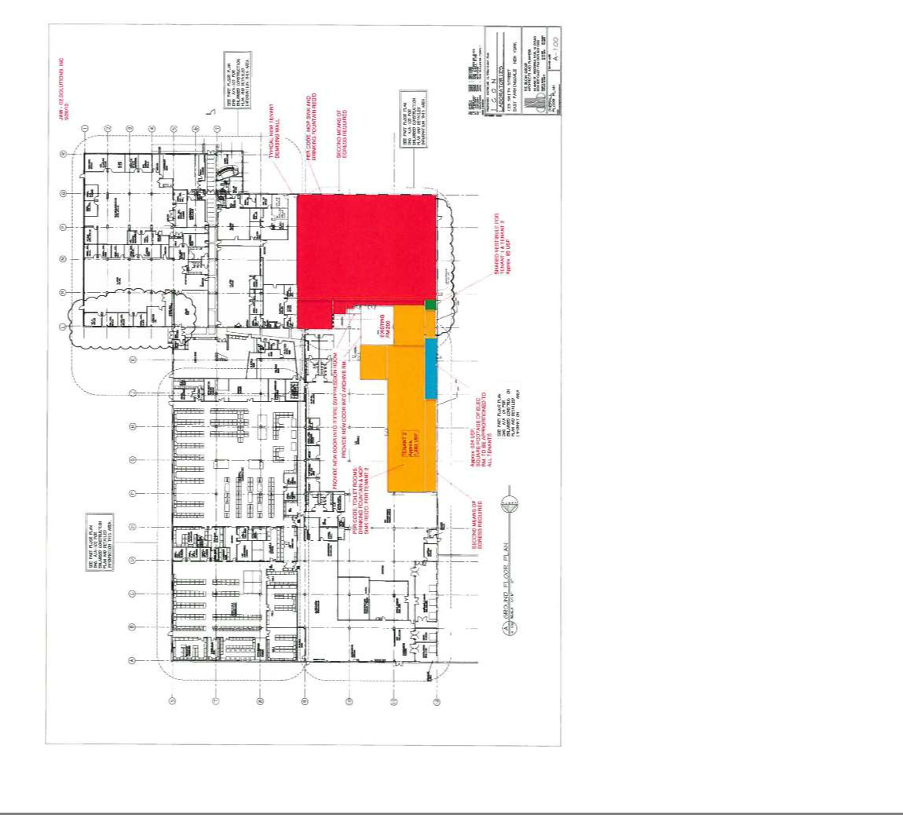

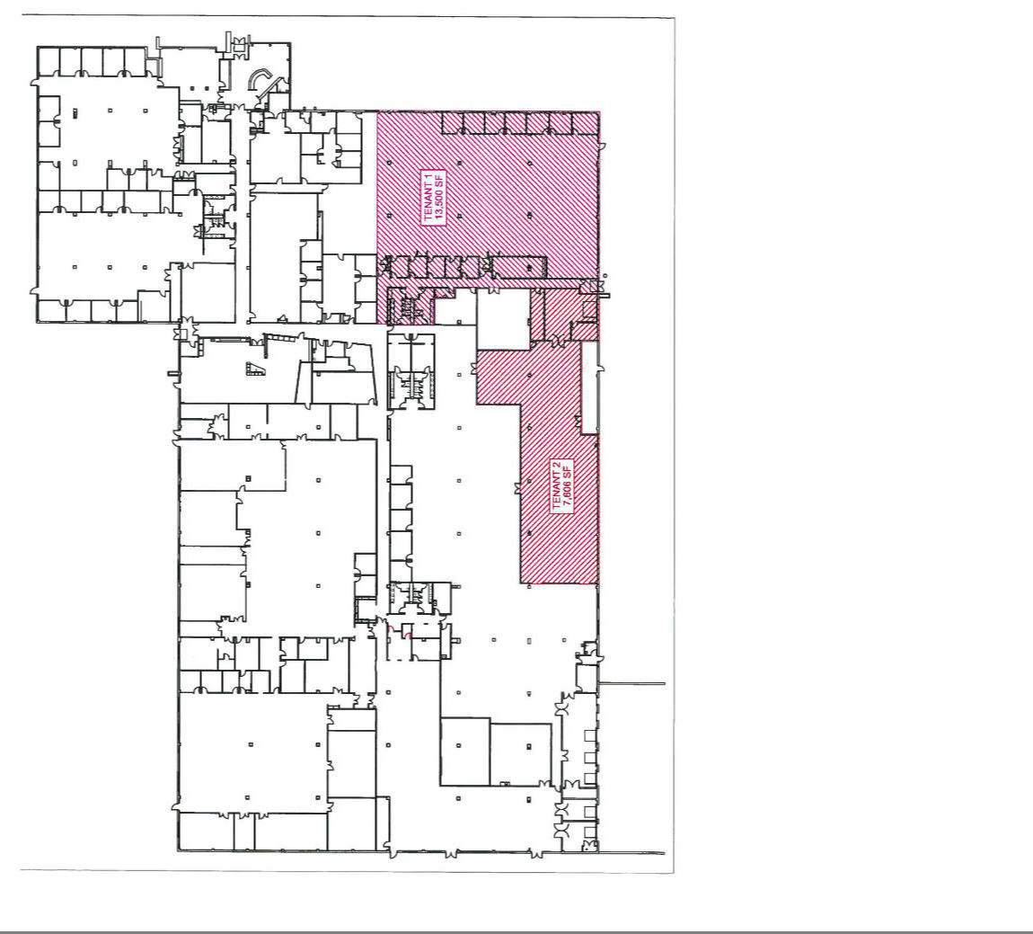

EXHIBIT B

FIXED ANNUAL RENT SCHEDULE

Initial Term


PeriodTIME |  | Fixed Annual Rent |  |  | Monthly Installment |  |  | $ / RSF
Amendment Date 2/28/2019
Laboratory & Office 83,712 sq. | $ | 2,111,796.00 |  | $ |  | 175,983.00 |  | 25.227
Warehouse 31,288 sq. ft | $ |  | 250,304.00 |  | $ | 20,858.67 |  | 8.000
Total 115,000 sq. ft. | $ | 2,362,100.00 |  | $ |  | 196,841.67
3/01/2019 - 2/28/2020 | $ | 1,506,816.00 |  | $ |  | 125,568.00 |  | 18.00
3/01/2020 - 2/28/2021 | $ | 1,544,486.40 |  | $ |  | 128,707.20 |  | 18.45
3/01/2021 - 2/28/2022 | $ | 1,582,993.92 |  | $ |  | 131,916.16 |  | 18.91
3/01/2022 - 2/28/2023 | $ | 1,622,338.56 |  | $ |  | 135,194.88 |  | 19.38
3/01/2023 - 2/28/2024 | $ | 1,663,357.44 |  | $ |  | 138,613.12 |  | 19.87
3/01/2024 - 2/28/2025 | $ | 1,704,376.32 |  | $ |  | 142,031.36 |  | 20.36
3/01/2025 - 2/28/2026 | $ | 1,747,069.44 |  | $ |  | 145,589.12 |  | 20.87
3/01/2026 - 2/28/2027 | $ | 1,791,436.80 |  | $ |  | 149,286.40 |  | 21.40
3/01/2027 - 2/28/2028 | $ | 1,835,804.16 |  | $ |  | 152,983.68 |  | 21.93
* Beginning on 3/1/2019, the Demised Premises shall be reduced to 83,712 rentable square feet, subject to Section 20 of the First Amendment

EXHIBIT C

TANK WORK PLAN





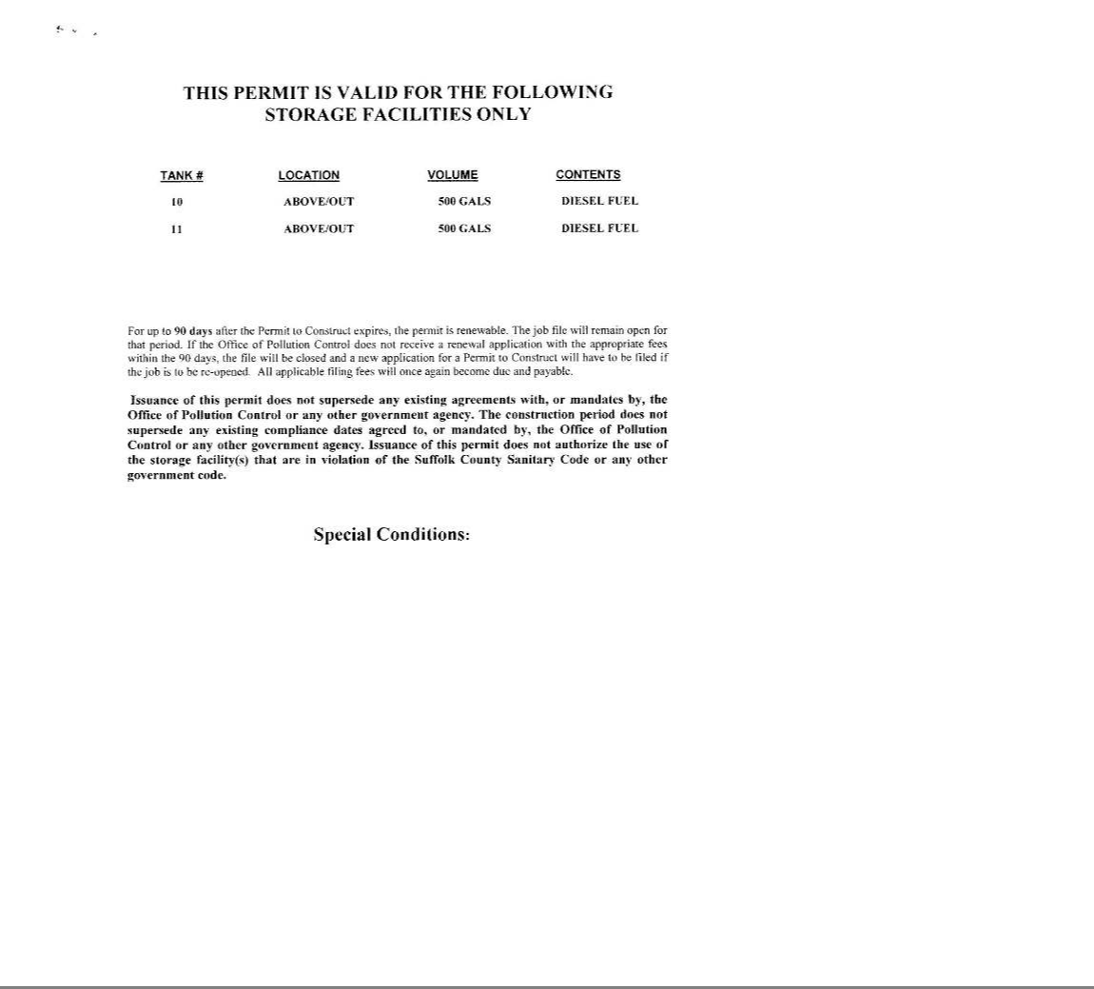

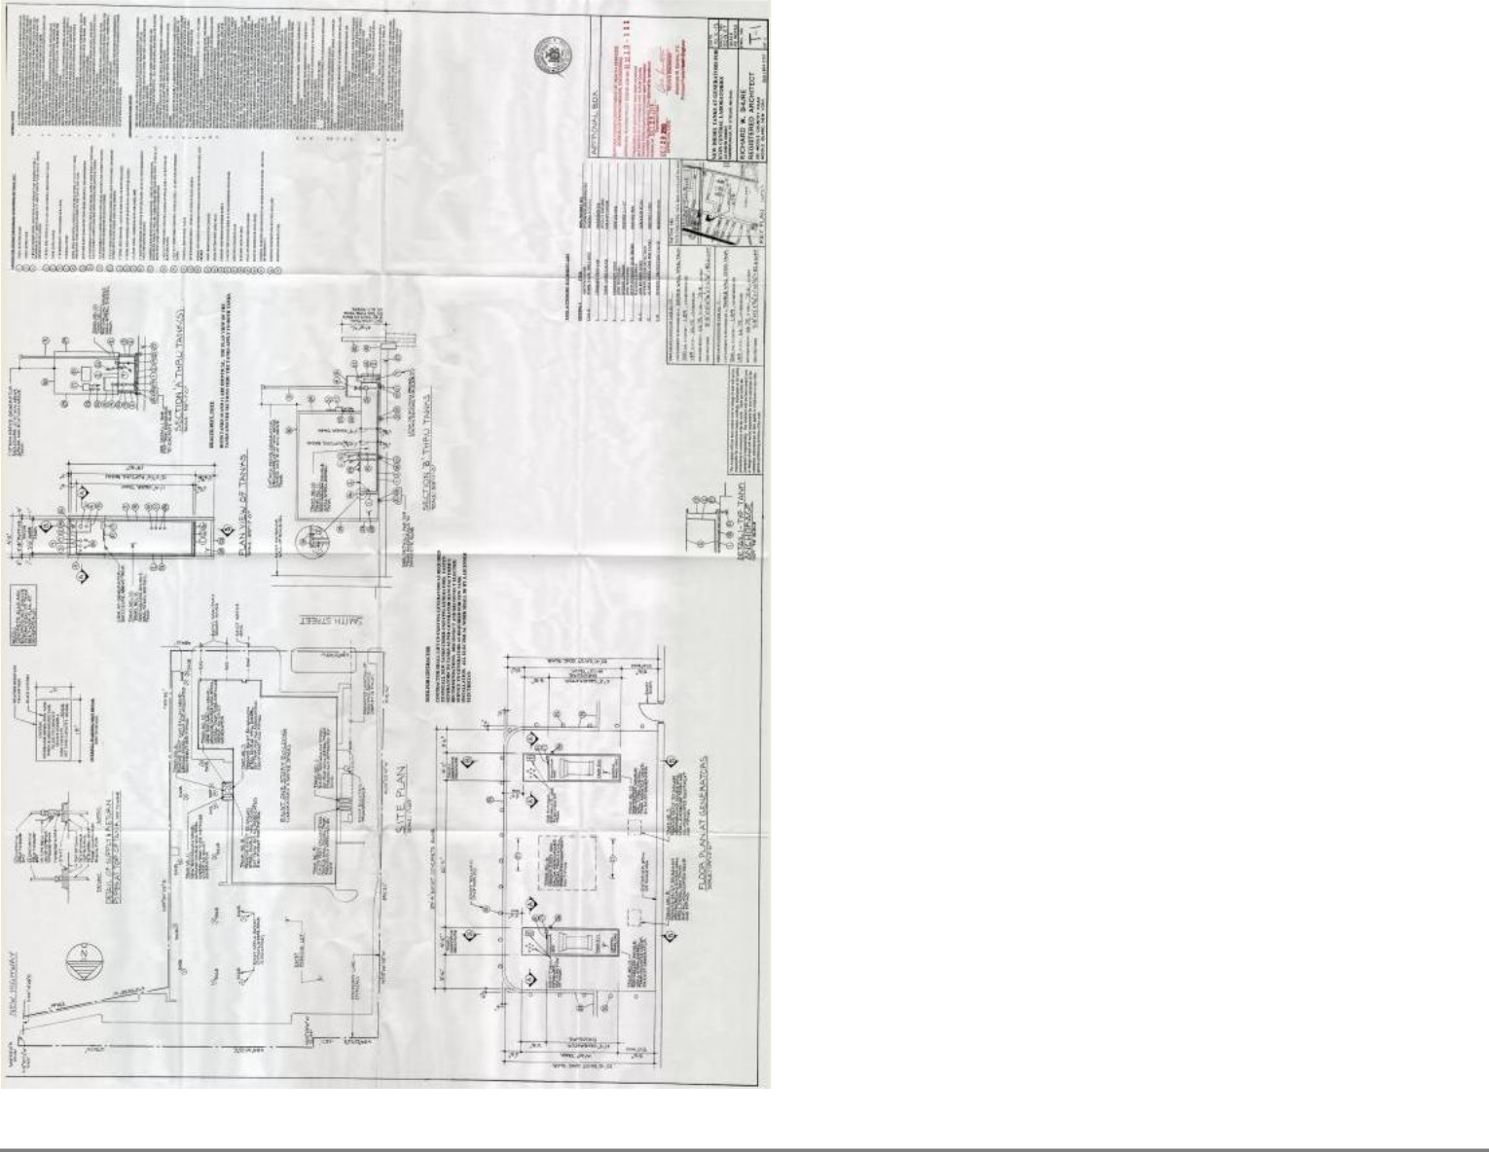

EXHIBIT D

HVAC PLAN

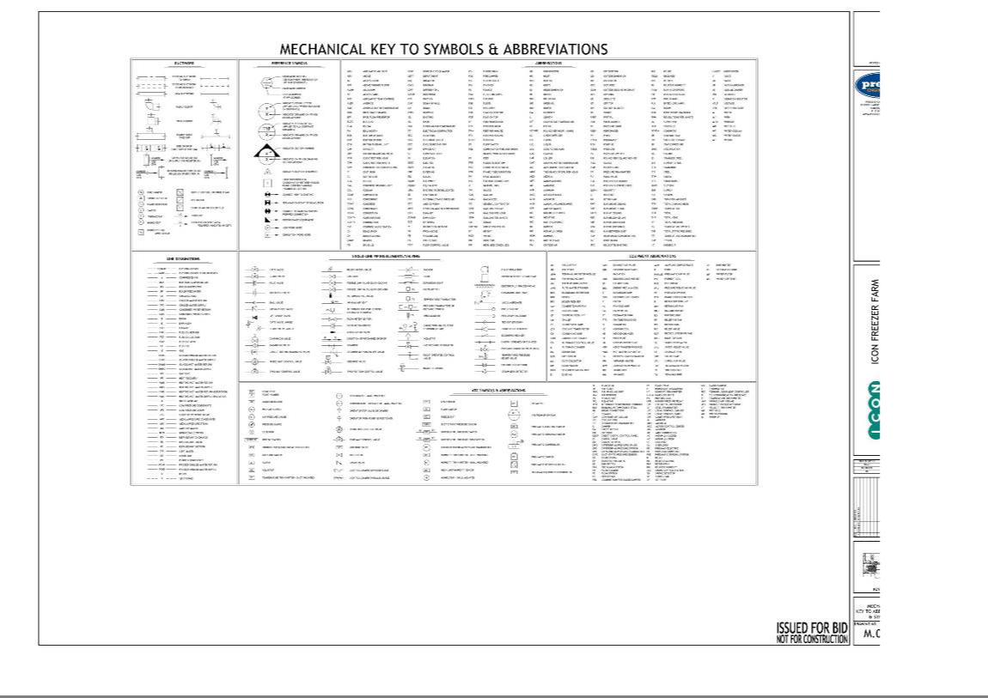

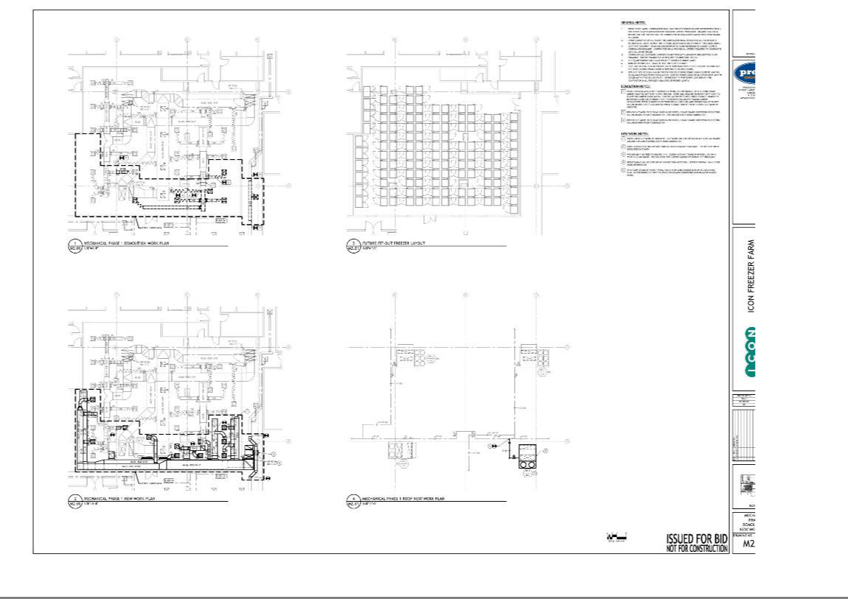

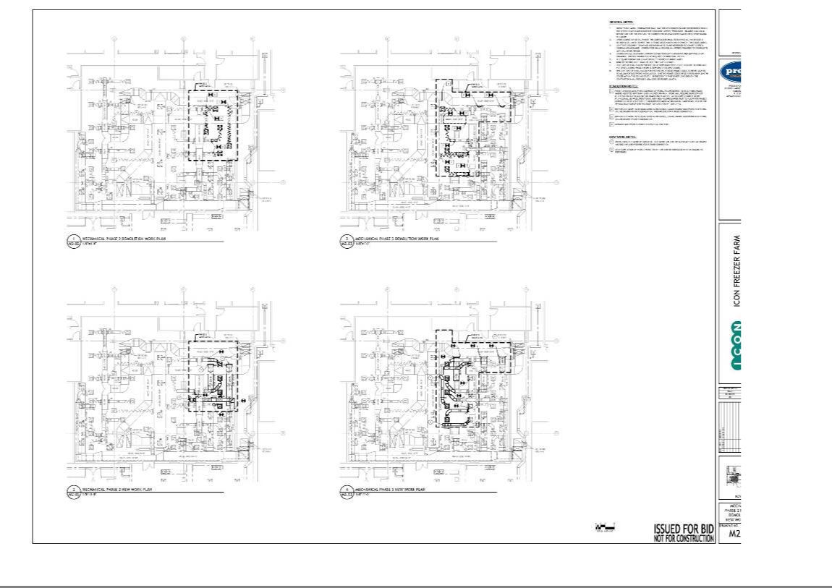

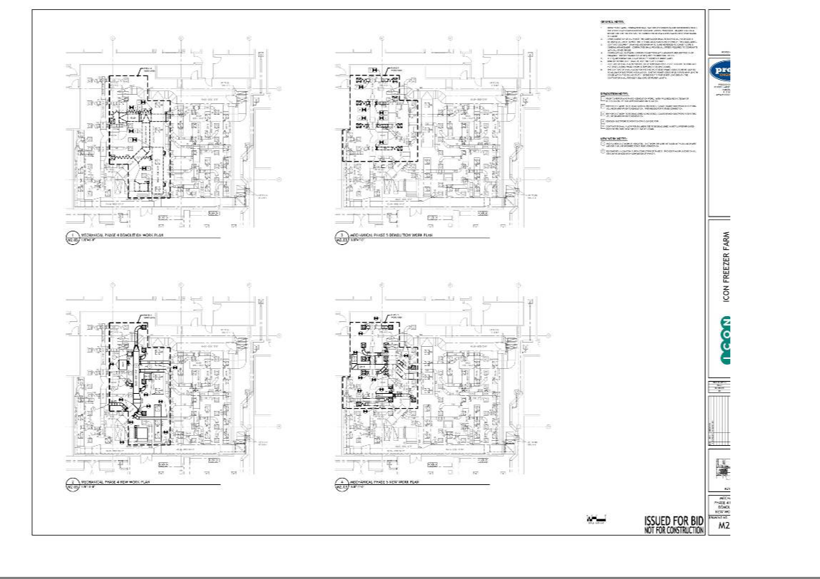

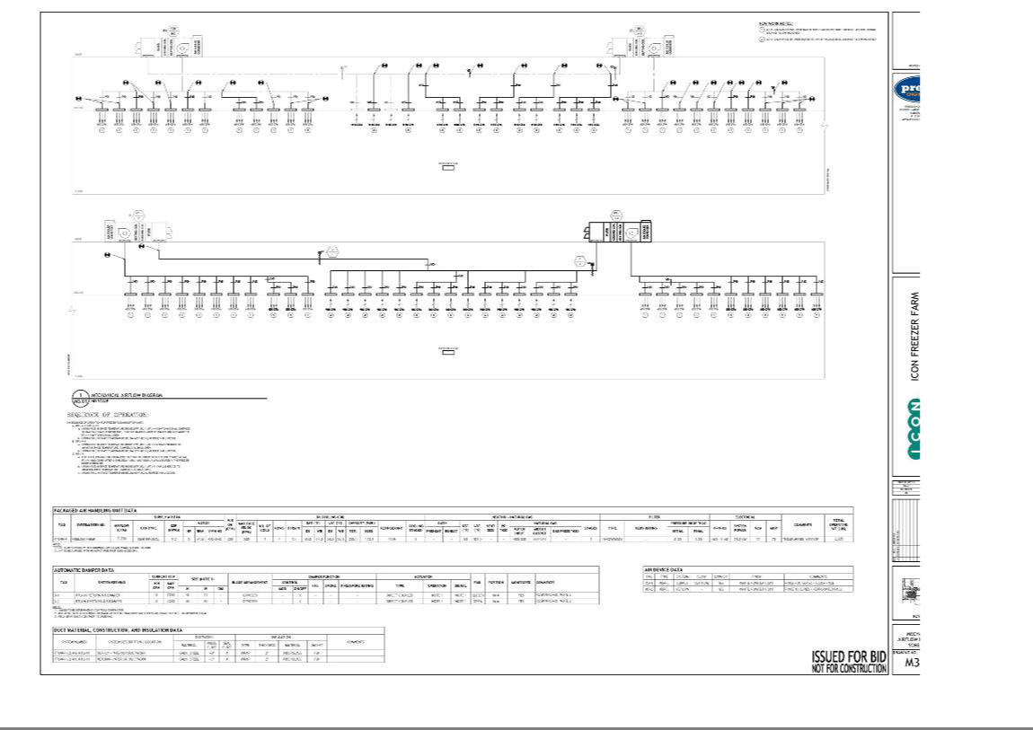

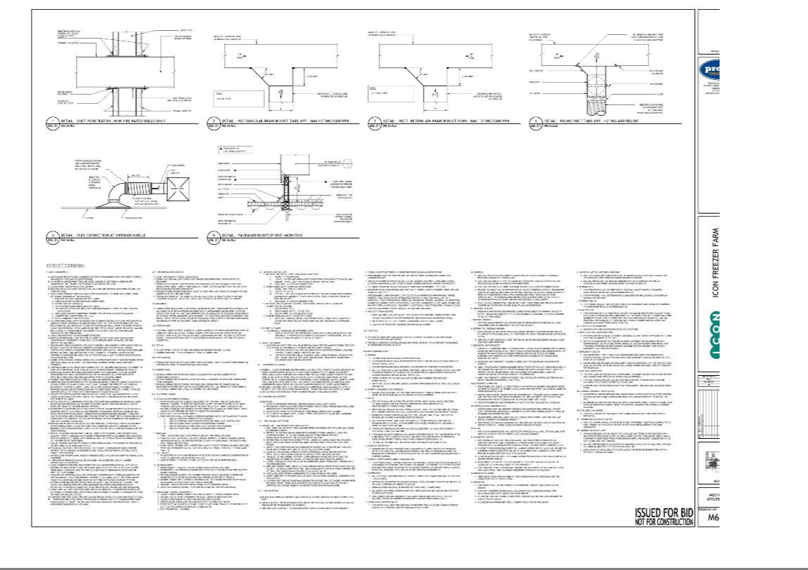

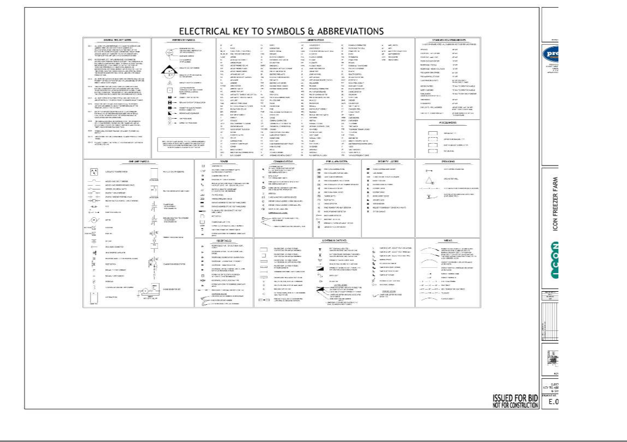

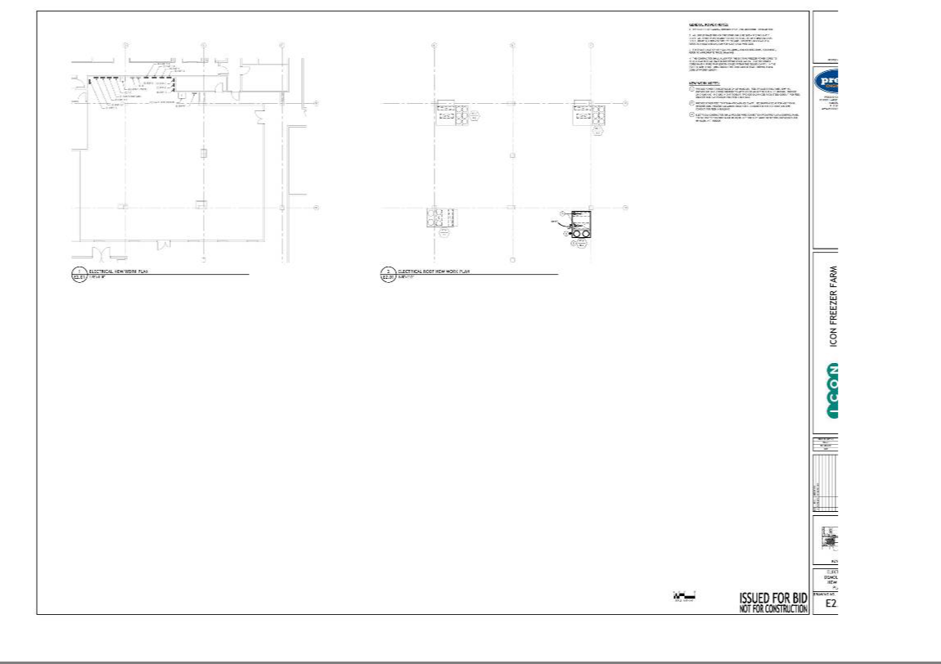

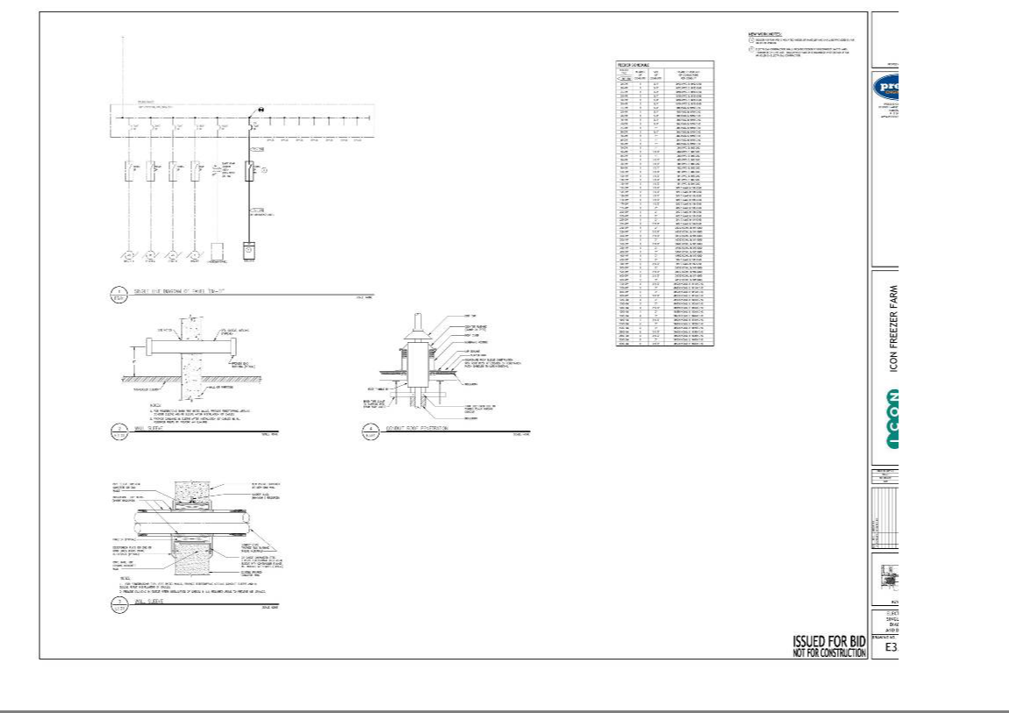

EXHIBIT E

ROOF PLAN

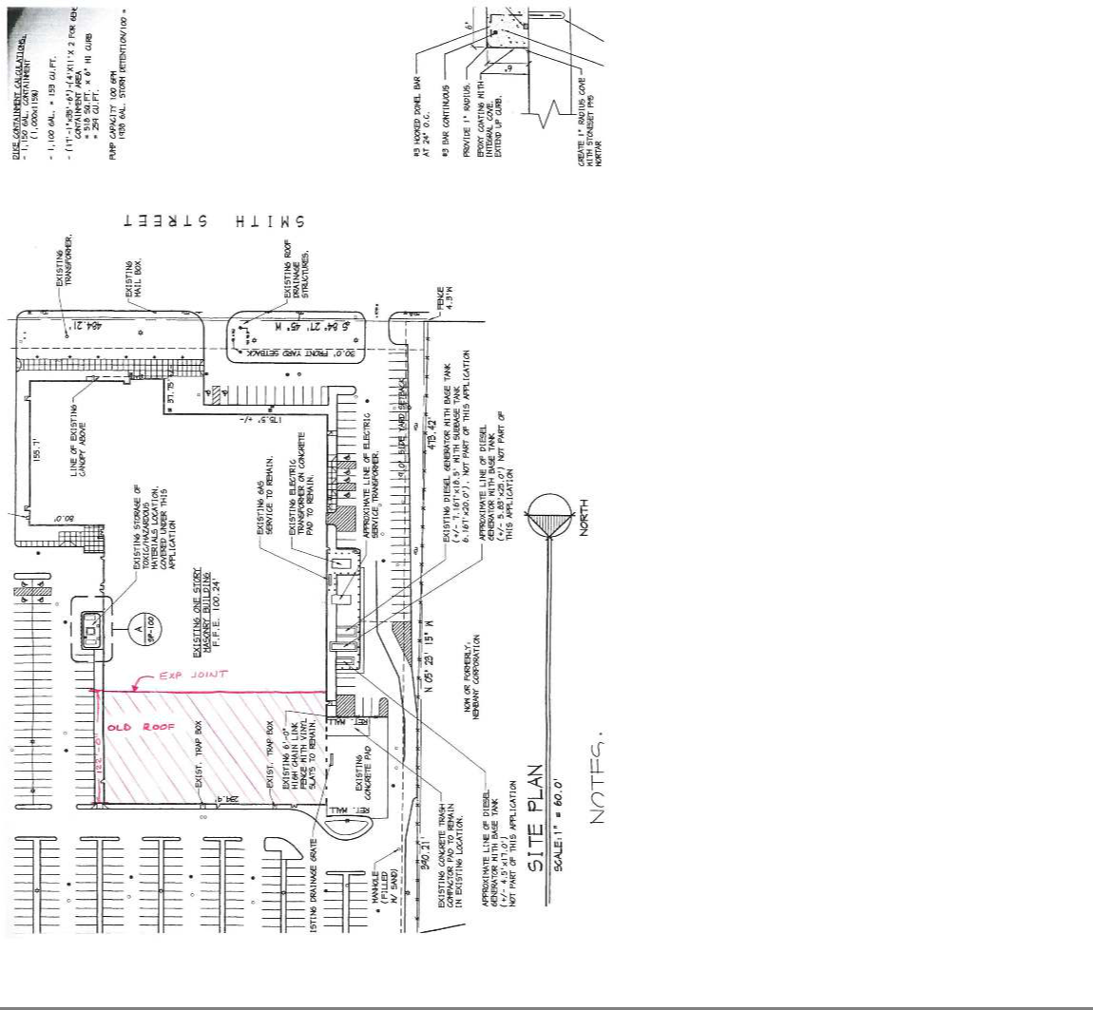

SCHEDULE “A”

IDA REAL PROPERTY TAX ABATEMENTS

Tax Savings for property with physical address of:

 | 123 Smith Street |  |  |  | April 17, 2013
 | Farmingdale, 11735
 | SCTM# 0100 002.00 01.00 011.002
 | Assuming:
 | Assessed Value of: |  | 169900
 | 2012/2013 Tax without Exemption |  |  |  | 399,334
 | 2012/2013 Tax Rate of: |  | 218.9689
 | Rate Increment of: |  | 2.00%
 | PILOT number of years |  | 15
 | Abatements starting at |  | 100%
Number |  |  |  | Estimated Taxes
of Years | Abatement % | PILOT % |  | To be Paid |  | Estimated Savings
 | 1 | 100.0% | 0.0% | $ | 27,306 | $ | 379,469
 | 2 | 93.3% | 6.7% |  | 53,231 |  | 361,133
 | 3 | 86.6% | 13.4% |  | 80,217 |  | 341,888
 | 4 | 79.9% | 20.1% |  | 108,248 |  | 321,753
 | 5 | 73.2% | 26.8% |  | 137,379 |  | 300,676
 | 6 | 66.5% | 33.5% |  | 167,668 |  | 278,602
 | 7 | 59.8% | 40.2% |  | 199,099 |  | 255,551
 | 8 | 53.1% | 46.9% |  | 231,731 |  | 231,465
 | 9 | 46.4% | 53.6% |  | 265,625 |  | 206,289
 | 10 | 39.7% | 60.3% |  | 300,767 |  | 180,039
 | 11 | 33.0% | 67.0% |  | 337,220 |  | 152,656
 | 12 | 26.3% | 73.7% |  | 375,049 |  | 124,079
 | 13 | 19.6% | 80.4% |  | 414,239 |  | 94,325
 | 14 | 12.9% | 87.1% |  | 454,857 |  | 63,332
 | 15 | 6.2% | 93.8% |  | 496,975 |  | 31,032
Estimate Taxes to be paid |  |  |  | $ | 3,649,611
Estimated Savings |  |  |  |  |  | $ | 3,322,289

Exhibit 10.2

SECOND AMENDMENT TO LEASE AGREEMENT

This SECOND AMENDMENT TO LEASE AGREEMENT entered into this 10 day of July , 2013 (the "Second Amendment"), by and between HIGHWOODS REALTY

LIMITED PARTNERSHIP, a North Carolina limited partnership ("Landlord"), and ICON CLINICAL RESEARCH, INC., a Pennsylvania corporation ("Tenant").

WITNESSETH:

WHEREAS, Tenant and Landlord entered into that certain Office Lease dated February 17, 2003 (the "Original Lease"), as amended by that certain First Amendment to Lease Agreement dated October 22, 2009 (the "First Amendment") (the Original Lease and First Amendment hereinafter collectively referred to as the "Lease"), for space containing approximately 54,594 rentable square feet (the "Existing Premises"), comprising the entire fourth and fifth floors of the Seven Springs I Building (the "Building"), located at 320 Seven Springs Way, Brentwood, Tennessee; and

WHEREAS, the parties hereto desire to alter and modify said Lease in the manner hereinafter set forth.

NOW THEREFORE, in consideration of the mutual and reciprocal promises contained herein and for other good and valuable consideration, the receipt and sufficiency of which is hereby acknowledged,

Landlord and Tenant hereby agree to amend the Lease as follows:

- Downsize of Existing Premises. Effective as of January 1, 2014, Tenant shall vacate and surrender to Landlord part of the fourth floor portion of the Existing Premises, comprising 10,028 rentable square feet (the "Give Back Space"). Effective on January 1, 2014: (a) all references in the Lease to the "Premises" shall be amended to include only the fifth floor portion of the Existing Premises and the remaining fourth floor portion of the Existing Premises (less the Give Back Space), comprising a total of 44,566 rentable square feet (the "Remaining Premises"); and (b) Landlord and Tenant shall be released of their obligations with respect to the Give Back Space that would otherwise accrue under the Lease on and after January 1, 2014, except for any indemnifications or other obligations under the Lease, such as Operating Expense reconciliations, that are intended to survive Tenant's surrender of the Give Back Space. Nothing in this provision shall be deemed to release either party of its obligations with respect to the Give Back Space that accrue prior to January 1, 2014.

- Surrender of Give Back Space. Prior to January 1, 2014, Tenant shall vacate the Give Back Space and remove all of Tenant's furniture, trade fixtures, equipment and other personal property from the Give Back Space and shall surrender the Give Back Space in good condition and repair, ordinary wear and tear and damage from casualty excepted. Notwithstanding any provision in the Lease to the contrary, Tenant shall not be obligated to remove from the Give Back Space any existing improvements that have been made to the Give Back Space, including, without limitation, server racks (without servers), supplemental air conditioning (Liebert unit), File System (including pre-action panel and FM 200 system) and Support System; provided, however, Tenant, at its sole cost and expense, shall remove any and all data and telecommunications wiring and cabling that was installed by or on behalf of Tenant. Tenant hereby acknowledges that effective as of the date this Second Amendment is fully executed, subject to Section 11.b of the Original Lease, Landlord (a) shall have the right to enter the Give Back Space at all reasonable times to show the space to prospective third-party tenants and (b) shall have the right to enter into a lease for the Give Back Space with a third-party tenant commencing on or after January 1, 2014.

- Term. Section l .b of the Lease, entitled "Term", is hereby amended by extending the Term for an additional period of 75 months, commencing on July 1, 2018, and ending on September 30, 2024.

4. | Base Rent. Section l.e of the Lease, entitled "Base Rent'', shall |  |  | be further amended to provide | that during the period beginning on January 1, 2014 |  | and ending on September 30, 2024, Tenant shall
 | pay Base Rent for the Remaining Premises in monthly |  | installments | in accordance with the following rent schedule (which shall replace the existing rent schedules in the Lease effective January 1, 2014):
 | MONTHS |  | ANNUAL RENT PSF |  | MONTHLY RENT |  | PERIOD RENT
 | 1/1/14 - 6/30/14 |  |  | $26.00 | $96,559.67 |  | $579,358.02
 | 7/1/14 - 6/30/15 |  |  | $26.52 | $98,490.86 |  | $1,181,890.32
 | 7/1/15 - 6/30/16 |  |  | $27.05 | $100,459.19 |  | $1,205,510.28
 | 7/1/16 - 6/30/17 |  |  | $27.59 | $102,464.66 |  | $1,229,575.92
 | 7/1/17 - 6/30/18 |  |  | $28.14 | $104,507.27 |  | $1,254,087.24
 | 7/1/18 - 6/30/19 |  |  | $28.70 | $106,587.02 |  | $1,279,044.24
 | 7/1/19 - 6/30/20 |  |  | $29.28 | $108,741.04 |  | $1,304,892.48
 | 7/1/20 - 6/30/21 |  |  | $29.86 | $110,895.06 |  | $1,330,740.72
 | 7/1/21 - 6/30/22 |  |  | $30.46 | $113,123.36 |  | $1,357,480.32
 | 7/1/22 - 6/30/23 |  |  | $31.07 | $115,388.80 |  | $1,384,665.60
 | 7/1/23 - 6/30/24 |  |  | $31.69 | $117,691.38 |  | $1,412,296.56
 | 7/1/24 - 9/30/24 |  |  | $32.32 | $120,031.09 |  | $360,093.27

The above rent schedule does not include operating expense pass through adjustments to be computed annually in accordance with Section 5.d of the Lease, as amended herein.

- Additional Rent - Operating Expenses. Section 5.d of the Lease, entitled "Additional Rent - Operating Expenses'', shall be further amended as follows:

  - Effective as of January 1, 2014, Tenant's Proportionate Share for the Remaining Premises shall be 34.38%, calculated by dividing the approximately 44,566 rentable square feet of the Remaining Premises by the approximately 129,629 rentable square feet of the Building.

  - Effective as of July 1, 2018 and continuing thereafter through September 30, 2024, Tenant shall pay Tenant's Proportionate Share of increases in Operating Expenses above the actual Operating Expenses for the calendar year 2018. Prior to July 1, 2018, Tenant shall continue to pay Tenant's Proportionate Share of increases in Operating Expenses above the applicable Expense Stops currently set forth in the Lease.

Except as expressly amended herein, the provision of Section 5.d of the Lease shall remain in full force and effect.

- Tenant Allowance. Effective on July 1, 2018, Landlord shall provide Tenant with an allowance of up to $99,428.87 ("Improvement Allowance") to be used for alterations and improvements in and to the Remaining Premises ("Tenant Improvements"), subject to the following terms and conditions:

  - The Improvement Allowance shall be used to pay for the costs incurred by Landlord to perform the Tenant Improvements on Tenant's behalf, including, but not limited to, architectural and engineering fees, if any, and a construction supervision fee equal to 2% of the hard cost of the Tenant Improvements. If the cost of the Tenant Improvements is less than the maximum
Improvement Allowance, Landlord shall retain the excess amount. If the cost of the Tenant

Improvements exceeds the Improvement Allowance, then Landlord shall invoice Tenant for the overage, and Tenant shall reimburse Landlord for the overage amount within 10 business days after Tenant's receipt of Landlord's invoice and reasonable documentation to support the cost of the Tenant Improvements. All plans, drawings and specifications for the construction and completion of the Tenant Improvements shall be subject to the applicable terms and conditions set forth in the Lease and to Landlord's prior written approval, which shall not be unreasonably withheld; provided, however, that Landlord shall have sole and absolute discretion to grant or deny its approval to any proposed improvements or alterations that would (i) create an unreasonable burden on the load bearing capability of the floor or otherwise affect any structural elements of the Building and/or Premises; (ii) modify or interfere with any Building systems (such as the HVAC system); or (iii) be visible from outside the Premises. Notwithstanding any provision herein to the contrary, except as resulting from Landlord's delays in connection with Tenant Improvements or delays resulting from force majeure, the Improvement Allowance is only available for Tenant's use until December 31, 2019. Any portion of the Improvement Allowance not used by December 31, 2019 shall be deemed forfeited by Tenant and shall no longer be available for Tenant's use. No portion of the Improvement Allowance may be used for the purchase of furniture or other personal property; provided, however, Tenant may apply any unused portion of the Improvement Allowance as a credit against Tenant's Base Rent obligations under the Lease as long as Tenant notifies Landlord of Tenant's election to do so on or before December 31, 2019.

  - Notwithstanding the foregoing, Tenant may use its own contractor to perform any alterations approved by Landlord, provided that: (i) the contractor is properly insured and bonded and holds a valid license in the State of Tennessee; (ii) the contractor is reputable and meets with Landlord's prior written approval, which shall not be unreasonably withheld; and (iii) all work performed by the contractor is subject to Landlord's inspection and reasonable approval. If Tenant uses its own contractor to perform the Tenant Improvements, Landlord shall not be obligated to pay Tenant the Improvement Allowance until Landlord receives the following from Tenant: (A) copies of paid invoices evidencing that Tenant has spent an amount at least equal to the portion of the Improvement Allowance requested by Tenant; and (B) final releases of lien from all contractors, subcontractors and materialmen performing any work or providing any materials for the Tenant Improvements, and from any lienors giving notice required under law. Regardless of whether Tenant uses its own contractor to construct the Tenant Improvements or elects to have Landlord contract for the completion of the Tenant Improvements, Tenant shall pay Landlord the 2% construction supervision fee referenced above.

  - Tenant, at its election, may have the Tenant Improvements completed at any time prior to July 1, 2018; provided, however, Landlord shall have no obligation to make the Improvement Allowance available to reimburse Tenant for the cost of the Tenant Improvements prior to July 1, 2018.

- Renewal Options. Tenant shall retain its two remaining 5-year Renewal Options, subject to the provisions of Section 30 of the Original Lease; provided, however, this Renewal Option shall not include the Give Back Space.

- Right to Lease. Section 31 of the Original Lease (as previously amended), entitled "Expansion Options of Tenant", is hereby deleted in its entirety and replaced with the following:

"From and after July 1, 2014, Landlord grants Tenant a right to lease (the "Right to Lease") the Give Back Space on the following basis:

  - If Landlord does not lease the Give Back Space to a third party prior to July l, 2014, then following receipt of Landlord's written notice indicating that the Give Back Space remains available for lease ("Landlord's Offer Notice"), Tenant shall have 5 days within which to give Landlord its notice of its election to exercise its Right to Lease as to the Give Back Space ("Tenant's Acceptance Notice"). In order to exercise its Right to Lease, Tenant must lease all of the Give Back Space and not only a portion thereof. Additionally, if Landlord's Offer Notice states that Landlord is negotiating with a third party for space which is greater than but includes the Give Back Space, then to exercise the Right to Lease, Tenant must lease the entire space offered by Landlord and not only a portion thereof. For purposes of this provision, the space described in Landlord's Offer Notice, which shall include, at a minimum, the Give Back Space, hereinafter shall be referred to as the "Offered Space". If Tenant does not timely deliver Tenant's Acceptance Notice to Landlord, it will be conclusively presumed that Tenant has forever waived its Right to Lease, and Tenant will have no further rights to the Offered Space.

  - The Offered Space will be offered to Tenant for a term coterminous with the Term and upon the provisions and at the Base Rent rate Landlord would lease the Offered Space to third parties. After exercise of the Right to Lease, the parties will execute an amendment to the Lease evidencing the addition of the Offered Space to the Lease. Unless expressly waived by Landlord, Tenant's Right to Lease is conditioned on: (a) Tenant not being in default under the Lease at the time of exercise of the Right to Lease or on the date that Tenant's occupancy of the Offered Space is scheduled to commence; (b) Tenant not having vacated or subleased more than 25% of the Premises or assigned its interest in the Lease at the time it exercises the Right to Lease or on the date that Tenant's occupancy of the Offered Space is scheduled to commence; (c) Tenant's financial condition not having materially adversely changed since the Effective Date; and (d) there being at least three years remaining in the Term. Notwithstanding the foregoing, if there is less than three years remaining in the Term but the Right to Lease would otherwise be available to Tenant and an option to extend the Term is available to Tenant hereunder, Tenant may exercise the Right to Lease provided Tenant simultaneously exercises its option to extend the Term of the Lease. Tenant's rights pursuant to this Section are personal to Icon Clinical Research, Inc.; and, upon an assignment of the Lease by Icon Clinical Research, Inc. (other than to an assignee permitted pursuant to Section 17 without Landlord's consent), this Section shall be null and void. Furthermore, Tenant's rights hereunder shall forever terminate and expire following a relocation of Tenant to Substitute Premises in a building other than the Building or if the Premises are downsized below the square footage leased by Tenant as of the Commencement Date.

  - Tenant only has the Right to Lease the Give Back Space if the Give Back Space is vacant and available. Tenant shall not have the Right to Lease the Give Back Space upon the renewal or extension of an existing lease for the Give Back Space, even if the lease being extended or renewed does not contain an extension or renewal right.

- Guaranty. Effective as of the date of this Second Amendment, that certain Guaranty of Lease, dated February 11, 2003, given by ICON plc in favor of Landlord, is void and of no further force or effect, and ICON plc shall have no further obligation to Landlord with respect to such Guaranty of Lease.

- Brokers. Tenant hereby represents and warrants to Landlord that Tenant has not dealt with any real estate broker, finder or other person with respect to this Second Amendment, the downsize of the Existing Premises and the extension of the Lease except for DTZ, a UGL Company ("Tenant's Broker"), whose address is 4208 Six Forks Road, Suite 918, Raleigh, North Carolina 27609. Tenant shall indemnify, defend and hold harmless Landlord from and against any claims, damages, expenses and liabilities arising from Tenant's breach of this representation and warranty. Landlord hereby represents and warrants to Tenant that Landlord has not dealt with any real estate broker, finder or other person with respect to this Second Amendment, the downsize of the Existing Premises and the extension of the Lease except for Highwoods Properties, Inc., whose address is 3322 West End Avenue, Suite 600, Nashville, Tennessee 37203. Landlord shall indemnify, defend and hold harmless Tenant from and against any claims, damages, expenses and liabilities arising from Landlord's breach of this representation and warranty. Landlord shall pay Tenant's Broker a commission in connection with this Second Amendment pursuant to a separate agreement.

- Miscellaneous. The foregoing is intended to be an addition and a modification to the Lease. Unless otherwise defined herein, all capitalized terms used in this Second Amendment shall have the same

definitions ascribed in the Lease. Except as modified and amended by this Second Amendment, the Lease shall remain in full force and effect. If anything contained in this Second Amendment conflicts with any terms of the Lease, then the terms of this Second Amendment shall govern and any conflicting terms in the Lease shall be deemed deleted in their entirety.

- Tenant Acknowledgment. Tenant acknowledges that Landlord has complied with all of its obligations under said Lease to date, and, to the extent not expressly modified hereby, all of the terms and conditions of said Lease shall remain unchanged and in full force and effect.

[SIGNATURE BLOCKS ON NEXT PAGE]

IN WITNESS WHEREOF, Tenant and Landlord have caused this instrument to be executed as of the date first above written, by their respective officers or parties thereunto duly authorized.

Tenant:

ICON CLINICAL RESEARCH, INC.

a Pennsylvania corporation

By: /s/ Stephen Cutler

Printed Name: Stephen Cutler

Title: President

Date: 03 July 2013

Landlord:

HIGHWOODS REALTY LIMITED PARTNERSHIP
a North Carolina limited partnership

By: | Highwoods Properties, Inc., a Maryland corporation,
 | its sole General Partner
 | By: /s/ W. Brian Reames
 | Printed Name: W. Brian Reames
 | Title: Senior Vice President - Regional Manager
 | Date: 7-10-13

Exhibit 10.3

LEASE AGREEMENT

THIS LEASE AGREEMENT, dated August 30, 2012 is made by and between PENNBROOK DEVELOPMENT PARTNERS 2100, L.P., a Pennsylvania limited partnership ("LANDLORD") with a business office address at 311 N. Sumneytown Pike, Suite IA, North Wales, PA 19454, and ICON CLINICAL RESEARCH, INC. ("TENANT") with a business office address at 212 Church Road, North Wales, PA 19454, and is dated as of the date on which this Lease has been fully executed by Landlord and Tenant.

- Summary of Terms and Certain Definitions.

(a) "PREMISES": |  | Proposed
(a) "PREMISES": | Rentable square feet: 135,920 | Address: 2100 Pennbrook Parkway,
(Section 2) | Upper Gwynedd Township, Montgomery County, PA
 | (See Exhibit "A")

The Premises shall consist of the following:

  - The entire building known as 1700 Pennbrook Parkway, Upper Gwynedd Township, Montgomery County, PA ("1700 Pennbrook") consisting of 40,000 rentable square feet, as more fully described in that certain lease dated February 14, 2003, as amended, by and between Tenant, as tenant, and Patriarch I, L.P., as landlord (the "1700 Pennbrook Lease");

  - The entire building known as 2100 Pennbrook Parkway, Upper Gwynedd Township, Montgomery County, PA ("2100 Pennbrook") consisting of 59,755 rentable square feet, as more fully described in that certain lease dated January 19, 2007, as amended, by and between Tenant, as tenant, and Pennbrook Development Partners, 2100 L.P., as landlord (the

"2100 Pennbrook Lease"); and

  - 36,165 rentable square feet¹ of space to be constructed in the Connector Building, (as defined below in Section 2(a)).

- "BUILDING": The combined 1700 Parkway, 2100 Parkway and the Connector Building, which is to be known as 2100 Pennbrook Parkway, Upper Gwynedd Township, Montgomery County, PA.

- "TERM": Commences in accordance with Paragraph (c)(i) and ends in accordance with Paragraph (c)(ii).

1 At Landlord's or Tenant's election, the actual "rentable square feet" of the Connector Building shall be measured by standards of the Building Owners and Managers Association (BOMA) once construction is complete. The ANSI/BOMA Z65. l-2010, Method B method shall be used in measuring the actual "rentable square feet" of the Connector Building. Once measurement is complete and reasonably approved by Landlord and Tenant, Minimum Annual Rent shall be adjusted in accordance with such measurement on a fair and equitable basis, and confirmed by Landlord and Tenant in writing.

1

- "COMMENCEMENT* DATE":

  - "EXPIRATION DATE":

- Minimum Rent (Section 6) & Operating Expenses (Section 7)

  - "MINIMUM ANNUAL RENT" (not including operating expenses): Lease Year

1

2

3

4

5

6

7

8

9

10

The date that is twenty-two (22) days after the Basic Building, Common Areas and Tenant Improvements are Substantially Completed and all space therein is ready for occupancy and Landlord provides notice of such condition to Tenant (See Section 5). In no event, however, shall the Commencement Date occur: (i) prior to July l, 2013, unless Tenant is conducting business operations in all portions of the Premises, including the Connector Building; and (ii) until the Basic Building (as hereinafter defined), Common Areas (as hereinafter defined), Tenant Improvements (as hereinafter defined) and the Premises are Substantially Completed, as defined in Section 5(a).

The date that is immediately prior to the tenth anniversary of the Commencement Date,unless sooner terminated or extended pursuant to the terms of this Lease.

Monthly Base Rent | Annual Base Rent
$215,426.94 | $2,585,123.33
$216,632.44 | $2,599,589.33
$217,837.94 | $2,614,055.33
$219,043.44 | $2,628,521.33
$220,248.94 | $2,642,987.33
$221,454.44 | $2,657,453.33
$222,659.94 | $2,671,919.33
$223,865.44 | $2,686,385.33
$225,070.94 | $2,700,851.33
$226,276.44 | $2,715,317.33
2

  - Estimated "ANNUAL OPERATING EXPENSES": $5.50 per rentable square foot, subject to adjustment (Section 7).

  - "LEASE YEAR" has the meaning set forth in Section 6(a).

- "PROPORTIONATE SHARE" (Section 7(a)): 100% - Ratio of rentable square feet in the Premises to rentable square feet in the Building.

- "USE" (Section 4): General office use, including cafeteria and fitness center, or uses ancillary to a general office permitted by applicable zoning codes for the use of the employees and invitees of Tenant, as well as those of any permitted subtenant or assignee (see Section 18).

- "SECURITY DEPOSIT": None.

- "CONTENTS": This Lease consists of the Index, pages 1 through_ containing Sections 1through 32 and the following, all of which are attached hereto and made a part of this Lease:

Exhibits: | "A" | - | Plan showing Premises
 | "A-l(a-c)" | - | Landlord's Work (Basic Building and Common Areas)
 | "A-2" | - | Property Plan
 | "A-3" | - | Site Plan
 | "A-3L" | - | Tenant Loading Area
 | "A-3V" | - | Vacated Parking Area
 | "A-4" | - | TI Plans
 | "B" | - | Architect's Schedule
 | "C" | - | Building Rules
 | "D" | - | Environmental Questionnaire
 | "E" | - | Lease Commencement Certificate
 | "F" | - | Intentionally Deleted
 | "G" | - | Tenant Estoppel Certificate Form
 | "H" | - | Form of Guaranty
 | "I" | - | Letter of Credit
Schedules: | "2(aa)" - Description of Existing Mortgages
 | "21(a)" - Improvements to be Removed
 |  |  | 3

- "TENANT INSURANCE OBLIGATION": $3,000,000.00

- "OPTIONS TO RENEW": See Section 30.

- "TARGET COMMENCEMENT DATE": The date that is nine (9) months after the date on which the Conversion occurs, subject to extension as provided in the penultimate sentence of Section 5(a) and/or in the third to last sentence of Section 2(c)(ii).

The foregoing summary of terms and certain definitions contained in this Section 1 is incorporated into and made part of this Lease and if any conflict exists between the summary of terms and certain definitions and the other terms of this Lease, then such other terms shall control.

- Premises.

- Lender Approval. Promptly after the execution of this Lease, Landlord shall use its best diligent efforts to obtain from Provident Life and Accident Insurance Company ("Lender"), the holder of mortgage liens encumbering the Property, as more fully described on Schedule 2(aa), one or more applications (collectively, the "Lender Application"), and to submit the Lender Application to Lender, together with all fees and other charges payable thereunder, not later than August 31, 2012, such Lender Application to provide Lender's approval of the following:

  - The acquisition by Landlord of all portions of the Property (and the contribution by Pennbrook Development Partners and Patriarch I, L.P. of those portions of the Property owned by them), including (without limitation) the Building and the Common Areas, not currently owned by Landlord;

  - Landlord's acquisition and assumption of the Patriarch I, L.P.'s interest, as lessor, under the 1700 Pennbrook Lease; and

  - The refinancing and restructuring of all indebtedness held by Lender on or about the Commencement Date.

Landlord shall deliver a copy of the Lender Application to Tenant simultaneously with its submission to Lender. If the Lender Application has not been so submitted by August 31, 2012, or if the Lender Application has been timely submitted but Lender has not approved the terms and conditions of this Lease on or before September 14, 2012, then either Landlord or Tenant may terminate this Lease upon five (5) days notice to the other, and upon such termination, this Lease shall be of no further force or effect. Landlord shall work cooperatively with Pennbrook Development Partners, owners of the property commonly known as 2300 Pennbrook ("2300 Pennbrook"), and Patriarch I, L.P. to complete the various items set forth above in this Section 2(aa).

4

- Connector Building. It is the intention of the parties for Landlord to construct, as part of the Basic Building work, a new building containing approximately 36,165 rentable square feet in the area between 1700 Pennbrook and 2100 Pennbrook, to serve as a connector building between the two existing buildings (the "Connector Building") and to make appropriate connections between the Connector Building and 1700 Pennbrook and 2100 Pennbrook, so that the three buildings become one combined building in terms of function, use and appearance, and to improve the interior of the Connector Building and certain portions of 1700 Pennbrook and 2100 Pennbrook and the exterior of the Property (as hereinafter defined), all as more fully set forth in this Lease. Effective as of the Conversion (as defined below), Landlord hereby leases to Tenant and Tenant hereby leases from Landlord the Premises as shown on attached Exhibit "A" within the Building (the Building and all of the land shown on Exhibit "A-2" being called the "Property"), together with the non-exclusive right with Landlord and other occupants of the Building, if any, to use all areas and facilities provided by Landlord for the use of all tenants of the Property, including any driveways, patio areas, sidewalks and parking, loading and landscaped areas (the "Common Areas"). Tenant shall have the right to use the stairwells and elevators in the Building to access the Premises, including the right to install an electronic access system controlling the doors in the stairwell, and/or the opening of elevator doors, providing access directly into the Premises or into the floors on which Tenant is the sole occupant. Landlord shall not give any third party the right to use, lease or occupy any portion of the Property, unless and until Tenant has elected not to lease all of the rentable square feet within the Building.

- Parking. There shall be available for Tenant's use not less than 734 parking spaces located in the parking area associated with the Building as shown on Exhibit "A-3" (the "Parking Area") during the Term, subject to such terms, conditions and regulations as are from time to time applicable to patrons of the Parking Area as promulgated in the reasonable discretion of the Landlord. During any time that Tenant is not the sole tenant of the Building, Tenant shall have the right to use a pro rata share of such parking spaces on a "first come, first served" basis based on the rentable square feet of the Premises as compared to the entire Building. So long as the entire Building is leased to Tenant, Tenant shall have the right to designate "visitor" and "reserved" parking spaces near the entrance to the Building in such numbers as Tenant may elect. In addition, so long as Tenant leases at least 95,920 rentable square feet, Tenant shall have the right to twenty (20) reserved parking spaces at a location near the main entrance to the portion of the Premises then leased by Tenant, the exact location of such spaces to be determined by Tenant and Landlord. Tenant shall be responsible for the cost of constructing the loading dock area identified as "Tenant Loading Area" on Exhibit "A-3L", which cost may be deducted from the Tenant Improvements Allowance.

- Construction.

  - Landlord, at Landlord's sole cost, shall construct the building and site improvements specified in Exhibit "A-1" and shown on Exhibit "A-3" (the "Basic Building"), subject to such modifications as shall be required by Upper Gwynedd Township and which Landlord and Tenant shall work cooperatively and in good faith to approve in their reasonable discretion. Landlord shall use new components in the Connector Building and in other modifications of the Basic Building. Landlord shall complete the Basic Building substantially in accordance with the Basic Building specifications set forth in Exhibit "A-1" and as shown on Exhibit "A-3". The scope of the Basic Building work in the lobby area in the Connector Building shall be as shown and noted on Exhibit"A-1". The Basic Building shall be designed and constructed in accordance with applicable federal, state and local codes including, without limitation, the Americans With Disabilities Act (the "ADA") and applicable state and local codes pertaining to required life safety systems. Tenant shall have no obligation to perform any of the Basic Building work.

5

- Tenant has caused to be prepared preliminary plans and specifications for the finish of the interior of the Building (the "Tenant Improvements"), which preliminary plans and specifications are attached hereto as Exhibit "A-4" (the "Preliminary TI Plans"). Not later than fifteen (15) days after the date of the Conversion Notice (as hereinafter defined), Tenant shall cause the project architect to submit final Tenant Improvements plans (including lobby finishes) (the "Final TI Plans") to Landlord that are consistent with the Preliminary TI Plans. Upon submission, Landlord shall review the Final TI Plans and provide notice to Tenant of its approval or rejection of same within five (5) days after submission, subject to any required review by Lender, which approval Landlord shall use its best diligent efforts to receive in a timely manner. Landlord shall not unreasonably withhold or delay its approval of such Final TI Plans and shall only reject such Final TI Plans if such Final TI Plans (l) are incomplete, (II) are not in compliance with all applicable building code requirements, (ill) are incompatible with Building floor load limits, (IV) cause the Building mechanical or electrical systems to be insufficient to provide adequate service to the Premises, or (V) include improvements which are not considered normal office fit-out that Landlord requires to be removed upon the termination of the Term in a manner consistent with the requirements of Schedule 2l(a). IfLandlord (or Lender) shall reject such Final TI Plans, Landord shall include in such notice detailed reasons for such rejection together with requested modifications. Inthe case of any rejection, Landlord shall work with Tenant diligently and in good faith to correct any matter which causes Landlord's rejection. IfLandlord fails to respond to the initially submitted, or any re-submitted, Final TI Plans within such five (5) day period after submission to Landlord, subject to any required review by Lender, then Landlord's approval thereto shall be deemed granted. Tenant shall have the Final TI Plans revised and resubmitted to Landlord within five (5) days of receipt of any notice of rejection from Landlord, and the process set forth above shall be employed, until all of Landlord's objections to the Final TI Plans have been satisfied. Once approved by Landlord, the Final TI Plans shall be deemed the "TI Plans" and to be attached to this Lease in substitution for Exhibit "A-4". The date of Landlord's approval or deemed approval of the Final TI Plans shall be referred to herein as the "Tl Plans Approval Date".

- If the TI Plans Approval Date has not occurred by the date (the "TI Plans Approval Deadline") which is thirty (30) days after the later of the Conversion or the date of the Conversion Notice, other than as a result of delay caused by either Landlord's failure to comply with its obligations under Section 2(c)(iii), or by the Lender's review and approval process, then Landlord may notify Tenant of such failure, in which event: (A) the Target Commencement Date shall be extended by one day for each such day of delay after the TI Plans Approval Deadline and prior to the TI Plans Approval Date (the "Delay Period"); (B) the Early Entry Period shall be decreased by one day for each day of the Delay Period, and (C) if Landlord Substantially Completes the Basic Building and Common Areas, but is unable to Substantially Complete the Tenant Improvements as the result of a delay in the TI Plans Approval Date not resulting from delay caused by Landlord or by the Lender's review and approval process, so long as Landlord has proceeded diligently and in good faith to Substantially Complete the Tenant Improvements, then Tenant's obligation to pay Minimum Annual Rent and Annual Operating Expenses shall commence (notwithstanding that the Commencement Date has not yet occurred) on the date which is the one hundred twelfth (I 12th) day after construction of the Connector Building has reached the Shell Completion Stage (as hereinafter defined), but in no event prior to July I, 2013. Ifsubsequent to such commencement the Commencement Date does not occur within a period of time equal to the number of days in the Delay Period, then Tenant's rental obligations for the Connector Building under this Lease shall abate thereafter until the Commencement Date occurs.

6

- Tenant shall assign all of its rights in the TI Plans prepared for the Tenant Improvements to Landlord, including, without limitation, design and engineering warranties. Landlord shall, at Tenant's cost, but subject to the Tenant Improvements Allowance, complete the Tenant Improvements pursuant to the TI Plans. Tenant shall not be responsible for the construction of the Tenant's Improvements. Tenant shall have the right to institute changes to the TI Plans, at any time prior to the Construction Contract Bid Date (as defined below), in which event the revised TI Plans shall be substituted for Exhibit "A-4" and constitute the TI Plans. If Tenant requests any change to the TI Plans after the Construction Contract Bid Date, Landlord shall advise Tenant of the cost thereof and whether in Landlord's good faith opinion any delay will result therefrom, and may reject such change on account of any delay, unless Tenant agrees to reasonable modifications to the timing provisions in this Lease on account of such delay. If Tenant chooses to proceed with such change, Tenant will be solely responsible for the cost thereof.

- Engineering, Space Design and Layout. In addition to the Tenant Improvement Allowance, Landlord shall provide to Tenant for Tenant's engineering, space design and layout costs an amount not to exceed $18,082.50 (the "Space Plan Allowance"). The Space Plan Allowance shall be paid to Tenant within thirty (30) days after the later of (i) the complete execution of this Lease and (ii) delivery of invoices therefor, which such payment shall not be unreasonably withheld or delayed.

- Tenant Improvements Allowance. Over and above Landlord's cost of constructing the Basic Building and the Common Areas in accordance with Exhibit "A-1" and Exhibit "A-3'', Landlord shall pay for the Tenant lmprovements, including hard costs and soft costs and moving, set up and related expenses related to Tenant's occupancy and vacation of various portions of the Premises at different times, and including architectural, engineering and construction drawings, and cabling and wiring, and any termination fees (but not more than $500,000.00 thereof) payable by Tenant in connection with Tenant's lease for 212 Church Road, North Wales, PA (the "Church Road Lease") in the amount of$2,993,953 (the "Tenant Improvements Allowance"). Once the Tenant lmprovements Allowance has been fully paid and exhausted in accordance with this Lease, Tenant agrees to pay to Landlord, within thirty (30) days after receipt of a bill (with supporting AIA documentation, approved by Landlord and the project architect), all actual Excess Costs (as defined below), as the same may be increased by any change order approved by Tenant, in excess of the Tenant's lmprovements Allowance, incurred by Landlord in connection with the Tenant lmprovements.

7

- Competitive Bids for Tenant lmprovements. Within five (5) days after completion and approval of the TI Plans, the project architect will prepare a contractor bid package for approval by Landlord and Tenant, such bid package to have a clear delineation between the Basic Building work and the Tenant lmprovements work in accordance with Exhibit A-1 and the TI Plans. Such approved bid package shall be submitted promptly by Landlord to Penntex, The Norwood Company and Shields Construction Company for the Tenant lmprovements work, the date of such submission being the "Construction Contract Bid Date". Landlord shall receive sealed (but not in accordance with "public" works bid requirements) competitive bids for the Tenant lmprovements from Penntex, The Norwood Company and Shields Construction Company. In order for a contractor to be eligible to receive a bid request, such contractor must be "bondable". Landlord shall require each selected contractor to provide a completion bond, the cost of the bond shall be a cost of the work. Landlord shall not mark up or charge a supervisory fee for supervising the construction of the Tenant Improvements. Landlord shall select the general contractor to complete the Tenant lmprovements which need not be the contractor that submitted the lowest bid; provided, however, that the contract price of the selected contractor for the Tenant lmprovements Work shall not be more than the amount of the lowest bid submitted. Landlord may request any contractor that submitted a bid to revise its bid to conform to the bid package requirements. Landlord will contract with the general contractor selected through the foregoing bidding process on or before the date which is thirty (30) days after the general contractor is selected. Any such contract shall include, at a minimum, a one (1) year warranty as to workmanship and materials from the contractor. Landlord shall obtain customary warranties from all manufacturers of any components used in the Basic Building or in the Tenant lmprovements. Landlord shall provide to Tenant a true and complete copy of the contract for the Tenant lmprovements, including the contract price, together with a statement that shall indicate the amount, if any, by which the total cost of the Tenant lmprovements work exceeds the Tenant lmprovements Allowance (the "Excess Costs"). Any changes in the Tenant lmprovements work or in the cost of such work shall only be by written change order approved and executed by Tenant.

8

- Tenant Options.

- Tenant shall have the right, prior to the date on which Landlord commences construction of the Basic Building (the "Construction Commencement Date"), to cause Landlord to include and install a security system in the Building pursuant to Tenant's specifications which shall be installed at Tenant's sole cost and expense. Such security system may, at Tenant's option, be removed from the Building at the expiration of the Term, and Tenant shall repair any damage to the Building caused by such removal, provided no wiring shall be removed from walls.

- Tenant shall have the right, within one (1) month after the Construction Commencement Date, to cause Landlord to include and install semi-recessed pendant style sprinkler heads in lieu of upright heads at locations selected by Tenant in accordance with Tenant's plan in the Premises at Tenant's sole expenses, at a cost to Tenant of$155.00 per head. Any additional semi recessed pendant style sprinkler heads requested by Tenant shall be at a cost of$150.00/head.

- Tenant shall have the right, prior to the Construction Commencement Date, to cause Landlord to include and install phone/data outlets in the floor slab pursuant to Tenant's specifications and at Tenant's sole expense, at a cost of$350.00/location.

- Landlord shall include and install in the Building, at Tenant's sole cost and expense, the following changes to the Connector Building:

  - Add butt glazed railing system, at a cost of $55,000.00;

  - Add 2 sets of exterior glass doors, at a cost of $7,195.00.

- Landlord shall include in the Connector Building the following additions to serve the fitness center, at Tenant's sole cost and expense:

  - Locker room exhaust system, at a cost of $7,738.00; and

  - 25 ton rooftop HVAC unit to service the fitness center, at a cost of $37,500.00.

- Landlord shall include in the Connector Building the following additions to serve the kitchen, at Tenant's sole cost and expense:

  - Add a dishwasher exhaust system, including all duct work, at a cost of $15,456.00;

9

- Add a grease exhaust system, including all duct work, at a cost of $16, 920.00;

- Add a natural gas service system, at a cost of $2,625.00 (excluding PECO charges);

- Add a grease interceptor, to be installed prior to pouring the floor, at a cost of $4,935.00; and

- Add a make-up air exchange and ductwork in the kitchen, at a cost of $25,410.00.

All of the costs noted above in this Section 2(g)(i) through (vi) shall be at Tenant's cost and be subject to application of the Tenant Improvements Allowance. The work described in Section 2(g)(i) shall be part of the Tenant Improvements work (without the need for a separate change order). The work described in Section 2(g)(ii), (iii), (iv), (v) and (vi) shall be part of the Basic Building work, notwithstanding that the cost thereof shall be as noted above. Tenant's rights under this Section 2(g) shall be exercised in a writing delivered to Landlord. The work described in Sections 2(g)(iv), (v) and (vi) shall be performed by Landlord notwithstanding that such work may be noted on the plans for the Basic Building or the TI Plans as "add alternates."

- Existing Leases. Until the Conversion, the 1700 Pembrook Lease and the 2100 Pembrook Lease shall remain in full force and effect, amended only as provided below. Upon Landlord Successfully Obtaining (as hereinafter defined) all Permits and Approvals (as hereinafter defined) (the "Conversion"), the 1700 Pembrook Lease and the 2100 Pembrook Lease shall automatically end and terminate without the need for any further action by the parties and this Lease shall thereafter solely apply to and control the relationship between Tenant and Landlord with respect to 1700 Pembrook and 2100 Pembrook, as well as the Connector Building. Ifthe Conversion will not occur until after October 31, 2012, Landlord shall promptly notify Tenant thereof, and, further, Landlord shall give Tenant prompt notice (the "Conversion Notice") of the date the Conversion actually occurs. Notwithstanding anything to the contrary set forth in the 1700 Pembrook Lease or in the 2100 Pembrook Lease, Tenant shall not have any duty or obligation to remove any alterations or improvements or restore any part of the space leased under either such lease upon the termination described above. In addition, Landlord acknowledges that no defaults by Tenant have occurred and are continuing, and no events have occurred that with the passing of time or the giving of notice or both would constitute a default by Tenant under either the 1700 Pembrook Lease or the 2100 Pembrook Lease. Effective automatically upon the occurrence of the Conversion, the 1700 Pembrook Lease and the 2100 Pembrook Lease shall be deemed amended, to provide that, notwithstanding anything to the contrary set forth therein, for the period from the date hereof until the Conversion (the "Pre-Conversion Period"), the Minimum Annual Rent due thereunder shall, retroactively reduced, so as to be: (i) in the case of the 1700 Pennbrook Lease, $718,000, and (ii) in the case of the 2100 Pembrook Lease $1,072,602, which amounts are based on a $17.95 per rentable square foot basis (the "Revised 1700/2100 MAR"). Within thirty (30) days after the Conversion, Landlord shall reimburse Tenant for the excess amount of such Minimum Annual Rent paid by Tenant over the Revised 1700/2100 MAR for the Pre-Conversion Period. After the Conversion, the Revised 1700/2100 MAR shall be due and payable as provided in the 1700 Pennbrook Lease and the 2100 Pennbrook Lease, as applicable, and shall be calculated on a pro-rated basis for any initial partial month based on the number of days remaining in the month in which the Conversion occurs. From and after the Conversion, and continuing until the Commencement Date, the Revised 1700/2100 MAR shall be the Minimum Annual Rent due under this Lease.

10

- Permits and Approvals. Landlord shall, using its good faith and best efforts, at its sole cost and expense, apply for and diligently pursue the issuance of all permits and approvals required by all local, state, federal and other governmental authorities, as well as applicable utility service providers, for the construction and use on the Property of the Basic Building and the Tenant Improvements, other than the installation of Tenant's telecommunications equipment and cabling (the "Permits and Approvals"). To that end, and without limiting Landlord's obligations, Landlord shall use its good faith and best efforts to submit to Upper Gwynedd Township (the "Township"), in accordance with the Township's subdivision and land development ordinance and other applicable ordinances, a completed application for a preliminary/final land development plan, in substantially the form of the plan attached as Exhibit "A-3", by such date as shall be required for such plan to be placed on the agenda for the first meeting in August, 2012 of the Township Planning Commission. "Successfully Obtained'', as that term is used herein, means the grant by the appropriate governmental body or utility service provider of the stated permits and approvals, without conditions or qualifications unacceptable to Landlord or Tenant, acting reasonably and in good faith, and the expiration of any period provided by law for challenging or appealing such permits and approvals, during which time no challenge or appeal shall have been taken, or if taken, the final and unappealable termination or resolution thereof in a manner favorable to Landlord and Tenant. In the event that Landlord has not Successfully Obtained the Permits and Approvals on or before December 31, 2012 (the "Approval Date"), then Tenant and Landlord shall each have the right to terminate this Lease upon five (5) days prior notice given to the other at any time prior to the date on which Landlord has Successfully Obtained the Permits and Approvals, and in the case of Tenant, Landlord has provided notice thereof to Tenant, unless prior thereto the Conversion has otherwise occurred. Upon any such termination, there shall be no further liability hereunder between the parties, except for liabilities which specifically survive the termination of this Lease or for liabilities arising prior to the date of such termination, it being expressly understood that the rights and obligations of the parties under the 1700 Pennbrook Lease and the 2100 Pennbrook Lease shall continue in full force and effect.

- Commencement and Completion of Construction. Landlord shall commence construction of the Basic Building on or before the date that is ten (10) days after Landlord has Successfully Obtained all Permits and Approvals (the "Construction Start Date"), and shall Substantially Complete the Basic Building, Tenant Improvements and Common Areas within two hundred seventy (270) days thereafter.

11

- Vacation of Certain Parking Areas and 1700 Pennbrook. Tenant agrees that within seven (7) days after receipt of notice from Landlord that Landlord is prepared to commence construction of the Connector Building and that Landlord requires that those parking areas shown on Exhibit A-3V be vacated for staging areas and otherwise to perform Landlord's work to complete the Basic Building, and provided that Conversion has occurred, Tenant shall vacate such parking areas. Tenant agrees that within thirty (30) days after receipt of notice from Landlord that Landlord is prepared to commence construction of the Basic Building relating to the Connector Building and that Landlord requires that 1700 Pennbrook be vacated in order to complete the Basic Building work and Tenant Improvements work in such space, and provided that Landlord has Successfully Obtained all Permits and Approvals, Tenant shall vacate 1700 Pennbrook (including the removal of all personnel and desktop computers, and all personal property shall be removed from the surfaces of the desks) until such time as such work has progressed to the point that the Connector Building is closed-in and weather-tight (the

"Shell Completion Stage"), including without limitation, the installation of the roof, doors, windows and exterior walls (the "Vacated Period"). Upon the end of the Vacated Period, Landlord shall return possession of 1700 Pennbrook to Tenant in a professionally cleaned condition, free and clear of all construction debris, trash, materials and equipment with all access ways, elevators and building systems properly functioning to permit Tenant's full access to and use and occupancy of 1700 Pennbrook and with appropriate temporary walls in place to separate and protect 1700 Pennbrook from any on-going Basic Building work or Tenant Improvements work being conducted in the Connector Building. During the Vacated Period, Tenant shall be permitted to leave in place in 1700 Pennbrook Tenant's fixtures, furniture and equipment, and Landlord shall take such precautions as shall be necessary to protect Tenant's fixtures, furniture and equipment from damage during the course of Landlord's Work. Tenant shall continue to pay Minimum Annual Rent and applicable additional rent for 1700 Pennbrook during the Vacated Period, but such additional rent shall be no greater on a monthly basis (other than on account of cost increases beyond Landlord's reasonable control or resulting from additional services requested by Tenant) than the average monthly additional rent paid by Tenant during the twelve-month period prior to the Vacated Period, and the 1700 Pennbrook Lease shall be deemed to be modified accordingly.

- 2100 Pennbrook. Landlord agrees as part of the Basic Building work and the Tenant Improvements work to use best construction practices to minimize any negative effect on air quality in the Premises from dust or similar air-borne particles. Prior to undertaking any of the Basic Building work or the Tenant Improvements work necessary to connect the Connector Building to 2100 Pennbrook (the "2100 Connection Work") or to install the Loading Area, Landlord shall provide twenty (20) days' prior notice to Tenant, which notice shall not be given prior to the status of the Basic Building work having achieved the Shell Completion Stage. The 2100 Connection Work and the work relating to the Loading Area and any Tenant Improvements work within 2100 Pennbrook shall be undertaken by Landlord in such a manner as to reasonably minimize interference with or disruption of Tenant's use and enjoyment of2100 Pennbrook and pursuant to a staging and construction plan to be mutually and reasonably determined by Landlord and Tenant. Landlord shall promptly (on a daily basis) remove all trash and construction material from 2100 Pennbrook in connection with such work.

12

  - Landlord's Representations. Landlord represents and warrants to Tenant that: (i) as of the Conversion, Landlord will be the fee owner of the entire Property; (ii) as of the Conversion, the lessor's interest under the 1700 Pennbrook Lease will have been assigned to Landlord by Patriarch I, L.P. and assumed by Landlord; (iii) as of the Conversion, the Property shall consist of one or more separate and distinct Condominium units, consisting of the area shown on Exhibit "A-2"; (iv) Landlord has access to the capital necessary to pay for the entire Basic Building and Common Area work and the Tenant Improvements work, including without limitation, to fund the Tenant Improvements Allowance; and (v) as of the Conversion, Borrower has received the Lender Application and all modifications to the loans required as of the Conversion Date under the terms of the Lender Application have been completed and all consents or approvals of Lender to the execution and performance of this Lease by Landlord have been obtained.

- Communications, Equipment and Technology, Emergency Generator and UPS System. Landlord shall permit Tenant to install, at Tenant's cost, but not subject to additional rent, certain communications equipment including rooftop communications equipment (i.e. a satellite dish) for Tenant's use only and not for Tenant to sell or distribute. Tenant's installation of communications equipment and technology or backup power system including, without limitation, its own UPS System shall be subject to Tenant's submission of plans and specifications to Landlord for Landlord's approval, which approval shall not be unreasonably withheld or delayed. In addition, Tenant shall pay the reasonable cost of Landlord's engineering review of any plans submitted by Tenant to Landlord for approval of communications equipment, technology equipment, emergency generators, power backup systems including, without limitation, UPS Systems, as needed, and Landlord shall have the right to require Tenant to remove such communication equipment and technology or backup power system upon termination ofthis Lease; provide, notice of such requirement is given to Tenant by Landlord at the time of Landlord's approval of the installation plans relating thereto.

- Use; Compliance.

  - Permitted Use. Tenant shall occupy and use the Premises for and only for the Use specified in Section l(f) above and in such a manner as is lawful, reputable and will not create any nuisance or otherwise interfere with any other Building tenant's normal operations or the prudent management (when used in this Lease, the term "prudent management" shall mean management in accordance with commercially reasonable standards for Class A suburban office facilities) of the Building. Notwithstanding anything to the contrary set forth in this Lease, Tenant shall be responsible for obtaining any and all health and sanitation permits or approvals for its food service operations within the Premises ("Food Service Permits"). Subject to the terms and conditions ofthis Lease, all Common Areas shall be subject to Landlord's exclusive management at all times. Except as otherwise provided in this Lease, Tenant shall not use or permit the use of any portion of the Property for outdoor storage or installations outside of the Premises or for any use that would interfere with any other Building tenant's use of any portion of the Property outside of the Premises.

13

- Compliance. Landlord represents that the Basic Building and Common Areas will be constructed in strict compliance with all applicable laws (including Title III of the ADA), ordinances, notices, orders: rules, regulations and requirements (as the same may be amended, the "Laws and Requirements") applicable to the Basic Building or to the Common Areas, other than the design of the Premises' interior (except for the lobby area, entrances, stairs, landings, elevators and restrooms within the Premises interior), which shall be Tenant's responsibility. From and after the Commencement Date, Tenant shall comply promptly, at its sole expense, (including making any alterations or improvements), with (i) all Laws and Requirements regulating the Property during the Term which impose any duty upon Landlord or Tenant with respect to Tenant's specific use, occupancy or alteration of, or Tenant's installations in, the Premises, as well as (ii) the building rules attached as Exhibit "C", as reasonably amended by Landlord from time to time (the "Building Rules"); provided, however, that Tenant shall not be required to comply with the Laws and Requirements with respect to any part of the Property, unless the need for such compliance arises out of Tenant's specific use, occupancy or alteration of the Premises, or by any negligent act or omission of Tenant or any employees, agents, contractors, licensees or invitees ("Agents") of Tenant. With respect to Tenant's obligations as to the Property, other than the Premises, if any, at Landlord's option and at Tenant's expense, if Tenant shall fail to comply with any applicable Laws and Requirements with reasonable promptness and diligence after notice from Landlord, Landlord may comply with any repair, replacement or other construction requirements of the Laws and Requirements and Tenant shall pay to Landlord all costs thereof as additional rent. Inno event shall Tenant be responsible for compliance with Laws and Requirements respecting Building restrooms, means of ingress and egress and elevators, which shall be Landlord's sole responsibility; provided, that Landlord's cost of compliance with any Laws and Requirements enacted after the Commencement Date shall, to the extent it necessitates any capital improvement, be amortized over the useful life of the improvement (not to exceed 10 years), and the annual allocable amount with respect thereto shall be included within Annual Operating Expenses for each calendar year in question.

- Environmental. Tenant shall comply, at its sole expense, with all Laws and Requirements as set forth above, all manufacturers' instructions and all requirements of insurers relating to the treatment, production, storage, handling, transfer, processing, transporting, use, disposal and release of hazardous substances, hazardous mixtures, chemicals, pollutants, petroleum products, toxic or radioactive matter by Tenant or its Agents (the "Restricted Activities"). Tenant shall deliver to Landlord copies of all Material Safety Data Sheets or other written information prepared by manufacturers, importers or suppliers of any chemical and all notices, filings, permits and any other written communications from or to Tenant and any entity regulating any Restricted Activities.

14

  - Environmental Questionnaire and Notice. Tenant shall complete the environmental questionnaire and notice in the forms collectively attached hereto as Exhibit "D". Tenant acknowledges that the Premises are located within a "Super Fund" site.

  - Notice. Ifat anytime during or afterthe Term, Tenant becomes aware of any inquiry, investigation or proceeding regarding the Restricted Activities or becomes aware of any claims, actions or investigations regarding the ADA which are related to the Property, Tenant shall give Landlord written notice within 5 days after first learning thereof, providing all available information and copies of any notices.

- Term.

  - Commencement Date. The Commencement Date shall occur on the date that is twenty two (22) days after Landlord's Substantial Completion (as hereinafter defined) of the Basic Building, Common Areas, Tenant lmprovements and other work as required in this Lease. The twenty-one (21) day period immediately prior to the Commencement Date for Tenant's early entry as provided below is called the "Early Entry Period". In no event shall the Commencement Date be before July 1, 2013, without the prior consent of Tenant. The Building, Common Areas and Tenant Improvements shall be "Substantially Completed" when (i) construction is completed in accordance with the construction plans and specifications attached hereto or as referenced herein, including in Exhibits "A-1", "A-3" and "A-4", except for punch list items which will not materially interfere with Tenant's ability to operate in the Premises for all of their intended purposes (subject to Tenant having obtained the Food Service Permits) and which will be completed by Landlord to the extent reasonably possible within thirty (30) days (but construction shall not be considered Substantially Completed if there are any material deviations from the plans and specifications attached hereto or referenced herein, including in Exhibits "A-1", "A-3" and "A-4'', which would prevent Tenant from occupying and utilizing the Premises for all of the purposes for which they are being leased); (ii) all utility systems (including telephone trunk lines) are in place and fully operational; (iii) certificates of occupancy from the Pennsylvania Department of Labor and Industry and Upper Gwynedd Township shall have been delivered to Tenant, which may be of a temporary nature, so long as Tenant is not prevented from occupying and utilizing the Premises for all of the purposes for which they are being leased and Landlord thereafter undertakes and promptly completes all work necessary to obtain a permanent certificate of occupancy, unless the temporary certificate of occupancy is due to any failure by Tenant to obtain any required Food Service Permit; and (iv) a Pennsylvania licensed architect delivers a certificate to Tenant confirming the matters set forth in clauses (i)-(iii) of this sentence, which certificate must also confirm that the Connector Building contains no less than 35,665 and no more than 36,565 rentable square feet of space. Without limiting or extending the time periods set forth elsewhere in this Lease, Landlord shall be responsible to Successfully Obtain all Permits and Approvals for the Tenant lmprovements. In the event that Tenant elects to change any of the TI Plans after the Construction Contract Bid Date by a change order made pursuant to Section 2(e) above or in the event the project architect designing the Base Building and the Tenant Improvements fails to meet its deliverables schedule for the Base Building attached hereto as Exhibit "B", other than as a result of delay caused by Landlord, its agents, employees or contractors, and such change or failure by the architect results in any actual delay in construction of the Base Building and/or the Tenant Improvements, then: (i) the Target Commencement Date shall be extended by one day for each such day of delay; and (ii) the Early Entry Period shall be decreased by one day for each such day of delay. Landlord shall give Tenant notice of any such potential delay on the account of any failure by the project architect within three (3) business days of Landlord becoming aware of such potential delay.

15

  - Expiration Date. The Term of this Lease shall commence on the Commencement Date and shall end at 11:59 p.m. on the Expiration Date, without the necessity for notice from either party, unless sooner terminated or extended in accordance with the terms hereof. Landlord and Tenant shall confirm the Commencement Date and Expiration Date by executing a lease commencement certificate in the form attached as Exhibit "E".

  - Entry. Landlord shall provide notice to Tenant that the Building, Common Areas and Premises are Substantially Completed promptly following the achievement of such condition. Tenant shall have the right to enter into and use all part of the Building, Common Areas and Premises, without the payment of any rent or other charge to Landlord with respect to the Connector Building, during the Early Entry Period to install Tenant's telephone and other communication systems and devices, computer systems, trade fixtures, furniture and equipment. Tenant agrees that during the Early Entry Period Tenant shall not conduct its general business operations in the Connector Building only. Prior to such early entry Tenant shall provide to Landlord the evidence of the insurance coverage required to be maintained by Tenant under Section 7(f)(ii) below.

- Minimum Annual Rent. Tenant agrees to pay to Landlord the Minimum Annual Rent in equal monthly installments in the amount set forth in Section l(d) (as increased at the beginning of each Lease Year as set forth in Section 1(d)), in advance; on the first day of each calendar month during the Term, without notice, demand or setoff, unless otherwise herein expressly provided, at Landlord's address designated at the beginning of this Lease unless Landlord designates otherwise; provided, that if the Commencement Date falls on a day other than the first day of a calendar month the rent shall be apportioned pro rata on a per diem basis for the period from the Commencement Date until the first day of the following calendar month and shall be paid promptly after the Commencement Date. As used in this lease, the term "Lease Year" means the period from the Commencement Date through the succeeding 12 full calendar months (including for the first Lease Year any partial month from the Commencement Date until the first day of the first full calendar month) and each successive 12 month period thereafter during the Term; provided, that the last Lease Year shall end on the Expiration Date, subject to extension of the Term in accordance herewith.

- Operation of Propertv; Payment of Annual Operating Expenses.

16

- Payment of Operating Expenses. Tenant shall pay to Landlord the Annual Operating Expenses in equal monthly installments at the amount set forth in Section l(d) (prorated for any partial month), from the Commencement Date and continuing throughout the Term on the first day of each calendar month during the Term, as additional rent, without notice, demand or setoff. Landlord shall apply such payments to the operating expenses owed to Landlord by Tenant pursuant to this Section 7. The amount of the Annual Operating Expenses set forth in Section l(d) represents Tenant's Proportionate Share of the estimated operating expenses during the first Lease Year on an annualized basis; from time to time Landlord may reasonably adjust such estimated amount ifthe estimated Annual Operating Expenses increase. With respect to any calendar year in which the Building is not occupied to the extent of ninety-five percent (95%) of the rentable area of the Building, the Annual Operating Expenses for such calendar year shall, for the purposes hereof, be increased to the amount which would have been incurred had the Building been occupied to the extent of ninety-five percent (95%) of the rentable area thereof. By April 30th of each year (and as soon as practical after the expiration or termination of this Lease or at any time in the event of a sale of the Property), Landlord shall provide Tenant with a statement of the actual amount of such expenses for the preceding calendar year or part thereof. Landlord or Tenant shall pay to the other the amount of any deficiency or overpayment then due from one to the other or, at Landlord's option for any year other than the last year, Landlord may credit Tenant's account for any overpayment. Tenant's obligation to pay the Annual Operating Expenses pursuant to this Section 7 shall survive the expiration or termination of this Lease.

- Operating Expenses. As used herein, "ANNUAL OPERATING EXPENSES" means all of Landlord's reasonable costs incurred in the prudent management and operation of the Property; provided, that Annual Operating Expenses shall not include any of the following items:

  - Leasing commissions, attorneys' fees, costs, disbursements and other expenses incurred by Landlord or its agents in connection with negotiations for leases with tenants, other occupants or prospective tenants or other occupants of the Property, and similar costs incurred in connection with disputes with and/or enforcement of any lease with tenants, other occupants, or prospective tenants or other occupants of the Property;

  - "Tenant allowances", "tenant concessions", work letter payments, and other costs or expenses (including permit, license and inspection fees) incurred in completing, fixturing, furnishing, renovating or otherwise improving, decorating or redecorating space for tenants or other occupants of the Property, or vacant, leasable space in the Property, including space planning/interior design fees for same;

  - Depreciation and other "non-cash" expense items;

  - Except as specifically authorized in this Lease, costs of a capital nature, including, but not limited to, capital additions, and capital improvements, all in accordance with generally accepted accounting principles, consistently applied;

17

- Services, items and benefits for which Tenant or any other tenant or occupant of the Property specifically reimburses Landlord or for which Tenant or any other tenant or occupant of the Property pays third persons or services, items or benefits which are not generally made available to Tenant as an occupant of the Building or the Property;

- Costs or expenses (including fines, penalties and legal fees) incurred due to the violation by Landlord of any terms and conditions of this Lease or of the leases of other tenants in the Property, that would not have incurred but for such violation by Landlord;

- Penalties for late payment of any Annual Operating Expenses by Landlord, including, without limitation, with respect to taxes, equipment leases, etc.;

- Payments in respect of overhead and/or profit to any subsidiary or affiliate of Landlord, as a result of a non-competitive selection process for services (other than a management fee in the amount specified in Section 7(g)(iii)) on or to the Property, or for goods, supplies or other materials, to the extent that the costs of such services, goods, supplies or materials exceed the costs that would have been paid if the services, goods, supplies or materials had been provided by parties unaffiliated with Landlord, of similar skill, competence and experience, on a competitive basis;

- Payments of principal, finance charges or interest on debt or amortization on any deed of trust or other debt encumbering the Property, and rental payments (or increases in same) under any ground or underlying lease or leases encumbering the Property (except to the extent the same may be made to pay or reimburse property taxes);

- Except for a management fee no more than an amount equal to three percent (3%) of the gross rents collected for the applicable Lease Year, costs of Landlord's general overhead and general administrative expenses (individual, partnership or corporate, as the case may be) and wages, salaries and other compensation and benefits (as well as adjustments thereto) for all employees and personnel of Landlord above the level of manager for the Property, which costs would not be chargeable to Annual Operating Expenses in accordance with generally accepted accounting principles, consistently applied;

- Rentals and other related expenses, if any, incurred in leasing air conditioning systems or other equipment ordinarily considered to be of a capital nature, except equipment which is used in providing janitorial services and which is not affixed to the Property and equipment which is leased on a temporary basis in emergency situations;

- Advertising and promotional expenses;

- Costs or expenses for the acquisition of sculpture, paintings or other works of art, but not the reasonable expenses of maintaining, repairing and insuring same;

18

- Costs for which Landlord is compensated through or reimbursed by insurance;

- Contributions to operating expense reserves (including tax reserves);

- Contributions to political or charitable organizations;

- Costs incurred in removing the property of former tenants and/or other occupants of the Property;

- The costs of any "tax fees" or one-time lump sum sewer, water or other utility reservation, connection or tapping fees for initial construction and occupancy of the Property. Annual Operating Expenses shall include any other lump sum assessment for sewer, water or other utility during the Term; provided, that if such assessment is payable in installments, only those installments payable during any calendar year shall be included in Annual Operating Expenses for such calendar year;

- Costs or fees relating to the defense of Landlord's title to or interest in the Property, or any part thereof;

- Any other expense which, under generally accepted accounting principles, consistently applied, would not be considered to be a commercially reasonable maintenance or operating expense of the Property;

- Any income, excess profits or corporate capital stock tax imposed or assessed upon Landlord, unless such tax or any similar tax is levied or assessed in lieu of all or any part of any ad valorem real estate tax or an increase in any ad valorem real estate tax;

- Any ground rents; or

- Any repairs to the Property resulting from the faulty design or construction respecting (A) the Building (including, without limitation, the Basic Building and/or the Tenant Improvements) and the

Building systems and arising during the first Lease Year or (B) the Common Areas and arising during the first Lease Year, as well as any repairs to or replacements of equipment or component (such as byway of example only, the roof) during the period (and to the extent) of the warranty for such equipment provided by the manufacturer and/or installer thereof Landlord shall diligently pursue all its rights under any and all applicable warranties/guaranties obtained by Landlord respecting the Property before incurring any Annual Operating Expense respecting the repair or replacement of any Property component.

- Savings. If it shall not be lawful for Tenant to reimburse Landlord for any of the Annual Operating Expenses, the Minimum Annual Rent shall be increased by the amount of the portion of such Annual Operating Expenses payable by Tenant, unless prohibited by law.

19

- Audit. Tenant and its duly authorized representatives shall have the right, once annually, at Tenant's expense except as hereafter provided, to audit and inspect at Landlord's office Landlord's books and records relating to Annual Operating Expenses after thirty (30) days prior written notice to Landlord in advance of the proposed audit ("Audit"); provided, that the Audit for any calendar year or part thereof shall be conducted within twelve months after delivery of Landlord's annual reconciliation statement to Tenant for such calendar year or part thereof. If Tenant's Audit shall disclose that Tenant's aggregate monthly payments on account of Annual Operating Expenses are greater than the actual amount of Tenant's Proportionate Share of Annual Operating Expenses, and Landlord does not contest the results of such Audit, Tenant shall be entitled to a payment or a credit against future Minimum Annual Rent owing in an amount equal to the amount so overcharged to Tenant. IfTenant's audit reveals that Landlord overstated the Annual Operating Expenses by more than ten percent (10%), Landlord shall also pay the reasonable cost of Tenant's Audit. Amounts so owing by Landlord and not paid or credited to Tenant within thirty days shall accrue interest thereafter until paid in full.

- Appeal. Tenant shall have the right to initiate and prosecute an appeal of the real estate tax assessment of the Property and in connection therewith Landlord agrees to fully cooperate with Tenant, including authorizing Tenant in writing, to file in Landlord's name all applications, pleadings, motions and related documents or instruments, as reasonably determined by Tenant to be necessary.

- Insurance.

  - Property. Landlord shall keep in effect as part of Annual Operating Expenses, insurance against loss or damage to the Building or the Property by fire and such other casualties as may be included within fire, extended coverage and special form insurance covering the full replacement cost of the Building with inflation endorsements (but excluding coverage of Tenant's personal property in, and any alterations by Tenant to, the Premises, other than the Tenant Improvements), comprehensive liability insurance in reasonable amounts covering occurrences on all portions of the Property, other than the Premises, and Landlord's operations at the Property, and such other insurance as Landlord may reasonably deem appropriate or as may be required from time-to-time by any mortgagee.

  - Liability. Tenant, at its own expense, shall keep in effect comprehensive general public liability insurance with respect to the Premises and the Property, including contractual liability insurance, with such limits of liability for bodily injury (including death) and property damage as reasonably may be required by Landlord from time-to-time, but not less than a combined single limit of $3,000,000 per occurrence and a general aggregate limit of not less than $3,000,000 (which aggregate limit shall apply separately to each of Tenant's locations if more than the Premises); however, such limits shall not limit the liability of Tenant hereunder. All policies of comprehensive general public liability insurance maintained by either party shall name Tenant, Landlord and Landlord's agent as insured parties, shall be written on an "occurrence" basis and not on a "claims made" basis and shall be issued in form reasonably satisfactory to the parties. Each party shall provide proof of coverage to the other. Tenant shall provide notice to Landlord of any notice Tenant receives that any such coverage has or will be cancelled or modified. Each insurer shall be a responsible insurance carrier which is authorized to issue such insurance and licensed to do business in the state in which the Property is located and which has at all times during the Term a rating of no less than A VII in the most current edition of Best's Insurance Reports. Each party shall deliver to the other on or before the Commencement Date, a certificate of insurance evidencing such coverage to be maintained by it and the waiver of subrogation described below.

20

  - Waiver of Subrogation. Landlord and Tenant shall have included in their respective property insurance policies waivers of their respective insurers' right of subrogation against the other party. If such a waiver should be unobtainable or unenforceable, then such policies of insurance shall state expressly that such policies shall not be invalidated if, before a casualty, the insured waives the right of recovery against any party responsible for a casualty covered by the policy.

  - Increase of Premiums. Tenant agrees not to do anything or fail to do anything which will increase the cost of Landlord's insurance or which will prevent Landlord from procuring policies (including public liability) from companies and in a form satisfactory to Landlord. If any breach of the preceding sentence by Tenant causes the rate of fire or other insurance to be increased, Tenant shall pay the amount of such increase as additional rent promptly upon being billed.

- Repairs and Maintenance; Common Areas; Building Management. Except as specifically otherwise provided in this Lease, Tenant at its sole expense shall maintain the Premises in good order and condition, reasonable wear and tear and casualty damage excepted, promptly make all repairs necessary to maintain such condition, and repair any damage to the Premises caused by Tenant or its Agents. All repairs made by Tenant shall utilize materials and equipment which are comparable to those originally used in constructing the Premises. When used in this Lease, the term "repairs" shall include replacements and renewals when necessary.

  - Landlord, at its sole expense, shall make all necessary repairs to the footings, foundations, structural steel columns and girders forming a part of the Building and Premises, provided that Landlord shall have no responsibility to make any repair until Landlord receives written notice or has actual knowledge of the need for such repair.

  - Landlord shall, subject to reimbursement to the extent included under Annual Operating Expenses, maintain, repair and replace the HVAC systems appurtenant to the Premises.

  - Landlord, as part of Annual Operating Expenses, shall make all necessary repairs to the roof, exterior portions of the Premises and the Building, utility and communications lines, equipment and facilities in the Building, and to the Common Areas (but not including any facilities constructed by or for Tenant pursuant to Section 3); provided, that Landlord shall have no responsibility to make any repair until Landlord receives written notice or has actual knowledge of the need for such repair. Landlord shall operate and manage the Property and shall maintain all Common Areas and any paved areas appurtenant to the Property in good repair and in a clean and orderly condition. Subject to Section ll(b) below, Landlord reserves the right to make reasonable alterations to the Common Areas from time to time. Subject to Section 7(b), Annual Operating Expenses also shall include (A) all sums expended by Landlord for the maintenance, repair, replacement and operation of the Common Areas (including the costs of Common Areas utility services), (B) any costs of building improvements made by Landlord to the Property that are required by any governmental authority or for the purpose of reducing operating expenses and (C) a management and administrative fee applicable to the overall operation of the Property. Notwithstanding the foregoing, Landlord agrees that the maximum management fee charged for managing the Property shall not exceed three (3%) percent of the Minimum Annual Rents and Annual Operating Expenses collected for any calendar year during the Term, as it may be extended pursuant to this Lease.

21

- Tenant acknowledges and agrees that the Premises comprise a part of a condominium governed by a condominium association of which Landlord is a member (the "Condominium"). Tenant acknowledges and agrees that Annual Operating Expenses include that portion of Landlord's Condominium fees which are attributable to the Premises on a pro-rata basis. Tenant's share of Landlord's Condominium fee is approximately $15,334.75 per annum at the execution of this Lease. Landlord represents and warrants to Tenant that, to Landlord's knowledge, there are not any planned major capital expenditures for the Condominium for 2013 or 2014.

- Notwithstanding anything herein to the contrary, repairs and replacements to the Premises made necessary by Tenant's specific use or alteration of, or Tenant's installation in or upon the Premises or by any act or omission of Tenant or its Agents, other than ordinary wear and tear, shall be made at the sole expense of Tenant to the extent not covered by any applicable insurance proceeds paid to Landlord. Tenant shall not bear the expense of any repairs or replacements to the Property arising out of or caused by any other tenant's use, occupancy or alteration of, or any other tenant's installation in or upon, the Property or by any act or omission of any other tenant or any other tenant's Agents.

(h) Utility Charges. Tenant shall pay for water, sewer, gas, electricity, heat, power, telephone and other communication services and any other utilities, supplied to or consumed in or on the

Premises. Landlord shall not be responsible or liable for any interruption to utility service, unless caused by the negligence of Landlord, its employees, agents or contractors, and no such interruption affect the continuation or validity of this Lease, so long as Landlord proceeds diligently and in good faith to remedy any interruption. Tenant agrees to pay for utility charges calculated either through separate submeters or direct billing from the utility company.

- Net lease. Except for the obligations of Landlord expressly set forth herein, Landlord is not and shall not be required to render any services of any kind to Tenant other than those explicitly set forth within this Lease and as set forth on Exhibit "F". The term "Rent" as used in this Lease means the Minimum Annual Rent, Annual Operating Expenses and any other additional rent or sums payable by Tenant to Landlord pursuant to this Lease, all of which shall be deemed rent for purposes of Landlord's rights and remedies with respect thereto. Tenant shall pay all Rent to Landlord within 30 days after Tenant is billed, unless otherwise provided in this Lease, and interest shall accrue on all sums due but unpaid after thirty (30) days. The foregoing notwithstanding, Minimum Annual Rent and monthly installments of Annual Operating Expenses shall be payable monthly, without prior notice or billing, as hereinabove provided.

22

- Landlord's Services. Landlord agrees to operate and manage the Property to the standards of a Class A suburban office facility, providing to Tenant parking, access, elevator, HVAC service, utilities, janitorial and other services consistent with a Class A suburban office facility. Ifany of such services is interrupted in any material way (making the Premises unusable for its intended use consistent with the standards of Class A suburban office space) for a period in excess of forty-eight (48) hours, unless the cause of such interruption is beyond Landlord's reasonable control, Tenant shall be entitled to a fair and equitable abatement of the Minimum Annual Rent and other charges payable hereunder based upon the extent and duration of such interruption. In any event, Landlord shall proceed with all reasonable diligence to have any interruption of service restored as quickly as possible.

- Expenses. For any period during which Tenant actually occupies less than the entire Building for less than an entire calendar year, Landlord and Tenant shall cooperate with each other and use commercially reasonable efforts to minimize Annual Operating Expenses during such period, as reasonable and appropriate in light of such reduced occupancy.

  - Capital Expenses. Anything else in the Lease to the contrary notwithstanding, to the extent that this Agreement provides for any capital expense to be included in Annual Operating Expenses, such expense shall be amortized over the useful life of the underlying improvement (not to exceed 10 years), and the annual allocable amount with respect thereto shall be included within Annual Operating Expenses for each calendar year in question.

- Signs. As long as the Premises consist of at least 95,920 rentable square feet, Tenant, at its cost but subject to application of the Tenant Improvement Allowance, shall be permitted to install signage at Tenant's entrances and on the Building (which signage may identify divisions and affiliates of Tenant), subject to any signage restrictions applicable to the Condominium and to any applicable Upper Gwynedd Township regulations and approval. The size and location of Tenant's exterior signs shall be determined by Landlord and Tenant in good faith, based upon an allocation of exterior signage among all Building occupants, and the relative sizes of their respective premises. Landlord shall fully cooperate with Tenant in connection with Tenant's efforts to obtain any required approval or permit from the Condominium association or Upper Gwynedd Township; provided that Landlord shall not be required to incur any third-party costs in connection therewith. Landlord shall provide a customary commercial standard signs at the Pennbrook Drive Entrances identifying Tenant. Except as set forth hereinabove, and except for signs which are located wholly within the interior of the Premises and not visible from the exterior of the Premises, no signs shall be placed on the Property without the prior written consent of Landlord, which shall not be unreasonably withheld or delayed. All signs installed by Tenant shall be maintained by Tenant in good condition and Tenant shall remove all such signs at the termination ofthis Lease and shall repair any damage caused by such installation, existence or removal.

23

- Alterations and Fixtures.

  - Trade Fixtures. Subject to Section 10, Tenant shall have the right to install its trade fixtures in the Premises, provided that no such installation or removal thereof shall damage any structural portion of the Property nor any utility lines, communications lines, equipment or facilities in the Building serving any tenant other than Tenant. At the expiration or termination of this Lease, Tenant shall remove such installation(s) and Tenant shall repair any damage caused by such installation or removal; ifTenant elects not to remove such installation(s) at the expiration or termination of this Lease all such installations shall remain on the Property and become the property of Landlord without payment by Landlord.

  - Alterations. Tenant shall not make or permit to be made any alterations to the Premises without Landlord's prior written consent, which shall not be unreasonably withheld or delayed. Tenant shall pay the reasonable costs of any required architectural/engineering reviews. Inmaking any alterations, (i) Tenant shall deliver to Landlord the plans, specifications and necessary permits, together with certificates evidencing that Tenant's contractors and subcontractors have adequate insurance coverage naming Landlord and Landlord's agent as additional insureds at least ten (10) days prior to commencement thereof,

  - such alterations shall not impair the structural strength of the Building or any other improvements or damage any utility lines, communications lines, equipment or facilities in the Building serving any tenant other than Tenant, (iii) Tenant shall comply with Section 10 and (iv) the occupants of the Building and of any adjoining property shall not be disturbed thereby. All alterations to the Premises by Tenant shall be the property of Tenant until the expiration or termination of this Lease; at that time all such alterations shall remain on the Property and become the property of Landlord without payment by Landlord, unless Landlord gives written notice to Tenant to remove the same, in which event Tenant will remove such alterations and repair any resulting damage. At Tenant's request prior to Tenant making any alterations, Landlord shall notify Tenant in writing whether Tenant is required to remove such alterations at the expiration or termination of this lease. Notwithstanding the foregoing, except as otherwise specifically provided in Section 21 below, Tenant shall not be required to, and Tenant shall not, remove the Tenant Improvements constructed pursuant to Section 2 of this Lease, and Tenant shall be entitled to leave up to $200,000.00 of total alterations at the end of the Term and Tenant shall not be required to remove any paint or carpeting, which shall not count toward such $200,000.00 amount. This $200,000.00 amount will be increased by $100,000.00 for each subsequent renewal period.

24

  - Work. Tenant shall be responsible for supervising the work in connection with all 24 changes and improvements to the Premises hereafter made by or at the request of Tenant (other than the Tenant Improvements), and Landlord shall not be entitled to any supervisory or other fee with regard to such work. Landlord hereby approves Shields Construction Company as Tenant's contractor for the performance of any or all of such work, with any other contractor to be approved by Landlord, which approval shall not be unreasonably withheld, conditioned or delayed. After receiving any submission, Landlord will promptly either approve, disapprove, or comment on the submission. Any disapproval shall be accompanied by detailed reasons for such disapproval. IfLandlord does not promptly respond to such submission, such submission shall be deemed approved.

  - Inspections. In performing any alterations, in addition to the right of Landlord and its agents to inspect the Premises set forth in Section 11 of this Lease, Landlord and its agents shall have the right to conduct walk-through inspections of the Premises at reasonable times as any alteration work is being completed by Tenant. Prior to making any such inspection, Landlord will give reasonable prior notice to Tenant. Such notice shall be given at least twenty-four (24) hours in advance of the inspection, and may be given by telephone. The warranties from Tenant's contractor(s) for any alteration work shall be for the benefit of Landlord as well as Tenant, and Tenant shall deliver copies of such warranties to Landlord upon receipt. All alterations shall be done in a good and workmanlike manner and shall comply at the time of completion with all Laws and Requirements. Tenant shall deliver to Landlord copies of all Certificates of Occupancy, permits, and licenses required to be issued by any authority in connection with any such Tenant alteration work.

- Mechanics' Liens. Tenant shall pay promptly any contractors and materialmen who supply labor, work or materials to Tenant at the Property and shall take all steps permitted by law in order to avoid the imposition of any mechanic's lien upon all or any portion of the Property as a result oflabor or materials furnished to Tenant. Should any such lien or notice oflien be filed for work performed for Tenant other than by Landlord, Tenant shall bond against or discharge the same within 5 days after Tenant has notice that the lien or claim is filed regardless of the validity of such lien or claim. Nothing in this Lease is intended to authorize Tenant to do or cause any work to be done or materials to be supplied for the account of Landlord, all of the same to be solely for Tenant's account and at Tenant's risk and expense. Throughout this Lease the term "mechanic's lien" is used to include any lien, encumbrance or charge levied or imposed upon all or any portion of, interest in or income from the Property on account of any mechanic's, laborers, materialman' s or construction lien or arising out of any debt or liability to or any claim of any contractor, mechanic, supplier, materialman or laborer and shall include any mechanic's notice of intention to file a lien given to Landlord or Tenant, any stop order given to Landlord or Tenant any notice of refusal to pay naming Landlord or Tenant and any injunctive or equitable action brought by any person claiming to be entitled to any mechanic's lien.

25

- Certain Rights Reserved by Landlord.

  - Landlord's Right ofEntry. Tenant shall permit Landlord and its Agents to enter the Premises at all reasonable times following forty-eight (48) hours prior notice (except in the event of an emergency), for the purpose of inspection, maintenance or making repairs, alterations or additions as well as to exhibit the Premises for the purpose of sale or mortgage and, during the last twelve (12) months of the Term, to exhibit the Premises to any prospective tenant. Landlord will make reasonable efforts not to inconvenience Tenant to exercising the foregoing rights, but shall not be liable for any loss of occupation or quiet enjoyment thereby occasioned, so long as such reasonable efforts are used. In connection with any such entry, Landlord, and any party entering with Landlord, shall comply with all safety and confidentiality requirements of Tenant. Except in the event of any access in connection with an emergency, Landlord shall only access the Premises in the presence of a representative of Tenant. Any such entry by Landlord and any party entering with Landlord shall be at Landlord's sole risk, except to the extent caused by Tenant's negligence or willful misconduct.

  - Limits. As long as Tenant leases the entire Premises, Landlord shall not (i) erect any temporary or permanent improvements or make any material modifications to the Common Areas or the roof or exterior of the Building; or (ii) change the name or address of the Premises, without Tenant's prior consent.

- Damage by Fire or Other Casualty.

  - Damage. Ifthe Premises or Building shall be damaged or destroyed by fire or other casualty, Tenant promptly shall notify Landlord and Landlord, subject to the conditions set forth in this Section 12, shall promptly and diligently repair such damage and restore the Premises, including, without limitation, the Tenant Improvements, to substantially the same condition in which they were immediately prior to such damage or destruction, but not including the repair, restoration or replacement of the fixtures or alterations installed by Tenant. Landlord shall notify Tenant in writing, within thirty (30) days after the date of the casualty, whether Landlord reasonably anticipates that the restoration will take more than one hundred eighty (180) days from the date of the casualty to complete; and in such event, Tenant may terminate this Lease effective as of the date of casualty by giving written notice to Landlord within thirty (30) days after Landlord's notice. In addition, in the case of a casualty where the damage is not actually repaired within one hundred eighty (180) days after the date of the casualty, Tenant may terminate this Lease by written notice given to Landlord at any time after such period and until the damage is repaired. Ifa casualty occurs during the last twelve (12) months of the Term or any extension thereof, Landlord may cancel this Lease unless Tenant has the right to extend the Term for at least three (3) more years and does so in writing within thirty (30) days after the date of the casualty. Notwithstanding anything herein to the contrary, Landlord shall have the right to terminate this Lease if insurance proceeds payable under the insurance required to be maintained by Landlord plus the amount of Landlord's deductible are insufficient to pay the cost of such repair and restoration, provided that Landlord has maintained in place the insurance coverages required under Section 7(f)(i). Landlord shall promptly file and diligently pursue its insurance claim following the occurrence of any such casualty or damage.

26

  - Rental Interruption. Landlord shall maintain a twelve (12) month rental coverage endorsement or other comparable form of coverage as part of its fire, extended coverage and special form insurance. Tenant will receive an abatement of its Minimum Annual Rent and Annual Operating Expenses during any period and to the extent the Premises are rendered untenantable.

- Condemnation.

  - Termination. If(i) all of the Premises are taken by a condemnation or otherwise for any public or quasi-public use, (ii) any part of the Premises is so taken and the remainder thereof is insufficient for the reasonable operation of Tenant's business or (iii) any of the Property is so taken, and, in Landlord's reasonable opinion, it would be impractical or the condemnation proceeds payable to Landlord are insufficient to restore the remainder of the Property, then this Lease shall terminate and all unaccrued obligations hereunder shall cease as of the day before possession is taken by the condemnor.

  - Partial Taking. If there is a condemnation and this Lease has not been terminated pursuant to Section 13(a), (i) Landlord shall restore the Building, Common Areas and the Premises to a condition and size as nearly comparable as reasonably possible to the condition and size thereof immediately prior to the date upon which the condemnor took possession and (ii) the obligations of Landlord and Tenant shall be unaffected by such condemnation except that there shall be an equitable abatement of the Minimum Annual Rent according to the rental value of the Premises before and after the date upon which the condemnor took possession and/or the date Landlord completes such restoration.

  - Award. In the event of a condemnation affecting Tenant, Tenant shall have the right to make a claim against the condemnor for moving expenses, loss of equipment, improvements and betterments and business dislocation damages to the extent that such claim does not reduce the sums otherwise payable by the condemnor to Landlord. Except as aforesaid and except as set forth in Section 13(d) below, Tenant hereby assigns all claims against the condemnor to Landlord.

  - Temporarv Taking. No temporary taking of the Premises shall terminate this Lease or give Tenant any right to any rental abatement. Such a temporary taking will be treated as ifTenant had sublet the Premises to the condemnor and had assigned the proceeds of the subletting to Landlord to be applied on account of Tenant's obligations hereunder. Any award for such a temporary taking during the Term shall be applied first, to Landlord's costs of collection and second, on account of sums owing by Tenant hereunder, and if such amounts applied on account of sums owing by Tenant hereunder should exceed the entire amount owing by Tenant for the remainder of the Term, the excess will be paid to Tenant.

27

- Non-Abatement ofRent; Landlord's Representations.

  - Abatement. Except as otherwise expressly provided in this Lease, there shall be no abatement or reduction of the rent for any cause whatsoever, and this Lease shall not terminate, and Tenant shall not be entitled to surrender the Premises.

  - Representations of Landlord. Landlord represents, that: (i) to the best of Landlord's knowledge, the Property is in compliance with all applicable laws, ordinances and governmental regulations (including all Enviromnental Laws, hereinafter defined) and Tenant's Use is in compliance with all applicable ordinances and other governmental regulations (including Environmental Laws); (ii) Landlord is a limited partnership duly formed and in good standing and has taken all partnership action necessary to carry out the transaction contemplated herein, so that when executed, this Lease constitutes a valid and binding obligation enforceable in accordance with its terms. Landlord shall provide Tenant with consents or other proof in a form acceptable to Tenant, authorizing the execution of this Lease at the time of such execution; (iii) Landlord has the right, power and authority to enter into this Lease and to perform Landlord's obligations hereunder, and no joinder by any other party and no approvals or consents of any other persons which have not already been obtained are necessary in order for this Lease to be valid and binding upon Landlord in accordance with its terms, except that prior to submission of the Application, Lender's approval is required; and (iv) none of Landlord's representations contained in this Lease contains any untrue statement of material fact or omits any material fact the omission of which would be misleading. As used herein, "Environmental Law" means any one or more of all federal, state and local environmental protection, occupational, health, safety and similar laws, ordinances, restrictions, licenses and regulations, including, without limitation, the Federal Water Pollution Control Act (33 U.S.C. Sec. 1251 et seq.), Resource Conservation and Recovery Act (42 U.S.C. Sec. 6991 et seq.), Safe Drinking Water Act (42 U.S.C. Sec. 300f et seq.), Toxic Substances Control Act (15 U.S.C. Sec. 2601 et seq.), Clean Air Act (42 U.S.C. Sec. 7401 et seq.), Comprehensive Environmental Response, Compensation and Liability Act (42 U.S.C. Sec. 9601 et seq.), Hazardous Materials Transportation Act (49 U.S.C. Sec. 1802 et seq.), and other similar federal, state or local laws, statutes, ordinances, orders, decrees, rules and/or regulations, regulating, relating to or imposing liability or standards of conduct concerning any hazardous, toxic or dangerous waste, substances or material now or at any time hereafter in effect. Notwithstanding the foregoing, Tenant acknowledges the environmental condition of the Property as set forth in Exhibit "D."

- Indemnification Obligations.

  - By Tenant. Subject to Sections 7(c)(iii) and 16, Tenant will protect, indemnify and hold harmless Landlord and its Agents from and against any and all claims, actions, damages, liability and expense (including reasonable fees of attorneys, investigators and experts) in connection with loss of life, personal injury or damage to property in or about the Premises or arising out of the occupancy or use of the Premises by Tenant or its Agents or occasioned wholly or in part by any negligent act or omission of Tenant or its Agents, during the Term, except to the extent such loss, injury or damage was caused by the negligence of Landlord or its Agents. In case any action or proceeding is brought against Landlord and/or its Agents by reason of the foregoing, Tenant, at its expense, shall resist and defend such action or proceeding, or cause the same to be resisted and defended by counsel (reasonably acceptable to Landlord and its Agents) designated by the insurer whose policy covers such occurrence or by counsel designated by Tenant and reasonably approved by Landlord and its Agents. Tenant's obligations pursuant to this Section 15(a) shall survive the expiration or termination of this Lease.

28

  - By Landlord. Subject to Sections 7(c)(iii) and 16, Landlord will protect, indemnify and hold harmless Tenant and its Agents from and against any and all claims, actions, damages, liability and expense (including reasonable fees of attorneys, investigators and experts) in connection with loss of life, personal injury or damage to property in or about the Premises prior to the Commencement Date or in or about the Property (other than the Premises) at any time or occasioned wholly or in part by any negligent act or omission of Landlord or its Agents, except to the extent such loss, injury or damage was caused by the negligence of Tenant or its Agents. In case any action or proceeding is brought against Tenant and/or its Agents by reason of the foregoing, Landlord, at its expense, shall resist and defend such action or proceeding, or cause the same to be resisted and defended by counsel (reasonably acceptable to Tenant and its Agents) designated by the insurer whose policy covers such occurrence or by counsel designated by Landlord and reasonably approved by Tenant and its Agents. Landlord's obligations pursuant to this Section 15(b) shall survive the expiration or termination of this Lease.

- Waiver of Claims. Landlord and Tenant each hereby waives all claims for recovery against the other for any loss or damage which may be inflicted upon the property of such party even if such loss or damage shall be brought about by the fault or negligence of the other party or its Agents; provided, however, that such waiver by
Landlord shall not be effective with respect to any liability of Tenant described in Sections 4(c) and 7(d)(iv).

- Quiet Enjoyment. Landlord covenants that Tenant, upon performing all of its covenants, agreements and conditions under this Lease, shall have quiet and peaceful possession of the Premises as against anyone claiming by or through Landlord, subject however, to the exceptions, reservations and conditions of this Lease.

- Assignment and Subletting.

  - Limitation. Tenant shall not transfer this Lease or sublet all or any part of the Premises, voluntarily or by operation oflaw (but not if Tenant is a corporation whose stock is traded as a public exchange or market) other than to a Permitted Transferee (as defined below), without the prior written consent of Landlord which shall not be withheld or delayed unreasonably. However, Landlord's consent shall not be required in the event of any Transfer by Tenant to an affiliate or subsidiary of Tenant; provided, that Tenant delivers to Landlord the instrument described in Section 18(b) (iii) below. Landlord shall approve or disapprove a written request for a Transfer within ten (10) business days after Landlord's receipt of such written request from Tenant. If Landlord fails to respond to Tenant's written request within the ten (10) business day period provided above, Landlord shall be automatically deemed to consent to such request. Any Transfer not in conformity with this Section 18 shall be void at the option of Landlord, and Landlord may exercise any or all of its rights under Section 23. A consent to one Transfer shall not be deemed to be a consent to any subsequent transfer. "Transfer", for purposes of this Lease, shall include any sublease, assignment, license or concession agreement, change in ownership or control of Tenant, mortgage or hypothecation of this Lease or Tenant's interest therein or in all or a portion of the Premises. Notwithstanding the foregoing, Tenant shall remain liable for all of Tenant's obligations under this Lease in the event ofa Transfer of this Lease. The terms of this Section 18 shall not apply or operate to limit Tenant's ability to enter into one or more concession, license or operation agreements with respect to the food service operations or fitness operations at the Property, provided, that such concession, license or operation agreement may be terminated upon thirty (30) days notice.

29

- Conditions. Notwithstanding the above, the following shall apply to any transfer, with or without Landlord's consent:

  - As of the date of any transfer, Tenant shall not be in any monetary or other material default under this Lease beyond any applicable notice and cure period nor shall any material act or omission have occurred which would constitute a default with the giving of notice and/or the passage of time.

  - No Transfer shall relieve Tenant of its obligation to pay the Rent and to perform all its other obligations hereunder, nor relieve the guarantor of this Lease of its Guaranty obligations. The acceptance of Rent by Landlord from any person shall not be deemed to be a waiver by Landlord of any provision of this Lease or to be a consent to any Transfer.

  - Each Transfer shall be by a written instrument in form and substance reasonably satisfactory to Landlord which shall (A) include an assumption ofliability by any transferee of all Tenant's obligations and the transferee's ratification of and agreement to be bound by all the provisions of this Lease, (B) afford Landlord the right of direct action against the transferee pursuant to the same remedies as are available to Landlord against Tenant, and (C) be executed by Tenant and the transferee.

  - Tenant shall pay, within fourteen (14) days of receipt of an invoice which shall be no less than $250, Landlord's reasonable attorneys' fees and costs in connection with the review, processing and documentation of any Transfer for which Landlord's consent is requested.

- Permitted Transfer. Notwithstanding anything contained in this Section 18 to the contrary, provided such transaction is not an intentional attempt to circumvent the restrictions and terms of this

Section 18, Tenant may, upon at least fifteen (15) days' prior written notice to Landlord (unless Tenant is legally or contractually prohibited (e.g., due to governmental or exchange requirements or confidentiality agreements), in which case Tenant shall provide such notice to Landlord no later than one (1) business day prior to such transfer to the Permitted Transferee) but without the need for Landlord's prior written consent, assign, sublet, or transfer all or part of its entire interest in this Lease to a corporation or other business entity (herein sometimes referred to as a "successor corporation") into or with which Tenant shall be merged or consolidated, or to which substantially all of the assets or ownership interests of Tenant may be transferred, provided that the successor corporation shall assume in writing to Landlord's reasonable satisfaction all of the obligations and liabilities of Tenant under this Lease. Any successor entity or related entity in compliance with and as defined in this Section 18 (d) shall be referred to herein as "Permitted Transferee''.

30

  - Landlord's Assignment. In consideration of Tenant entering into this Lease, Landlord agrees that prior to the one year anniversary of the Commencement Date (the "End Date") Landlord shall not have the right to assign this Lease without Tenant's consent, except as collateral security given by Landlord in connection with a loan to Landlord relating to the Building. In addition, until the End Date, Landlord shall at all times cause a qualified individual with requisite experience in construction matters to be directly responsible for overseeing the development and construction activities of Landlord, including without limitation the development and construction of the Basic Building and the Tenant hnprovements as required hereunder. Moreover, prior to the End Date, the ownership structure and interests of Landlord shall not change, except that partnership interests may be transferred (i) by existing partners to their respective spouses and children in connection with tax and estate planning issues and (ii) by existing partners to other existing partners in accordance with the terms and conditions of existing "buy-sell" or similar provisions of the partnership agreement of Landlord or of a separate buy-sell agreement by and among such partners, subject, however, to the preceding sentence. Following the End Date, Landlord shall be free to assign this Lease, in writing, without Tenant's consent. In addition, in the event that prior to the End Date Lender declares Landlord to be in default of the loan extended to Landlord by Lender which is secured by the Property and accelerates the repayment of the principal obligation of such loan, Landlord shall have the right to assign this Lease in connection with a bonafides, arms length sale of the Property, provided that the purchaser ofthe Property agrees in writing to assume all of the outstanding obligations of Landlord under this Lease, including without limitation, all construction and funding obligations.

- Subordination; Mortgagee's Rights.

  - Subordination. This Lease shall be subordinate to any first mortgage or other primary encumbrance now or hereafter affecting the Premises, but only ifthe mortgagee agrees in a written instrument (an "SNDA") (i) to the use of any insurance proceeds or condemnation award to repair and restore the Premises in accordance with Sections 12 and 13, respectively, unless this Lease is terminated by Tenant as therein provided, and (ii) not to disturb Tenant's possession and enjoyment of the Premises so long as Tenant does not default in the performance of its obligations hereunder beyond any period of grace herein provided, and (iii) confirming Tenant's remedies set forth in Section 24 in connection with a breach by Landlord or any subsequent owner of the Property. Although the subordination is self-operative, within ten (I 0) days after written request, Tenant shall execute and deliver any further instruments confirming such subordination of this Lease and any further instruments of attornment that reasonably may be desired by any such mortgagee or Landlord. However, any mortgagee may at any time subordinate its mortgage to this Lease without Tenant's consent, by giving written notice to Tenant, and thereupon this Lease shall be deemed prior to such mortgage without regard to their respective dates of execution and delivery, provided, however, that such subordination shall not affect any mortgagee's right to condemnation awards, casualty insurance proceeds, intervening liens or any right which shall arise between the recording of such mortgage and the execution of this Lease. Within thirty (30) days after the Landlord places a mortgage upon the Property, Landlord shall deliver to Tenant an SNDA executed from each mortgagee of the Property in such form as is reasonably acceptable to each mortgagee and Tenant. Prior to the Conversion, Landlord shall cause each and every holder of a mortgage on the Premises to execute and deliver to Tenant (and Landlord shall execute and deliver counterparts to same) an SNDA respecting the Property substantially similar to the SNDA currently in effect respecting the 2100 Pennbrook Lease, but otherwise confirming their respective agreement to this Section 19(a), in a form reasonably acceptable to Tenant (an "Existing Mortgagee SNDA"), if any such holder succeeds to Landlord's interest under this Lease. Inthe event that Landlord fails to timely deliver any Existing Mortgagee SNDA, Tenant shall have the right to terminate this Lease upon ten (10) days prior notice to Landlord, if such Existing Mortgagee SNDA is not delivered to Tenant within such ten (10) day period.

31

  - Funds. It is understood and agreed that any mortgagee shall not be liable to Tenant for any funds paid by Tenant to Landlord unless such funds actually have been transferred to such mortgagee by Landlord.

- Recording; Certificate. Tenant shall not record this Lease or a memorandum hereof without Landlord's prior written consent. Within five (5) business days after written request from time to time from the other party, Landlord and Tenant:

  - shall execute acknowledge and deliver to the requesting party a written statement certifying the Commencement Date and Expiration Date, that this Lease is in full force and effect and has not been modified and otherwise as set forth in the form of estoppel certificate attached as Exhibit "G" or with such modifications as may be necessary to reflect accurately the stated facts and/or such other certifications as reasonably may be requested by a mortgagee or purchaser. Tenant understands that its failure to execute such documents may cause Landlord serious financial damage by causing the failure of a financing or sale transaction.

  - Tenant shall furnish to Landlord, Landlord's mortgagee, prospective mortgagee or purchaser reasonably requested financial information which is otherwise available to the public.

- Surrender; Abandoned Property.

  - Surrender. Subject to the terms of Sections 9(b), 12(a) and 13(b), at the expiration or termination of this Lease (unless such termination is due to a default by Landlord), Tenant promptly shall yield up in the same condition, order and repair in which they are required to be kept by Tenant throughout the Term, the Premises and all improvements thereto, and all Building fixtures and equipment within the Premises, ordinary wear and tear excepted. Notwithstanding anything to the contrary set forth in this Lease, upon the expiration or termination of this Lease, except if such termination is pursuant to Section 12 or 13, Tenant, at Tenant's cost and expense, shall cause to be removed from the Premises those improvements listed on Schedule 21(a) attached hereto, and Tenant shall in connection with such removal cause those portions of the Premises affected by such removal to be left in a safe and tenantable condition; provided that Tenant shall have a period of fifteen (15) days following the expiration or termination of this Lease to complete such work, and such fifteen (15) day period shall not be or constitute a holdover by Tenant under Section 21(c) below.

32

  - Removal. Upon or prior to the expiration or termination of this Lease, Tenant shall remove Tenant's personal property from the Property. Any personal property remaining thereafter shall be deemed conclusively to have been abandoned, and Landlord, at Tenant's expense, may remove, store, sell or otherwise dispose of such property in such manner as Landlord may see fit and/or Landlord may retain such property as its property. Ifany part thereof shall be sold, then Landlord may receive and retain the proceeds of such sale and apply the same, at its option, against the expenses of the sale, the cost of moving and storage and any Rent due under this Lease.

  - Holdover. If Tenant, or any person claiming through Tenant, shall continue to occupy the Premises after the expiration or termination of the Term or any renewal thereof, such occupancy shall be deemed to be under a month-to-month tenancy under the same terms and conditions set forth in this lease except that the monthly installment of the Minimum Annual Rent during such continued occupancy shall be 150% the amount applicable to the last month of the Term. Anything to the contrary notwithstanding, any holding over by Tenant without Landlord's prior written consent shall constitute a default hereunder and shall be subject to all the remedies available to Landlord. Notwithstanding the foregoing, in the event of a holdover by Tenant at the end of the Term, Tenant shall not be liable to Landlord for any indirect, special, consequential or punitive damages unless and until such holdover continues for more than sixty (60) days after the end of the Term.

- Curing Tenant's Defaults. If Tenant shall be in default in the performance of any ofits obligations hereunder beyond any applicable period of notice and/or grace herein provided, Landlord, without any obligation to do so, in addition to any other rights it may have in law or equity, may elect to cure such default on behalf of Tenant after written notice (except in the case of emergency) to Tenant. Tenant shall reimburse Landlord upon demand for any reasonable sums paid or reasonable costs incurred by Landlord in curing such default, including interest thereon from the respective dates of Landlord's incurring such costs, which sums and costs together with interest shall be deemed additional rent.

33

- Tenant Defaults - Landlord's Remedies.

  - Defaults. It shall be an event of default by Tenant:

    - IfTenant does not pay in full when due any and all Rent;

    - IfTenant fails to observe and perform or otherwise breaches any other provision of this Lease;

    - IfTenant abandons and leaves the Premises unoccupied, which shall be conclusively presumed if the Premises remain unoccupied for more than ten (10) consecutive days, or except in the case of a transfer, removes or attempts to remove Tenant's goods or property other than in the ordinary course of business; or

    - IfTenant becomes insolvent or bankrupt in any sense or makes a general assignment for the benefit of creditors or offers a settlement to creditors, or if a petition in bankruptcy or for reorganization or for an arrangement with creditors under any federal or state law is filed by or against Tenant, or a bill in equity or other proceeding for the appointment of a receiver for any of Tenant's assets is commenced, or if any of the real or personal property of Tenant shall be levied upon: provided, however, that any proceeding brought by anyone other than Tenant under any bankruptcy, insolvency, receivership or similar law shall not constitute a default until such proceeding has continued unstayed for more than sixty (60) consecutive days.

  - Remedies. Upon an event of default by Tenant, Landlord shall have the following rights:

    - To charge a late payment fee equal to the greater of One Hundred Dollars ($100) or five percent (5%) of any amount owed to Landlord pursuant to this Lease which is not paid within five (5) days after the due date.

    - To enter and repossess the Premises by breaking open locked doors if necessary, and removing all persons and all or any property therefrom, by action at law or otherwise, without being liable for prosecution or damages therefor, and Landlord may, at Landlord's option, make reasonable alterations and repairs in order to relet the Premises and relet all or any parts) of the Premises for Tenant's account Tenant agrees to pay to Landlord on demand any deficiency that may arise by reason of such reletting. In the event of reletting without termination of this Lease, Landlord may at any time thereafter elect to terminate this Lease for such previous breach.

    - To terminate this Lease and the Term without any right on the part of Tenant to save the forfeiture by payment of any sum due or by other performance of any condition, term or covenant broken. In the case of an event of default, Landlord shall use commercially reasonable efforts to mitigate its damages.

34

- Grace Period. Notwithstanding anything herein stated, neither party will exercise any available right because of any default of the other, except those remedies contained in Section 23(b)(i), unless such party shall have first given ten (10) days written notice thereof to the defaulting party, and the defaulting party shall have failed to cure the default within such period; provided, however, that:

  - No such notice shall be required in the case of emergency as set forth in Section 22 or in the event of any default enumerated in Sections 23(a)(iii).

  - Landlord shall not be required to give such ten (10) days notice more than two (2) times during any twelve (12) month period with respect to any monetary or other material default by Tenant.

  - If the default consists of something other than the failure to pay money which cannot reasonably be cured within ten (10) days, neither party will exercise any right if the defaulting party begins to cure the default within the ten (10) days and continues actively and diligently in good faith to completely cure said default; provided, however, that this provision shall not apply to or serve to extend the cure period for any default by Landlord for which a specific time period to cure has been provided in this Lease, or for which this Lease expressly provides that no cure period is available, such as, by way of example only, a Construction Breach (as hereinafter defined), or for which Tenant enjoys a termination right.

  - Tenant and Landlord each agree that any notice given by the other pursuant to this Section 23(c) which is served in compliance with Section 28 shall be adequate notice for the purpose of the other's exercise of any available remedies.

- Non-Waiver, Non-Exclusive. No waiver by Landlord or Tenant of any breach by the other shall be a waiver of any subsequent breach, nor shall any forbearance by Landlord or Tenant to seek a remedy for any breach by the other be a waiver of any rights and remedies with respect to such or any subsequent breach. Efforts by Landlord to mitigate the damages caused by Tenant's default shall not constitute a waiver of Landlord's right to recover damages hereunder. No right or remedy herein conferred upon or reserved to either party is intended to be exclusive of any other right or remedy provided herein or by law, but each shall be cumulative and in addition to every other right or remedy given herein or now or hereafter existing at law or in equity. No payment by Tenant or receipt or acceptance by Landlord of a lesser amount than the total amount due Landlord under this Lease shall be deemed to be other than on account nor shall any endorsement or statement on any check or payment be deemed an accord and satisfaction, and Landlord may accept such check or payment without prejudice to Landlord's right to recover the balance of Rent due, or Landlord's right to pursue any other available remedy.

- Costs and Attorneys' Fees. If either party commences an action against the other party arising out of or in connection with this Lease, the prevailing party shall be entitled to have and recover from the losing party reasonable attorneys' fees, costs of suit, investigation expenses and discovery costs, including costs of appeal.

35

- Landlord Defaults - Tenant's Remedies.

  - Default. The Property being unique, if Landlord shall default hereunder, and provided Tenant is not then in material default hereunder beyond applicable notice and cure periods, Tenant shall be entitled to exercise all remedies available to it at law or in equity, including (without limitation) an action for specific performance, without limiting, and notwithstanding, Tenant's rights and remedies hereafter provided in this Section 24.

  - Deliverv and Commencement Date. If the Commencement Date occurs on or before the Target Commencement Date, Tenant shall pay Landlord, within thirty (30) days after the Commencement Date, a bonus rental payment of $50,000.00. If for any reason whatsoever the Commencement Date occurs after the Target Commencement Date, Landlord shall pay Tenant the amounts set forth below, within fifteen
(15) days after the monthly accrual thereof in each instance, based upon when the Conversion occurs and when the Commencement Date occurs, as follows:

    - If the Conversion occurs on or before October 1, 2012, Landlord shall pay Tenant: $50,000.00 for all or any part of the first month the Commencement Date is delayed beyond the Target Commencement Date; $100,000.00 for all or any part of the second month the Commencement Date is delayed beyond the Target Commencement Date; $200,000.00 for all or any part of the third month the Commencement Date is delayed beyond the Target Commencement Date; and the Full Indemnity Amount (as hereinafter defined) if there is any further delay of the Commencement Date;

    - If the Conversion occurs after October l, 2012, but on or before November 1, 2012, Landlord shall pay Tenant: $50,000.00 for all or any part of the first month the Commencement Date is delayed beyond the Target Commencement Date; $100,000.00 for all or any part of the second month the Commencement Date is delayed beyond the Target Commencement Date; $200,000.00 for all or any part of the third month the Commencement Date is delayed beyond the Target Commencement Date; and the Full Indemnity Amount if there is any further delay of the Commencement Date;

    - If the Conversion occurs after November 1, 2012, but on or before December 1, 2012, Landlord shall pay Tenant: $100,000.00 for all or any part of the first month the Commencement Date is

delayed beyond the Target Commencement Date; $150,000.00 for all or any part of the second month the Commencement Date is delayed beyond the Target Commencement Date; $230,000.00 for all or any part of the third month the Commencement Date is delayed beyond the Target Commencement Date; and the Full Indemnity Amount ifthere is any further delay of the Commencement Date; and

36

- If the Conversion occurs after December 1, 2012, but on or before January 1, 2013, Landlord shall pay Tenant: $100,000.00 for all or any part of the first month the Commencement Date is delayed beyond the Target Commencement Date; $230,000.00 for all or any part of the second month the Commencement Date is delayed beyond the Target Commencement Date; and the Full Indemnity Amount ifthere is any further delay of the Commencement Date.

In the event Landlord fails to timely make any payment to Tenant required under Sections 24(b)(i), (ii), (iii) or (iv), then Tenant may drawn on the Letter of Credit (as defined below) in the amount owing to Tenant.

- Full IndemnitvAmount. "Full Indemnity Amount" means all actual out-of-pocket costs or expenses (not including any consequential changes which may be asserted by Tenant, such as Tenant's lost profits), including reasonable legal fees and disbursements, actually incurred by Tenant on account of any delay in the occurrence of the Commencement Date beyond the Target Commencement Date, including (without limitation) as a result of (i) Tenant's payment of any amount towards the cost of Tenant Improvements, (ii) Tenant's incurrence oflegal fees and expenses in connection with the negotiation ofthis Lease, (iii) Tenant's failure to timely vacate the premises demised under the Church Road Lease and Tenant's becoming a holdover tenant or subject to a similar tenancy pursuant to the terms of the Church Road Lease, (iv) Tenant's need to lease replacement premises for its operations intended to be conducted at the Premises, but which Tenant locates elsewhere, and (v) Tenant's incurrence of moving costs and similar expenses; provided, that in determining the Full Indemnity Amount, (1) Landlord shall be credited for any amounts previously paid by Landlord pursuant to Section 24(b) and (II) ifTenant terminates this Lease pursuant to Section 24(d), no expenses accruing to Tenant subsequent to the date of termination shall be included in the Full Indemnity Amount. The amounts payable by Landlord under the circumstances described in Section 24(b) and this Section 24(c) have been agreed upon by Landlord and Tenant as reasonable compensation and specific amounts given the difficulty in otherwise attempting to determine the harm Tenant will incur in the circumstances described, and it is acknowledged that such amounts are not punitive in nature.

- Termination. Without limiting the remedies otherwise available to Tenant, ifthe Commencement Date does not occur for any reason whatsoever on or before the date which is ninety (90) days after the Target Commencement Date, then Tenant shall have the right to terminate this Lease, effective on a date selected by Tenant, which date shall in no event be later than June 30, 2015, by notice given to Landlord at any time prior to (i) the Basic Building, Common Areas and Tenant Improvements being Substantially Completed, and (ii) Landlord's notice to Tenant thereof; provided, that for the purpose of ascertaining Tenant's termination right under this Section 24(d), such ninety (90) day period shall be extended by the actual delay caused by circumstances beyond Landlord's reasonable control, as defined in Section 24(f); provided, further, that Landlord (i) promptly notifies Tenant upon Landlord becoming aware of the circumstances which will cause delay, as well as what actions Landlord will take to minimize the delay and the anticipated length of the delay, (ii) keeps Tenant apprised of Landlord's actions to minimize the delay and provides updates to Tenant on the anticipated length of the delay and (iii) proceeds diligently to complete construction and tender possession of the Premises to Tenant as promptly as possible.

37

- Right to Cure. If(i) Landlord fails to commence construction of the Basic Building, Common Areas or Tenant Improvements on or before the Construction Start Date as required above, and such failure continues for a period of thirty (30) days, or (ii) if Landlord commences construction thereof, but fails to complete such construction diligently and without interruption as required under the terms and conditions of this Lease and such failure continues for thirty (30) days, (any, a "Construction Breach"), Tenant may elect, upon notice to Landlord, to cure such Construction Breach (a "Tenant Cure"). In the event that Tenant elects a Tenant Cure, at Tenant's option Landlord shall assign to Tenant or otherwise entitle Tenant to the benefit of all Permits and Approvals, contracts, plans, drawings and other agreements relating to the construction of the Basic Building, Common Areas and the Tenant hnprovements, as the case may be, and Landlord shall promptly and in good faith take such other actions reasonably requested by Tenant to enable Tenant to undertake the Tenant Cure. Tenant shall have the right to draw on the Letter of Credit (as defined below) in an amount equal to all of the actual costs and expenses, including without limitation all reasonable fees of Tenant's attorneys and other professionals, incurred in connection with the Tenant Cure, plus a management and overhead fee in an amount equal to ten percent (10%) of such costs ("Tenant Cure Costs"). If Tenant elects a Tenant Cure following a Construction Breach, Tenant shall not have the right to terminate this Lease as a result of such Construction Breach. Tenant shall complete the Tenant Cure within ninety (90) days after the commencement of such cure; provided that Landlord fully complies with its obligations set forth in this Section and in this Lease. During any Construction Breach, the Annual Minimum Rent payable under this Lease shall abate with respect to any portion of the Premises that Tenant is unable to use. Tenant's time period in which to complete the Tenant Cure shall be extended by such time as is necessary to cause Landlord's compliance. In the event that Tenant elects a Tenant Cure following a Construction Breach Landlord shall not have any obligation to reimburse or pay for Tenant's Cure Costs in excess of One Million Dollars ($1,000,000). On or before the Conversion Date, and as a condition precedent thereto for Tenant's benefit only, Landlord shall provide to Tenant an unconditional and irrevocable letter of credit, in the amount of One Million Dollars ($1,000,000), that (i) by its terms permits multiple draws; (ii) is issued by Bank of America, or such other commercial bank, located in the Philadelphia, PA metropolitan area that has a credit rating with respect to certificates of deposit, short term deposits or commercial paper of at least P-2 (or equivalent) by Moody's Investor Service, Inc., or at least A-2 (or equivalent) by Standard & Poor's Corporation; (iii) is made payable to, and expressly transferable and assignable (in connection with an assignment of this Lease) at no charge, to Tenant (including a successor to Tenant, which transfer/assignment shall be conditioned only upon the execution of a written document in connection therewith; provided, however, that in the event the issuing bank of the Letter of Credit charges a fee for a transfer and/or assignment, any and all such fees shall be payable by Landlord); (iv) payable at sight upon presentation of a simple sight draft at any Philadelphia, PA metropolitan area branch office of the issuing bank of the Letter of Credit or by overnight mail, and includes the institution's applicable form of presentation statement; and (v) at least thirty (30) days prior to the then-current expiration date of such Letter of Credit, renews (or automatically and unconditionally extends) from time to time through the date that is one year after the Target Commencement Date (the "Letter of Credit"). The Letter of Credit shall be held by Tenant. The form of the required Letter of Credit shall be subject to Tenant's approval, such approval not to be unreasonably withheld, conditioned or delayed. Landlord shall produce a form letter of credit approved by Tenant on or prior to September 14, 2012. Once agreed to, the form ofletter of credit shall be attached hereto as Exhibit "I". Landlord hereby agrees to use commercially reasonable efforts to cause such issuer to use such form; provided, however, that if such issuer refuses to use such form, Landlord shall be entitled to provide such letter of credit in the form required by such issuer subject to Tenant's approval thereof, which approval shall not be umeasonably withheld, delayed, or conditioned. In the event the issuer of the Letter of Credit is placed into receivership or conservatorship by the Federal Deposit Insurance Corporation or any successor or similar entity, then, effective as of the date such receivership or conservatorship occurs, Letter of Credit shall be deemed to not meet the requirements of this Section, and, within thirty (30) days thereof, Landlord shall replace such Letter of Credit with a new letter of credit satisfying the requirements of this Section (and Landlord's failure to do so shall, notwithstanding anything in the Lease to the contrary, constitute an event of default for which there shall be no notice or grace or cure periods being applicable thereto). Landlord shall be responsible for the payment of any and all costs incurred with the review of any replacement Letter of Credit (including without limitation Tenant's reasonable attorneys' fees), which transfer or replacement is required pursuant to this Section. Tenant shall surrender the Letter of Credit upon the earlier to occur of (i) the date that is ten (10) days after the Building, Common Areas and Tenant Improvements are Substantially Completed, without any Tenant Cure being undertaken by Tenant; and (ii) within thirty (30) days after the completion by Tenant of the Tenant Cure and the full occupancy of the Property by Tenant. Prior to exercising its right to a Tenant Cure, Tenant shall first provide to Lender notice of such Construction Breach and a thirty (30) day period in which to cure such Construction Breach or to provide to Tenant written assurances, reasonably acceptable to Tenant, that such mortgagee shall timely and fully cure such Construction Breach and complete the construction obligations of Landlord set forth in this Lease. If such mortgagee elects to cure the Construction Breach, the costs and expenses incurred by such mortgagee or Landlord relating to such Construction Breach shall not be recaptured as rent under this Lease or affect the Tenant Improvements Allowance in any way.

38

  - Limitation. Tenant shall not have the right to exercise a Tenant Cure, if Landlord's default is caused by circumstances beyond Landlord's reasonable control; provided, that Landlord (i) promptly notifies Tenant upon Landlord becoming aware of the circumstances which will cause delay, as well as what actions Landlord will take to minimize the delay and the anticipated length of the delay, (ii) keeps Tenant apprised of Landlord's actions to minimize the delay and provides updates to Tenant on the anticipated length of the delay and (iii) proceeds diligently to complete construction and tender possession of the Premises to Tenant as promptly as possible. For purposes of this Agreement, the term "circumstances beyond Landlord's reasonable control" shall mean acts of God; epidemics; weather of unusual severity and duration; earthquake; flood; fire and/or explosion not caused by Landlord's negligence; riot; mob violence or sabotage; unforeseeable failure of transportation; condemnation or public requisition; or the passage of new laws or orders of government or civil or defense authorities. Specifically excluded from "circumstances beyond Landlord's reasonable control" are delays resulting from Landlord's

  - inability to obtain financing or lack of capital, (b) failure to obtain Permits and Approvals from governmental authorities if such failure is the result of Landlord's failure or delay in making timely application therefor or lack of due diligence in respect thereof; or (c) failure to promptly and diligently commence and pursue construction within the time requirements set forth herein. The time period provided herein for any delay in performance by Landlord shall only include the actual period of delay caused by such circumstances beyond Landlord's reasonable control.

  - Reinstatement. If the Construction Breach is due to Landlord's failure to commence construction of the Basic Building, Common Areas or Tenant's hnprovements by the Construction Start Date, or thereafter diligently and continuously to prosecute completion thereof, then Tenant shall have the further right, in addition to and not in limitation of the rights provided above, to terminate this Lease upon notice to Landlord. IfTenant terminates this Lease pursuant to this Section 24(g) or Section 24(d), the 1700 Pennbrook Lease and the 2100 Pennbrook Lease shall be reinstated as of the date of such termination, as if the Conversion had not occurred, notwithstanding anything to the contrary provided above in Section 2(h), and shall thereafter continue in full force and effect, modified, as to the rent payable thereunder only, as provided in Section 2(h); provided, further, that Tenant shall have the right at any time thereafter to terminate either the 1700 Pennbrook Lease, the 2100 Pennbrook Lease, or both, upon not less than six (6) months prior notice to Landlord.

  - Credit. All amounts to which Tenant may become entitled to receive from Landlord on account of any breach by Landlord of its obligations hereunder may be offset, together with interest thereon at the rate of ten percent (10%) per annum until full offset or payment of such amounts, against Tenant's obligations for rents and any other amounts payable by Tenant hereunder.

- Representations of Tenant. Tenant represents to Landlord and agrees that:

    - The word "Tenant" as used herein includes the Tenant named above as well as its legal representatives, successors and assigns, each of which shall be under the same obligations and liabilities and each of which shall have the same rights, privileges and powers as it would have possessed had it originally signed this Lease as Tenant. However, no such rights, privileges or powers shall inure to the benefit of any assignee of Tenant immediate or remote, unless Tenant has complied with the terms of Section 18 and the assignment to such assignee is permitted or has been approved in writing by Landlord.

    - IfTenant is a corporation, partnership or any other form of business association or entity, Tenant is duly formed and in good standing, and has full corporate or partnership power and authority, as the case may be to enter into this Lease and has taken all corporate or partnership action, as the case may be, necessary to carry out the transaction contemplated herein, so that when executed, this Lease constitutes a valid and binding obligation enforceable in accordance with its terms. Tenant shall provide Landlord with corporate resolutions or other proof in a form acceptable to Landlord, authorizing the execution of this Lease at the time of such execution.

39

- Liability of Landlord. The word "Landlord" as used herein includes the Landlord named above as well as its authorized representatives, successors and assigns, each of which shall have the same rights, remedies, powers, authorities and privileges as it would have had it originally signed this Lease as Landlord. Any such person or entity, whether or not named herein, shall have no liability hereunder after it ceases to hold title to the Property, except for obligations already accrued. Landlord shall be relieved of all liability therefor upon transfer of such portion to its successor in interest) and Tenant shall look solely to Landlord's successor in interest for the performance of the covenants and obligations of the Landlord hereunder which thereafter shall accrue. From and after the Commencement Date, neither Landlord nor any principal of Landlord nor any owner of the Property, whether disclosed or undisclosed, shall have any personal liability with respect to any of the provisions of this Lease or the Premises, and if Landlord is to breach or default with respect to Landlord's obligations accruing under this Lease or otherwise from and after the Commencement Date, Tenant shall look solely to the equity of Landlord in and proceeds from the Property for the satisfaction of Tenant's claims. Notwithstanding the foregoing, no mortgagee or ground lessor succeeding to the interest of Landlord hereunder (either in terms of ownership or possessoryrights) shall be (a) liable for any previous act or omission of a prior landlord (b) subject to any rental offsets or defenses against a prior landlord or (c) bound by any amendment ofthis Lease made without its written consent, or by payment by Tenant of Minimum Annual Rent in advance in excess of one monthly installment.

- Interpretation; Definitions.

  - Captions. The captions in this Lease are for convenience only and are not a part of this Lease and do not in any way define, limit, describe or amplify the terms and provisions of this Lease or the scope or intent thereof.

  - Entire Agreement. This Lease represents the entire agreement between the parties hereto and there are no collateral or oral agreements or understandings between Landlord and Tenant with respect to the Premises or the Property. No rights, easements or licenses are acquired in the Property or any land adjacent to the Property by Tenant by implication or otherwise except as expressly set forth in the provisions of this Lease. This Lease shall not be modified in any manner except by an instrument in writing executed by the parties. The masculine (or neuter) pronoun and the singular number shall include the masculine, feminine and neuter genders and the singular and plural number. The word "including" followed by any specific item(s) is deemed to refer to examples rather than to be words of limitation. Both parties having participated fully and equally in the negotiation and preparation ofthis Lease, this Lease shall not be more strictly construed, nor any ambiguities in this Lease resolved, against either Landlord or Tenant.

  - Covenants. Each covenant, agreement, obligation, term, condition or other provision herein contained shall be deemed and construed as a separate and independent covenant of the party bound by, undertaking or making the same, not dependent on any other provision of this Lease unless otherwise expressly provided. All of the terms and conditions set forth in this Lease shall apply throughout the Term unless otherwise expressly set forth herein.

40

  - Interest. Wherever interest is required to be paid hereunder, such interest shall be at the highest rate permitted under law but not in excess of fifteen (15%) per annum.

  - Severability; Governing Law. If any provisions of this Lease shall be declared unenforceable in any respect, such unenforceability shall not affect any other provision of this Lease, and each such provision shall be deemed to be modified if possible, in such a manner as to render it enforceable and to preserve to the extent possible the intent of the parties as set forth herein. This Lease shall be construed and enforced in accordance with the laws of the state in which the Property is located.

  - "Mortgage" and "Mortgagee." The word "mortgage" as used herein includes any lien or encumbrance on the Premises or the Property or on any part of or interest in or appurtenance to any of the foregoing, including without limitation any ground rent or ground lease if Landlord's interest is or becomes a leasehold estate. The word "mortgagee" as used herein includes the holder of any mortgage, including any ground lessor if Landlord's interest is or becomes a leasehold estate. Wherever any right is given to a mortgagee, that right may be exercised on behalf of such mortgagee by any representative or servicing agent of such mortgagee.

  - "Person." The word "person" is used herein to include a natural person, a partnership, a corporation, an association and any other form of business association or entity.

- Notices. To be effective, any notice or other communications under this Lease shall be in writing and addressed to Landlord or Tenant at their respective addresses specified at the beginning of this Lease (or to such other address as either may designate by notice to the other) with a copy to any mortgagee or other party designated by Landlord or Tenant. Following the Commencement Date, any notice required to be given to Tenant shall be sent to Tenant at ICON, pie, South County Business Park, Leopardstown, Dublin 18, Ireland, Attention: Vice President of Facilities Administration, with a copy sent to: ICON, pie, South County Business Park, Leopardstown, Dublin 18, Ireland, Attention: General Counsel, and to McCausland Keen & Buckman, Radnor Court, Suite 160, 259 N. Radnor-Chester Road, Radnor, PA 19087, Attention: Real Estate Partner. Each notice or other communication shall be deemed given if sent by prepaid overnight delivery service or by certified mail, return receipt requested, postage prepaid or in any other manner, with delivery in any case evidenced by a receipt, and shall be deemed received on the day of actual receipt by the intended recipient or on any business day delivery is refused. The giving of notice by a party's attorneys, representatives and agents under this Section 28 shall be deemed to be the acts of the party; however, the foregoing provisions governing the date on which a notice is deemed to have been received shall mean and refer to the date on which a party to this Lease, and not its counsel or other recipient to which a copy of the notice may be sent, is deemed to have received the notice.

41

- Guaranty. Not later than September 15, 2012, Tenant shall deliver to Landlord a lease guaranty in the form attached hereto as Exhibit "H" fully executed by ICON, plc (the "Guaranty"). Subject to no material adverse change in the financial condition of Tenant having occurred as of the commencement date of the first Renewal Period, the Guaranty shall terminate upon the commencement of the first Renewal Period and shall not be required during any Renewal Period.

- Option to Renew.

  - Renewal Right. Provided Tenant is not at the time of exercise in monetary default beyond any applicable notice and grace period, under the terms and conditions ofthis Lease, Tenant may extend the Term for two (2) additional period of five (5) years (each a "Renewal Period") by giving written notice to Landlord thereof at least ten (10) months prior to the then scheduled expiration date of the Term (each, a "Renewal Notice"). IfTenant has not provided a Renewal Notice to Landlord pursuant to the preceding sentence, then at least nine (9) months prior to the expiration of the initial Term or a Renewal Period, as applicable, Landlord shall provide written notice to Tenant notifying Tenant of Tenant's right to renew as provided in this Section 30 (a "Landlord Reminder"). IfTenant fails to provide a Renewal Notice within ten (10) days after Tenant receives the Landlord Reminder (the "Reminder Deadline"), then Tenant's right to renew hereunder shall automatically lapse and be of no further force or

effect. IfTenant does provide a Renewal Notice prior to the Reminder Deadline, then Tenant shall be deemed to have properly exercised its renewal option. Each such notice shall specify whether Tenant will lease, at Tenant's sole option, either all or less than all of the space in the Building during such Renewal Period; provided, that Tenant must lease at least 95,920 rentable square feet; and further, provided, that ifTenant elects to lease less than all of the space in the Building for any Renewal Period, (i) Landlord and Tenant shall work together in good faith to agree upon the configuration of the space to be so leased by Tenant, taking into consideration leaseability and access to common facilities; (ii) Tenant's Proportionate Share shall be adjusted to reflect the portion of the Building's rentable square footage to be so leased by Tenant; (iii) exterior Building signage shall be allocated among all Building occupants based upon the relative sizes of their respective premises; and (iv) Tenant may not thereafter elect to lease any such space which was not leased during a subsequent Renewal Period, absent Landlord's written consent. Any space in the Building which Tenant so elects not to lease must have access to means of ingress and egress (including elevator or lobby areas, as applicable, and fire stairs) and must be of a configuration which is readily leaseable by another tenant, as reasonably determined by Landlord and Tenant. Tenant shall be responsible for the costs of any renovations necessary to divide the Building and demise the Premises, which costs may be paid by Tenant utilizing the allowance amounts to be made available by Landlord hereunder.

  - Terms. The terms and conditions of the Lease, as amended hereby, during the Renewal Period shall be identical to those in effect during the initial Term hereunder, except that the Minimum Annual Rent shall be as provided below, the Guaranty shall no longer be in force or effect, and shall be null and void, neither the Tenant Improvement Allowance or the Space Plan Allowance shall be applicable, and, ifTenant is leasing less than 100% of the rentable square footage of the Building, Tenants' obligations for Annual Operating Expenses shall be pro-rated on a rentable square foot basis.

42

- Process. Within 30 days after Landlord's receipt of notice from Tenant that Tenant elects to renew the Term of this Lease, Landlord shall give written notice to Tenant setting forth the Minimum Annual Rent Landlord will charge for the Premises during the applicable Renewal Term which Base Rent shall be 95% of the Fair Market Rent (as hereinafter defined) for the Premises as reasonably determined by Landlord as of the date of receipt of Tenant's notice. Within 20 days after receipt of such notice from Landlord, Tenant shall give written notice to Landlord either (i) accepting Landlord's proposed Fair Market Rent, or (ii) rejecting Landlord's proposed Fair Market Rent. IfTenant rejects the Fair Market Rent, this Lease shall expire at the end of the then current Term; provided, however, that ifTenant wants to renew the Term but disputes Landlord's determination of the Fair Market Rent, Tenant within such 20-dayperiod shall give notice to Landlord of its election to renew the Term and of Tenant's determination of 95% of the Fair Market Rent, whereupon the parties shall have 15 days to agree upon the amount that is 95% of Fair Market Rent for the applicable Renewal Term (the "Negotiation Period"). If the parties do not agree upon the Fair Market Rent for the applicable Renewal Term within the Negotiation Period, the dispute shall be settled by the appraisal method provided below. In any case permitted hereunder where Tenant desires that the Fair Market Rent be determined by appraisal, Tenant shall so notify Landlord and within 15 days following such notice Landlord and Tenant shall each designate an independent certified appraiser, who shall be a member of MAI, to act on such party's respective behalf and shall jointly select a third independent certified appraiser, who shall be a member of MAI, to act as arbiter. IfLandlord and Tenant are unable to agree upon an arbiter within such 15-day period, the two designated appraisers shall agree upon an arbiter within 10 days following the date the last one of the two was appointed. Each party shall be responsible for the cost of its designated appraiser and the parties shall share equally in the cost of any such independent arbiter. Within 30 days of their appointment, each designated appraiser shall establish a Fair Market Rent and within 15 days thereafter, the arbiter shall select one of the two determinations and an amount equal to 95% of the determination so selected shall be the Minimum Annual Rent. Such decision shall be binding on the parties. The Term "Fair Market Rent" shall mean the base rent per rentable square foot that a willing, comparable, non-equity, non-renewal, non-expansion new tenant would pay and a willing landlord would accept at arm's length, giving appropriate consideration to annual rental rates per rentable square foot, the type of escalation clauses (including, but without limitation, operating expense, real estate taxes, CPI), free rent during the period of construction or any other period during the lease term, brokerage commissions, length of lease term, size and location of premises being leased, building standard work letter and/or tenant improvement allowances, if any, and other generally applicable terms and conditions of tenancy for a multi-tenant office building in the Upper Gwynedd, Montgomery County, PA market. Notwithstanding the foregoing, in no event shall the Minimum Annual Rent during either Renewal Period be less than those amounts per rentable square foot as follows:

43

 | Space in 1700 Pennbrook |  | Space in the
 | or 2100 Pennbrook |  | Connector Building
First Renewal Period | $19.80 | $23.60
Second Renewal Period | $21.80 | $25.60

- Waiver of Liens. At Tenant's request, and in order to aid Tenant in the financing of any or all of its personal property, equipment and/or trade fixtures located at the Premises, Landlord shall execute any document, including but not limited to, a waiver of liens, reasonably requested by Tenant's lender confirming that any and all rights of Landlord with respect to Tenant's personal property, equipment and trade fixtures are subject and subordinate to the rights and security interests of Tenant's lender, and that Landlord will cooperate with Tenant's lender's efforts to inspect and/or remove such personal property and trade fixtures in the exercise of its rights against Tenant.

- Brokers. Each of Landlord and Tenant represents and warrants to the other that it has engaged no broker in connection with this Lease other than Studley, Inc. who shall be entitled to commissions from Landlord in accordance with a separate agreement. Each of Landlord and Tenant agrees to indemnify, defend, and hold the other harmless from and against any claims made by any other broker engaged by it, or claiming to have been engaged by it, in connection with this Lease.

- Joinder. Landlord shall cause each of Patriarch I, L.P. and Pennbrook Development Partners to join in this Agreement by executing and delivering the Joinder attached hereto and made a part hereof concurrently with the execution and delivery of this Lease by Landlord.

[SIGNATURES APPEAR ON NEXT PAGE]

44

IN WITNESS WHEREOF, and in consideration of the mutual entry into this Lease and for other good and valuable consideration, and intending to be legally bound, Landlord and Tenant have executed this Lease.

PENNBROOK DEVELOPMENT PARTNERS 2100, L.P.

By: Pennbrook Development Partners 2100, LLC, its general partner

By: /s/ Anthony Imbesi
Name: Anthony Imbesi
Title: VP
Date Signed: 8/30/12

ICON CLINICAL RESEARCH, INC.

By: /s/ Diarmaid Cunningham
Name: Diarmaid Cunningham
Title: Secretary
Date Signed: 8/30/12

Tenant is a Pennsylvania corporation

[JOINDER ON NEXT PAGE]

SIGNATURE PAGE

JOINDER

PENNBROOK DEVELOPMENT PARTNERS, a Pennsylvania general partnership ("PDP"), and PATRIARCH I, L.P., a Delaware limited partnership ("Patriarch"), for good and valuable consideration, the receipt and sufficiency of which is acknowledged and intending to be legally bound hereby, join in the execution of this Lease, knowing that Tenant is relying upon such joiilder in entering into this Lease, to acknowledge:

- PDP and Patriarch represent and warrant that they are the fee owners of 2300 Pennbrook and 1700 Pennbrook, respectively, (collectively, the "Contributed Property") which property, when taken together with 2100 Pennbrook, will constitute all portions of the Property, including the Building and Common Areas, and the land upon which the Connector Building is to be constructed;

- PDP's and Patriarch's agreement to contribute the Contributed Property to Landlord no later than the date of the Conversion;

- PDP's and Patriarch's acceptance of and agreement with the terms and conditions ofthis Lease, including without limitation, Tenant's remedies; and

- PDP's and Patriarch's agreement to use their good faith and best diligent efforts to work cooperatively with Landlord in the performance of Landlord's obligations under this Lease, including the satisfaction of the various conditions set forth in Section 2 of this Lease.

Capitalized terms used in this Joinder, but not defined herein, shall have the meanings ascribed thereto elsewhere in this Lease.

JOINDER

This Joinder shall inure to the benefit of Tenant and be binding upon the parties hereto and their respective successors and assigns.

PENNBROOK DEVELOPMENT PARTNERS

By: Patriarch Development, L.P ., its general partner

By: Patriarch Management, LP, its general partner

By: Patriarch Management, LLC, its general partner

By: /s/ Anthony Imbesi

Name: Anthony Imbesi

Title: Member

Date Signed: August 30, 2012

PATRIARCH I, L.P.

By: | Patriarch Management, L.P., its general partner
 | By: | Patriarch Management, LLC, its general
 |  | By: /s/ Anthony Imbesi
 |  | Name: Anthony Imbesi
Title: Member

Date Signed: August 30, 2012

JOINDER - PAGE 2

EXHIBIT "A"

PLAN SHOWING PREMISES

EXHIBIT A

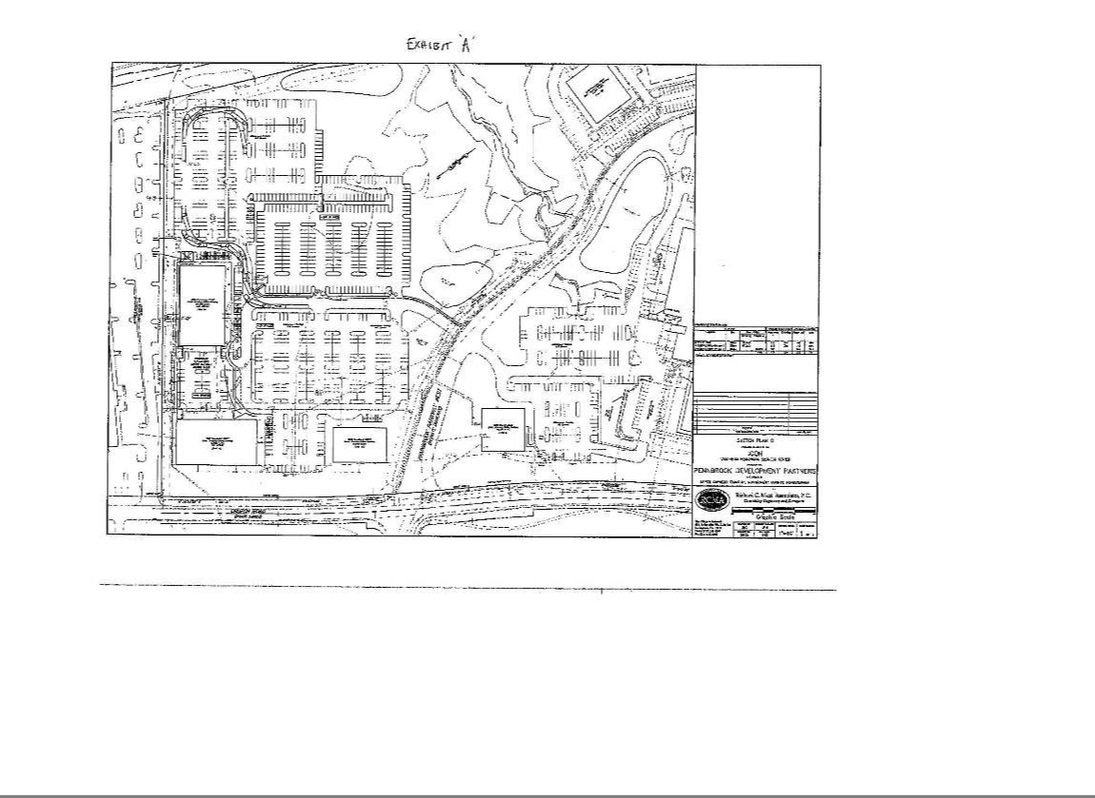

EXHIBIT "A-1"

LANDLORD'S WORK

  - Basic Building

- Common Areas

EXHIBIT A-1

EXHIBIT ‘A1a’

June 27, 2012

Page 1 of 6


Icon Clinical Research

Penn brook Business Center

2 STORY CONNECTOR BUILDING

SCOPE OF WORK

Revised 06/27/12

- SITEWORK: New building pad in location of existing paved parking area; re-locate existing sanitary sewer to outside building footprint as shown on the site plan; remove existing water service and easement running on the north side of 1700 and re-locate as shown on the site plan; Cut in preparation of new building pad to align with elevation of bldg. 2100 first floor slab; Soil and erosion control; strip and spread topsoil; site grading sanitary sewer; storm sewer; 2"domestic and 6" fire water service; 6" 2a modified base, 4.5"BCBC binder, 1.5" wearing surface bituminous paving; pavement markings and signs; concrete curbs, sidewalks, lighting, and

- LANDSCAPING: All landscaping plants and seeding by landlord and will be shown on final landscape plan.

- DEMOLITION: Selective demolition of the building exterior skin at both 1700 and 2100 as shown on the plans.

- CONCRETE: First floor shall be 4" reinforced concrete, 3,500 psi over 4" crushed stone with a floor flatness ofFF25/FL20 minimum average that is verified by an independent testing agency hired by contractor. The second floor will be concrete slab poured on metal decking consisting of 5½ reinforced slab, 3,500 psi, 4" slump with minimum average FF25 that is verified by an independent testing agency hired by contractor. All concrete slab surfaces are to be installed ready to receive carpet that complies fully with Section 6.2 of the Standard for Installation of Commercial Textile Floor Covering Materials as prepared by the Carpet & Rug Institute. CRI 104-1994 (or any subsequent updates). Evidence of such shall be submitted to the Owner in the form of Alkalinity and moisture tests conducted in accordance with the recommendations made in CRI 104-1994. ; Vapor barrier; elevator pit; concrete fill for stairs.

- FOUNDATIONS: Provide all concrete work including column footings and piers as required to support floors, walls and structural members. Provide and install a foundation insulation of 2"

perimeter isocyanurate insulation. Column footings for the new connector building along the face of the existing walls at 1700 and 2100 will need to be designed to bridge over so as not to over load existing column footings. See attached footing plan and section sketches.

2540 Renaissance Boulevard | Suite 100 | King of Prussia, PA 19406 | www.d2.com

610.238.0330 p | 610.238.0299 f

EXHIBIT ‘A1a’

June 27, 2012

Page 2 of 6

- STRUCTURAL FRAME: Structural steel columns and beams; steel joists; metal floor and roof deck; angle support frame for cold formed metal panels(CFMP panels); galvanized / painted framing for roof screen; floors designed for 100 pound live load which would included Tenant furniture, equipment and wall partitions. The floor to floor height of the building on the first floor shall be designed to align with the finished floor elevation of the building at 2100 on the ground level and the finished floor elevation of building at 1700 at the second floor. The first floor will be +/- 16'- 2" and will accommodate a clear finished ceiling height of 12'-0". The floor to floor height on the 2nd floor will be designed to match the floor to floor height of 1700 building at the second floor. The second floor will be +/- 15'-8" with a clear finished ceiling height of 9'-0"

2540 Renaissance Boulevard | Suite 100 | King of Prussia, PA 19406 | www.d2.com

610.238.0330 p | 610.238.0299 f

EXHIBIT ‘A1a’

June 27, 2012

Page 3 of 6

- MISCELLANEOUS METALS: Two (2) metal pan stairs; handrail at enclosed egress stairs; One (1) monumental stair priced as add alternate w/ open risers terrazzo treads, butt-glazed

glass railing system wl stainless steel cap priced as add alternate (refer to Attachment ”A”); connector bridge, steel frame, concrete on metal deck floor, butt-glazed glass railing system w/ stainless steel cap; elevator pit ladder; roof access ladder; channel supports for counter tops in toilet rooms.

- EXTERIOR WALL FRAMING: 6" x 18 gauge metal stud @ 16" o/c; 6" R-19 fiberglass batt insulation; ½,''dense glass gold sheathing; Tyvek air infiltration barrier; 16 gauge for the isolated locations with full height studs at the first floor.

- EXTERIOR WALL PANELS:

a. Alucobond aluminum composite exterior wall panels with concealed fasteners 4mm thickness; Rout and return wet seal system; PVDF MICA PEARLESCENT -3 Coat finish

- FLOOR EXPANSION JOINT: Wabo Fast Wrap, Low Profile-Floor (Model "LPF"), Plaza (Model "LPP") or carpet (Model "'LPC") Expansion Control System for interior floors located at 2nd floor level continuous slab conditions shown on the plan at the intersection of the connector building and the existing floor slabs at 1700 and 2100.

- ROOF TO WALL EXPANSION JOINT: Construction Specialties BRJW 600 series, stainless steel flange; neoprene 60 mil.

- ROOFING: Furnish and install Firestone or Carlisle 0.045 Black EPDM fully adhered fastened roof system; R-24 ( 4"total thickness) isocyanurate insulation 2 layers with staggered joints; one (1) roof hatch; clear anodized aluminum parapet wall coping; Atas 24 gauge equipment screen in standard Kynar colors; Firestone Red Shield NOL warranty 10 year on workmanship, 20 year on membrane; caulking. Roofing to follow "energy Star" criteria. General contractor to provide all rigid insulation boards, curbs, caps/copings, vents, access hatches, roof drains, scuppers, over-flow drains and pitch pockets as appropriate to address roof access, maintenance and drainage work.

- SPRAY FIREPROOFING: Cementitious Spray fireproof structural steel framing members supporting stairs and elevators, as required by code; fire stop at edge of upper floor slabs; Structural steel framing members and metal deck 10'-0" from 2100 building at roof of connector building 2 story open lobby.

- ROOF SCREEN: Furnish and install 24 gauge, Atas flush seam, 12" wide DSF- 120 Equipment roof screen panels

2540 Renaissance Boulevard | Suite 100 | King of Prussia, PA 19406 | www.d2.com

610.238.0330 p | 610.238.0299 f

EXHIBIT ‘A1a’

June 27, 2012

Page 4 of 6

- WINDOWS AND ENTRANCES:

      - Curtainwall System: Frames to be thermally broken with clear anodized finish.

Manufacturer: Kawneer 1600 Wall System 1 or 2 or approved equal; (See building elevations for mullion types. quantities and locations.

    - Store front window system frames to be thermally broken with clear anodized fmish. Manufacturer: Kawneer Aluminum 451 T or approved equal

  - All window systems to be front glazed.

    - The vision glass will be 1" insulated unit, incorporating reflective ¼'' Low-E glass in either of the aforementioned framing systems. Minimum performance requirements, Solar Heat Gain Coefficient (SHGC) 39 or less; Fixed U-Value .57 or less.
    - Spandrel units will either be insulated 1” glazing panel as indicated above with an opacifier coating on the glass lite #4 (White).

    - Final approval of all glass and glazing system components require a sample and mock-up panel approved by the Architect and Owner prior to fabrication.

    - Entrance doors shall be 350 Kawneer or approved equal; medium stiles; furnish and install additional aluminum door for the kitchen entrance; furnish and install electric latch retraction rim exit device with power supply for main entrance door, vestibule exit door, 2 stair exterior doors and kitchen entrance door; Small front canopy at front entrance constructed with steel framing and clad with Alucabond or equal cladding, will be provided. Price as add alternate 3 sets 6' x 8 entry doors at rear first floor as shown on the plans. (refer to attachment "A”)

- SKYLIGHT: Oldcastle Building Envelope Naturalite BMS-3000 Sloped Glazing System priced as add alternate.

    - Framing Members: Fabricate from 6063-T6 extruded aluminum alloy. Include integral gutter system.

    - Finish: Two Coats 70% Kynar 500/Haylar 5000 resin base fluoropolymer finish complying with AAMA 2605

    - Glazing Technique: Two sided structural silicone glazing.

    - Glazing: 1 3/16" insulated two-sided glazing units dual sealed with primary seal of polyisobutylene and secondary seal of two-part silicone; IGCC Class A rated

    - Glazing Gaskets and Blocking: Extruded, dense EPDM black rubber gaskets below glazing infill. Extruded closed-cell sponge EPDM black rubber gaskets above glazing infill. Silicone setting blocks.

    - Anchors and Fasteners: Cadmium plated non exposed; Stainless steel exposed to weather.

    - Sealants: Dow Corning 795 silicone sealant,

- H.M. DOORS, FRAMES AND FINISHED HARDWARE: Interior Frames: Knock down hollow metal; Interior doors: Solid core birch veneer wood doors; finished hardware sets; no tenant entrance doors; furnish and install exit device at stair doors with electric unlock function with cylinder bypass and power supply with fire alarm interface.

2540 Renaissance Boulevard | Suite 100 | King of Prussia, PA 19406 | www.d2.com

610.238.0330 p | 610.238.0299 f

EXHIBIT ‘A1a’

June 27, 2012

Page 5 of 6

- CARPENTRY AND MILLWORK:

Install solid core, birch veneer wood doors and hollow metal frames, and hardware. Provide all fire treated rough carpentry as required for the construction of the building in the shell and core areas including toilet, mechanical, electrical, telephone and elevator rooms. Roof blocking and backboards for telephone and electrical equipment are included.

- CORE AREA FINISHES:

  - 1 Hour fire rated shaft wall assembly enclosing structure of new connector building adjacent to the south wall of the 2100 building; return and fire caulk at existing window heads, and sills; Provide concealed sprinkler heads in soffits at all floor levels both sides of each existing window on the south side of2100 as shown on the plans.
  - Drywall partitions to be 3 5/8'', 25 gauge metal studs with 5/8" drywall; tape and spackle on all base building drywall, on Tenant side of all fire stairs, elevators, bathrooms, electrical rooms, telephone rooms, and janitor closets; drywall light cove in toilet rooms; foiled faced FSK insulation at perimeter walls.
  - Acoustical ceiling tile in toilet rooms to be Armstrong "Dune" 2 x 4 lay-in, non-directional, fine textured tile in standard 15/16" grid;

  - Furnish and install ceramic tile floors in toilet rooms; furnish and install ceramic tile on wet walls to ceiling of toilet rooms, provide mid-grade wall covering on other walls;

  - Mid range local Granite or Solid Surface material counter tops with recycled content, Avonite or equal, and under mount sinks in toilet rooms;

  - Pre-finished doors, painted frames, drywall partitions, stairs and handrails; floor mounted toilet partitions, toilet accessories;

  - 1" mini blinds on all windows which shall be installed after substantial completion of the Tenant Improvements but prior to Lease Commencement Date.

  - Lobby areas all wall and ceiling surfaces to be finished with GWB & prepped to receive Tenant's finishes.

  - Inside face of exterior walls within Tenant Spaces to be left unfinished. GWB and window sills to be installed as part of future tenant work and should not be included in Base Building construction.

2540 Renaissance Boulevard | Suite 100 | King of Prussia, PA 19406 | www.d2.com

610.238.0330 p | 610.238.0299 f

EXHIBIT ‘A1a’

June 27, 2012

Page 6 of 6

- ELEVATOR: Furnish and install two (2) Schindler (or equal) holeless Elevators, One 2,500 pound passenger elevator and one 3,500 pound capacity combination freight and passenger elevator; #4 brushed stainless steel ceiling with 6 down lights; #4 stainless steel finish for entrance door and frame; Wood veneer interior wall panels; 1½”round handrail inside car; provide wiring from the elevator cab to the machine room for card reader and security. Card reader to be furnished by others. Elevator speeds are 125 fpm, and the 3,500 pound elevator to have minimum 7'-0" clearance.

2540 Renaissance Boulevard | Suite 100 | King of Prussia, PA 19406 | www.d2.com

610.238.0330 p | 610.238.0299 f

‘EXHIBIT‘A1b’
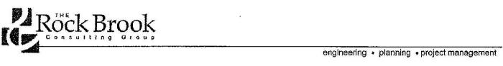

ICON BUILDING CONNECTOR

NORTH WALES, PA

9/27/11

STATEMENT OF CRITERIA FOR MEP/FP SYSTEMS

HVAC

SUMMARY

The HVAC system consists offour-(4), VAV packaged RTU's dueled to the Office, Atrium/Core, Fitness Center, and Kitchen/Cafe areas. Medium pressure supply ductwork will be routed horizontally on each floor and vertically within duct shafts. Return ductwork will be routed from each unit to the isolated ceiling plenum of each area. VAV boxes will be provided for all interior core spaces and Series Fan Powered Fan Terminal Units will be provided for any exterior base building spaces. Branch ductwork and diffusers will be connected to all VAV's and FTU's serving Atrium/Core areas only. Exhaust ductwork will be routed from Toilet and Utility rooms and rise vertically within duct shafts to rooftop exhaust fans. A new independent BAS system will be installed to control and monitor all new HVAC systems or, alternatively, tied into the existing Building 2100 Building Automation System.

CODES AND STANDARDS

2009 International Mechanical Code.

ASHRAE Standard 15-2007 Safety standard for Refrigeration Systems.

ASHRAE Standard 34-2007 Designation and Safety Classification of Refrigerants. ASHRAE Standard 62-2007 Ventilation for Acceptable Indoor Air Quality.

ASHRAE Standard 90.1.2007 Energy Standard for Buildings Except Low Rise Residential Buildings, I-P Edition.

SMACNA HVAC Air Duct Leakage Test Manual, 1st Edition, 1985.

SMACNA HVAC Duct Construction Standards, Metal and Flexible, 2nd Edition, 2005.

HVAC DESIGN CRITERIA

Environmental Design Criteria

Design of the facility is to follow the Codes and Regulations deemed appropriate under the jurisdiction of the project site.

Ambient Weather Crileria

- Winter oonditions are to be based on the climatic design conditions, dry bulb (DB) and wet bulb (WB), as outlined in the ASHRAE Fundamentals Handbook and ASHRAE Standard 90.1 for the 99.6 percentile.

ICON Building Connector

Project No. 11191 1 of 15 © 2011 The Rock Brook Consulting Group

‘EXHIBIT‘A1b’

- Summer conditions are to be based on the climatic design conditions, dry bulb (DB) and wet bulb (WB), as outlined in the ASHRAE Fundamentals Handbook and ASHRAE Standard 90.1 for the 1.0 percentile.

Space Temperature and Humidity

In general, indoor office space design conditions are relative to the comfort level of the occupants. Space design conditions, dry bulb (db) and relative humidity {RH) should be as follows unless otherwise noted:

•

Summer:

75'F db Max.

60% RH Max.

•

Winter:

70'F db Min.

Provide Fitness Center with cooling and heating as required. Space design conditions, dry bulb (db) and relative humidity (RH) should be as follows:

•

Summer:

78'F db Max.

60% RH Max.

•

Winter:

70'F db Min.

Provide Cafe with cooling and heating as required. Space design conditions, dry bulb (db) and relative humidity (RH) should be as follows:

•

Summer:

75'F db Max.

60% RH Max.

•

Winter:

70'F db Min.

Provide Kitchen areas with cooling and heating as required. Space design conditions, dry bulb (db) and relative humidity {RH) should be as follows:

•

Summer:

78'F db Max.

60% RH Max.

•

Winter:

70'F db Min.

Provide Utility spaces such as Mechanical Equipment Rooms, Electrical Switchgear and Transforrner Rooms with cooling and heating as required. Space design conditions, dry bulb (db), should be as follows:

•

Summer:

105'F db Max.

•

Winter:

60'F (16'C) db.

Ventilation Criteria

The HVAC system will maintain constant ventilation air flow to control indoor air contaminants and odors. ASHRAE Standard 62 will be used as a basis to determine the proper ventilation rates and system design.

Where exhaust systems are located, outside air will be provided as necessary to satisfy the exhaust make up air. A monitoring and control system will be provided to monitor and control outdoor air volume.

Pressurization Criteria

The building should be maintained positively pressurized relative to the exterior to minimize infiltration. Toilet Rooms, Janitor Closets, Mechanical/Electrical Utility Closets and Elevator Machine Rooms, will be maintained under negative pressure relative to adjacent spaces.

ICON Building Connector

Project No. 11191 2 of 15 © 2011 The Rock Brook Consulting Group

‘EXHIBIT‘A1b’

Filtration Criteria

Air filtration at the air handling units will be provided with filters having an MERV of 7 as defined by ASHRAE Standard 52-2, 1999 (formerly 25-30% as defined by ASHRAE Standard 52.1).

Acoustical Criteria

Equipment and air devices will be selected based on a resultant space noise criteria not-to-exceed the following:

• | Corridors and Lobbies | NC-40
• | Mechanical and Electrical Equipment Rooms | NC-65

HVAC SYSTEMS

Variable air volume (VAY) packaged rooftop units will be provided to serve each of the following applications:

  - Office - 75 tons

  - Atrium and Core areas - 20 tons

  - Fitness Center - 25 tons•

  - Kitchen I Cafe - 35 tons

* This unit will be installed as part of the core and shell construction, cost of.purchase and installatiori will be deducted from tenant fit out allowance.

Each unit will include a supply fan with premium efficiency motors and variable frequency drives, return fan with premium efficiency motors and variable frequency drives, DX cooling coil, electric heating coil, 85% efficient cartridge filters, 30% efficient fiat filters, and economizer. The unit will provide a constant 55°F supply air temperature to the spaces.

Acceptable manufacturers are Carrier, York Johnson Controls, Trane, or McQuay.

MAKEUP AIR SYSTEMS (ADD ALTERNATE)

A constant volume rooftop makeup air unit will be provided to serve the kitchen hood. The makeup air will be based on the size of the hood (assume 3000 CFM).

The unit will include a supply fan with premium efficiency motor, DX cooling, electric heating coil, 30% efficient fiat filters, and intake hood. The unit will provide a constant 70°F supply air temperature to the hood.

ICON Building Connector

Project No. 11191 3 of 15 © 2011 The Rock Brook Consulting Group

‘EXHIBIT‘A1b’

EXHAUST SYSTEMS

Toilel Rooms

Provide one roof mounted downblast type centrifugal exhaust fan for the toilet rooms and janitor closet. The exhaust will be based on a minimum of 75 CFM per toilet or urinal. Utility Rooms

Provide one roof mounted downblast type centrifugal exhaust fan for the electrical, mechanical, and elevator machine rooms. The exhaust will be based on a minimum of 1 CFM per square foot. Locker Rooms (Add Alternate)

Provide one roof mounted downblast type centrifugal exhaust fan for the locker rooms, The exhaust will be based on a minimum of 50 CFM per shower and 1 CFM per square foot. (Refer to Attachment 'A')

Dishwasher (Add Alternate)

Provide one roof mounted upblast type centrifugal exhaust fan for the dishwasher. The exhaust will be based on dishwashing equipment (Assume 500 CFM). (Refer to Attachment 'A')

Grease Exhaust (Add Alternate)

Provide one roof mounted upblast type, grease rated, centrifugal exhaust fan for the Type 1 Hood. The exhaust will be based on hood (Assume 5000 CFM). (Refer to Attachment 'A')

AIR DISTRIBUTION

The following items will be included in the air distribution systems as related to the atrium, and lobby, restrooms, and mechanical space:

- Linear diffusers will be provided at perimeter walls in the atrium and lobby,

- Interior diffusers will be louvered face 24 inch by 24 inch in the restrooms and mechanical spaces.

- Fire dampers shall be provided where required by the International Mechanical Code.

- Volume dampers shall be provided to facilitate air balancing.

- Smoke dampers shall be provided in all air systems 15,000 CFM and over in accordance with the International Mechanical Code requirements.

- Smoke detectors shall be provided in all air systems 2,000 CFM and over in accordance with the International Mechanical Code.

- All supply, return, and exhaust (except dishwasher and grease exhaust) air shall be galvanized steel.

- Ductwork in "H" pattern consisting of approximately 225 LF of horizontal supply ductwork on each

floor ranging in size from 65" x 22" to 22" x 7" into future tenant spaces for future connection of VAV units.

ICON Building Connector

Project No. 11191 4 of 15 © 2011 The Rock Brook Consulting Group

‘EXHIBIT‘A1b’

- Dishwasher exhaust shall be welded stainless steel (assume 100 LF of ductwork). (Add Alternate)

- Grease exhaust shall be welded carbon steel (assume 100 LF of ductwork). (Add Alternate)

- All supply ductwork shall be insulated with 1-1/2 inch batt insulation.

- Grease exhaust shall be insulated with 1 hour rated fire wrap insulation. (Add Alternate)

- Supply, return, and exhaust ductwork serving the first floor will be located within a shaft.

• Access doors shall be provided in the ductwork installed as part of the landlords work, in the following locations:

- At all automatic control dampers.

- On both upstream and downstream sides of each reheat coil, sound trap, and in-line fan. On both upstream and downstream side at each duct flow and pressure measuring device. At each duct mounted temperature sensor.

- At fire dampers, smoke dampers and smoke detectors.

BALANCING AND PRESSURE TESTING

Testing. Adjusting and Balancing (Applicable to Atrium, Lobby, Toilet Exhaust, and Electrical/Mechanical Exhaust)

All air handling systems, steam system and hydronic systems shall be tested, adjusted and balanced in accordance with the design criteria by a certified testing agency and certified technicians. The agency and technicians shall be certified and trained by either NEBB or AABC.

Test

All duct systems installed as part of landlord work will be pressure and leak tested.

CONTROL SYSTEM

Provide new BACnet compliant, DDC control system to monitor new systems, capable of setpoint adjustment, scheduling, setpoint trending, remote alarm notification, and password protected web access.

Provide new control system in connector building. Provide separate control system within existing 2100 building. Confirm existing control system manufacturer prior to submission of pricing.

ICON Building Connector

Project No. 11191 5 of 15 © 2011 The Rock Brook Consulting Group

‘EXHIBIT‘A1b’

PLUMBING

CODES AND STANDARDS

International Building Code (IBC).

International Plumbing Code (IPC), 2009 Edition. International Fuel Gas Code (IFGC), 2009 Edition. '

DOMESTIC COLD WATER SYSTEM

The domestic cold water system will be distributed to core areas only. System capacities will be sized based upon fixture unit values with appropriate code factors and actual equipment demands. Water velocity in the branch piping will not exceed 8 feet per second and provisions will be made to arrest water hammer. Piping shall be sized to maintain 25 psig at the most hydraulically remote fixture. Service branches will be located in pipe chases or wall cavities as required. Accessible shut off valves will be specified at all branch piping.

A reduced pressure type backflow preventer will be provided on Ihe new incoming domestic water service. Coordination will take place with the local utility company for the water meter and installation.

Connections from the domestic water system to mechanical systems wlll be provided with reduced pressure type backflow preventers.

Water hammer arrestors will be provided at all locations where automated quick closing valves are installed, such as fiushvalves.

Domestic water piping located within building will be Type L copper. The entire domestic cold water system will be insulated.

DOMESTIC HOT WATER SYSTEM

Domestic hot water will be distributed to core areas only. An electric hot water heater will generate 120°F hot water for distribution.

An expansion tank will be provided on the incoming cold water side of the water heater to absorb expansion and to prevent piping damage.

System capacities will be sized based on fixture unit values with appropriate code factors and actual equipment demands. The domestic hot water piping shall be sized to maintain a minimum of 25 psig at the most hydraulically remote fixture. Water velocity in the hot water distribution piping will not exceed 6 feet per second. Accessible shut off valves will be specified at all branch piping.

Water hammer arrestors will be provided at all locations where automated quick closing valves are installed, such as dishwashers.

Domestic water piping located within building will be Type L copper. The entire domestic hot water system will be insulated.

ICON Building Connector

Project No. 11191 6 of 15 © 2011 The Rock Brook Consulting Group

‘EXHIBIT‘A1b’

SANITARY WASTE AND VENT SYSTEMS

The sanitary drain and vent system will be supplied to water closets, urinals, sinks, mop receptors, ftoor drains, and other locations, where required.

All sanitary drainage, waste and vent piping will be located either below floor slabs, above ceilings, in pipe chases, or in wall cavities. Complete accessibility will be available to all clean outs in the drainage piping system.

Sanitary waste and vent piping located within building will be Hubless cast-iron soil pipe and fittings with stainless steel couplings.

STORM WATER SYSTEM

System capacities will be sized based upon roof square footage with appropriate code tables and factors.

Storm water piping located within building will be Hubless cast-iron soil pipe and fittings with stainless steel couplings. The roof drain bodies and horizontal piping of the storm water system will be insulated.

NATURAL GAS SYSTEM (ADD ALTERNATE)

A new natural gas service is anticipated for the future tenant's kitchen. It is noted that a gas line is run in Church Road. We have a phone call into PECO to confirm service from Church Road. We have not heard from PECO at this lime, to confirm if PECO can provide a new service to the building.

Any new piping will be welded or seamless Schedule 40 black steel ASTM A120. Lock up type regulators are required upstream of each connection to ensure proper pressure. (Refer to Attachment 'A')

ICON Building Connector

Project No. 11191 7 of 15 © 2011 The Rock Brook Consulting Group

‘EXHIBIT‘A1b’

EQUIPMENT AND MATERIALS

Except as previously identified, the following will be the basis of design for the equipment and materials:

• Sanitary waste and vent piping: Hubless cast-iron soil pipe and fittings with stainless steel couplings.

- Storm piping: Hubless cast-iron soil pipe and fittings with stainless steel couplings.

- Domestic Cold Water Piping: Copper tube Type L with wrought copper fittings and lead free (95/5 Tin Antimony) solder joints

- Domestic Hot Water Piping: Copper tube Type L with wrought copper fittings and lead free (95/5 Tin Anlimony) solder joints

- Natural Gas Piping: Welded or threaded Black Steel, Schedule 40.

PLUMBING - FIXTURES, EQUIPMENT AND SPECIALTIES

- Plumbing fixtures high efficiency, low fiow type.

  - Toilets, vitreous china wall hung, dual fiush 0.8/1.6 gpf.

  - Urinals, vitreous china wall hung, 1.0 gpf.

  - Lavatories, vitreous china wall hung, battery sensor faucet, 0.5 gpm aerators.

  - Electric Water Cooler, self-contained, wall mount, electric refrigerated individual unit on each floor.

  - Mop Service Basin, floor mounted molded stone, minimum 24"x24" with wall mounted faucet with bucket hook and integral vacuum breaker.

  - Exterior Wall Hydrants, non-freeze type with integral vacuum breaker and stainless steel recessed wall box.

- A temperature limiting device set at 105'F will be provided at all hand washing facilities.

- Water hammer arrestors: Stainless steel construction, installed as required to absorb hydrostatic shock pressure in the potable water piping system

- Floor Drain: Cast iron deep seal p-1rap with trap primer connection and nickel bronze strainer.

    - Floor drains will be provided in toilet rooms and mechanical rooms.

- Grease Interceptor: recessed floor, steel interceptor with steel cover and flow control device. (add alternate) (Refer to Attachment 'A')

- Valves: Two piece bronze body ball valves for 2' and smaller. Iron body gate valves for 2-½" and larger.

- Roof Drain: medium cast iron sump with cast iron dome strainer, under deck clamp and fiashing clamp.

ICON Building Connector

Project No. 11191 8 of 15 © 2011 The Rock Brook Consulting Group

‘EXHIBIT‘A1b’

FIRE PROTECTION

SYSTEM DESCRIPTION

The building shall be fully sprinklered with a new automatic wet sprinkler system. The required sprinkler density for the sprinkler system design shall be Light Hazard for all areas.

A double check detector type backflow preventer will be provided on the new incoming fire water service. Design and installation shall be in accordance latest adopted edition of NFPA 13 Installation of Sprinkler Systems and any other applicable codes and standards as required by the local Authority Having Jurisdiction (AHJ) and Factory Mutual Insurance (FM).

Components of the sprinkler system shall be UL listed and FM approved and meet all requirements of NFPA 13 and FM.

Contractor is responsible for conducting a flow test Results of the flow test are to be submitted to the Owner and used by the Sprinkler Contractor to design the sprinkler system for the building.

Fire department connection shall be located within 50 feet of an existing fire hydrant on the site.

Where fire protection systems are required to be protected against earthquake damage by Code, system shall be installed according to the requirements of NFPA 13 to withstand seismic forces.

CODES AND STANDARDS

Fire-suppression-system equipment, specialties, accessories, installation, and testing shall comply with the following:

- 2009 International Building Code {IBC)

- NFPA 13, Installation of Sprinkler Systems.

- NFPA 25, Standard for the Inspection, Testing and Maintenance of Water Based Fire Protection Systems.

- NFPA 24, Standard for the Installation of Private Fire Senlice Mains and Their Appurtenances.

- Factory Mutual Data Sheet 2-8N: NFPA 13 Standard for Installation of Sprinkler Systems.

- Factory Mutual Data Sheet 3-26: Fire Protection Water Demand for Non-Storage Sprinklered Properties.

ICON Building Connector

Project No. 11191 9 of 15 © 2011 The Rock Brook Consulting Group

‘EXHIBIT‘A1b’

PRODUCTS AND MATERIALS

Sprinklers shall be UL listed, FM approved, quick response. ·concealed pendant sprinklers shall be installed in the public areas. Through the shell space, sprinklers heads shall be installed turned upright.

Install sprinkler heads on either side of the demising wall at the atrium to create a one hour rating in accordance with NFPA requirements.

Sprinkler Pipe and Fittings: Wet System Sprinkler Piping shall be black steel with threaded, grooved or welded fittings. Dry Pipe System Sprinkler Piping shall be galvanized. Wall thickness of pipe shall be as permissible by NFPA 13 and FM.

Underground Piping between Fire Department Connections and Check Valves: Piping shall be galvanized, standard-weight steel pipe with grooved ends; grooved-end fittings; grooved-end-pipe couplings; and grooved joints. Pipe shall be externally coated and wrapped.

Underground Service-Entrance Piping: Ductile-iron, Class 52, push on, or mechanical-joint pipe and fittings and restrained joints. Include corrosion-protective encasement where required.

A new Service Riser will be provided for Ihe building including alarm check valve(s), How and tamper switches as required to meet NFPA 13 and FM.

Valves: Valves shall be UL Listed and FM approved with 175 psig minimum pressure rating.

Fire Department Connection shall be exposed, freestanding-type, and meet specifications of local AHJ.

ICON Building Connector

Project No. 11191 10 of 15 © 2011 The Rock Brook Consulting Group

‘EXHIBIT‘A1b’

ELECTRICAL

SUMMARY

The incoming electrical service for the building will be supplied from the street service of Philadelphia

Electric and Gas Company (PECO). The electrical service will enter the building via a new outdoor pad mounted utility transformer. The electric service will terminate into a Main Distribution Panel (MOP) within the building. The main electrical service will be sized to accommodate approximately 18 Watts/Square Foot (W/SF) of demand load. All power throughout the building will be supplied from the new MOP. One 480V power feed will be supplied from the MOP to a base building distribution panel on the frrst fioor. A second 480V power feed will be supplied from the MOP to a base building distribution panel on the second floor.

The electrical infrastructure will include the following:

- Power feeder circuit wiring/conduit to base building Mechanical and Plumbing related equipment

- Branch circuit wiring to base building lighting fi tures, receptacle devices, etc.

- Minimal exit and egress lighting to meet code requirements

- Exterior lighting at each entry and exit from the building

- New digital, programmable lighting controller panel to control building lighting

- New fire alarm system and signaling/notification devices to meet cod requirements

- Conduit raceways for telecommunication service to the building

CODES AND STANDARDS

The electrical engineering design, materials, equipment and workmanship will conform to the latest approved edition of all local and national codes, as well as all applicable laws and regulations or regulatory bodies having jurisdiction over this work. These include, but are not limited to, the most current edition of following standards and guidelines:

- NFPA 70: National Electrical Code (NEC).

- NFPA 72: National Fire Alarm Code.

- NFPA 101: Life Safety Code.

- NFPA 110: Standard for Emergency and Standby Power Systems.

- Institute for Electrical and Electronics Engineers (IEEE).

- Illuminating Engineering Society (IES) Standards.

- ANSl/ASHRAEllESNA Standard 90.1-2007 -Sections 9 and 10 (Power and Lighting).

NEW MAIN ELECTRICAL SERVICE EQUIPMENT AND DISTRIBUTION

Base Scope of Work

The incoming electrical service will be sized to accommodate a minimum of 18 Watts/Square Foot r,:N/SF) for the new building. Based upon an overall building size of approximately 37,000 square feet, the newelectrical service to the building will be rated 1,200 Amps (A) at 480 Volt M. 3 Phase, 4 Wire (W).

ICON Building Connector

Project No. 11191 11 of 15 © 2011 The Rock Brook Consulting Group

‘EXHIBIT‘A1b’

The incoming electrical service will be supplied from Philadelphia Electric and Gas Company (PECO) via a new 750kVA (Kilo-Volt-Ampere) outdoor. pad-mounted, liquid-filled utility transformer. 'The PECO utility transformer will be located on new concrete housekeeping pad adjacent to the existing PECO utility transformers on the site.

Transformer Primary and Secondary Conductors and Raceways

The primary, medium-voltage service conductors from the utility company to the transformer will be provided by PECO. For the medium-voltage service conductors from PECO to the primary side of the new transformer, two 5" Schedule 80 PVC (polyvinyl chloride) conduits shall be routed from the primary windings side of the PECO transformer to a point designated by the utility company. For pricing purposes, it may be assumed that the conduit distance from the outdoor transformer to the point designated by PECO is approximately 150 feet.

For the secondary, low-voltage (i.e. 480V) service conductors that will connect from |  | the secondarywinding side of the PECO transformer to the new main distribution panel
(MOP), four 4" Schedule 80 conduits (one shall be a designated spare) will be routed underground within a |  | concrete-encased electrical duct bank. These secondary conduits will be routed into the
building and will terminate into the MOP, which will be located in a new main electrical room within the new connector building. The new MDP shall be rated 1200A, 480Y/277V, 3 Phase, 4 Wire,
65kAIC. For pricing purposes, it may be assumed that distance from transformer to the MOP is approximately 200 feet.
Main Distribution Panel (MDP)

The new MDP will be front-connected, front-accessible only and will be rated for 1200A, 480Y/277V, 30, 4W, 65kAIC (Kiloamps Interrupting Capacity) with continuous copper bussing. The MDP will include a 1200A, 3 Pole, 100% rated main circuit breaker with integral ground-fault protection. Four separate sections or cabinets will comprise the MDP. The secondary conductors from the outdoor, pad-mounted transfonmer will terminate into the first section ol the MDP, which is the utility metering cabinet. The utility metering cabinet will house the Current Transfonmers (CTs) that PECO will utilize lo meter the building's electrical consumption.

The main distribution panai will include a flush-mounted, muili-function, digital meter that will be microprocessor-based and that will be capable of monitoring power characteristics such as voltage, current, kW (Kilowatt), kWH (Kilowatt Hours) power factor, etc.

Add Alternate

As an Add Alternate scope of work, the incoming electrical service will be sized to accommodate a minimum of 25 W/SF for the new building. Based upon an overall building size of approximately 37,000 square feet, the new electrical service to the building will be rated 1,600 Amps at 480V, 3 Phase, 4W. (Refer to Attachment 'A')

The incoming electrical service will be supplied from PECO via a new 1000kVA outdoor, pad-mounted, liquid-filled utility transformer. The PECO utility transformer will be located on new concrete housekeeping pad adjacent to the existing PECO utility transformers on the site.

Transformer Primary and Secondary Conductors and Raceways

The primary, medium-voltage service conductors from the utility company to the transformer will be provided by PECO. For the medium-voltage service conductors from PECO to the primary side of the new transformer, two 5" Schedule 80 PVC (polyvinyl chloride) conduits s.hall be routed from the primary windings side of the PECO transformer to a point designated by the utility company. For pricing
purposes, it may be assumed that the conduit distance from the outdoor translormer | to the point designated by PECO is approximately 150 feet.
ICON Building Connector
Project No. 11191 | 12 of 15
© 2011 The Rock Brook Consulting Group

‘EXHIBIT‘A1b’

For the secondary, low-voltage (Le. 480V) service conductors that will connect from the secondary winding side of the PECO transformer to the new MDP, five 4" Schedule 80 conduits (one shall be a designated spare) will be routed underground within a concrete-encased electrical duct bank. These secondary conduits will be routed into the building and will terminate into the main distribution panel, which will be located in a new main electrtcal room within the new connector building. The new MDP shall be rated 1600A, 480Y/277V, 3 Phase, 4 Wire, 65kAIC. For pricing purposes, it may be assumed that distance from transformer to the MDP is approximately 200 feet.

Main Distribution Panel (MDP)

The new MDP shall have the same characteristics as described under the Base scope of work with the exception of the equipment rating, which shall be 1,600 Amps under the Alternate scope of work.

BUILDING POWER DISTRIBUTION

Base Building Power Distribution

Landlord will provide step down transformers and panels for the core area only. All other distribution shall be tenant finish.

A dry-type, voltage-reducing transformer will be located on the first floor to provide 208Y/120V power to one 208Y/120V receptacle distribution panelboard. 208V and 120V receptacle loads for base building spaces such as the main lobby, atrium, toilet rooms, janitorial closets, etc. will be supplied from the house

branch circuit panelboard. Equipment within the scope of this project will be rated to operate from 480V, 277V, 208V, and/or 120V power.

Two 4" conduits from the main electrical room to the second floor, for tenant use, shall be provided.

NEW SYSTEMS AND EQUIPMENT - DESIGN CRITERIA

Power Requirements and Conductors

All electrical and equipment grounding conductors will be copper and UL-listed with a minimum insulation temperature rating of 75°C. Conductor insulation will be 600V, type THHNffHWN.

The minimum conductor size for power will be no smaller than #12 AWG (American Wire Gauge) and no smaller than #14 for control/communication wiring. Each circuit will contain its own dedicated copper neutral conductor. Under no circumstances will neutral conductors be shared between circuits.

Conduit Raceways

The minimum conduit trade size permissible for power conductors is 3/4 inch and 1/2 inch for control/communication conductors. All indoor feeder conductors will be contained within

electrical metallic tubing (EMT) with compression-type fittings. EMT conduit will also be utilized for lighting and receptacle branch circuits, fire alarm system circuits, and security and telecommunication circuits.

Electrical Devices

Standard convenience receptacles will be specification grade, duplex, NEMA 5 20R, and will be rated for 125V, 20A operation. Ground-fault circuit interrupter (GFCI) receptacles will be specification grade,

NEMA 5-20R, and will be rated for 125V, 20A operation.

ICON Building Connector

Project No. 11191 13 of 15 © 2011 The Rock Brook Consulting Group

‘EXHIBIT‘A1b’

Panelboards

All panelboards and associated overcurrent protection devices will be rated for the normal load current and the maximum available short circuit current. Each panel will be housed in a steel cabinet with a hinged locking door. Panel enclosures located in dry locations will be rated for NEMA 1 use in general purpose areas. Panel enclosures located in wet locations or outdoors will be rated for NEMA 3R use. Each panel will contain copper bus bars, a 100% rated copper neutral bus, and a copper safety ground bus.

Low-Voltage Transformers

The power distribution system will include 480V - 208Y/120V, 30, 4W step-down transformers that will provide 208Y/120V power branch circuit devices such as base building receptacles. All transformers will have continuous copper windings.

GROUNDING

Equipment Grounding

All electrical systems will be properly grounded in accordance with Article 250 of the NEC to protect personnel and equipment and to meet applicable code requirements. All feeders and branch circuits will include their own dedicated, insulated copper grounding conductor. Under no circumstances will metal conduit of any kind, type, or length be utilized as an equipment grounding conductor.

LIGHTING SYSTEMS

Atrium and Lobby

Minimum co e required lighting will be provided by the landlord in these spaces.

Electrical/Mechanical Rooms and Areas

Lighting fixtures located in electrical and/or mechanical areas will be 4 feet long, chain-hung, utility-type industrial fixtures with fluorescent lamps, type T5 or T8.

Exterior Lighting

Exterior lighting will be provided at each entry/exit into the building.

Exit and Egress Lighting

Egress and exit lighting will be designed to provide sufficient illumination and direction to allow personnel to safely exit the building in the event of a power failure or emergency condition. During a loss of power, a minimum of one (1) foot candle at the floor level will be provided to allow for safe egress, as required by NFPA 101 (the applicable life safety code).

LED exit signs and egress (emergency) lighting fixtures will be located along the path of egress in accordance with good engineering practice for life safety and all applicable codes. Each exit sign and emergency lighting fixture will. have an integral emergency battery pack rated for 90 minutes of continuous operation in accordance with NFPA requirements.

ICON Building Connector

Project No. 11191 14 of 15 © 2011 The Rock Brook Consulting Group

‘EXHIBIT‘A1b’

LIGHTING CONTROLS

General Lighting Control Design Criteria - Atrium and Lobby

Automatic lighting controls will be provided Atrium and lobby lighting via a digital, programmable lighting control system.

Electrical/Mechanical Rooms and Areas

Lighting within electrical and mechanical rooms or areas will be controlled from a local wall switch within the room.

FIRE ALARM SYSTEM

General System Design Criteria

The building's new fire alarm system will be a fully addressable system that is comprised of various fire alarm signaling and notification devices such as manual pull stations, audible horns, visual strobes, combination horn/strobes, and smoke detectors. The main fire alarm control panel will be located in the main electrical room. A fire alarm annunciator panel will be located at the main entrance into the building.

The fire alarm notification devices will be located in accordance with good engineering practice for life safety and applicable codes and will be ADA-compliant. Each device will be located to provide an adequate level of visual and/or audible notificaf1on to personnel.

Conduit Racewav Requirements

For fire alarm cabling to each wall or partition-mounted data device, a 3/4 inch conduit with an EMT grommet bushing and pull wire will be connected to junction box in the wall or partition and stubbed up to above the finished ceiling.

ICON Building Connector

Project No. 11191 15 of 15 © 2011 The Rock Brook Consulting Group

‘EXHIBIT‘A1b’

ATTACHMENT "A"

TO

SCOPE OF WORK 2 STORY CONNECTOR BUILDING

  - Section 8 MISCELLANEOUS METALS: (a) Monumental Stair, Add Alternate $99,895; (b) Butt Glazed Railing System, Add Alternate $73,696.

  - Section 16 Windows and Entrances: Add Alternate 3 sets 6'x8 entry doors at rear first floor $17,850.

  - Section 17 Skylight: Add Alternate $109,599

  - Rockbrook, Locker Room Exhaust, Add Alternate $7,738

  - Rockbrook, Dishwasher Exhaust, Add Alternate $15,456 (includes ductwork)

  - Rockbrook, Grease Exhaust, Add Alternate $16,920 (includes ductwork)

- Rockbrook, Natural Gas System, Add Alternate $2625 (excludes PECO charges)

- Roclkbrook, Grease Interceptor, Add Alternate $4,935 {installed prior to floor pour)

- Rockbrook, 1600 Amp Service, Add Alternate $5,000

- Rockbrook, 25 ton Fitness Unit, Unit to be installed as part of shell at a cost of $37,500 to Tenant

EXHIBIT 'A1c'
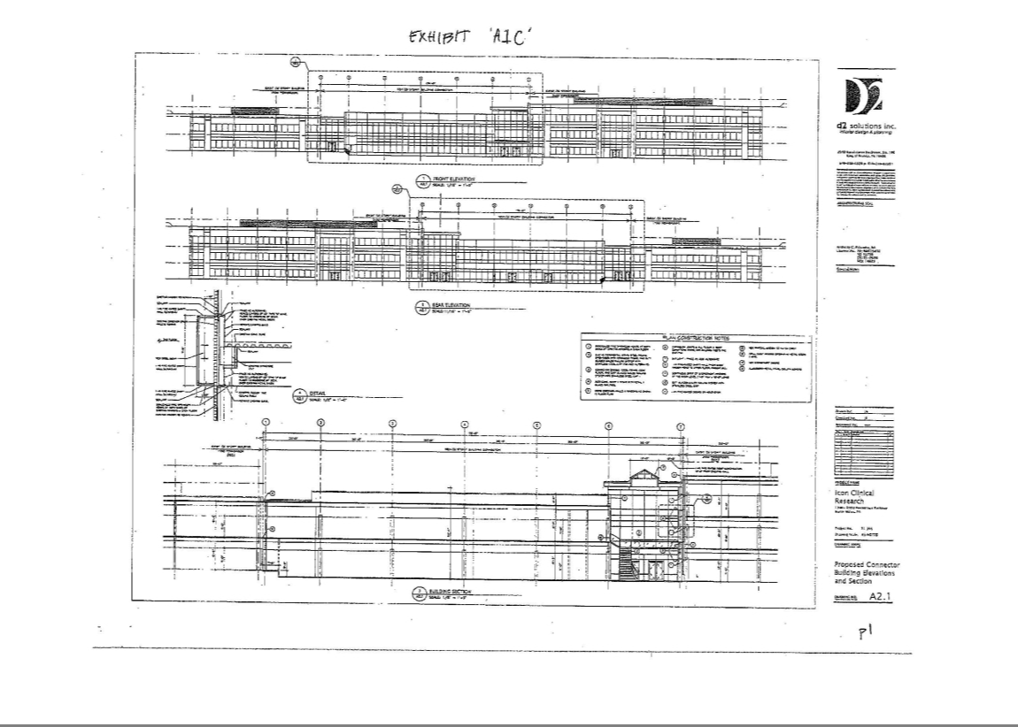

EXHIBIT 'A1c'
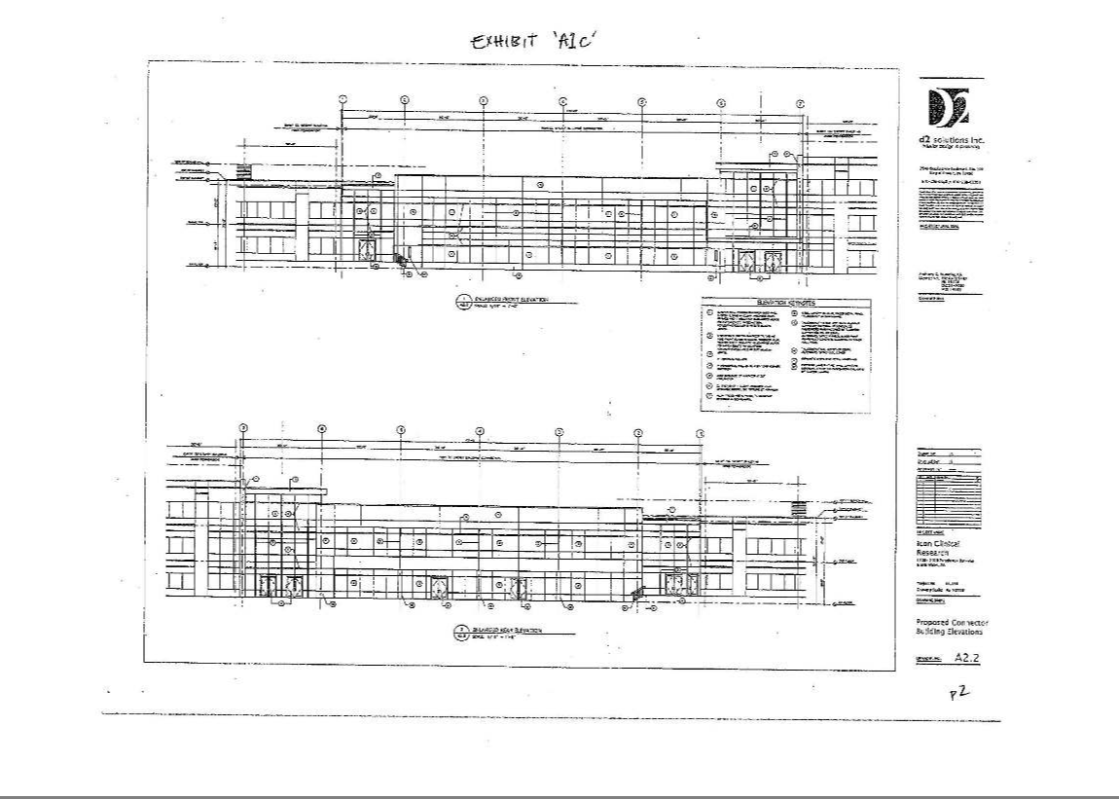

EXHIBIT 'A1c'
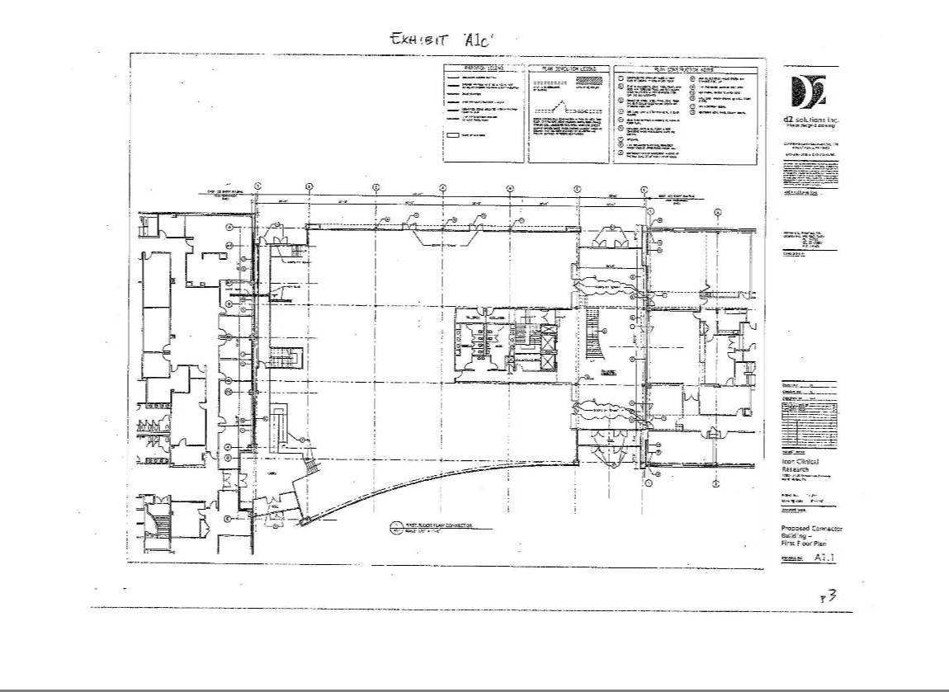

EXHIBIT 'A1c'
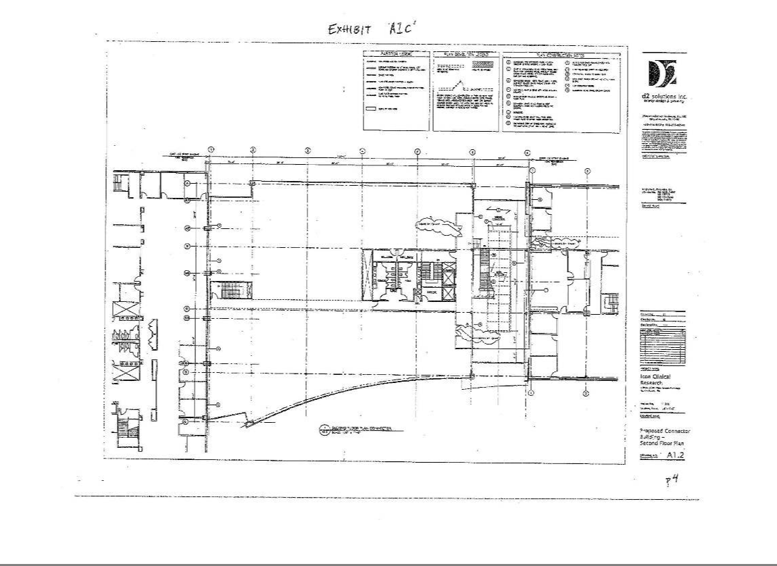

EXHIBIT 'A1c'
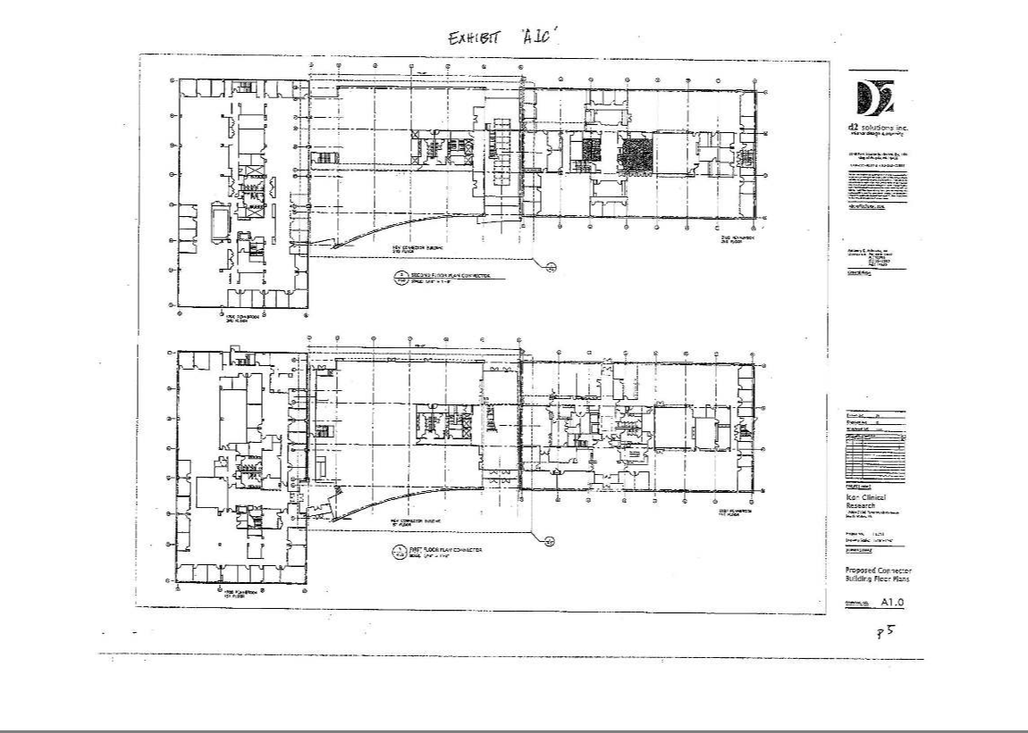

EXHIBIT "A-2"

PROPERTY PLAN

EXHIBIT A-2

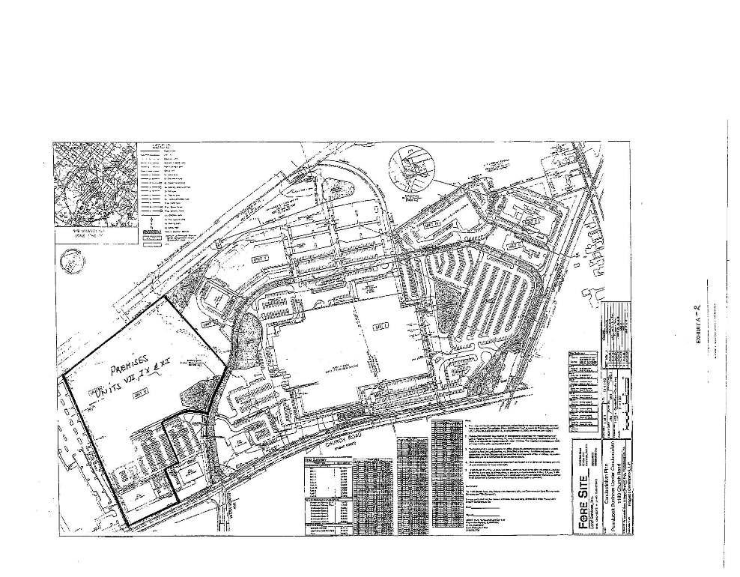

EXHIBIT "A-3"

SITE PLAN

EXHIBIT A-3

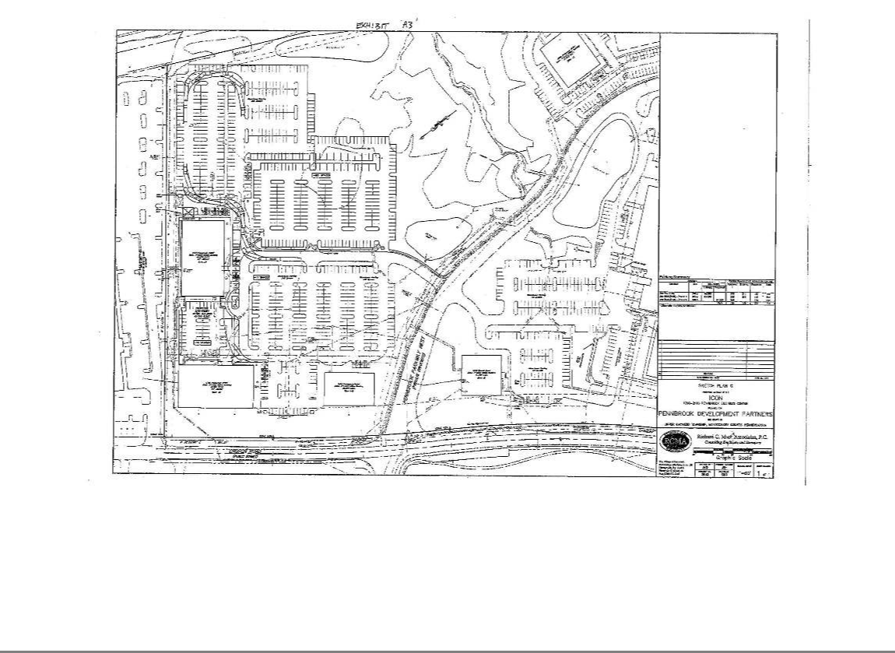

EXHIBIT "A-3L"

TENANT LOADING AREA

EXHIBIT A-3L

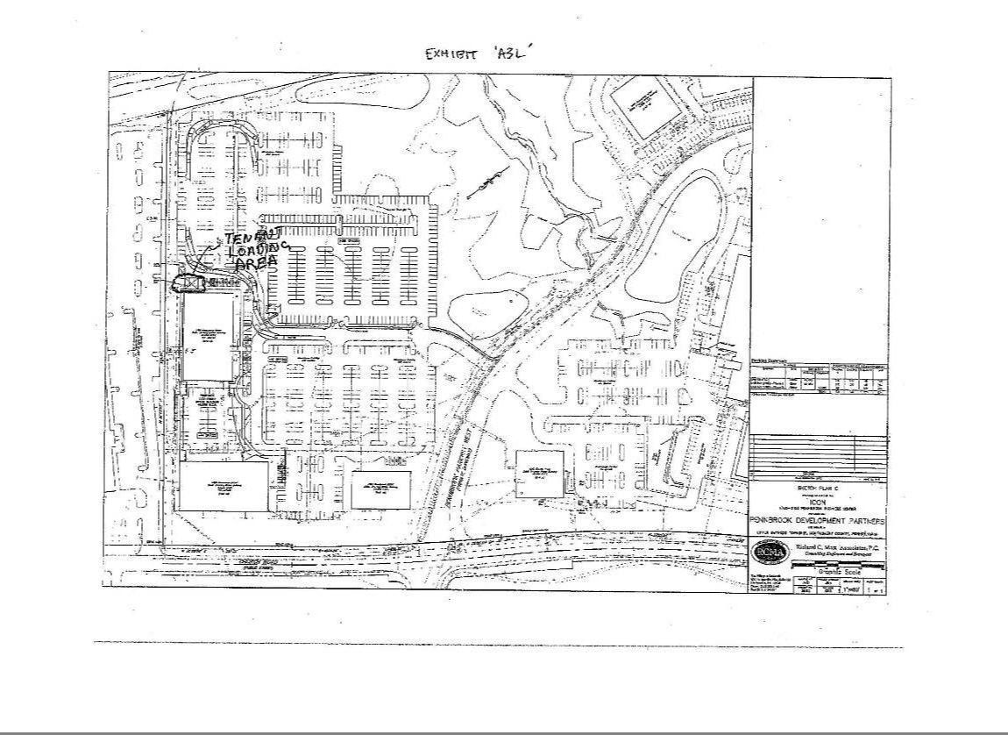

EXHIBIT "A-3V"

VACATED PARKING AREA

EXHIBIT A-3V

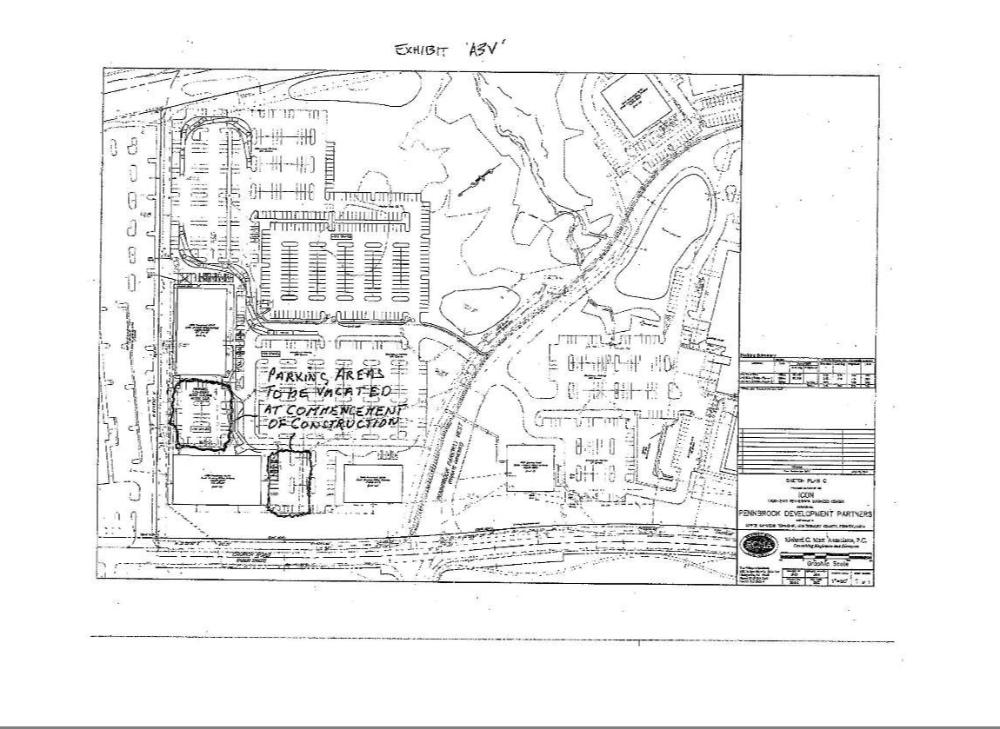

EXHIBIT "A-4"

TI PLANS

EXHIBIT A-4

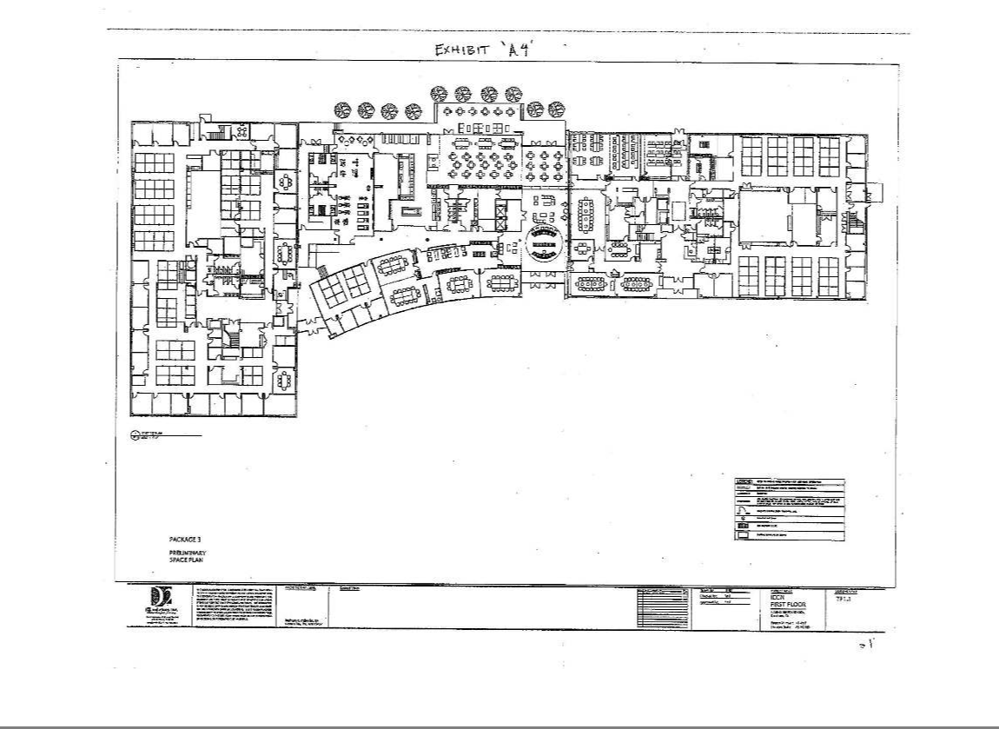

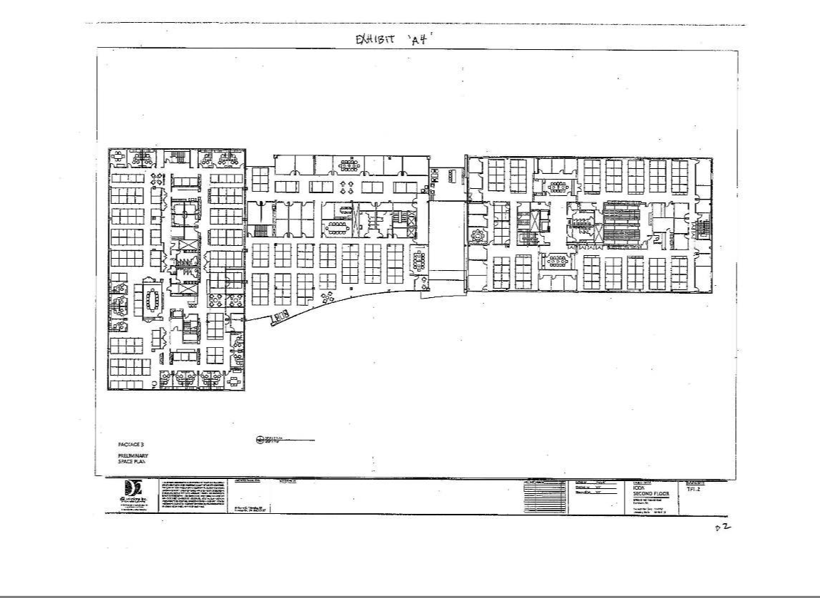

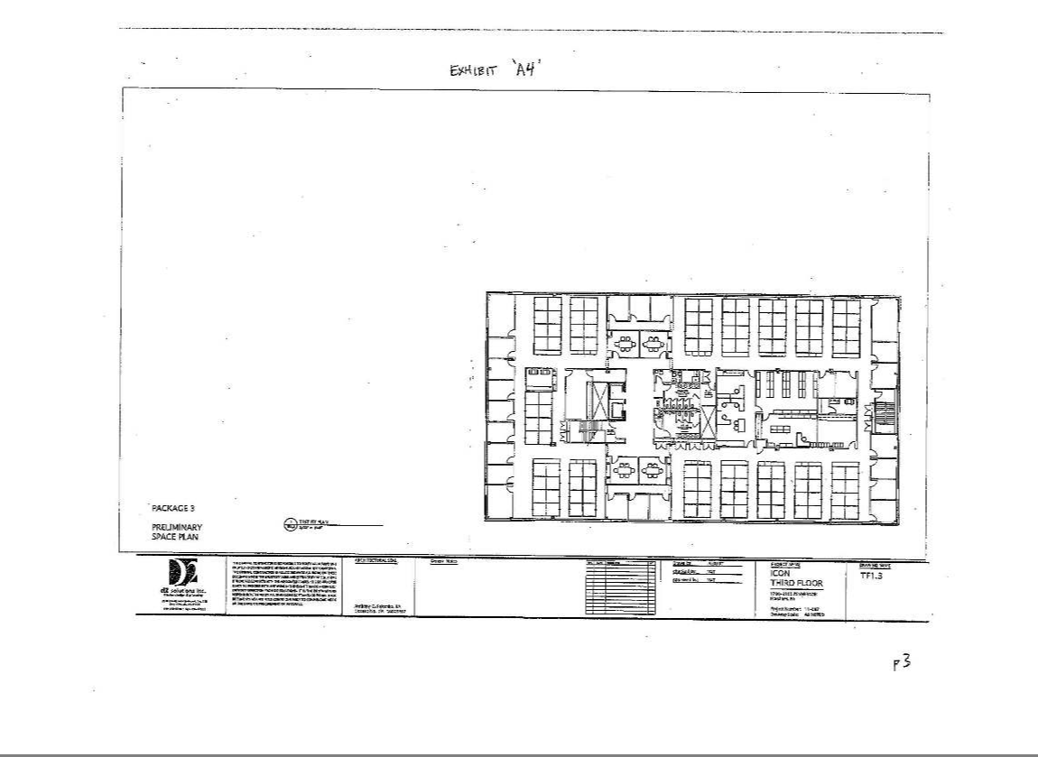

EXHIBIT "B"

ARCHITECT'S SCHEDULE

EXHIBIT B

EXHIBIT "B"

ARCHITECT'S SCHEDULE

July 2nd - July-13th - Finalize Schematic Design - COMPLETED

July 16th -Issue updated Schematic Drawings for GC Bid-(includes civil engineering site drawings - by Landlord) - COMPLETED

August 31st -Issue Structural Steel Drawings for final Pricing

September 3rd -Issue Foundation Drawings for Permitting

September 28th - Issue Core & Shell Architectural/Structural & Mechanical Drawings for Permit October 26th -Issue Core & Shell Construction Drawings

EXHIBIT B

EXHIBIT "C"

BUILDING RULES

- As stated in the lease, Tenant shall not use the Premises as a "place of public accommodation" as defined in the Americans with Disabilities Act of 1990, and as interpreted by caselaw decisions rendered prior to January 1, 2006, which identifies the following categories into one or more of which a business must fall to be a "place of public accommodation":

  - Places of lodging (examples: hotel, motel)

  - Establishments serving food or drink (examples: bar, restaurant)

  - Places of exhibition or entertainment (examples: motion picture house, theater, stadium, concert hall)

  - Places of public gathering (examples: auditorium, convention center, lecture hall)

  - Sales or rental establishments (examples: bakery, grocery store, hardware store, shopping center)

  - Service establishments (examples: bank, laundromat, barber shop, funeral parlor,

hospital, gas station, business offices such as lawyer, accountant, healthcare provider or insurance office)

  - Stations used for specified public transportation (examples: bus terminal, depot)

  - Places of public display or collection (examples: museum, library, gallery)

1. Places of recreation (examples: park, zoo, amusement park)

- Social service center establishments (examples: day-care center, senior citizen center, homeless shelter, food bank, adoption agency)

      - Places of exercise or recreation (examples: gym, health spa, bowling alley, golf course)

  - Unless Tenant is the only occupant of the Building, any sidewalk or common lobby, passage or stairway shall not be obstructed or used by Tenant for any purpose other than ingress and egress from and to the Premises. Unless Tenant is the only occupant of the Building, Landlord shall in all cases retain the right to control or prevent access by all persons whose presence, in the reasonable judgment of Landlord, shall be prejudicial to the safety, peace or character of the Property. In no event shall Tenant cause the Building, or any sidewalk or common lobby, passage or stairway, to be obstructed or used in a manner in violation oflocal, state or federal codes, statutes or regulations.

    - The toilet rooms, toilets, urinals, sinks, faucets, plumbing or other service apparatus of any kind shall not be used for any purposes other than those for which they were installed, and no signs, rubbish, rags, ashes, chemicals or other refuse or injurious substances shall be placed therein or used in connection therewith or left in any lobbies, passages, elevators or stairways.

- Tenant shall comply with all safety, fire protection and evacuation procedures and regulations established by Landlord or any governmental agency. No person shall go on the roof without Landlord's permission.

EXHIBIT C-1

- Skylights, windows, doors and transoms shall not be covered or obstructed by Tenant, and Tenant shall not install any window covering which would affect the exterior appearance of the Building, except as approved in writing by Landlord. Tenant shall not remove, without Landlord's prior written consent, any shades, blinds or curtains in the Premises.

- Without Landlord's prior written consent, Tenant shall not hang, install, mount, suspend or attach anything from or to any sprinkler, plumbing, utility or other lines. IfTenant hangs, installs, mounts, suspends or attaches anything from or to any doors, windows, walls, floors or ceilings. Tenant shall spackle and sand all holes and repair any damage caused thereby or by the removal thereof at or prior to the expiration or termination of the lease.

- Tenant shall surrender all keys and passes at the end of the Term.

  - Tenant shall not use nor keep in the Building any matter having an offensive odor, nor explosive or highly flammable material, nor shall any animals other than seeing eye dogs in the company of their masters be brought into or kept to or about the Premises.

  - Anything else in the Lease, as amended hereby, to the contrary notwithstanding, Tenant shall have the right, without Landlord's consent, to install electrical, signaling, telegraphic,

telephonic, protective alarm or other wires, apparatus or devices in the Building without obtaining Landlord's prior consent thereto; provided, that: (a) such installation shall be completed in compliance with all applicable laws and regulations; (b) upon Landlord's request, Tenant shall provide Landlord with plans delineating all material components of such installations; (c) absent Landlord's consent, which consent shall not be unreasonably withheld, conditioned or delayed, all such installations shall be located within the risers and chutes within the Building provided for such purpose; (d) all wires installed by Tenant shall be tagged at the distributing boards and junction boxes to indicate the space within the Building serviced by them; and (e) no such installation shall interfere, in any material respect, with Landlord's maintenance and operation of the Building or Landlord's ability to lease any space in the Building not leased by Tenant to another tenant.

- Tenant shall not place weights anywhere beyond the safe carrying capacity of the Building.

- The use of rooms as sleeping quarters is strictly prohibited at all times.

EXHIBIT C-2

- Tenant shall have the right, at Tenant's sole risk and responsibility, to use its proportional share of the parking spaces at the Property. Tenant shall comply with all parking regulations reasonably promulgated by Landlord from time to time for the orderly use of the vehicle parking areas. Parking shall be limited to automobiles, passenger or equivalent vans, motorcycles, light four wheel pickup trucks and (in designated areas) bicycles. Parked vehicles shall not be used for vending or any other business or other activity while parked in the parking areas. Vehicles shall be parked only in striped parking spaces, except for loading and unloading, which shall occur solely in zones marked for such purpose, and be so conducted as to not unreasonably interfere with traffic flow within the Property or with loading and unloading areas of other tenants. Employee and tenant vehicles shall not be parked in spaces marked for visitor parking or other specific use. All vehicles entering or parking in the parking areas shall do so at owner's sole risk and Landlord assumes no responsibility for any damage, destruction, vandalism or theft. Tenant shall cooperate with Landlord in any measures reasonably implemented by Landlord to control abuse of the parking areas, including without limitation access control programs, tenant and guest vehicle identification programs, and validated parking programs, provided that no such validated parking program shall result in Tenant being charged for spaces to which it has a right to free use under the Lease. Each vehicle owner shall promptly respond to any sounding vehicle alarm or horn, and failure to do so may result in temporary or permanent exclusion of such vehicle from the parking areas. Any vehicle which violates the parking regulations may be cited, towed at the expense of the owner, temporarily or permanently excluded from the parking areas, or subject to other lawful consequence.

  - If Landlord designates the Building as a non-smoking building and provides outdoor smoking area(s), Tenant and its Agents shall not smoke in the Building.

  - If at Tenant's request, Landlord consents to Tenant having a dumpster at the Property, Tenant shall locate the dumpster in the area designated by Landlord and shall keep and maintain the dumpster

clean and painted with lids and doors to good working order and, at Landlord's request, locked.

- Tenant shall provide Landlord with a written identification of any vendors engaged by Tenant to perform services for Tenant at the Premises (examples: cleaners, security guards/monitors, trash haulers, telecommunications installers/ maintenance).

- Tenant shall cause all of Tenant's Agents to comply with these Building Rules.

- Landlord reserves the right to rescind, suspend or modify any rules or regulations and to make such other rules and regulations as, in Landlord's reasonable judgment, may from time to time be needed for the safety, care, maintenance, operation and cleanliness of the Property. Notice of any action by Landlord referred to in this paragraph 17, given to Tenant, shall have the same force and effect as if originally made a part of the Lease. New rules or regulations will not, however, be unreasonably inconsistent with the proper and rightful enjoyment of the Premises by Tenant under the Lease.

  - These Building Rules are not intended to give Tenant any rights or claims in the event that Landlord does not enforce any of them against any other tenants or if Landlord does not have the right to enforce them against any other tenants; provided, that such nonenforcement will constitute a waiver as to Tenant.

  - Tenant shall be deemed to have read these Building Rules and to have agreed to abide by them as a condition to Tenant's occupancy of the Premises.

EXHIBIT C-3

EXHIBIT "D"

ENVIRONMENTAL QUESTIONNAIRE

EXHIBIT D

EXHIBIT "D"

Exhibit 4

CERTIFICATION OF COMPLIANCE

WITH AGREEMENT AND COVENANT NOT TO SUE

Certified mail

Regional Counsel

U.S. Environmental Protection Agency

1650 Arch Street

Philadelphia, PA 19103-2029

Re: Certification of Compliance with Agreement and Covenant Not to Sue, Docket No.

North Penn 7 Superfund Site

In accordance with paragraph 25 of the Agreement and Covenant Not to Sue, Docket No. 0-01 (“Agreement”), the undersigned party (“Signator”) hereby notifies the U.S. Environmental Protection Agency (“EPA”) that it intends to (acquire an interest in) (lease) all or a portion of the real property that is the subject of the Agreement. The Agreement was originally entered into by and between EPA and Progress Lansdale Development Associates, L.P., Progress Lansdale Development Holdings, L.P., Progress Development I, L.P., NSALC Acquisitions, L.L.C., 1180 Church Road, Inc., Pennsylvania Real Estate Holdings, Inc., and Commonwealth of Pennsylvania State Employees Retirement System, and concerns the real property described in Exhibit I (the “Property”).

(Insert a paragraph which identifies: (1) the parties to the lease or sublease; (2) a description of the portion of the Property which is the subject of the lease or sublease; (3) the effective date and terms of the lease or sublease).

Signator acknowledges that it has reviewed the Agreement and any modifications and notices thereto, Pursuant to paragraph 26 of Section XI of the Agreement (Parties Bond/Transfer of Covenant), Signator hereby agrees and certifies that:

- Signator has not caused or contributed to the release or threat of realize of any amount of the Existing Contamination;

- Signator will not, over the course of any 12 month period, generate, use or store, without the express written consent of EPA (such consent not to be unrealistically withheld), any hazardous substance or extremely hazardous substance, as defined in 42 U.S.C. § § 9601(14), 11002(a), in an amount equal to or exceeding its reportable quantity as established by 42 U.S.C. § § 9602(a), 11002(a), at the portion of the Property which is the subject of the lease or sublease;

- Signator will not use the portion of the Property which is the subject of the lease or sublease in any manner that could cause or contribute to the migration or release of any Existing Contamination;

- Signator will permit access to the portion of the Property which is the subject of the lease or sublease as set forth in paragraph 12 of the Agreement;

- Signator will exercise due care at the Site and cooperate with EPA as set forth in paragraph 15 of the Agreement;

- Signator will not interfere with response actions taken on or around the Property; and

- Signator will be bound by and subject to the terms of the Agreement, and will act consistent with the terms of the Agreement.

EXHIBIT "D"

Upon submission of this letter to EPA, Signator shall have the rights and benefits set forth in Sections VIII (United States’ Covenant Not to Sue) and XVIII (Contribution Protection) of the Agreement will respect to the portion of the Property which is the subject of the lease or sublease. However, if at any time EPA determines that Signator’s certification is materially inaccurate or incomplete, the Covenant Not to Sue and Contribution Protection shall be null and void with respect to Signator, and the United States reserves all rights it may have against Signator.

Notices and submissions required under this Agreement that affect Signator’s interest in the Property shall be sent to the following contact persons for Signator:

(INSERT CONTACT INFORMATION)

So acknowledged and agreed:

________________________

________________________

Name and Title

________________________

Name of Business

________________________

Date

EXHIBIT "D"

August 20, 2002

George M. Danyliw, Manager

Department of Environmental Protection

Southeastern Regional Office

Environmental Cleanup Program

555 North Lane

Suite 6010, Lee Park

Conshohocken, PA 19428-2233

Re: 1180 Church Road Facility, North Penn 7, Montgomery County, PA –

Transfer Notice

Dear Sir:

In accordance with Paragraph 9 of that certain Prospective Purchaser Agreement – Consent Order and Agreement (the “Consent Order and Agreement”) dated May 24, 2000, regarding the 1180 Church Road Facility, North Penn 7 Site, Montgomery County, Pennsylvania, the Respondents (as defined in the Consent Order and Agreement) have agreed to transfer a portion of the above-referenced property to

_______________ (the “Lessee”). Lessee will be occupying a portion of the property.

In connection therewith, the Lessee has made certain certifications as set forth in the enclosed certificate.

If you have any questions, please do not hesitate to contact the undersigned.

Sincerely,

Anthony P. Lordi

EXHIBIT "D"

CERTIFICATE

Reference is hereby made to that certain Prospective Purchaser Agreement – Consent Order and Agreement (the “Consent Order and Agreement”) dated May 24, 2000. In accordance therewith, _____________ (the

“Lessee”) hereby certifies as follows:

- Lessee did not cause or contribute to, or is otherwise is liable for, any of the Existing Contamination (as defined in the Consent Order and Agreement) on the property.

- Lessee hereby agrees to all terms and conditions set forth in the Consent Order and Agreement, except for the payment required in Paragraph 3.

- The subject lease was executed on ______________, 2002 and accordingly, this notice is intended to comply with clause (3) of Paragraph 9 of the Consent Order and Agreement.

________________________________

Name:

Title:

EXHIBIT "E"

LEASE COMMENCEMENT CERTIFICATE

The undersigned, as duly authorized officers and/or representatives of _____________________________________ ("Landlord") and ___________________________________ ("Tenant"), hereby agree

as follows with respect to the Lease Agreement (the "Lease") between them for premises located at ________________________________________________________________________ (the "Premises"):

1. | Date of Lease: | ______________, _____
2. | Commencement Date: | ______________, _____
3. | Expiration Date: | ______________, _____

- Rent and operating expenses due on or before the Commencement Date for the period from the Commencement Date until the first day of the next calendar month (not applicable if the Commencement Date is the first day of the calendar month):

Apportioned Minllnum Rent: | $ | _____
Apportioned Operating Expenses: | $ | _____
TOTAL: |  | $ _____

Thereafter regular monthly payments due in the following amounts until adjusted in accordance with the Lease:

Monthly Rent Installment:

$ _____

Monthyl Operating Payment:

TOTAL MONTHLY PAYMENT:

$ _____

$ _____

- The parties certify that, as of the date hereof, (a) the Lease is in full force and effect and has not been amended, (b) neither party has any offsets or defenses against the performance of any of its obligations under the Lease and (c) Landlord has Substantially Completed any improvements to be performed by Landlord in accordance with the Lease, excepting the Punch List items set forth on the Schedule attached hereto and initialed by Landlord and Tenant, if any.

IN WITNESS WHEREOF, Landlord and Tenant, intending to be legally bound, have executed this Certificate as of ______________________________, _____.

LANDLORD:

By:

TENANT:

By:

EXHIBIT E

EXHIBIT "F"

INTENTIONALLY DELETED

EXHIBIT F

EXHIBIT "G"

TENANT ESTOPPEL CERTIFICATE

Please refer to the documents described in Schedule 1 hereto, (the "Lease Documents") including the "Lease" therein described: all defined terms in this Certificate shall have the same meanings as set forth in the Lease unless otherwise expressly set forth herein. The undersigned Tenant hereby certifies that it is the tenant under the Lease. Tenant hereby further acknowledges that it has been advised that the Lease may be collaterally assigned in connection with a proposed financing secured by the Property and/or may be assigned in connection with a sale of the Property and certifies both to Landlord and to any and all prospective mortgagees and purchasers of the Property, including any trustee on behalf of any holders of notes or other similar instruments, any holders from time to time of such notes or other instruments, and their respective successors and assigns (the "Mortgagees") that as of the date hereof

- The information set forth in attached Schedule I is true and correct.

- Tenant is in occupancy of the Premises and the Lease is in full force and effect, and, except by such writings as are identified on Schedule 1, has not been modified, assigned, supplemented or amended since its original execution, nor are there any other agreements between Landlord and Tenant concerning the Premises, whether oral or written.

- To Tenant's knowledge, all conditions and agreements under the Lease to be satisfied or performed by Landlord have been satisfied and performed.

- Tenant is not in default under the Lease Documents, Tenant has not received any notice of default under the Lease Documents, and, to Tenant's knowledge, there are no events which have occurred that, with the giving of notice and/or the passage of time, would result in a default by Tenant under the Lease Documents.

- Tenant has not paid any Rent due under the Lease more than 30 days in advance of the date due under the Lease and Tenant has no rights of setoff counterclaim, concession or other rights of diminution of any Rent due and payable under the Lease except as set forth in Schedule 1.

- To Tenant's knowledge, there are no uncured defaults on the part of Landlord under the Lease Documents, Tenant has not sent any notice of default under the Lease Documents to Landlord, and there are no events which have occurred that, with the giving of notice and/or the passage of time, would result in a default by Landlord thereunder, and that at the present time Tenant has no claim against Landlord under the Lease Documents.

- Except as expressly set forth in the Lease, there are no provisions for any, and Tenant has no options with respect to the Premises or all or any portion of the Property.

EXHIBIT G-1

- Except as set forth on Part M of Schedule 1, no action, voluntary or involuntary, is pending against Tenant under federal or state bankruptcy or insolvency law.

- The undersigned has the authority to execute and deliver this Certificate on behalf of Tenant and acknowledges that all Mortgagees will rely upon this Certificate in purchasing the Property or extending credit to Landlord or its successors to interest.

- This Certificate shall be binding upon the successors, assigns and representatives of Tenant and any party claiming through or under Tenant and shall inure to the benefit of all Mortgagees.

IN WITNESS WHEREOF, Tenant has executed this Certificate this _____ day of ____________________________, 20____.

Name of Tenant

By:

Title:

EXHIBIT G-2

SCHEDULE 1 TO TENANT ESTOPPEL CERTIFICATE

LEASE DOCUMENTS, LEASE TERMS AND CURRENT STATUS

- Date of Lease:

- Parties:

  - Landlord:

    - Tenant d/b/a:

- Premises known as:

- Modifications, Assignments, Supplements or Amendments to Lease:

- Commencement Date:

- Expiration of Current Term:

- Deleted:

- Security Deposit Paid to Landlord- $

- Current Fixed Minimum Rent (Annualized): $

JCurrent Additional Rent (Annualized): $

- Current Total Rent: $

- Square Feet Demised:

- Tenant's Bankruptcy or other Insolvency Actions:

SCHEDULE 1

EXHIBIT "H"

FORM OF

LEASE GUARANTY

LEASE AGREEMENT BY AND BETWEEN ICON CLINICAL RESEARCH, INC. AND PENNBROOKDEVELOPMENT PARTNERS 2100, L.P.,

DATED AUGUST_, 2012 (THE "LEASE")

ICON, pie, a Dublin, Ireland corporation with an address in the United States at 2100 Pennbrook Parkway, Upper Gwynedd, Pennsylvania 19454, is the parent corporation of the Tenant, ICON Clinical Research, Inc., and shall benefit from the execution and fulfillment of the within Agreement of Lease. As an inducement to Landlord to enter into this Lease with Tenant, ICON, pie (hereinafter "Guarantor") guarantees all of Tenant's obligations pursuant to this Lease as hereinafter set forth. Guarantor acknowledges that Landlord is unwilling to enter into and deliver the Lease to Tenant unless Guarantor guarantees the full and timely performance and observance of all of the terms, covenants and conditions of the Lease to be performed by Tenant and its permitted successors and assigns.

Now, therefore, in consideration of, and as an inducement for, the execution and delivery of the Lease by Landlord to Tenant, and for other good and valuable consideration, the receipt and adequacy of which is hereby acknowledged, Guarantor hereby agrees as follows:

- Guarantor hereby guarantees to Landlord, and Landlord's heirs, executors, administrators and assigns, the full and prompt payment of all rents, additional rent, and any and all other sums and charges payable by Tenant, its successors and assigns, during the initial term under the Lease, and Guarantor hereby further guarantees the full and timely performance and observance of all the terms, covenants and conditions therein provided to be performed and observed by Tenant, its successors and assigns during the initial term under the Lease. Notwithstanding the foregoing, in no event shall Guarantor's total obligation or liability under this Guaranty be more than Fourteen Million Sixty-One Thousand Three Hundred Ninety Dollars (U.S.) ($14,061,390.00) (the "Liability Limit"). The Liability Limit shall be reduced as follows: (a) on the seventh anniversary of the Commencement Date (as defined in the Lease) to Ten Million Seven Hundred Thirty Thousand and One Hundred Ninety-Two Dollars (U.S.) ($10,730,192.00); (b) on the eighth anniversary of the Commencement Date to Seven Million One Hundred Eighty-Five Thousand Seven Hundred One Dollars (U.S.) ($7,185,701.00); and (c) on the ninth anniversary of the Commencement Date to Three Million Six Hundred Nine Thousand Eighty-Five Dollars (U.S.) ($3,609,085.00).

- If default shall at any time be made by Tenant, its successors or assigns, in the payment of any such rents, or if Tenant should default in the performance and observance of any of the tenns, covenants and conditions contained in the Lease, Guarantor shall and will immediately pay such rents to Landlord, its successors and assigns, and any arrears thereof, subject, however, to any applicable grace periods provided to Tenant in the Lease; and shall and will immediately and faithfully perform and fulfill all such terms, covenants and conditions, subject, however, to any applicable grace periods provided to Tenant in the Lease, and shall pay to Landlord all damages that may arise in consequence of any default of Tenant, its successor or assigns, under the Lease, including, without limitation, reasonable attorney's fees and costs incurred by Landlord or caused by any such default and/or by the enforcement of this Guaranty. Notwithstanding the foregoing, Landlord shall not be entitled to seek damages from Guarantor resulting from an issue for which a court of competent jurisdiction has found Tenant not to be liable to Landlord; unless such finding is due to Tenant's insolvency or inability to pay.

EXHIBIT H-1

- This Guaranty is an absolute and unconditional Guaranty of payment and of performance. It shall be enforceable against the Guarantor, its successors and assigns, without the necessity for any suit or proceedings on Landlord's part of any kind or nature whatsoever against Tenant, its successors and assigns, and, except as herein or in the Lease otherwise specifically provided, without the necessity of any notice of non-payment, non-performance or non-observance or any notice of acceptance of this Guaranty or of any other notice or demand to which Guarantor might otherwise be entitled, all of which the

Guarantor hereby expressly waives; and the Guarantor hereby expressly agrees that the validity of this Guaranty and the obligations of the Guarantor hereunder shall in no wise be terminated, affected, diminished or impaired by reason of the assertion or failure to assert by Landlord against Tenant, or against Tenant's successors or assigns, of any of the rights or remedies reserved to Landlord pursuant to the provisions of the Lease.

- This Guaranty shall be a continuing Guaranty, and the liability of the Guarantor hereunder shall in no way be affected, modified or diminished by reason of any assignment, renewal, modification or extension of the Lease or by reason of any modification or waiver of or change in any of the terms, covenants or conditions of the Lease by Landlord and Tenant, or by reason of any extension of time that may be granted by Landlord to Tenant, its successors or assigns, or by reason of any bankruptcy, insolvency, reorganization, arrangement, assignment for the benefit of creditors, receivership or trusteeship affecting Tenant.

- All of the Landlord's rights and remedies under the Lease or under this Guaranty are intended to be distinct, separate and cumulative and no such right or remedy therein or herein mentioned is intended to be in exclusion of or a waiver of any of the others.

- Upon any event of default under the Lease, Landlord shall simultaneously send a copy of any such notice of default which it sends to Tenant under the Lease to the Guarantor, and Landlord shall permit the Guarantor to cure such default within the time period granted to Tenant under the Lease to cure the same, if any. Such notice shall be sent to the Guarantor at its address as set forth in the background to this Guaranty in accordance with the notice provisions of the Lease.

- The Guarantor agrees that any action or proceeding against him to enforce, or arising out of, this Guaranty may be commenced in the Court of Common Pleas of Montgomery County or in the United States District Court for the Eastern District of Pennsylvania and the Guarantor waives personal service of process and agrees that a summons and complaint commencing an action or proceeding in any such court shall be properly served and shall confer personal jurisdiction if served by registered or certified mail to the address set forth above, as such address may be changed from time to time by written notice to the Landlord from such Guarantor. The Guarantor waives any right to a trial by jury in any action or proceeding to enforce or defend any rights under this Guaranty, or any proceeding in any way arising out of or in connection with this Guaranty, and the Guarantor agrees that any such action or proceeding shall be tried before a court and not before a jury.

EXHIBIT H-2

- Notwithstanding any payments made or obligations performed by Guarantor by reason of this Guaranty, for so long as the Guarantor has any liability to Landlord outstanding hereunder, the Guarantor hereby subordinates to Landlord, and agrees to take no actions against Tenant on account of any and all rights it may have at any time (whether arising directly or indirectly, by operation oflaw, contract or otherwise); (a) to assert any claim against Tenant or any other person, or against any direct or indirect security, on account of payments made or obligations performed under or pursuant to this Guaranty, including, without limitation, any and all rights of subrogation, reimbursement, exoneration, contribution or indemnity; or (b) to require the marshalling of any assets of Tenant, which right of marshalling might otherwise arise from payments made or obligations performed under or pursuant to this Guaranty, and any and all rights that would result in Guarantor being deemed a "creditor", under the United States Bankruptcy Code, of Tenant or any other person.

- Miscellaneous.

  - This Agreement shall bind the Guarantor and the Guarantor's successors and assigns, and shall inure to the benefit of the Landlord and Landlord's heirs, executors, administrators, successors and assigns.

  - This Agreement and the rights and obligations hereunder shall be construed in accordance with and governed by the internal laws of the Commonwealth of Pennsylvania.

  - Any provision hereof which is found by a court of competent jurisdiction to be prohibited or unenforceable in any jurisdiction, shall, as to such jurisdiction be ineffective only to the extent of such prohibition or unenforceability, and such prohibition or unenforceability shall not invalidate such provision to the extent it is not prohibited or unenforceable in any other jurisdiction, nor invalidate the other provisions hereof, all of which shall be liberally construed in favor of the Landlord in order to effect the provisions hereof.

  - This Agreement contains the entire agreement of the parties hereto with respect to the subject matter hereof and may not be modified or amended except by written agreement signed by the party against whom such modification or amendment is to be enforced.

EXHIBIT H-3

IN WITNESS WHEREOF, the Guarantor has caused this Guaranty to be duly executed this _____ day of August, 2012.

GUARANTOR:

ICON, plc

By:

Name:

Title:

EXHIBIT H-4

EXHIBIT "I"

LETTER OF CREDIT

EXHIBIT I

SCHEDULE 2(aa)

DESCRIPTION OF EXISTING MORTGAGES

Open-End Mortgage and Security Agreement, dated November 30, 2006, between Patriarch I LP and Provident Life and Accident Company, encumbering 1700 Pennbrook and securing indebtedness in the original principal amount of $5,300,000.00

Open-End Mortgage and Security Agreement, dated February 14, 2008, between Pennbrook Development Partners 2100, LP and Provident Life and Accident Company, encumbering 2100 Pennbrook and securing indebtedness in the original principal amount of

$9,300,000.00.

SCHEDULE 2(aa)

SCHEDULE 2l(a)

IMPROVEMENTS TO BE REMOVED

Upon the termination of the Term, Tenant will be required to remove any Tenant improvements which are not considered normal office fit out. Based on the Preliminary TI Plans attached to this Lease as Exhibit A-4, the only improvements subject to removal are in the cafeteria and fitness areas of the Connector Building. The items to be removed generally include kitchen equipment, grease traps and vertical shafts and penetrations. In connection with such removal, Tenant required repairs will include capping of plumbing, removal of vertical shafts, removal of associated roof equipment and the repair of any floor or roof penetrations.

SCHEDULE 21(a)

AGREEMENT OF LEASE

Between

PENNBROOKDEVELOPMENT PARTNERS 2100, L.P.

("LANDLORD")

and

ICON CLINICAL RESEARCH, INC.

("TENANT")

for

[21001] PENNBROOK PARKWAY

Pennbrook Business Center Condominium

Lansdale, Pennsylvania

Dated: August_____, 2012

 |  | Lease Agreement
 |  | (Multi-Tenant)
 |  |  | PAGE
1. | Summary of Terms and Certain Definitions | 1
2. | Premises | 4
3. | Communications, Equipment and Technology, Emergency Generator and UPS System | 13
4. | Use; Compliance | 13
5. | Term | 15
6. | Minimum Annual Rent | 16
7. | Operation of Property; Payment of Annual Operating Expenses | 16
8. | Signs | 23
9. | Alterations and Fixtures | 24
10. | Mechanics' Liens | 25
11. | Certain Rights Reserved by Landlord | 25
12. | Damage by Fire or Other Casualty | 26
13. | Condemnation | 27
14. | Non-Abatement of Rent; Landlord's Representations | 27
15. | Indemnification Obligations | 28
16. | Waiver of Claims | 29
17. | Quiet Enjoyment | 29
18. | Assignment and Subletting | 29
19. | Subordination; Mortgagee's Rights | 31
20. | Recording; Certificate | 32
21. | Surrender; Abandoned Property | 32
22. | Curing Tenant's Defaults | 33
23. | Tenant Defaults - Landlord's Remedies | 33
24. | Landlord Defaults - Tenant's Remedies | 35
25. | Representations of Tenant | 40
26. | Liability of Landlord | 40
27. | Interpretation; Definitions | 41
28. | Notices | 42
29. | Guaranty | 42
30. | Option to Renew | 42
31. | Waiver of Liens | 44
32. | Brokers | 44
33. | Joinder | 44

Exhibit 12.1

Certification of Chief Financial Officer

Pursuant to Section 302 of

the Sarbanes-Oxley Act of 2002

I, Brendan Brennan, certify that:

- I have reviewed this annual report on Form 20-F of ICON plc (“the registrant”).

- Based on my knowledge, this report does not contain any untrue statement of a material fact or omit to state a material fact necessary to make the statements made, in light of the circumstances under which such statements were made, not misleading with respect to the period covered by this report;

- Based on my knowledge, the financial statements, and other financial information included in this report, fairly present in all material respects the financial condition, results of operations and cash flows of the registrant as of, and for, the periods presented in this report;

- The registrant's other certifying officer and I are responsible for establishing and maintaining disclosure controls and procedures (as defined in Exchange Act Rules 13a-15(e) and 15d-15(e)) and internal control over financial reporting (as defined in Exchange Act Rules 13a-15(f) and 15d-15(f)) for the registrant and have:

  - Designed such disclosure controls and procedures, or caused such disclosure controls and procedures to be designed under our supervision, to ensure that material information relating to the registrant, including its consolidated subsidiaries, is made known to us by others within those entities, particularly during the period in which this report is being prepared;

  - Designed such internal control over financial reporting, or caused such internal control over financial reporting to be designed under our supervision, to provide reasonable assurance regarding the reliability of financial reporting and the preparation of financial statements for external purposes in accordance with generally accepted accounting principles;

  - Evaluated the effectiveness of the registrant's disclosure controls and procedures and presented in this report our conclusions about the effectiveness of the disclosure controls and procedures, as of the end of the period covered by this report based on such evaluation; and

  - Disclosed in this report any change in the registrant's internal control over financial reporting that occurred during the period covered by the annual report that has materially affected, or is reasonably likely to materially affect, the company’s internal control over financial reporting.

- The registrant's other certifying officer and I have disclosed, based on our most recent evaluation of internal control over financial reporting, to the registrant's auditors and the audit committee of the registrant's board of directors (or persons performing the equivalent functions):

- All significant deficiencies and material weaknesses in the design or operation of internal control over financial reporting which are reasonably likely to adversely affect the registrant's ability to record, process, summarize and report financial information; and

- Any fraud, whether or not material, that involves management or other employees who have a significant role in the registrant's internal control over financial reporting.

Dated: March 12, 2014

/s/ Brendan Brennan

---------------------------

Brendan Brennan

Chief Financial Officer

Certification of Chief Executive Officer

Pursuant to Section 302 of

the Sarbanes-Oxley Act of 2002

I, Ciaran Murray, certify that:

- I have reviewed this annual report on Form 20-F of ICON plc (“the registrant”).

- Based on my knowledge, this report does not contain any untrue statement of a material fact or omit to state a material fact necessary to make the statements made, in light of the circumstances under which such statements were made, not misleading with respect to the period covered by this report;

- Based on my knowledge, the financial statements, and other financial information included in this report, fairly present in all material respects the financial condition, results of operations and cash flows of the registrant as of, and for, the periods presented in this report;

- The registrant's other certifying officer and I are responsible for establishing and maintaining disclosure controls and procedures (as defined in Exchange Act Rules 13a-15(e) and 15d-15(e)) and internal control over financial reporting (as defined in Exchange Act Rules 13a-15(f) and 15d-15(f)) for the registrant and have:

  - Designed such disclosure controls and procedures, or caused such disclosure controls and procedures to be designed under our supervision, to ensure that material information relating to the registrant, including its consolidated subsidiaries, is made known to us by others within those entities, particularly during the period in which this report is being prepared;

  - Designed such internal control over financial reporting, or caused such internal control over financial reporting to be designed under our supervision, to provide reasonable assurance regarding the reliability of financial reporting and the preparation of financial statements for external purposes in accordance with generally accepted accounting principles;

  - Evaluated the effectiveness of the registrant's disclosure controls and procedures and presented in this report our conclusions about the effectiveness of the disclosure controls and procedures, as of the end of the period covered by this report based on such evaluation; and

  - Disclosed in this report any change in the registrant's internal control over financial reporting that occurred during the period covered by the annual report that has materially affected, or is reasonably likely to materially affect, the company’s internal control over financial reporting.

- The registrant's other certifying officer and I have disclosed, based on our most recent evaluation of internal control over financial reporting, to the registrant's auditors and the audit committee of the registrant's board of directors (or persons performing the equivalent functions):

- All significant deficiencies and material weaknesses in the design or operation of internal control over financial reporting which are reasonably likely to adversely affect the registrant's ability to record, process, summarize and report financial information; and

- Any fraud, whether or not material, that involves management or other employees who have a significant role in the registrant's internal control over financial reporting.

Dated: March 12, 2014

/s/Ciaran Murray

---------------------------

Ciaran Murray

Chief Executive Officer

Exhibit 12.2

Certification Pursuant to 18 U.S.C. Section 1350,

As Adopted Pursuant to Section 906 of the Sarbanes-Oxley Act of 2002

In connection with the Annual Report of ICON plc (the “Company”) on Form 20-F for the year ending December 31, 2013 as filed with the Securities and Exchange Commission on the date hereof (the “Report”), I, Brendan Brennan, Chief Financial Officer of the Company, certify, pursuant to 18 U.S.C. § 1350, as adopted pursuant to § 906 of the Sarbanes-Oxley Act of 2002, that to my knowledge:

- the Report fully complies with the requirements of section 13(a) or 15(d) of the Securities Exchange Act of 1934; and

- the information contained in the Report fairly presents, in all material respects, the financial condition and result of operations of the Company.

Date: March 12, 2014

/s/ Brendan Brennan

_______________________

Brendan Brennan

Chief Financial Officer

The foregoing certification is being furnished solely pursuant to section 906 of the Sarbanes-Oxley Act of 2002 (subsections (a) and (b) of section 1350, chapter 63 of title 18, United States Code) and is not being filed as part of the report or as a separate disclosure document. A signed original of this written statement required by section 906 has been provided to ICON plc and will be retained by ICON plc and furnished to the Securities and Exchange Commission or its staff upon request.

Certification Pursuant to 18 U.S.C. Section 1350,

As Adopted Pursuant to Section 906 of the Sarbanes-Oxley Act of 2002

In connection with the Annual Report of ICON plc (the “Company”) on Form 20-F for the year ending December 31, 2013 as filed with the Securities and Exchange Commission on the date hereof (the “Report”), I, Ciaran Murray, Chief Executive Officer of the Company, certify, pursuant to 18 U.S.C. § 1350, as adopted pursuant to § 906 of the Sarbanes-Oxley Act of 2002, that to my knowledge:

- the Report fully complies with the requirements of section 13(a) or 15(d) of the Securities Exchange Act of 1934; and

- the information contained in the Report fairly presents, in all material respects, the financial condition and result of operations of the Company.

Date: March 12, 2014

/s/Ciaran Murray

_______________________

Ciaran Murray

Chief Executive Officer

The foregoing certification is being furnished solely pursuant to section 906 of the Sarbanes-Oxley Act of 2002 (subsections (a) and (b) of section 1350, chapter 63 of title 18, United States Code) and is not being filed as part of the report or as a separate disclosure document. A signed original of this written statement required by section 906 has been provided to ICON plc and will be retained by ICON plc and furnished to the Securities and Exchange Commission or its staff upon request.

Exhibit 23.1

CONSENT OF INDEPENDENT REGISTERED PUBLIC ACCOUNTING FIRM

The Board of Directors

ICON plc

Dear Sirs:

We consent to the incorporation by reference in the registration statement on Form S-8 (No. 333-190068) of ICON plc of our reports dated March 12, 2014, with respect to the consolidated balance sheets of ICON plc as of December 31, 2013 and 2012 and the related consolidated statements of operations, shareholders’ equity and comprehensive income, and cash flows for each of the years in the three-year period ended December 31, 2013, and the effectiveness of internal control over financial reporting as of December 31, 2013, which reports appear in the December 31, 2013 Annual Report on Form 20-F of ICON plc.

/s/ KPMG

KPMG

Chartered Accountants

Dublin, Ireland

March 12, 2014

