FORM 6-K

SECURITIES AND EXCHANGE COMMISSION

Washington, D.C. 20549

Report of Foreign Private Issuer

Pursuant to Rule 13a-16 under

the Securities Exchange Act of 1934

For the month ended January, 2016

ICON plc

(Registrant's name)

333-08704

(Commission file number)

South County Business Park, Leopardstown, Dublin 18, Ireland

(Address of principal executive offices)

Brendan Brennan, CFO

South County Business Park, Leopardstown, Dublin 18, Ireland.

Brendan.Brennan@iconplc.com

00-353-1-291-2000

(Name, telephone number, email and/or facsimile number and address of Company contact person)

Indicate by check mark whether the registrant files or will file annual reports under cover Form 20-F or Form 40-F.

Yes___X___ No_______

Indicate by check mark whether the registrant is submitting the Form 6-K in paper as permitted by Regulation S-T Rule 101(b)(1):

Yes______ No___X___

Indicate by check mark whether the registrant is submitting the Form 6-K in paper as permitted by Regulation S-T Rule 101(b)(7):

Yes______ No___X___

Indicate by check mark whether the registrant by furnishing the information contained in this Form is also thereby furnishing the information to the Commission pursuant to Rule12g3-2(b) under the Securities Exchange Act of 1934.

Yes______ No___X___

If "Yes" is marked, indicate below the file number assigned to the registrant in connection with Rule 12g3-2(b):82 N/A

 |  |  |  | EXHIBIT LIST
Exhibit |  | Description
99.1 |  | Form B7 Notice of Redemption of 19,234 Shares on November 23, 2015 filed in Companies Registration Office in Ireland on January 12, 2016
99.2 |  | Form B7 Notice of Redemption of 47,459 Shares on November 24, 2015 filed in Companies Registration Office in Ireland on January 12, 2016
99.3 |  | Form B7 Notice of Redemption of 21,000 Shares on November 25, 2015 filed in Companies Registration Office in Ireland on January 12, 2016
99.4 |  | Form B7 Notice of Redemption of 78,173 Shares on November 27, 2015 filed in Companies Registration Office in Ireland on January 12, 2016
99.5 |  | Form B7 Notice of Redemption of 19,000 Shares on November 30, 2015 filed in Companies Registration Office in Ireland on January 12, 2016
99.6 |  | Form B7 Notice of Redemption of 14,232 Shares on December 1, 2015 filed in Companies Registration Office in Ireland on January 12, 2016
99.7 |  | Form B7 Notice of Redemption of 9,918 Shares on December 2, 2015 filed in Companies Registration Office in Ireland on January 12, 2016
99.8 |  | Form B7 Notice of Redemption of 79,281 Shares on December 3, 2015 filed in Companies Registration Office in Ireland on January 12, 2016
99.9 |  | Form B7 Notice of Redemption of 45,016 Shares on December 4, 2015 filed in Companies Registration Office in Ireland on January 12, 2016
99.10 |  | Form B7 Notice of Redemption of 49,636 Shares on December 7, 2015 filed in Companies Registration Office in Ireland on January 12, 2016
99.11 |  | Form B7 Notice of Redemption of 68,716 Shares on December 8, 2015 filed in Companies Registration Office in Ireland on January 12, 2016
99.12 |  | Form B7 Notice of Redemption of 41,198 Shares on December 9, 2015 filed in Companies Registration Office in Ireland on January 12, 2016
99.13 |  | Form B7 Notice of Redemption of 31,188 Shares on December 10, 2015 filed in Companies Registration Office in Ireland on January 12, 2016
99.14 |  | Form B7 Notice of Redemption of 40,406 Shares on December 11, 2015 filed in Companies Registration Office in Ireland on January 12, 2016
99.15 |  | Form B7 Notice of Redemption of 69,996 Shares on December 14, 2015 filed in Companies Registration Office in Ireland on January 12, 2016
99.16 |  | Form B7 Notice of Redemption of 46,855 Shares on December 15, 2015 filed in Companies Registration Office in Ireland on January 12, 2016
99.17 |  | Form B7 Notice of Redemption of 45,870 Shares on December 16, 2015 filed in Companies Registration Office in Ireland on January 12, 2016
99.18 |  | Form B7 Notice of Redemption of 30,247 Shares on December 17, 2015 filed in Companies Registration Office in Ireland on January 12, 2016
99.19 |  | Form B7 Notice of Redemption of 30,942 Shares on December 18, 2015 filed in Companies Registration Office in Ireland on January 12, 2016
99.20 |  | Form B7 Notice of Redemption of 33,894 Shares on December 21, 2015 filed in Companies Registration Office in Ireland on January 12, 2016
99.21 |  | Form B7 Notice of Redemption of 66,408 Shares on December 22, 2015 filed in Companies Registration Office in Ireland on January 12, 2016
99.22 |  | Form B7 Notice of Redemption of 26,059 Shares on December 23, 2015 filed in Companies Registration Office in Ireland on January 12, 2016

SIGNATURES

Pursuant to the requirements of the Securities Exchange Act of 1934, the Registrant has duly caused this report to be signed on its behalf by the undersigned thereunto duly authorized.

ICON plc

/s/ Brendan Brennan

Date: January 12 , 2016 Brendan Brennan Chief Financial Officer

Exhibit 99.1

Exhibit 99.2
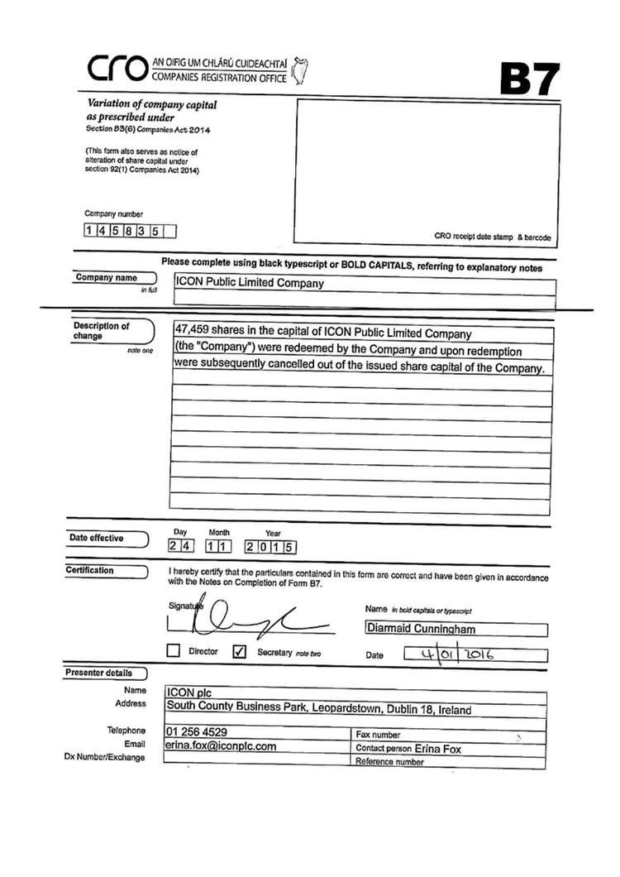

Exhibit 99.3
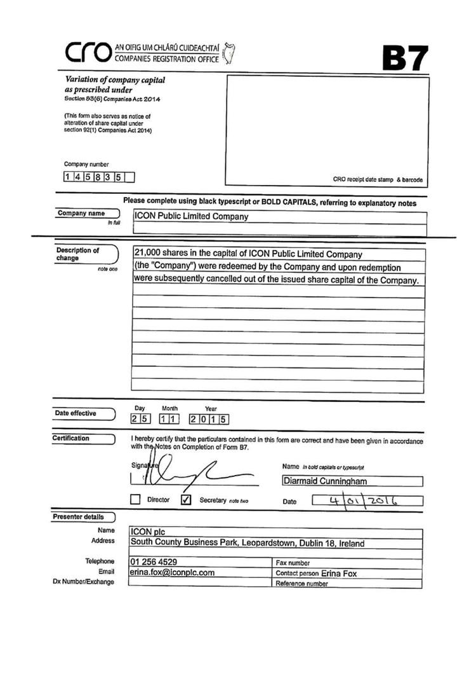

Exhibit 99.4
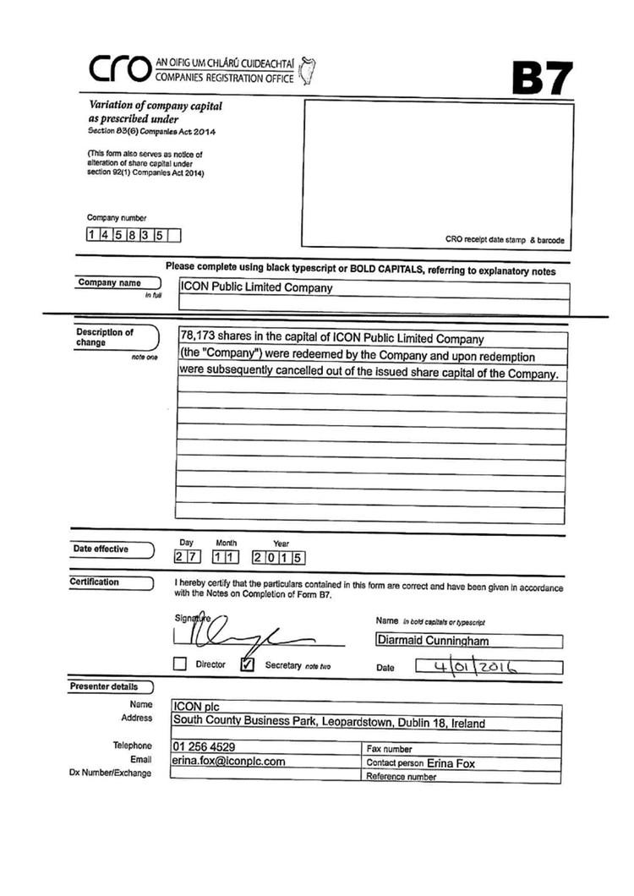

Exhibit 99.5
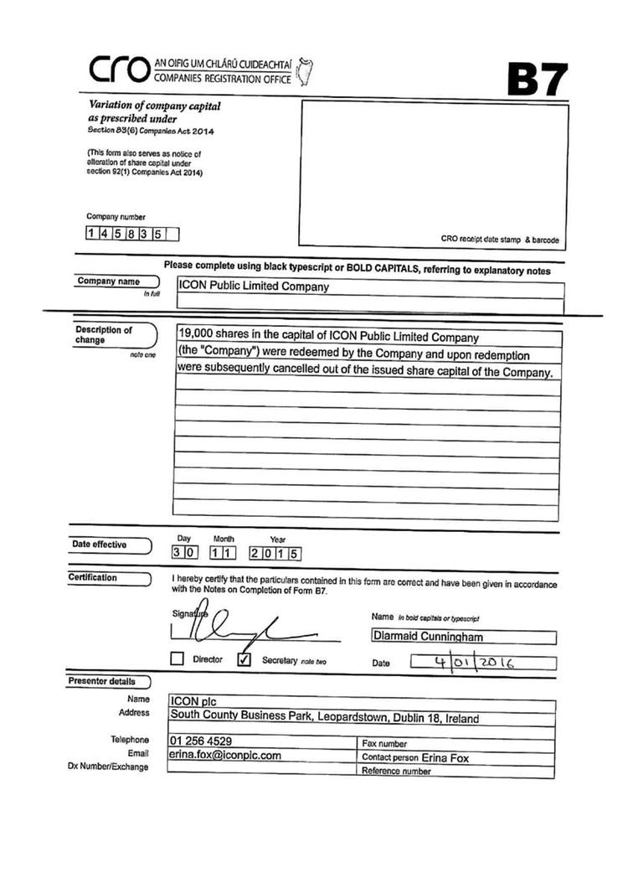

Exhibit 99.6
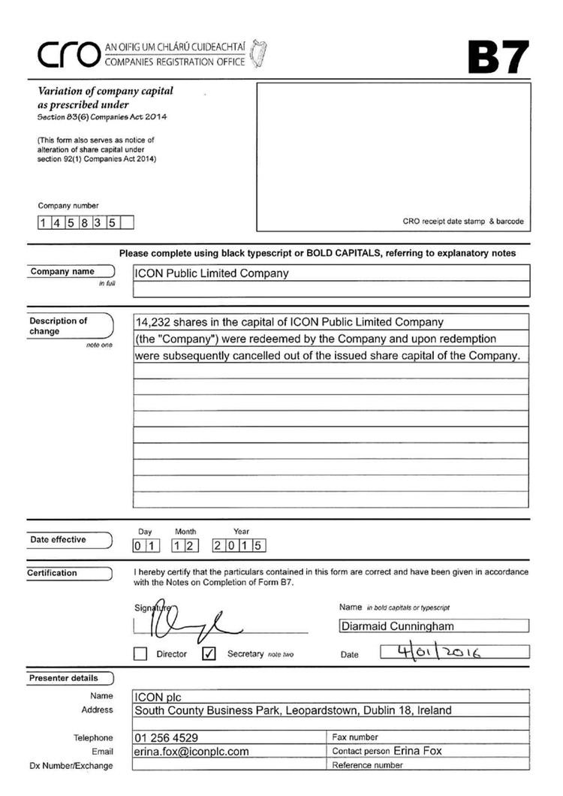

Exhibit 99.7
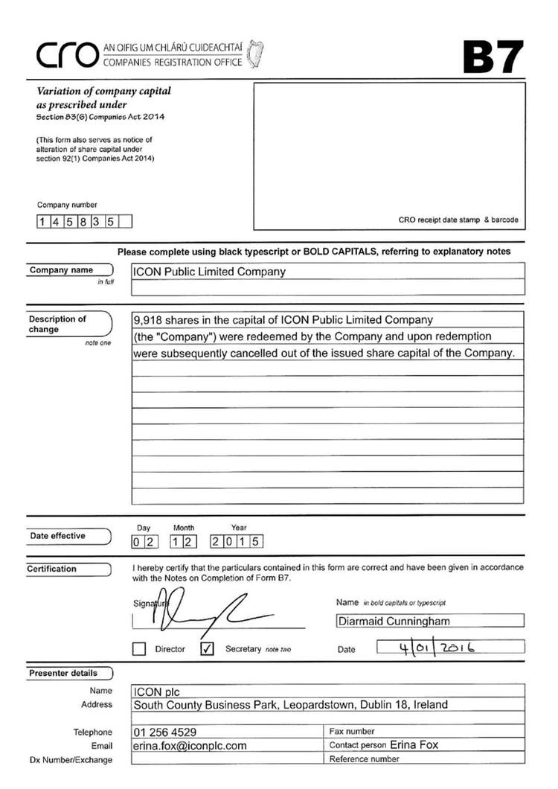

Exhibit 99.8
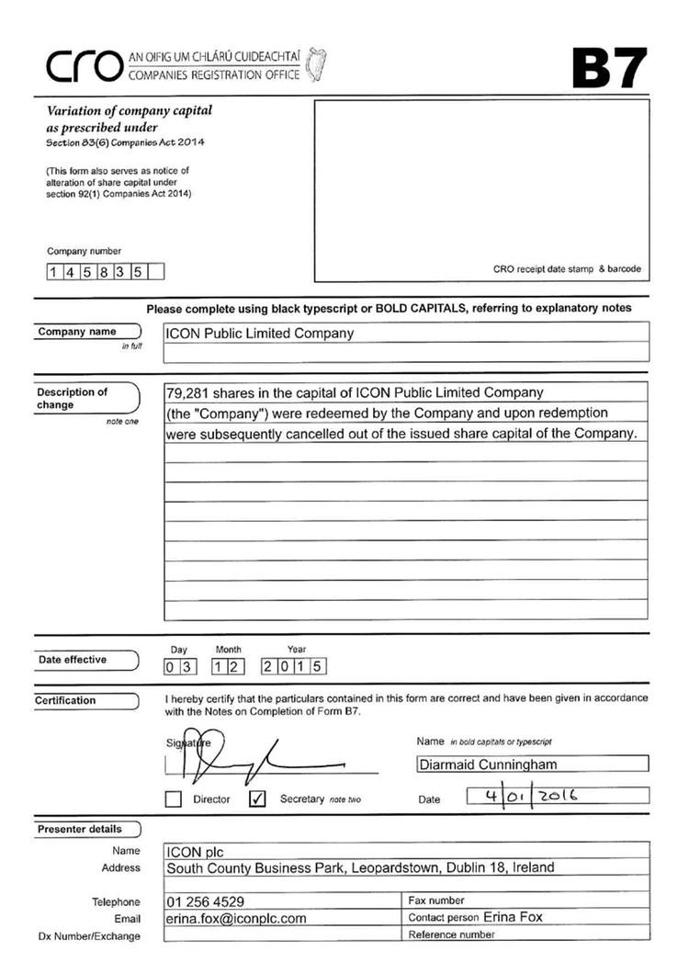

Exhibit 99.9
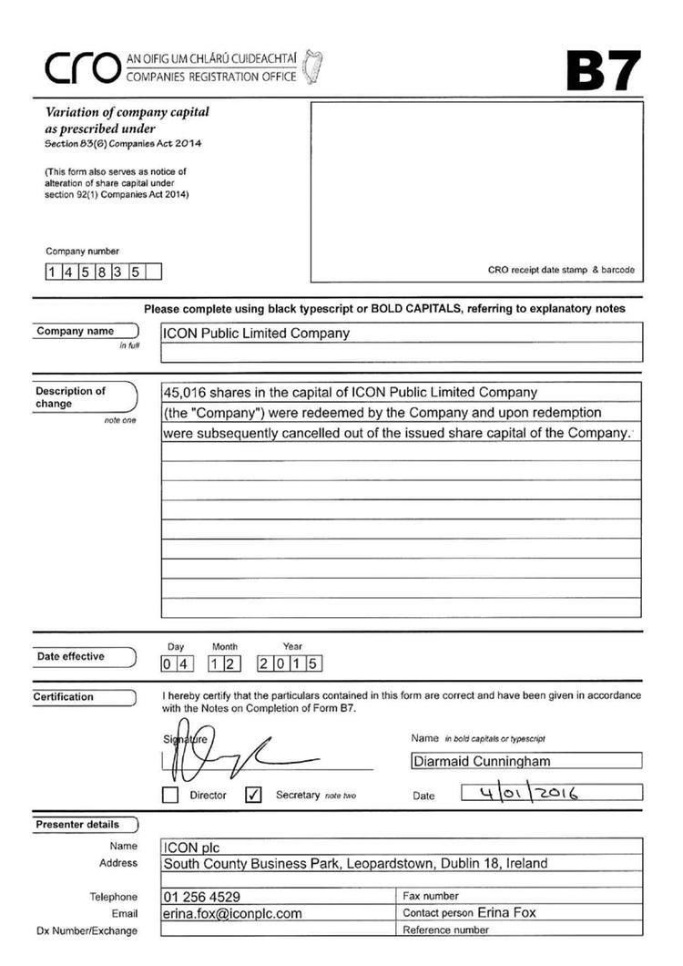

Exhibit 99.10
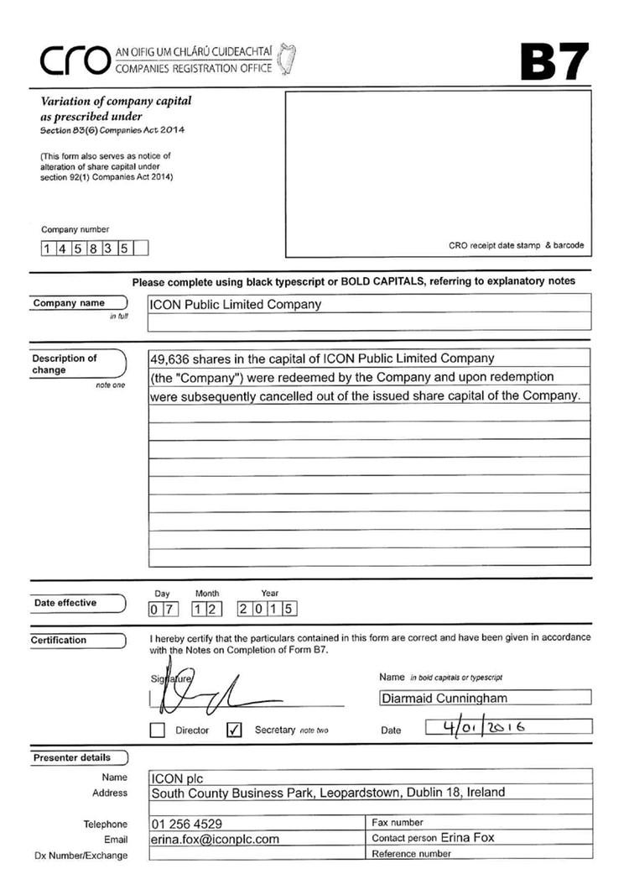

Exhibit 99.11
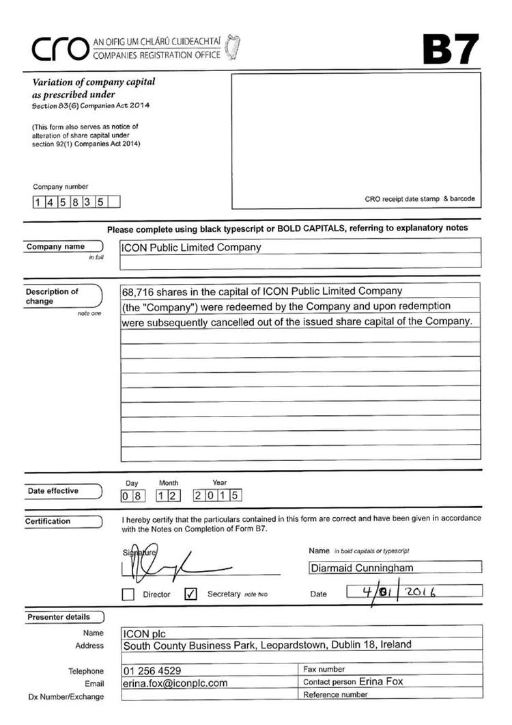

Exhibit 99.12
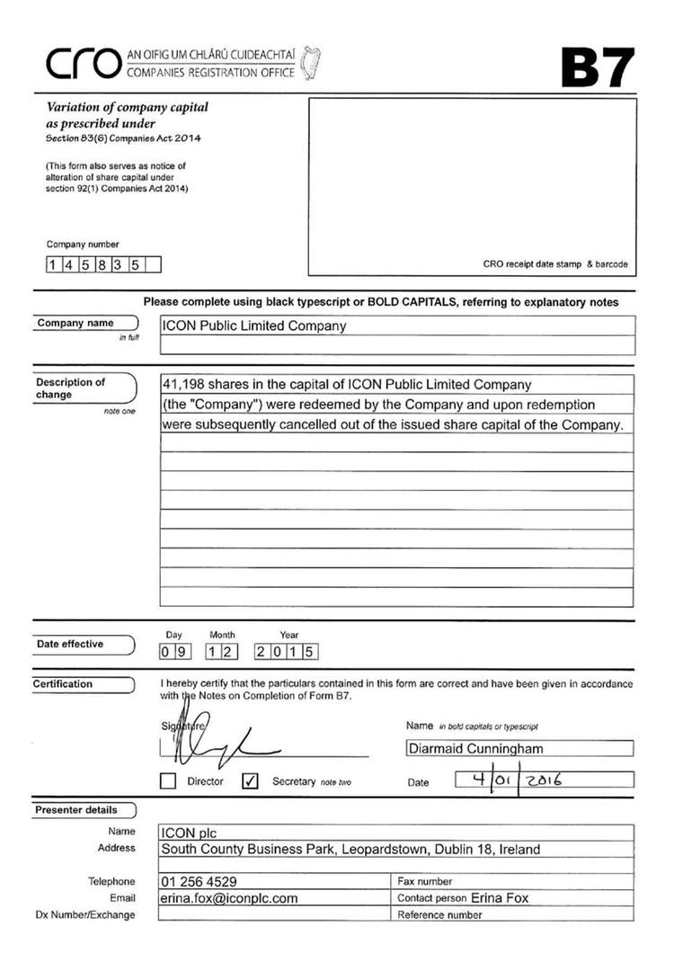

Exhibit 99.13
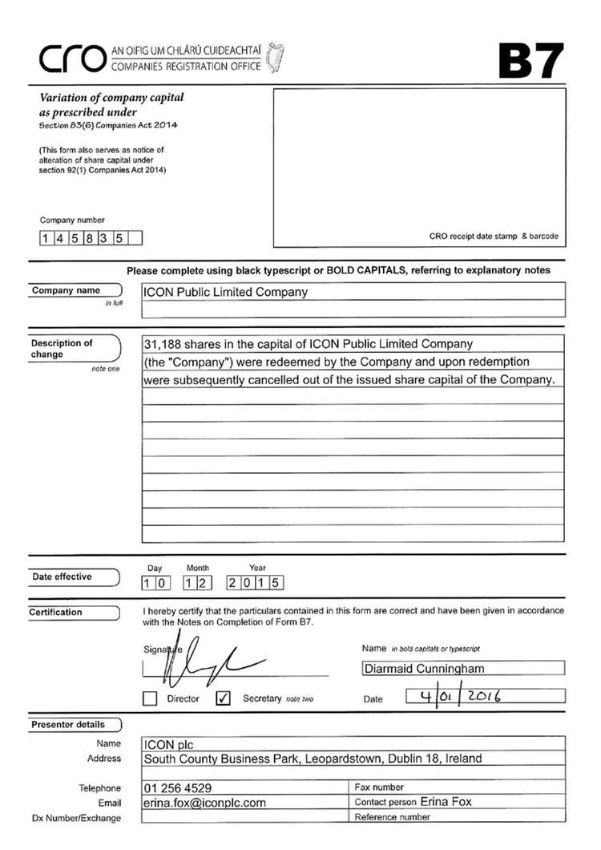

Exhibit 99.14
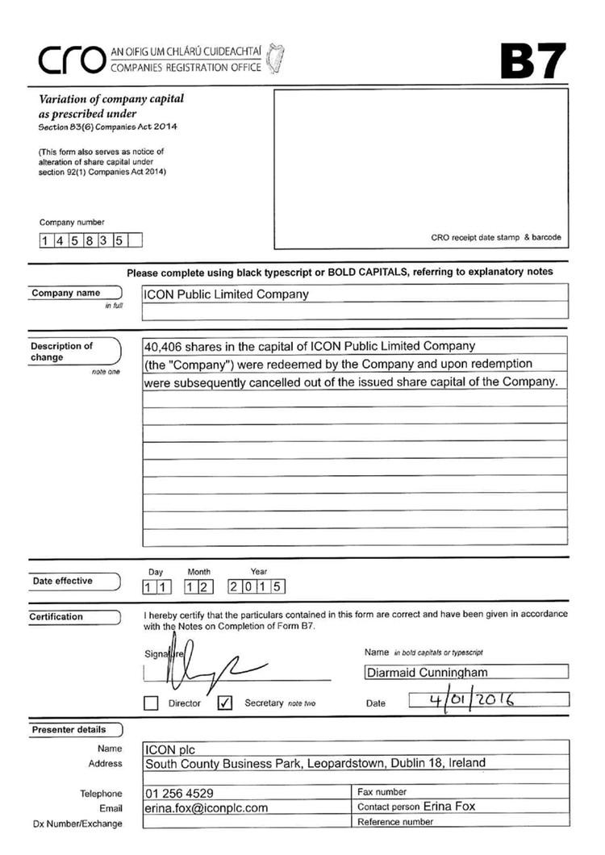

Exhibit 99.15
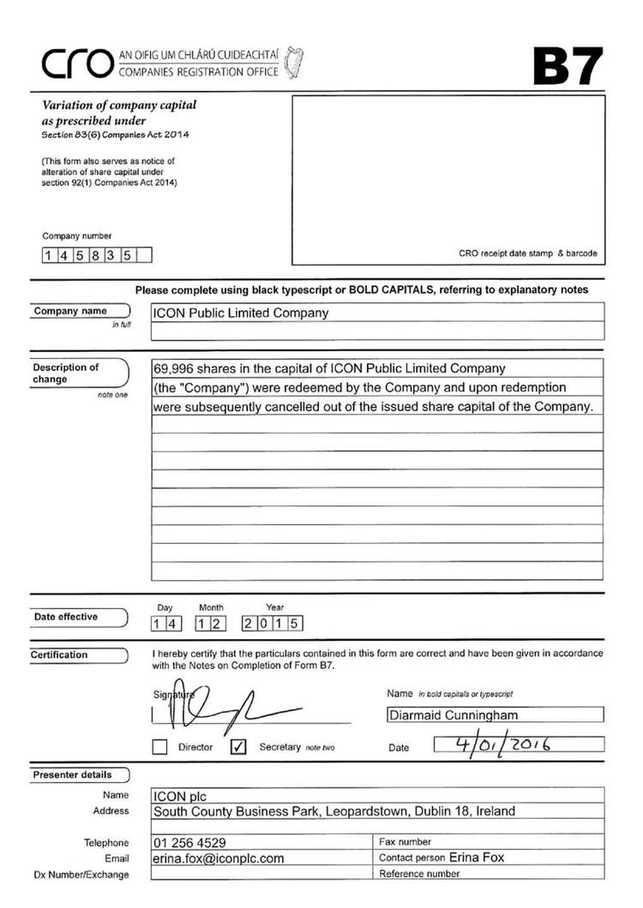

Exhibit 99.16
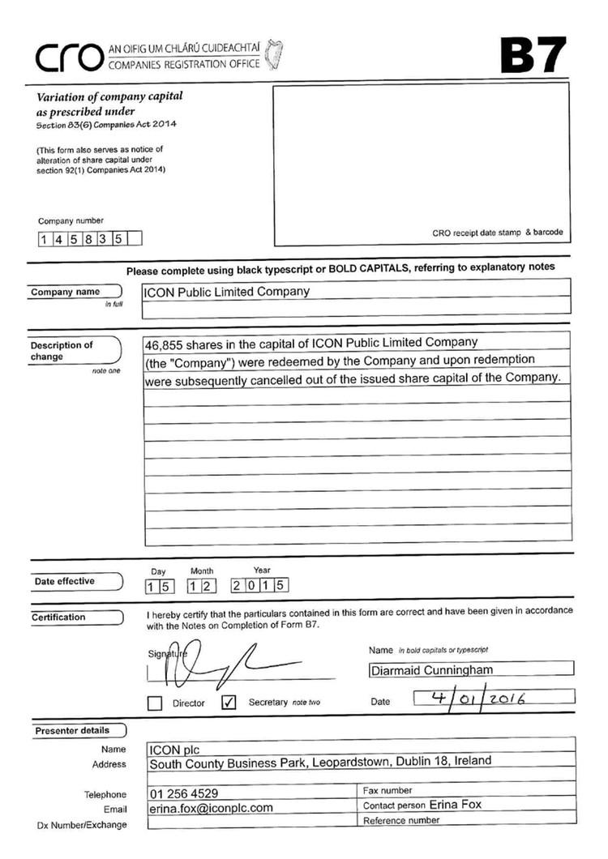

Exhibit 99.17
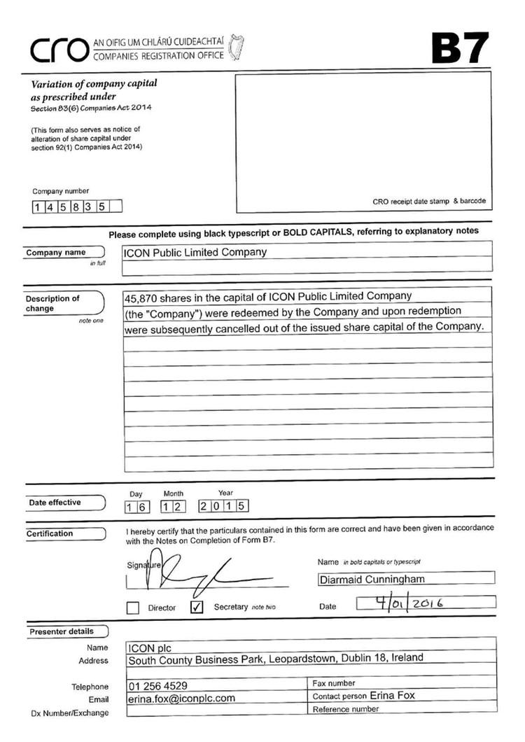

Exhibit 99.18
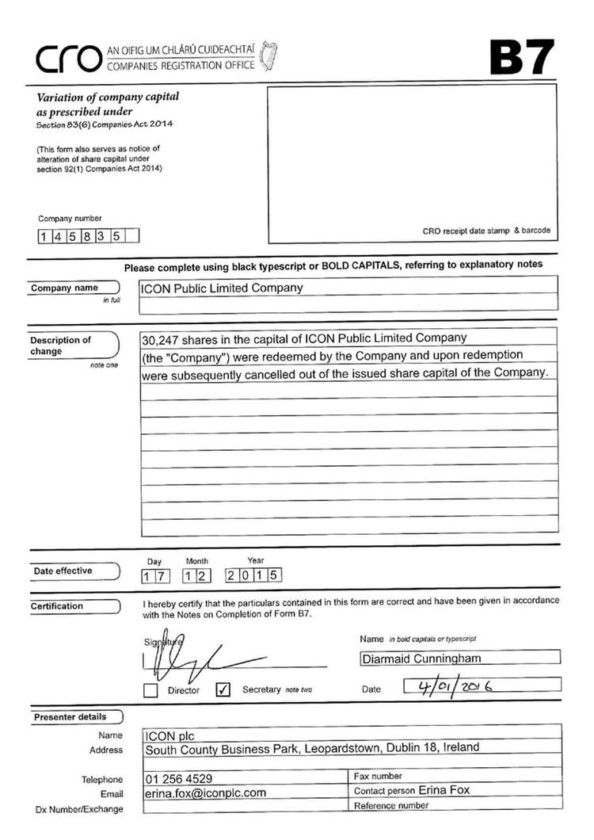

Exhibit 99.19
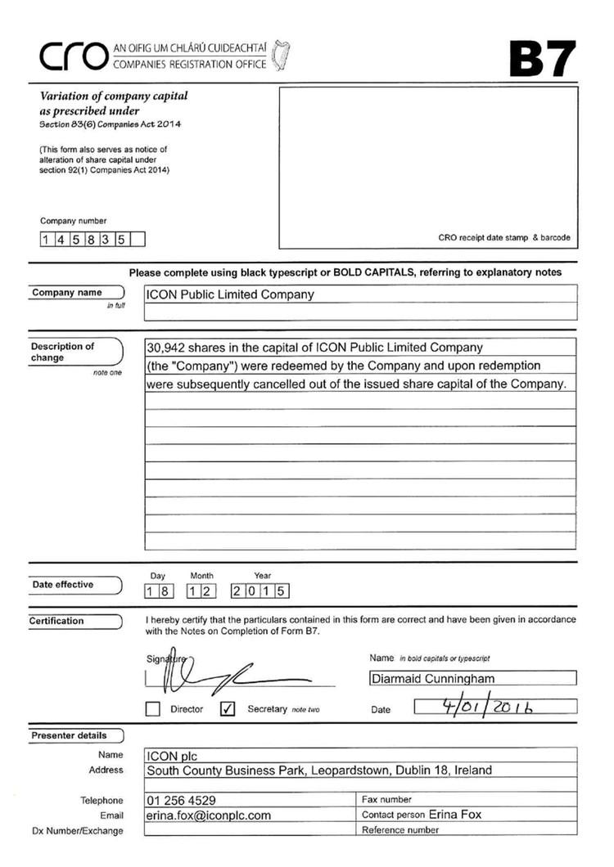

Exhibit 99.20
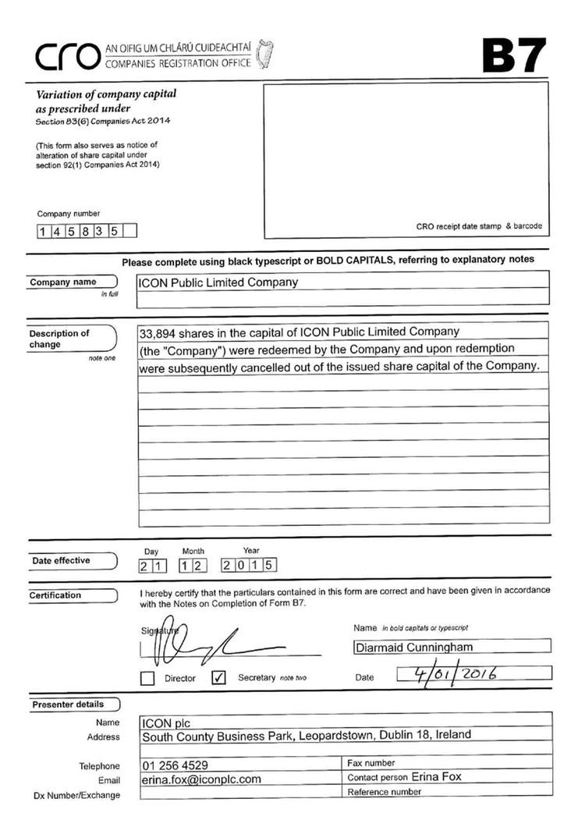

Exhibit 99.21
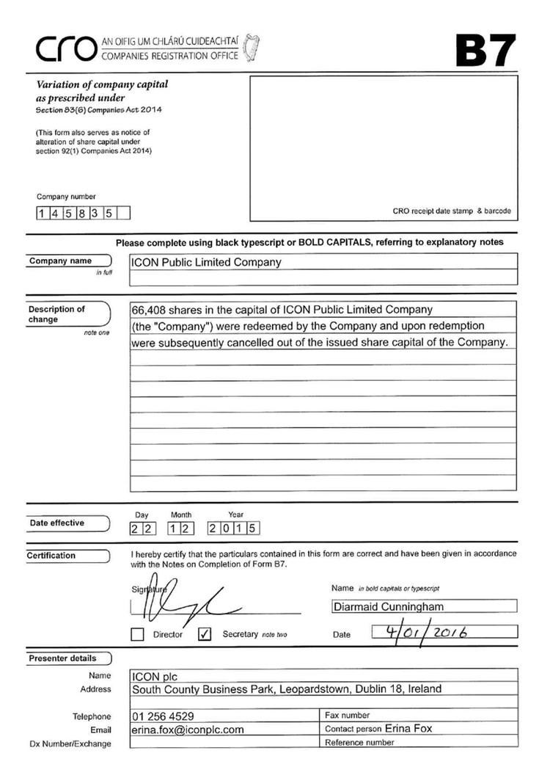

Exhibit 99.22


