FORM 6-K

SECURITIES AND EXCHANGE COMMISSION

Washington, D.C. 20549

Report of Foreign Private Issuer

Pursuant to Rule 13a-16 under

the Securities Exchange Act of 1934

For the month ended November, 2015

ICON plc

(Registrant's name)

333-08704

(Commission file number)

South County Business Park, Leopardstown, Dublin 18, Ireland

(Address of principal executive offices)

Brendan Brennan, CFO

South County Business Park, Leopardstown, Dublin 18, Ireland.

Brendan.Brennan@iconplc.com

00-353-1-291-2000

(Name, telephone number, email and/or facsimile number and address of Company contact person)

Indicate by check mark whether the registrant files or will file annual reports under cover Form 20-F or Form 40-F.

Yes___X___ No_______

Indicate by check mark whether the registrant is submitting the Form 6-K in paper as permitted by Regulation S-T Rule 101(b)(1):

Yes______ No___X___

Indicate by check mark whether the registrant is submitting the Form 6-K in paper as permitted by Regulation S-T Rule 101(b)(7):

Yes______ No___X___

Indicate by check mark whether the registrant by furnishing the information contained in this Form is also thereby furnishing the information to the Commission pursuant to Rule12g3-2(b) under the Securities Exchange Act of 1934.

Yes______ No___X___

If "Yes" is marked, indicate below the file number assigned to the registrant in connection with Rule 12g3-2(b):82 N/A

 |  |  |  |  | EXHIBIT LIST
Exhibit |  |  | Description
99.1 |  |  | Form B7 Notice of Redemption of 42,500 Shares on October 8, 2015 filed in Companies Registration Office in Ireland on November
 |  | 9, 2015
99.2 |  | Form B7 Notice of Redemption of 50,000 Shares on October 9, 2015 filed in Companies Registration Office in Ireland on November
 |  | 9, 2015
99.3 |  | Form B7 Notice of Redemption of 45,000 Shares on October 13, 2015 filed in Companies Registration Office in Ireland on November
 |  | 9, 2015
99.4 |  | Form B7 Notice of Redemption of 44,000 Shares on October 14, 2015 filed in Companies Registration Office in Ireland on November
 |  | 9, 2015
99.5 |  | Form B7 Notice of Redemption of 45,000 Shares on October 15, 2015 filed in Companies Registration Office in Ireland on November
 |  | 9, 2015
99.6 |  | Form B7 Notice of Redemption of 43,075 Shares on October 15, 2015 filed in Companies Registration Office in Ireland on November
 |  | 9, 2015
99.7 |  | Form B7 Notice of Redemption of 45,000 Shares on October 16, 2015 filed in Companies Registration Office in Ireland on November
 |  | 9, 2015
99.8 |  | Form B7 Notice of Redemption of 43,500 Shares on October 19, 2015 filed in Companies Registration Office in Ireland on November
 |  | 9, 2015
99.9 |  | Form B7 Notice of Redemption of 42,500 Shares on October 20, 2015 filed in Companies Registration Office in Ireland on November
 |  | 9, 2015
99.10 |  | Form B7 Notice of Redemption of 42,500 Shares on October 21, 2015 filed in Companies Registration Office in Ireland on November
 |  | 9, 2015
99.11 |  | Form B7 Notice of Redemption of 41,500 Shares on October 22, 2015 filed in Companies Registration Office in Ireland on November
 |  | 9, 2015
99.12 |  | Form B7 Notice of Redemption of 40,000 Shares on October 23, 2015 filed in Companies Registration Office in Ireland on November
 |  | 9, 2015
99.13 |  | Form B7 Notice of Redemption of 42,500 Shares on October 26, 2015 filed in Companies Registration Office in Ireland on November
 |  | 9, 2015
99.14 |  | Form B7 Notice of Redemption of 50,000 Shares on October 27, 2015 filed in Companies Registration Office in Ireland on November
 |  | 9, 2015
99.15 |  | Form B7 Notice of Redemption of 45,000 Shares on October 28, 2015 filed in Companies Registration Office in Ireland on November
 |  | 9, 2015
99.16 |  | Form B7 Notice of Redemption of 43,000 Shares on October 29, 2015 filed in Companies Registration Office in Ireland on November
 |  | 9, 2015
99.17 |  | Form B7 Notice of Redemption of 45,000 Shares on October 30, 2015 filed in Companies Registration Office in Ireland on November
 |  | 9, 2015
99.18 |  | Form B7 Notice of Redemption of 44,000 Shares on November 2, 2015 filed in Companies Registration Office in Ireland on
 |  | November 9, 2015
99.19 |  | Form B7 Notice of Redemption of 43,983 Shares on November 3, 2015 filed in Companies Registration Office in Ireland on
 |  | November 9, 2015

SIGNATURES

Pursuant to the requirements of the Securities Exchange Act of 1934, the Registrant has duly caused this report to be signed on its behalf by the undersigned thereunto duly authorized.

ICON plc

/s/ Brendan Brennan

Date: November 9, 2015 Brendan Brennan Chief Financial Officer

Exhibit 99.1
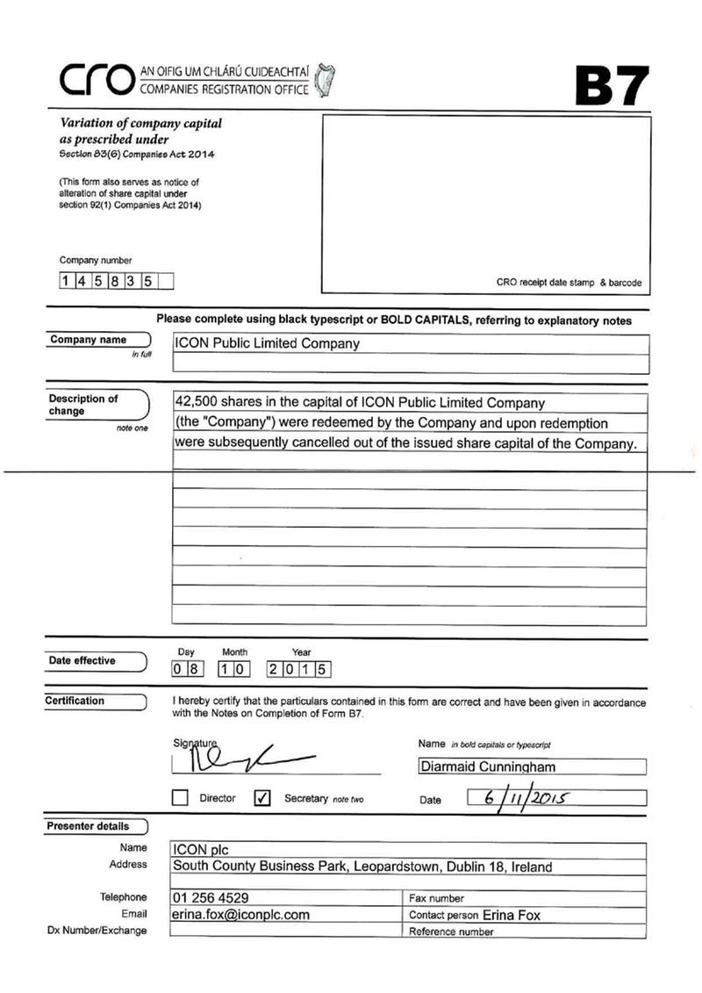

Exhibit 99.2
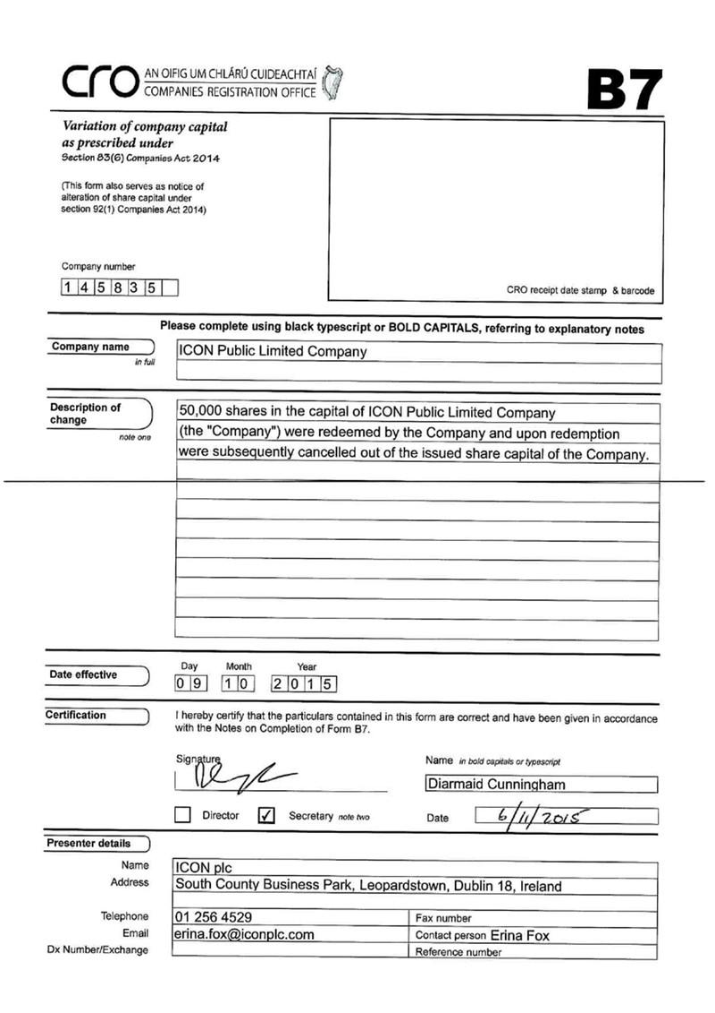

Exhibit 99.3
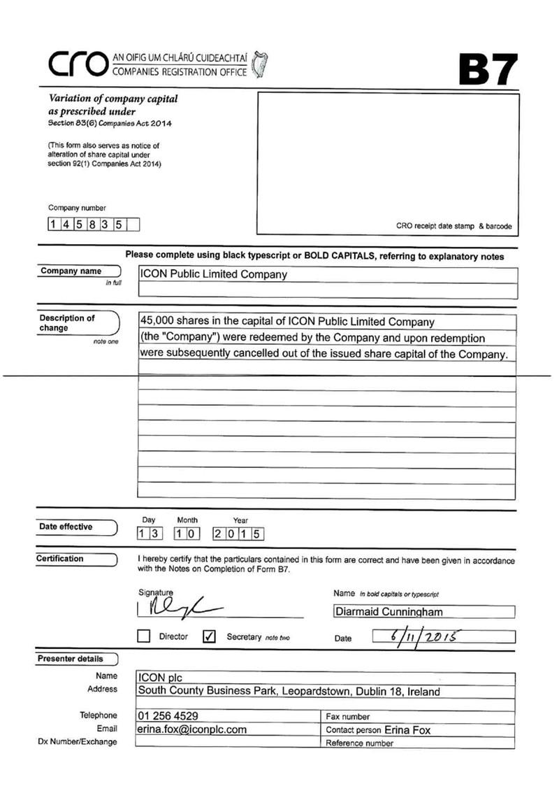

Exhibit 99.4
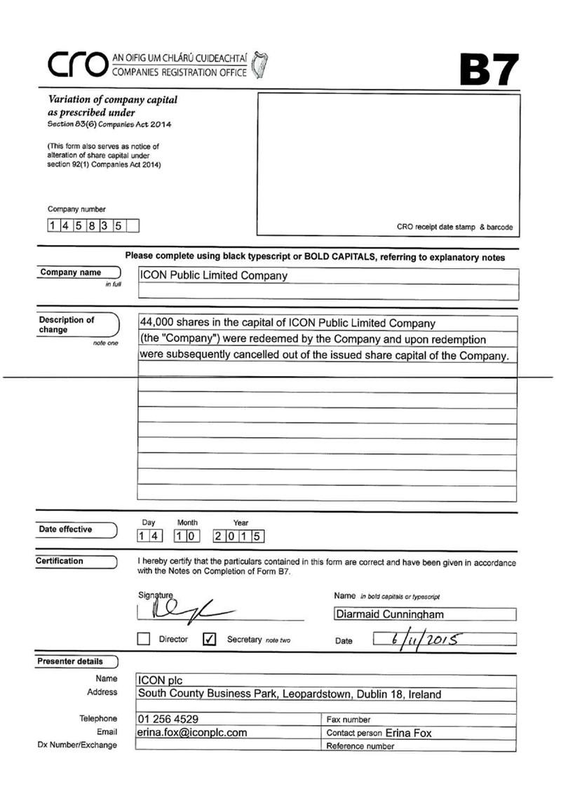

Exhibit 99.5
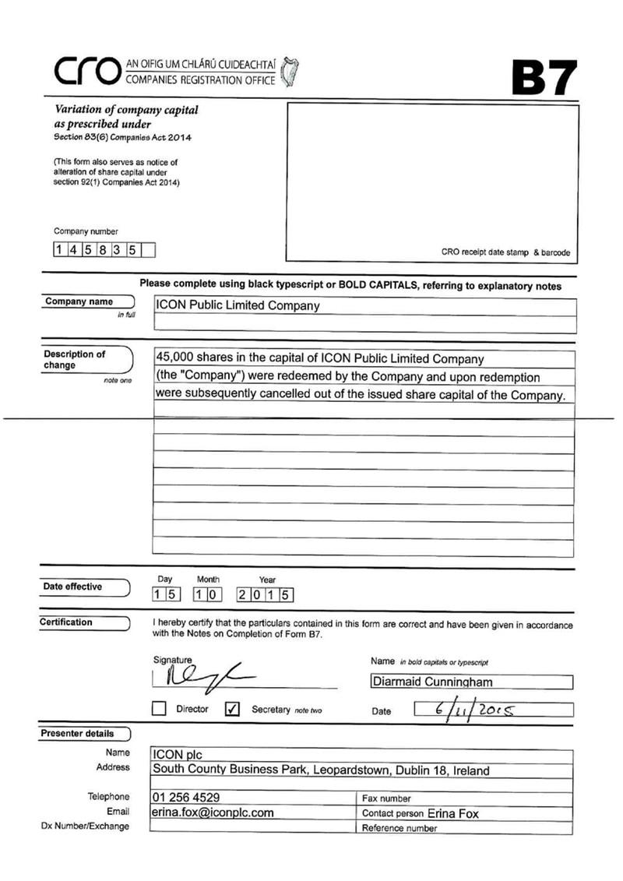

Exhibit 99.6
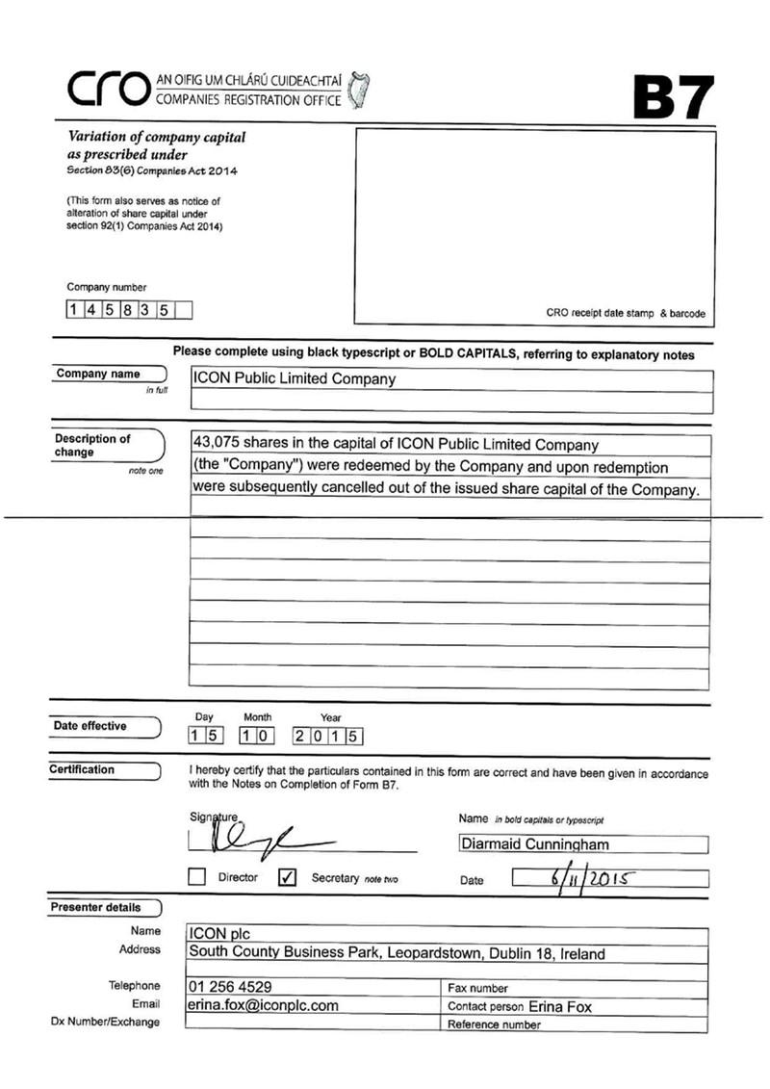

Exhibit 99.7
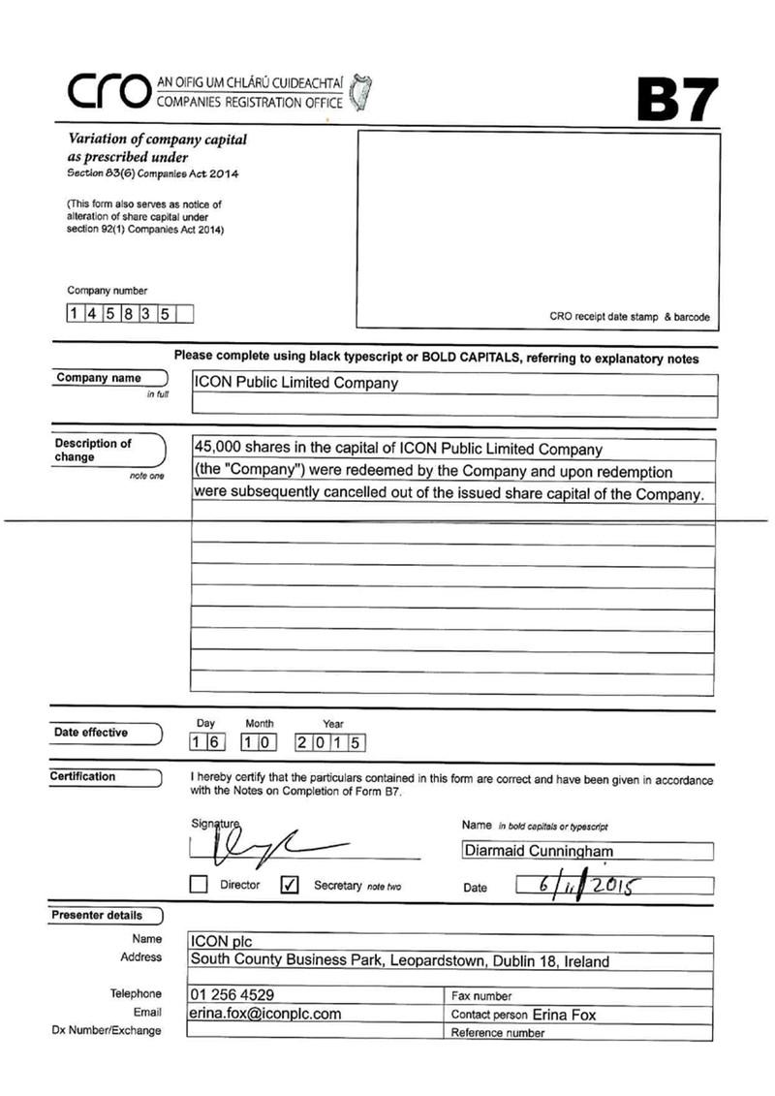

Exhibit 99.8
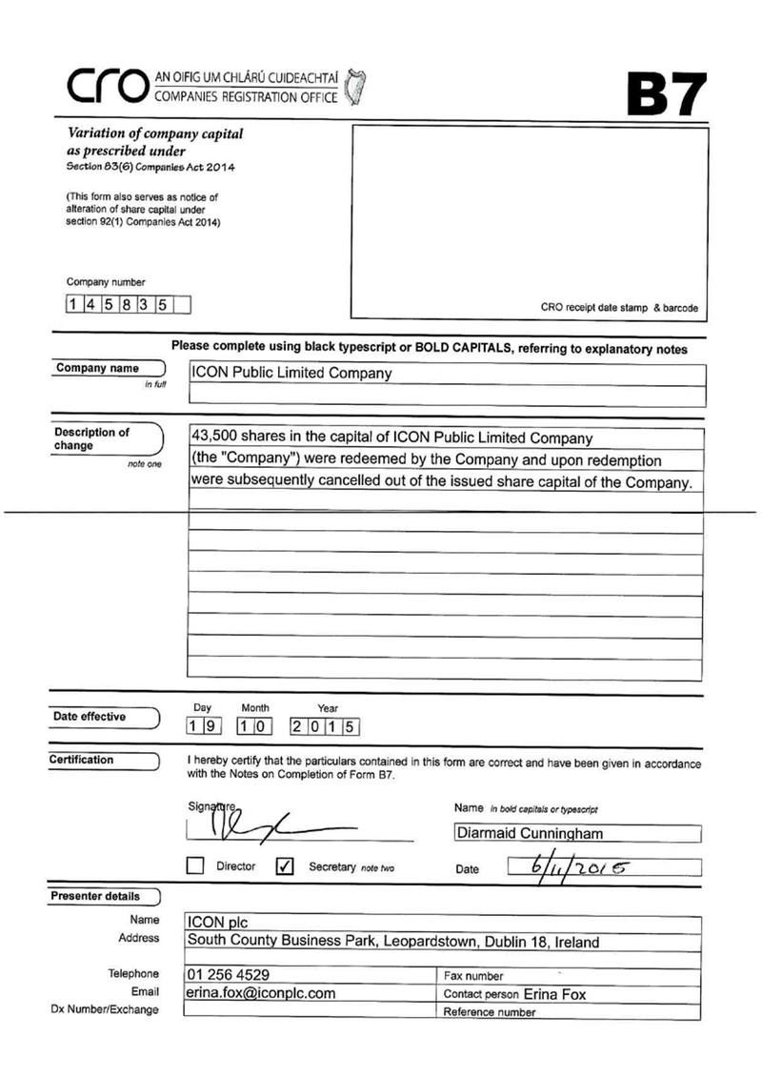

Exhibit 99.9
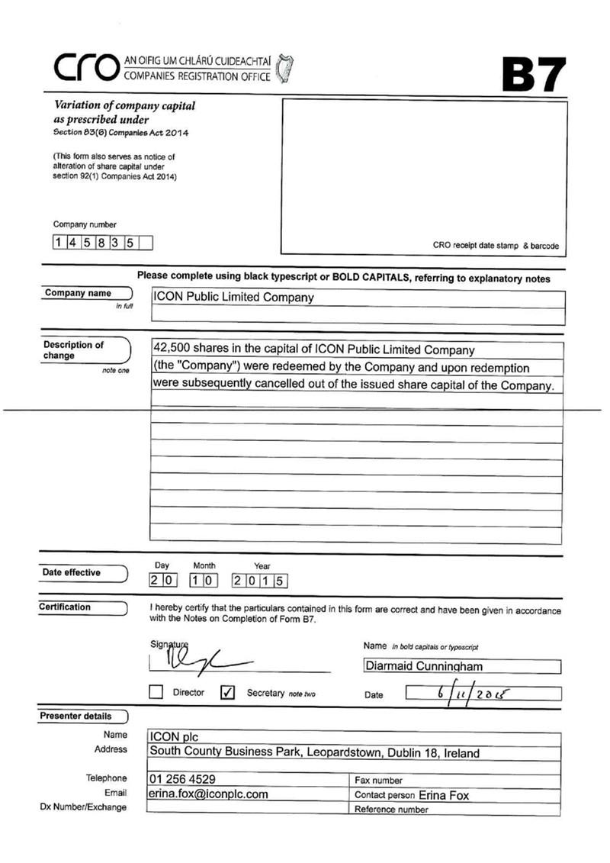

Exhibit 99.10
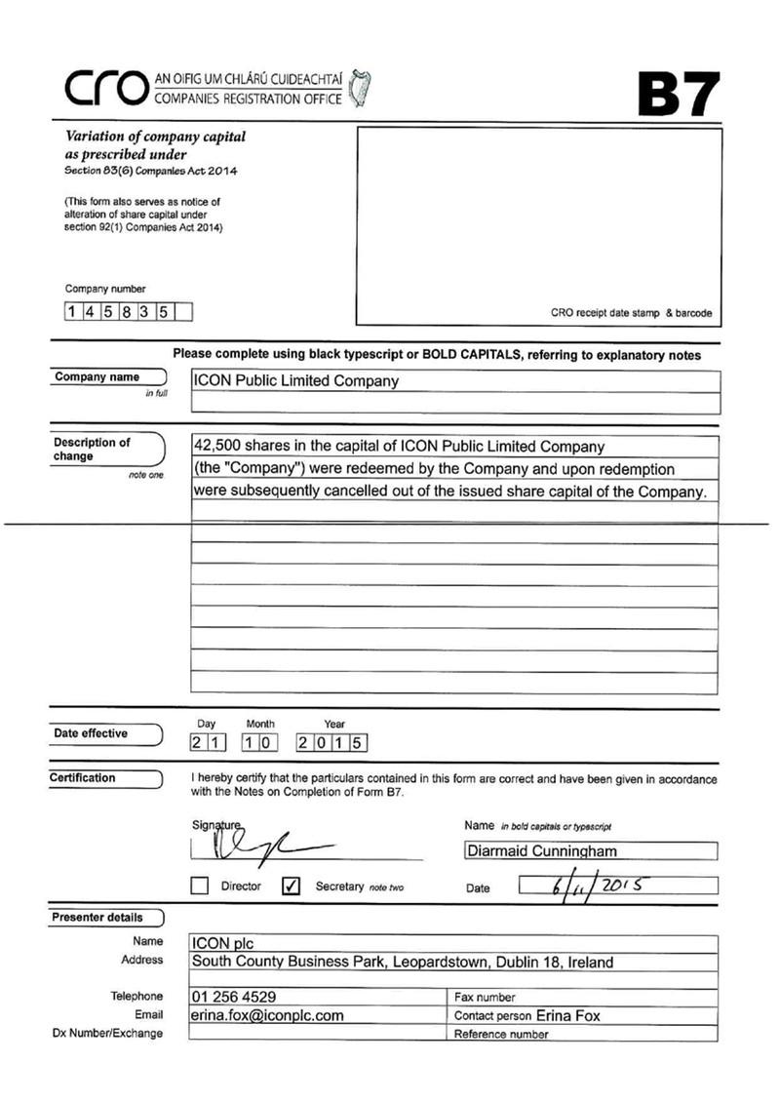

Exhibit 99.11

Exhibit 99.12
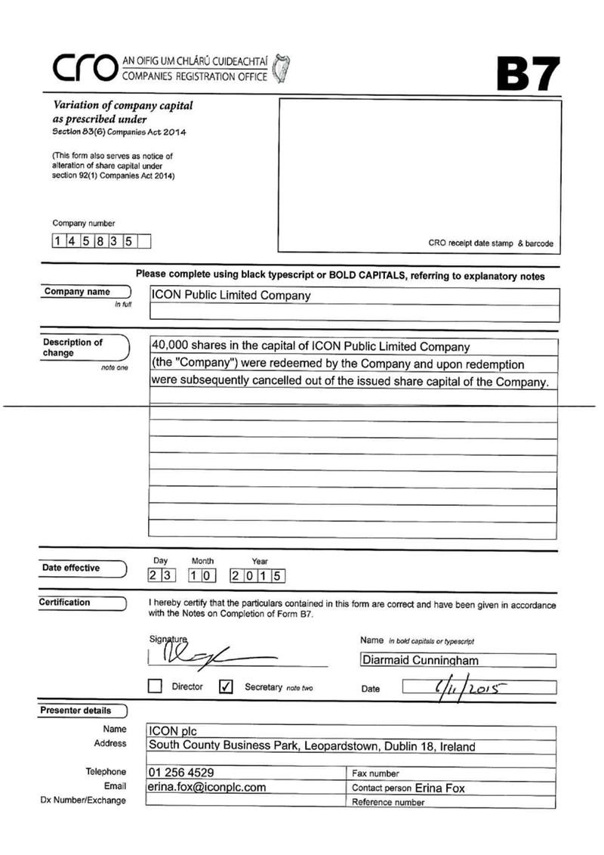

Exhibit 99.13
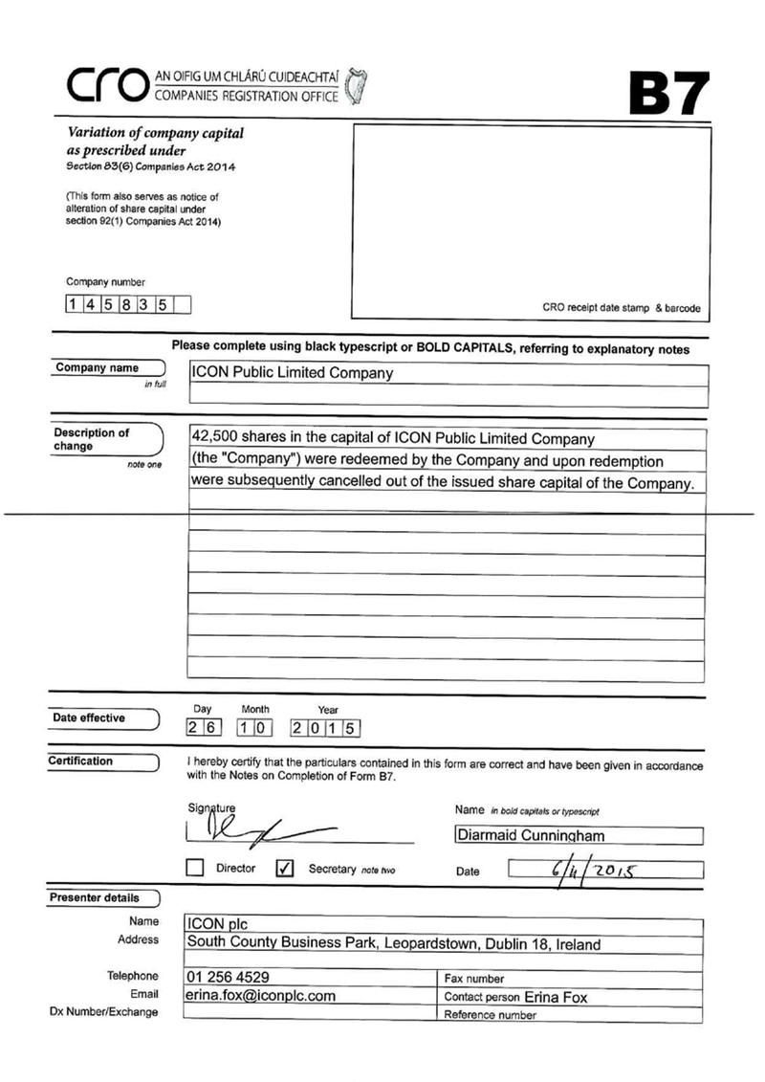

Exhibit 99.14
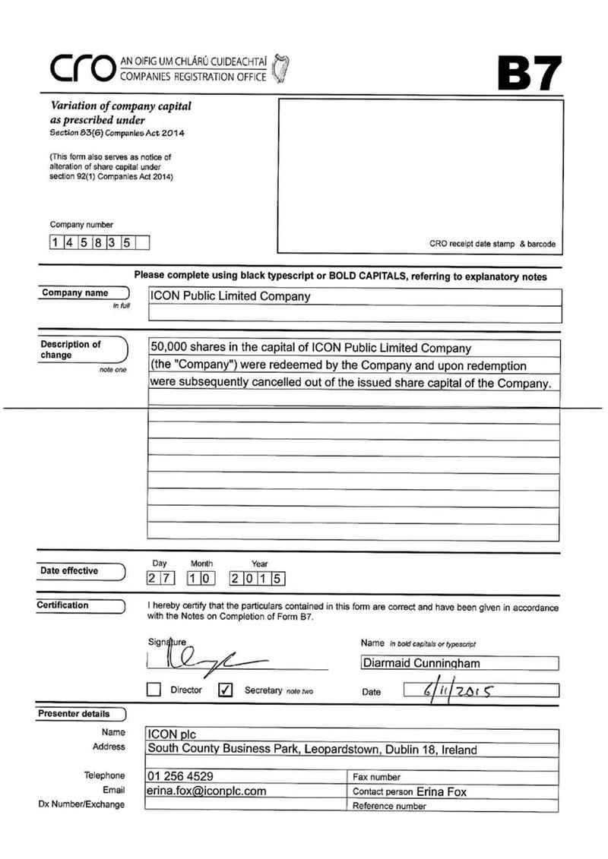

Exhibit 99.15
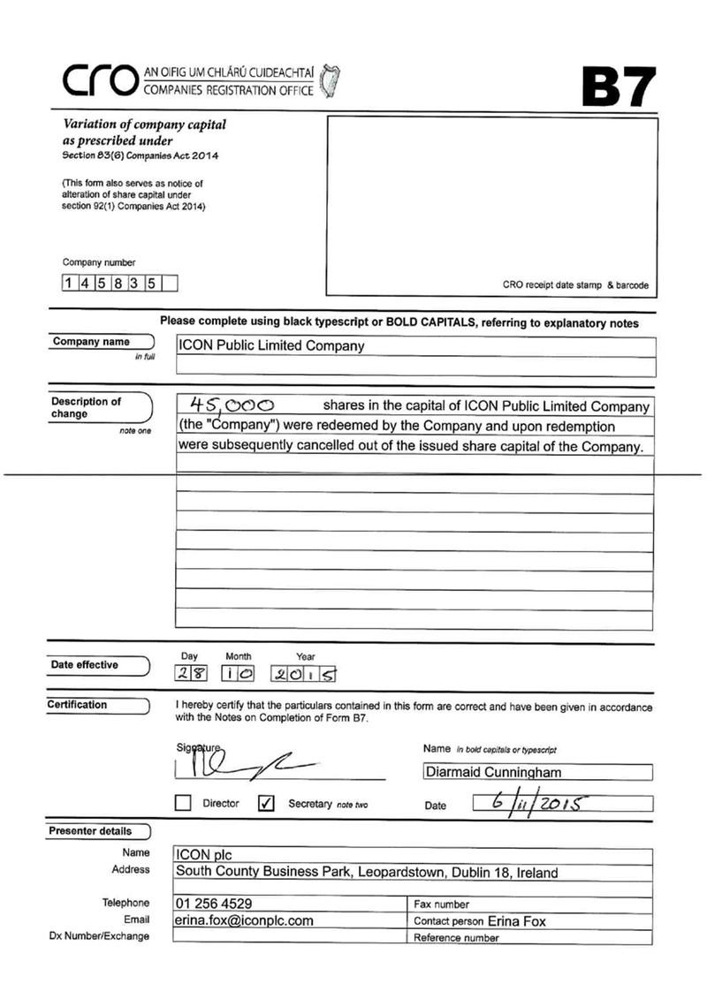

Exhibit 99.16
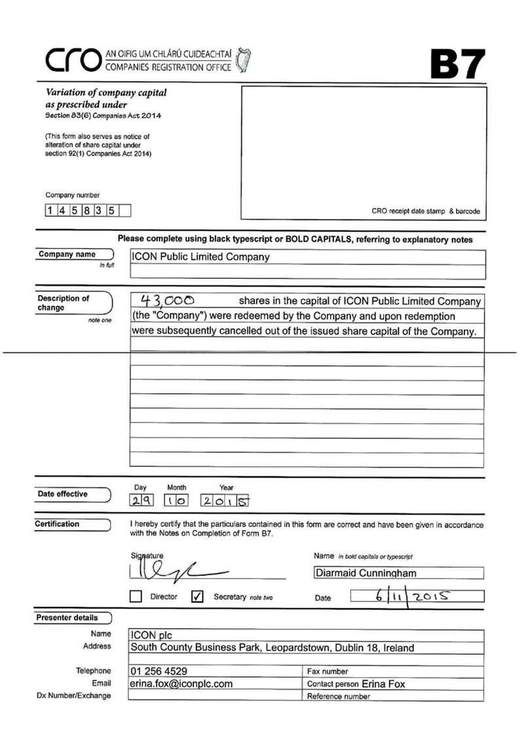

Exhibit 99.17
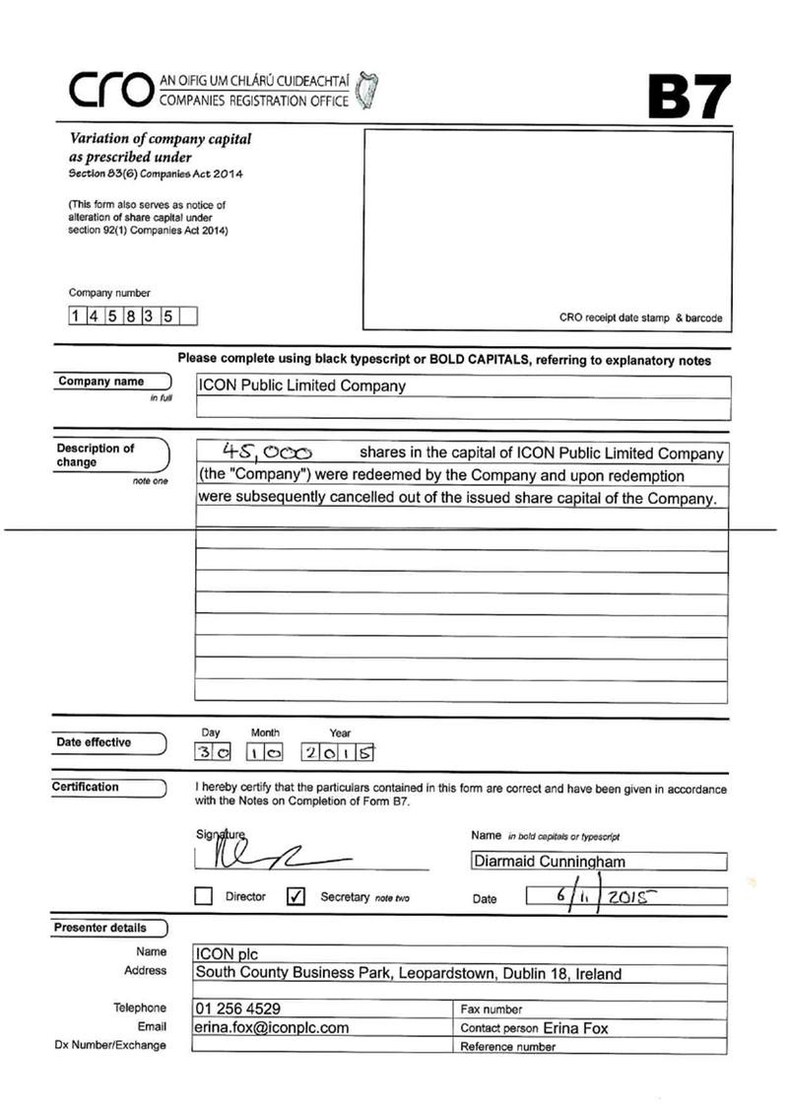

Exhibit 99.18
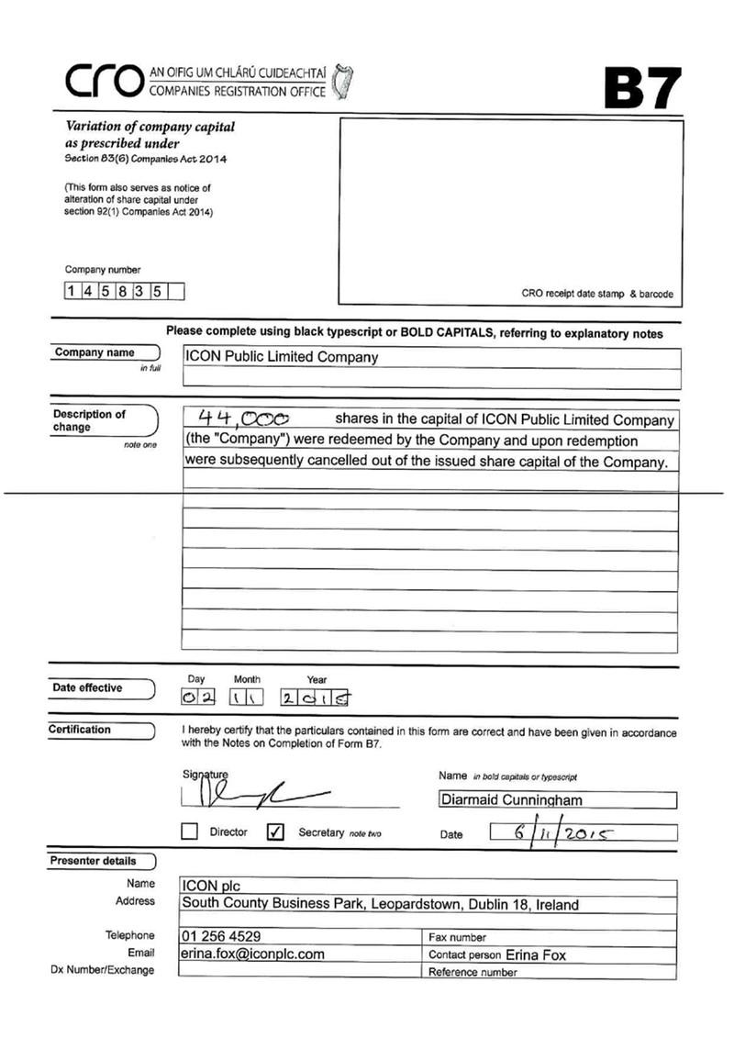

Exhibit 99.19


