Filed by ICON plc

This communication is filed pursuant to Rule 425 under the United States Securities Act of 1933

Subject Company: PRA Health Sciences, Inc.

(Commission File No. 001-36732)

Date: May 19, 2021
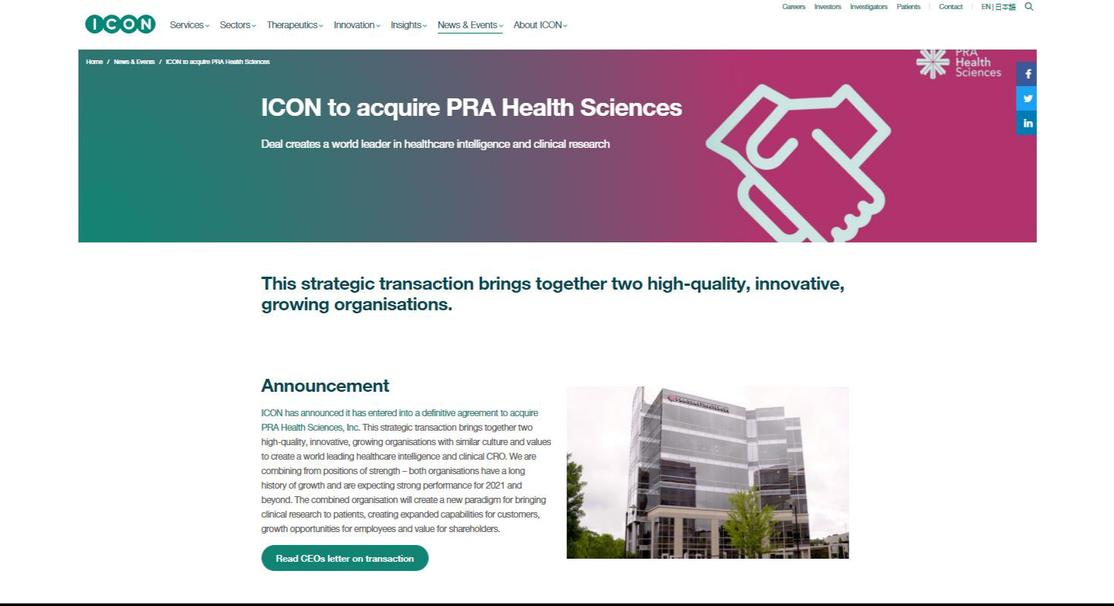



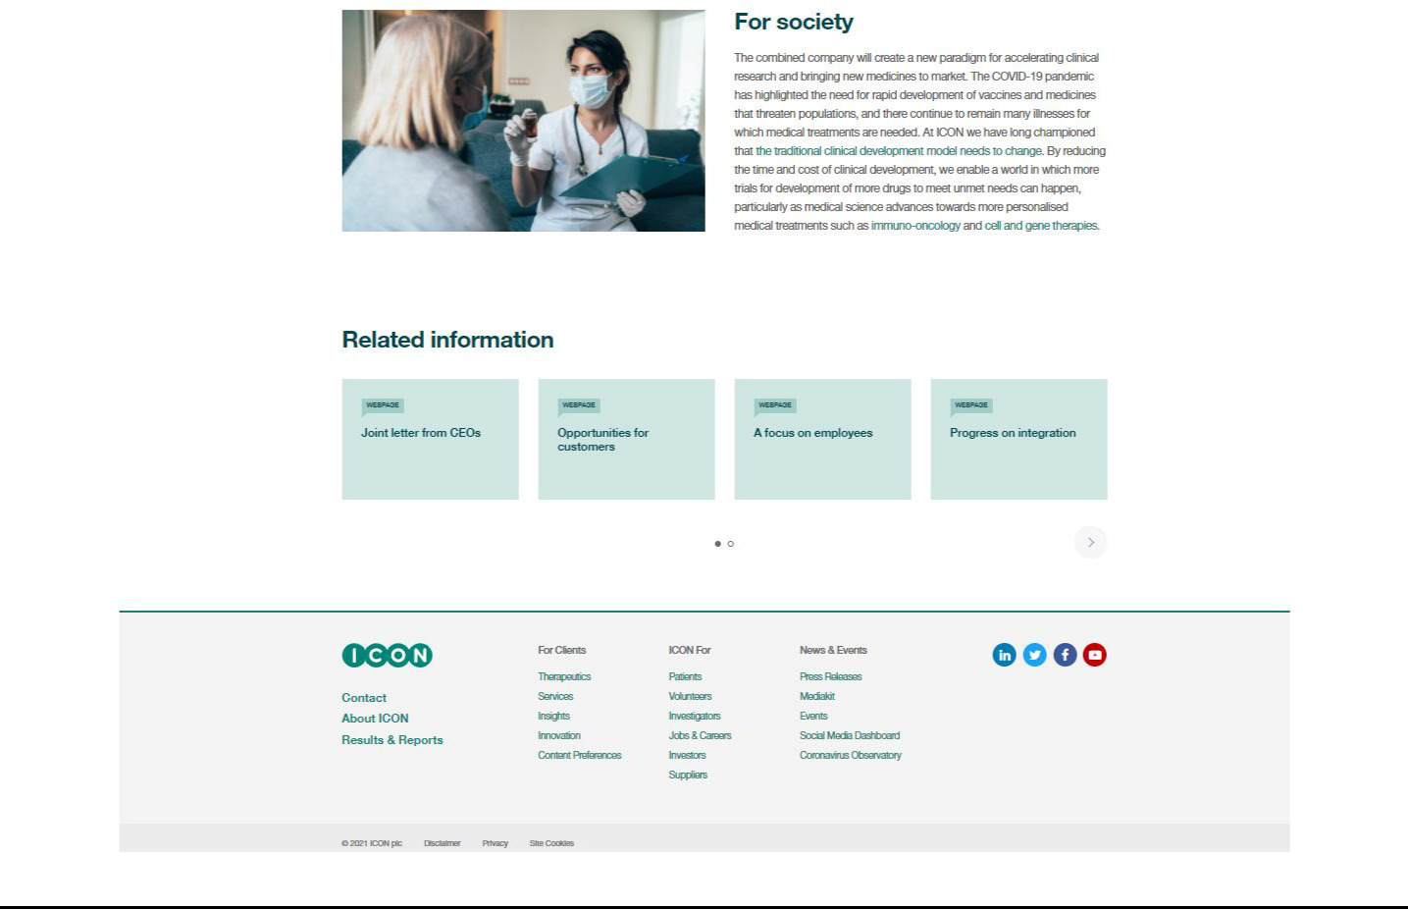

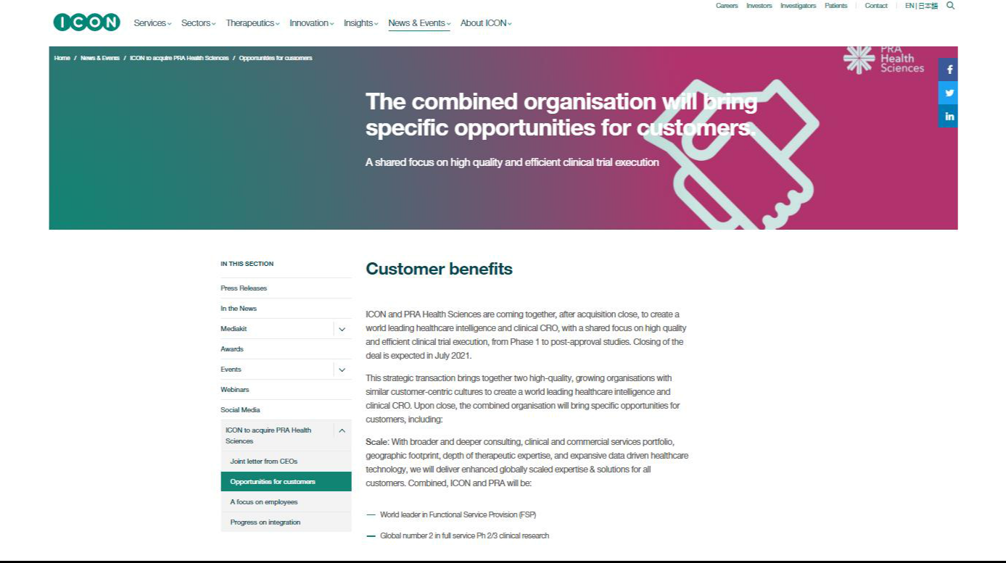

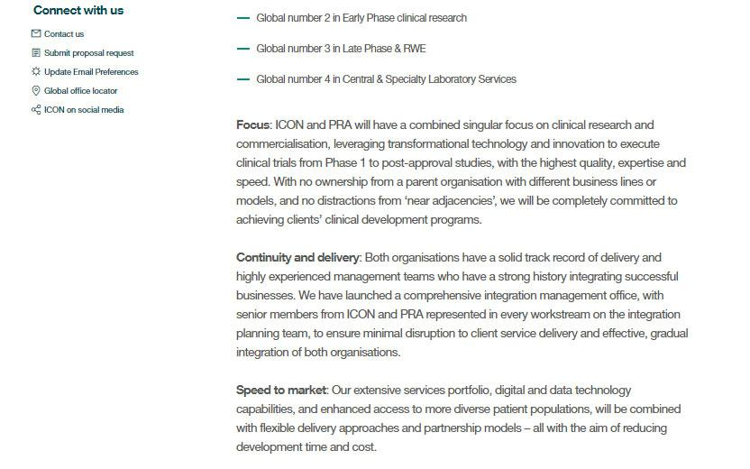

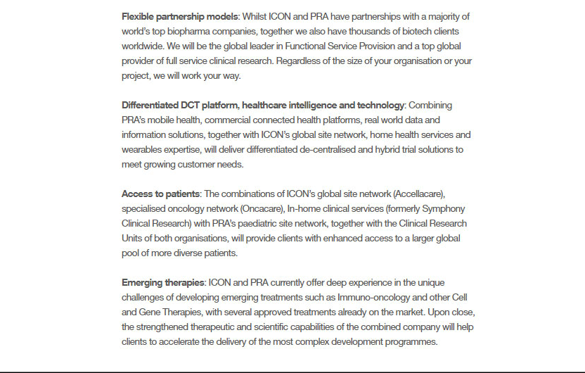

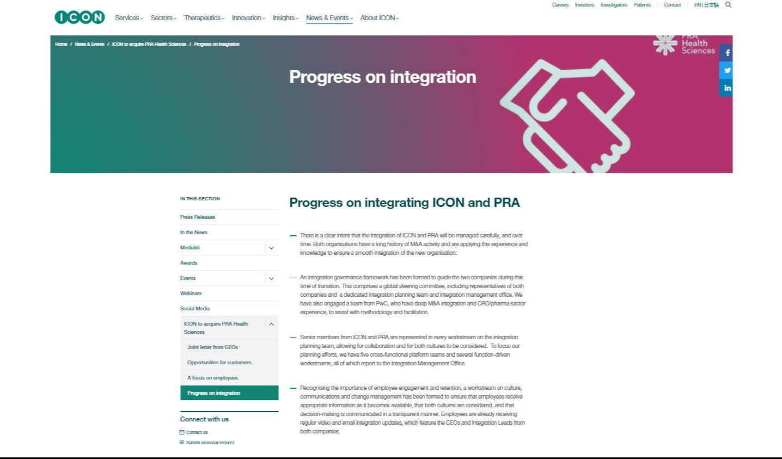

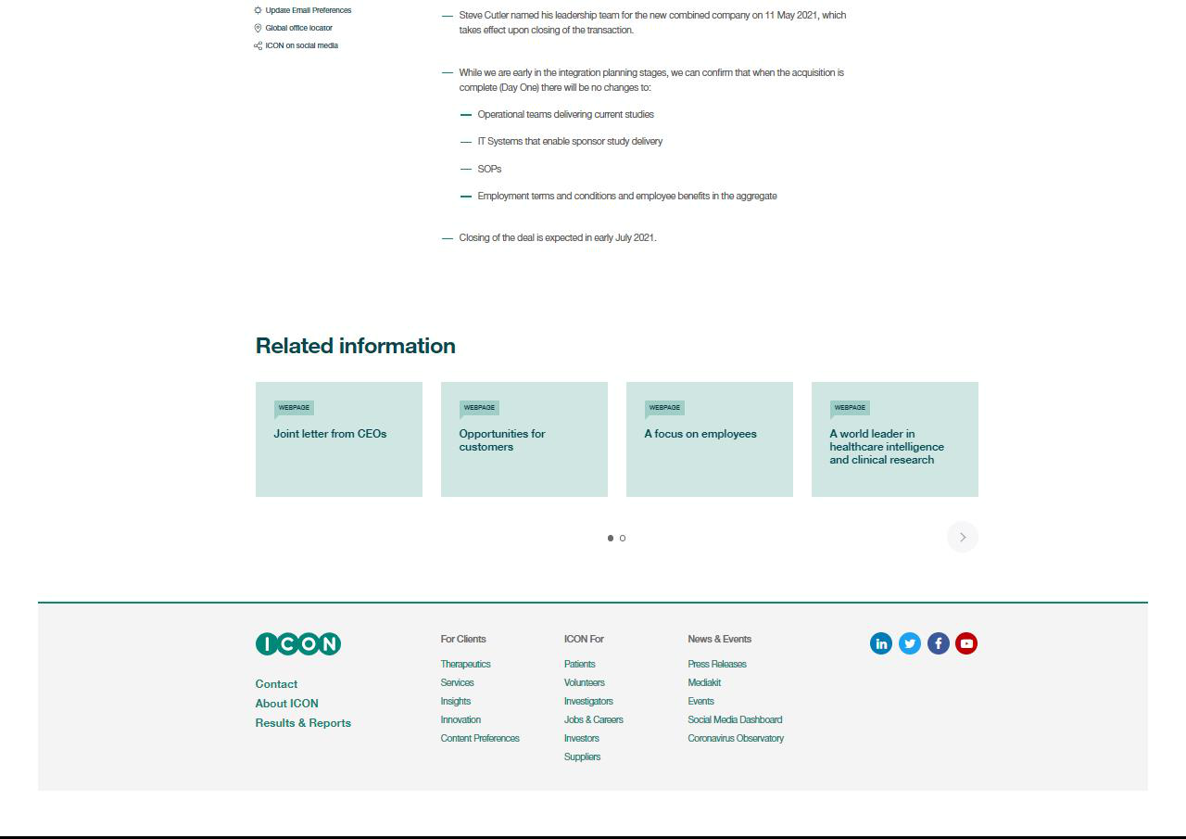

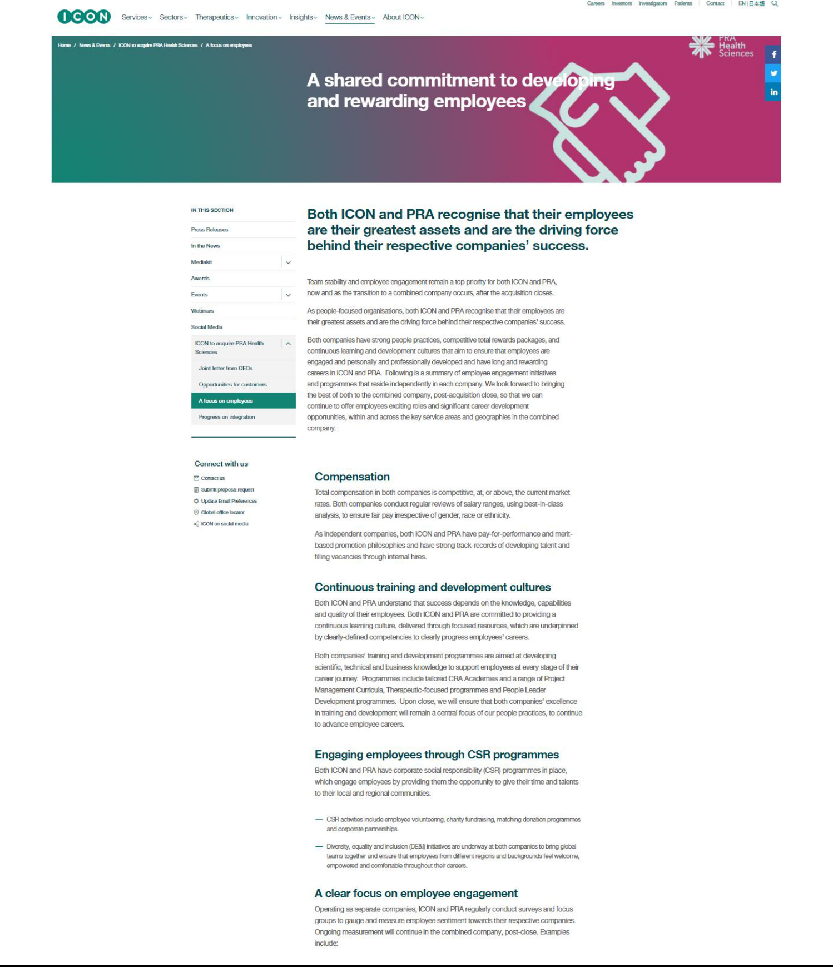

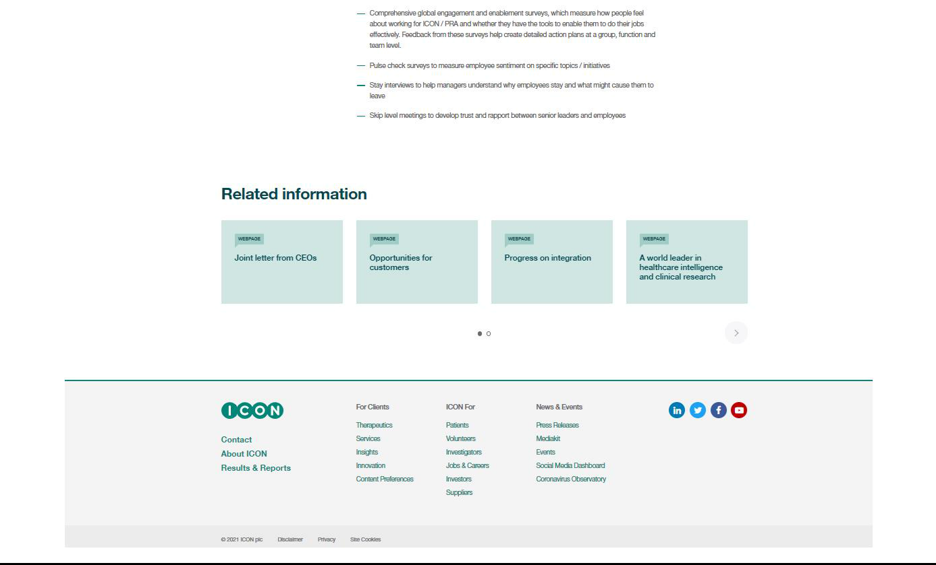

Cautionary Note Regarding Forward-Looking Statements

This communication contains forward-looking statements within the meaning of the Private Securities Litigation Reform Act of 1995, Section 27A of the Securities Act of 1933, as amended, and Section 21E of the Securities Exchange Act of 1934, as amended. These forward-looking statements generally include statements regarding the potential transaction between ICON public limited company, a public limited company in Ireland (“ICON”) and PRA Health Sciences, Inc., a Delaware corporation (“PRA”), including any statements regarding the expected timetable for completing the potential transaction, the ability to complete the potential transaction, the expected benefits of the potential transaction (including anticipated synergies, projected financial information and future opportunities) and any other statements regarding ICON’s and PRA’s future expectations, beliefs, plans, objectives, results of operations, financial condition and cash flows, or future events or performance. These statements are often, but not always, made through the use of words or phrases such as “anticipate,” “intend,” “plan,” “believe,” “project,” “estimate,” “expect,” “may,” “should,” “will” and similar expressions. All such forward-looking statements are based on current expectations of ICON’s and PRA’s management and therefore involve estimates and assumptions that are subject to risks, uncertainties and other factors that could cause actual results to differ materially from the results expressed in the statements. Key factors that could cause actual results to differ materially from those projected in the forward-looking statements include the ability to obtain the requisite ICON and PRA stockholder approvals; uncertainties as to the timing to consummate the potential transaction; the risk that a condition to closing the potential transaction may not be satisfied; the risk that regulatory approvals are not obtained or are obtained subject to conditions that are not anticipated by the parties; litigation relating to the potential transaction that has been or could be instituted against ICON, PRA or their respective directors; the effects of disruption to ICON’s or PRA’s respective businesses; restrictions during the pendency of the potential transaction that may impact ICON’s or PRA’s ability to pursue certain business opportunities or strategic transactions; the effect of this communication on ICON’s or PRA’s stock prices; transaction costs; ICON’s ability to achieve the benefits from the proposed transaction; ICON’s ability to effectively integrate acquired operations into its own operations; the ability of ICON or PRA to retain and hire key personnel; unknown liabilities; and the diversion of management time on transaction-related issues. Other important factors that could cause actual results to differ materially from those in the forward-looking statements include the effects of industry, market, economic, political or regulatory conditions outside of ICON’s or PRA’s control (including public health crises, such as pandemics and epidemics); risks regarding PRA’s ability to maintain large customer contracts or enter into new contracts; PRA’s ability to attract suitable investigators and patients for its clinical trials; PRA’s ability to keep pace with rapid technological change; PRA’s potential liability if a patient is harmed; and the factors set forth under the heading “Risk Factors” of ICON’s Annual Report on Form 20-F and PRA’s Annual Report on Form 10-K and most recent Quarterly Report on Form 10-Q, and in subsequent filings with the U.S. Securities and Exchange Commission (the “SEC”). These risks, as well as other risks associated with the potential transaction, are more fully discussed in the joint proxy statement/prospectus filed with the SEC in connection with the proposed transaction. Other unpredictable or unknown factors not discussed in this communication could also have material adverse effects on forward-looking statements. Neither ICON nor PRA assumes any obligation to update any forward-looking statements, except as required by law. Readers are cautioned not to place undue reliance on these forward-looking statements that speak only as of the date hereof.

No Offer or Solicitation

This communication does not constitute an offer to sell or the solicitation of an offer to buy any securities or a solicitation of any vote or approval, nor shall there be any sale of securities in any jurisdiction in which such offer, solicitation or sale would be unlawful prior to registration or qualification under the securities laws of any such jurisdiction. No offer of securities shall be made except by means of a prospectus meeting the requirements of Section 10 of the Securities Act of 1933, as amended.

Important Information for Investors and Stockholders

In connection with the potential transaction, ICON has filed a registration statement on Form F-4 (File No. 333-254891) with the SEC containing a prospectus of ICON that also constitutes a proxy statement of each of ICON and PRA. The registration statement, as amended, was declared effective, by the SEC on April 28, 2021. Each of ICON and PRA commenced mailing copies of the definitive joint proxy statement/prospectus to stockholders of ICON and PRA, respectively, on or about April 28, 2021. ICON and PRA may also file other documents with the SEC regarding the potential transaction. This communication is not a substitute for the joint proxy statement/prospectus or registration statement or for any other document that ICON or PRA have filed or may file with the SEC in connection with the potential transaction. INVESTORS AND SECURITY HOLDERS OF ICON AND PRA ARE URGED TO READ THE JOINT PROXY STATEMENT/PROSPECTUS AND OTHER DOCUMENTS THAT ARE FILED OR WILL BE FILED WITH THE SEC, AS WELL AS ANY AMENDMENTS OR SUPPLEMENTS TO THESE DOCUMENTS, CAREFULLY AND IN THEIR ENTIRETY BECAUSE THEY CONTAIN IMPORTANT INFORMATION. Investors and security holders are able to obtain free copies of the joint proxy statement/prospectus and other documents filed with the SEC by ICON or PRA through the website maintained by the SEC at http://www.sec.gov. Copies of the documents filed with the SEC by ICON are available free of charge on ICON’s website at https://www.iconplc.com and copies of the documents filed with the SEC by PRA are available free of charge on PRA’s website at https://www.prahs.com/. Additionally, copies may be obtained by contacting the investor relations departments of ICON or PRA.

ICON and PRA and certain of their respective directors, certain of their respective executive officers and other members of management and employees may be considered participants in the solicitation of proxies with respect to the potential transaction under the rules of the SEC. Information about the directors and executive officers of ICON is set forth in its annual report on Form 20-F, which was filed with the SEC on February 24, 2021. Information about the directors and executive officers of PRA is set forth in its Amendment to Annual Report on Form 10-K/A for the fiscal year ended December 31, 2020, which was filed with the SEC on March 30, 2021. These documents can be obtained free of charge from the sources indicated above. Additional information regarding the interests of such participants in the solicitation of proxies in respect of the potential transaction are included in the registration statement and joint proxy statement/prospectus and other relevant materials filed with the SEC.

The term “ICON” and such terms as “the company,” “our,” “we,” “us” and “its” may refer to ICON public limited company, one or more of its consolidated subsidiaries, or to all of them taken as a whole. All of these terms are used for convenience only and are not intended as a precise description of any of the separate companies, each of which manages its own affairs.

