FORM 6-K

SECURITIES AND EXCHANGE COMMISSION

Washington, D.C. 20549

Report of Foreign Private Issuer

Pursuant to Rule 13a-16 under

the Securities Exchange Act of 1934

For the month ended October, 2015

ICON plc

(Registrant's name)

333-08704

(Commission file number)

South County Business Park, Leopardstown, Dublin 18, Ireland

(Address of principal executive offices)

Brendan Brennan, CFO

South County Business Park, Leopardstown, Dublin 18, Ireland.

Brendan.Brennan@iconplc.com

00-353-1-291-2000

(Name, telephone number, email and/or facsimile number and address of Company contact person)

Indicate by check mark whether the registrant files or will file annual reports under cover Form 20-F or Form 40-F.

Yes___X___ No_______

Indicate by check mark whether the registrant is submitting the Form 6-K in paper as permitted by Regulation S-T Rule 101(b)(1):

Yes______ No___X___

Indicate by check mark whether the registrant is submitting the Form 6-K in paper as permitted by Regulation S-T Rule 101(b)(7):

Yes______ No___X___

Indicate by check mark whether the registrant by furnishing the information contained in this Form is also thereby furnishing the information to the Commission pursuant to Rule12g3-2(b) under the Securities Exchange Act of 1934.

Yes______ No___X___

If "Yes" is marked, indicate below the file number assigned to the registrant in connection with Rule 12g3-2(b):82 N/A

 |  |  |  | EXHIBIT LIST
Exhibit |  | Description
99.1 |  | Form B7 Notice of Redemption of 79,018 Shares on September |  |  |  | 14, 2015 filed in Companies Registration Office in Ireland on October 14,
 |  | 2015
99.2 |  | Form B7 Notice of Redemption of 102,454 Shares on September |  |  |  | 15, 2015 filed in Companies Registration Office in Ireland on October 14,
 |  | 2015
99.3 |  | Form B7 Notice of Redemption of 60,786 Shares on September |  |  |  | 16, 2015 filed in Companies Registration Office in Ireland on October 14,
 |  | 2015
99.4 |  | Form B7 Notice of Redemption of 66,702 Shares on September |  |  |  | 17, 2015 filed in Companies Registration Office in Ireland on October 14,
 |  | 2015
99.5 |  | Form B7 Notice of Redemption of 69,929 Shares on September |  |  |  | 18, 2015 filed in Companies Registration Office in Ireland on October 14,
 |  | 2015
99.6 |  | Form B7 Notice of Redemption of 35,584 Shares on September |  |  |  | 21, 2015 filed in Companies Registration Office in Ireland on October 14,
 |  | 2015
99.7 |  | Form B7 Notice of Redemption of 35,798 Shares on September |  |  |  | 22, 2015 filed in Companies Registration Office in Ireland on October 14,
 |  | 2015
99.8 |  | Form B7 Notice of Redemption of 96,736 Shares on September |  |  |  | 23, 2015 filed in Companies Registration Office in Ireland on October 14,
 |  | 2015
99.9 |  | Form B7 Notice of Redemption of 38,700 Shares on September |  |  |  | 24, 2015 filed in Companies Registration Office in Ireland on October 14,
 |  | 2015
99.10 |  | Form B7 Notice of Redemption of 42,500 Shares on September |  |  |  | 25, 2015 filed in Companies Registration Office in Ireland on October 14,
 |  | 2015
99.11 |  | Form B7 Notice of Redemption of 39,800 Shares on September |  |  |  | 28, 2015 filed in Companies Registration Office in Ireland on October 14,
 |  | 2015
99.12 |  | Form B7 Notice of Redemption of 42,000 Shares on September |  |  |  | 29, 2015 filed in Companies Registration Office in Ireland on October 14,
 |  | 2015
99.13 |  | Form B7 Notice of Redemption of 47,500 Shares on September |  |  |  | 30, 2015 filed in Companies Registration Office in Ireland on October 14,
 |  | 2015
99.14 |  | Form B7 Notice of Redemption of 43,500 Shares on October |  |  | 1, 2015 filed in Companies Registration Office in Ireland on October 14, 2015
99.15 |  | Form B7 Notice of Redemption of 45,000 Shares on October |  |  | 2, 2015 filed in Companies Registration Office in Ireland on October 14, 2015
99.16 |  | Form B7 Notice of Redemption of 43,500 Shares on October 5, 2015 filed in Companies Registration Office in Ireland on October 14, 2015
99.17 |  | Form B7 Notice of Redemption of 43,500 Shares on October 6, 2015 filed in Companies Registration Office in Ireland on October 14, 2015
99.18 |  | Form B7 Notice of Redemption of 42,500 Shares on October |  |  | 7, 2015 filed in Companies Registration Office in Ireland on October 14, 2015

SIGNATURES

Pursuant to the requirements of the Securities Exchange Act of 1934, the Registrant has duly caused this report to be signed on its behalf by the undersigned thereunto duly authorized.

ICON plc

/s/ Brendan Brennan

Date: October 14, 2015 Brendan Brennan Chief Financial Officer

Exhibit 99.1
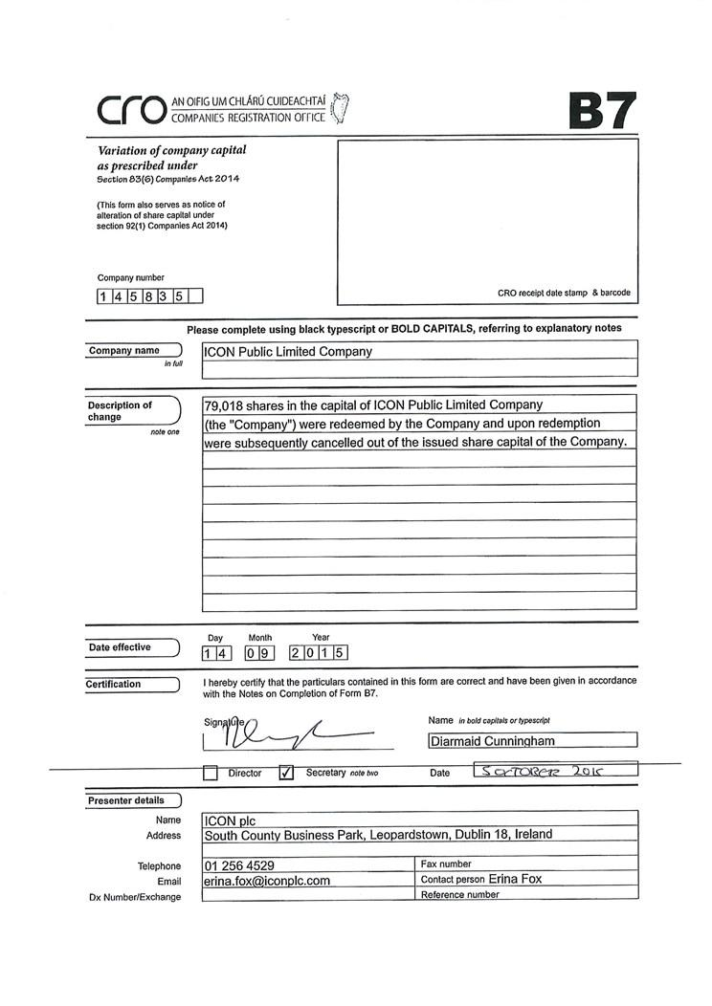

Exhibit 99.2
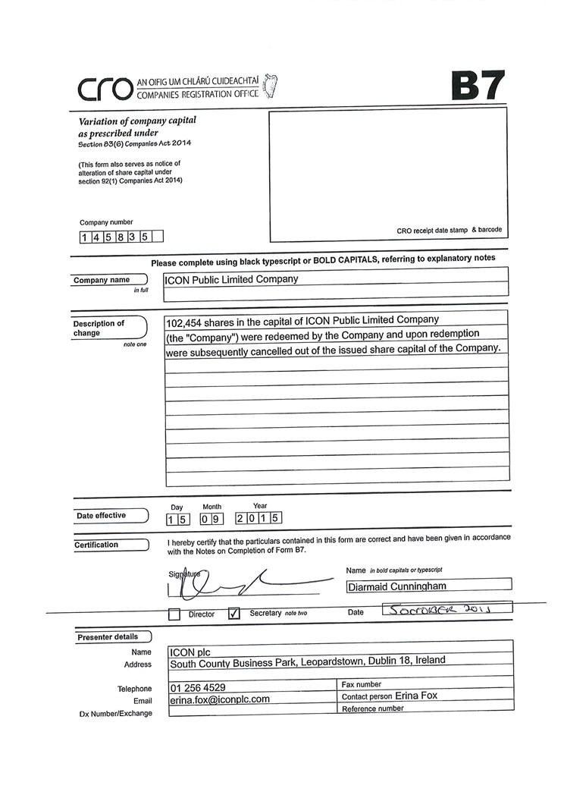

Exhibit 99.3
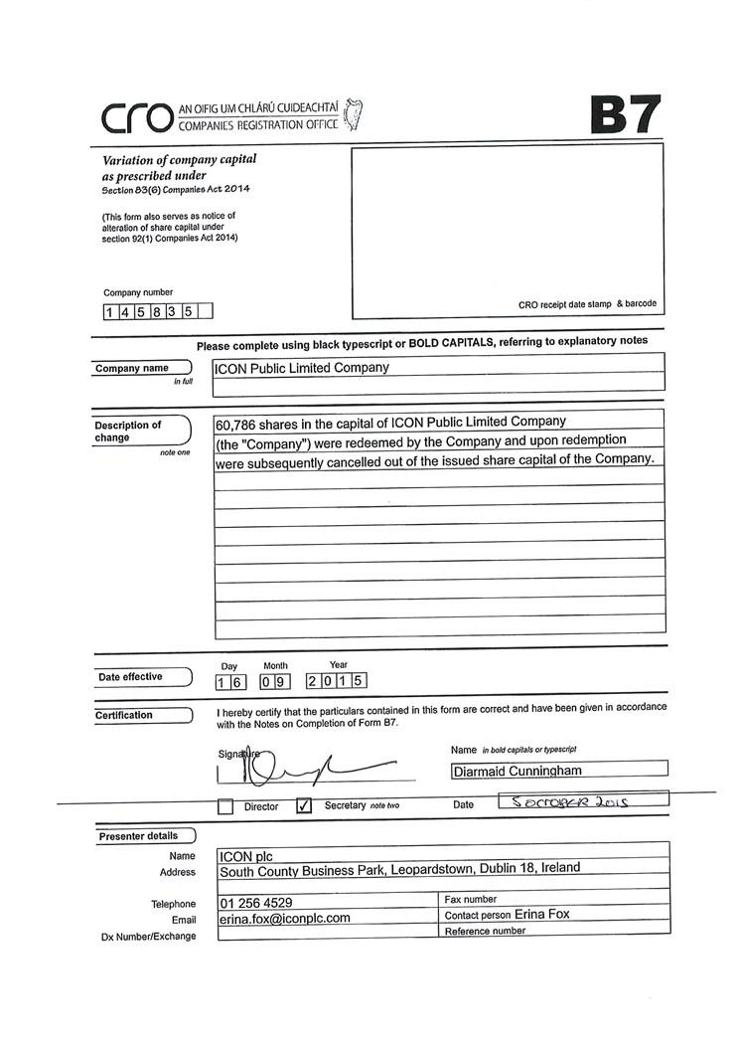

Exhibit 99.4
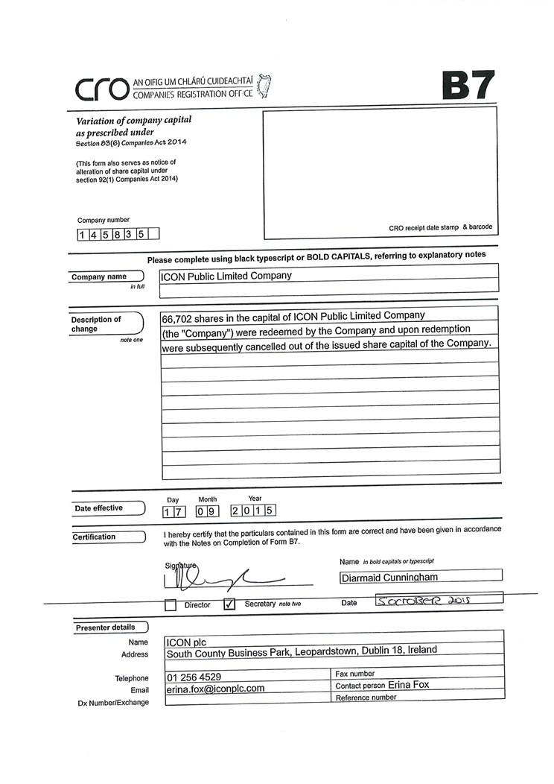

Exhibit 99.5
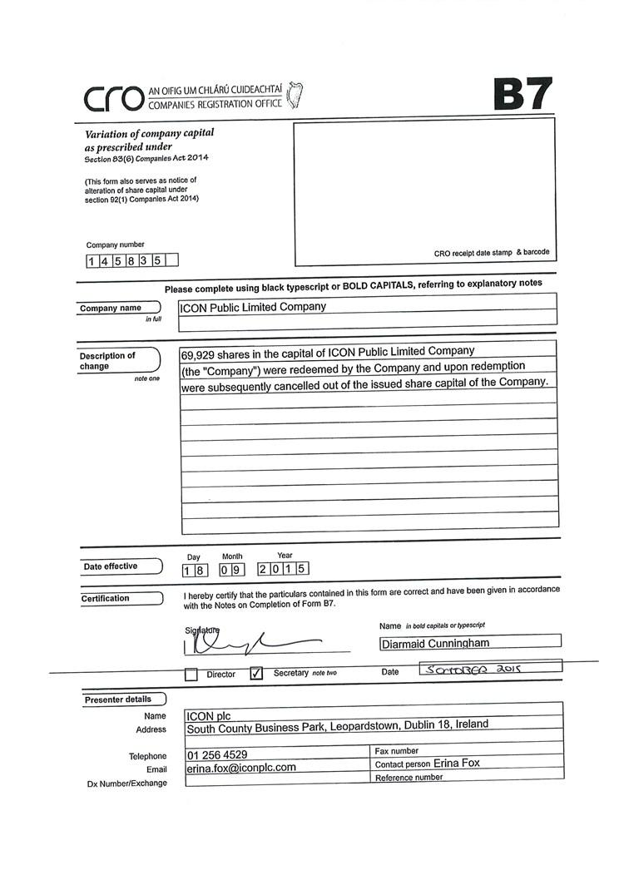

Exhibit 99.6
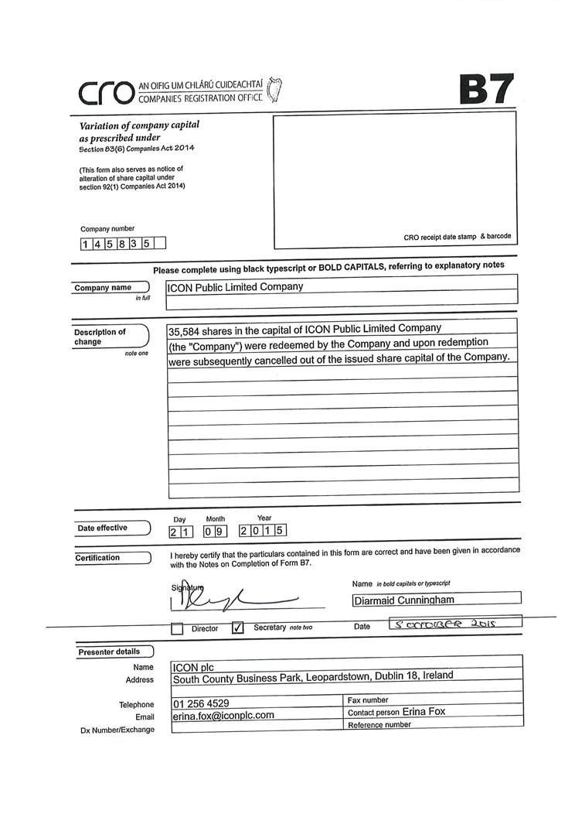

Exhibit 99.7
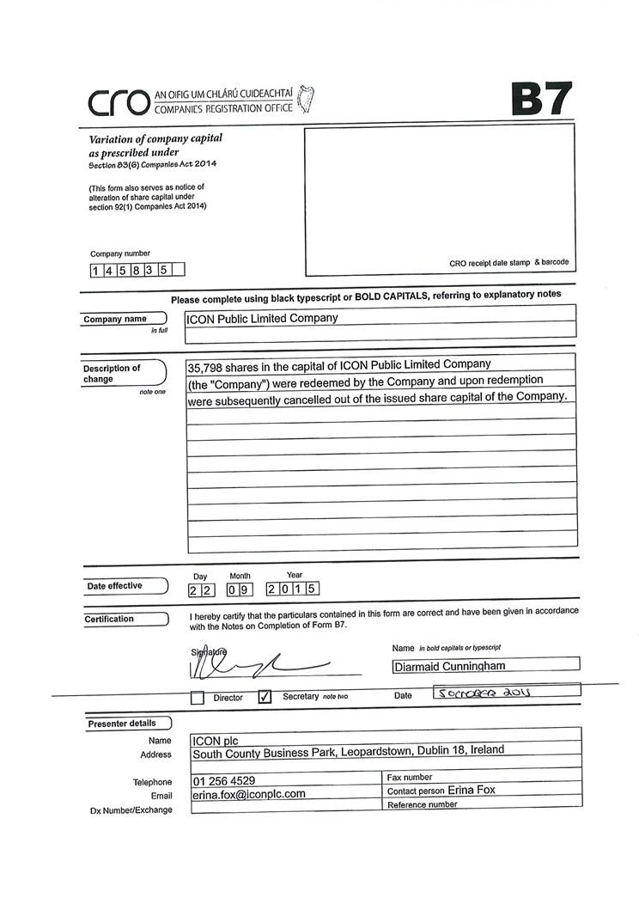

Exhibit 99.8

Exhibit 99.9
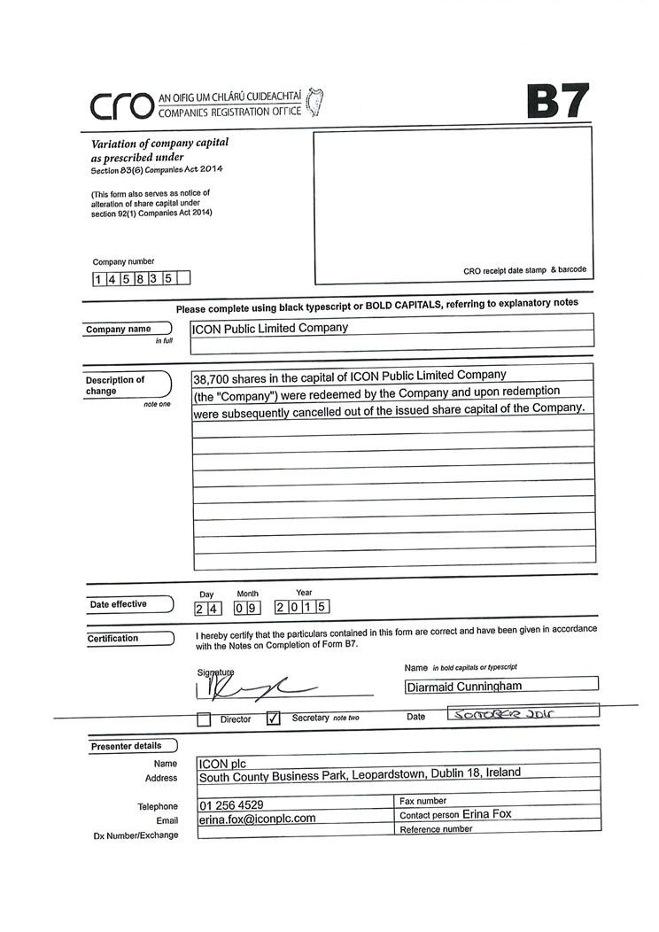

Exhibit 99.10
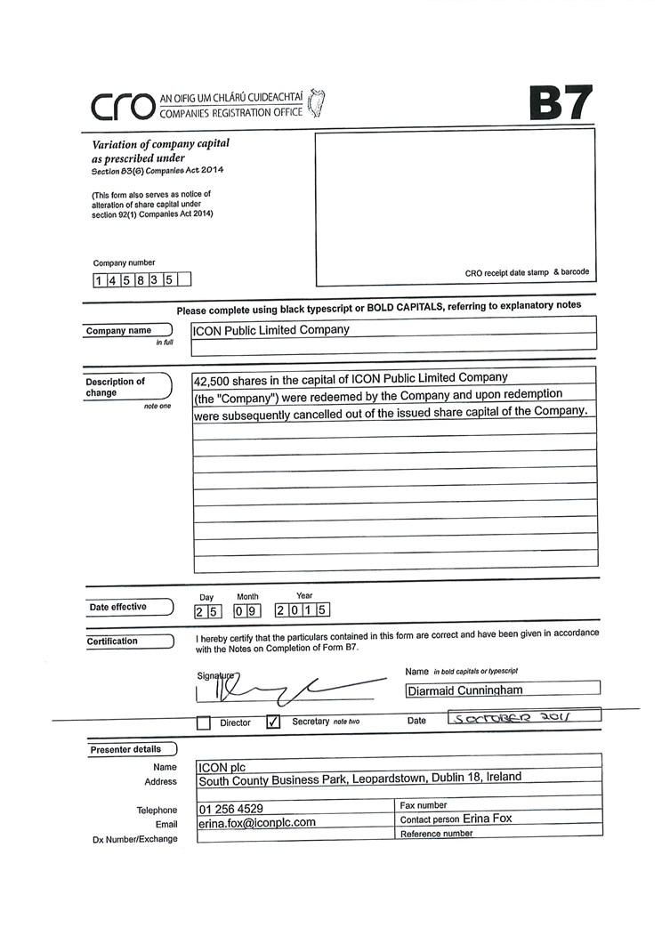

Exhibit 99.11
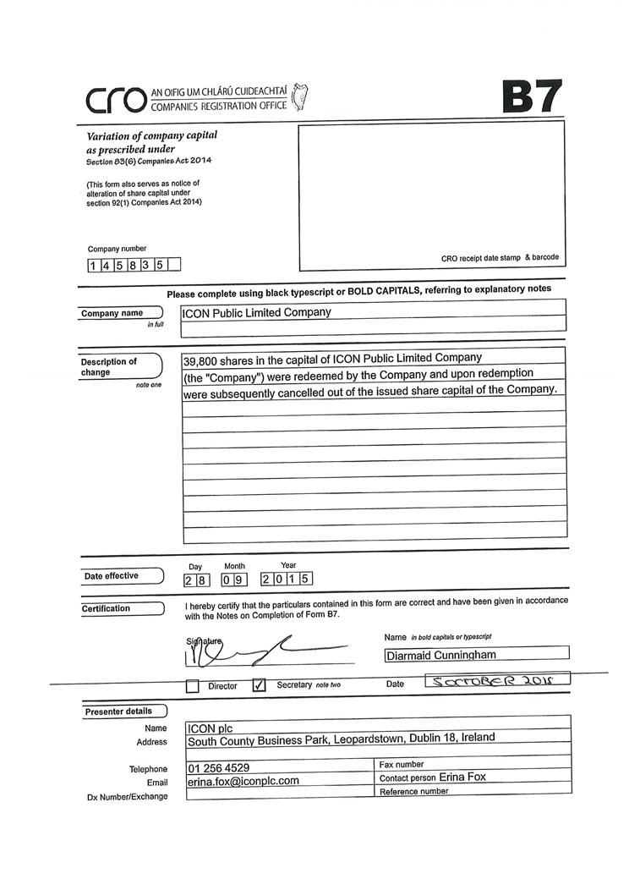

Exhibit 99.12
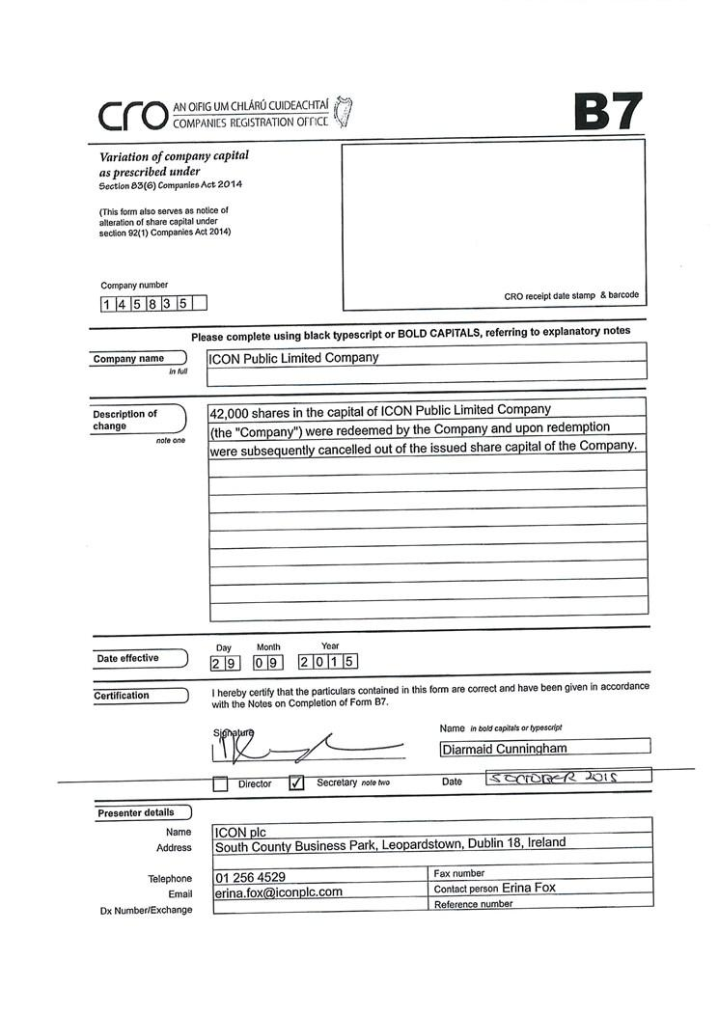

Exhibit 99.13
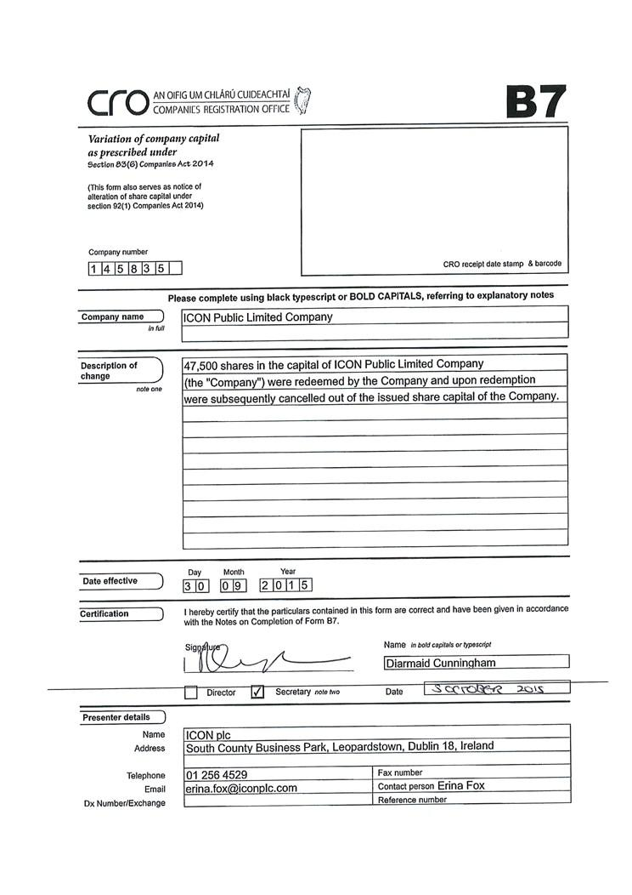

Exhibit 99.14
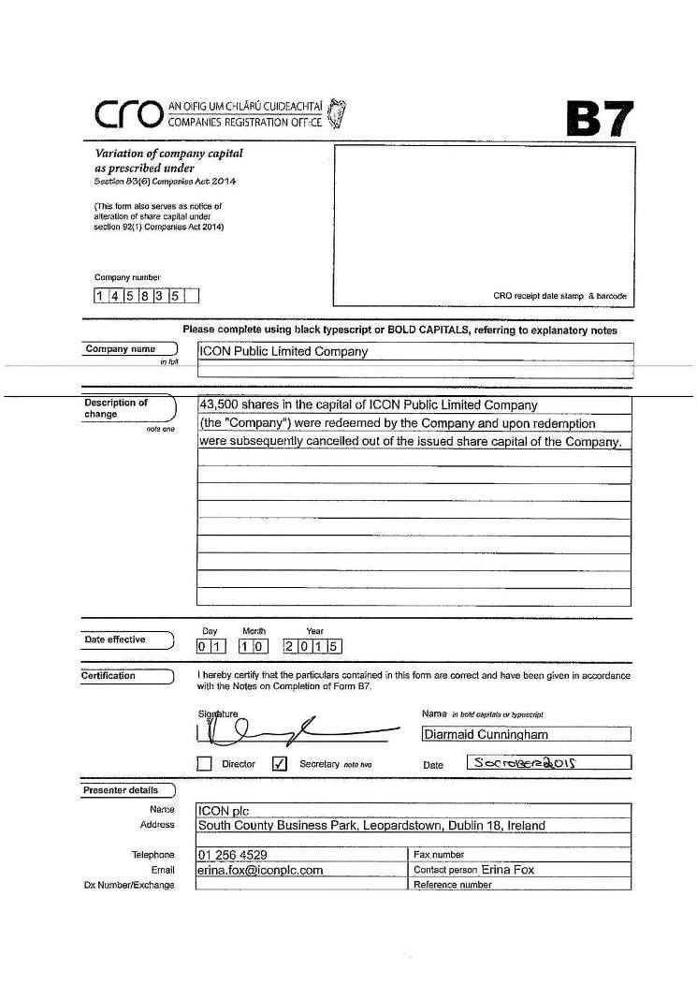

Exhibit 99.15
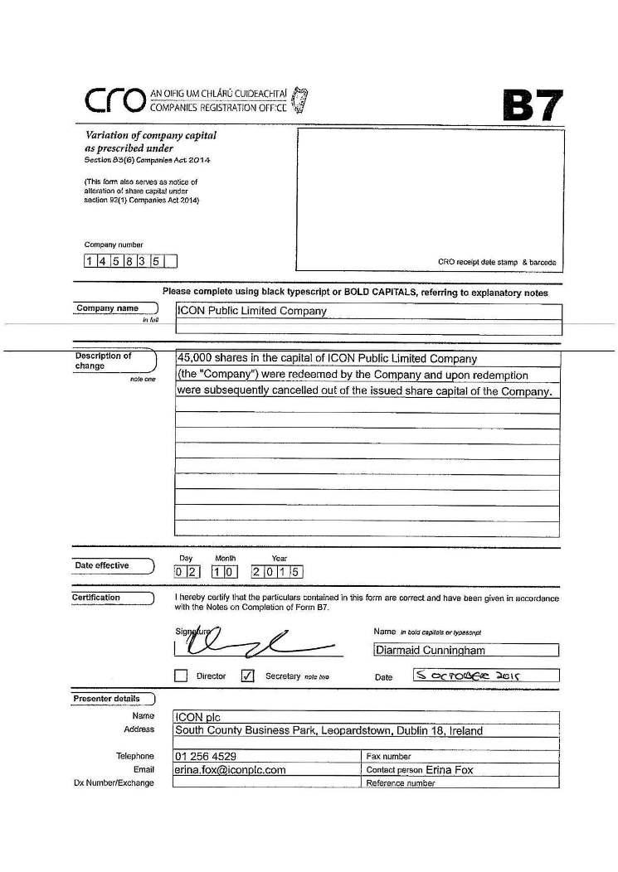

Exhibit 99.16
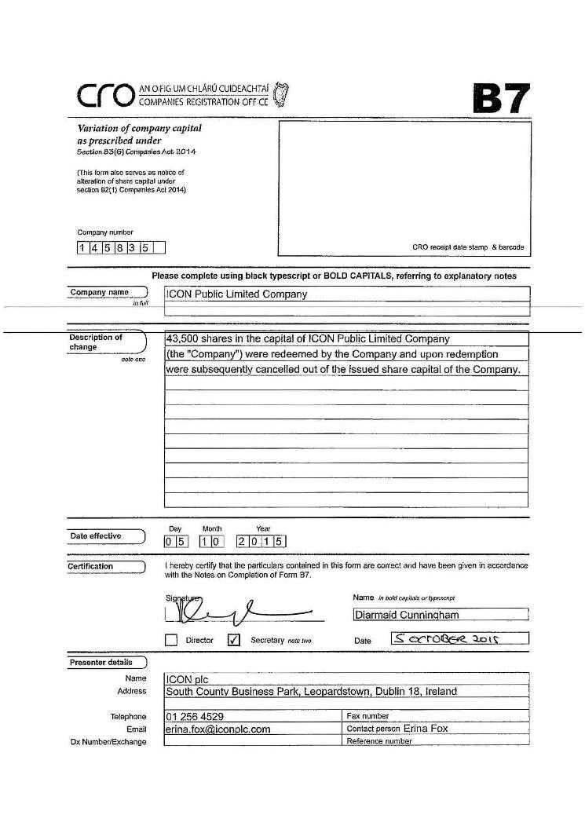

Exhibit 99.17
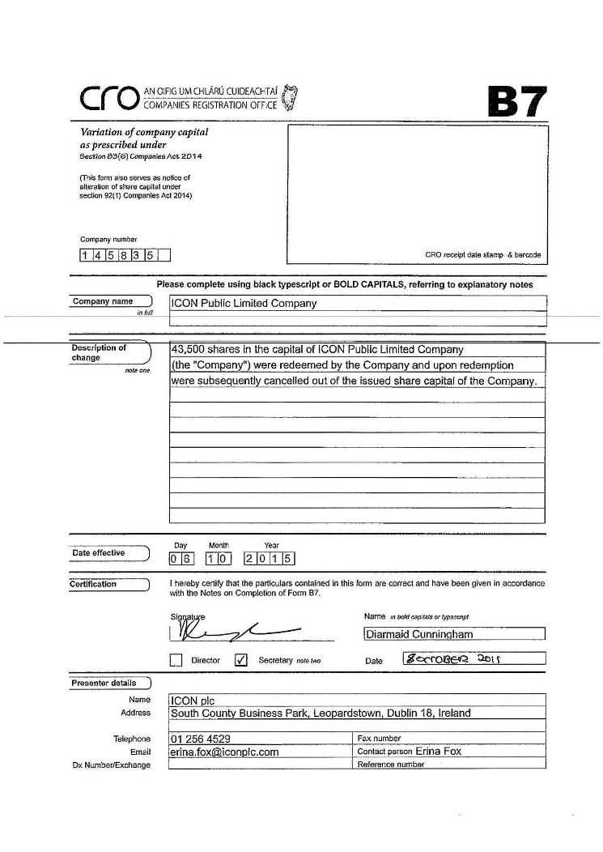

Exhibit 99.18


