FORM 6-K

SECURITIES AND EXCHANGE COMMISSION

Washington, D.C. 20549

Report of Foreign Private Issuer

Pursuant to Rule 13a-16 under

the Securities Exchange Act of 1934

For the month ended September, 2015

ICON plc

(Registrant's name)

333-08704

(Commission file number)

South County Business Park, Leopardstown, Dublin 18, Ireland

(Address of principal executive offices)

Brendan Brennan, CFO

South County Business Park, Leopardstown, Dublin 18, Ireland.

Brendan.Brennan@iconplc.com

00-353-1-291-2000

(Name, telephone number, email and/or facsimile number and address of Company contact person)

Indicate by check mark whether the registrant files or will file annual reports under cover Form 20-F or Form 40-F.

Yes___X___ No_______

Indicate by check mark whether the registrant is submitting the Form 6-K in paper as permitted by Regulation S-T Rule 101(b)(1):

Yes______ No___X___

Indicate by check mark whether the registrant is submitting the Form 6-K in paper as permitted by Regulation S-T Rule 101(b)(7):

Yes______ No___X___

Indicate by check mark whether the registrant by furnishing the information contained in this Form is also thereby furnishing the information to the Commission pursuant to Rule12g3-2(b) under the Securities Exchange Act of 1934.

Yes______ No___X___

If "Yes" is marked, indicate below the file number assigned to the registrant in connection with Rule 12g3-2(b):82 N/A

Exhibit |  | Description
99.1 |  | Form B7 Notice of Redemption of 91,263 Shares on August 5, 2015 filed in Companies Registration Office in Ireland on September 4, 2015
99.2 |  | Form B7 Notice of Redemption of 78,322 Shares on August 6, 2015 filed in Companies Registration Office in Ireland on September 4, 2015
99.3 |  | Form B7 Notice of Redemption of 70,878 Shares on August 7, 2015 filed in Companies Registration Office in Ireland on September 4, 2015
99.4 |  | Form B7 Notice of Redemption of 56,852 Shares on August 10, 2015 filed in Companies Registration Office in Ireland on September 4, 2015
99.5 |  | Form B7 Notice of Redemption of 99,686 Shares on August 11, 2015 filed in Companies Registration Office in Ireland on September 4, 2015
99.6 |  | Form B7 Notice of Redemption of 77,030 Shares on August 12, 2015 filed in Companies Registration Office in Ireland on September 4, 2015
99.7 |  | Form B7 Notice of Redemption of 42,903 Shares on August 13, 2015 filed in Companies Registration Office in Ireland on September 4, 2015
99.8 |  | Form B7 Notice of Redemption of 47,045 Shares on August 14, 2015 filed in Companies Registration Office in Ireland on September 4, 2015
99.9 |  | Form B7 Notice of Redemption of 71,310 Shares on August 17, 2015 filed in Companies Registration Office in Ireland on September 4, 2015
99.10 |  | Form B7 Notice of Redemption of 47,300 Shares on August 18, 2015 filed in Companies Registration Office in Ireland on September 4, 2015
99.11 |  | Form B7 Notice of Redemption of 45,402 Shares on August 19, 2015 filed in Companies Registration Office in Ireland on September 4, 2015
99.12 |  | Form B7 Notice of Redemption of 134,650 Shares on August 20, 2015 filed in Companies Registration Office in Ireland on September 4,
 |  | 2015
99.13 |  | Form B7 Notice of Redemption of 99,522 Shares on August 21, 2015 filed in Companies Registration Office in Ireland on September 4, 2015
99.14 |  | Form B7 Notice of Redemption of 100,970 Shares on August 24, 2015 filed in Companies Registration Office in Ireland on September 4,
 |  | 2015
99.15 |  | Form B7 Notice of Redemption of 151,177 Shares on August 25, 2015 filed in Companies Registration Office in Ireland on September 4,
 |  | 2015
99.16 |  | Form B7 Notice of Redemption of 153,367 Shares on August 26, 2015 filed in Companies Registration Office in Ireland on September 4,
 |  | 2015
99.17 |  | Form B7 Notice of Redemption of 175,000 Shares on August 27, 2015 filed in Companies Registration Office in Ireland on September 4,
 |  | 2015
99.18 |  | Form B7 Notice of Redemption of 64,000 Shares on August 28, 2015 filed in Companies Registration Office in Ireland on September 4, 2015
99.19 |  | Form B7 Notice of Redemption of 49,350 Shares on August 31, 2015 filed in Companies Registration Office in Ireland on September 4, 2015
99.20 |  | Form B7 Notice of Redemption of 63,375 Shares on September 1, 2015 filed in Companies Registration Office in Ireland on September 4,
 |  | 2015
99.21 |  | Form B7 Notice of Redemption of 36,700 Shares on September 2, 2015 filed in Companies Registration Office in Ireland on September 4,
 |  | 2015

SIGNATURES

Pursuant to the requirements of the Securities Exchange Act of 1934, the Registrant has duly caused this report to be signed on its behalf by the undersigned thereunto duly authorized.

ICON plc

/s/ Brendan Brennan

Date: September 4, 2015 Brendan Brennan Chief Financial Officer

Exhibit 99.1

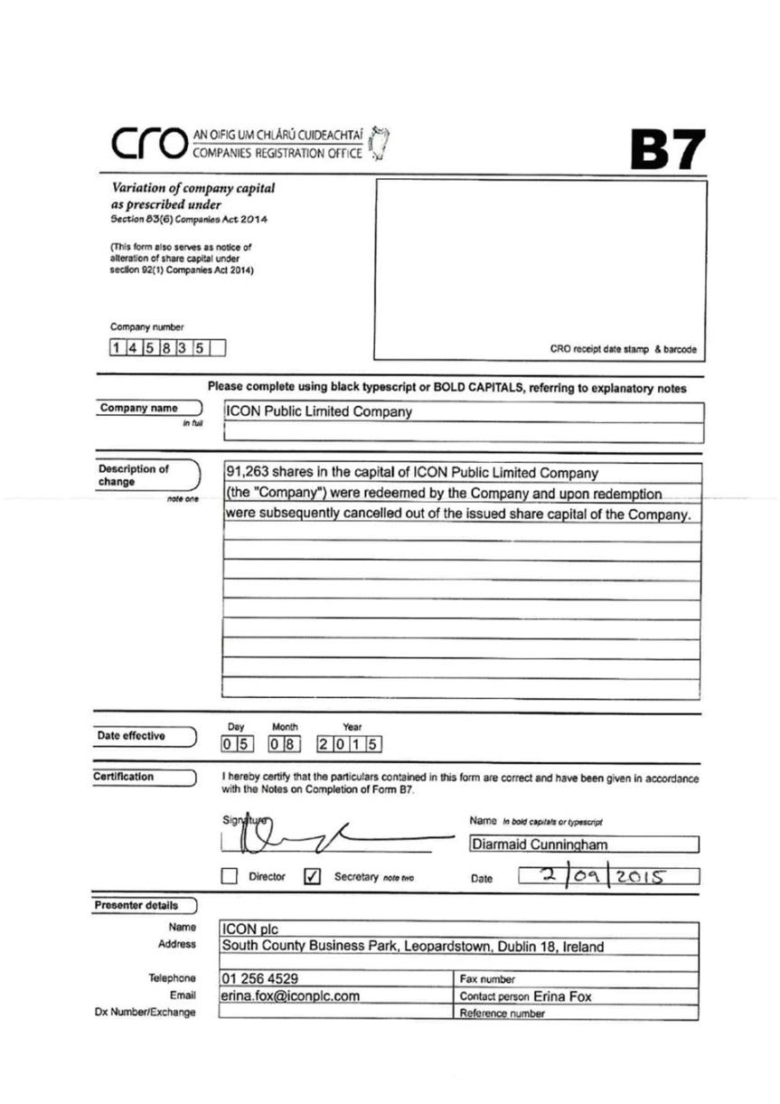

Exhibit 99.2

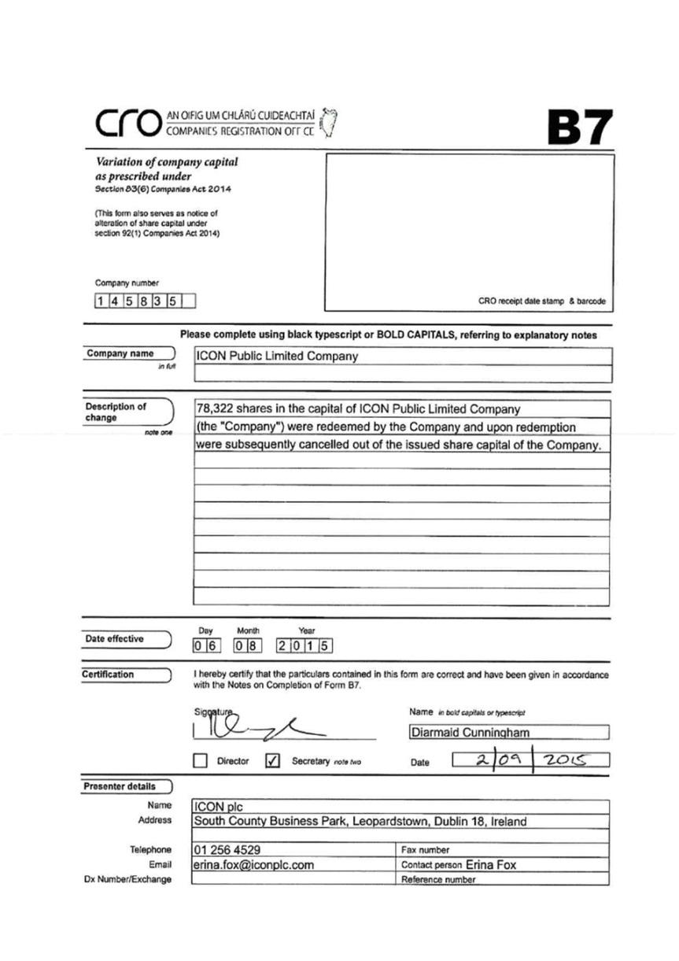

Exhibit 99.3

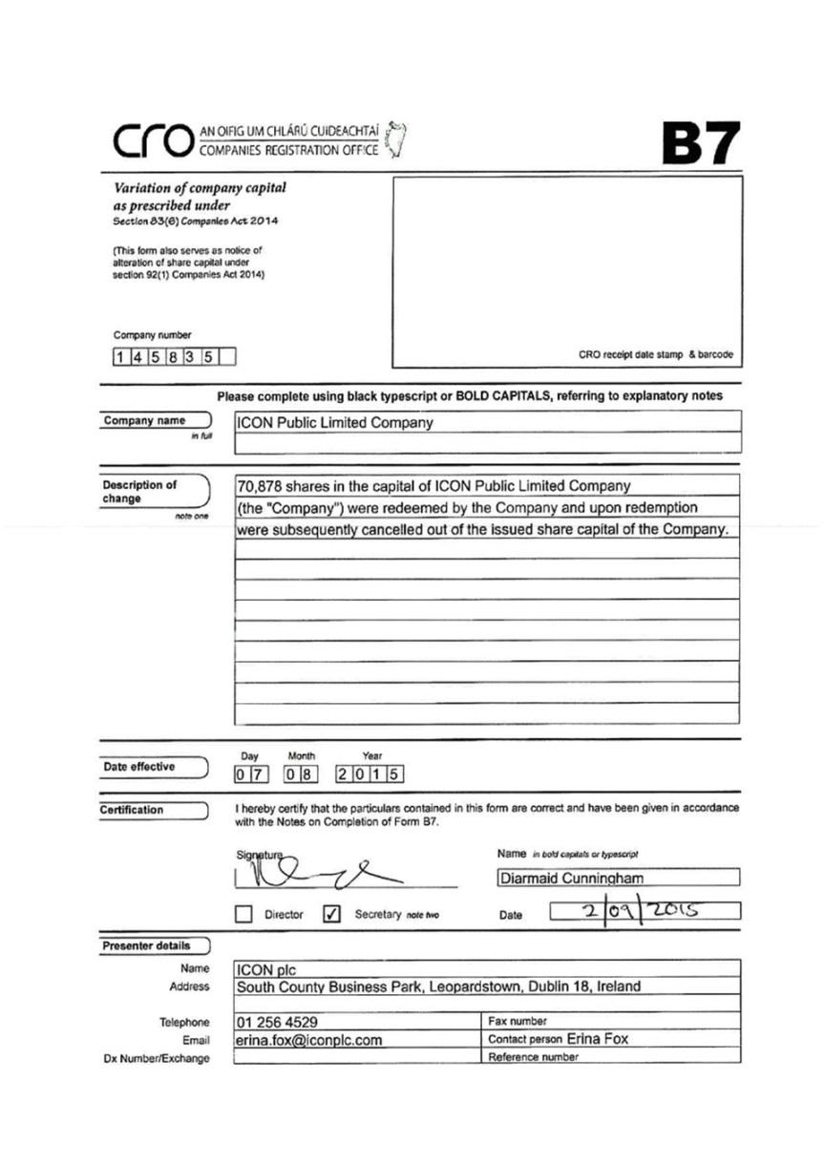

Exhibit 99.4

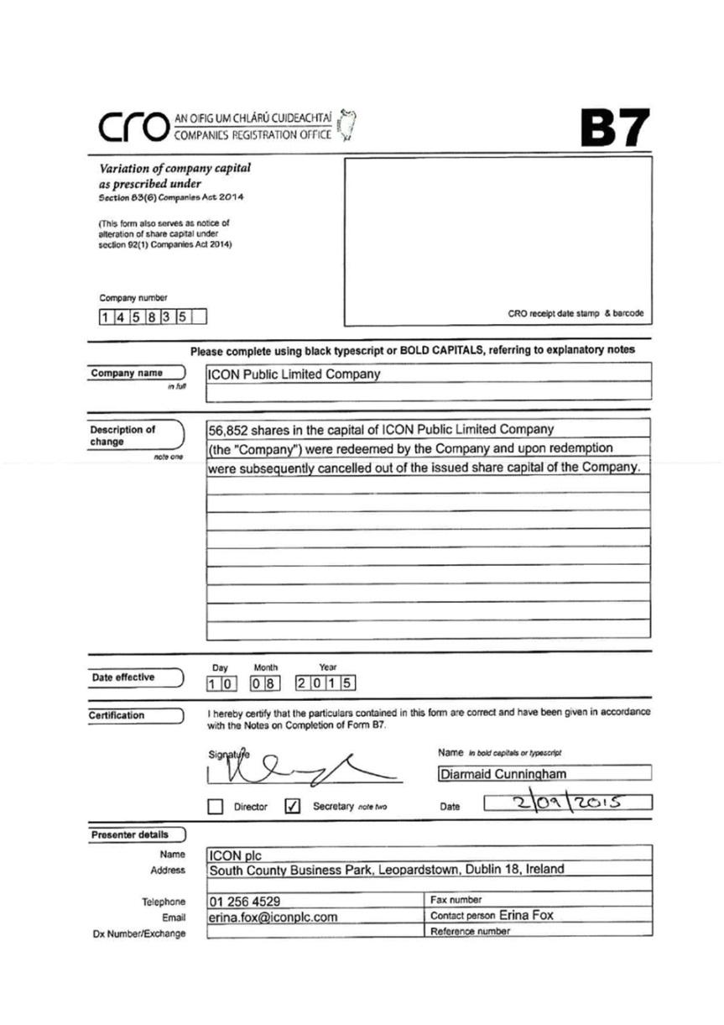

Exhibit 99.5

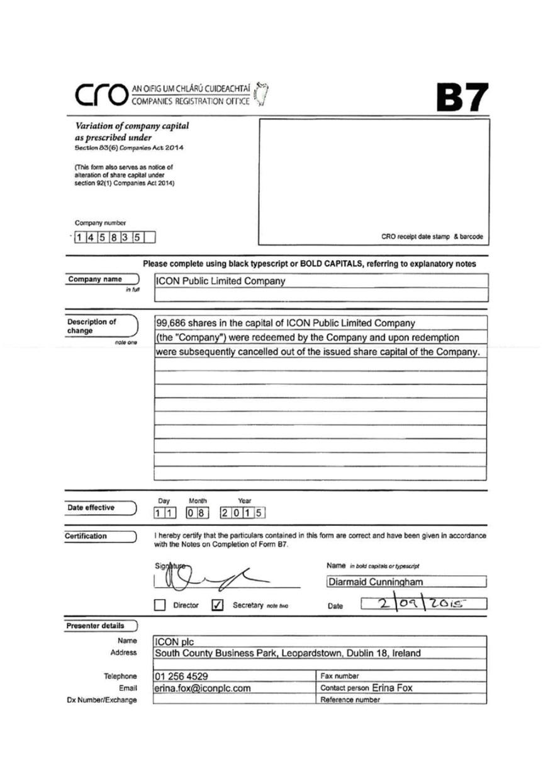

Exhibit 99.6

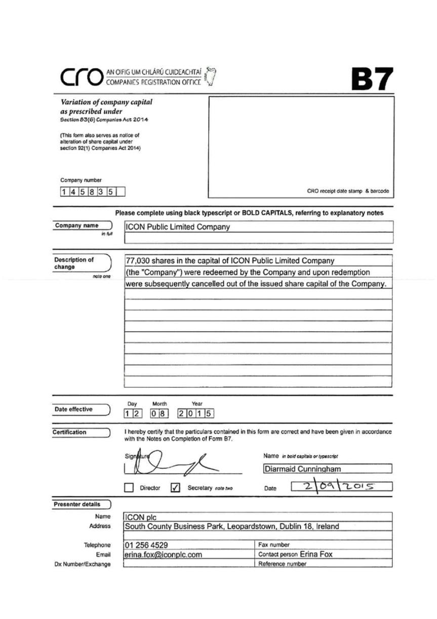

Exhibit 99.7

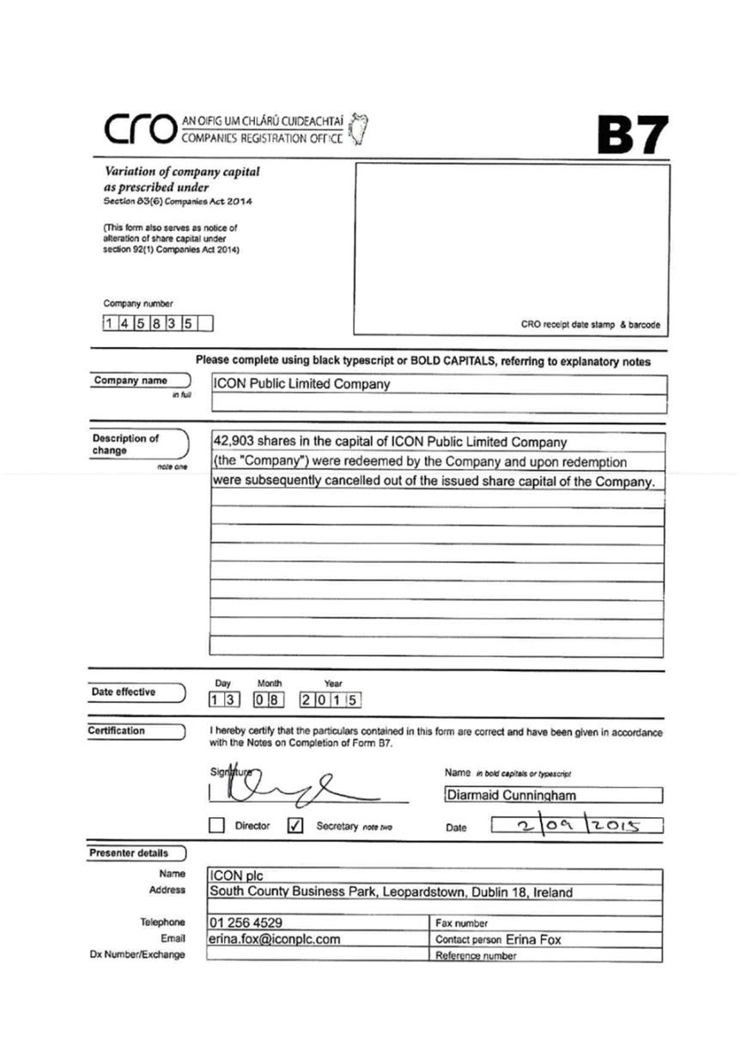

Exhibit 99.8

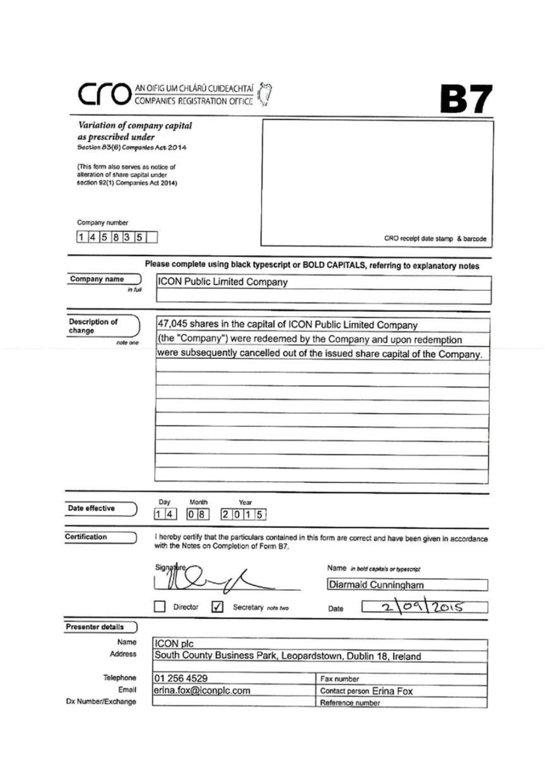

Exhibit 99.9

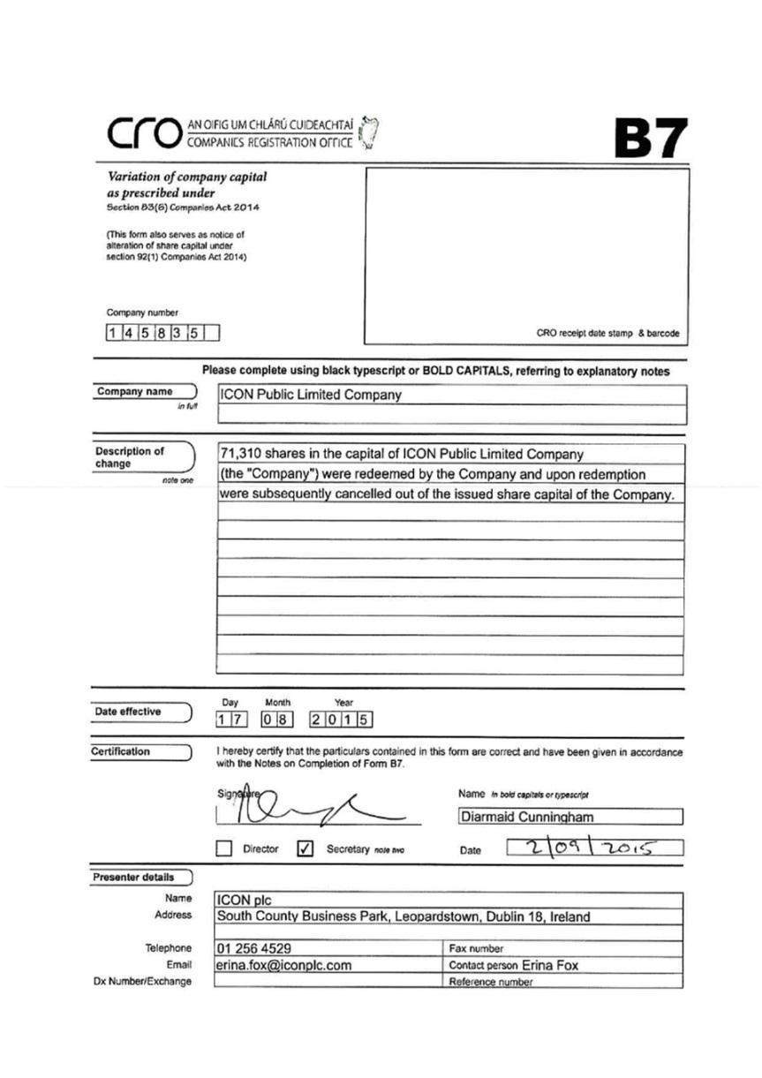

Exhibit 99.10

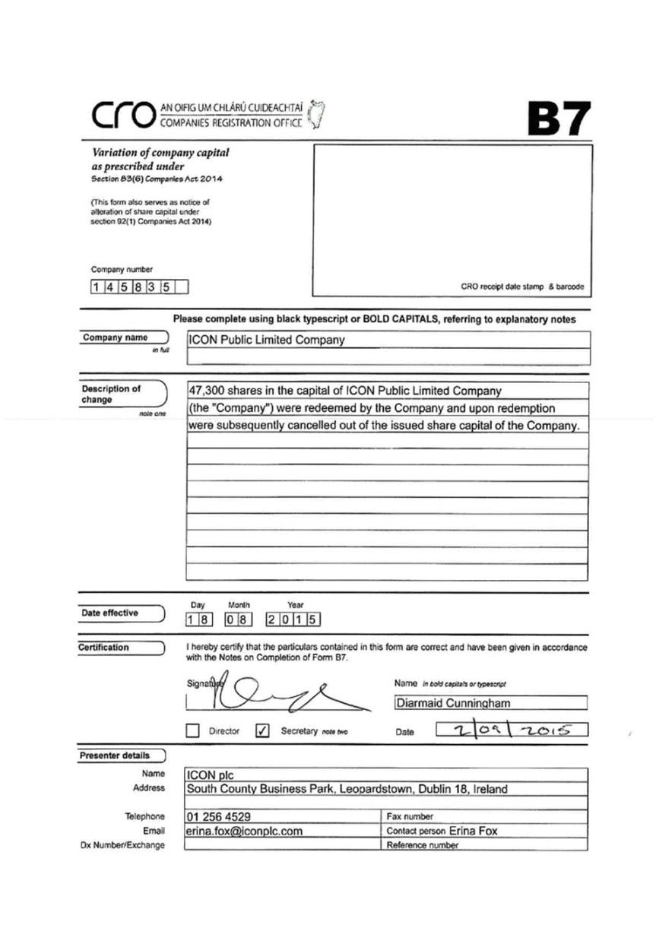

Exhibit 99.11

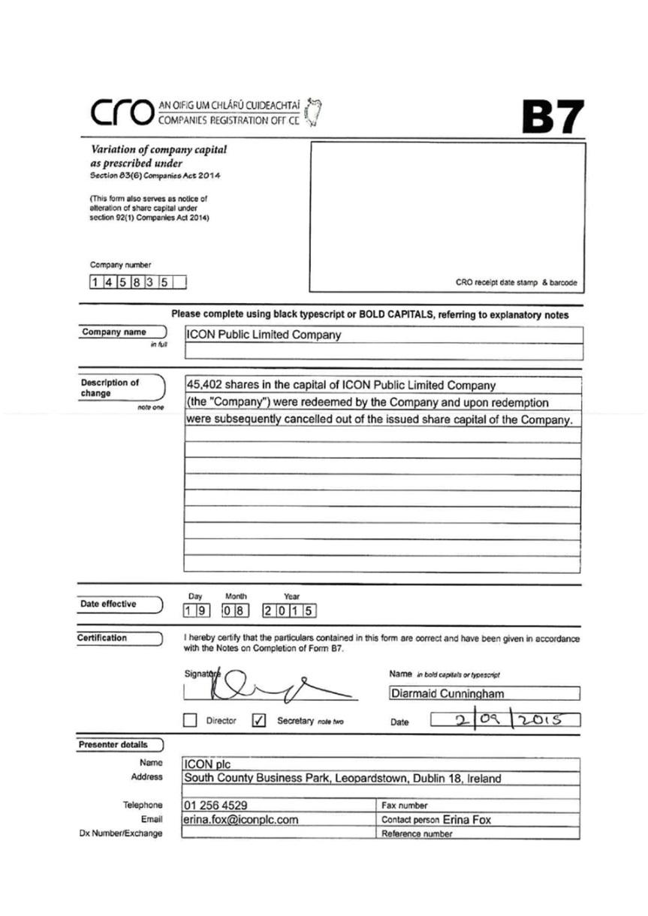

Exhibit 99.12

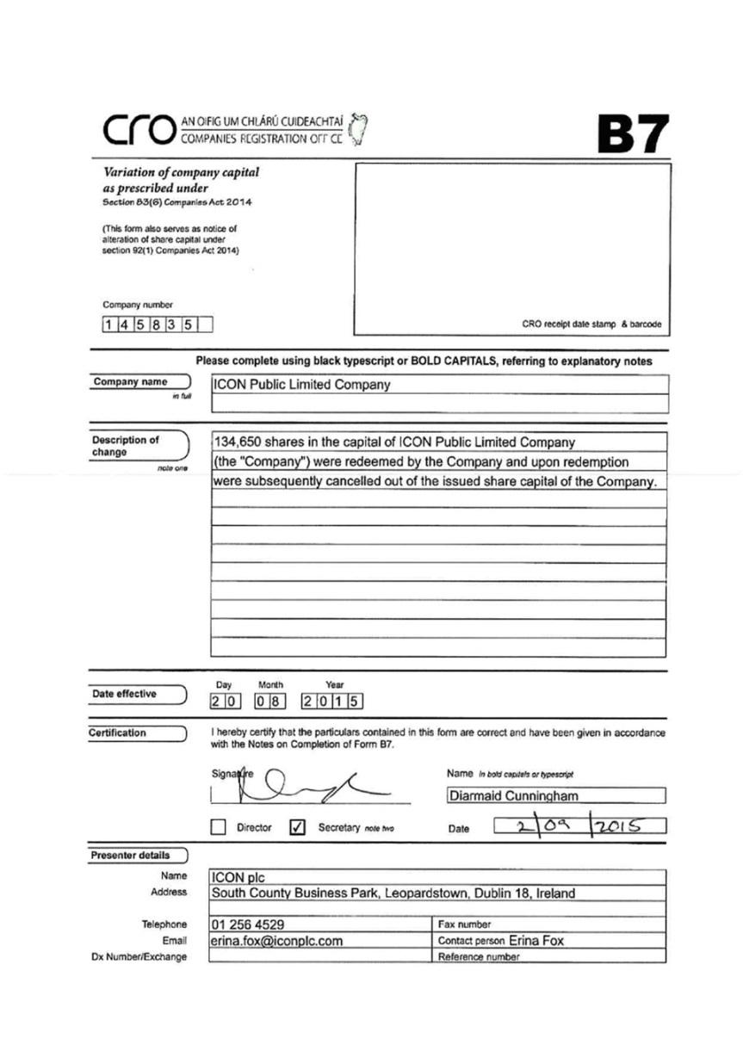

Exhibit 99.13

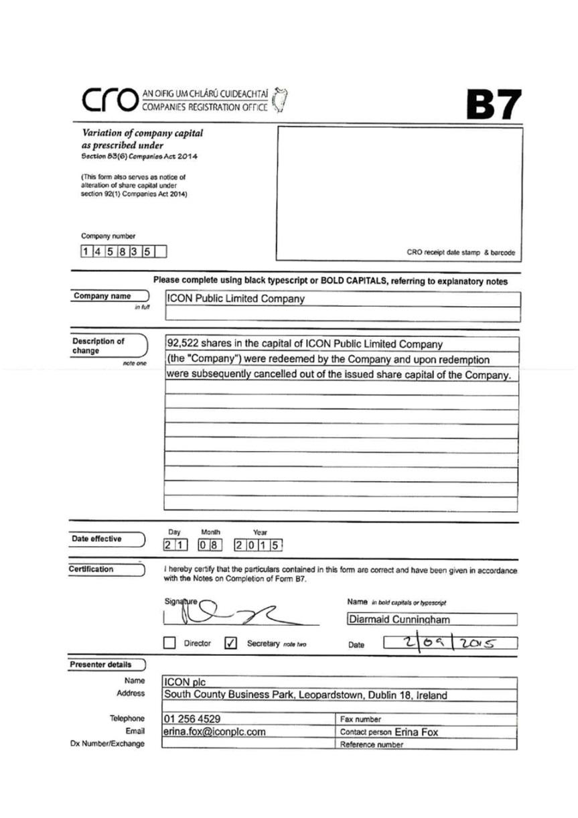

Exhibit 99.14

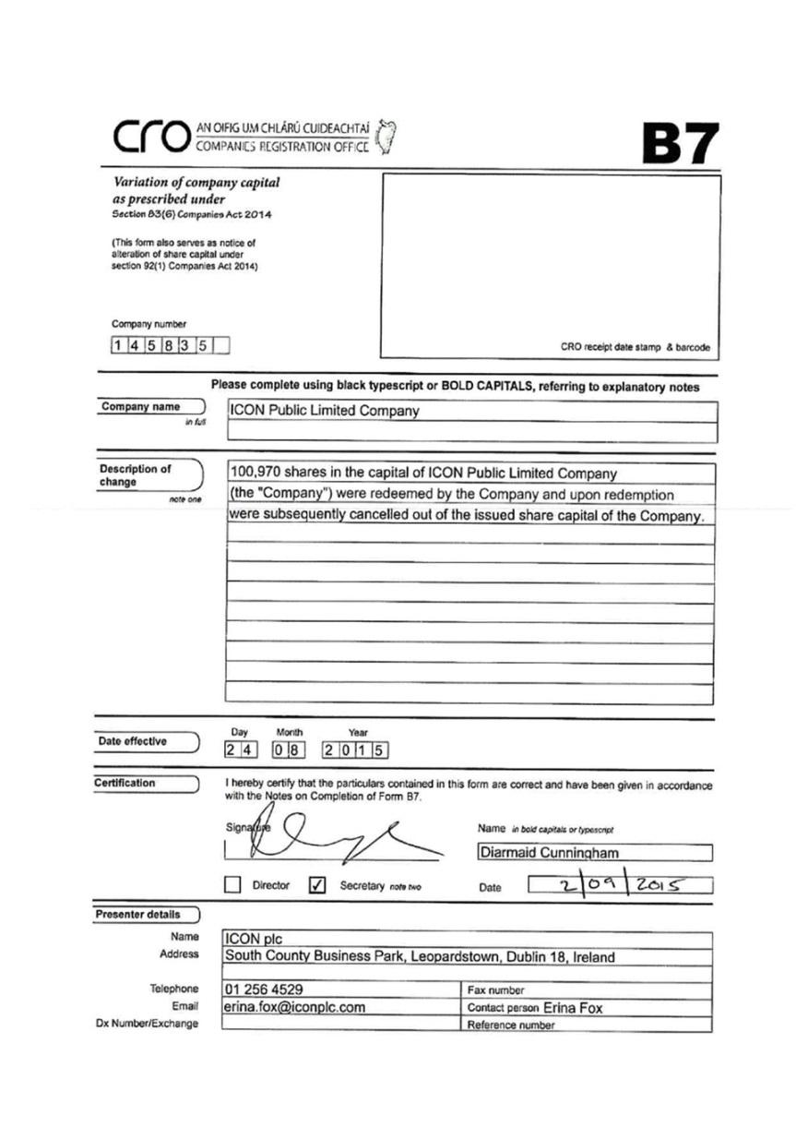

Exhibit 99.15

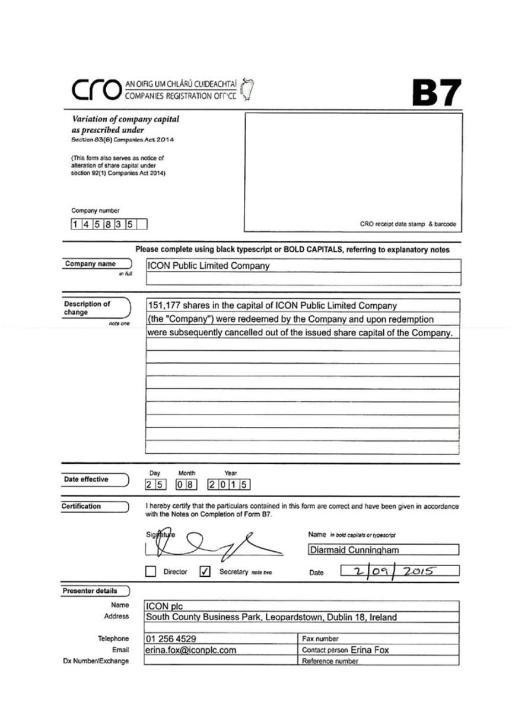

Exhibit 99.16

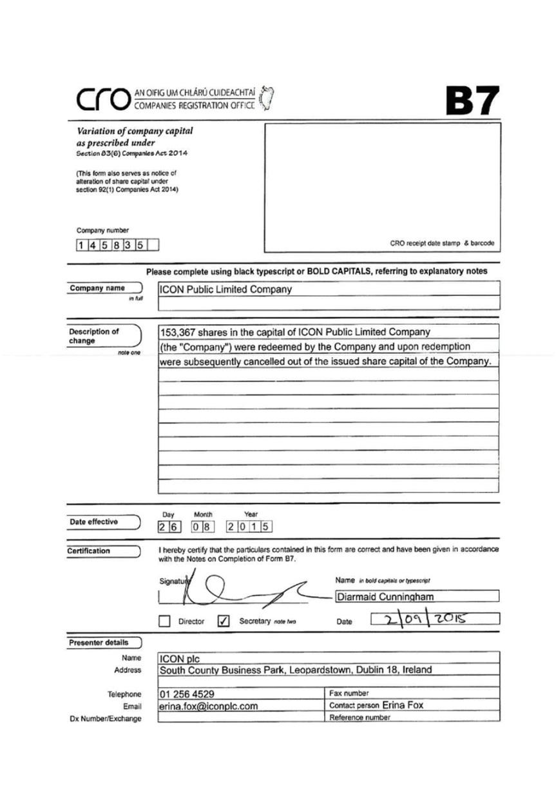

Exhibit 99.17

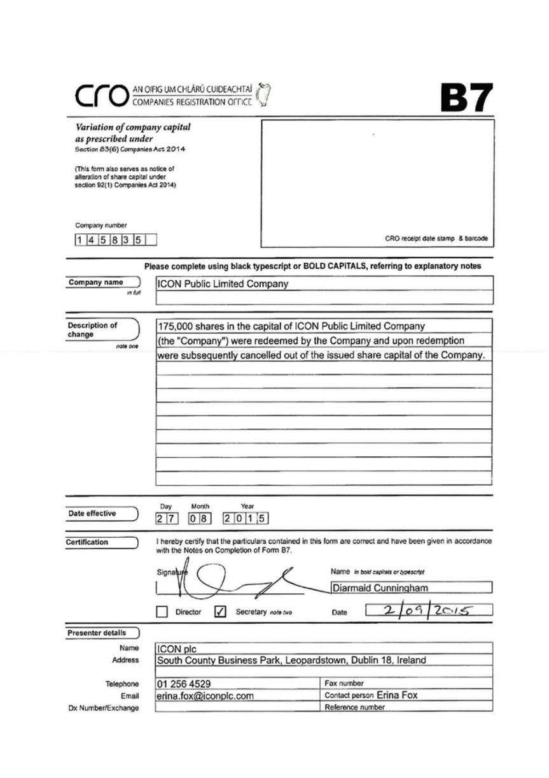

Exhibit 99.18

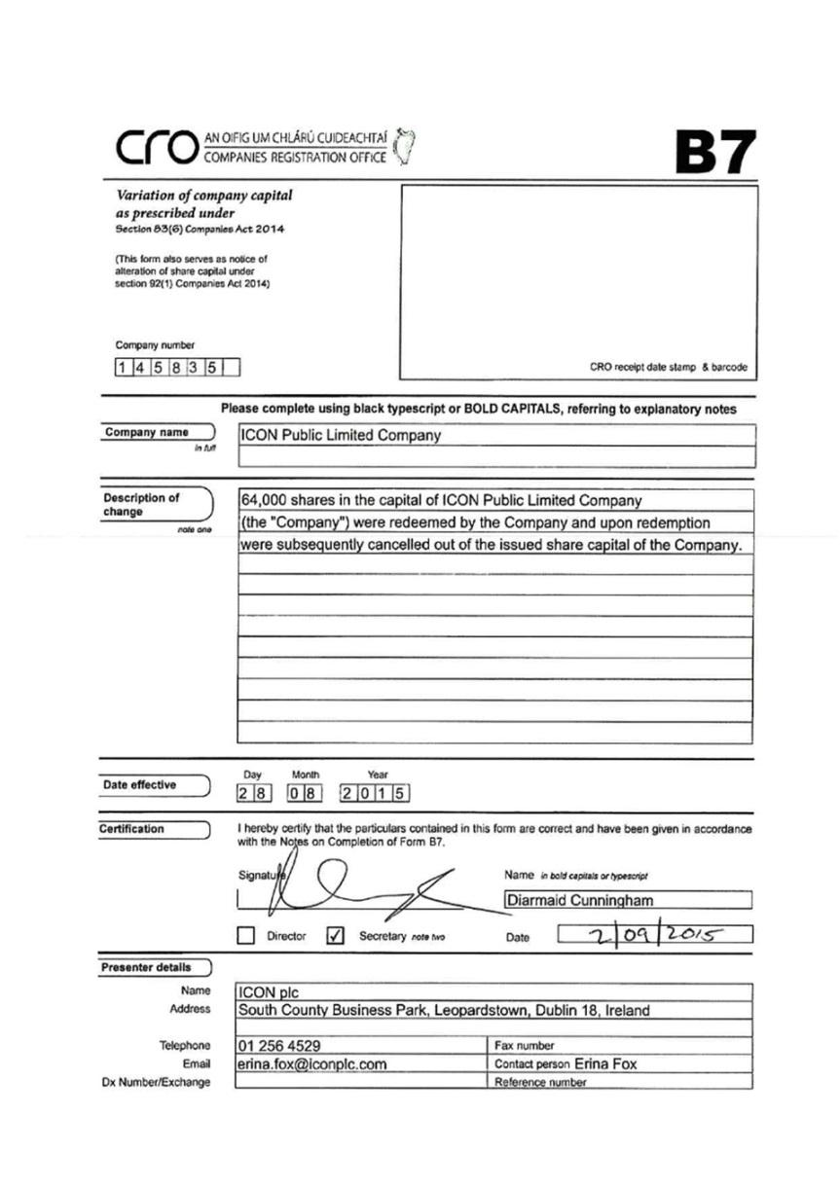

Exhibit 99.19

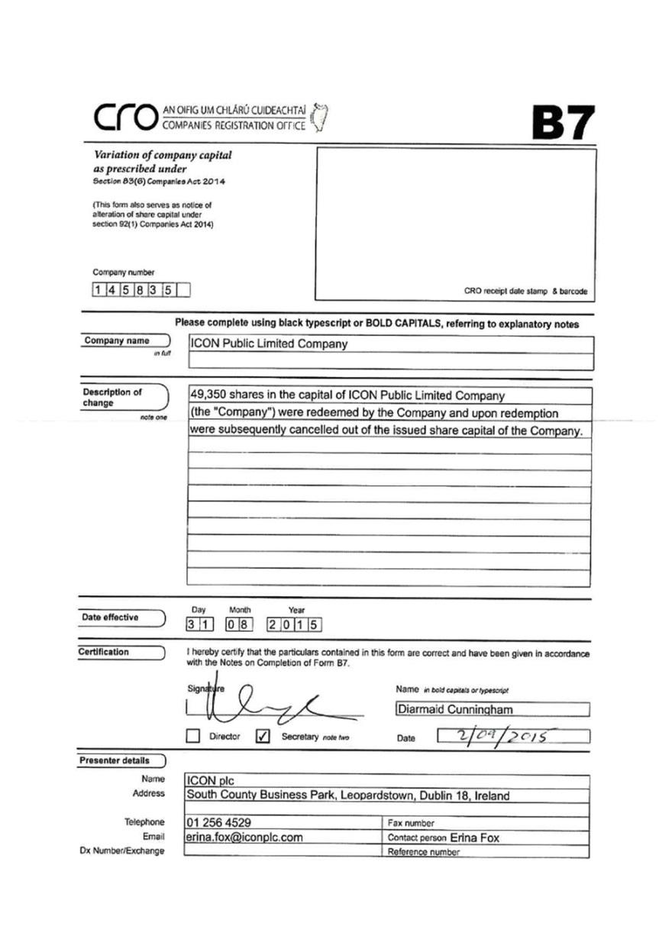

Exhibit 99.20

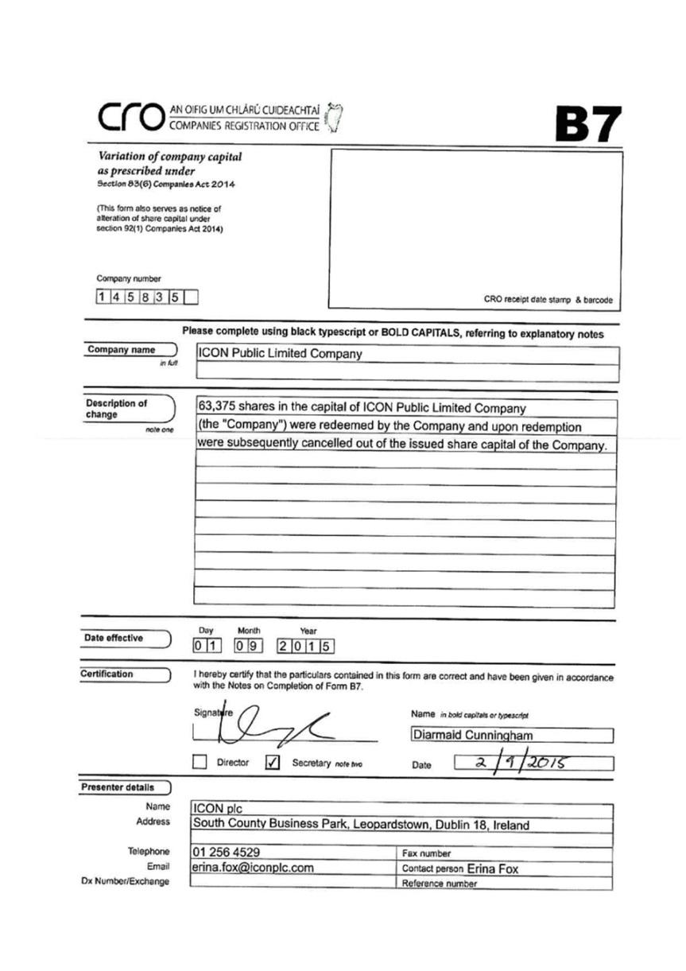

Exhibit 99.21



