FORM 6-K

SECURITIES AND EXCHANGE COMMISSION

Washington, D.C. 20549

Report of Foreign Private Issuer

Pursuant to Rule 13a-16 under

the Securities Exchange Act of 1934

For the month ended January, 2018

ICON plc

(Registrant's name)

333-08704

(Commission file number)

South County Business Park, Leopardstown, Dublin 18, Ireland

(Address of principal executive offices)

Brendan Brennan, CFO

South County Business Park, Leopardstown, Dublin 18, Ireland.

Brendan.Brennan@iconplc.com

00-353-1-291-2000

(Name, telephone number, email and/or facsimile number and address of Company contact person)

Indicate by check mark whether the registrant files or will file annual reports under cover Form 20-F or Form 40-F.

Yes___X___ No_______

Indicate by check mark whether the registrant is submitting the Form 6-K in paper as permitted by Regulation S-T Rule 101(b)(1):

Yes______ No___X___

Indicate by check mark whether the registrant is submitting the Form 6-K in paper as permitted by Regulation S-T Rule 101(b)(7):

Yes______ No___X___

Indicate by check mark whether the registrant by furnishing the information contained in this Form is also thereby furnishing the information to the Commission pursuant to Rule12g3-2(b) under the Securities Exchange Act of 1934.

Yes______ No___X___

If "Yes" is marked, indicate below the file number assigned to the registrant in connection with Rule 12g3-2(b):82 N/A

 |  |  |  |  |  |  |  |  |  | EXHIBIT LIST
Exhibit |  |  |  | Description
99.1 |  |  |  | Form B7 Notice of Redemption of 1,500 |  |  |  | Shares on November 20, 2017 filed in Companies Registration Office in Ireland on January 10, 2018
99.2 |  |  |  | Form B7 Notice of Redemption of 876 Shares on November 22, 2017 filed in Companies Registration Office in Ireland on January 10, 2018
99.3 |  |  |  | Form B7 Notice of Redemption of 44,059 |  |  |  |  | Shares on December 1, 2017 filed in Companies Registration Office in Ireland on January 10, 2018
99.4 |  |  |  | Form B7 Notice of Redemption of 2,921 |  |  |  | Shares on December 4, 2017 filed in Companies Registration Office in Ireland on January 10, 2018
99.5 |  |  |  | Form B7 Notice of Redemption of 600 Shares on December 5, 2017 filed in Companies Registration Office in Ireland on January 10, 2018
99.6 |  |  |  | Form B7 Notice of Redemption of 58,526 |  |  |  |  | Shares on December 6, 2017 filed in Companies Registration Office in Ireland on January 10, 2018
99.7 |  |  |  | Form B7 Notice of Redemption of 18,410 |  |  |  |  | Shares on December 7, 2017 filed in Companies Registration Office in Ireland on January 10, 2018
99.8 |  |  |  | Form B7 Notice of Redemption of 14,500 |  |  |  |  | Shares on December 8, 2017 filed in Companies Registration Office in Ireland on January 10, 2018
99.9 |  |  |  | Form B7 Notice of Redemption of 17,697 |  |  |  |  | Shares on December 11, 2017 filed in Companies Registration Office in Ireland on January 10, 2018
99.10 |  |  |  | Form B7 Notice of Redemption of 7,786 |  |  |  | Shares on December 12, 2017 filed in Companies Registration Office in Ireland on January 10, 2018
99.11 |  |  |  | Form B7 Notice of Redemption of 14,500 |  |  |  |  | Shares on December 13, 2017 filed in Companies Registration Office in Ireland on January 10, 2018
99.12 |  |  |  | Form B7 Notice of Redemption of 4,500 |  |  |  | Shares on December 14, 2017 filed in Companies Registration Office in Ireland on January 10, 2018
99.13 |  |  |  | Form B7 |  | Notice of Redemption of 5,990 |  | Shares on December 15, 2017 filed in Companies Registration Office in Ireland on January 10, 2018
99.14 |  |  |  | Form B7 |  | Notice of Redemption of 10,480 |  |  | Shares on December 18, 2017 filed in Companies Registration Office in Ireland on January 10, 2018
99.15 |  |  |  | Form B7 |  | Notice of Redemption of 5,000 |  | Shares on December 19, 2017 filed in Companies Registration Office in Ireland on January 10, 2018
99.16 |  |  |  | Form B7 |  | Notice of Redemption of 13,746 |  |  | Shares on December 20, 2017 filed in Companies Registration Office in Ireland on January 10, 2018

SIGNATURES

Pursuant to the requirements of the Securities Exchange Act of 1934, the Registrant has duly caused this report to be signed on its behalf by the undersigned thereunto duly authorized.

ICON plc

/s/ Brendan Brennan

Date: January 10, 2018 Brendan Brennan Chief Financial Officer

Exhibit 99.1

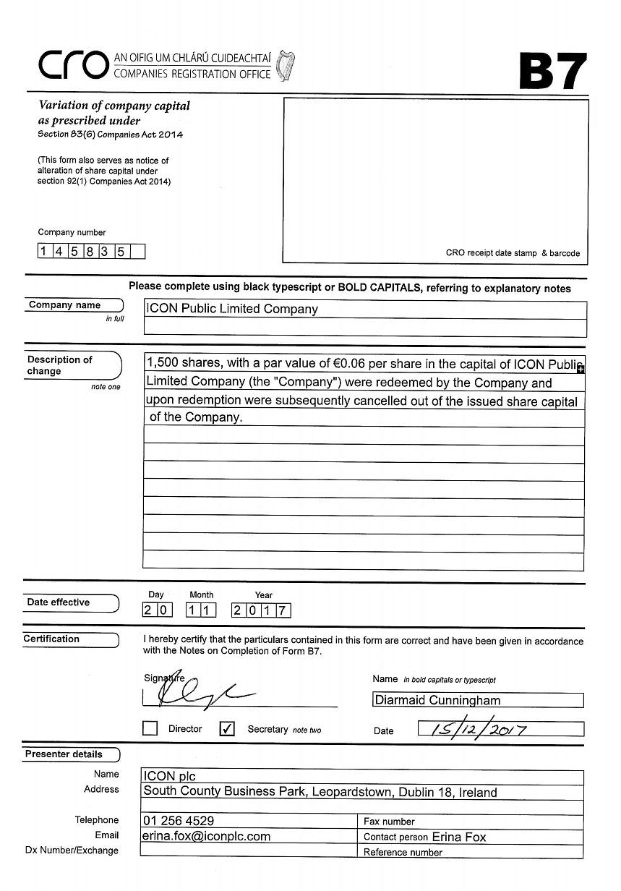

Exhibit 99.2

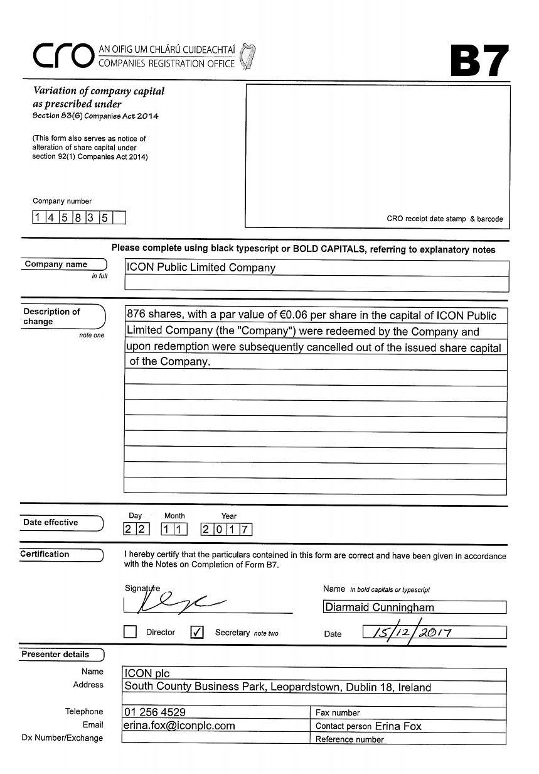

Exhibit 99.3

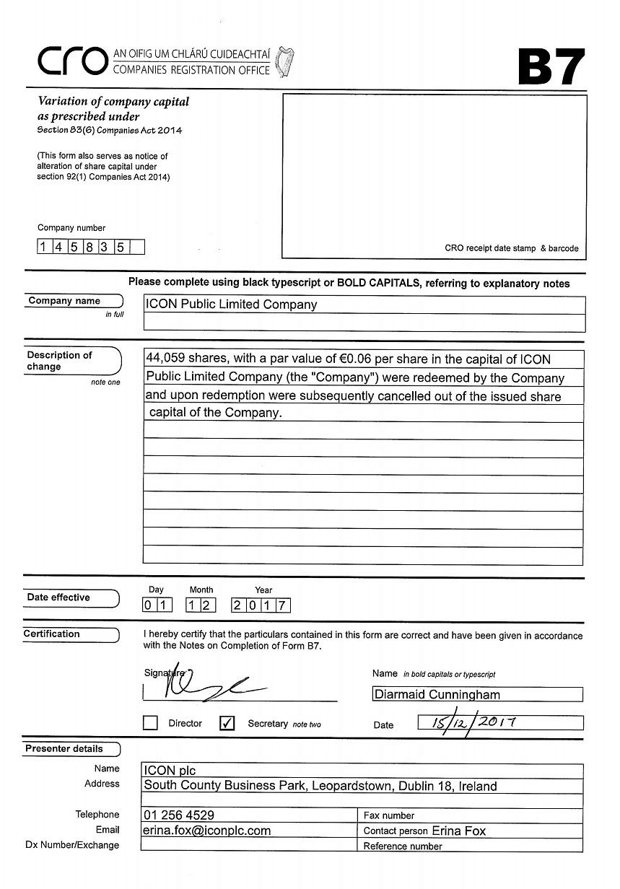

Exhibit 99.4

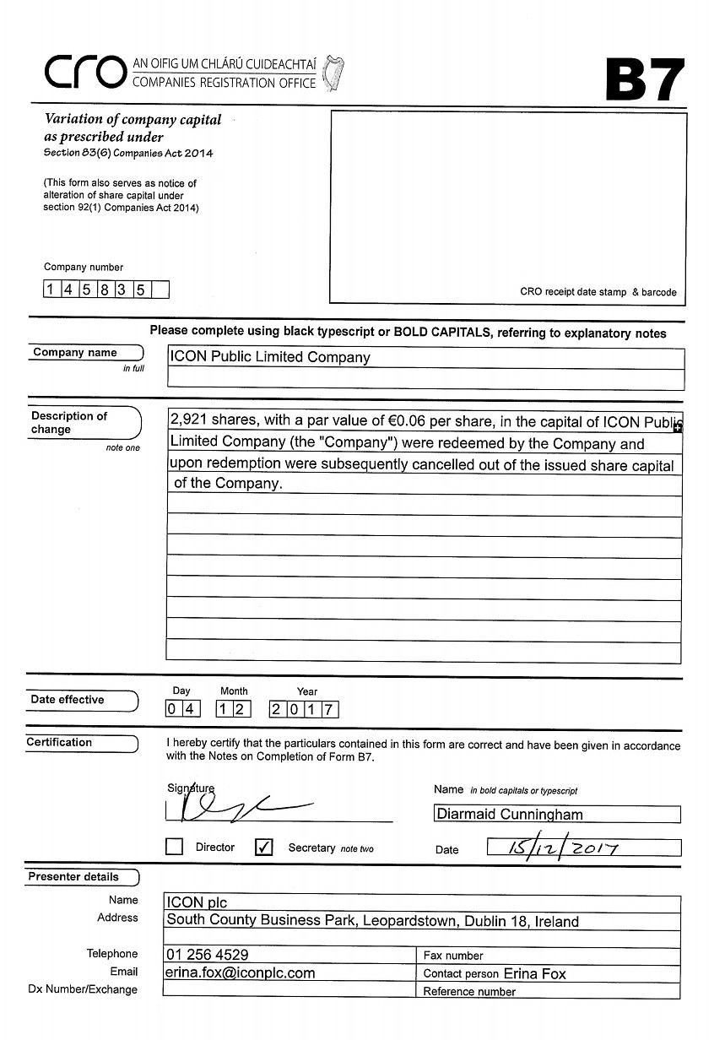

Exhibit 99.5

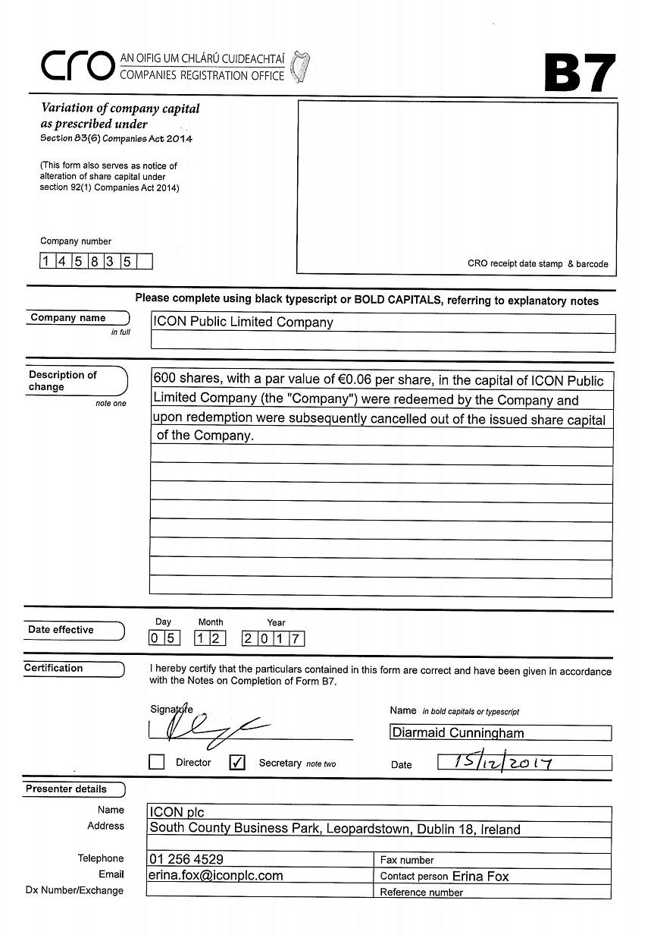

Exhibit 99.6

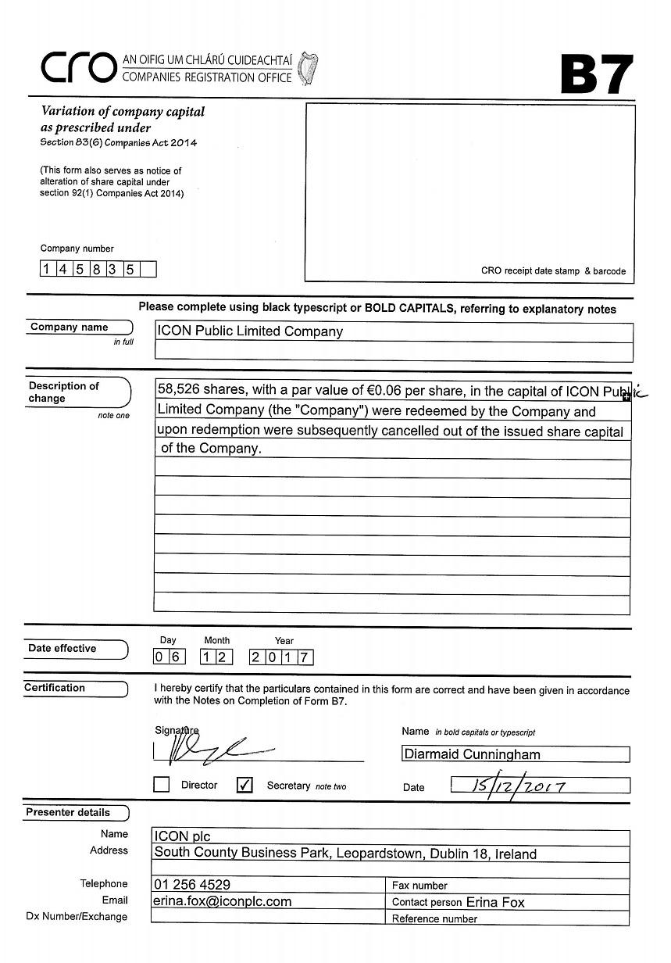

Exhibit 99.7

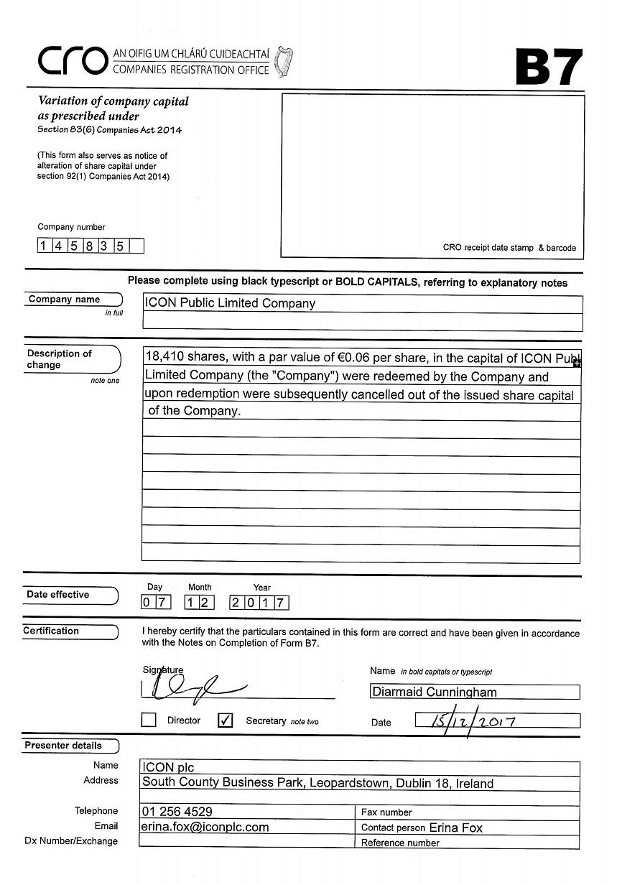

Exhibit 99.8

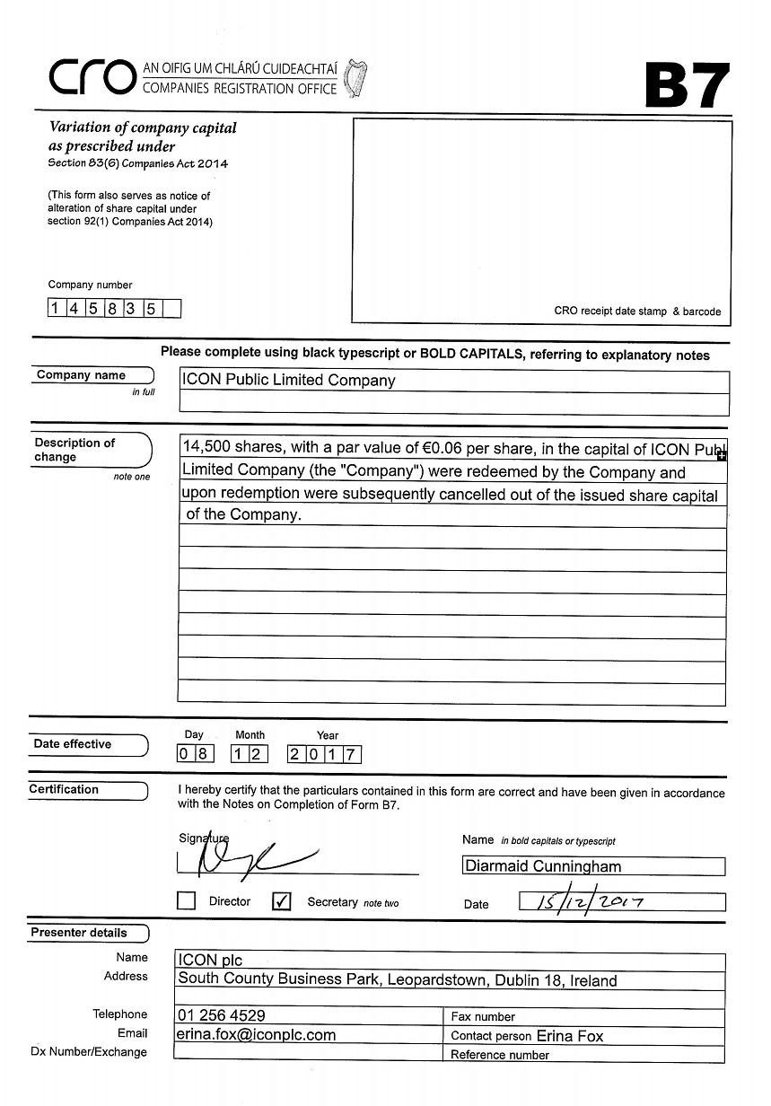

Exhibit 99.9

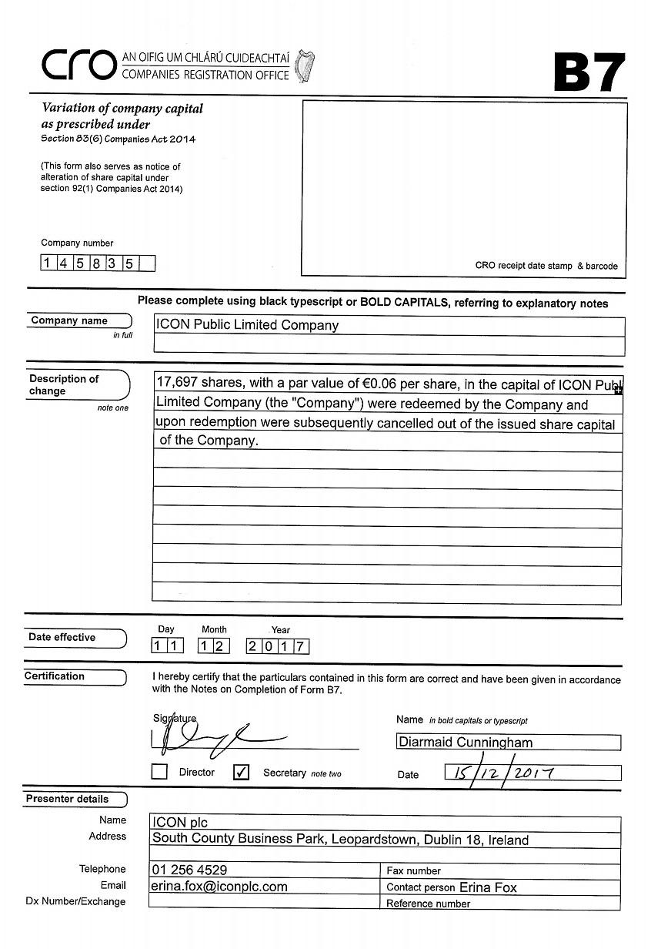

Exhibit 99.10

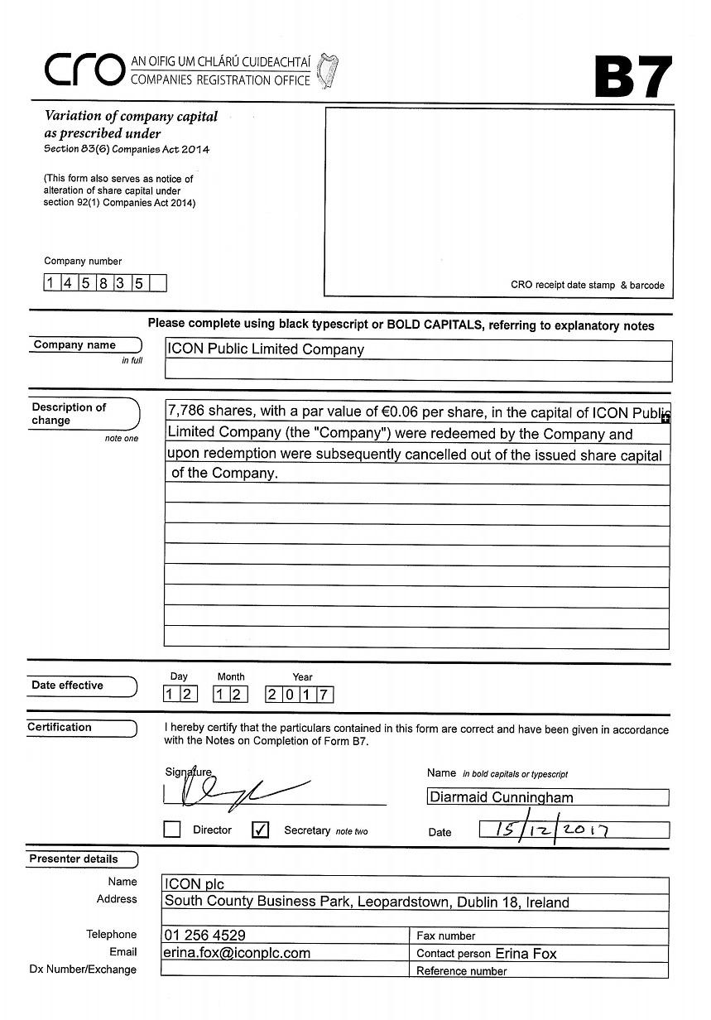

Exhibit 99.11

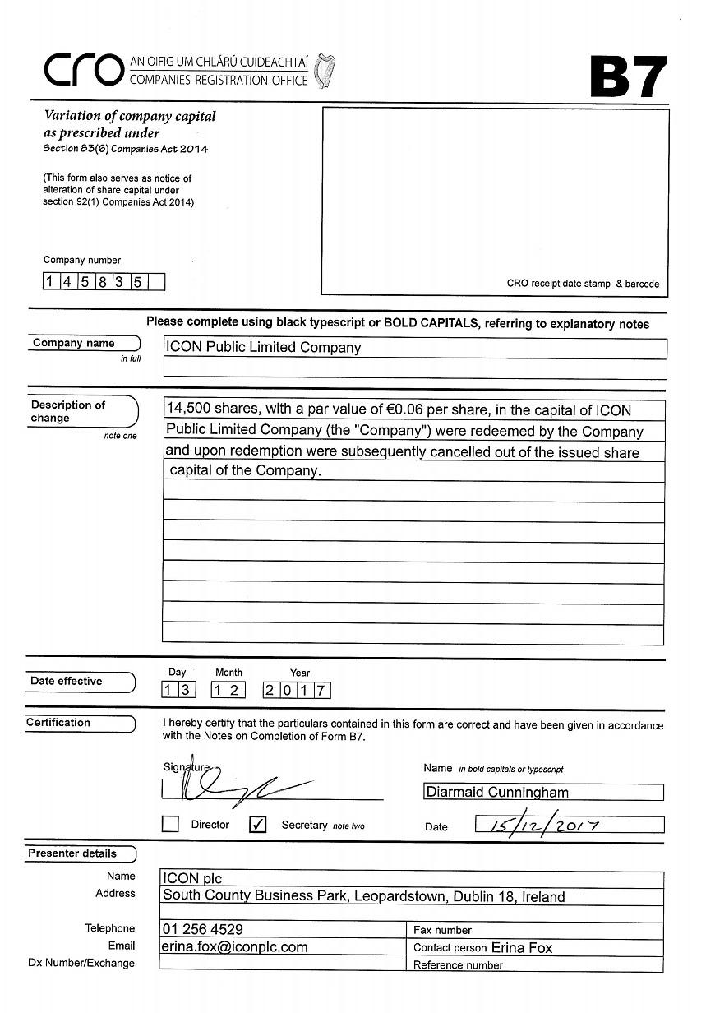

Exhibit 99.12

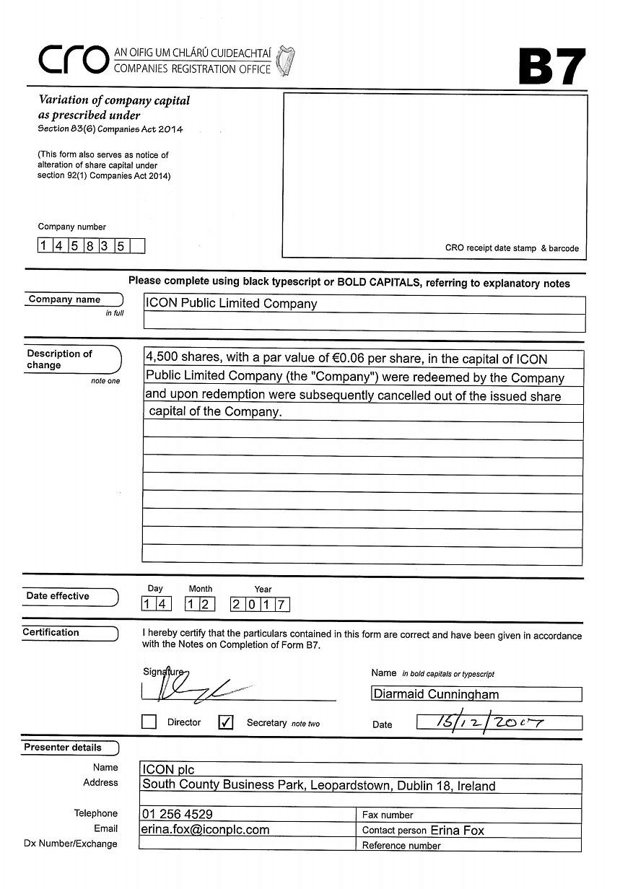

Exhibit 99.13

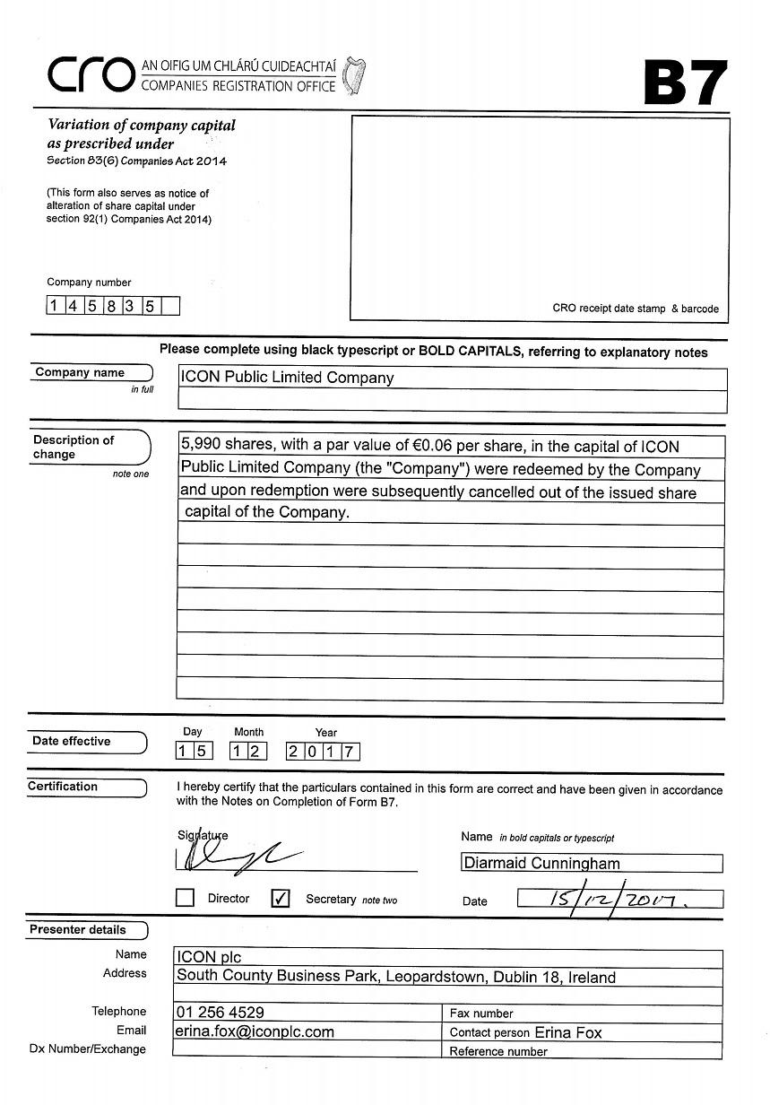

Exhibit 99.14

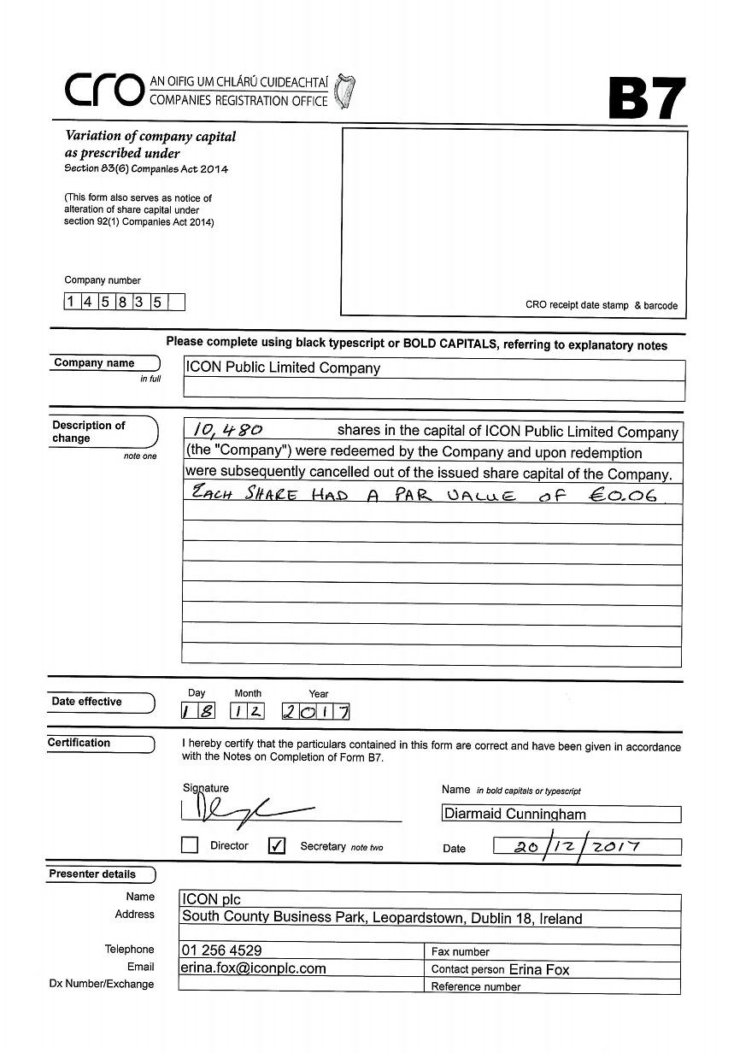

Exhibit 99.15

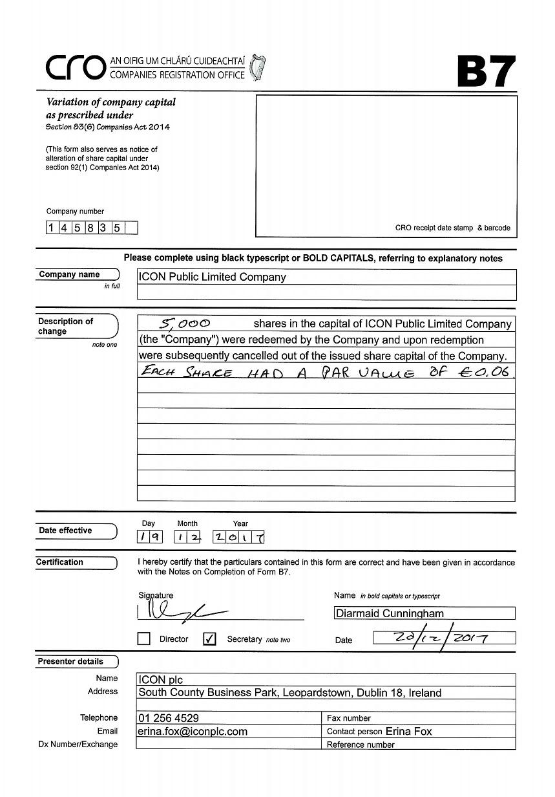

Exhibit 99.16



