FORM 6-K

SECURITIES AND EXCHANGE COMMISSION

Washington, D.C. 20549

Report of Foreign Private Issuer

Pursuant to Rule 13a-16 under

the Securities Exchange Act of 1934

For the month ended October, 2016

ICON plc

(Registrant's name)

333-08704

(Commission file number)

South County Business Park, Leopardstown, Dublin 18, Ireland

(Address of principal executive offices)

Brendan Brennan, CFO

South County Business Park, Leopardstown, Dublin 18, Ireland.

Brendan.Brennan@iconplc.com

00-353-1-291-2000

(Name, telephone number, email and/or facsimile number and address of Company contact person)

Indicate by check mark whether the registrant files or will file annual reports under cover Form 20-F or Form 40-F. Yes___X___

No_______

Indicate by check mark whether the registrant is submitting the Form 6-K in paper as permitted by Regulation S-T Rule 101(b)(1):

Yes______ No___X___

Indicate by check mark whether the registrant is submitting the Form 6-K in paper as permitted by Regulation S-T Rule 101(b)(7):

Yes______ No___X___

Indicate by check mark whether the registrant by furnishing the information contained in this Form is also thereby furnishing the information to the Commission pursuant to Rule12g3-2(b) under the Securities Exchange Act of 1934.

Yes______ No___X___

If "Yes" is marked, indicate below the file number assigned to the registrant in connection with Rule 12g3-2(b):82 N/A

 |  |  |  |  |  | EXHIBIT LIST
Exhibit |  | Description
99.1 |  | Form B7 Notice of Redemption of 44,389 |  |  |  | Shares on October 6, 2016 filed in Companies Registration Office in Ireland on October 27, 2016
99.2 |  | Form B7 Notice of Redemption of 39,000 |  |  |  | Shares on October 7, 2016 filed in Companies Registration Office in Ireland on October 27, 2016
99.3 |  | Form B7 Notice of Redemption of 41,849 |  |  |  | Shares on October 11, 2016 filed in Companies Registration Office in Ireland on October 27, 2016
99.4 |  | Form B7 Notice of Redemption of 30,900 |  |  |  | Shares on October 12, 2016 filed in Companies Registration Office in Ireland on October 27, 2016
99.5 |  | Form B7 Notice of Redemption of 69,888 |  |  |  | Shares on October 13, 2016 filed in Companies Registration Office in Ireland on October 27, 2016
99.6 |  | Form B7 Notice of Redemption of 49,593 |  |  |  | Shares on October 14, 2016 filed in Companies Registration Office in Ireland on October 27, 2016
99.7 |  | Form B7 Notice of Redemption of 58,073 |  |  |  | Shares on October 17, 2016 filed in Companies Registration Office in Ireland on October 27, 2016
99.8 |  | Form B7 Notice of Redemption of 26,951 |  |  |  | Shares on October 18, 2016 filed in Companies Registration Office in Ireland on October 26, 2016
99.9 |  | Form B7 Notice of Redemption of 37,100 |  |  |  | Shares on October 19, 2016 filed in Companies Registration Office in Ireland on October 27, 2016
99.10 |  | Form B7 |  | Notice of Redemption of 28,343 |  | Shares on October 20, 2016 filed in Companies Registration Office in Ireland on October 27, 2016
99.11 |  | Form B7 |  | Notice of Redemption of 19,700 |  | Shares on October 21, 2016 filed in Companies Registration Office in Ireland on October 27, 2016
99.12 |  | Form B7 |  | Notice of Redemption of 27,352 |  | Shares on October 24, 2016 filed in Companies Registration Office in Ireland on October 27, 2016
99.13 |  | Form B7 |  | Notice of Redemption of 200 Shares on October 25, 2016 filed in Companies Registration Office in Ireland on October 27, 2016

SIGNATURES

Pursuant to the requirements of the Securities Exchange Act of 1934, the Registrant has duly caused this report to be signed on its behalf by the undersigned thereunto duly authorized.

 | ICON plc
Date: October 27, 2016 | /s/ Brendan Brennan
 | Brendan Brennan
 | Chief Financial Officer

Exhibit 99.1

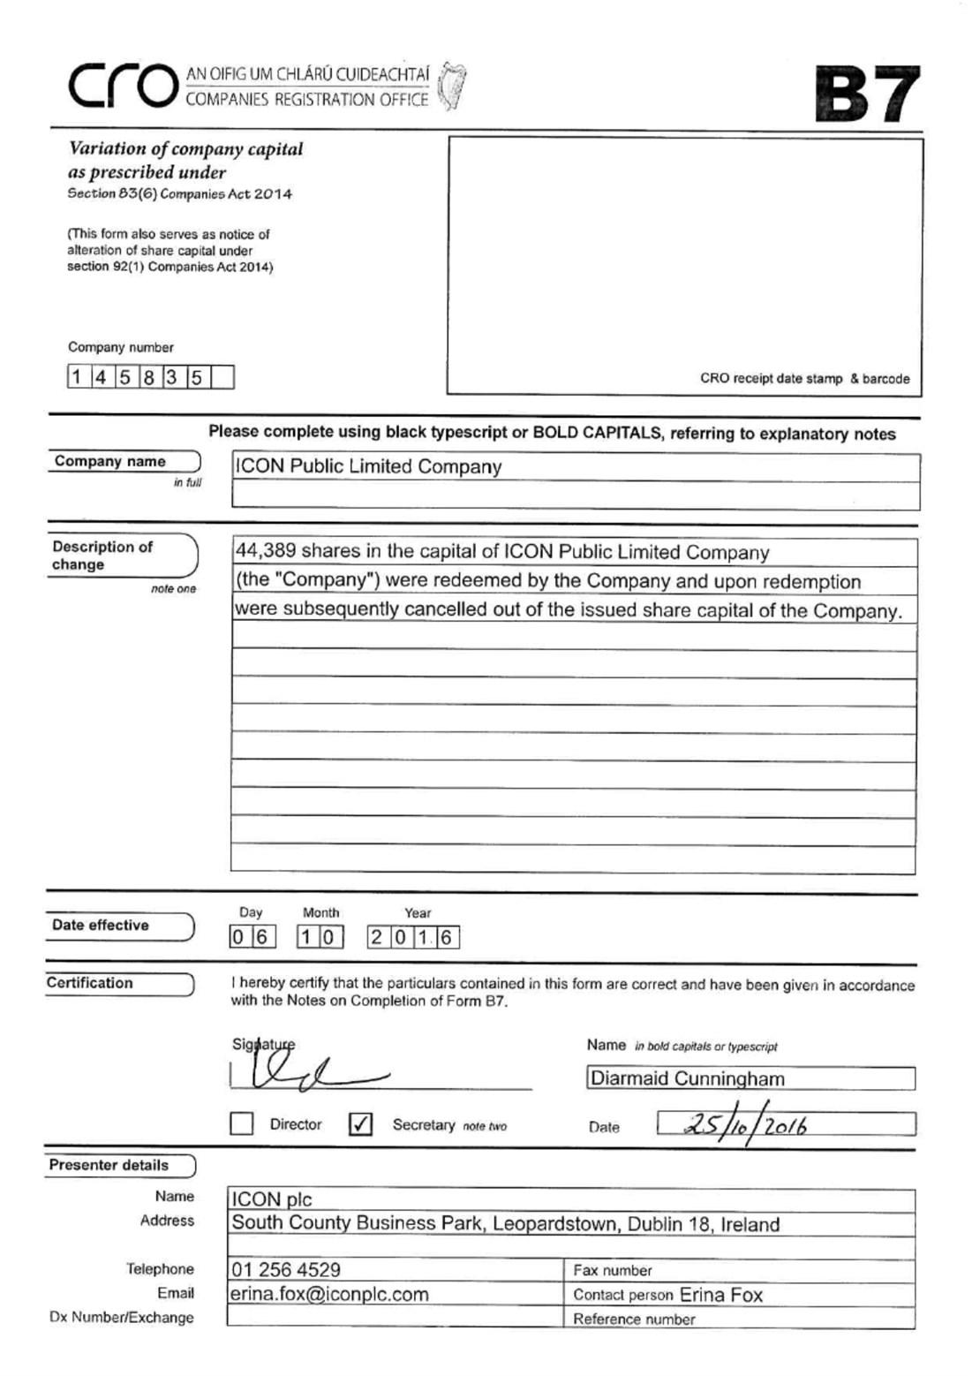

Exhibit 99.2

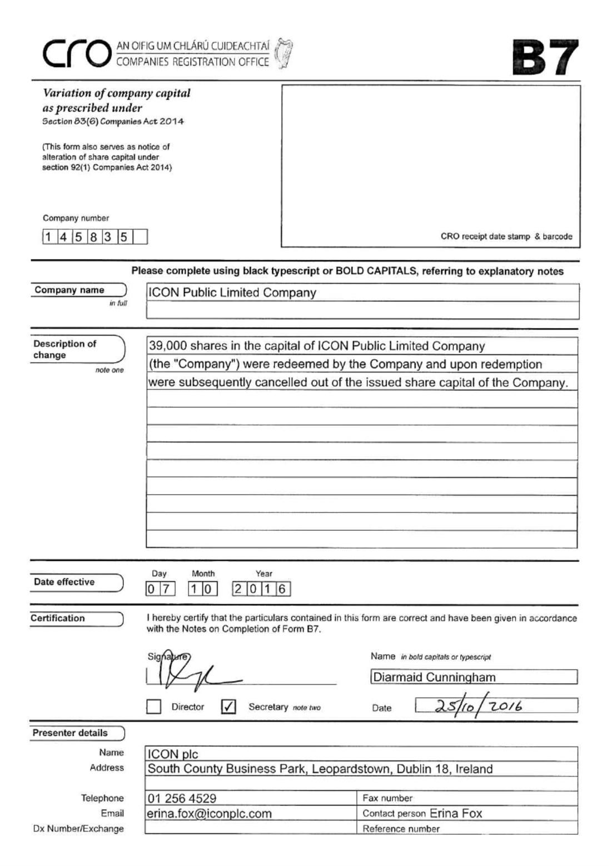

Exhibit 99.3

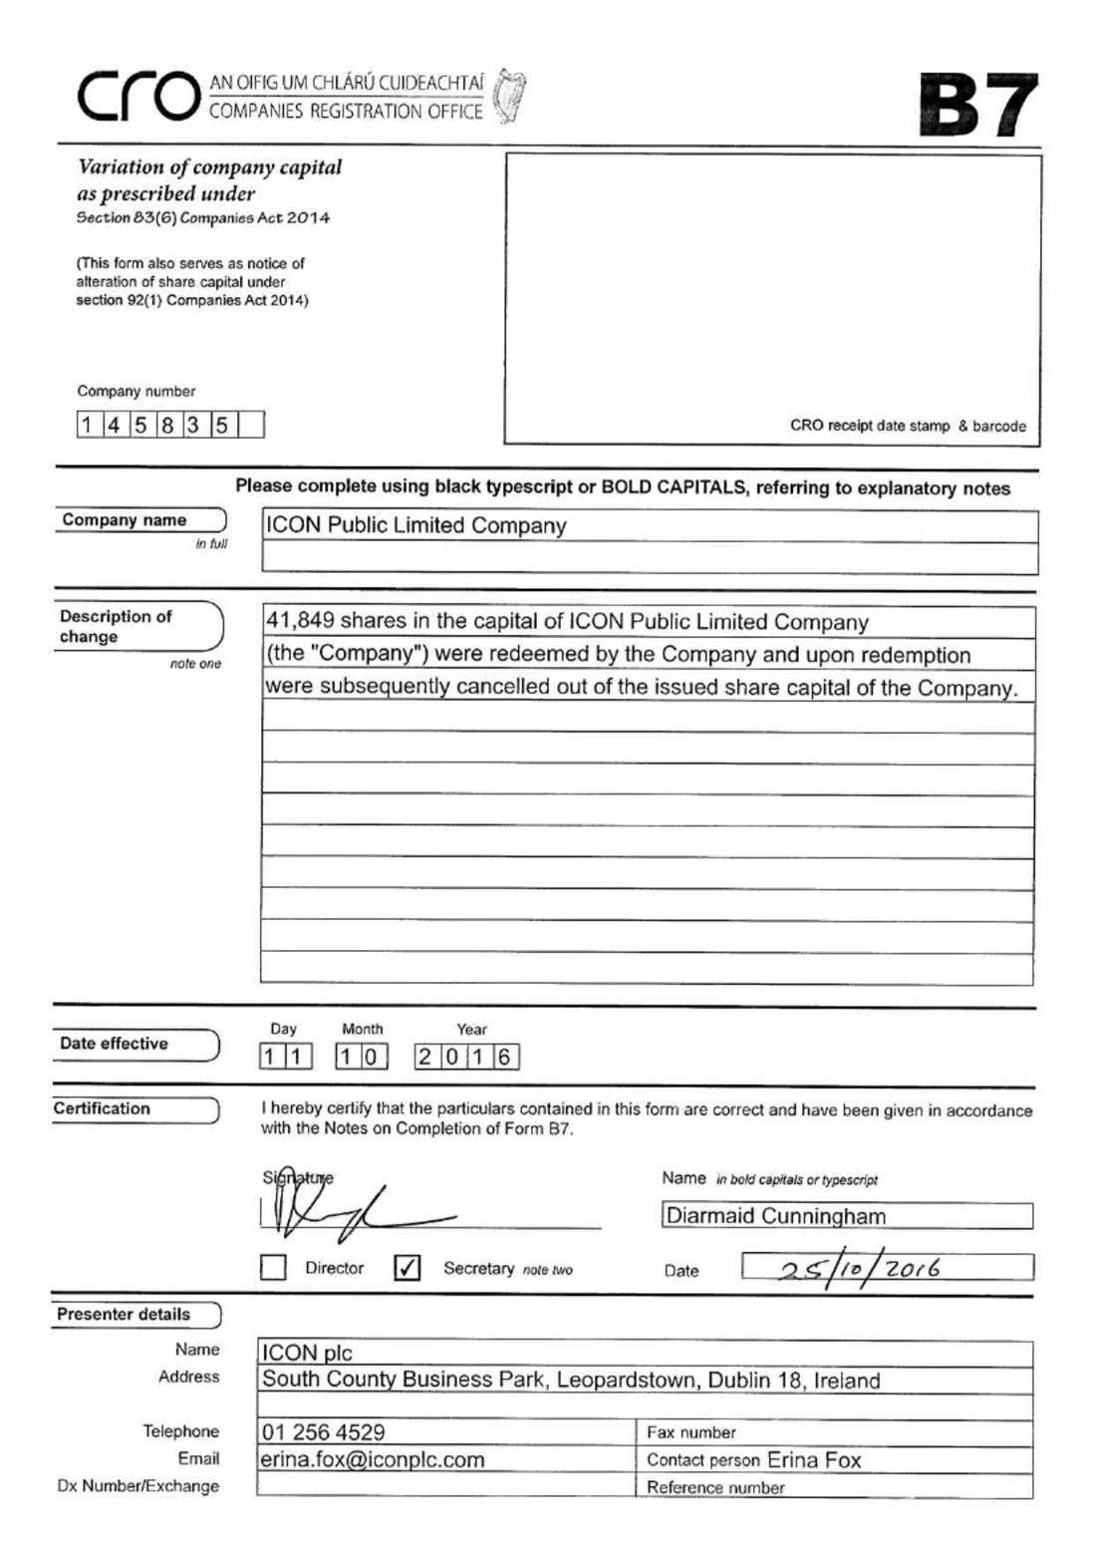

Exhibit 99.4

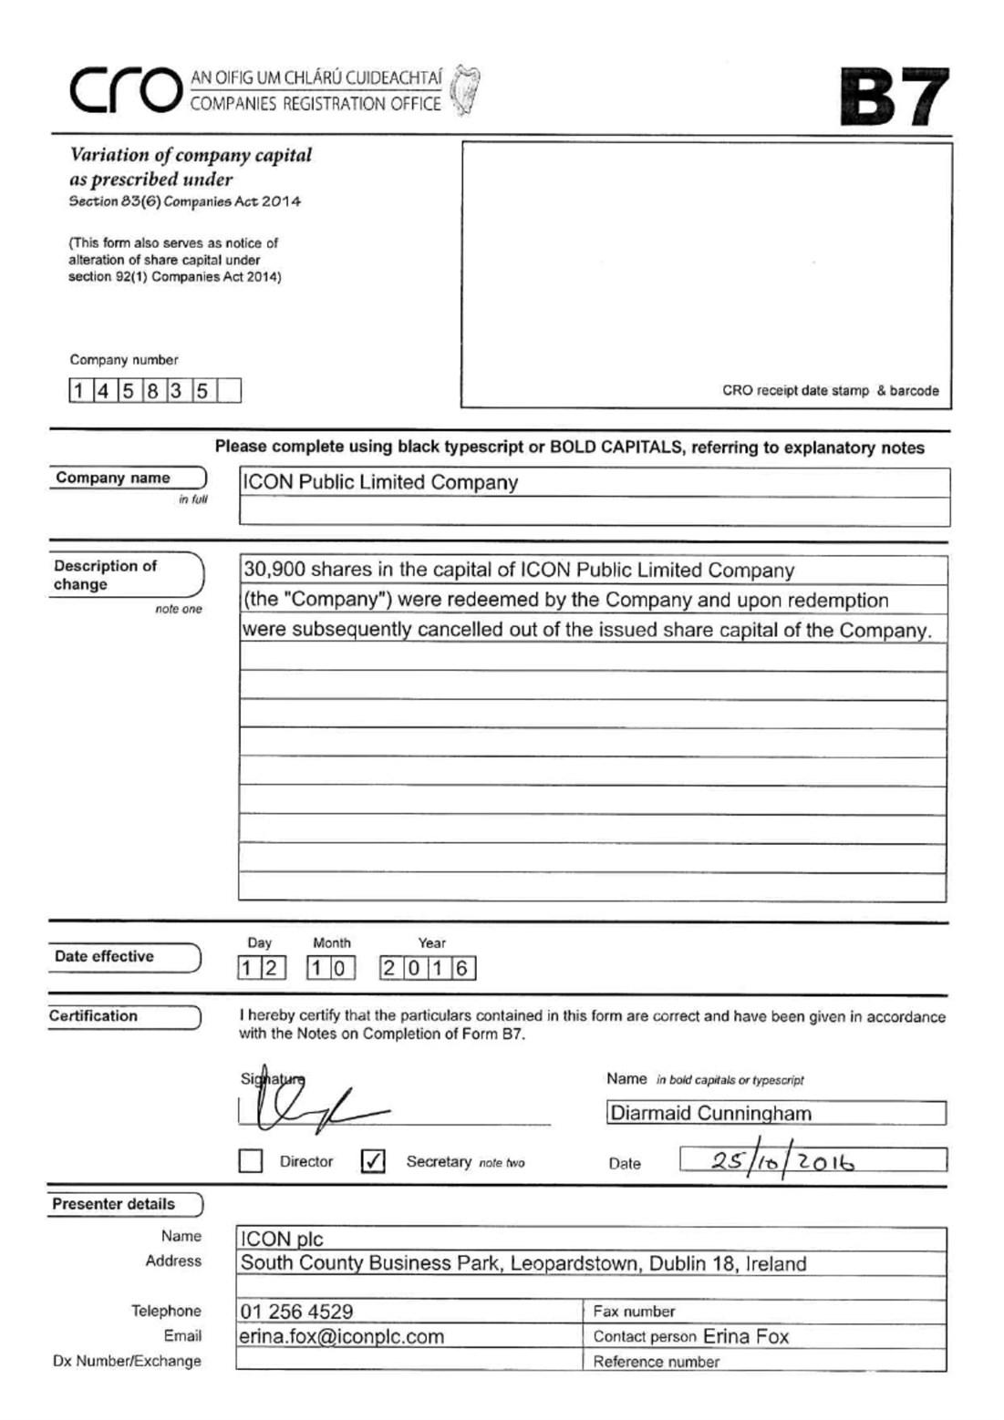

Exhibit 99.5

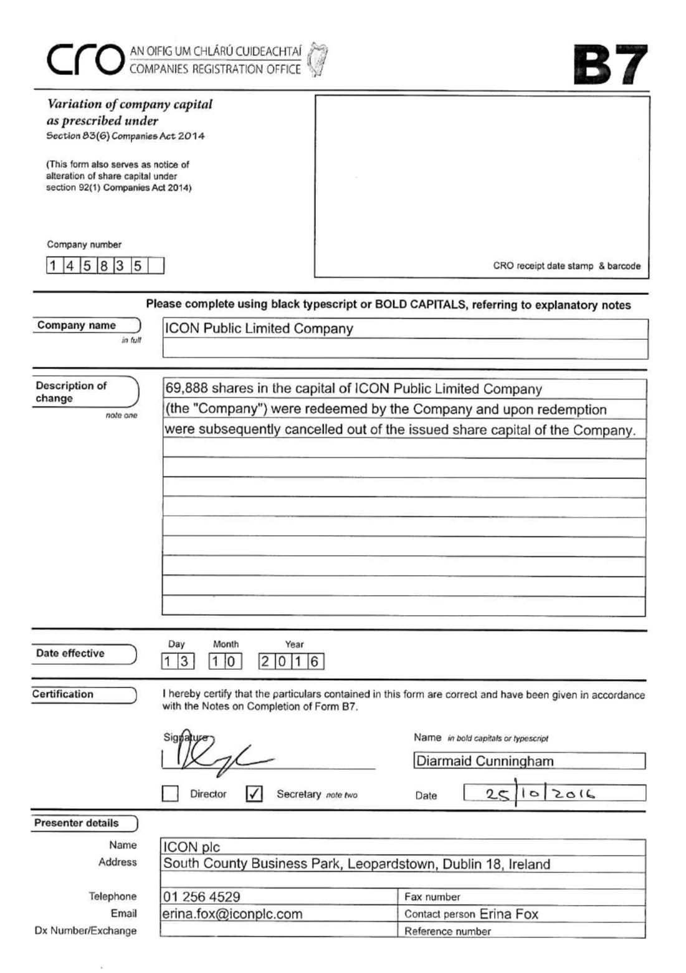

Exhibit 99.6

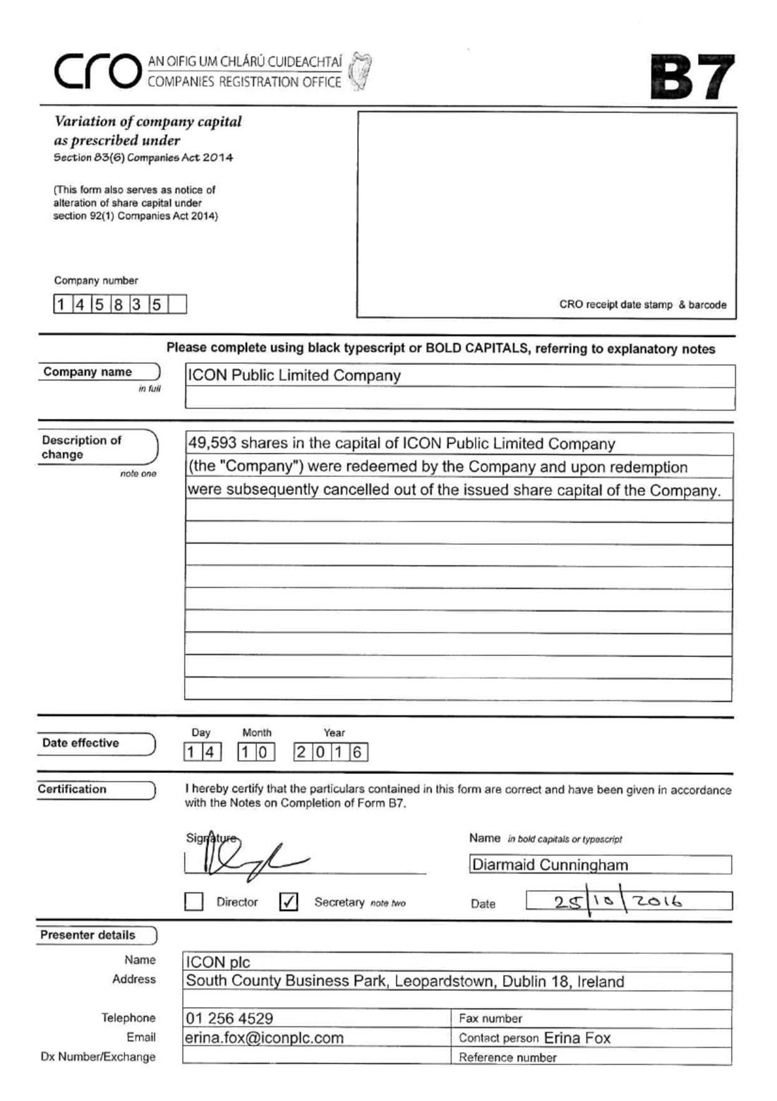

Exhibit 99.7

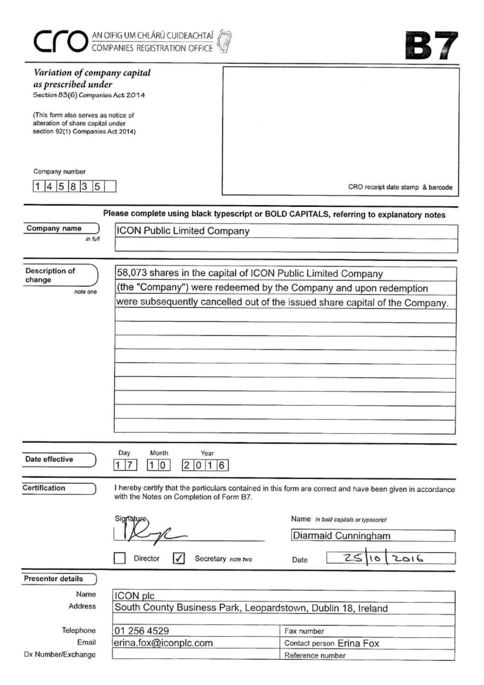

Exhibit 99.8

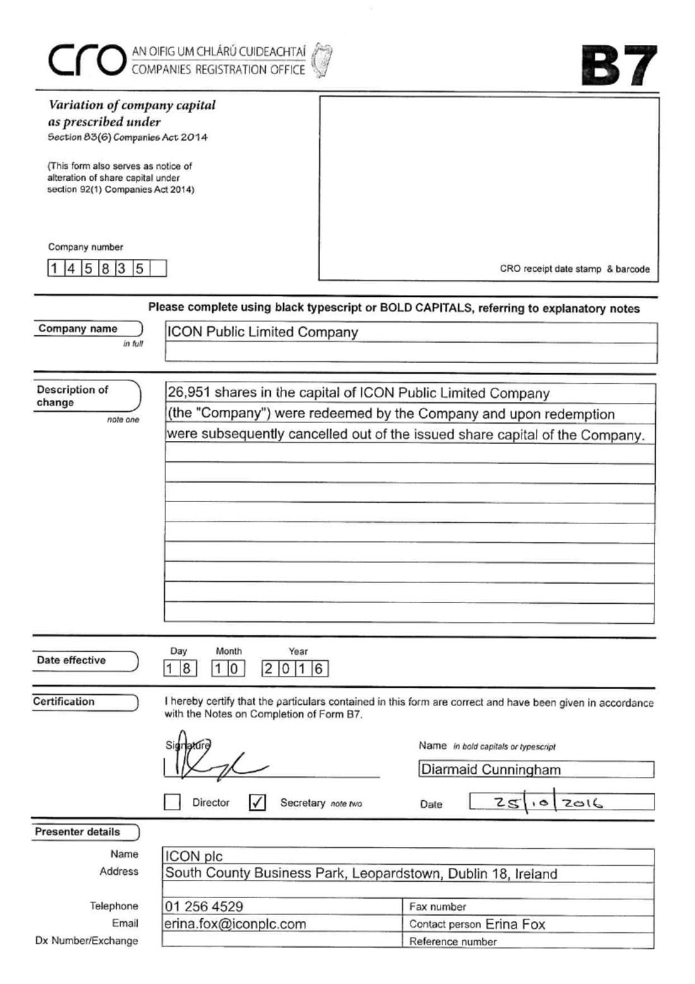

Exhibit 99.9

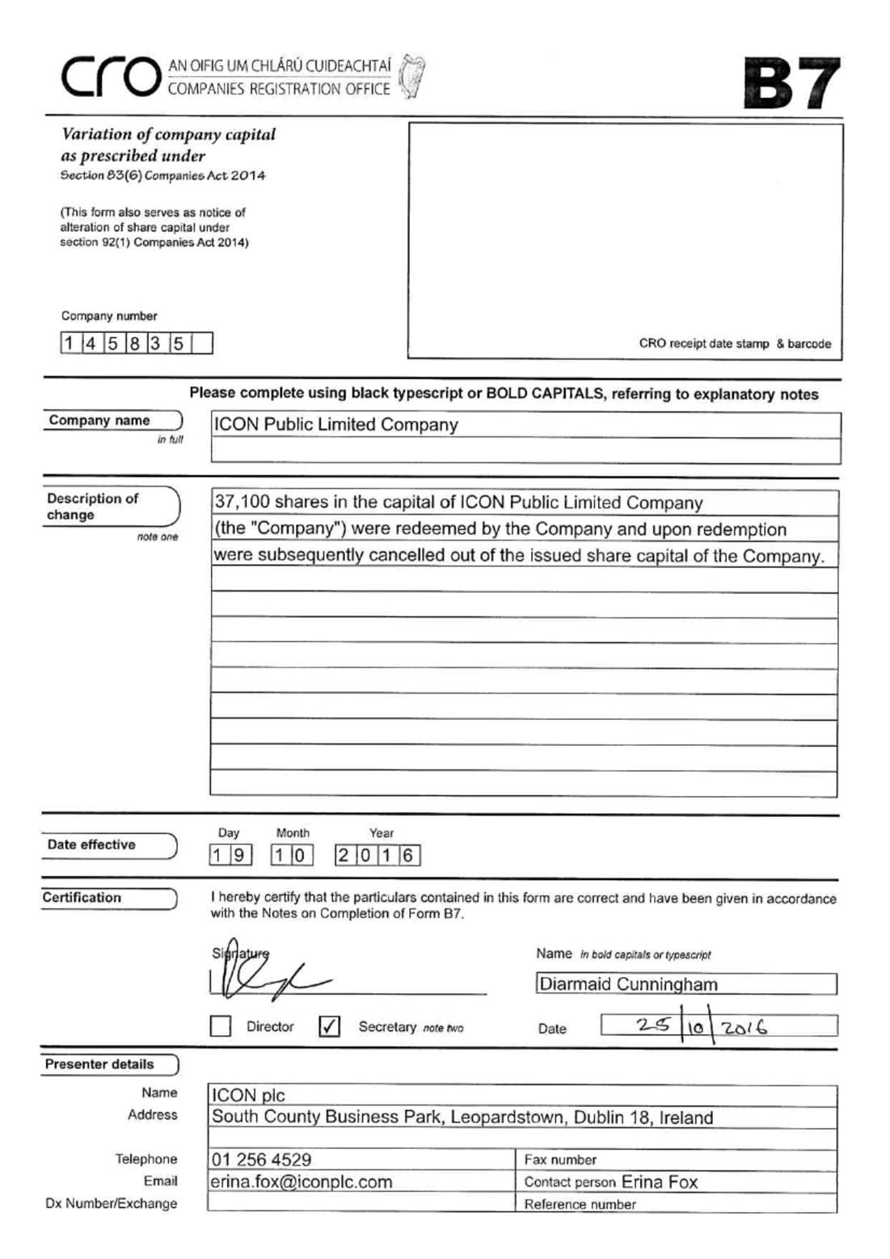

Exhibit 99.10

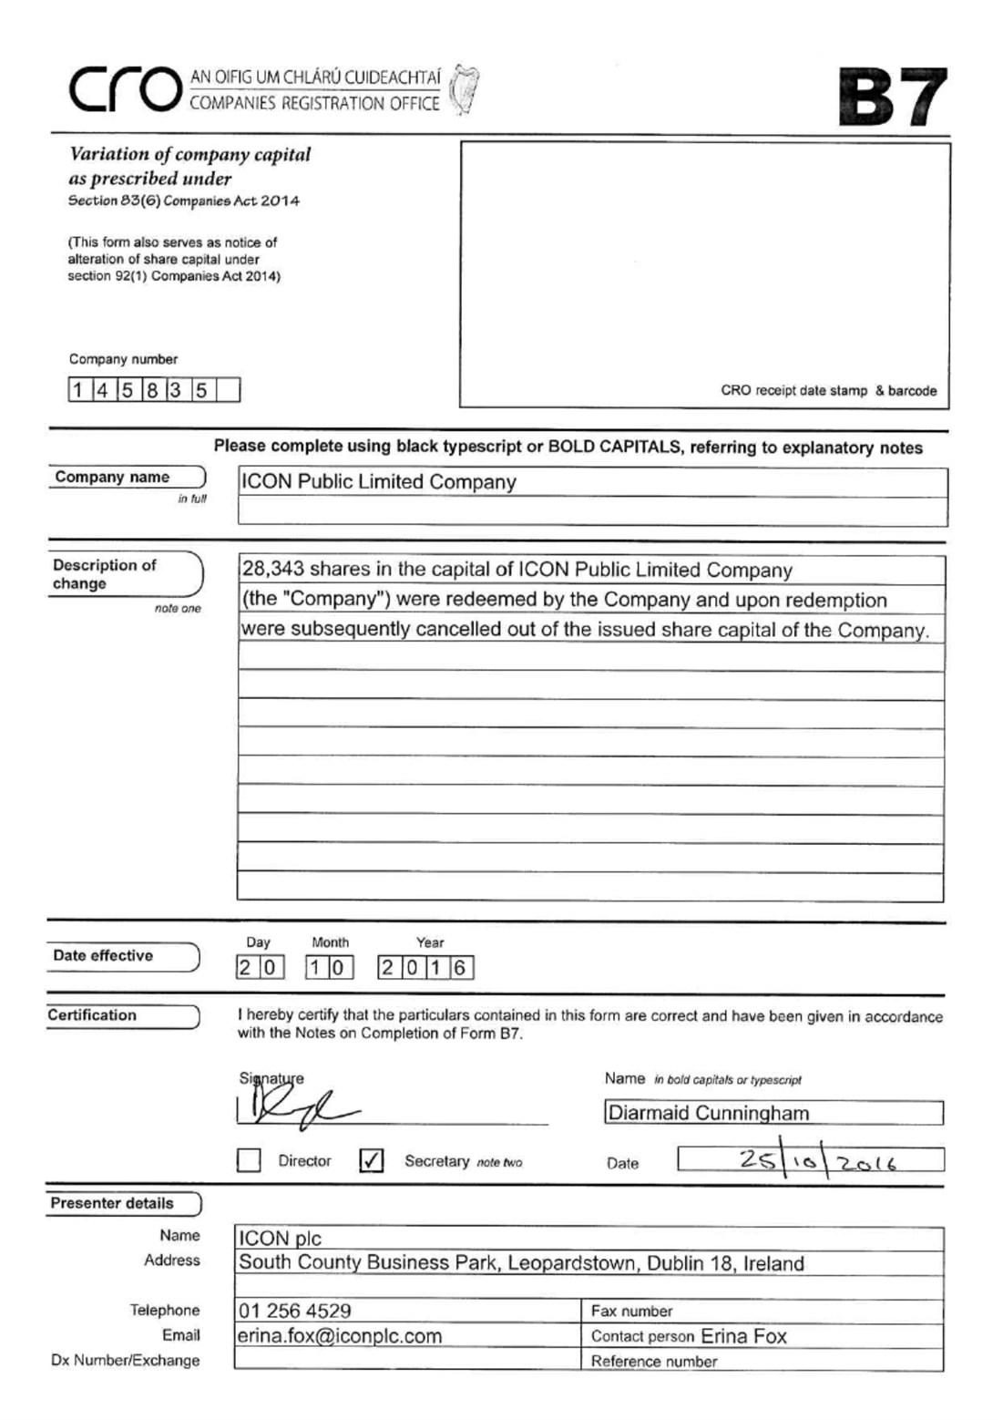

Exhibit 99.11

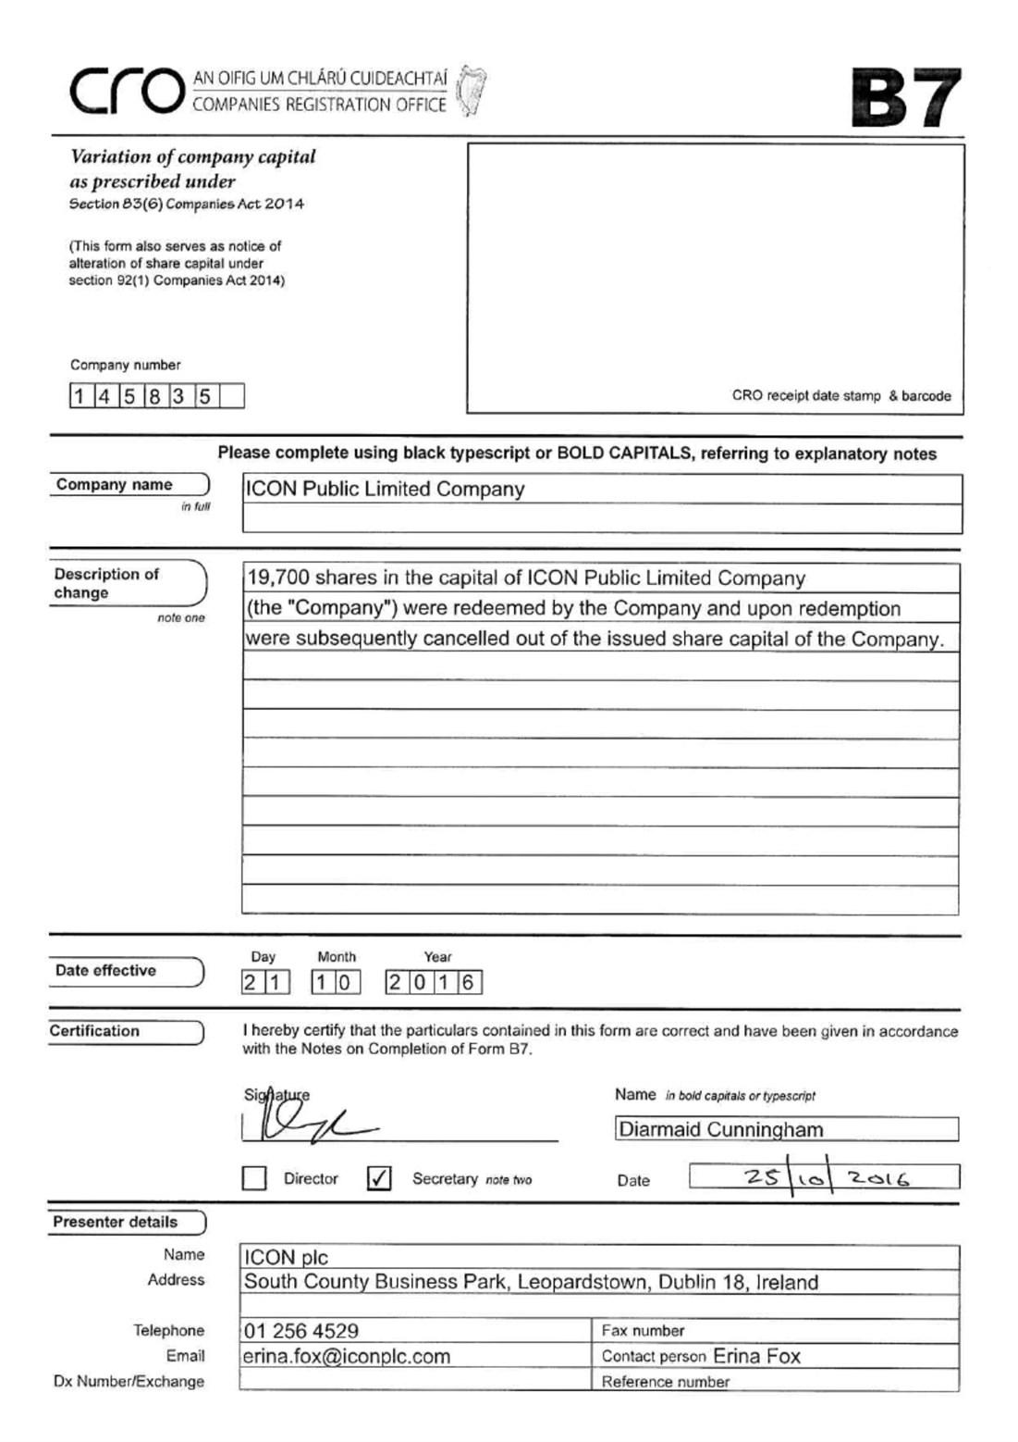

Exhibit 99.12

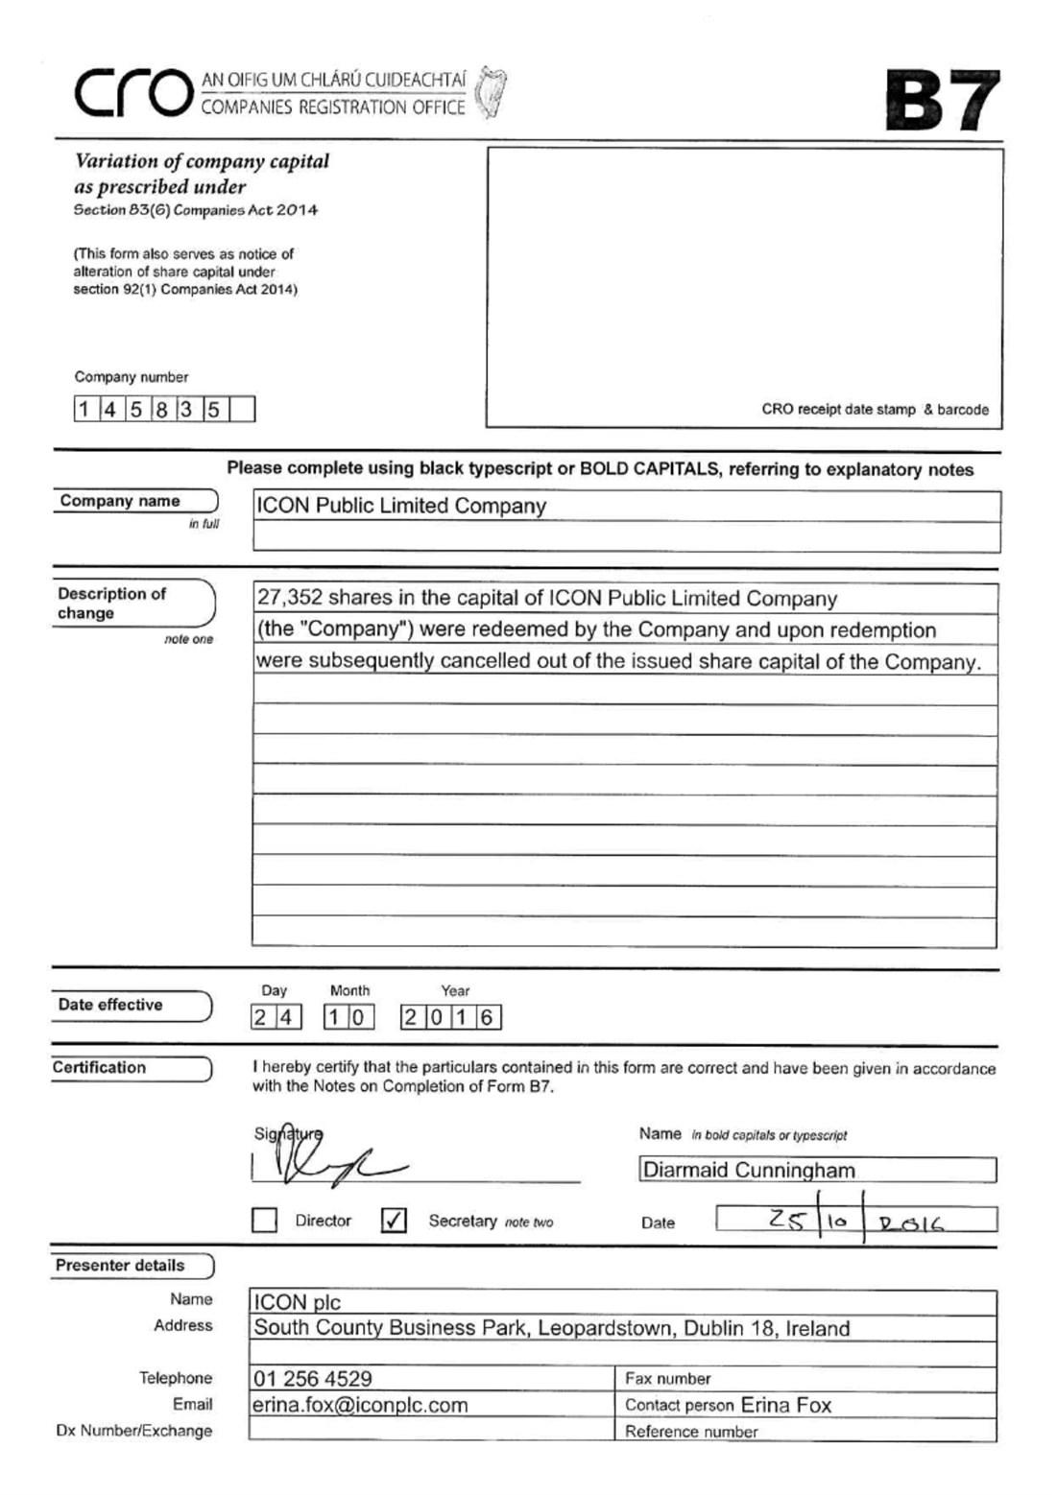

Exhibit 99.13

