FORM 6-K

SECURITIES AND EXCHANGE COMMISSION

Washington, D.C. 20549

Report of Foreign Private Issuer

Pursuant to Rule 13a-16 under

the Securities Exchange Act of 1934

For the month ended December, 2016

ICON plc

(Registrant's name)

333-08704

(Commission file number)

South County Business Park, Leopardstown, Dublin 18, Ireland

(Address of principal executive offices)

Brendan Brennan, CFO

South County Business Park, Leopardstown, Dublin 18, Ireland.

Brendan.Brennan@iconplc.com

00-353-1-291-2000

(Name, telephone number, email and/or facsimile number and address of Company contact person)

Indicate by check mark whether the registrant files or will file annual reports under cover Form 20-F or Form 40-F.

Yes___X___ No_______

Indicate by check mark whether the registrant is submitting the Form 6-K in paper as permitted by Regulation S-T Rule 101(b)(1):

Yes______ No___X___

Indicate by check mark whether the registrant is submitting the Form 6-K in paper as permitted by Regulation S-T Rule 101(b)(7):

Yes______ No___X___

Indicate by check mark whether the registrant by furnishing the information contained in this Form is also thereby furnishing the information to the Commission pursuant to Rule12g3-2(b) under the Securities Exchange Act of 1934.

Yes______ No___X___

If "Yes" is marked, indicate below the file number assigned to the registrant in connection with Rule 12g3-2(b):82 N/A

 |  |  |  | EXHIBIT LIST
Exhibit |  | Description
99.1 |  | Form B7 Notice of Redemption of 780 Shares on November 2, 2016 filed in Companies Registration Office in Ireland on December 21, 2016
99.2 |  | Form B7 Notice of Redemption of 75,710 Shares on November 4, 2016 filed in Companies Registration Office in Ireland on December 21, 2016
99.3 |  | Form B7 Notice of Redemption of 84,071 Shares on November 7, 2016 filed in Companies Registration Office in Ireland on December 21, 2016
99.4 |  | Form B7 Notice of Redemption of 88,664 Shares on November 8, 2016 filed in Companies Registration Office in Ireland on December 21, 2016
99.5 |  | Form B7 Notice of Redemption of 67,718 Shares on November 9, 2016 filed in Companies Registration Office in Ireland on December 21, 2016
99.6 |  | Form B7 Notice of Redemption of 78,046 Shares on November 10, 2016 filed in Companies Registration Office in Ireland on December 21, 2016
99.7 |  | Form B7 Notice of Redemption of 25,620 Shares on November 14, 2016 filed in Companies Registration Office in Ireland on December 21, 2016
99.8 |  | Form B7 Notice of Redemption of 200 Shares on November 15, 2016 filed in Companies Registration Office in Ireland on December 21, 2016
99.9 |  | Form B7 Notice of Redemption of 4 Shares on November 16, 2016 filed in Companies Registration Office in Ireland on December 21, 2016
99.10 |  | Form B7 Notice of Redemption of 9,728 Shares on November 17, 2016 filed in Companies Registration Office in Ireland on December 21, 2016
99.11 |  | Form B7 Notice of Redemption of 10,437 Shares on November 18, 2016 filed in Companies Registration Office in Ireland on December 21, 2016
99.12 |  | Form B7 Notice of Redemption of 60,641 Shares on November 21, 2016 filed in Companies Registration Office in Ireland on December 21, 2016
99.13 |  | Form B7 Notice of Redemption of 32,503 Shares on November 22, 2016 filed in Companies Registration Office in Ireland on December 21, 2016
99.14 |  | Form B7 Notice of Redemption of 58,198 Shares on November 23, 2016 filed in Companies Registration Office in Ireland on December 21, 2016
99.15 |  | Form B7 Notice of Redemption of 52,650 Shares on November 25, 2016 filed in Companies Registration Office in Ireland on December 21, 2016
99.16 |  | Form B7 Notice of Redemption of 45,376 Shares on November 28, 2016 filed in Companies Registration Office in Ireland on December 21, 2016

99.17 | Form B7 Notice of Redemption of 37,325 Shares on November 29, 2016 filed in Companies Registration Office in Ireland on December 21, 2016
99.18 | Form B7 Notice of Redemption of 29,110 Shares on November 30, 2016 filed in Companies Registration Office in Ireland on December 21, 2016
99.19 | Form B7 Notice of Redemption of 39,282 Shares on December 1, 2016 filed in Companies Registration Office in Ireland on December 21, 2016
99.20 | Form B7 Notice of Redemption of 6,965 | Shares on December 2, 2016 filed in Companies Registration Office in Ireland on December 21, 2016
99.21 | Form B7 Notice of Redemption of 21,558 Shares on December 5, 2016 filed in Companies Registration Office in Ireland on December 21, 2016
99.22 | Form B7 Notice of Redemption of 7,200 | Shares on December 14, 2016 filed in Companies Registration Office in Ireland on December 21, 2016
99.23 | Form B7 Notice of Redemption of 4,499 | Shares on December 15, 2016 filed in Companies Registration Office in Ireland on December 21, 2016
99.24 | Form B7 Notice of Redemption of 34,242 Shares on December 16, 2016 filed in Companies Registration Office in Ireland on December 21, 2016
99.25 | Form B7 Notice of Redemption of 34,056 Shares on December 19, 2016 filed in Companies Registration Office in Ireland on December 21, 2016
99.26 | Form B7 Notice of Redemption of 19,858 Shares on December 20, 2016 filed in Companies Registration Office in Ireland on December 21, 2016
99.27 | Form B7 Notice of Redemption of 31,408 Shares on December 21, 2016 filed in Companies Registration Office in Ireland on December 21, 2016

SIGNATURES

Pursuant to the requirements of the Securities Exchange Act of 1934, the Registrant has duly caused this report to be signed on its behalf by the undersigned thereunto duly authorized.

ICON plc

/s/ Brendan Brennan

Date: December 21, 2016 Brendan Brennan Chief Financial Officer

Exhibit 99.1

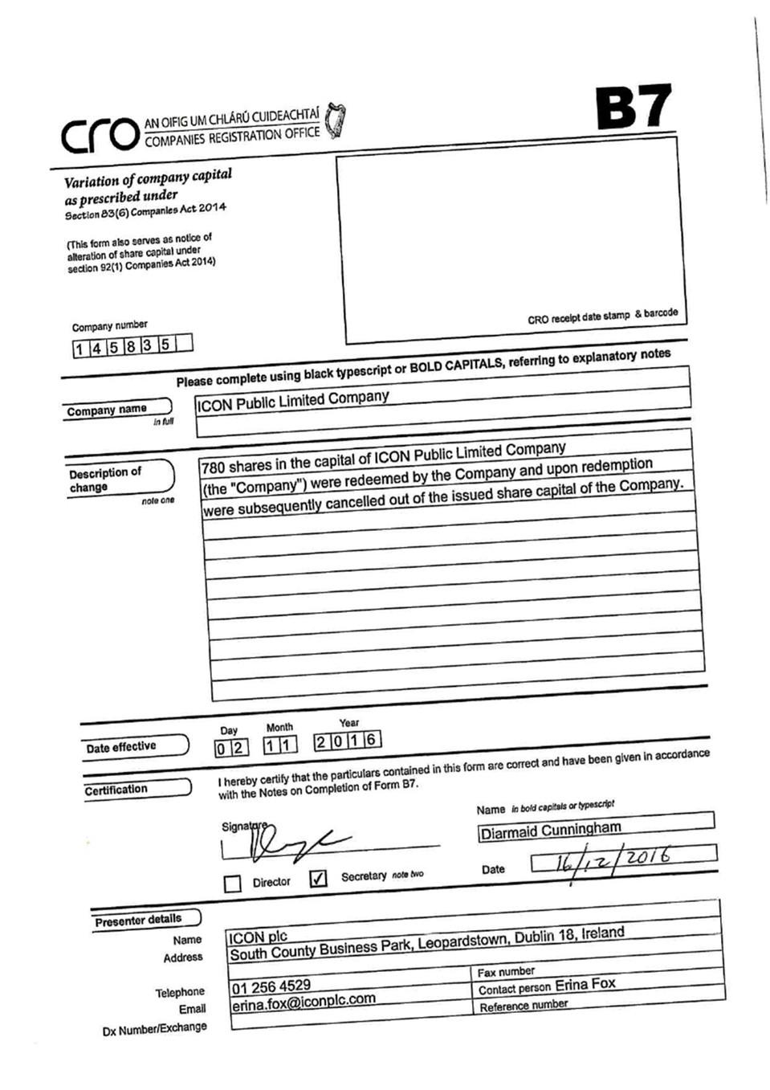

Exhibit 99.2

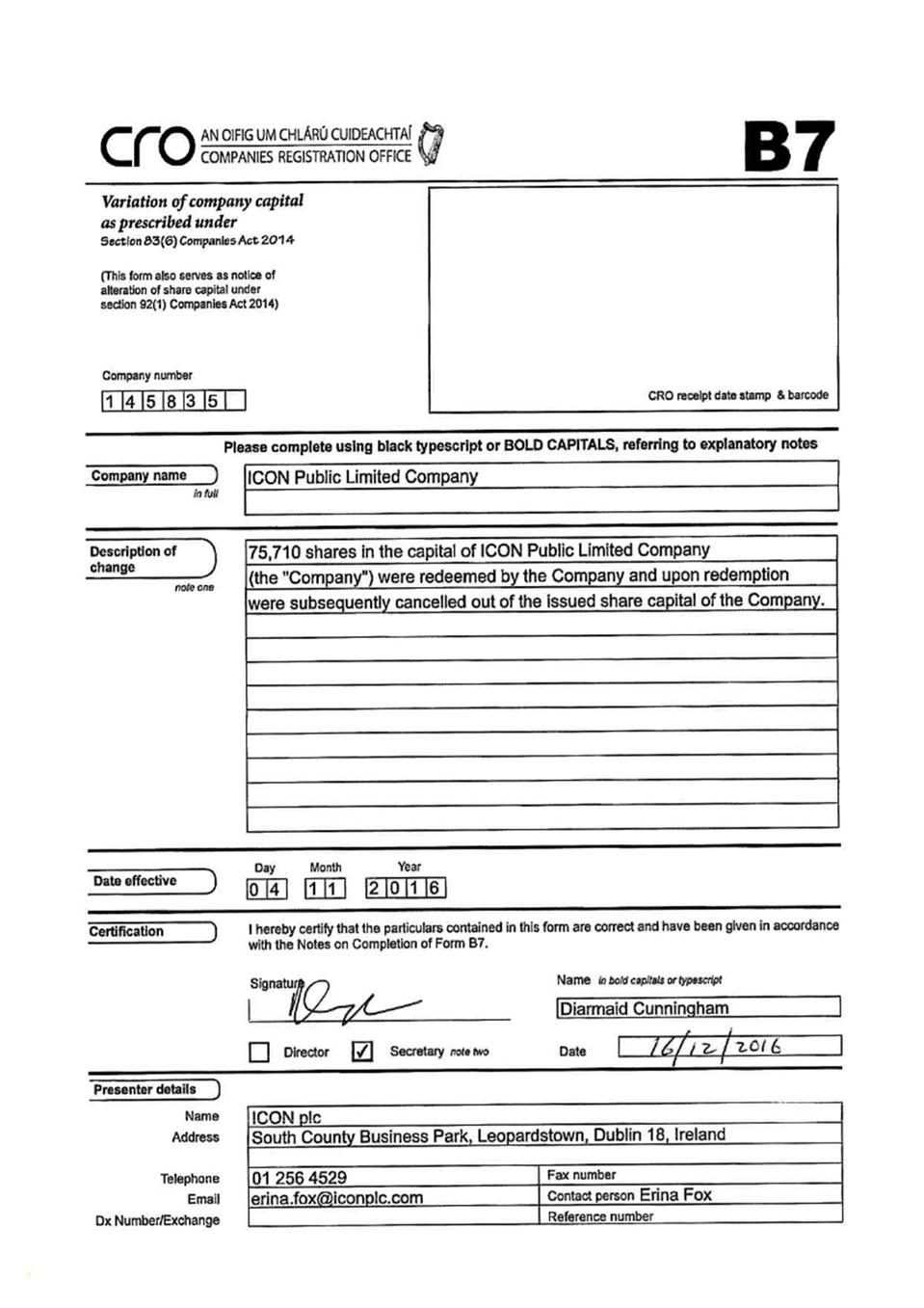

Exhibit 99.3

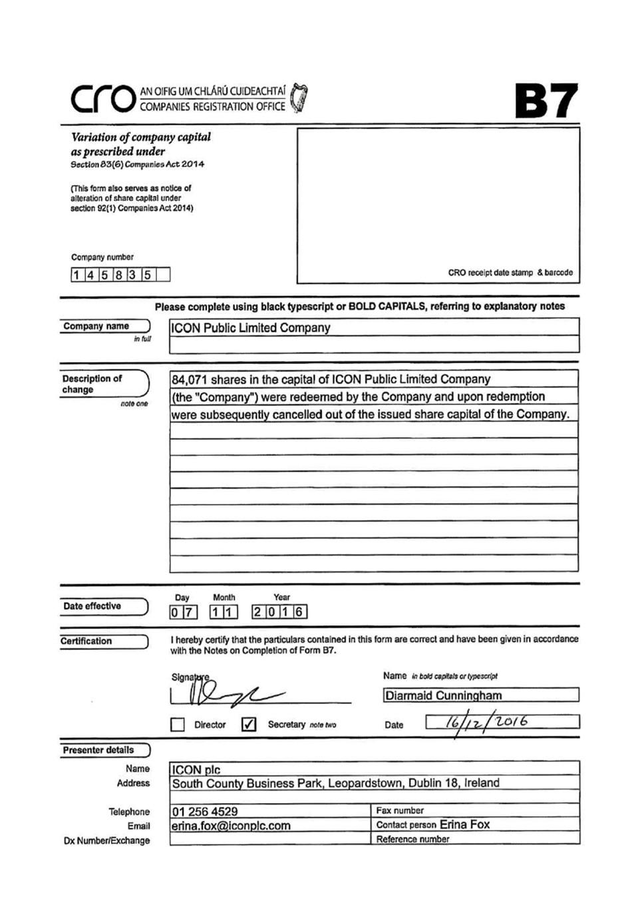

Exhibit 99.4

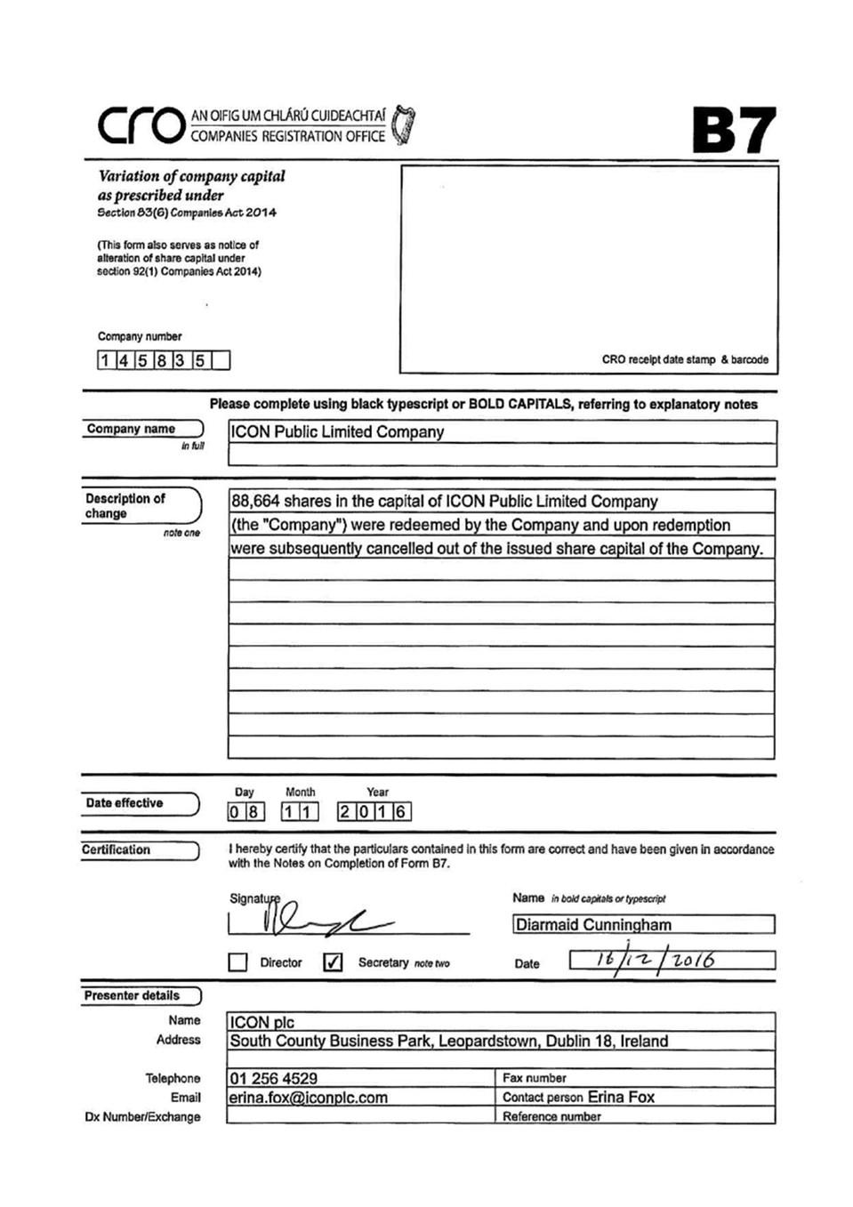

Exhibit 99.5

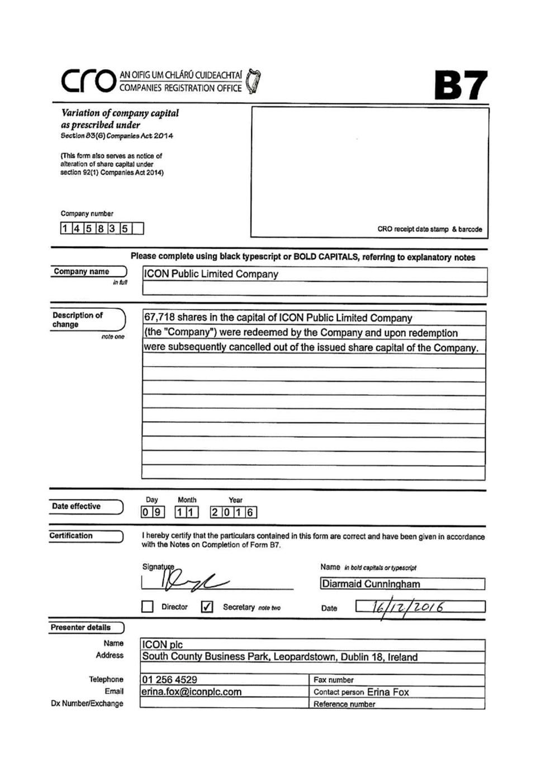

Exhibit 99.6

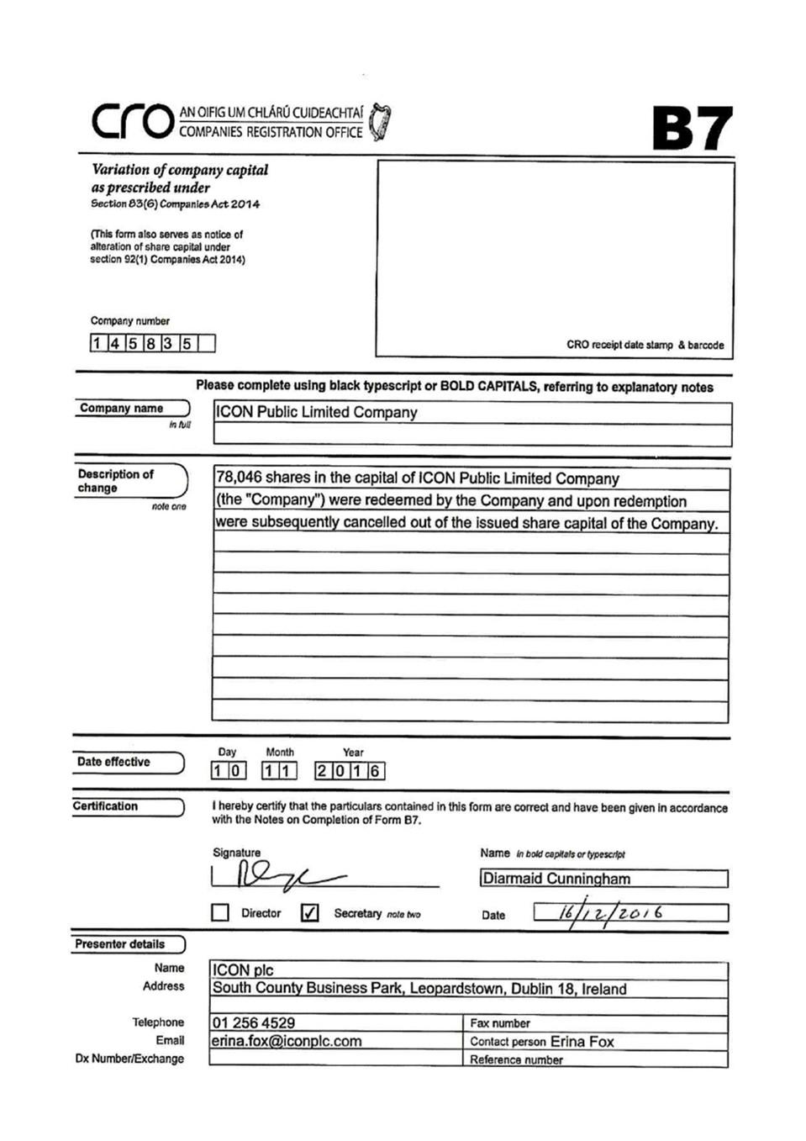

Exhibit 99.7

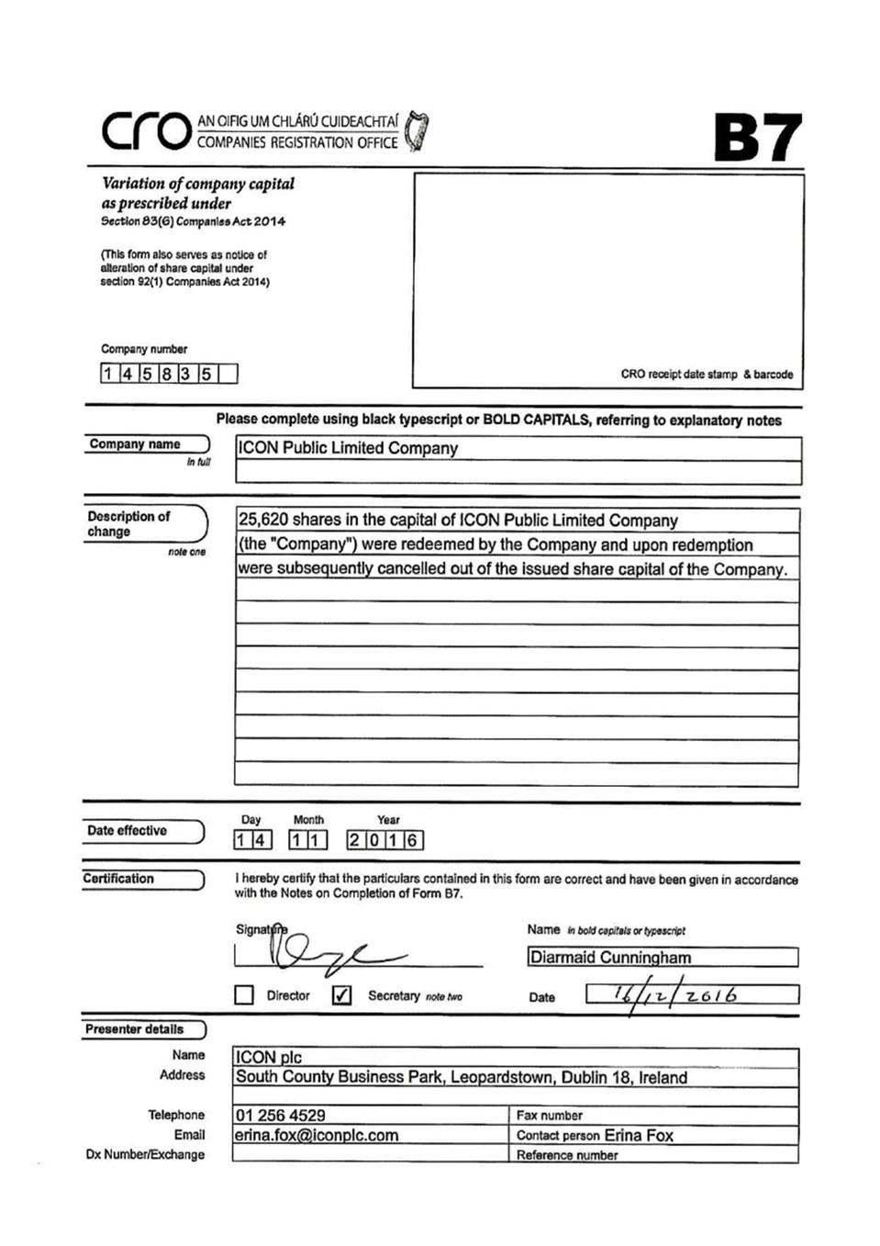

Exhibit 99.8

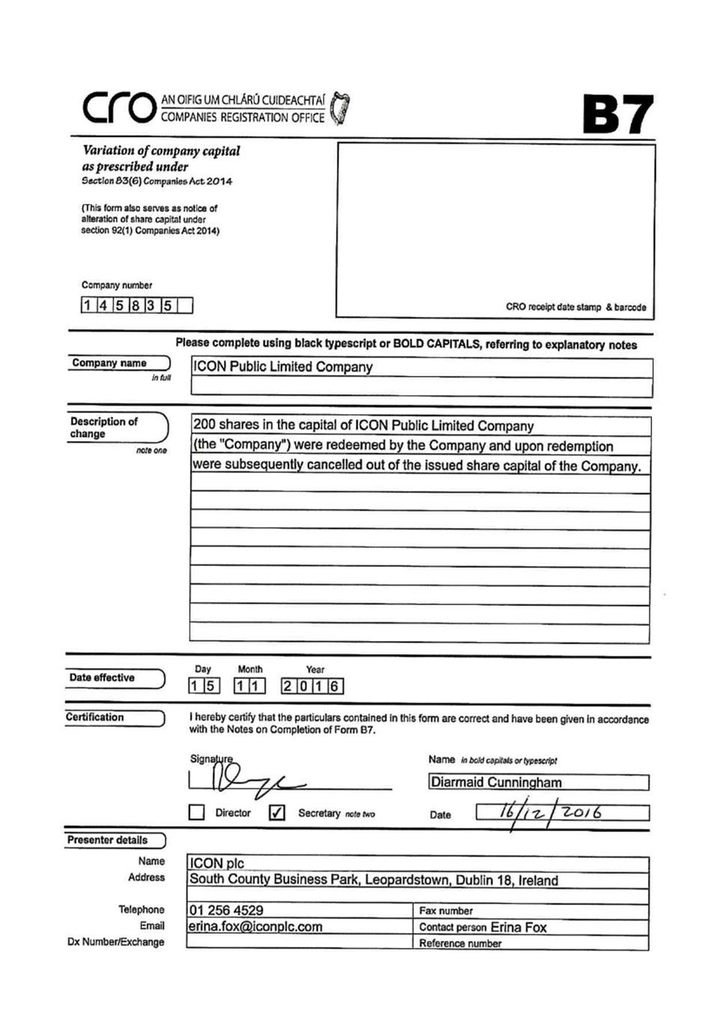

Exhibit 99.9

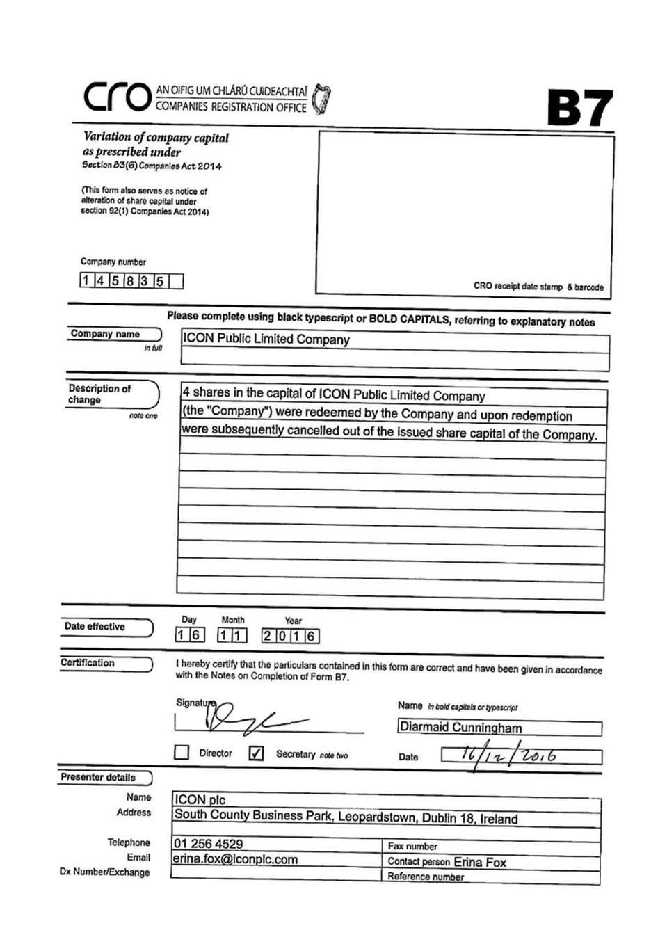

Exhibit 99.10

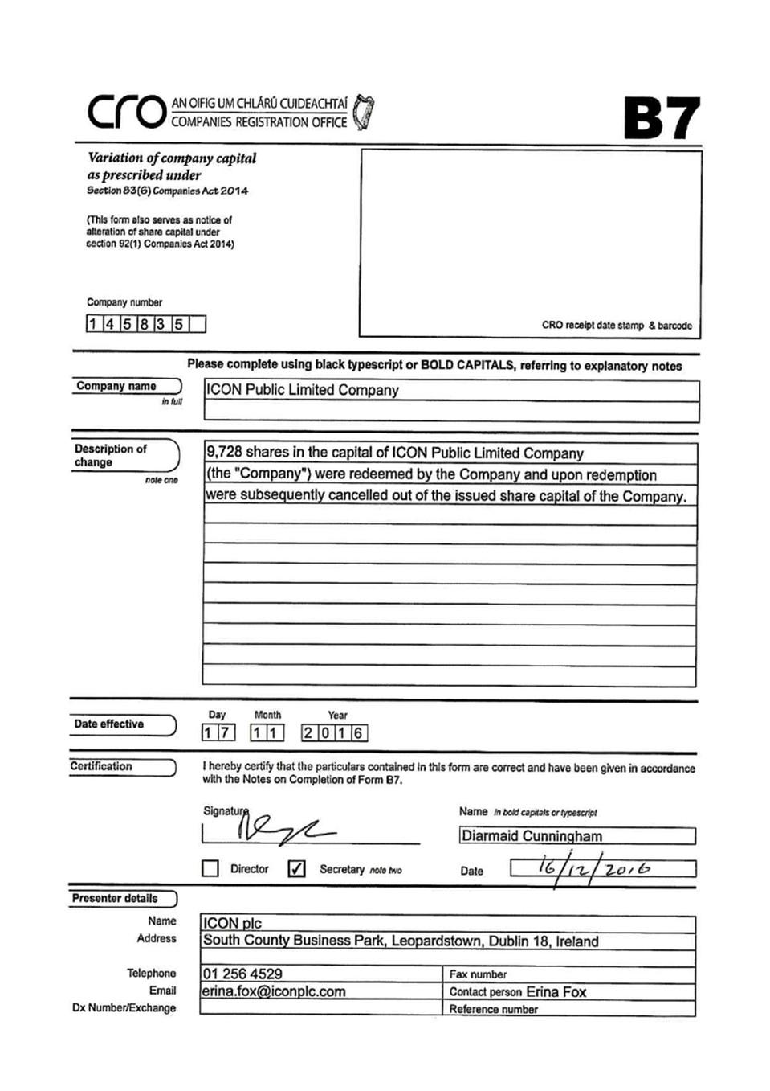

Exhibit 99.11

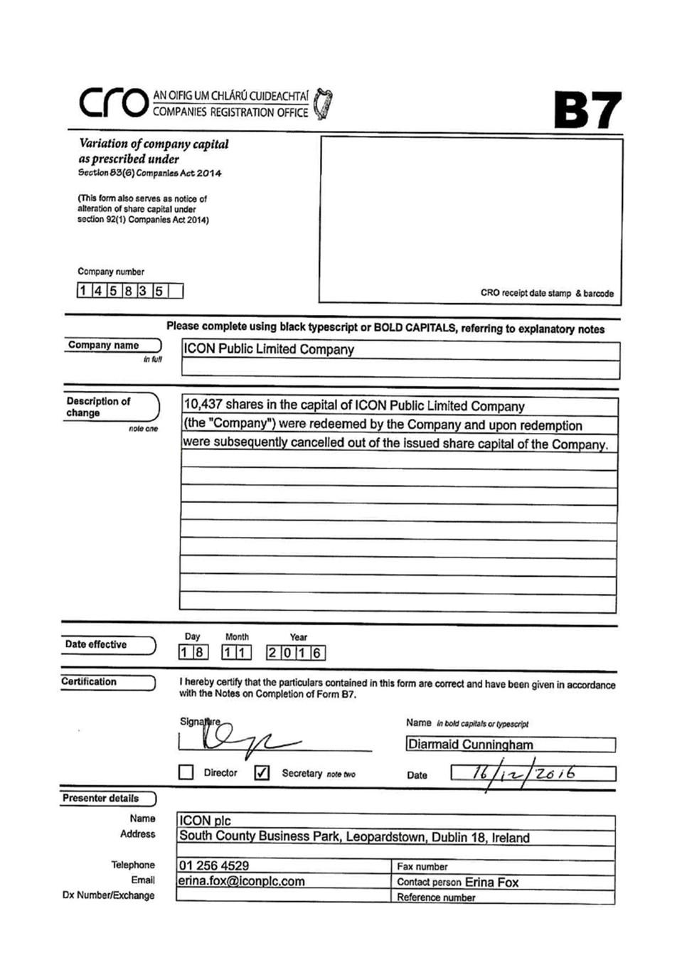

Exhibit 99.12

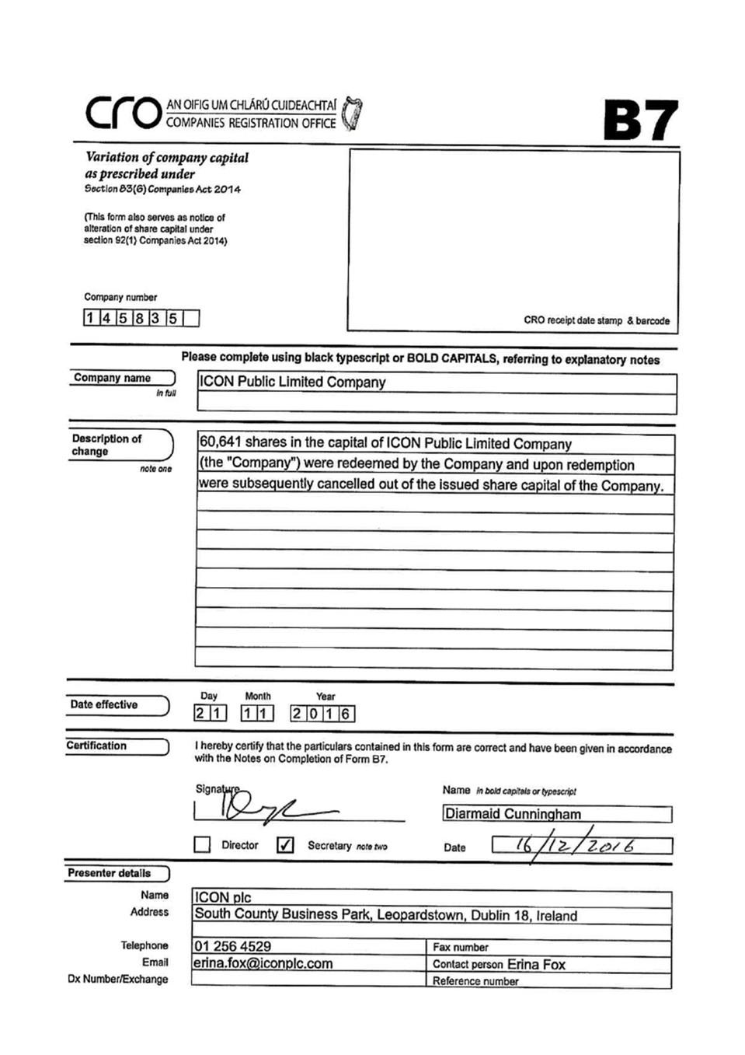

Exhibit 99.13

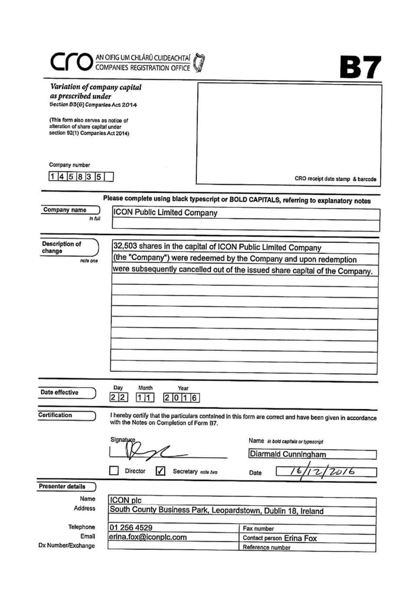

Exhibit 99.14

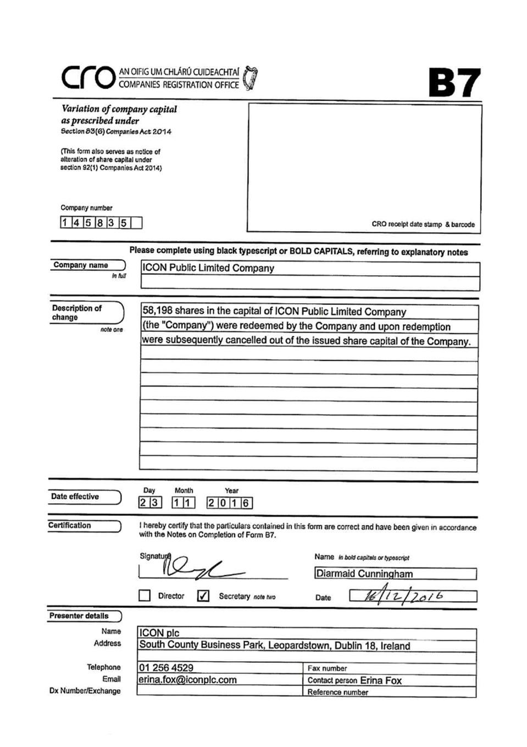

Exhibit 99.15

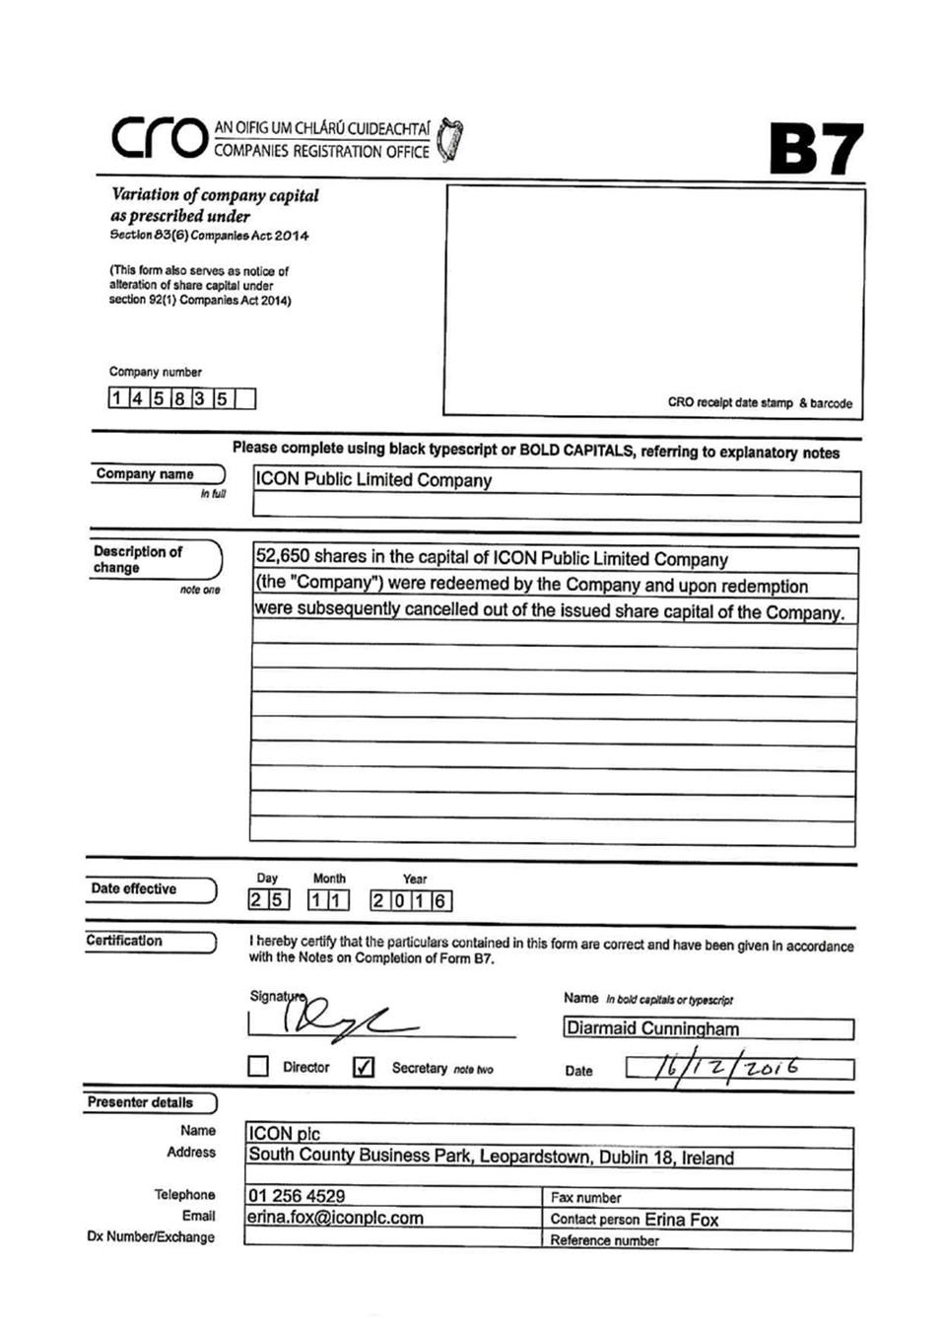

Exhibit 99.16

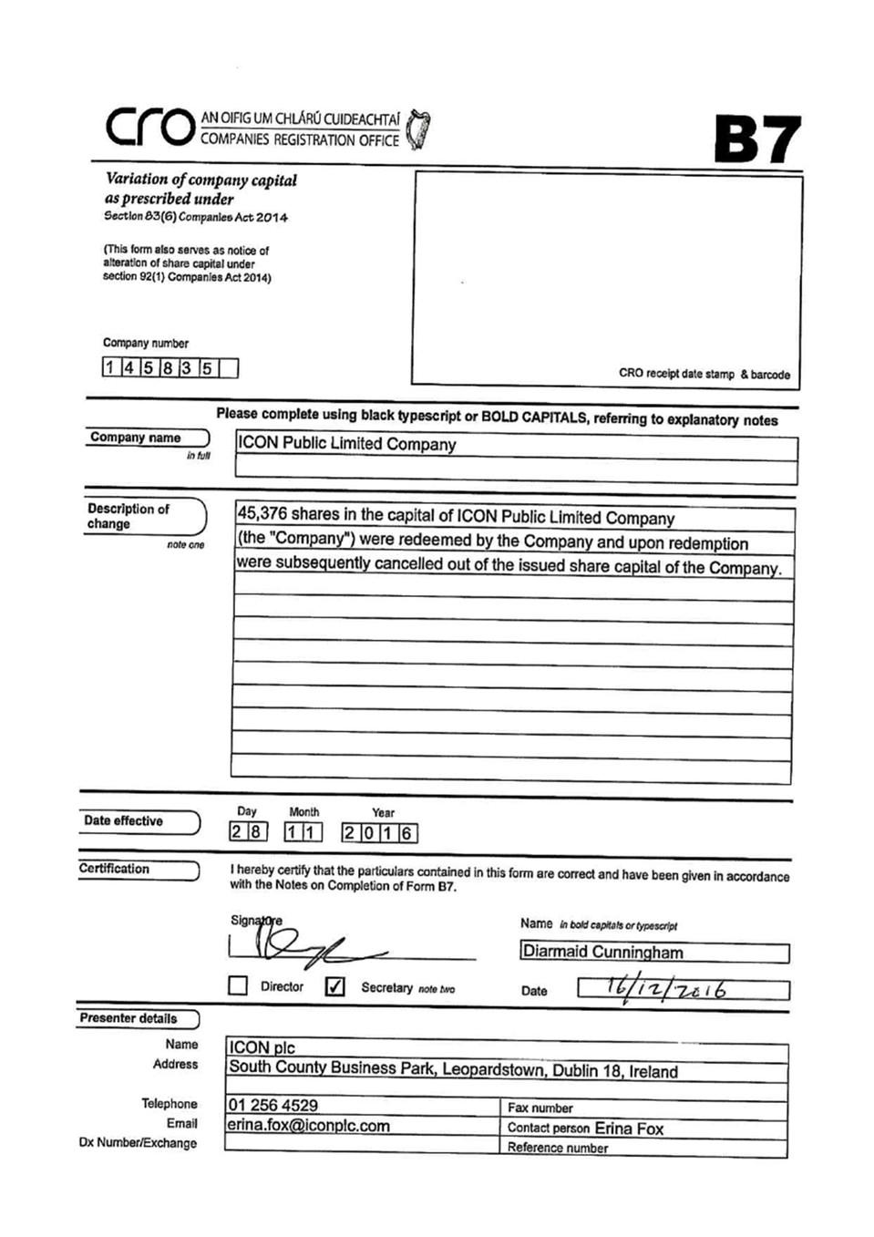

Exhibit 99.17

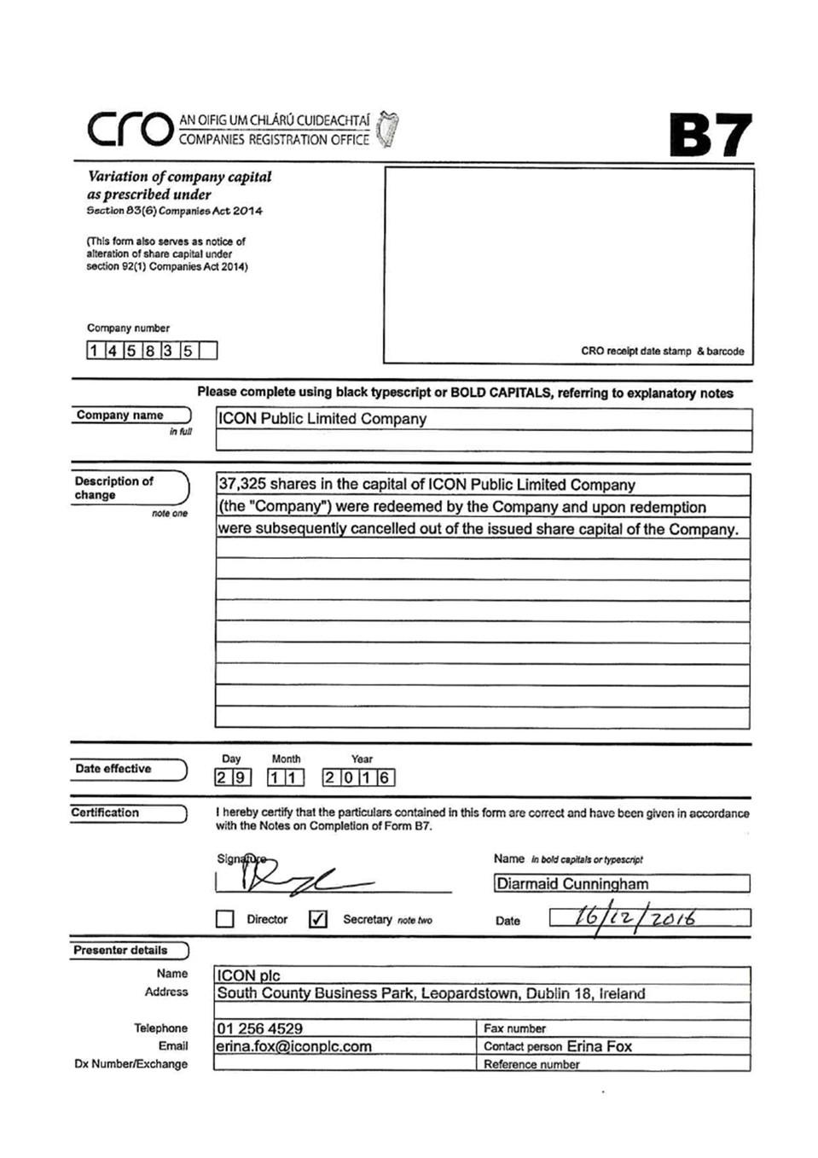

Exhibit 99.18

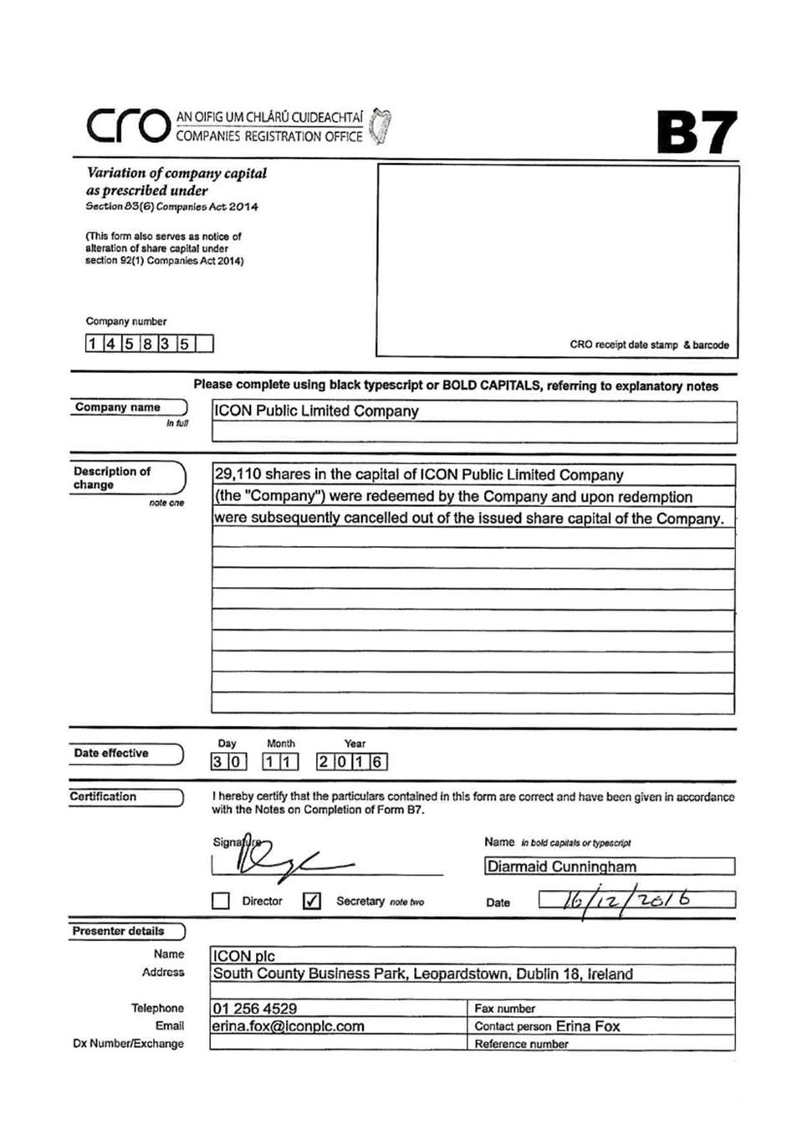

Exhibit 99.19

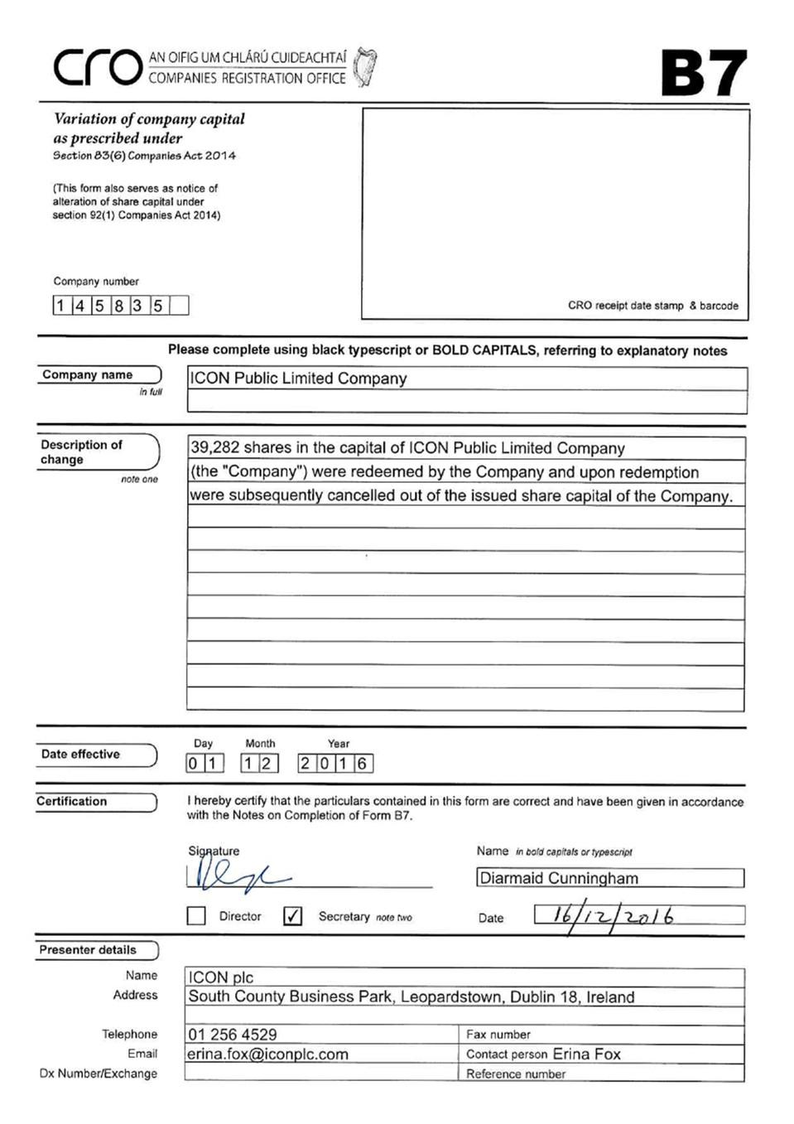

Exhibit 99.20

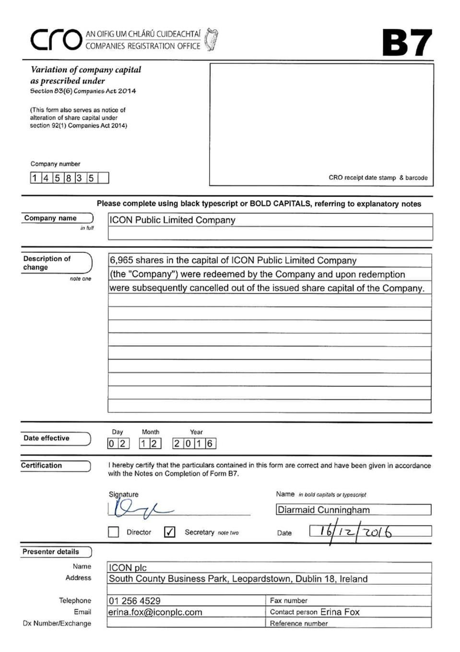

Exhibit 99.21

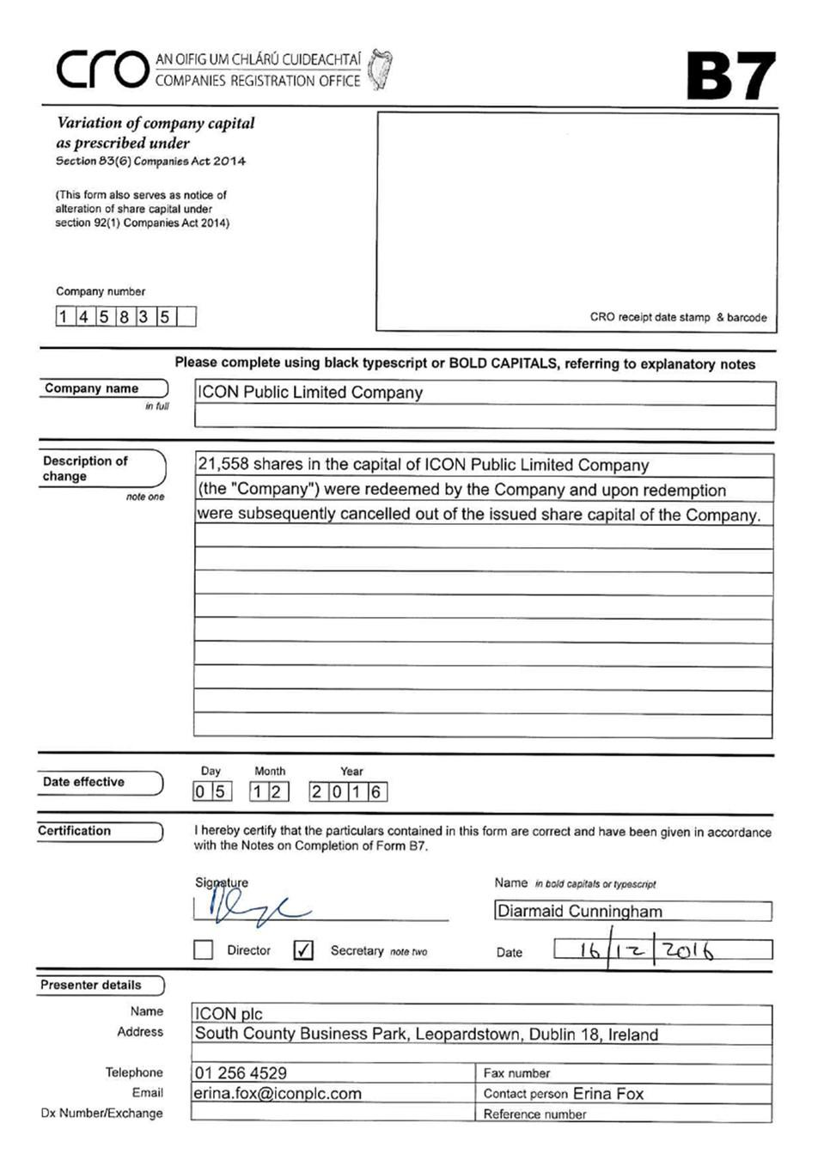

Exhibit 99.22

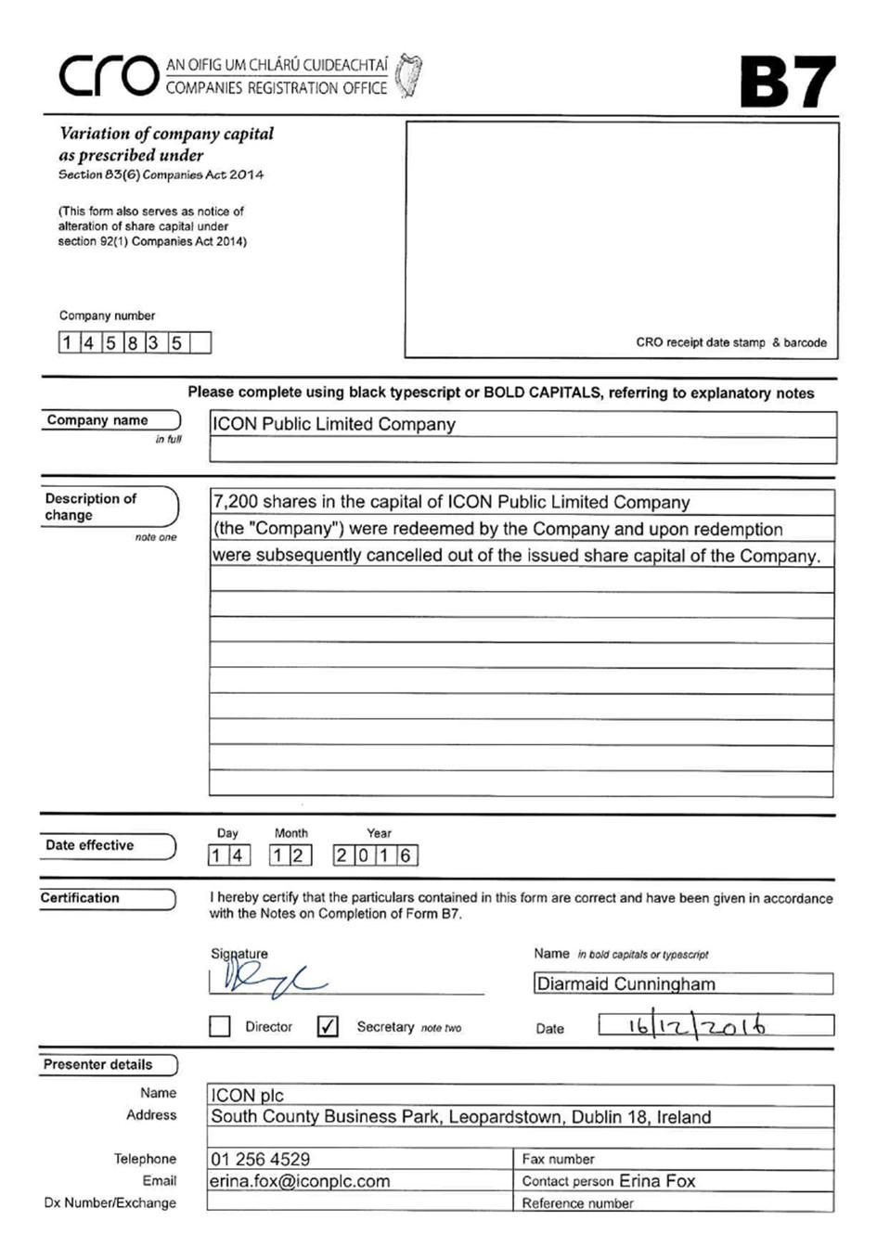

Exhibit 99.23

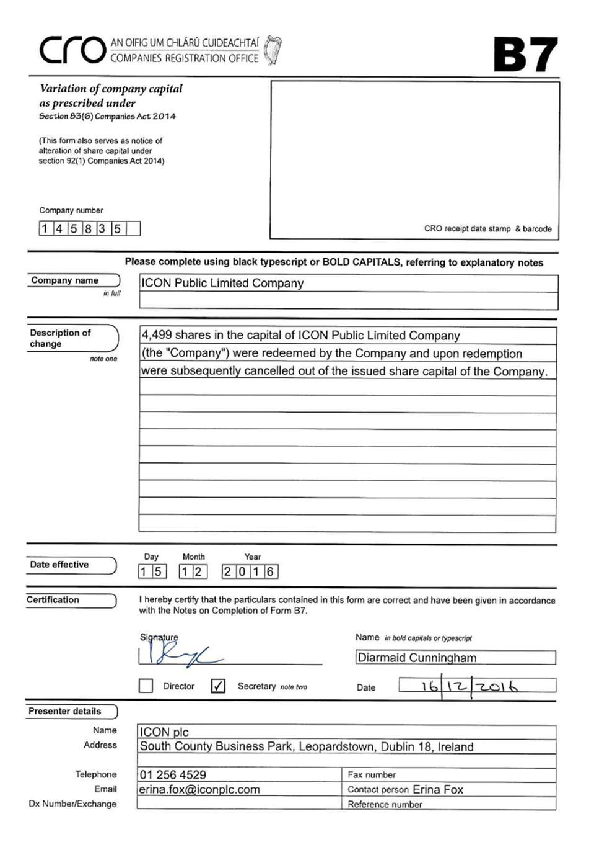

Exhibit 99.24

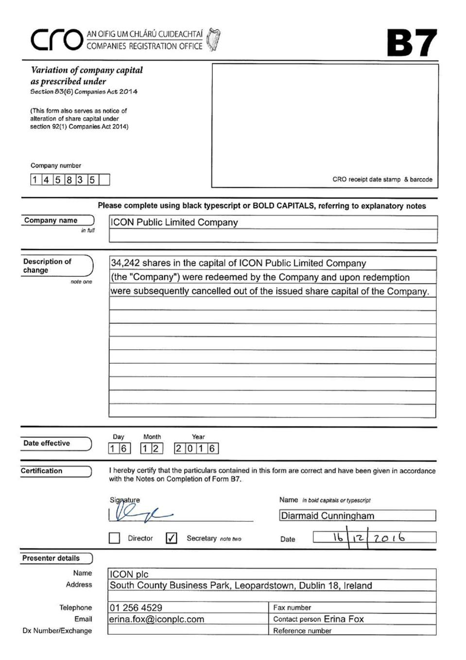

Exhibit 99.25

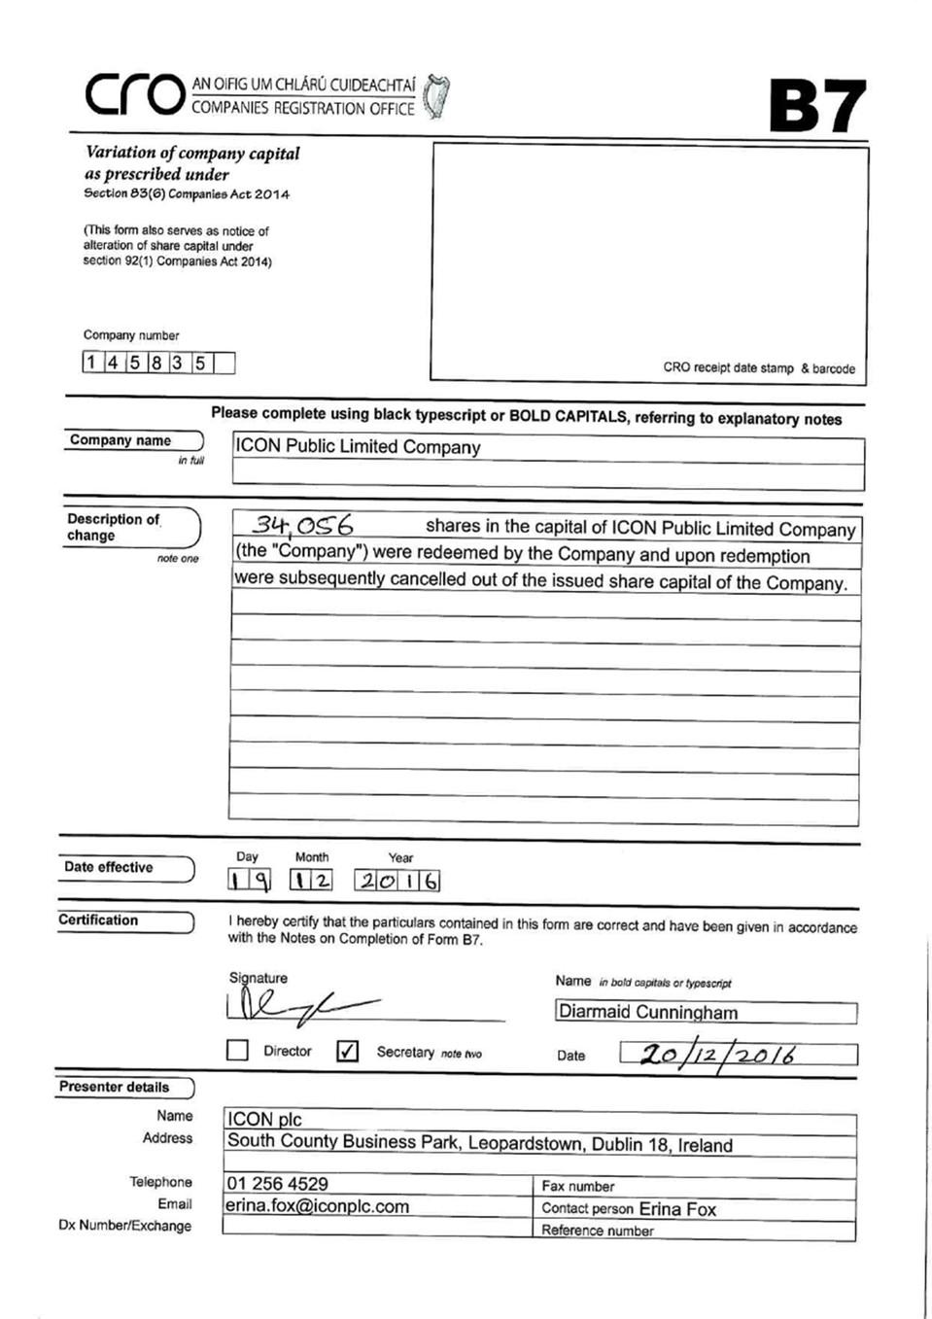

Exhibit 99.26

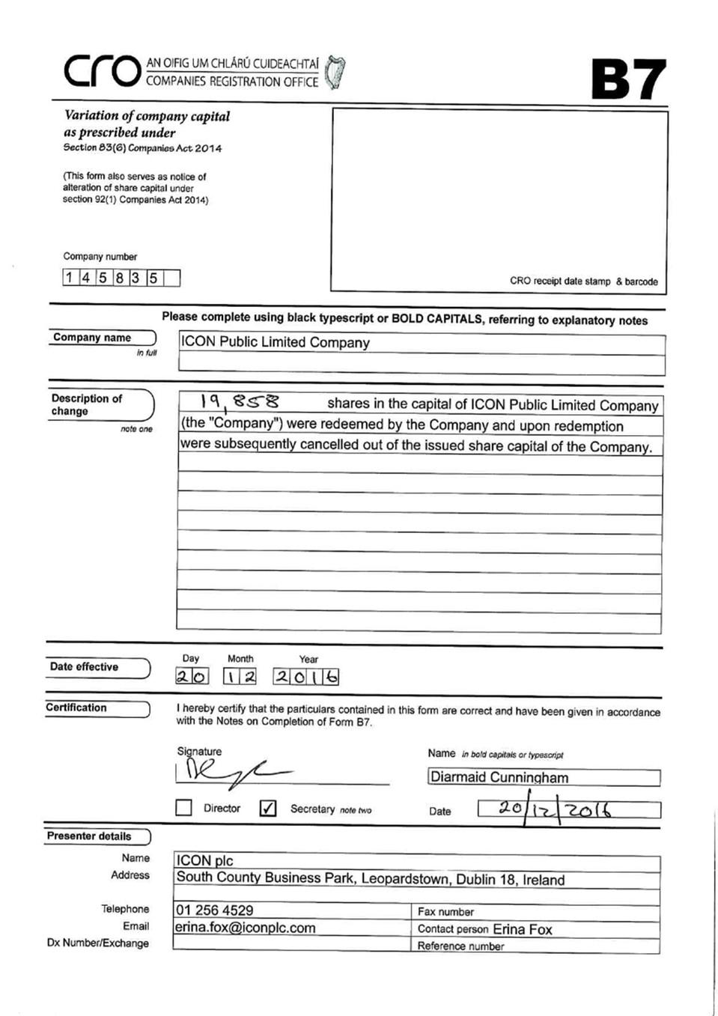

Exhibit 99.27

